AY 2022-23

Hardware models built for following courses:

**MCOA506L, MCOA506P –Real Time Embedded Systems**

**EEE4020 –Embedded System Design**

This prototype models are integrated in the education of embedded system design course. These prototypes are designed to drive students to a deeper understanding and integration of the diverse theoretical concepts that often come from different disciplines such as digital/analog electronics, sensors, control systems, communication and programming. Rather than proposing the experiment for a particular course within an embedded system engineering curriculum, this prototypes describes how the experiment can be tailored to the needs and diverse background of both undergraduate and graduate students’ education.

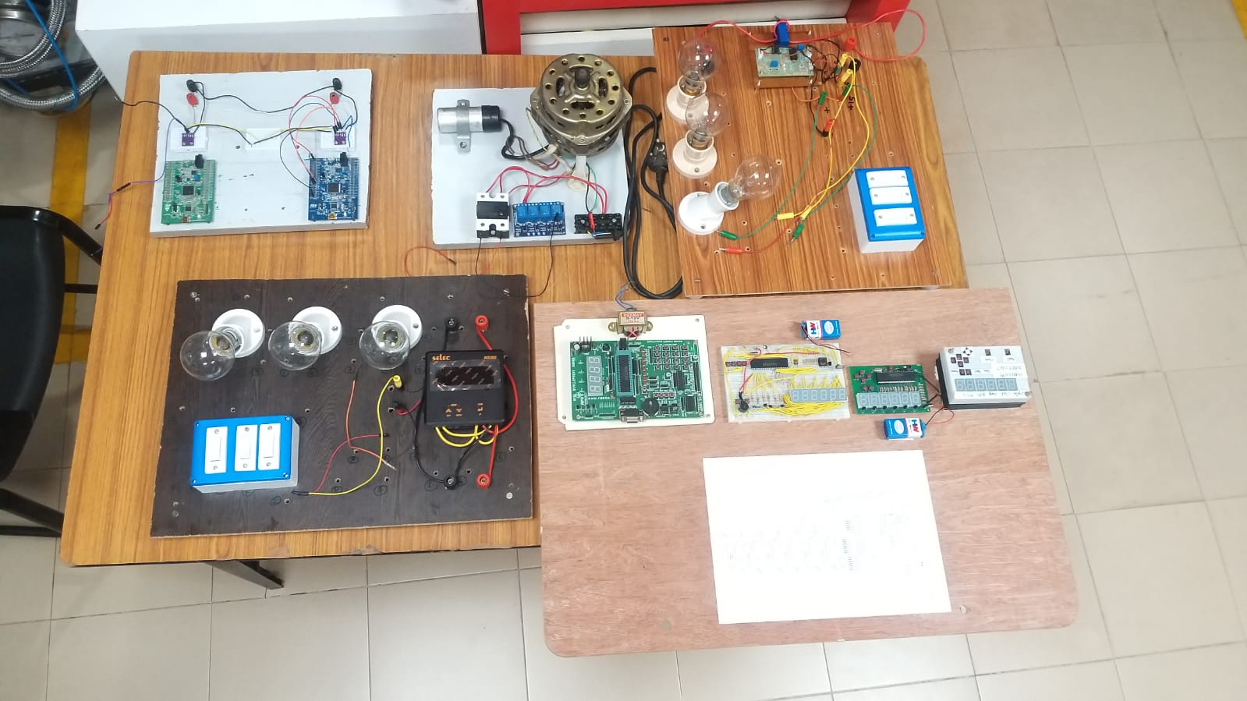

1. Open loop induction motor control using Solid State Relays, Electromechanical Relays, and ARM microcontroller

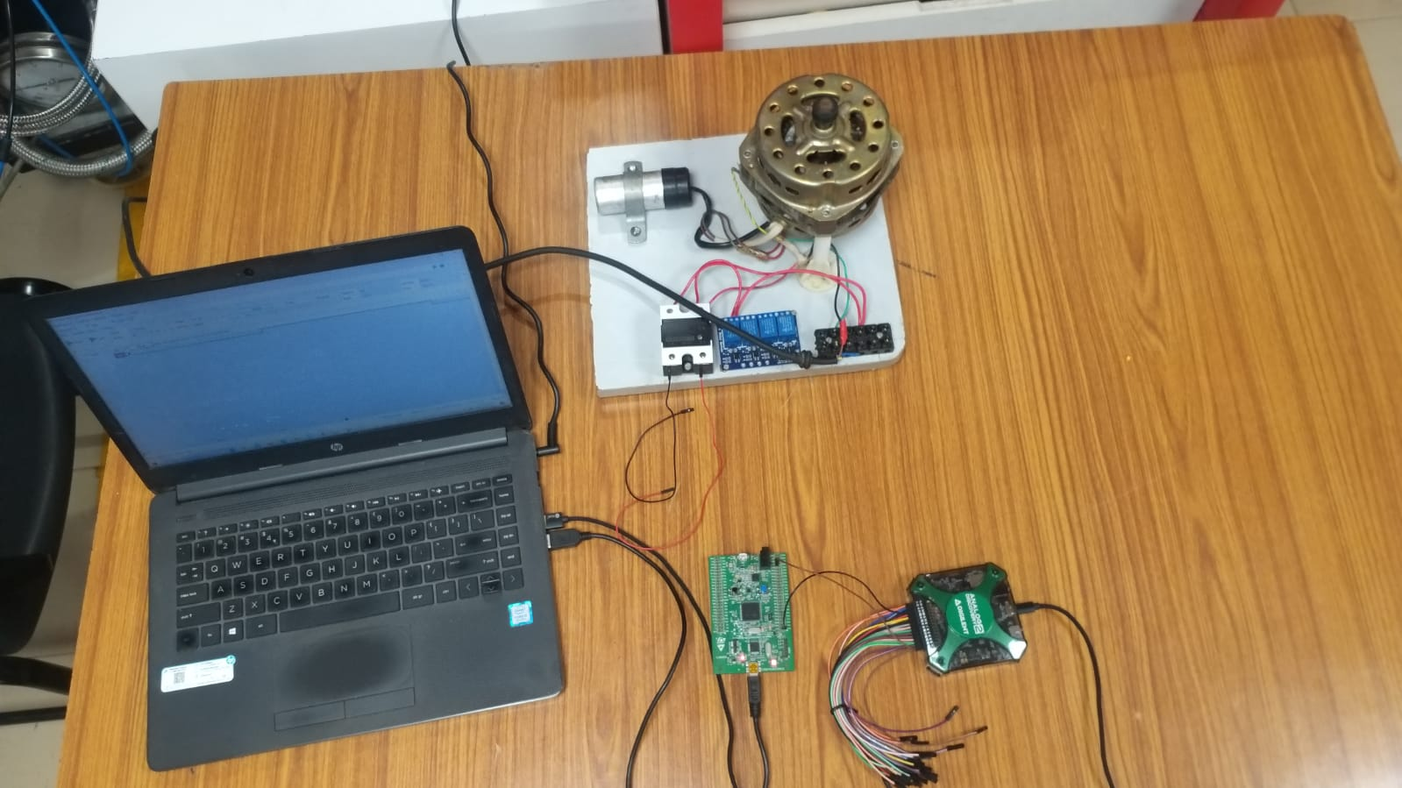

1. Real-time RMA current measurement using Hall effect based LEM 55A current sensor and ARM Microcontroller

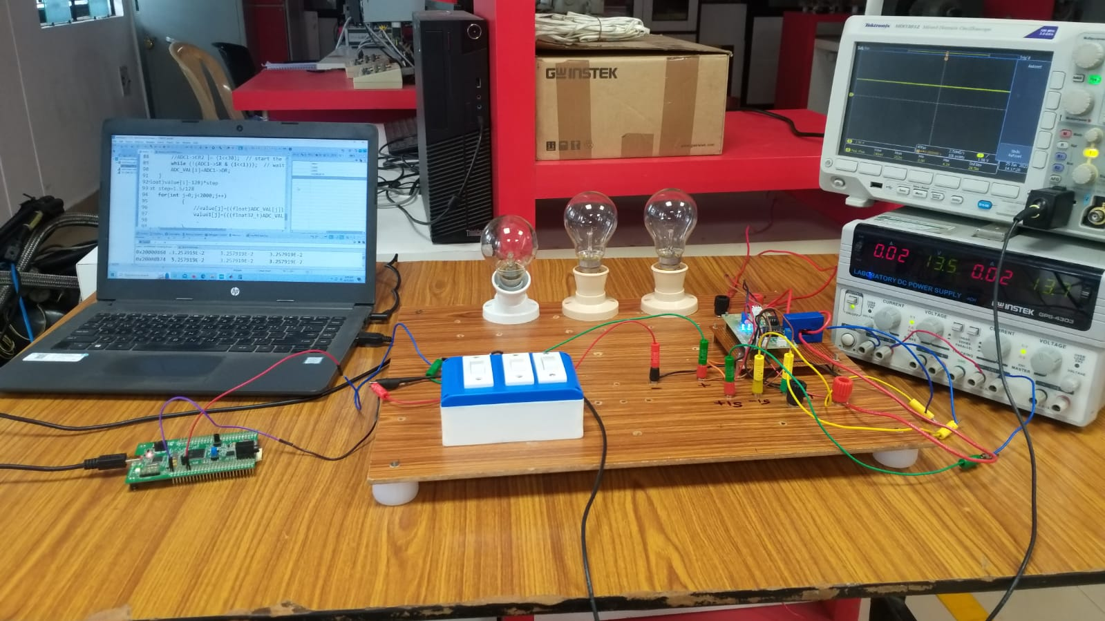

1. Real-time multifunction meter parameters (Voltage, Current, and Frequency) fetching using RS-485 Modbus protocol and ARM microcontroller

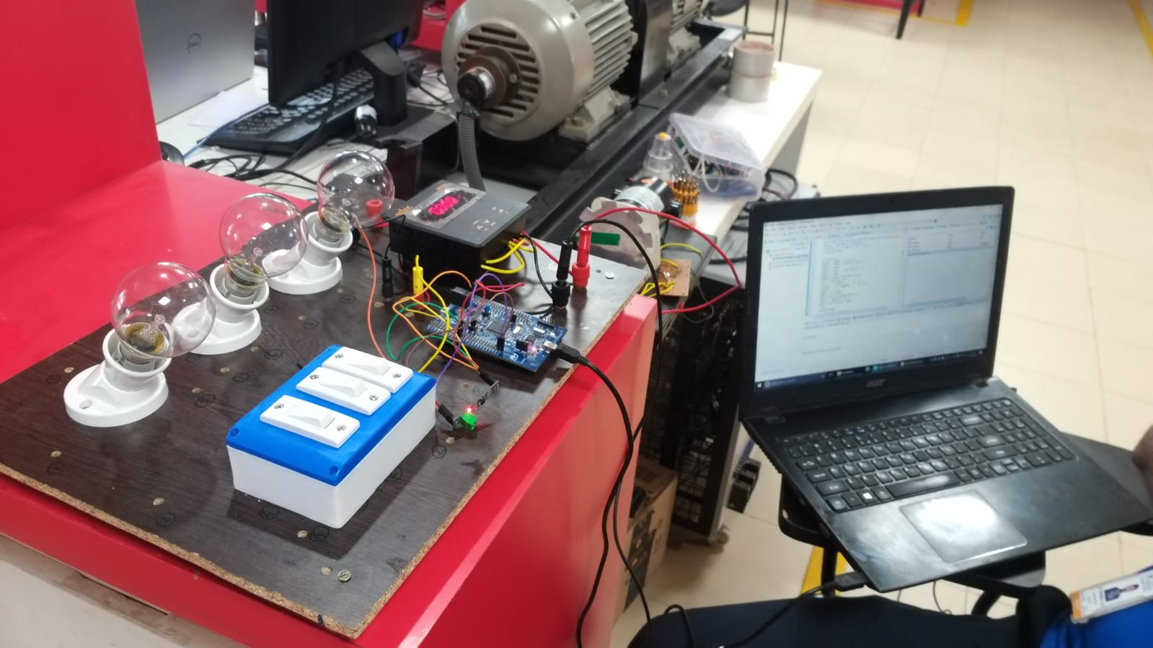

1. CAN communication and data frame visualization using ARM microcontroller and Logic analyzer

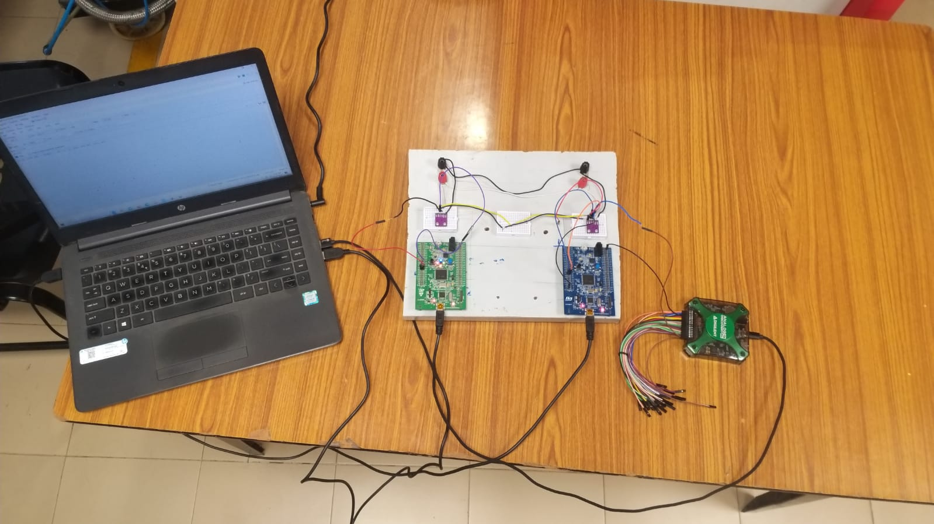

1. 8051 based product development: Detailed steps

