DevOps Bootcamp – Assignment 4

1. Create 2 nodes, One is the master one and another is slave one.



1. Configure the master node to enable password less authentication.
   1. Configure and set the password of slave node

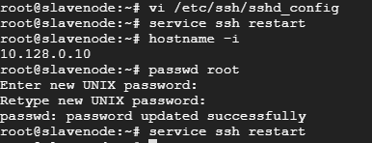

* 1. Create a the pair of SSH Key

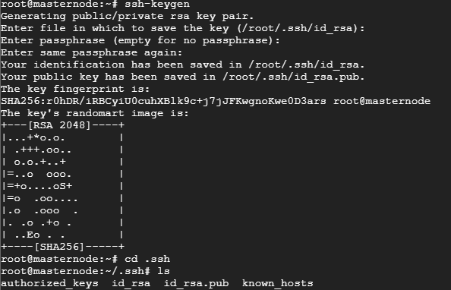

* 1. Copy the public key into the slave authentication file

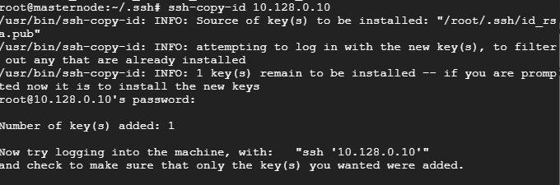

* 1. Successful able to connect the slave without password

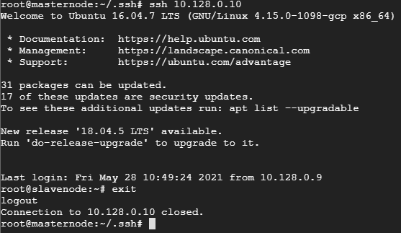

1. Install Ansible on Master node.
   1. Updated the apt cache and add the ansible repository

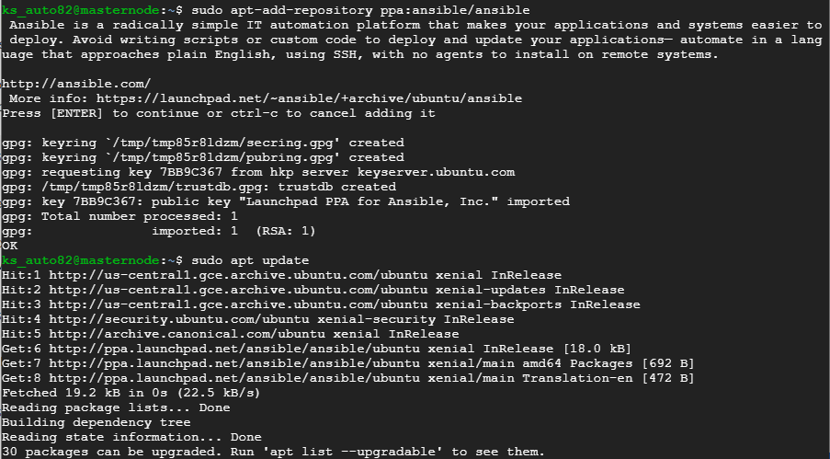

* 1. Install the Ansible

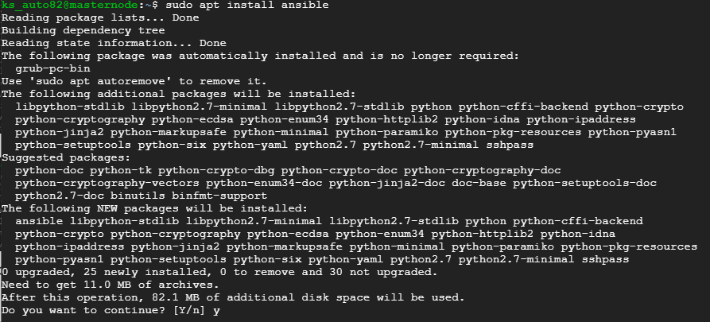

* 1. Checking the Ansible version

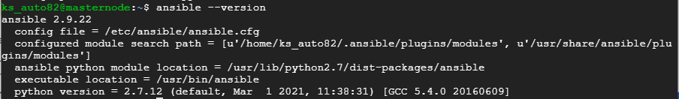

* 1. Added private IP of client machine in /etc/ansible/hosts file

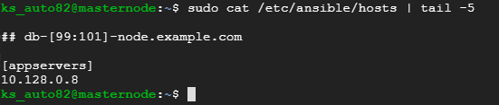

* 1. Checking the connectivity with slave

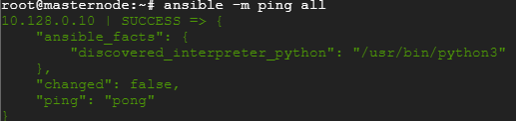

1. Write a playbook to install following software in the slave node.
   1. Java
   2. Maven
   3. Nginx
   4. Docker
2. Creating the playbook script
   * + 1. 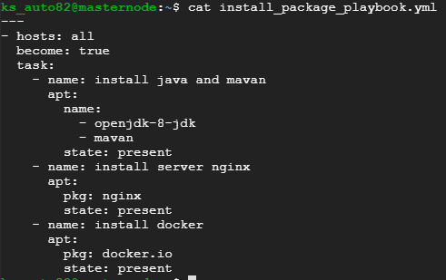
3. Configure playbook to deploy the application available in the below repository as docker container in the slave node.

Repo : https://github.com/shubhamkushwah123/war-test.git

1. Creating the war file on different machine

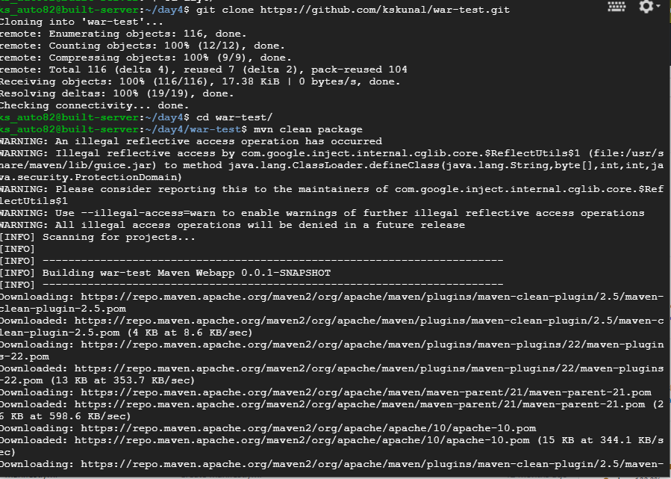

1. create the image and push the image to remote repository

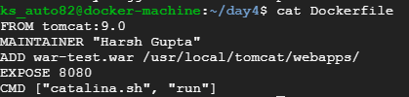

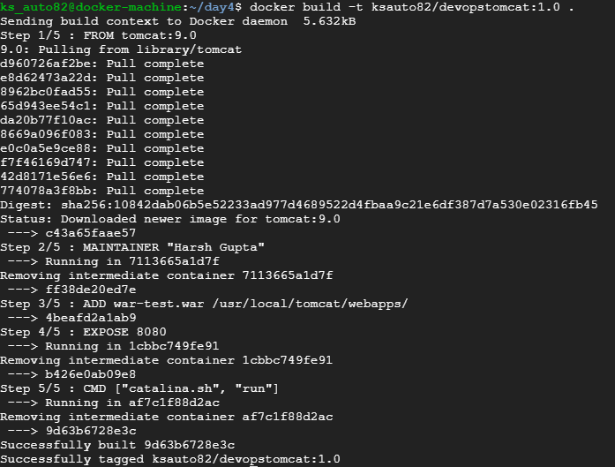

1. Push to remote

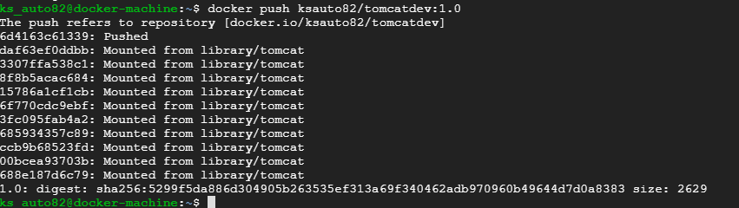

1. Configure playbook to deploy the application

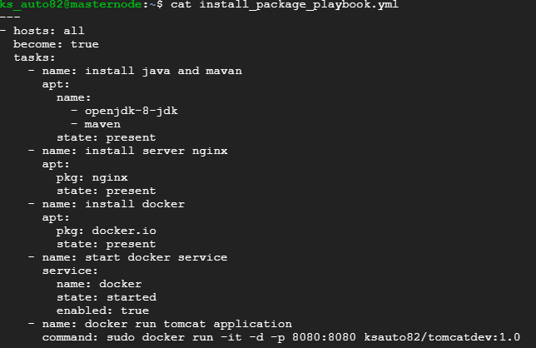

1. Run playbook and attach the screenshots of the playbook yml and output of the playbook execution.
   1. Running the playbook

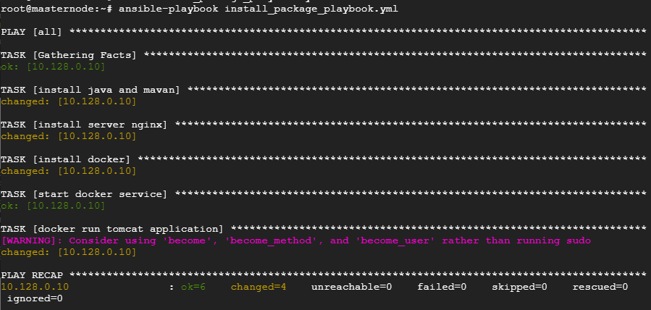

* 1. Docker is running on Slave node and port is in listening mode

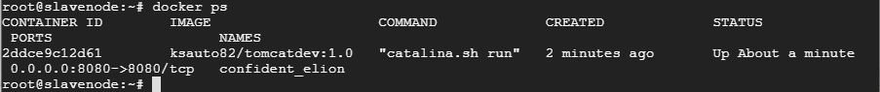

* 1. Check the deployed application is accessible from slave public ip

