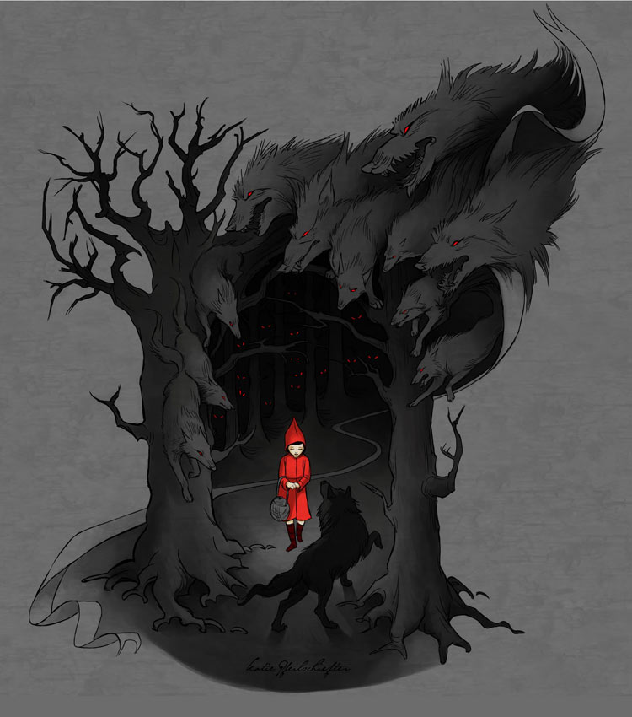

*RED*

by

Meme Team

Table of Contents

Version History 3

Game Overview 4

Win/Lose Conditions 4

Game Controls 4

Game Mechanics 4

Coffee Cups 4

HUD Layout 4

Level Layouts 5

IPM Chart 5

Asset List 5

Programming 5

Art 5

Audio 5

Level Design 5

# Version History

|  |  |
| --- | --- |
| **Version** | **Change log** |
| V1.0 | * Initial Draft |
| V2.0 | * Alpha Build * Updated the Mechanics Section |
|  |  |
|  |  |

# Game Overview

*Red* is a 2D side-scrolling, platformer, puzzle game. The player takes the role of Little Red, trying to get to her grandma’s house. The player wins when they reach grandma’s house, but to get there they must outwit the wolf or risk being eaten.

# Win/Lose Conditions

The player wins when they reach grandma’s house.

The player loses when they are killed by the wolf or other environmental factors.

# Game Controls

The players will move using a WASD movement scheme, using W to climb at indicated locations, spacebar to jump, and S to crouch.

# Game Mechanics

Walking

* When used:
  + Triggers walk animation
  + Plays snow crunching sound
  + Moves the character

Sprinting

* Will be used to speed up the character to cross longer jumps and to escape wolves.

Climbing vines

* Used for evading the wolf and climbing past obstacles too high to jump over or are too dangerous
* Will trigger climbing animation

Jumping/Double Jumping

* Used for getting over smaller obstacles and across gaps
* Will trigger jump animation
* Will play grunt and landing sound effects
* Can reach double the character’s height

Checkpoints

* Will look like a spooky rock shrine
* When activated will have glowing markings
* Will play a chime sound effect when passed
* The player will respawn as many times as it takes for them to reach the next checkpoint

# HUD Layout

[Mockup of your game’s HUD. Be sure to include a key and describe any important features. If your HUD changes during gameplay you need to include multiple HUD mockups to show this.]

# Level Layouts

[Include a mockup of each level, complete with a key and title for each. Be sure to label important areas like player starting point, win zone, collectibles, obstacles, etc.]

# IPM Chart

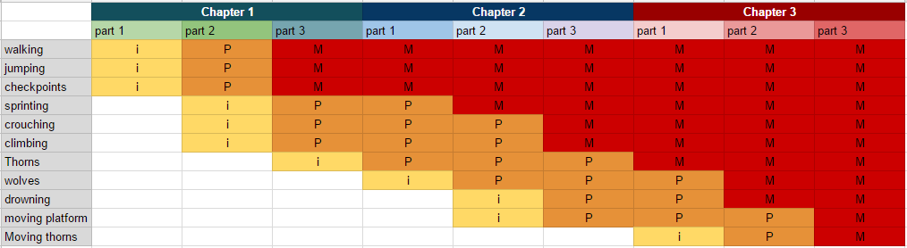

# Asset List

## Programming

|  |
| --- |
| Walk (w, a, s, d) |
| Run (shift) |
| Jump (space) |
| |  | | --- | | Climb(?) (up over ladder) | | Wolf walk back and forth | | Wolf walk towards player when player is near | | Parallaxing effect on background | |
| Checkpoints |
| floating particle effects? |
| Crouching |

## Art

|  |
| --- |
| **Assets** |
| Little Red Walk cycle |
| Little Red Run cycle |
| Little Red Jump cycle |
| Little Red Push cycle (?) |
| Wolf Walk Cycle |
| Wolf Run Cycle |
| Wolf Jump cycle (?) |
| Trees/Bushes/etc. |
| Bloody Death Animation |
| Checkpoints (1 large shrine rock plus 2 small versions) |
| Grandma's house |
| Red climbing cycle |
| Water/ pit indicator |
| Particle effects? |
| **Snow Area** |
| bg skinny pine tree 1 |
| bg skinny pine tree 2 |
| bg skinny pine tree 3 |
| foreground branch pine 1 |
| foreground branch pine 2 |
| foreground branch pine 3 |
| foreground branch pine 4 |
| pine with vines? |
| rock 1 |
| rock 2 |
| rock 3 |
| log 1 |
| log 2 |
| thorn bush 1 |
| repeatable thorn |
| repeatable thorn small |
| small mini pine 1 |
| small mini pine 2 |
| winter plant 1 |
| winter plant 2 |
| Little Red Run cycle |
| **Final Spooky Level** |
| Take Everything and add blood^^ |
| bg skinny pine tree 1 |
| bg skinny pine tree 2 |
| bg skinny pine tree 3 |
| foreground branch pine 1 |
| foreground branch pine 2 |
| foreground branch pine 3 |
| foreground branch pine 4 |
| pine with vines? |
| rock 1 |
| rock 2 |
| rock 3 |
| log 1 |
| log 2 |
| thorn bush 1 |
| repeatable thorn |
| repeatable thorn small |
| small mini pine 1 |
| small mini pine 2 |
| winter plant 1 |
| winter plant 2 |
| Grandma's House |
| The blood river |

## Audio

|  |
| --- |
| snow crunch Footsteps |
| Wolf noises breathing, growling |
| death scream |
| ominous forest sounds |
| crow sound |
| jump sound (hup) (crunch of snow) |
| ambient wind |
| room tone forest |
| running water/blood sound |
| crunching of leaves |

## Level Design

|  |
| --- |
| river of blood |
| thorns as danger |
| snowy area that goes from light to heavy |
| thick thorny swamp area |
| bioluminescent cave area |