**Progressive Duplicate Detection**

**1. INTRODUCTION**

Information are among the most critical resources of an organization. In any case, because of information changes and messy information passage, mistakes, for example, copy sections may happen, making information purifying and specifically copy discovery key. In any case, the immaculate size of today's datasets renders copy location forms costly. Online retailers, for instance, offer gigantic indexes containing an always developing arrangement of things from a wide range of suppliers. As autonomous persons change the item portfolio, copies emerge. In spite of the fact that there is an undeniable requirement for deduplication, online shops without downtime can't bear the cost of customary deduplication. Dynamic copy discovery recognizes most copy matches ahead of schedule in the recognition process. Rather than decreasing the general time expected to complete the whole process, dynamic methodologies attempt to diminish the normal time after which a copy is found. Early end, specifically, then yields more finishes results on a dynamic calculation than on any customary methodology. Dynamic strategies make this exchange off more gainful as they convey more finish results in shorter measures of time. Besides, they make it less demanding for the client to characterize this exchange off, in light of the fact that the recognition time or result size can specifically be indicated rather than parameters whose impact on discovery time and result size is difficult to figure. We introduce a few use situations where this gets to be essential:

1) A client has just constrained, perhaps obscure time for information purging and needs to make most ideal utilization of it. At that point, essentially begin the calculation and end it when required. The outcome size will be amplified. 2) A client has little learning about the given information yet needs to arrange the purging procedure. At that point, let the dynamic calculation pick window/square sizes and keys naturally. 3) A client needs to do the cleaning intuitively to, for case, discover great sorting keys by experimentation. At that point, run the dynamic calculation over and again; every run rapidly reports perhaps huge results. 4) A client needs to accomplish a specific review. At that point, utilize the outcome bends of dynamic calculations to gauge what number of more copies can be discovered further; as a rule, the bends asymptotically focalize against the genuine number of copies in the dataset. We propose two novel, dynamic copy location calculations to be specific dynamic sorted neighborhood strategy (PSNM), which performs best on little and clean datasets, and dynamic blocking (PB), which performs best on huge and extremely filthy datasets. Both improve the proficiency of copy identification even on expansive datasets. In contrast with customary copy recognition, dynamic copy identification fulfills two conditions.

Enhanced early quality: Let t be a subjective target time at which results are required. At that point the dynamic calculation finds more copy sets at t than the comparing conventional calculation. Commonly, t is littler than the general runtime of the conventional calculation.

Same possible quality: If both a customary calculation and its dynamic variant completion execution, without early end at t, they deliver the same results.

Given any settled size time space in which information purifying is conceivable, dynamic calculations attempt to expand their productivity for that measure of time. To this end, our calculations PSNM and PB progressively modify their conduct via naturally picking ideal parameters, e.g., window sizes, piece sizes, and sorting keys, rendering their manual determination pointless. Along these lines, we essentially facilitate the parameterization unpredictability for copy discovery as a rule and add to the advancement of more client intuitive applications: We can offer quick input and mitigate the frequently troublesome parameterization of the calculations.

Goal of the Project

Copy identification is the procedure of recognizing different representations of same true substances. Today, copy location strategies need to handle ever bigger datasets in ever shorter time: keeping up the nature of a dataset turns out to be progressively troublesome. We show two novel, dynamic copy discovery calculations that altogether build the proficiency of discovering copies if the execution time is constrained: They boost the increase of the general procedure inside the time accessible by reporting most results much sooner than customary methodologies.

**2. LITERATURE SURVEY**

**Pay-As-You-Go Entity Resolution**

Element determination (ER) is the issue of distinguishing which records in a database allude to the same element. By and by, numerous applications need to determine expansive information sets proficiently, yet don't require the ER result to be definite. For instance, individuals information from the Web may basically be too vast to totally resolve with a sensible measure of work. As another case, ongoing applications will be unable to endure any ER handling that takes longer than a specific measure of time. This paper explores how we can amplify the advancement of ER with a restricted measure of work utilizing "insights," which give data on records that are prone to allude to the

Same genuine substance. An indication can be spoken to in different arrangements (e.g., a gathering of records in light of their probability of coordinating), and ER can utilize this data as a rule for which records to think about first. We present a group of procedures for building indicates productively and systems for utilizing the insights to augment the quantity of coordinating records recognized utilizing a constrained measure of work. Utilizing genuine information sets, we outline the potential increases of our compensation as-you-go approach contrasted with running ER without utilizing insights.

We have proposed a compensation as-you-go approach for Entity Resolution (ER) where given a point of confinement in assets (e.g., work, runtime) we endeavor to gain the most extreme ground conceivable. We present the novel idea of insights, which can manage an ER calculation to concentrate on determining the more probable coordinating records first. Our methods are compelling when there are either excessively numerous records to determine inside a sensible measure of time or when there is a period limit (e.g., constant frameworks). We proposed three sorts of insights that are perfect with various ER calculations: a sorted rundown of record matches, a chain of importance of record parcels, and a requested rundown of records. We have likewise proposed different techniques for ER calculations to utilize these clues. Our trial results assessed the overhead of building insights and in addition the runtime advantages for utilizing clues. We considered an assortment of ER calculations and two genuine information sets.The results recommend that the advantages of utilizing insights can be definitely justified even despite the overhead required for building and utilizing clues. We trust our work is one of the first to characterize pay-as-you-go ER and unequivocally propose indications as a general system for quick ER. Numerous intriguing issues Remain to be tackled, including a more formal examination of various sorts of indications and a general direction for building and redesigning the "best" clue for any given ER calculation.

Copy Record Detection: A Survey

Regularly, in this present reality, elements have two or more representations in databases. Copy records don't share a typical key and/or they contain mistakes that make copy coordinating a troublesome errand. Mistakes are presented as the consequence of translation blunders, deficient data, absence of standard configurations, or any blend of these variables. In this paper, we exhibit an exhaustive investigation of the writing on copy record identification. We cover closeness measurements that are normally used to recognize comparable field passages, and we introduce a broad arrangement of copy location calculations that can identify around copy records in a database. We additionally cover various procedures for enhancing the proficiency and adaptability of surmised copy recognition calculations. We finish up with scope of existing apparatuses and with a brief examination of the enormous open issues in the territory.

In this overview, we have introduced a far reaching review of the current strategies utilized for identifying non indistinguishable copy passages in database records. The intrigued peruser may likewise need to peruse a correlative study by Winkler and the uncommon issue of the IEEE Data Engineering Bulletin on information quality. As database frameworks are turning out to be increasingly ordinary, information cleaning will be the foundation for adjusting blunders in frameworks which are collecting immense measures of mistakes once a day. Regardless of the broadness and profundity of the exhibited strategies, we trust that there is still space for significant change in the currentstate-of-the-craftsmanship. Above all else, it is right now misty which measurements and systems are the present cutting edge. The absence of institutionalized, huge scale benchmarking information sets can be a major hindrance for the further improvement of the field as it is verging on difficult to convincingly contrast new methods and existing ones. A storehouse of benchmark information sources with known and various attributes ought to be made accessible to engineers so they may assess their strategies amid the advancement process. Alongside benchmark and assessment information, different frameworks require some type of preparing information to create the underlying coordinating model. Albeit little information sets are accessible, we don't know about substantial scale, accepted information sets that could be utilized as benchmarks. Winkler [106] highlights systems on the most proficient method to infer information sets that are appropriately anonymized are still valuable for copy record identification purposes. As of now, there are two principle approaches for copy record discovery. Research in databases stresses moderately basic and quick copy identification systems that can be connected to databases with a great many records. Such

Methods regularly don't depend on the presence of preparing information and underline proficiency over viability.

Relationship-Based Duplicate Detection

Late work both in the social and the XML world have demonstrated that the adequacy and proficiency of copy discovery is upgraded by with respect to connections amongst predecessors and relatives. We exhibit a novel correlation system that utilizations connections however discards the strict base up and best down methodologies proposed for various leveled information. Rather, matches of items at any level of the chain of importance are thought about in a request that relies on upon their connections: Objects with numerous dependants impact numerous other deception choices and in this way it ought to be chosen early in the event that they are copies themselves. We apply this requesting methodology to two calculations. R ECON A permits reconsidering an article if its impacting neighbors end up being copies. Here requesting diminishes the quantity of such re-examinations. A DAM is more proficient by not permitting any re-correlation. Here the request minimizes the quantity of mix-ups made.

In this paper we displayed a novel copy identification approach for XML information, which, dissimilar to the basic top-down and base up methodologies, performs well in nearness of a wide range of connections between substances, i.e., 1:1, 1:n, and m:n. The examination procedure we displayed considers pair astute correlations in rising request of a rank, which assesses what number of sets must be reexamined if the first match was characterized at the present preparing state. We connected this system to two calculations: RECON An utilizations the request to characterize just few sets more than once, while A DAM A does not perform re-correlations and utilizations the request to miss few re-examinations and along these lines conceivably few copies. We promote displayed two augmentations to the calculations: Early grouping lessens the quantity of complex closeness calculations by registering an upper and lower bound to the similitude measure that can be utilized as channels. Imperative authorization is utilized to profit by a top-down procedure when pertinent, by implementing that impacting components are required to be copies all together for an applicant pair to be copies. Tests demonstrated that the request got utilizing rising is extremely powerful as a part of decreasing the quantity of re-examinations for RECON A, given a high interdependency between substances. For low entomb reliance there are just couple of conceivable re-examinations, so the contrast between the requests is not noteworthy for proficiency. At the point when connected to A DAM A we watched that the request utilizing performs marginally better as a part of terms of review and accuracy than different requests for high interdependency. In any case, the advantage in adequacy is not exactly the advantage of spared re-examinations in RECON A, which demonstrates that extra re-correlations prompted by different requests don't discover relatively more copies. At the point when contrasting RECON and A DAM A we watch that the more re-examinations are missed by A DAM A, the bigger the distinction is between the f-measure accomplished by R ECON ̇When assessing our augmentations we watched that the selectivity of early characterization is moderate, since it applies just to re-correlations, which don't happen every now and again when utilizing request . With respect to limitation authorization, we demonstrated that we can essentially enhance proficiency by upholding top-down when fitting. On this present reality Cora dataset, we watched that our answer is focused with other, perhaps more mind boggling arrangements, and that re-correlations don't risk proficiency while extraordinarily enhancing adequacy. Future work will incorporate further acceptance both on the Cora dataset and a huge certifiable information set for which we are as of now physically (and repetitively) deciding all copies. Keeping in mind the end goal to apply our calculations on this information, we will likewise address adaptability issues. We will likewise encourage examine on expanding viability, which was not the objective of this examination. A fascinating examination issue we plan to handle is the means by which to determine the contentions between settled XML copies to get clean XML information.

Certifiable Data is Dirty: Data Cleansing and the Merge/Purge Problem

The issue of consolidating different databases of data about regular elements is every now and again en-countered in KDD and choice bolster applications in expansive business and government associations. The issue we study is regularly called the Merge/Purge issue and is hard to fathom both in scale and precision. Substantial vaults of information ordinarily have various copy data passages about the same elements that are hard to winnow together without an int

**3.4. PROCESS MODEL USED WITH JUSTIFICATION**

**SDLC (Umbrella Model):**

**Umbrella Activity**

**Umbrella Activity**

**Umbrella Activity**

1. Feasibility Study
2. TEAM FORMATION
3. Project Specification PREPARATION

Business Requirement Documentation

ANALYSIS & DESIGN

CODE

UNIT TEST

DOCUMENT CONTROL

ASSESSMENT

TRAINING

INTEGRATION & SYSTEM TESTING

DELIVERY/INSTALLATION

ACCEPTANCE TEST

Requirements Gathering

SDLC is nothing but Software Development Life Cycle. It is a standard which is used by software industry to develop good software.

**Stages in SDLC:**

* Requirement Gathering
* Analysis
* Designing
* Coding
* Testing
* Maintenance

**Requirements Gathering** **stage:**

The prerequisites gathering process takes as its info the objectives distinguished in the abnormal state necessities area of the task arrangement. Every objective will be refined into an arrangement of one or more prerequisites. These necessities characterize the significant elements of the proposed application, characterize operational information ranges and reference information regions, and characterize the underlying information elements. Significant capacities incorporate basic procedures to be overseen, and additionally mission basic inputs, yields and reports. A client class pecking order is produced and connected with these significant capacities, information regions, and information elements. Each of these definitions is termed a Requirement. Prerequisites are recognized by one of a kind necessity identifiers and, at least, contain a necessity title and

literary portrayal.

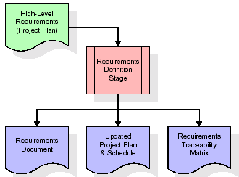

These necessities are completely depicted in the essential deliverables for this stage: the Requirements Document and the Requirements Traceability Matrix (RTM). The prerequisites report contains complete depictions of every prerequisite, including graphs and references to outside records as important. Note that point by point postings of database tables and fields are excluded in the necessities archive.

The title of every prerequisite is additionally set into the primary variant of the RTM, alongside the title of every objective from the undertaking arrangement. The motivation behind the RTM is to demonstrate that the item parts created amid every phase of the product improvement lifecycle are formally associated with the segments created in earlier stages.

In the necessities organize, the RTM comprises of a rundown of abnormal state prerequisites, or objectives, by title, with a posting of related prerequisites for every objective, recorded by prerequisite title. In this progressive posting, the RTM demonstrates that every necessity created amid this stage is formally connected to a particular item objective. In this arrangement, every prerequisite can be followed to a particular item objective, consequently the term necessities traceability.

The yields of the necessities definition stage incorporate the prerequisites report, the RTM, and an overhauled venture arrangement.

• Feasibility study is about recognizable proof of issues in a task.

• No. of staff required to handle an undertaking is spoken to as Team Formation, for this situation just modules are singular errands will be allocated to representatives who are working for that venture.

• Project Specifications are about speaking to of different conceivable inputs submitting to the server and comparing yields alongside reports kept up by overseer.

Examination Stage:

The arranging stage builds up a 10,000 foot perspective of the expected programming item, and utilizations this to set up the essential venture structure, assess possibility and dangers connected with the task, and depict fitting administration and specialized methodologies.

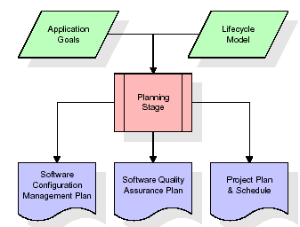

The most basic segment of the task arrangement is a posting of abnormal state item prerequisites, additionally alluded to as objectives. The greater part of the product item prerequisites to be created amid the necessities definition stage stream from one or a greater amount of these objectives. The base data for every objective comprises of a title and printed portrayal, albeit extra data and references to outside archives might be incorporated. The yields of the undertaking arranging stage are the setup administration arrange, the quality affirmation arrangement, and the task plan and calendar, with a point by point posting of planned exercises for the up and coming Requirements stage, and abnormal state appraisals of exertion for the out stages.

Outlining Stage:

The outline stage takes as its underlying info the necessities recognized in the affirmed prerequisites archive. For every prerequisite, an arrangement of one or more outline components will be delivered as a consequence of meetings, workshops, and/or model endeavors. Plan components depict the sought programming highlights in point of interest, and for the most part incorporate practical progressive system outlines, screen design graphs, tables of business principles, business process charts, pseudo code, and a complete element relationship graph with a full information word reference. These outline components are proposed to portray the product in adequate subtle element that talented software engineers may build up the product with insignificant extra input.

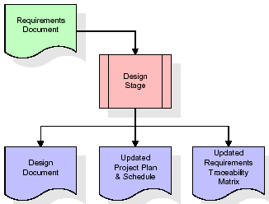  
At the point when the outline report is concluded and acknowledged, the RTM is overhauled to demonstrate that every configuration component is formally connected with a particular necessity. The yields of the outline stage are the configuration archive, a redesigned RTM, and an overhauled venture arrangement.

Advancement (Coding) Stage:

The advancement stage takes as its essential info the outline components depicted in the affirmed plan archive. For every configuration component, an arrangement of one or more programming ancient rarities will be delivered. Programming ancient rarities incorporate however are not constrained to menus, discoursed, information administration shapes, information reporting arranges, and concentrated strategies and capacities. Fitting experiments will be created for every arrangement of practically related programming antiques, and an online help framework will be produced to guide clients in their associations with the product.

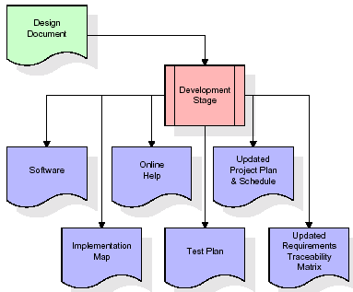

The RTM will be redesigned to demonstrate that each created antiquity is connected to a particular outline component, and that each created curio has one or all the more comparing experiment things. Right now, the RTM is in its last setup. The yields of the improvement stage incorporate a completely utilitarian arrangement of programming that fulfills the prerequisites and configuration components already recorded, an online help framework that depicts the operation of the product, an execution guide that recognizes the essential code passage focuses for all significant framework works, a test plan that portrays the experiments to be utilized to approve the rightness and culmination of the product, a redesigned RTM, and an upgraded venture arrangement.

Joining and Test Stage:

Amid the joining and test arrange, the product ancient rarities, online help, and test information are moved from the improvement environment to a different test environment. As of right now, all experiments are hurry to check the rightness and culmination of the product. Fruitful execution of the test suite affirms a powerful and complete relocation capacity. Amid this stage, reference information is concluded for creation use and generation clients are recognized and connected to their fitting parts. The last reference information (or connections to reference information source documents) and generation client rundown are ordered into the Production Initiation Plan.

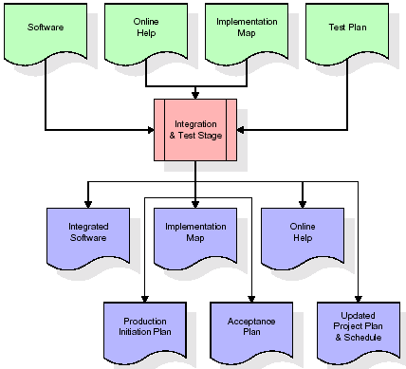

The yields of the incorporation and test stage incorporate a coordinated arrangement of programming, an online help framework, a usage guide, a creation start arrange for that portrays reference information and generation clients, an acknowledgment arrangement which contains the last suite of experiments, and an upgraded venture arrangement.

• Installation and Acceptance Test:

Amid the establishment and acknowledgment organize, the product antiques, online help, and beginning creation information are stacked onto the generation server. As of right now, all experiments are hurry to confirm the accuracy and fulfillment of the product. Effective execution of the test suite is an essential to acknowledgment of the product by the client.

After client work force have confirmed that the underlying generation information burden is right and the test suite has been executed with tasteful results, the client formally acknowledges the conveyance of the product.

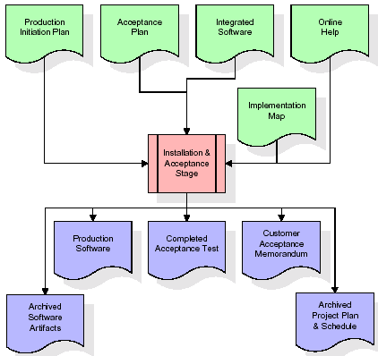

The essential yields of the establishment and acknowledgment stage incorporate a generation application, a finished acknowledgment test suite, and an update of client acknowledgment of the product. At long last, the PDR enters the remainder of the real work information into the undertaking timetable and locks the venture as a changeless task record. As of right now the PDR "locks" the venture by filing all product things, the usage outline, source code, and the documentation for future reference.

Support:

External rectangle speaks to support of a venture, Maintenance group will begin with prerequisite study, comprehension of documentation later representatives will be doled out work and they will under go preparing on that specific alloted class.

For this life cycle there is no end, it will be proceeded with so on like an umbrella (no closure point to umbrella sticks).

3.5. Programming Requirement Specification

3.5.1. General Description

A Software Requirements Specification (SRS) – a prerequisites detail for a product framework is a finished depiction of the conduct of a framework to be created. It incorporates an arrangement of utilization cases that portray every one of the collaborations the clients will have with the product. Notwithstanding utilize cases, the SRS likewise contains non-useful prerequisites. Nonfunctional necessities are prerequisites which force limitations on the outline or usage, (for example, efficiency tuning prerequisites, quality models, or plan imperatives).

Framework prerequisites determination: An organized gathering of data that exemplifies the necessities of a framework. A business investigator, some of the time titled framework expert, is in charge of breaking down the business needs of their customers and partners to recognize business issues and propose arrangements. Inside the frameworks improvement lifecycle area, the BA commonly performs a contact capacity between the business side of an undertaking and the data innovation office or outer administration suppliers. Activities are liable to three sorts of necessities:

• Business necessities portray in business terms what must be conveyed or achieved to give esteem.

• Product necessities portray properties of a framework or item (which could be one of a few approaches to finish an arrangement of business prerequisites.)

• Process necessities portray exercises performed by the creating association. For example, process prerequisites could indicate .Preliminary examination look at task possibility, the probability the framework will be valuable to the association. The fundamental target of the practicality study is to test the Technical, Operational and Economical attainability for including new modules and troubleshooting old running framework. All framework is attainable in the event that they are boundless assets and unending time. There are viewpoints in the practicality study segment of the preparatory examination:

• ECONOMIC FEASIBILITY

A framework can be created in fact and that will be utilized if introduced should even now be a decent speculation for the association. In the conservative attainability, the advancement cost in making the framework is assessed against a definitive advantage got from the new frameworks. Money related advantages must equivalent or surpass the expenses. The framework is financially practical. It doesn't require any expansion equipment or programming. Since the interface for this framework is produced utilizing the current assets and innovations accessible at NIC, There is ostensible use and prudent plausibility for certain.

• OPERATIONAL FEASIBILITY

Proposed ventures are useful just on the off chance that they can be transformed out into data framework. That will meet the association's working necessities. Operational possibility parts of the venture are to be taken as an essential part of the undertaking usage. This framework is focused to be as per the aforementioned issues. Heretofore, the administration issues and client prerequisites have been mulled over. So there is no doubt of resistance from the clients that can undermine the conceivable application advantages. The very much arranged configuration would guarantee the ideal usage of the PC assets and would help in the change of execution status.

• TECHNICAL FEASIBILITY

Prior no framework existed to take into account the requirements of 'Secure Infrastructure Implementation System'. The present framework created is in fact attainable. It is an online client interface for review work process at NIC-CSD. Subsequently it gives a simple access to .the clients. The database's motivation is to make, build up and keep up a work process among different elements with a specific end goal to encourage every single concerned client in their different limits or parts. Authorization to the clients would be conceded in light of the parts determined. Accordingly, it gives the specialized insurance of exactness, unwavering quality and security.

**3.5.2. External Interface Requirements**

**User Interface**

The user interface of this system is a user friendly Java Graphical User Interface.

**Hardware Interfaces**

The interaction between the user and the console is achieved through Java capabilities.

**Software Interfaces**

The required software is JAVA1.6.

**Operating Environment**

Windows XP, Linux.

**HARDWARE REQUIREMENTS:**

# Processor - Pentium –IV

* Speed - 1.1 Ghz
* RAM - 256 MB(min)
* Hard Disk - 20 GB
* Key Board - Standard Windows Keyboard
* Mouse - Two or Three Button Mouse
* Monitor - SVGA

**SOFTWARE REQUIREMENTS:**

* Operating System : Windows XP/95/98/2000
* Programming Language : JAVA, jdk1.6
* Front End : AWT, Swing
* Back End : MySql

**4. DESIGN**

**UML diagrams**

The Unified Modeling Language permits the product specialist to express an examination model utilizing the demonstrating documentation that is represented by an arrangement of syntactic semantic and down to business rules.

An UML framework is spoken to utilizing five diverse perspectives that portray the framework from unmistakably alternate point of view. Every perspective is characterized by an arrangement of graph, which is as per the following.

• User Model View

i. This view speaks to the framework from the clients viewpoint.

ii. The investigation representation depicts an utilization situation from the end-clients point of view.

• Structural Model perspective

i. In this model the information and usefulness are touched base from inside the framework.

ii. This model perspective models the static structures.

• Behavioral Model View

It speaks to the element of behavioral as parts of the framework, portraying the connections of accumulation between different auxiliary components depicted in the client model and basic model perspective.

• Implementation Model View

In this the auxiliary and behavioral as parts of the framework are spoken to as they are to be fabricated.

• Environmental Model View

In this the auxiliary and behavioral parts of nature in which the framework is to be actualized are spoken to.

4.1 Class outline:-

The class outline is the fundamental building piece of item situated demonstrating. It is utilized both for general theoretical displaying of the methodical of the application, and for nitty gritty demonstrating making an interpretation of the models into programming code. Class outlines can likewise be utilized for information demonstrating. The classes in a class graph speak to both the fundamental items, cooperations in the application and the classes to be customized. A class with three segments, in the graph, classes is spoken to with boxes which contain three sections:

• The upper part holds the name of the class

• The center part contains the properties of the class

• The base part gives the techniques or operations the class can take or embrace

**Class diagram:**



**4.2 Use case diagram:-**

An utilization case graph at its most straightforward is a representation of a client's association with the framework and delineating the particulars of an utilization case. An utilization case outline can depict the diverse sorts of clients of a framework and the different ways that they associate with the framework. This sort of chart is regularly utilized as a part of conjunction with the printed use case and will frequently be joined by different sorts of graphs also.

**4.2.1 Use case diagram**



**4.3. Sequence Diagram:**

A grouping graph is a sort of connection outline that shows how forms work with each other and in what request. It is a build of a Message Sequence Chart. A succession outline indicates object connections masterminded in time arrangement. It portrays the articles and classes required in the situation and the succession of messages traded between the items expected to do the usefulness of the situation. Grouping charts are commonly connected with use case acknowledge in the Logical View of the framework being worked on. Succession charts are in some cases called occasion outlines, occasion situations, and timing graphs.

**4.3.1 Sequence diagram:**



**4.4 Collaboration diagram**

A joint effort outline portrays cooperations among articles as far as sequenced messages. Joint effort outlines speak to a mix of data taken from class, grouping, and utilize case graphs portraying both the static structure and element conduct of a framework.

**4.5.1 Collaboration diagram:**



**4.6 Component Diagram**

In the Unified Modeling Language, a segment outline delineates how segments are wired together to frame bigger parts as well as programming frameworks. They are utilized to outline the structure of self-assertively complex frameworks

Segments are wired together by utilizing a gathering connector to associate the required interface of one segment with the gave interface of another part. This delineates the administration customer - administration supplier relationship between the two parts.

**4.6.1 Component diagram**



**4.7 Deployment Diagram**

An arrangement graph in the Unified Modeling Language models the physical sending of curios on hubs. To depict a site, for instance, an organization graph would indicate what equipment segments ("hubs") exist (e.g., a web server, an application server, and a database server), what programming parts ("antiques") keep running on every hub (e.g., web application, database), and how the distinctive pieces are associated (e.g. JDBC, REST, RMI).

The hubs show up as boxes, and the ancient rarities apportioned to every hub show up as rectangles inside the crates. Hubs may have sub hubs, which show up as settled boxes. A solitary hub in a sending graph may reasonably speak to different physical hubs, for example, a group of database servers.

**4.7.1 Deployment diagram**



**4.8 Activity diagram:**

Action chart is another imperative outline in UML to portray dynamic parts of the framework. It is essentially a stream diagram to speak to the stream structure one action to another movement. The action can be depicted as an operation of the framework.

So the control stream is attracted starting with one operation then onto the next. This stream can be consecutive, stretched or simultaneous.

**4.8.1 Activity diagram:**

Upload dataset

Select the sorting key and window/block size

Perform PSNM Algorithm

View duplicate text and runtime chart

May change the sorting key and block size

Perform PB algorithm

View duplicate text and runtime chart

**4.9 Data Flow Diagram:**

Information stream graphs delineate how information is handled by a framework as far as inputs and yields. Information stream charts can be utilized to give a reasonable representation of any business capacity. The system begins with a general photo of the business and proceeds by breaking down each of the practical territories of interest. This investigation can be completed in exactly the level of subtle element required. The strategy misuses a technique called top-down extension to direct the examination in a focused on way.

As the name recommends, Data Flow Diagram (DFD) is a representation that explains the section of data in a procedure. A DFD can be effortlessly drawn utilizing basic images. Also, convoluted procedures can be effectively computerized by making DFDs utilizing simple to-use, free downloadable charting instruments. A DFD is a model for developing and dissecting data forms. DFD outlines the stream of data in a procedure relying on the inputs and yields. A DFD can likewise be alluded to as a Process Model. A DFD exhibits business or specialized procedure with the backing of the outside information spared, in addition to the information spilling out of the procedure to another and the final results.

User

PSNM Algorithm

1. Upload the dataset 3. Perform the PSNM alg

2. Select sorting key and window/block size

4. Detect the duplicate data

7. View the runtime charts

6. Detect the duplicate data

PB Algorithm

5. Perform the PB algorithm

**5. IMPLEMENTATION**

**5.1. Introduction of technologies used**

**About Java**:

At first the dialect was called as "oak" however it was renamed as "java" in 1995.The essential inspiration of this dialect was the requirement for a stage free (i.e. design neutral)language that could be utilized to make programming to be inserted in different purchaser electronic gadgets.

Java is a software engineer's dialect

Java is strong and reliable

With the exception of those requirement forced by the Internet environment. Java gives the software engineer, full control

At last Java is to Internet Programming where c was to System Programming.

Significance of Java to the Internet

Java has profoundly affected the Internet. This is on the grounds that; java extends the Universe of items that can move about unreservedly in Cyberspace. In a system, two classes of items are transmitted between the server and the PC. They are latent data and dynamic projects. in the ranges of Security and likelihood. Be that as it may, Java addresses these worries and thusly, has opened the way to an energizing new type of project called the Applet.

Applications and applets

An application is a project that keeps running on our Computer under the working arrangement of that PC. It is pretty much like one making utilizing C or C++ .Java's capacity to make Applets makes it imperative. An Applet I san application, intended to be transmitted over the Internet and executed by a Java-perfect web program. An applet I really a minor Java program, powerfully downloaded over the system, much the same as a picture. Be that as it may, the distinction is, it is a shrewd system, not only a media document. It can be respond to the client info and powerfully change.

Java Architecture

Java engineering gives a versatile, strong, high performing environment for improvement. Java gives conveyability by aggregating the byte codes for the Java Virtual Machine, which is then deciphered on every stage by the run-time environment. Java is a dynamic framework, ready to load code when required from a machine in the same room or over the planet.

Arrangement of code

When you order the code, the Java compiler makes machine code (called byte code)for a speculative machine called Java Virtual Machine(JVM). The JVM is gathered t executed the byte code. The JVM is made for the defeating the issue of likelihood. The code is composed and accumulated for one machine and deciphered on all machines .This machine is called Java Virtual Machine.

**Compiling and interpreting java source code.**

**Source code**

**Pc compiler**

**Macintosh compiler**

**SPARC Compiler**

**Java Byte code**

**Platform independent**

**Java interpreter**

**Java interpretermacintosh**

**)))**

**Java interpreter(SPARC)**

Amid run-time the Java mediator traps the byte code record into suspecting that it is running on a Java Virtual Machine. In all actuality this could be an Intel Pentium windows 95 or sun SPARCstation running Solaris or Apple Macintosh running framework and all could get code from any PC through web and run the Applets.

Straightforward:

Java was intended to be simple for the Professional software engineer to learn and to utilize successfully. In the event that you are an accomplished C++ Programmer. Learning Java will arranged components of C++. The vast majority of the befuddling ideas from C++ are either let well enough alone for Java or actualized in a cleaner, more congenial way. In Java there are a little number of obviously characterized approaches to perform a given errand.

Object situated

Java was not intended to be source-code perfect with whatever other dialect. This permitted the Java group the flexibility to outline with a clear state. One result of this was a clean usable, even minded way to deal with items. The item demonstrate in Java is basic and simple to augment, while straightforward sorts, for example, numbers, are kept as elite non-objects.

Powerful

The multi-stage environment of the web places remarkable requests on a project, on the grounds that the system must execute dependably in an assortment of frameworks. The capacity to make strong projects. Was given a high need in the configuration of Java. Java is entirely written dialect; it checks your code at assemble time and runtime.

Java for all intents and purposes dispenses with the issues of memory administration and arrangement area, which is totally programmed. In an elegantly composed Java program, all run-time mistakes can and ought to be overseen by your project.

AWT and Swings:

AWT:

Graphical User Interface:

The client interface is that part of a project that collaborates with the client of the system. GUI is a sort of client interface that permits clients to communicate with electronic gadgets with pictures instead of content charges. A class library is given by the Java programming dialect which is known as Abstract Window Toolkit (AWT) for composing graphical projects. The Abstract Window Toolkit (AWT) contains a few graphical gadgets which can be added and situated to the showcase range with a format chief.

As the Java programming dialect, the AWT is not stage autonomous. AWT utilizes framework peers object for developing graphical gadgets. A typical arrangement of apparatuses is given by the AWT to graphical client interface outline. The execution of the client interface components gave by the AWT is done utilizing each stage's local GUI toolbox. One of the AWT's essentialness is that the look and feel of every stage can be protected.

Parts:

A graphical client interface is worked of graphical components called parts. A part is an article having a graphical representation that can be shown on the screen and that can interface with the client. Parts permit the client to collaborate with the system and give the contribution to the project. In the AWT, all client interface segments are cases of class Component or one of its subtypes. Ordinary segments incorporate such things as catches, scrollbars, and content fields.

**Types of Components:**

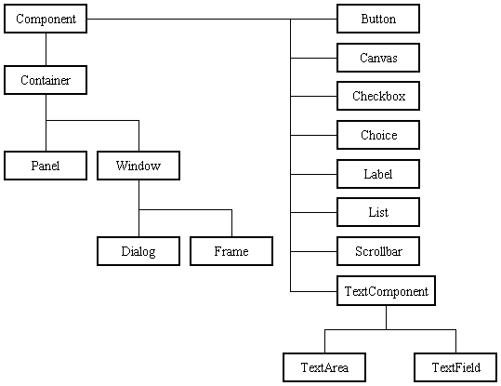

Before proceeding ahead, first we need to know what containers are. After learning containers we learn all components in detail.

**Containers:**

Parts don't remain solitary, yet rather are found inside compartments. Keeping in mind the end goal to make parts unmistakable, we have to add all segments to the holder. Holders contain and control the format of parts. In the AWT, all holders are occurrences of class Container or one of its subtypes. Segments must fit totally inside the holder that contains them. For adding parts to the holder we will utilize include() technique.

**Types of containers:**

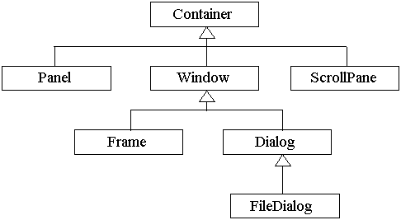

**Basic GUI Logic:**

The GUI application or applet is made in three stages. These are:

• Add segments to Container items to make your GUI.

• Then you have to setup occasion handlers for the client association with GUI.

• Explicitly show the GUI for application.

Another string is begun by the translator for client cooperation when an AWT GUI is shown. At the point when any occasion is gotten by this new string, for example, snap of a mouse, squeezing of key and so forth then one of the occasion handlers is called by the new string set up for GUI. One vital point to note here is that the occasion handler code is executed inside the string.

Making a Frame:

Method1:

In the main technique we will be making outline by developing Frame class which is characterized in java.awt bundle. Taking after project exhibit the making of an edge.

import java.awt.*;

open class FrameDemo1 develops Frame

{

FrameDemo1()

{

setTitle("Label Frame");

setVisible(true);

setSize(500,500);

}

open static void main(String[] args)

{

new FrameDemo1 ();

}

}

In the above project we are utilizing three techniques:

setTitle: For setting the title of the edge we will utilize this technique. It takes String as a contention which will be the title name.

SetVisible: For making our edge unmistakable we will utilize this technique. This strategy takes Boolean quality as a contention. In the event that we are passing genuine then window will be noticeable generally window won't be obvious.

SetSize: For setting the extent of the window we will utilize this technique. The main contention is width of the edge and second contention is stature of the casing.

Technique 2:

In this technique we will be making the Frame class case for making outline window. Taking after system show Method2.

import java.awt.*;

open class FrameDemo2

{

open static void main(String[] args)

{

Outline f = new Frame();

f.setTitle("My first edge");

f.setVisible(true);

f.setSize(500,500);

}

}

Sorts of Components:

1) Labels :

This is the least difficult segment of Java Abstract Window Toolkit. This part is for the most part used to demonstrate the content or string in your application and mark never perform any sort of activity.

Name l1 = new Label("One");

Name l2 = new Label("Two");

Name l3 = new Label("Three",Label.CENTER);

In the above three lines we have made three names with the name "one, two, three". In the third mark we are passing two contentions. Second contention is the avocation of the mark. Presently subsequent to making segments we will be adding it to the holder.

add(l1);

add(l2);

add(l3);

We can set or change the content in a name by utilizing the setText( ) technique. You can acquire the present mark by calling getText( ). These techniques are appeared here:

void setText(String str)

String getText( )

2) Buttons :

This is the part of Java Abstract Window Toolkit and is utilized to trigger activities and different occasions required for your application. The sentence structure of characterizing the catch is as per the following :

Catch l1 = new Button("One");

Catch l2 = new Button("Two");

Catch l3 = new Button("Three");

We can change the Button's mark or get the name's content by utilizing the Button.setLabel(String) and Button.getLabel() strategy.

3) CheckBox:

A check box is a control that is utilized to kill a choice on or. It comprises of a little box that can either contain a check stamp or not. There is a name connected with every check box that portrays what choice the crate speaks to. You change the condition of a check box by tapping on it. The linguistic structure of the meaning of Checkbox is as per the following :

Checkbox Win98 = new Checkbox("Windows 98/XP", invalid, genuine);

Checkbox winNT = new Checkbox("Windows NT/2000");

Checkbox solaris = new Checkbox("Solaris");

Checkbox macintosh = new Checkbox("MacOS");

The primary structure makes a check box whose name is determined in first contention and whose gathering is indicated in second contention. In the event that this check box is not part of a gathering, then cbGroup must be invalid. (Check confine gatherings are depicted the following area.) The worth genuine decides the underlying condition of the check box is checked. The second shape makes a check box with stand out parameter.

To recover the present condition of a check box, call getState( ). To set its state, call setState( ). You can acquire the present mark connected with a check box by calling getLabel( ). To set the name, call setLabel( ). These techniques are as per the following:

boolean getState( )

void setState(boolean on)

String getLabel( )

void setLabel(String str)

Here, if on is valid, the container is checked. On the off chance that it is false, the crate is cleared. The string went in str turns into the new name connected with the summoning check box.

4) Radio Button:

This is the unique instance of the Checkbox part of Java AWT bundle. This is utilized as a gathering of checkboxes which amass name is same. One and only Checkbox from a Checkbox Group can be chosen at once. Language structure for making radio catches is as per the following:

CheckboxGroup cbg = new CheckboxGroup();

Checkbox Win98 = new Checkbox("Windows 98/XP", cbg , genuine);

Checkbox winNT = new Checkbox("Windows NT/2000",cbg, false);

Checkbox solaris = new Checkbox("Solaris",cbg, false);

Checkbox macintosh = new Checkbox("MacOS",cbg, false);

For Radio Button we will be utilizing CheckBox class. The main contrast in Checkboxes and radio catch is in Check boxes we will indicate invalid for checkboxgroup yet while in radio catch we will be specifiying the checkboxgroup object in the second parameter.

5) Choice:

The Choice class is utilized to make a pop-up rundown of things from which the client may pick. Subsequently, a Choice control is a type of menu. Sentence structure for making decision is as per the following:

Decision os = new Choice();

/* adding things to decision */

os.add("Windows 98/XP");

os.add("Windows NT/2000");

os.add("Solaris");

os.add("MacOS");

We will be making decision with the assistance of Choice class. Pop up rundown will be making with the production of article, yet it won't have any things. For including things we will be utilizing include() technique characterized in Choice class. To figure out which thing is right now chosen, you may call either getSelectedItem( ) or getSelectedIndex( ). These techniques are appeared here:

String getSelectedItem( )

int getSelectedIndex( )

The getSelectedItem( ) strategy gives back a string containing the name of the thing. getSelectedIndex( ) gives back the file of the thing. The principal thing is at list 0. Naturally, the primary thing added to the rundown is chosen.

6) List:

List class is additionally same as decision yet the main distinction in rundown and decision is, in decision client can choose stand out thing though in List client can choose more than one thing. Punctuation for making rundown is as per the following:

List os = new List(4, genuine);

Initially contention in the List constructor indicates the quantity of things permitted in the rundown. Second contention determines whether various choices are permitted or not.

/* Adding things to the rundown */

os.add("Windows 98/XP");

os.add("Windows NT/2000");

os.add("Solaris");

os.add("MacOS");

In rundown we can recover the things which are chosen by the clients. In different determination client will be selecting various qualities for recovering all the qualities we have a strategy called getSelectedValues() whose arrival sort is string cluster. For recovering single esteem again we can utilize the strategy characterized in Choice i.e. getSelectedItem().

7) TextField:

Content fields permit the client to enter strings and to alter the content utilizing the bolt keys, cut and glue keys. TextField is a subclass of TextComponent. Linguistic structure for making rundown is as per the following:

TextField tf1 = new TextField(25);

TextField tf2 = new TextField();

In the principal content field we are determining the extent of the content field and the second content field is made with the default esteem. TextField (and its superclass TextComponent) gives a few strategies that permit you to use a content field. To get the string as of now contained in the content field, call getText( ). To set the content, call setText( ). These techniques are as per the following:

String getText( )

void setText(String str)

We can control whether the substance of a content field might be changed by the client by calling setEditable( ). You can decide editability by calling isEditable( ). These techniques are appeared here:

boolean isEditable( )

void setEditable(boolean canEdit)

isEditable( ) returns genuine if the content might be changed and false if not. In setEditable( ), if canEdit is valid, the content might be changed. On the off chance that it is false, the content can't be adjusted.

There might be times when we will need the client to enter content that is not showed, for example, a secret word. We can cripple the reverberating of the characters as they are written by calling setEchoChar( ).

8) TextArea:

TextArea is a various line editorial manager. Language structure for making rundown is as per the following:

TextArea range = new TextArea(20,30);

Above code will make one content range with 20 lines and 30 segments. TextArea is a subclass of TextComponent. Subsequently, it bolsters the getText( ), setText( ), getSelectedText( ), select( ), isEditable( ), and setEditable( ) strategies depicted in the first segment.

TextArea includes the accompanying techniques:

void append(String str)

void insert(String str, int file)

void replaceRange(String str, int startIndex, int endIndex)

The attach( ) strategy adds the string indicated by str to the end of the present content. embed( ) embeds the string went in str at the predetermined record. To supplant content, call replaceRange( ). It replaces the characters from startIndex to endIndex–1, with the substitution content went in str.

Format Managers:

A format supervisor naturally organizes controls inside a window by utilizing some kind of calculation. Every Container object has a design director connected with it. A format supervisor is an example of any class that actualizes the LayoutManager interface. The design chief is set by the setLayout( ) strategy. On the off chance that no call to setLayout( ) is made, then the default format supervisor is utilized. At whatever point a holder is resized (or estimated for the firs

**Difference between Swings and AWT:**

|  |  |
| --- | --- |
| **Swings** | **AWT** |
| Swings are the light weight components. | AWTs are the heavy weight components. |
| Swings are developed by using pure java language. | AWTs are developed by using C and C++. |
| We can have different look and feel in swings. | This feature is not available in awt. |
| Swing has many advanced features like JTabel, JTabbedPane and JTree | This are not available in awt. |

**Java Swing Class Hierarchy:**

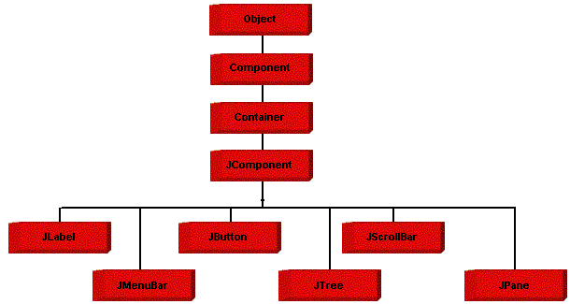

**Swing Components:**

All the components which are supported in AWT same components are also supported in Swings with a slight change in their class name.

|  |  |
| --- | --- |
| **AWT Components** | **Swing Components** |
| Label | JLabel |
| TextField | JTextField |
| TextArea | JTextArea |
| Choice | JComboBox |
| Checkbox | JCheckBox |
| List | JList |
| Button | JButton |
| - | JRadioButton |
| - | JPasswordField |
| - | JTable |
| - | JTree |
| - | JTabbedPane |
| MenuBar | JMenuBar |
| Menu | JMenu |
| MenuItem | JMenuItem |
| - | JFileChooser |
| - | JOptionPane |

We will discuss only those components which are not discussed in AWT chapter.

**JTabbedPane class:**

 The JTabbedPane container allows many panels to occupy the same area of the interface, and the user may select which to show by clicking on a tab.

**Constructor**

JTabbedPane tp = new JTabbedPane();

## Adding tabs to the JTabbedPane

Add tabs to a tabbed pane by calling addTab and passing it a String title and an instance of a class which should be called when we pressed a tab. That class should be a subclass of JPanel.

addTab(“String”,instance);

**Example program:**

import javax.swing.*;

import java.awt.*;

public class TabbedPaneDemo extends JFrame

{

TabbedPaneDemo()

{

setLayout(new FlowLayout(FlowLayout.LEFT));

setTitle("Tabbed Demo");

setVisible(true);

setSize(500,500);

setDefaultCloseOperation(JFrame.EXIT_ON_CLOSE);

JTabbedPane pane = new JTabbedPane();

pane.addTab("Countries",new Count());

pane.addTab("Cities",new Cit());

add(pane);

}

public static void main(String a[])

{

new TabbedPaneDemo();

}

}

class Count extends JPanel

{

Count()

{

JButton b1 = new JButton("India");

JButton b2 = new JButton("SriLanka");

JButton b3 = new JButton("Australia");

add(b1);

add(b2);

add(b3);

}

}

class Cit extends JPanel

{

Cit()

{

JCheckBox cb1 = new JCheckBox("Hyderabad");

JCheckBox cb2 = new JCheckBox("Banglore");

JCheckBox cb3 = new JCheckBox("Pune");

add(cb1);

add(cb2);

add(cb3);

}

}

**JMenuBar, JMenu, JMenuItem**

A top-level window can have a menu bar connected with it. A menu bar shows a rundown of top-level menu decisions. Every decision is connected with a drop-down menu. This idea is executed in Java by the accompanying classes: JMenuBar, JMenu, and JMenuItem. By and large, a menu bar contains one or more JMenu items. Each JMenu object contains a rundown of JMenuItem articles. Each JMenuItem object speaks to something that can be chosen by the client. To make a menu bar, first make an example of JMenuBar. This class just characterizes the default constructor. Next, make occasions of JMenu that will characterize the determinations showed on the bar. Taking after are the constructors for Menu:

JMenu( )

JMenu(String optionName)

Here, optionName indicates the name of the menu choice. The primary structure makes a vacant menu. Singular menu things are of sort MenuItem. It characterizes these constructors:

JMenuItem( )

JMenuItem(String itemName)

Here, itemName is the name appeared in the menu.

**5.4. Sample code**

**PB.java**

package duplicate;

import java.util.ArrayList;

import java.io.RandomAccessFile;

import java.io.File;

import org.jsoup.select.Elements;

import org.jsoup.Jsoup;

import org.jsoup.nodes.Document;

import org.jsoup.nodes.Element;

import org.apache.commons.lang3.StringUtils;

import javax.swing.SwingUtilities;

import java.util.HashSet;

public class PB{

static ArrayList<Sort> dataset = new ArrayList<Sort>();

static RandomAccessFile random;

static HashSet<String> duplicates = new HashSet<String>();

static long order = 0;

static int k = 0;

public static void setPartition(int val){

k = val;

System.out.println(k);

}

public static void pb(File file,String skey,int psize){

try{

dataset.clear();

duplicates.clear();

long tot = 0;

long partition = file.length()/psize;

print(partition+" size\n");

random = new RandomAccessFile(file,"r");

long block_size = 100; //block size

long block_per_partition = partition/ block_size;

for(k=0;k<psize;k++){

byte b[]=new byte[(int)partition];

random.read(b);

random.seek(random.getFilePointer());

String line = new String(b);

Document doc = Jsoup.parse(line);

Elements key = doc.select(skey);

for(Element value : key){

String text = value.text().trim();

text = text.toLowerCase().replaceAll("[^a-zA-Z\\s+]", "");

Sort sr = new Sort();

sr.setTitle(text.trim());

dataset.add(sr);

order = order + 1;

}

long from = 0;

long to = block_size;

final ArrayList blocks[] = new ArrayList[(int)block_per_partition];

for(int j=0;j<block_per_partition;j++){

if(to < dataset.size()){

ArrayList<Sort> block = new ArrayList<Sort>(dataset.subList((int)from,(int)to));

java.util.Collections.sort(block,new Sort());

blocks[j] = block;

from = to;

to = to + block_size;

}

}

dataset.clear();

print("Processing block size "+blocks.length+"\n");

new Thread(new Runnable(){

public void run(){

checkDup(blocks);

}

}).start();

}

random.close();

}catch(Exception e){

e.printStackTrace();

}

}

public static void checkDup(ArrayList data[]){

for(int m=0;m<data.length;m++){

if(data[m] != null){

ArrayList<Sort> block = data[m];

for(int i=0;i<block.size();i++){

Sort sr = block.get(i);

String s1 = sr.getTitle();

if(!duplicates.contains(s1)){

for(int j=i+1;j<block.size();j++){

Sort temp = block.get(j);

String s2 = temp.getTitle();

int distance = StringUtils.getLevenshteinDistance(s1,s2);

if(distance <= 1)

duplicates.add(s2);

if(distance > 1)

j = block.size();

}

}

}

}

}

print("Duplicate detection done on blocks. Current duplicate size "+duplicates.size()+"\n");

}

public static void print(final String text){

System.out.print(text);

}

}

**PSNM.java**

package duplicate;

import java.util.ArrayList;

import java.io.RandomAccessFile;

import java.io.File;

import org.jsoup.select.Elements;

import org.jsoup.Jsoup;

import org.jsoup.nodes.Document;

import org.jsoup.nodes.Element;

import org.apache.commons.lang3.StringUtils;

import javax.swing.SwingUtilities;

import java.util.HashSet;

public class PSNM{

static ArrayList<Sort> dataset = new ArrayList<Sort>();

static RandomAccessFile random;

static HashSet<String> duplicates = new HashSet<String>();

static long order = 0;

static int k = 0;

public static void setWindow(int val){

k = val;

System.out.println(k);

}

public static void psnm(File file,String skey,int window){

try{

dataset.clear();

duplicates.clear();

long tot = 0;

final long partition = file.length()/window;

print(partition+" size\n");

random = new RandomAccessFile(file,"r");

for(k=0;k<window;k++){

byte b[]=new byte[(int)partition];

random.read(b);

random.seek(random.getFilePointer());

String line = new String(b);

Document doc = Jsoup.parse(line);

Elements key = doc.select(skey);

for(Element value : key){

String text = value.text().trim();

text = text.toLowerCase().replaceAll("[^a-zA-Z\\s+]", "");

Sort sr = new Sort();

sr.setTitle(text.trim());

dataset.add(sr);

order = order + 1;

}

java.util.Collections.sort(dataset,new Sort());

print("Processing partition size "+dataset.size()+"\n");

final ArrayList<Sort> data = new ArrayList<Sort>(dataset);

dataset.clear();

new Thread(new Runnable(){

public void run(){

checkDup(data);

}

}).start();

}

random.close();

}catch(Exception e){

e.printStackTrace();

}

}

public static void checkDup(ArrayList<Sort> data){

for(int i=0;i<data.size();i++){

Sort sr = data.get(i);

String s1 = sr.getTitle();

if(!duplicates.contains(s1)){

for(int j=i+1;j<data.size();j++){

Sort temp = data.get(j);

String s2 = temp.getTitle();

int distance = StringUtils.getLevenshteinDistance(s1,s2);

if(distance <= 1)

duplicates.add(s2);

if(distance > 1)

j = data.size();

}

}

}

print("Duplicate detection done on partition. Current duplicate size "+duplicates.size()+"\n");

}

public static void print(final String text){

System.out.print(text);

}

}

**6. TESTING**

**Usage and Testing:**

**Usage is a standout amongst the most critical errands in venture is the stage in which one must be alerts since every one of the endeavors embraced amid the task will be extremely intelligent. Usage is the most pivotal stage in accomplishing fruitful framework and giving the clients certainty that the new framework is workable and compelling. Every project is tried independently at the season of improvement utilizing the example information and has confirmed that these projects connect together in the route indicated in the system determination. The PC framework and its surroundings are tried as per the general inclination of the client.**

**Usage**

**The usage stage is less innovative than framework outline. It is principally worried with client preparing, and record change. The framework might be requiring broad client preparing. The underlying parameters of the framework ought to be alters as a consequence of a programming. A straightforward working method is given so that the client can comprehend the distinctive capacities obviously and rapidly. The distinctive reports can be acquired either on the inkjet or speck framework printer, which is accessible at the transfer of the client. The proposed framework is anything but difficult to execute. When all is said in done execution is utilized to mean the procedure of changing over another or overhauled framework plan into an operational one.**

**Testing**

**Testing is the procedure where the test information is arranged and is utilized for testing the modules independently and later the approval given for the fields. At that point the framework testing happens which ensures that all parts of the framework property capacities as a unit. The test information ought to be picked such that it went through all conceivable condition. Really testing is the condition of execution which went for guaranteeing that the framework works precisely and productively before the genuine operation start. The accompanying is the depiction of the testing techniques, which were completed amid the testing period.**

**Framework Testing**

**Testing has turned into an indispensable part of any framework or venture particularly in the field of data innovation. The significance of testing is a strategy for supporting, on the off chance that one is prepared to move further, be it to be check in the event that one is able to with stand the rigors of a specific circumstance can't be underplayed and that is the reason testing before advancement is so basic. At the point when the product is created before it is given to client to client the product must be tried whether it is tackling the reason for which it is produced. This testing includes different sorts through which one can guarantee the product is solid. The system was tried legitimately and example of execution of the project for an arrangement of information are rehashed. In this manner the code was comprehensively checked for all conceivable right information and the results were additionally checked.**

**Module Testing**

**To find mistakes, every module is tried independently. This empowers us to identify blunder and right it without influencing some other modules. At whatever point the system is not fulfilling the required capacity, it must be remedied to get the required result. Therefore every one of the modules are exclusively tried from base up beginning with the littlest and most reduced modules and continuing to the following level. Every module in the framework is tried independently. For instance the employment grouping module is tried independently. This module is tried with various occupation and its inexact execution time and the consequence of the test is contrasted and the outcomes that are arranged physically. The correlation demonstrates that the outcomes proposed framework works proficiently than the current framework. Every module in the framework is tried independently. In this framework the asset order and occupation planning modules are tried independently and their relating results are gotten which diminishes the procedure holding up time.**

**Coordination Testing**

**After the module testing, the coordination testing is connected. While connecting the modules there might be chance for mistakes to happen, these blunders are remedied by utilizing this testing. In this framework all modules are associated and tried. The testing results are extremely right. In this way the mapping of employments with assets is done accurately by the framework.**

**Acknowledgment Testing**

**At the point when that client fined no real issues with its precision, the framework passers through a last acknowledgment test. This test affirms that the framework needs the first objectives, goals and necessities built up amid investigation without real execution which end wastage of time and cash acknowledgment tests on the shoulders of clients and administration, it is at last worthy and prepared for the operation.**

**7. SCREEN SHOTS**

Home screen

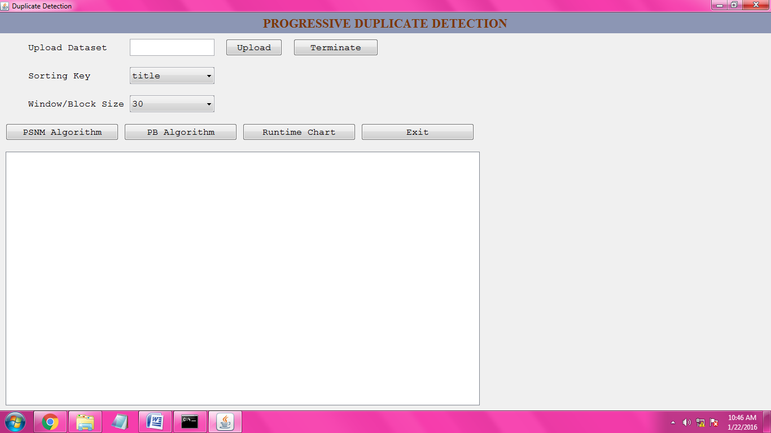

In this anticipate we take "dblp" dataset. On the off chance that you need to open this dataset we require "LTFViewr5u" application. When we are double tap on this application it show one window, in that window choose open document and after select dblp.xml record then tap on open catch. It will demonstrate the dblp.xml dataset. By utilizing Edit Plus we can't open this document.

Click on the “Upload” button to upload our dataset. So, opening the dataset,

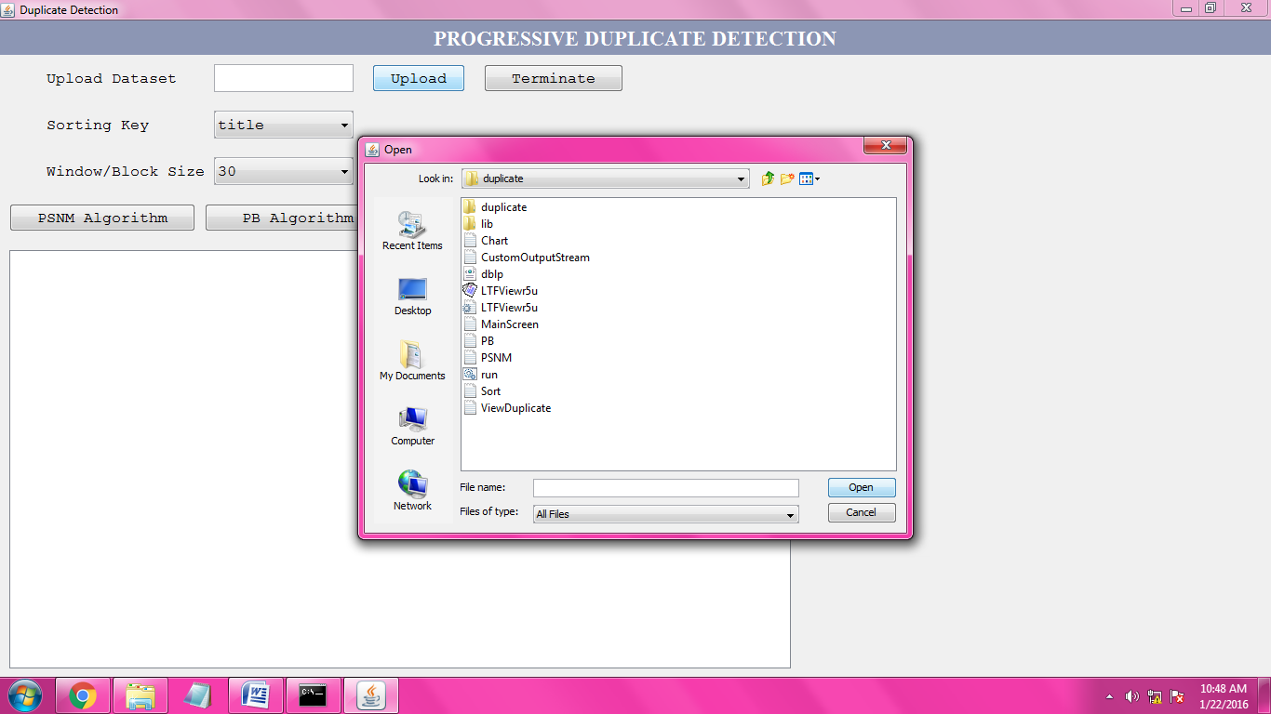

After uploading dblp dataset the screen is,

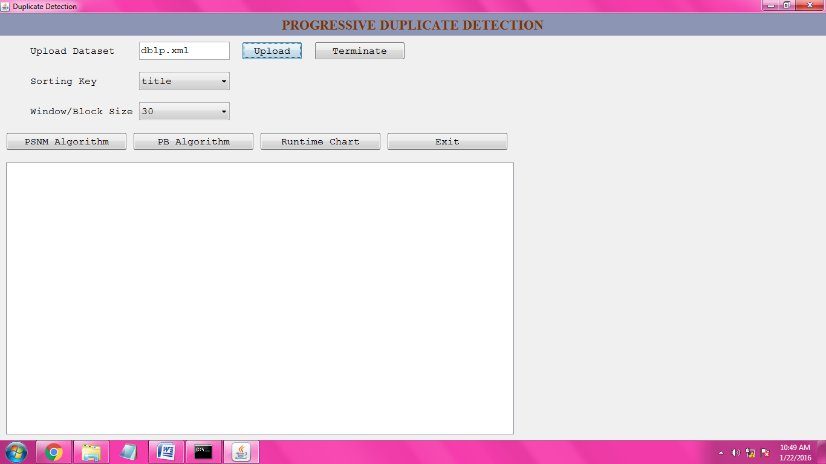

After uploading the dataset we have to sort the dataset.

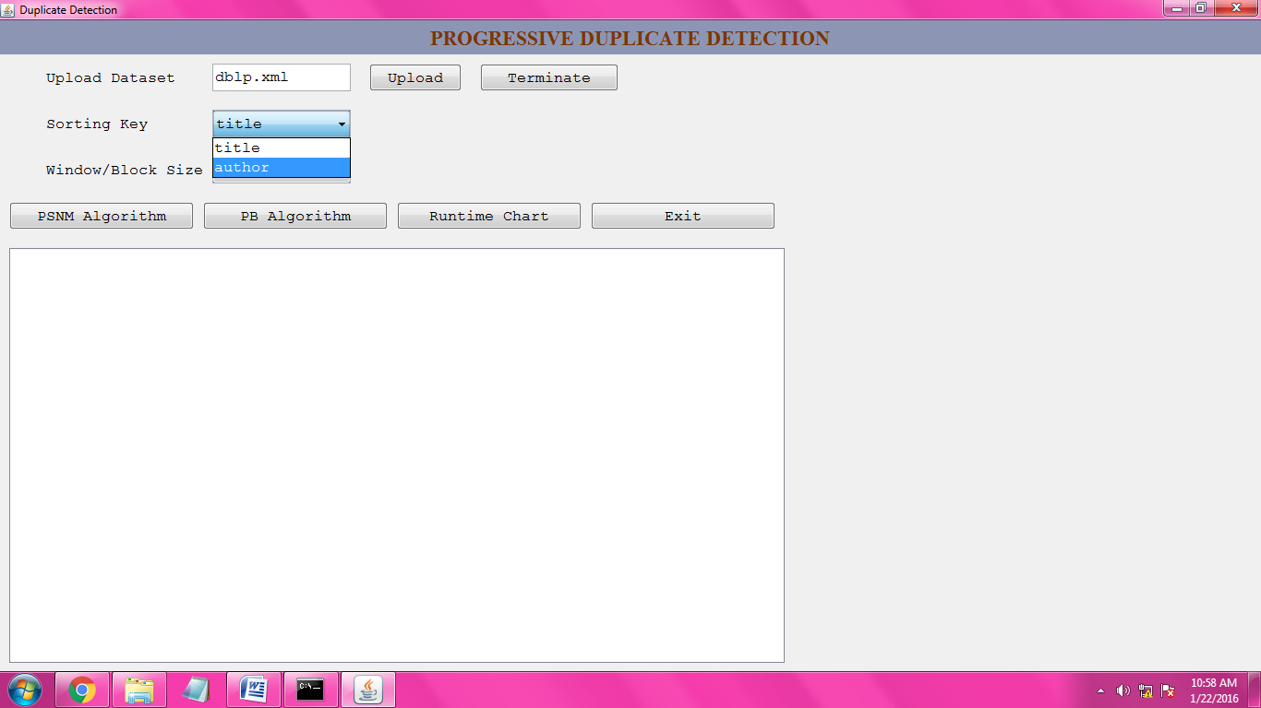

For that reason we have to select sorting keys, here we select the sorting key is “author”.

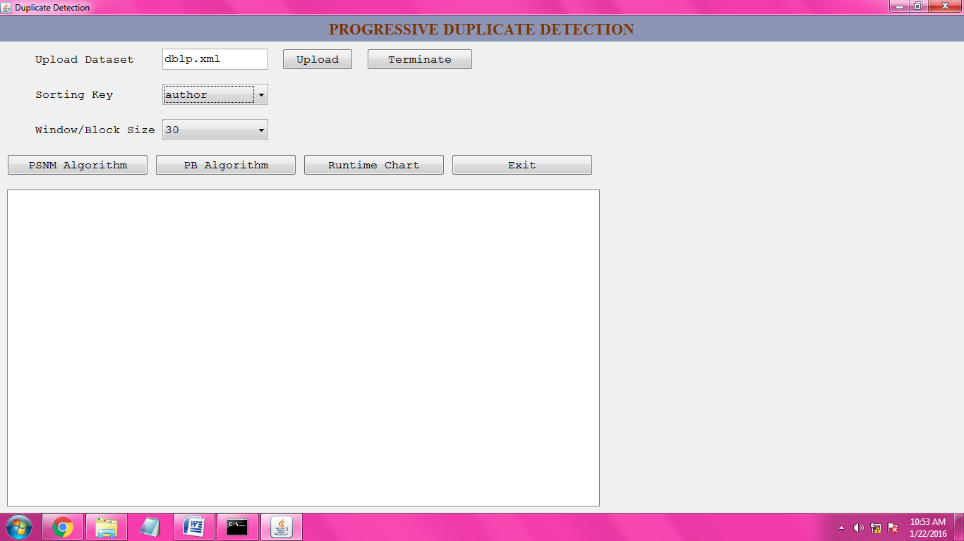

After completion of the sorting key selection we have select the window size to pair selection and pair comparison in the dataset.

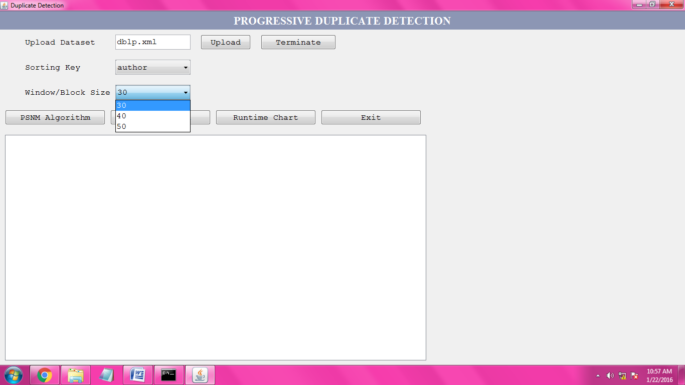

Here we select the window/block size is 30, then the screen is,

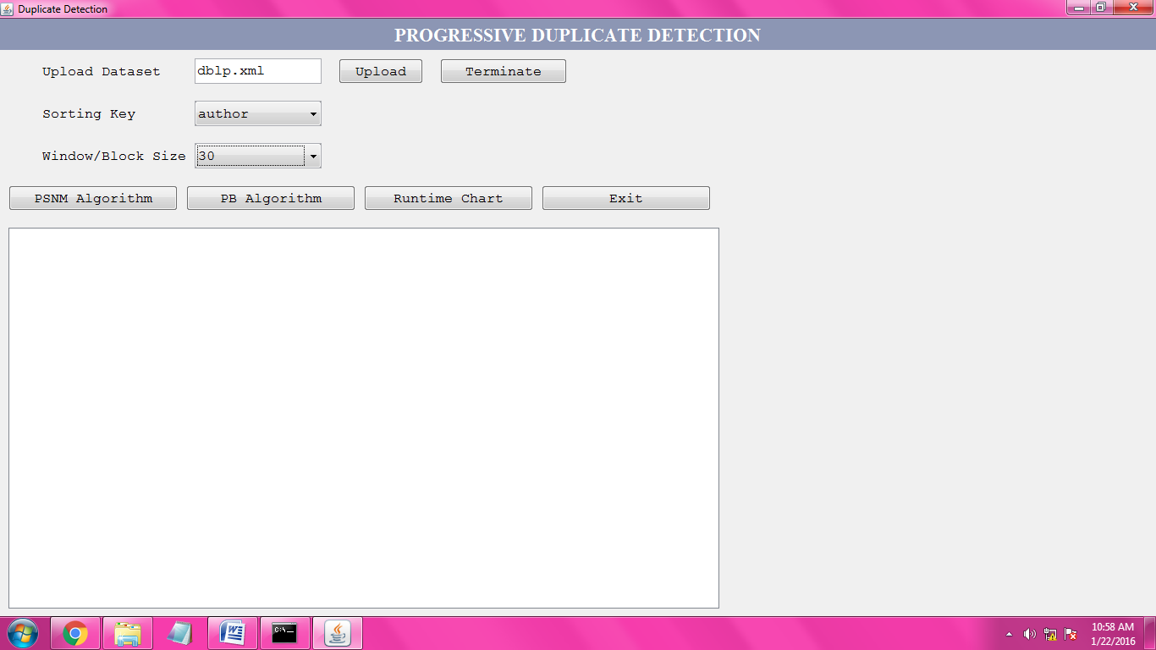

**PSNM Algorithm Working:**

Now we can click on the “PSNM Algorithm” button to apply this algorithm on uploaded dataset.

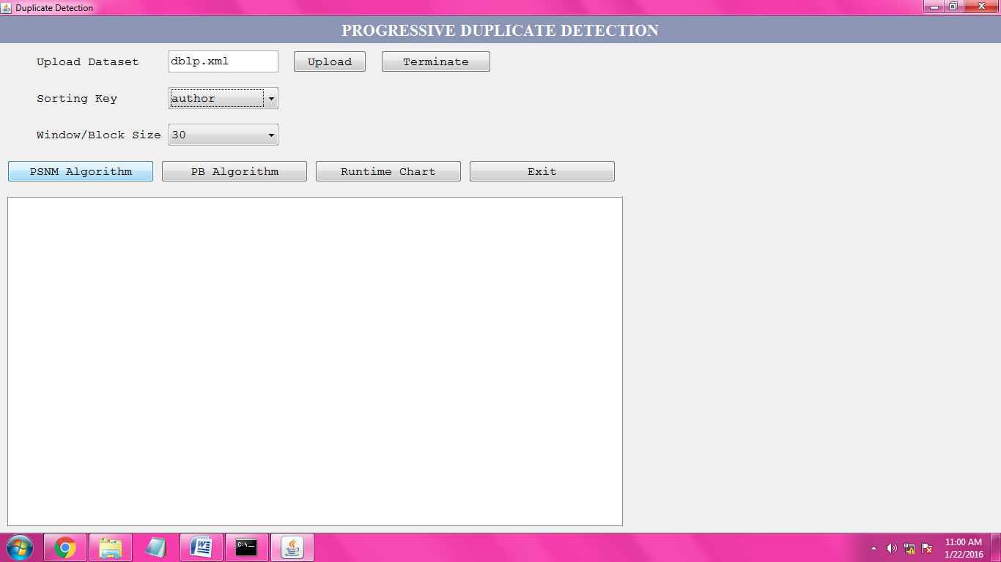

PSNM Algorithm performance is, it display the partition size here,

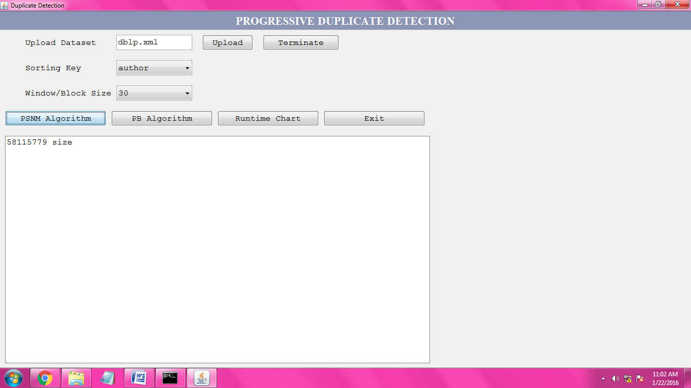

Now it detect the duplication on the dataset, and it perform the detection on partitions i.e., it detect the duplication on every partition. That means it verifies individual partition and also it displays duplicate size of the current partition.

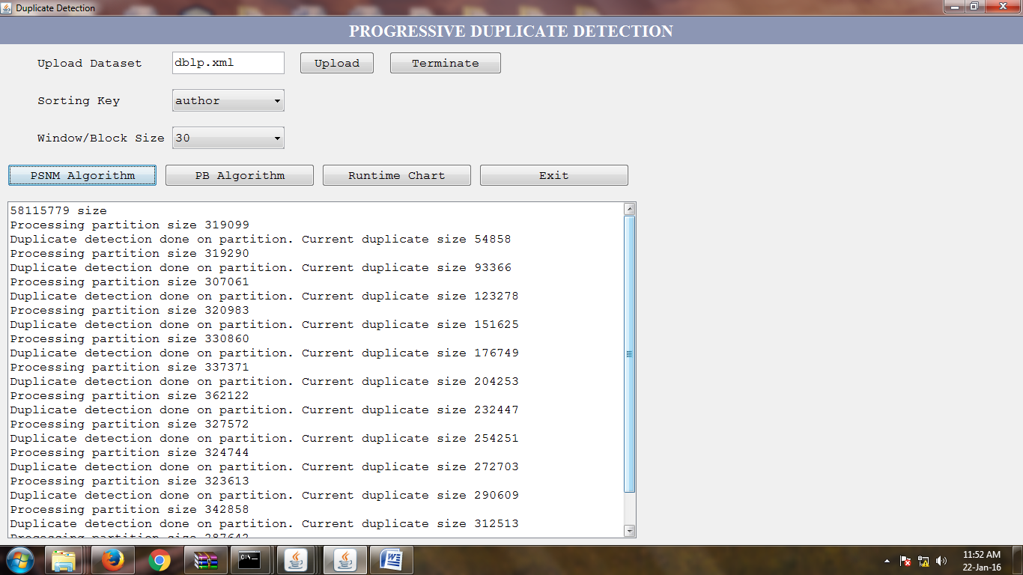

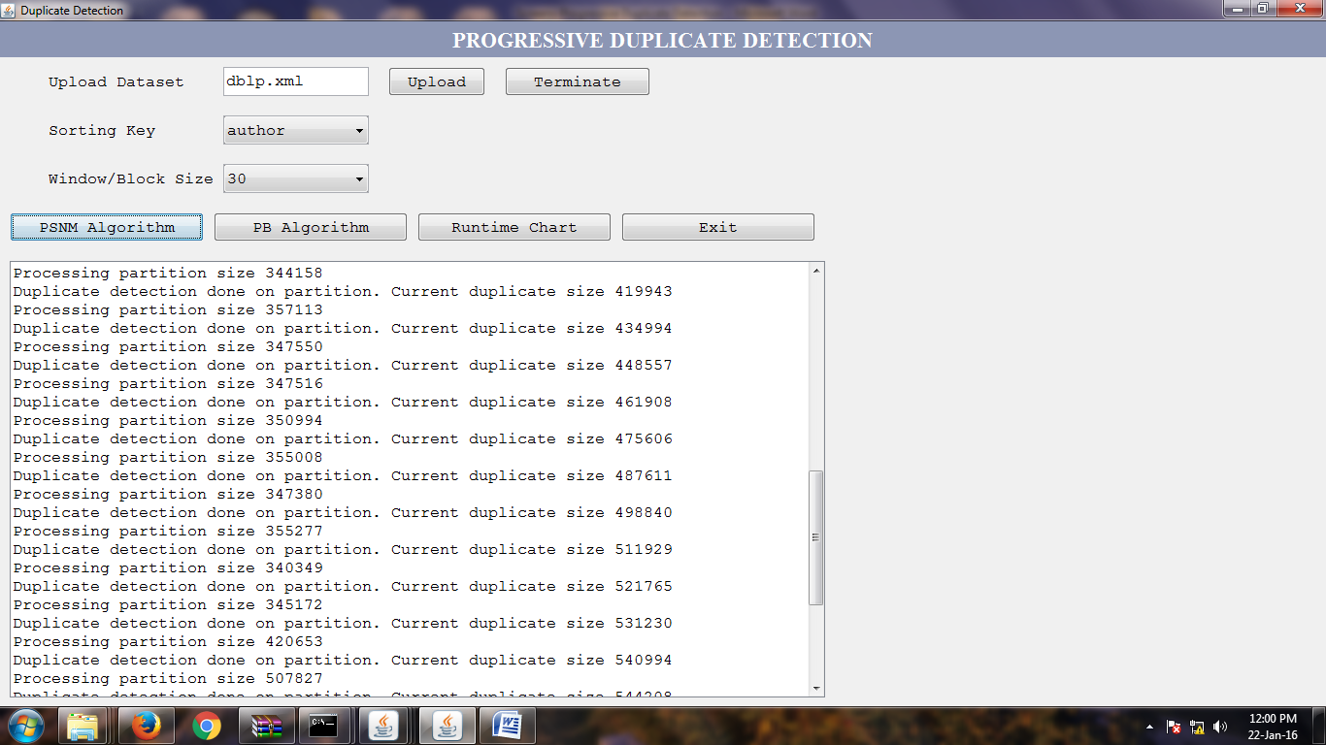

During processing the duplicate detection by using PSNM algorithm if we are click on terminate button it displays the duplicate text on the screen.

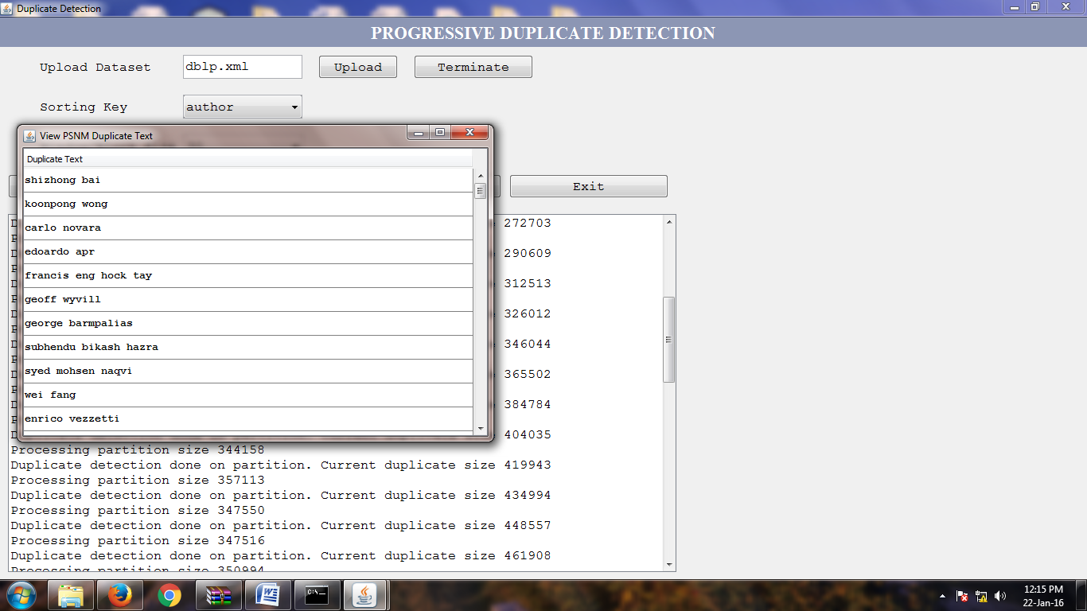

Next, we can observe the runtime chart of the PSNM Algorithm,

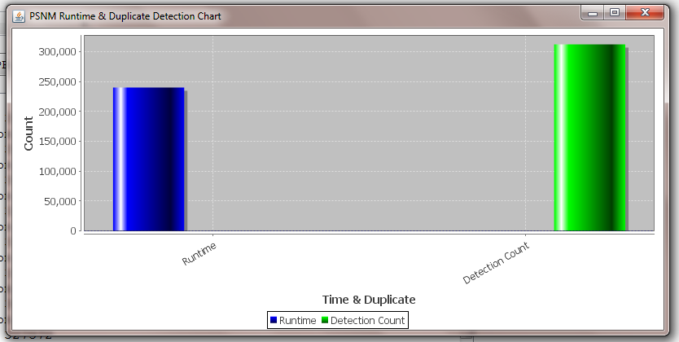

In this chart we can observe that, duplicate detection count is high and execution time is less. Here, duplicate detection on dataset is takes less time (in Milliseconds).

**PB Algorithm working:**

Here, we select the sorting key is same i.e., “author” and block size is “40”. Then click on the PB Algorithm button. First it displays the partition size,

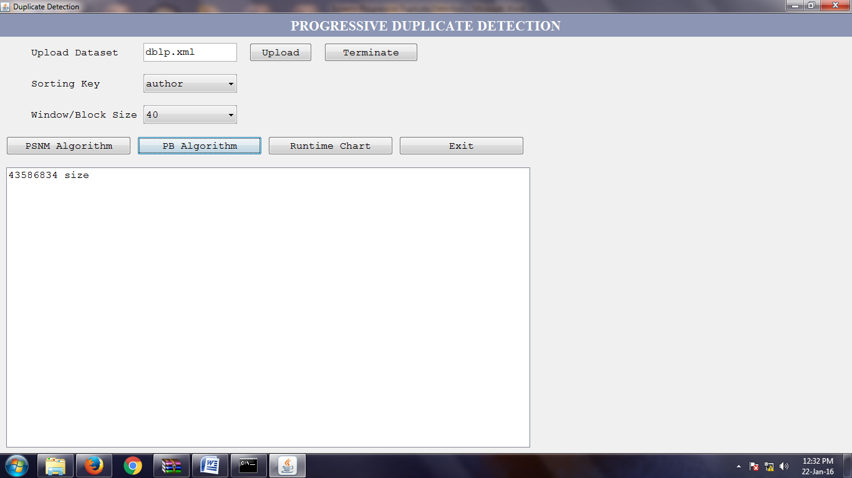

This PB algorithm detects the duplication on Blocks.

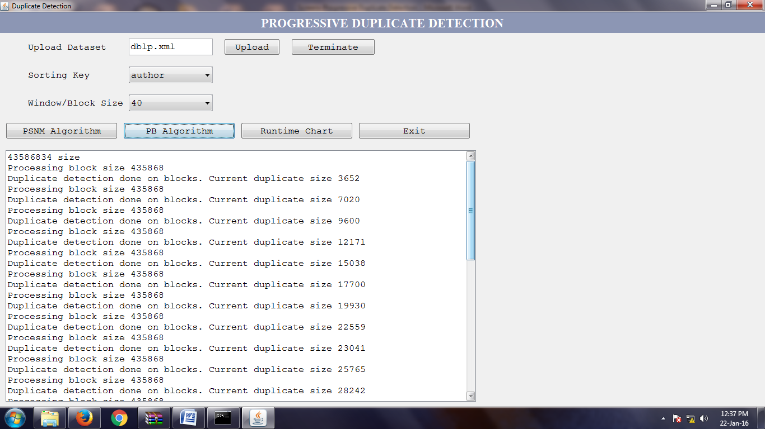

Finally, after detection it displays the duplicate text according to the sorting key i.e.,

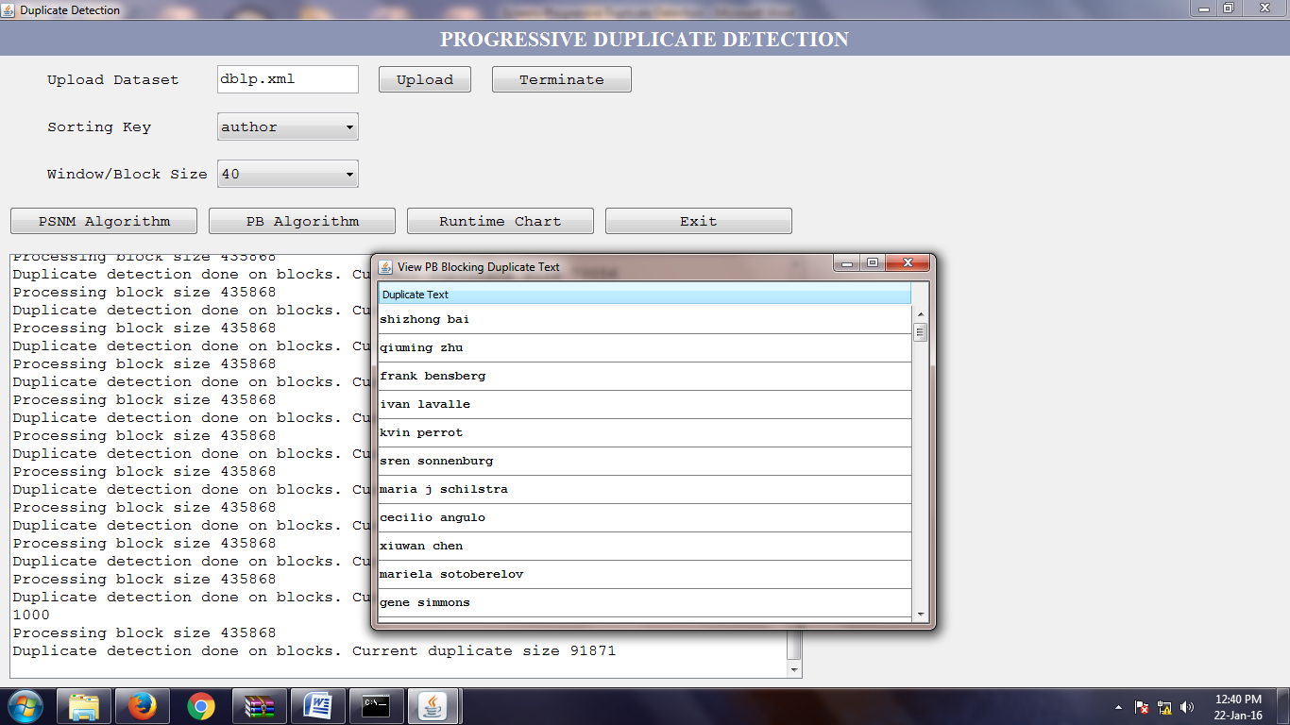

Now we can click on “Runtime Chart” button to view the chart,

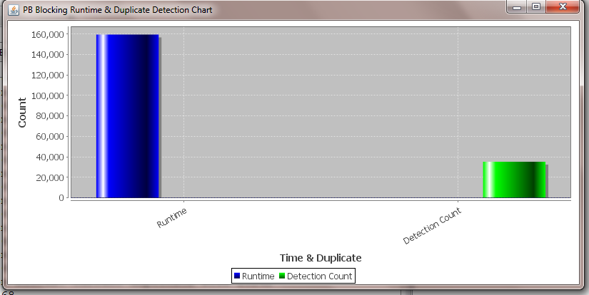

**8. CONCLUSION**

This paper presented the dynamic sorted neighborhood strategy and dynamic blocking. Both calculations build the productivity of copy location for circumstances with restricted execution time; they progressively change the positioning of examination competitors in light of halfway results to execute promising correlations first and less encouraging examinations later. To decide the execution addition of our calculations, we proposed a novel quality measure for progressiveness that incorporates flawlessly with existing measures. Utilizing this measure, tests demonstrated that our methodologies beat the conventional SNM by up to 100 percent and related work by up to 30 percent. For the development of a completely dynamic copy identification work process, we proposed a dynamic sorting strategy, Magpie, a dynamic multi-pass execution model, Attribute Concurrency, and an incremental transitive conclusion calculation. The adjustments AC-PSNM and AC-PB utilize different sort keys simultaneously to interleave their dynamic cycles. By investigating halfway results, both methodologies powerfully rank the distinctive sort keys at runtime, definitely facilitating the key choice issue.

**9. BIBLIOGRAPHY**

[1] S. E. Whang, D. Marmaros, and H. Garcia-Molina, “Pay-as-you-go entity resolution,” IEEE Trans. Knowl. Data Eng., vol. 25, no. 5, pp. 1111–1124, May 2012.

[2] A. K. Elmagarmid, P. G. Ipeirotis, and V. S. Verykios, “Duplicate record detection: A survey,” IEEE Trans. Knowl. Data Eng., vol. 19, no. 1, pp. 1–16, Jan. 2007.

[3] F. Naumann and M. Herschel, An Introduction to Duplicate Detection. San Rafael, CA, USA: Morgan & Claypool, 2010.

[4] H. B. Newcombe and J. M. Kennedy, “Record linkage: Making maximum use of the discriminating power of identifying information,” Commun. ACM, vol. 5, no. 11, pp. 563–566, 1962.

[5] M. A. Hern_andez and S. J. Stolfo, “Real-world data is dirty: Data cleansing and the merge/purge problem,” Data Mining Knowl. Discovery, vol. 2, no. 1, pp. 9–37, 1998.

[6] X. Dong, A. Halevy, and J. Madhavan, “Reference reconciliation in complex information spaces,” in Proc. Int. Conf. Manage. Data, 2005, pp. 85–96.

[7] O. Hassanzadeh, F. Chiang, H. C. Lee, and R. J. Miller, “Framework for evaluating clustering algorithms in duplicate detection,” Proc. Very Large Databases Endowment, vol. 2, pp. 1282–1293, 2009.

[8] O. Hassanzadeh and R. J. Miller, “Creating probabilistic databases from duplicated data,” VLDB J., vol. 18, no. 5, pp. 1141–1166, 2009.

[9] U. Draisbach, F. Naumann, S. Szott, and O. Wonneberg, “Adaptive windows for duplicate detection,” in Proc. IEEE 28th Int. Conf. Data Eng., 2012, pp. 1073–1083.

[10] S. Yan, D. Lee, M.-Y. Kan, and L. C. Giles, “Adaptive sorted neighborhood methods for efficient record linkage,” in Proc. 7th ACM/ IEEE Joint Int. Conf. Digit. Libraries, 2007, pp. 185–194.

[11] J. Madhavan, S. R. Jeffery, S. Cohen, X. Dong, D. Ko, C. Yu, and A. Halevy, “Web-scale data integration: You can only afford to pay as you go,” in Proc. Conf. Innovative Data Syst.

Res., 2007.

[12] S. R. Jeffery, M. J. Franklin, and A. Y. Halevy, “Pay-as-you-go user feedback for dataspace systems,” in Proc. Int. Conf. Manage. Data, 2008, pp. 847–860.

**2)**

**Existing System**

Information are among the most imperative resources of an organization. Be that as it may, because of information changes and messy information section, blunders, for example, copy passages may happen, making information purging and specifically copy recognition irreplaceable. Nonetheless, the immaculate size of today's datasets renders copy identification forms costly. Online retailers, for instance, offer tremendous inventories including an always developing arrangement of things from a wide range of suppliers. As autonomous persons change the item portfolio, copies emerge. Despite the fact that the sorting technique what ever we are utilizing till now it can't work with verifiable sorts. The multi pass system may prompt smashing of parcels. So we generally require a progressed and proficient copy location systems to defeat the information duplication issue.

**Disadvantages of Existing System:**

1. It will process only shorter datasets in a moment.
2. It is a time taken process.
3. It was not applicable for large datasets.

**Proposed System:**

In existing framework we utilized dynamic sorted neighborhood technique which is just ready to chip away at little and clean datasets. Presently we proposing another system parallel Sorted Neighborhood Method which could deal with gigantic information sets moreover. Our proposed procedure inside utilizations the Parallel Sorted Neighborhood Method for sorting. In this technique it will adjust the datasets when they are touching base in mass. Furthermore, here we can prepare them parallel when they are more than one. So when one work is handled in parallel it will finished before. So we are utilizing Parallel Sorted Neighborhood Method for parallel handling of copy discovery.

**Advantages of Proposed System:**

1. Increase the efficiency of duplicate detection.
2. It was much useful for larger datasets.

**Github link:**

https://github.com/kslpraveen/Group-1-Project

**PROJECT MANAGEMENT**

**Team members:**

1. **Sai Chand Nandyala – Project execution and Analysis**
2. **Venkoji Praveen Teja Kasula – Interpretation and Data Collection**

Dimension1:

*We have started this project clearly about detecting the progressive duplication and it is very interesting and we stated it in documentation.

*We have used the data source and it is explained

*We have data mining algorithms ie;decision trees.

Dimension 2:

*We team members equally associated with the project and we co ordinated well in cpmpletion of the project

*Project deliverables are stated clearly and we played equal role in doing the project.

Dimension 3:

*We started the different project first and we were not successful in gathering requirements to that project,So after we decided to implement the this concept and worked in gathering the requirements in doing this current project and we majorly succeeded in getting the better results in completing this project.

*Yes we do succeeded in learning the data mining concepts ,the main idea in doing this project is to learn in using data mining concept.In that area we did well in learning datamining concepts in ths process.