Kubernetes Theory

You’ve created a Docker container to wrap your application. But you still need to manage the various DevOps tasks for deploying and managing your containers. Here’s where Kubernetes steps in. It will handle all the crucial deployment, scaling and management steps so you don’t have to.
It’s essentially a tool for managing your containers. A platform of sorts that holds your hand along the way. It’s up to you to create a network of intertwined containers, tell Kubernetes what to do, and how to serve your containers.

Why do I need Kubernetes…?
Easy! Peace of mind, period.
You don’t have to worry about every instance you own. Nor, do you need to worry about whether the containers are running. If an instance fails, Kubernetes will re-create the containers of the failed instance on one that’s running. Fabulous!

1) Lets see how hardware is represented:

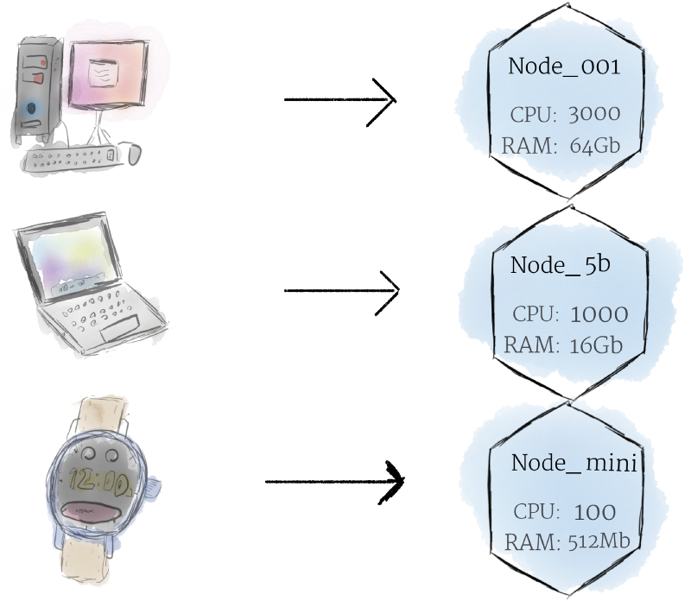
Node :

- Smallest unit of computating hardware
- representatin of single machine in cluster
- physical machine / VM
- thinking in terms of node gives abstraction
- instead of individual computers and hardware specific machines , we can view it as set of CPUs and RAMs
- hence, any m/c can substitute other m/c

The Master is the control panel of the whole cluster. All commands we will run will be run on the Master instance. It will then decide which Node, or worker machine, in the cluster will take the workload.

Cluster:

Although working with individual nodes can be useful, it’s not the Kubernetes way. In general, you should think about the cluster as a whole, instead of worrying about the state of individual nodes.
In Kubernetes, nodes pool together their resources to form a more powerful machine. When you deploy programs onto the cluster, it intelligently handles distributing work to the individual nodes for you. If any nodes are added or removed, the cluster will shift around work as necessary. It shouldn’t matter to the program, or the programmer, which individual machines are actually running the code.

Persistent Volumes:
Because programs running on your cluster aren’t guaranteed to run on a specific node, data can’t be saved to any arbitrary place in the file system. If a program tries to save data to a file for later, but is then relocated onto a new node, the file will no longer be where the program expects it to be.
To store data permanently, Kubernetes uses Persistent Volumes. While the CPU and RAM resources of all nodes are effectively pooled and managed by the cluster, persistent file storage is not. Instead, local or cloud drives can be attached to the cluster as a Persistent Volume. This can be thought of as plugging an external hard drive in to the cluster. Persistent Volumes provide a file system that can be mounted to the cluster, without being associated with any particular node.

2) Software
Containers:
Programs running on Kubernetes are packaged as Linux containers. Containers are a widely accepted standard, so there are already many pre-built images that can be deployed on Kubernetes.
Containerization allows you to create self-contained Linux execution environments. Any program and all its dependencies can be bundled up into a single file and then shared on the internet. Anyone can download the container and deploy it on their infrastructure with very little setup required. Creating a container can be done programmatically, allowing powerful CI and CD pipelines to be formed.
Multiple programs can be added into a single container, but you should limit yourself to one process per container if at all possible. It’s better to have many small containers than one large one. If each container has a tight focus, updates are easier to deploy and issues are easier to diagnose.

Pods:
Unlike other systems you may have used in the past, Kubernetes doesn’t run containers directly; instead it wraps one or more containers into a higher-level structure called a pod. Any containers in the same pod will share the same resources and local network. Containers can easily communicate with other containers in the same pod as though they were on the same machine while maintaining a degree of isolation from others.
Pods are used as the unit of replication in Kubernetes. If your application becomes too popular and a single pod instance can’t carry the load, Kubernetes can be configured to deploy new replicas of your pod to the cluster as necessary. Even when not under heavy load, it is standard to have multiple copies of a pod running at any time in a production system to allow load balancing and failure resistance.
Pods can hold multiple containers, but you should limit yourself when possible. Because pods are scaled up and down as a unit, all containers in a pod must scale together, regardless of their individual needs. This leads to wasted resources and an expensive bill. To resolve this, pods should remain as small as possible, typically holding only a main process and its tightly-coupled helper containers (these helper containers are typically referred to as “side-cars”).

Deployment:
Although pods are the basic unit of computation in Kubernetes, they are not typically directly launched on a cluster. Instead, pods are usually managed by one more layer of abstraction: the deployment.
A deployment’s primary purpose is to declare how many replicas of a pod should be running at a time. When a deployment is added to the cluster, it will automatically spin up the requested number of pods, and then monitor them. If a pod dies, the deployment will automatically re-create it.
Using a deployment, you don’t have to deal with pods manually. You can just declare the desired state of the system, and it will be managed for you automatically.

Kubectl:
The most important tool you use when setting up a Kubernetes environment is the kubectl command. This command allows you to interact with the Kubernetes API. It is used to create, update, and delete Kubernetes resources like pods, deployments, and load balancers.

There are two ways to add resources to Kubernetes: interactively through the command line using kubectl add, and declaratively, by defining resources in YAML files¹.
While interactive deployment with kubectl add is great for experimenting, YAML is the way to go when you want to build something maintainable. By writing all of your Kubernetes resources into YAML files, you can record the entire state of your cluster in a set of easily maintainable files, which can be version-controlled and managed like any other part of your system. In this way, all the instructions needed to host your service can be saved right alongside the code itself.

