Kubernetes Networking:

A pod consists of one or more containers that are collocated on the same host, and are configured to share a network stack and other resources such as volumes.

What does “share a network stack” actually mean? In practical terms it means that all the containers in a pod can reach each other on localhost. If I have a container running nginx and listening on port 80 and another container running scrapyd the second container can connect to the first as http://localhost:80.
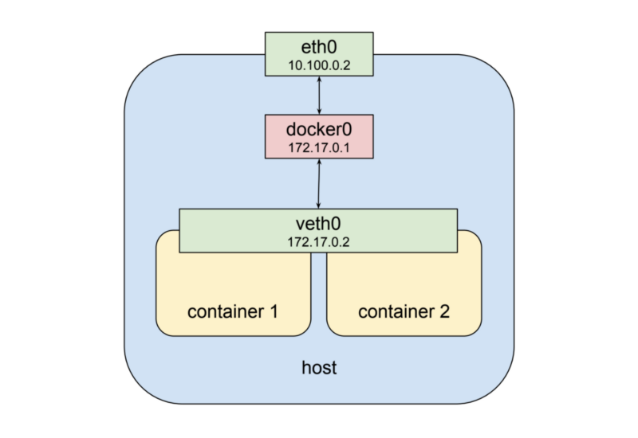

both containers are addressable from the outside on 172.17.0.2, and on the inside each can hit ports opened by the other on localhost. This also means that the two containers cannot open the same port, which is a restriction but no different than the situation when running multiple processes on a single host. In this way a set of processes can take full advantage of the decoupling and isolation of containers, while at the same time collaborating together in the simplest possible networking environment.Kubernetes implements this pattern by creating a special container for each pod whose only purpose is to provide a network interface for the other containers. If you ssh in to a kubernetes cluster node that has pods scheduled on it and run docker ps you will see at least one container that was started with the pause command. The pause command suspends the current process until a signal is received so these containers do nothing at all except sleep until kubernetes sends them a SIGTERM. Despite this lack of activity the “pause” container is the heart of the pod, providing the virtual network interface that all the other containers will use to communicate with each other and the outside world. So in a hypothetical pod-like thing the last picture sort of looks like this:
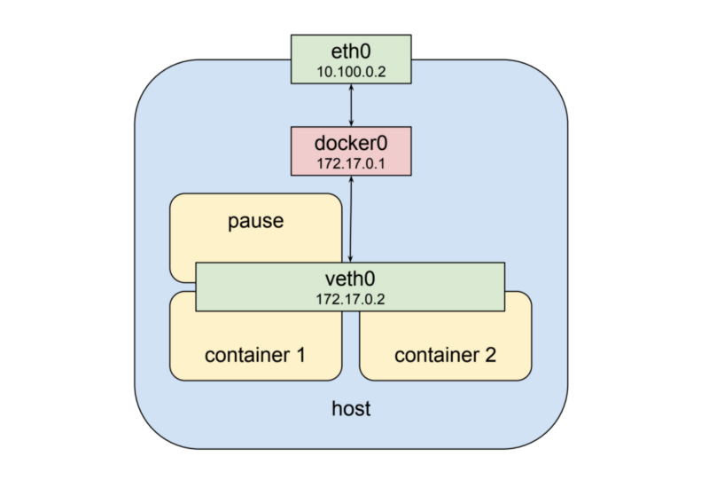
REFER: https://medium.com/google-cloud/understanding-kubernetes-networking-pods-7117dd28727

https://medium.com/google-cloud/understanding-kubernetes-networking-services-f0cb48e4cc82

https://github.com/ahmetb/kubernetes-network-policy-recipes

Services:

A service is a type of kubernetes resource that causes a proxy to be configured to forward requests to a set of pods. The set of pods that will receive traffic is determined by the selector, which matches labels assigned to the pods when they were created.

Requests can be sent to the service IP directly but it would be better to use a hostname that resolves to the IP address. Fortunately kubernetes provides an internal cluster DNS that resolves the service name

