**Using Soil CO2 and O2 Measurements to Understand the Interplay of Microbial Respiration and Biosynthesis**

Kyle E. Smart1, Daniel O. Breecker2, Christopher B. Blackwood3,4,5, and Timothy M. Gallagher1

1Department of Earth Sciences, Kent State University, Kent, OH, 44242, USA.

2Department of Geological Sciences, University of Texas at Austin, Austin, TX, 78712, USA.

3Department of Plant, Soil and Microbial Sciences, Michigan State University, East Lansing, MI, 48824, USA.

4Department of Plant Biology, Michigan State University, East Lansing, MI, 48824, USA.

5Ecology, Evolution, and Behaviour Program, Michigan State University, East Lansing, MI, 48824, USA.

*Correspondence to*: Kyle E. Smart (ksmart4@kent.edu)

**Abstract.**

Soils comprise the largest terrestrial carbon pool; therefore, constraining processes that control how carbon is either stabilized in soils or released to the atmosphere is vital to improving our understanding of the global carbon cycle. Heterotrophic respiration is the main pathway by which soil organic carbon is remineralized and returned to the atmosphere, however not all carbon utilized by heterotrophs shares this fate, as some portion is transformed through processes like biomass production and biosynthesis of extracellular enzymes and/or organic acids. A potentially powerful approach for studying organic carbon transformations and heterotrophic respiration is the respiratory quotient (RQ), which is the ratio of carbon dioxide produced to oxygen consumed during respiration. The soil RQ should theoretically reflect what carbon compounds are being respired, but other physical and biological processes can impact these values. This research investigates how carbon use efficiency (CUE) can affect soil RQ values using a series of soil incubation experiments, in which glucose was added to induce soil respiration. High temporal resolution results demonstrate that soil RQ values deviate significantly from theoretical predictions that are based solely on the stoichiometry of the glucose. A derived relationship between RQ and CUE is applied to incubation results to estimate biomass production, and these values compare favourably with independent estimates of biomass production based on chemical extractions in treatments provided with smaller quantities (100-200 mg) of glucose. However, in incubations provided with larger quantities (500-1000 mg) of glucose, we conclude that the chemical extraction carried out through Chloroform Fumigation Extraction may not be reliable in accurately capturing the dissolvable and extractable carbon pools. These findings demonstrate that soil RQ values may be used to continuously monitor changes in CUE and that studies that monitor soil RQ values should consider CUE as a potential key factor when changes in microbial biomass are expected, for instance, with changing environmental conditions or changes in production of plant derived compounds. These findings demonstrate, how measurements of soil RQ, may be leveraged to understand soil carbon transformations.

# 1 Introduction

Soils represent one of the largest pools of carbon on the Earth’s surface, with around 1477 Gt of carbon stored as soil organic matter (Scharlemann et al., 2014). The makeup of this pool can change dynamically as organic carbon is added through litter and root inputs, transformed by soil biogeochemical processes, and ultimately released back to the atmosphere via respiration (Dynarski et al., 2020; Kögel-Knabner, 2002; McDaniel et al., 2014; Paul, 2016). These exchanges of carbon are of particular importance, because as climate conditions continue to change and natural ecosystems exist in a state of increasing disequilibrium from previous conditions, it is difficult to predict the rates at which soils will accumulate or lose stored carbon. The processes that control soil carbon cycling are crucial to understand, not only in the context of global climate (Scharlemann et al., 2014), but also because soil organic carbon impacts soil fertility directly by providing essential nutrients and compounds for plants and microbes and indirectly by affecting soil physicochemical properties like wettability and drainage (Gaiser & Stahr, 2013).

Accurately quantifying heterotrophic respiration is critical because it is the main mechanism by which carbon is released from soils (Landsberg & Gower, 1997; Mukul et al., 2020; Walker et al., 2018). Total soil respiration consists of autotrophic (root) and heterotrophic (microbial and macrofaunal) respiration. The balance between autotrophic and heterotrophic respiration in soils can be highly variable, with estimates of root contributions ranging from 10 to 90 percent of total soil respiration (Hanson et al., 2000). In certain settings, the relative contribution of plants to total soil respiration may shift dramatically across seasons. For example, rhizospheric inputs in a deciduous forest may be high during the growing season and decline afterwards, leading to “boom and bust” pulses of heterotrophic respiration (Scott-Denton et al., 2006). On agricultural land autotrophic respiration can slow or halt completely after crops are harvested. Microbes consume soil organic matter not only as a source of energy via respiration, but also as a source of reduced carbon compounds for biosynthesis of compounds (Adingo et al., 2021; J. P. Schimel & Weintraub, 2003; J. Schimel & Schaeffer, 2012; Sinsabaugh et al., 2013). Biosynthesis of microbial biomass and extracellular compounds is important to constrain because it is thought to be an important pathway for long-term stabilization of organic carbon within soils (A Miltner, 2012; Cotrufo et al., 2015; MF Cotrufo, 2013; W Wieder, 2014). These complexities underscore the importance of improving our understanding of soil respiration, especially considering how variations in moisture and temperature may impact microbial and root respiratory activities differently (Lavigne et al., 2004).

To understand if soils are experiencing a net gain or loss of carbon, it is necessary to first examine the interplay of biosynthesis and respiration (Adingo et al., 2021; Blagodatskaya et al., 2014; KM Geyer, 2016; Manzoni et al., 2018; Sinsabaugh et al., 2013). The portion of carbon consumed by microbes that is retained in biomass, rather than respired is known as the Carbon-Use Efficiency (CUE). This concept can be applied at different spatial and temporal scales, depending on the question of interest (Adingo et al., 2021; K. M. Geyer et al., 2019; KM Geyer, 2016). For example, it may be useful to consider the CUE of individual microbial community members when studying ecological processes like competition or response to changes in environmental conditions, and other times the CUE of the community, as a whole, can be estimated when studying its effects on environmental scale factors like ecosystem oxidation state (K. M. Geyer et al., 2019; Sinsabaugh et al., 2013). There is also debate as to whether CUE is an inherent value, species specific, and constant or if CUE is a variable that can change over time given the needs of the microbes and the environmental conditions (Adingo et al., 2021; KM Geyer, 2016; Manzoni et al., 2012, 2018; Sinsabaugh et al., 2013). Regardless of the consistency or variation in CUE values, it is clear that when monitoring microbial metabolisms through respiration, CUE is an important factor to estimate accurately.

Several approaches have been developed over recent decades with the goal of measuring microbial biomass growth in effort to quantify CUE in the context of substrate specific use, across ecosystems, and in small scale incubations. Quantifying growth of biomass is necessary in order to calculate CUE because [ (CBiomass + CEnzymes ) / (CUptake) =CUE], where CEnzymes is commonly measured or assumed to be negligible, and has been shown to be less important when substrate amendments are in labile forms (Allison & Vitousek, 2005). Beare et al., (1990) described a Substrate Induced Respiration (SIR) method, where soils were incubated in duplicate at constant temperatures, with sterilized and sterilized-reinoculated soils amended with glucose, where measurements of CO2 evolved are used to quantify biomass. Further research centered on a more direct measurement using optical methods, with applications of flow cytometry for pure cultures and fluorescent methods; however, these methods are more targeted to pure cultures, or species-specific measurements (Madrid & Felice, 2008). Chemical extraction methods, such as the chloroform fumigation-extraction method (CFE) (Vance et al., 1987) have been developed and widely applied for a broader range of applications (Beare et al., 1990; Dilly et al., 2011; Godley, 2004; Grogan et al., 2004; Huang et al., n.d.; McDaniel et al., 2014; Mooshammer et al., 2017; J. P. Schimel & Clein, 1996; Spohn et al., 2016; von Lützow et al., 2007; Walker et al., 2018). Isotopic approaches have also been employed, whereby natural variation in stable isotopic values by different pools or specific compounds are leveraged (Dilly et al., 2011; Hicks Pries et al., 2020) or amendments of isotopically labelled substrate are applied (Barnett et al., 2021; Cotrufo et al., 2015; K. Geyer et al., 2020; Hill et al., 2008) Lastly, calorimetric methods of establishing CUE have been carried out by measuring the waste heat generated through the oxidation pathway of the substrate. This method has shown excellent agreement between past work and theoretical limitations on CUE (Chakrawal et al., 2020), however the level of precision required for the use of this method may prove to be prohibitively difficult for many research labs to implement. The wide use of the SIR and CFE methods, provide a measurement of microbial biomass, whether direct or indirect in order to calculate CUE. Several assumptions must be made in order to calculate CUE, in the SIR method, it is assumed that all substrate is utilized, and that the respiratory response ends after substrate depletion. In the CFE method, additional measurements of substrate are needed to determine when substrate depletion occurs. Both methods can be complicated by the priming effect, as well as uncertainties driven by laboratory practices and instrumentation and are limited by assumptions of solely glucose metabolism or that glucose and SOM metabolisms are equal (K. M. Geyer et al., 2019).

An emerging approach that can be used to study soil metabolisms and other soil processes is known as Respiratory Quotient (RQ), which is the ratio of CO2 produced to the O2 consumed during respiration (Dilly, 2001, 2003). The study of RQ can potentially provide insight into the substrate being metabolized because the stoichiometry of the compound should determine the reaction stoichiometry during aerobic respiration (Masiello et al., 2008), however this reaction does not account for carbon that is retained for biomass production of synthesis of compounds like extracellular enzymes, as these are not represented in the equation. For example, respiration of compounds like sugars and other carbohydrates are predicted to produce an RQ of 1.0, lipids are predicted to have RQ values around 0.7, and organic acids on average to be 1.4 (Hicks Pries et al., 2020; Hilman et al., 2022; Masiello et al., 2008). While some studies report RQ values that resemble substrate-based predictions, other studies observed systematic deviations that were linked to non-metabolic processes which can affect soil CO2 and O2 concentrations, such as different diffusion constants of CO2 and O2, calcite dissolution/precipitation, and oxidation of reduced chemical species (Angert et al., 2015; Gallagher & Breecker, 2020; Hicks Pries et al., 2020; Hodges et al., 2019; Sánchez-Cañete et al., 2018). The potential effect of microbial CUE on soil RQ values has received less attention to date, although Dilly (2001) suggested that incorporation of available substrates into microbial biomass could explain initial RQ values >1 observed during the initial stimulation period in soils amended with glucose. If microbial biosynthesis causes divergence from RQ values expected from substrate stoichiometry alone, then this approach may enable indirect monitoring of CUE in the field, under stable conditions when substrate is expected to remain constant, and in the laboratory. In order to examine if changing carbon use efficiency can drive differences between expected and measured RQ values, we designed substrate induced respiration incubation experiments to test if RQ values expected from substrate stoichiometry alone are produced and if not, if a derived relationship between RQ and CUE can reliably predict biomass production .

# 2 Connecting Carbon Use Efficiency and Respiratory Quotient

Given that RQ values are driven by the difference in oxidation state of carbon between substrate and reaction product, in a scenario where substrate is converted entirely to CO2 and yields no net biomass production, this would require that 100% of the carbon added would be lost through respiration and would be defined by a carbon use efficiency of 0.0. Using a mass balance approach, we can explore the relationship between RQ and CUE in the reaction [C6H12O6 + O2 + NO3- = CO2 + H2O + C1H1.8O0.5N0.2], where C1H1.8O0.5N0.2 represents an average microbial biomass stoichiometry (Roels, 1980) , normalized per mole of carbon. Due to its relative importance in microbial makeup, nitrogen was included in the calculations. Furthermore, we chose to use nitrate as the nitrogen bearing species due to its impact on RQ values by its redox state, given soil preparation methods of room temperature drying, and previous knowledge of site characteristics. By carrying out mass balance calculations, where CUE is defined by varying the relationship between how much biomass is produced and how much CO2 is produced, we then calculate resultant RQ values (Figure 1). The calculated relationship between RQ and CUE was derived in Excel using the reaction for the aerobic respiration of glucose, modified to also include NO3- as an additional reactant and the average microbial biomass stoichiometry (Roels, 1980) as an additional product. This reaction was then broken into equations for each element present and simplified. These component equations were then substituted for use in stepwise balancing the new respiration reaction for a range of defined carbon use efficiencies. Carbon use efficiencies were defined in the reaction by defining the balance between how much carbon was partitioned as biomass and how much carbon was being respired. RQ values were calculated for each balanced reaction and reported with the corresponding CUE. This new modeled dataset containing RQ and CUE was imported into RStudio, and an eighth order polynomial equation was fit to the data to minimize errors introduced by applying this relationship to observed RQ values. This model was applied to the measured RQ values using the predict.lm() function to produce CUE values at each timestep during substrate induced respiration. This modeled relationship shows that as CUE increases, RQ values will also increase, which may seem counter-intuitive at first, given that an increase in CUE would cause a net decrease in CO2 production. However, the concurrent O2 consumption decreases more substantially, which causes RQ values to increase. The slope of the modelled relationship shows that RQ increases rapidly as CUE values approach towards 60%. We limited our calculations to a maximum of 60% CUE, as this is referenced as a theoretical thermodynamic limit for microbial metabolisms (Sinsabaugh et al., 2013). Furthermore, using this theoretical limit produced sufficiently high RQ values to describe all observed RQ measurements in our incubations.

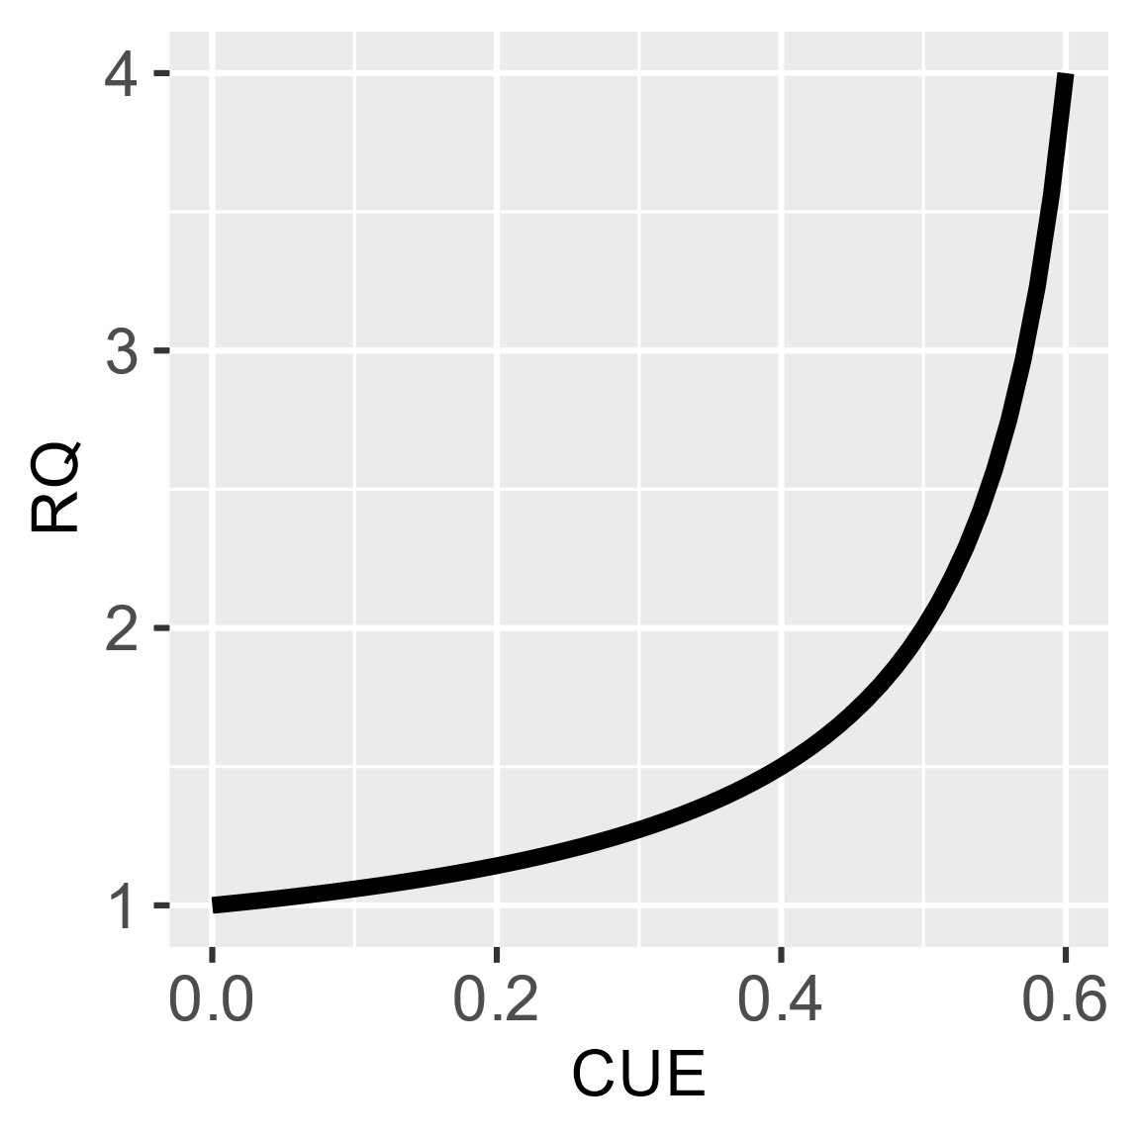

Figure 1: Plotted line displays the calculated relationship between carbon use efficiency and respiratory quotient of glucose respiration.

# 3 Materials and Methods

This study is comprised of two soil incubation experiments with joined datasets designed to address two questions. The first goal of this study was to investigate the effects of labile substrate (glucose) amendment on RQ values at high temporal resolution. The second goal is to investigate the effects of CUE on RQ. Control samples (Type 1 deionized water, Millipore Milli-Q) were incubated and measured for comparison. Treatment samples involved amendment with various masses of glucose (100 mg, 200 mg, 500 mg, or 1.0 g). All incubated samples contained 20 g of soil. RQ was determined by monitoring the composition of headspace gas in the incubation vessels every 2 h for the duration of the incubations (262 h at longest).

The soils used in incubations were collected from a temperate deciduous forest in Portage County, Northeast Ohio. Soils in this location are designated as Chili Loam by the USDA Soil Survey. Soil collection was performed with a shovel, excavation included approximately the top four inches of the profile to include the Oi-horizon, and top 5 cm of the A horizon. Soil was then returned to the lab and homogenized. For purposes of incubation, the field moist soils were passed through a 2 mm sieve to remove large detritus and leaf litter and to break up large aggregates. Soils were then allowed to dry down, open to lab air for 2 weeks to encourage the depletion of any preexisting labile carbon, and the decline of standing microbial biomass. Soil was then weighed out to 20 g (approximately 30 mL) for each incubation bottle. Glucose amendments were weighed and added to the soils, homogenized, and placed in 500 mL bottles. Once in the bottles, 10 mL of Type 1 deionized water (Millipore Milli-Q) was dripped evenly over the soils to encourage glucose dissolution before the bottles were capped and connected to the gas sampling apparatus. The addition of water led to an average soil moisture of 58% by mass at the start of incubation, determined gravimetrically as part of the Chloroform Fumigation Extraction procedure. Incubations were carried out in an incubator fridge and held to constant temperature of 20 ℃.

## 3.2 Automated Gas Sampling Apparatus

An automated gas sampling apparatus was constructed that allowed gas samples to be continuously collected and measured from soil incubations every two hours. Soils were incubated in 500 mL glass bottles (PYREXTM) with 3 gas-tight tube ports in the lid (Duran® GL45). One port on each bottle was connected to a Calibrated Instruments (McHenry, USA) Cali-5-BondTM gas sampling bag, filled with an additional 300mL of CO2-Free Air, to give the incubation vessel a variable volume, which enabled gas samples to be collected and new gas to be added while maintaining atmospheric pressure. Bev-A-Line IV tubing connected the bottles through a second port in the lid to a central manifold block with solenoid valves. The third port was closed off and was not used in this study. A Sable Systems (Las Vegas, USA) FoxBox was used to measure high precision CO2 and O2 gas concentrations. All sampled gas was dried using PermaPure (Lakewood, NJ, USA) Nafion™ Tubing, passing through an additional 500 mL bottle containing magnesium perchlorate, and held at partial vacuum, prior to measurement. The configuration of the sampling apparatus is depicted below in Fig. 2. From the central manifold system gas flow could be (1) closed, (2) directed from the bottles into the FoxBox, or (3) directed from compressed gas cylinders into the bottles. The manifold system could also direct flow of the compressed cylinders directly to the FoxBox.

The entire system was controlled by a programmable logic controller (PLC), which automatically opened and closed solenoid valves, directed the flow of gas through the system, and logged data from the FoxBox. Every two hours a measurement sequence would begin whereby bottles were sequentially measured for 3.5 min at a flow rate of 50 mL min-1 for a total of 175 mL of gas. To maintain high temporal resolution measurements (2 h), a maximum of eight individual samples could be incubated simultaneously. To account for any short-term drift in measured O2 values, ambient air was automatically measured directly from the laboratory HVAC inlet vent, between sample measurements. Sampling from HVAC inlet vent was preferred over lab air because HVAC air is a mixture of air sources from throughout the building and would provide a more stable measurement of CO2, whereas lab air CO2 concentration may fluctuate more dramatically with changes in room occupancy or sampling exhaust. Additionally, gas cylinders were measured containing zero (CO2-Free Air) and calibration (5000 ppm CO2) gasses to account for long-term measurement reproducibility. Lastly, the 175 mL of gas removed for analysis was replaced with CO2-Free Air by directing cylinder flow through a needle valve and a mass-flow meter into the incubation vial-gas bag system.

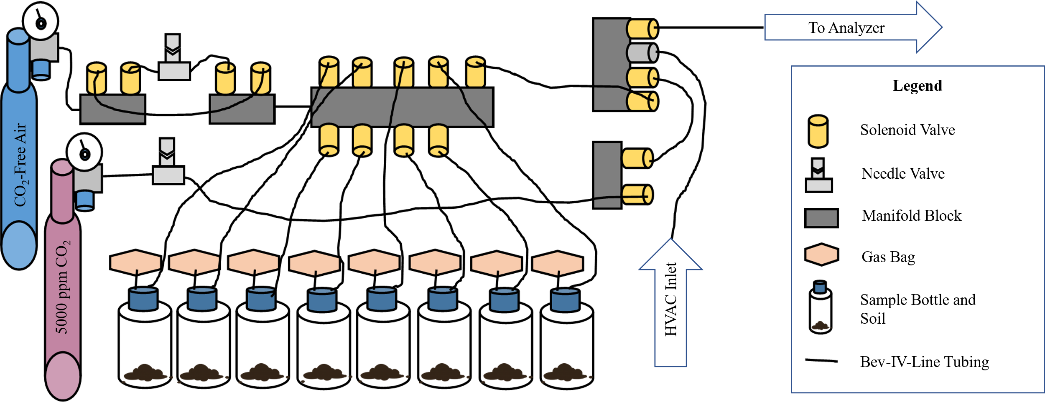Figure 2: This diagram displays the configuration of components used to construct the automated gas sampling apparatus. Blue and pink gas cylinders on the left are labelled by type. All other components are identified in the legend. Arrows indicate “HVAC Inlet” used between sample measurements to separate measurement periods, and “To Analyzer” as the final outflow to the sample drier and FoxBox.

## 3.3 Microbial Biomass

Microbial biomass carbon was measured via the Chloroform Fumigation Extraction method following the methods of (McDaniel et al., 2014; Vance et al., 1987). In short, duplicate subsamples (~5g) were weighed out and one set were immediately extracted with 0.5M K2SO4, on a rotator table for 1 hour, these samples served as unfumigated water (K2SO4) extractable carbon. Next, the remaining samples were fumigated using ethanol free chloroform (1mL) and capped for 24 h in a fume hood, then extracted with K2SO4; this set would serve as total extractable carbon. All extracts were filtered through a Whatman #1 filter with a vacuum filtration apparatus immediately following extraction. Total organic carbon was measured using a Shimadzu TOC-L Analyzer (Shimadzu Scientific Instruments Inc.). Dissolved organic carbon (DOC) for both fumigated and unfumigated subsamples were used to calculate biomass carbon as Fumigated DOC– Unfumigated DOC = Biomass Associated DOC. A correction factor (Kec= 0.45) was applied to account for the extraction efficiency of carbon by chloroform (Vance et al., 1987). Microbial biomass extraction was conducted on initial soil, on incubated control soil, and incubated amended soil.

## 3.4 Data Analysis

Following the incubation, raw gas concentration data were processed in RStudio to quantify sample CO2 and O2 concentrations, and apply a baseline correction. The baseline correction is done with a linear fit to HVAC air measurements immediately preceding sample measurements and background measurements were corrected to 20.95% O2. This correction is necessary to account for short-term drift on the fuel cell O2 sensor. Once corrected this linear correction is applied to sample measurement window, reported values of each sample are taken as the average value during the last 20 s (measurements are recorded every 2 s, 10 consecutive measurements are used) of the sampling window and an uncertainty is reported as the standard deviation. This new dataset is then exported from RStudio into Excel for further processing. In Excel, measured CO2 concentrations were corrected using a 2-point linear correction produced from measurements of CO2-Free Air and 5000 ppm CO2 gases. A mass balance approach was used to calculate the moles of CO2 produced (Fig. 3a) and O2 consumed (Fig. 3b) during each 2 h incubation window, accounting for the dilution effect of replacing the sampled gas volume with 175 mL of CO2-free air after each analysis. With these data, RQ values for each 2 h interval are calculated and shown in Fig. 3c. The variables of interest are saved in .csv files and imported to RStudio equipped with R version 4.2.2. Variables of interest include: time, CO2 production rate, O2 consumption rate, RQ, treatment, and replicate. Periods of substrate induced respiration are defined here as being represented by an RQ ≥ 1.0, and occurring during periods of elevated CO2 production. Following this, CUE and respiration rates were used to calculate moles of biomass produced for each incubation measurement. All variables, both measured and calculated were then plotted. Packages employed in R include tidyverse, gridExtra, and cowplot.

# 4 Results and Discussion

## 4.1 High Temporal Resolution RQ

Following the theoretical framework of RQ and the chemical stoichiometry of glucose, and other simple carbohydrates, this reaction produces an expected value of 1.0, (Masiello et al., 2008) with an assumed CUE of 0. Therefore, in these incubations a glucose amendment should correspond with a following respiratory quotient of 1.0, however, we observe RQs systematically greater than 1.0 post amendment. Using mass balance calculations, we determined RQ values with a 2 h resolution (Fig. 3c), over the duration of 262 hours (10 days and 22 hours). Please note the duration of 2 h data was not plotted in Fig. 3 as initial measurements and calculated values produced a false signal showing incredibly large O2 consumption, which was likely the result of rewetting the soils, rather values begin at 4 h. Initial respiration rates (Fig. 3a) show a similar overall trend regardless of amendment quantity, with all four amended treatments resulting in almost identical values from the beginning of the incubation period until 24 h had elapsed. The rate of increase in respiration initially appears to be inversely related to the amendment quantity, as the smaller amendment treatments begin to grow slightly faster than the larger amendments. Around 80 h of incubation, the respiration rate of the 100 mg treatments peaked, and declined over the remainder of the incubation. Peak respiration for the 200, 500, and 1000 mg treatments occurred at 46-60, 78, and 84-92 hours, respectively. Notably, the 500 mg treatments reached comparable maximum respiration rates with the 1000 mg treatments, suggesting that substrate availability alone may not be a reliable predictor of yield in peak microbial respiration. One possible explanation for this trend is slower dissolution of the glucose amendment in the 1000 mg treatment, which could be described by the data, because cumulative respiration totals still show a larger overall response in the 1000 mg treatment (Fig. 3a) . Respiratory decline occurred in all treatments following peak respiration rates. Oxygen consumption rates displayed in Fig. 3b show a similar behavior to respiration rates in Fig. 3a, apart from variability between timepoints and maximum values reached. Oxygen consumption rates occurred in a smoother, less erratic trend. Also, important to note is that the control bottles oxygen consumption and respiration of carbon dioxide did not respond during the incubation period in any meaningful way.

Initially, at 4 h of incubation, RQ values across all treatments range between ~0.3- 1.5. From 4 h onward, amended treatments start an overall ascent. After ~24 h of incubation, coinciding with an increase in CO2 respiration and O2 consumption, RQ values across most treatments are > 1.0. While the rates of gas exchange continue to climb RQ values also increase. RQ values observed during peak respiration are similar across treatments ~1.3-1.6. As the rates of gas exchange begin to decline, RQ values decline. Although treatment replicates are variable with respect to time, the overall trends are in good agreement. With respect to control samples, RQ is not plotted as we observe no overall trend (ie. no increase or decrease). We see that RQ values are dynamic at this temporal resolution, even during the period which should be dominated by substrate induced respiration, meaning that RQ values are not simply a direct result of the substrate being respired to produce CO2. One possible factor affecting this signal could be biosynthetic processes.

Peak RQ values observed during peak respiration are similar to that observed in (Dilly, 2001), with RQ values >1, commonly ~ 1.5. Notably, all treatments measure ~1.5 despite an order of magnitude increase in glucose amendment, this suggests that the anabolic processes are limited by the rate of synthesis of biomolecules or by the availability of other nutrients (eg. N or P). Also importantly, we see that the overall range in RQ values is quite large (0.3 – 1.9). These higher values could be explained through partially anabolic metabolism, however values below 1.0 likely indicate the use of some other substrate in which the carbon is more reduced.

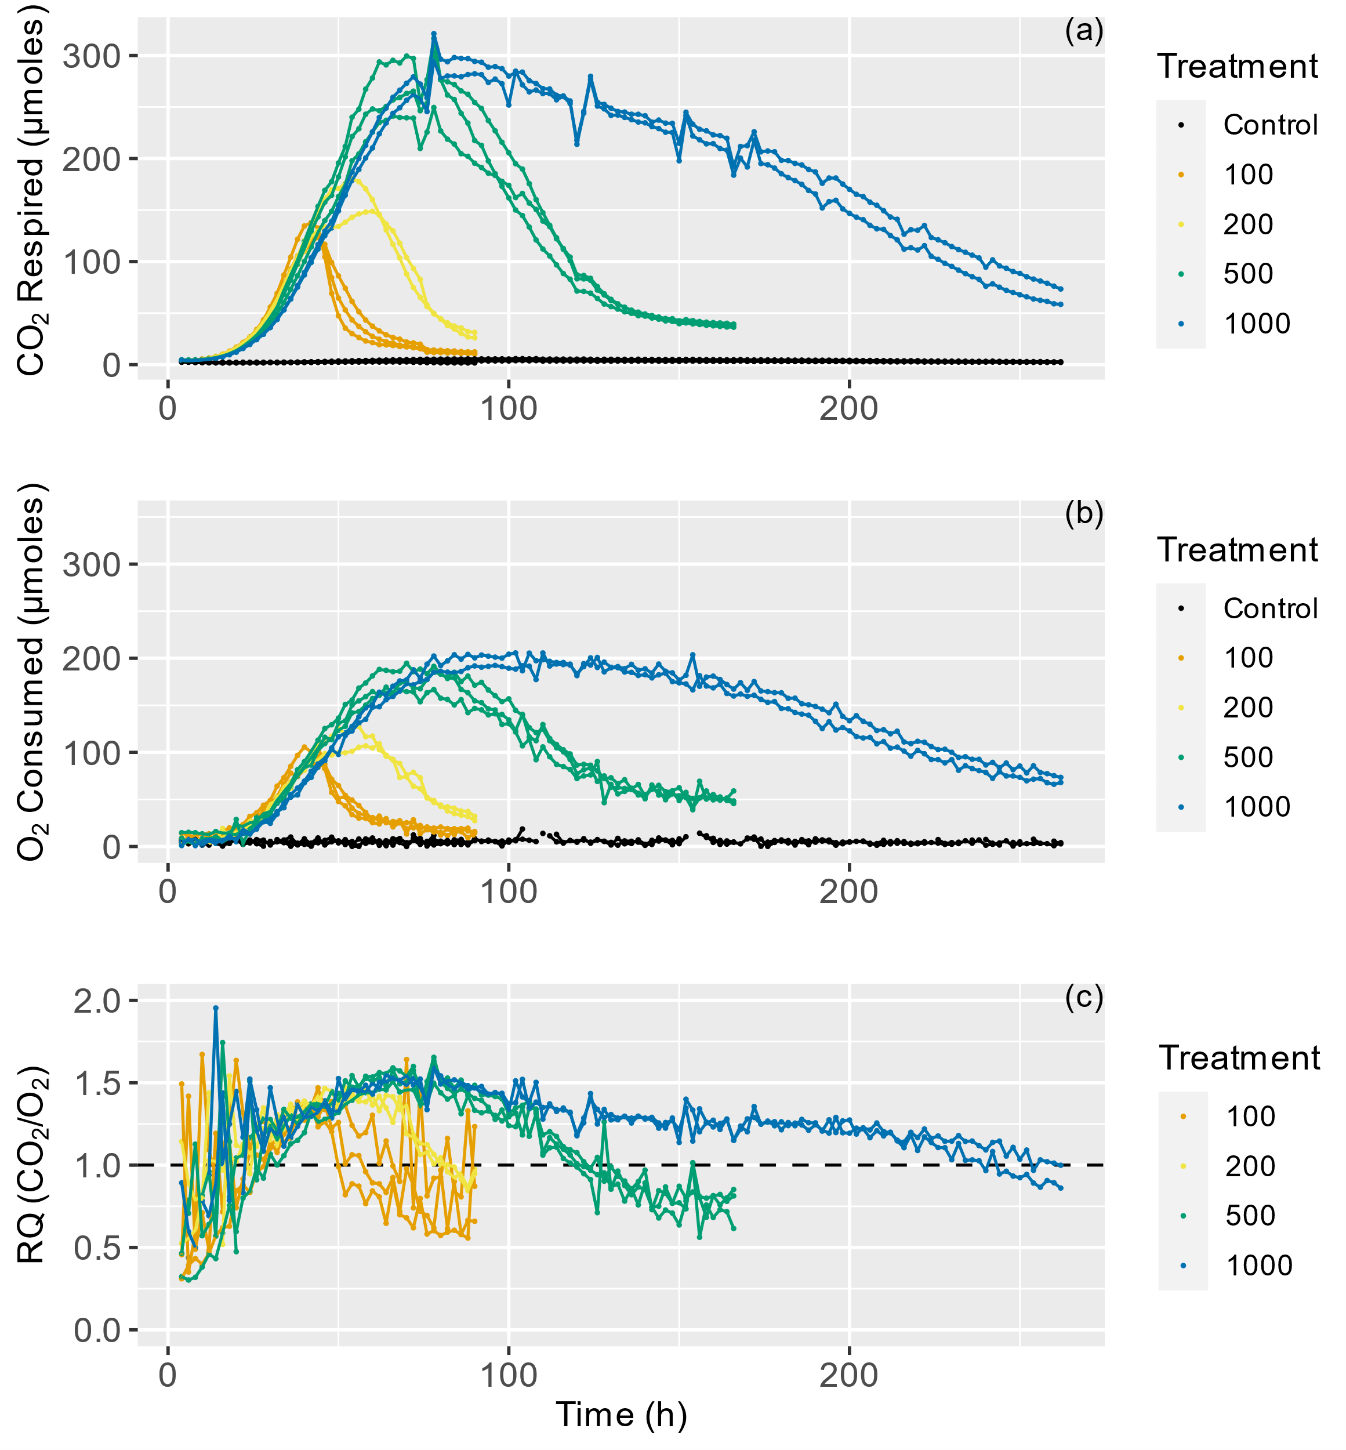

Figure 3: Panel (a) displays respiration rate of CO2 in micromoles for each 2 h period. Panel (b) displays O2 consumption rate in micromoles for each 2 h period. Panel (c) displays Respiratory Quotient (RQ) for each 2 h timepoint as calculated as [CO2 Respired / O2 Consumed].

## 4.2 High Temporal Resolution Carbon Use Efficiency Estimates

Applying the RQ—CUE relationship (Fig. 1) to the previous incubation (Fig. 3) allows CUE values to be estimated for the duration of the experiments. Using the respiration rate and CUE, biomass production can be estimated during each time step (Fig. 4b), using the following equation [Biomass Prod. = (CO2 Production Rate/ 1 - CUE) * CUE] (Fig. 4c) and cumulatively throughout the experiment (Figure 4d). CUE follows a similar overall trajectory to that of RQ, because of the positive relationship between RQ and CUE. It is important to note that, once RQ values drop below a value 1.0, the modeled RQ—CUE relationship for glucose no longer holds true. Further, when RQ values drop below 1.0, this coincides with the point that respiration rates return to basal respiration rates. We infer that all available glucose provided in the amendment has been utilized by this point of the incubation. Any further activity is likely driven by metabolism of an alternative substrate, or biomass turnover. Therefore, each treatment group were removed from the incubation and harvested for CFE procedures soon after this respiratory decline. Biomass production rates closely resemble respiration rate trends for the incubation. Curves of cumulative Biomass produced (Fig. 4d) show all treatments display a sigmoidal shape, which is to be expected as production rates begin low, increase, and then decline back to zero.

One thing to note is that we cannot capture any subsequent loss of biomass using this method. It is reasonable to assume that after peak activity, as substrate availability declines, loss of biomass is expected (J. P. Schimel & Weintraub, 2003). Maximum estimated CUE was ~0.56, and the highest values were seen in the beginning of the incubation which is typically termed the lag phase. As respiration rates begin to increase CUE estimates are ~0.3 and continue to increase with respiration rates to ~0.4. After respiratory decline, when CO2 evolution and O2 consumption rates return to basal conditions, RQ values decline to <1.0 initially and CUE estimate fall to zero. This period may represent a transitionary phase, when the high lability glucose amendment has been depleted and the microbes begin targeting alternate sources of organic carbon. (Masiello et al., 2008) provides RQ values for other common organic compounds in soils which may serve as these alternate sources. From the list of compounds and their associated RQ’s several candidate compounds could satisfy the requirements of our observations; for example, proteins produce RQ’s ranging from 0.67-1.01, lignin ranges from 0.88-0.94, and lipids range from 0.68-0.80. Oxidation of any or all of these classes of compounds could explain our observations given that they are basic constituents of soil organic matter. With respect to the values measured at the start of incubation (as high as ~1.9), very few compounds could be responsible for this signal. Most organic acids produce RQ values greater than 1.0, however with the exception of oxalic acid (4.0) most still remain below 1.33. Instead, these measured RQ values >1 reflect the signal of glucose metabolism affected by anabolic processes.

It is also important to consider any priming effects that were stimulated by this experimental design. (Qiao et al., 2014) showed that single addition experiments similar to ours do indeed create a priming effect which leads to increase in carbon cycling, typically leading to excess carbon mineralization and a net loss of carbon from organic matter. In order to fully appreciate the effects of priming it is important to consider time scale, for example, if glucose amendment and its stimulated increase in respiratory activity immediately lead to a net loss of carbon from organic matter or if the immediate response fueled by glucose amendment acts as a period of high microbial activity and enzyme (protein) synthesis which after respiratory decline can act on pre-existing organic matter slowly, making it more labile and sensitive to future microbial activity.

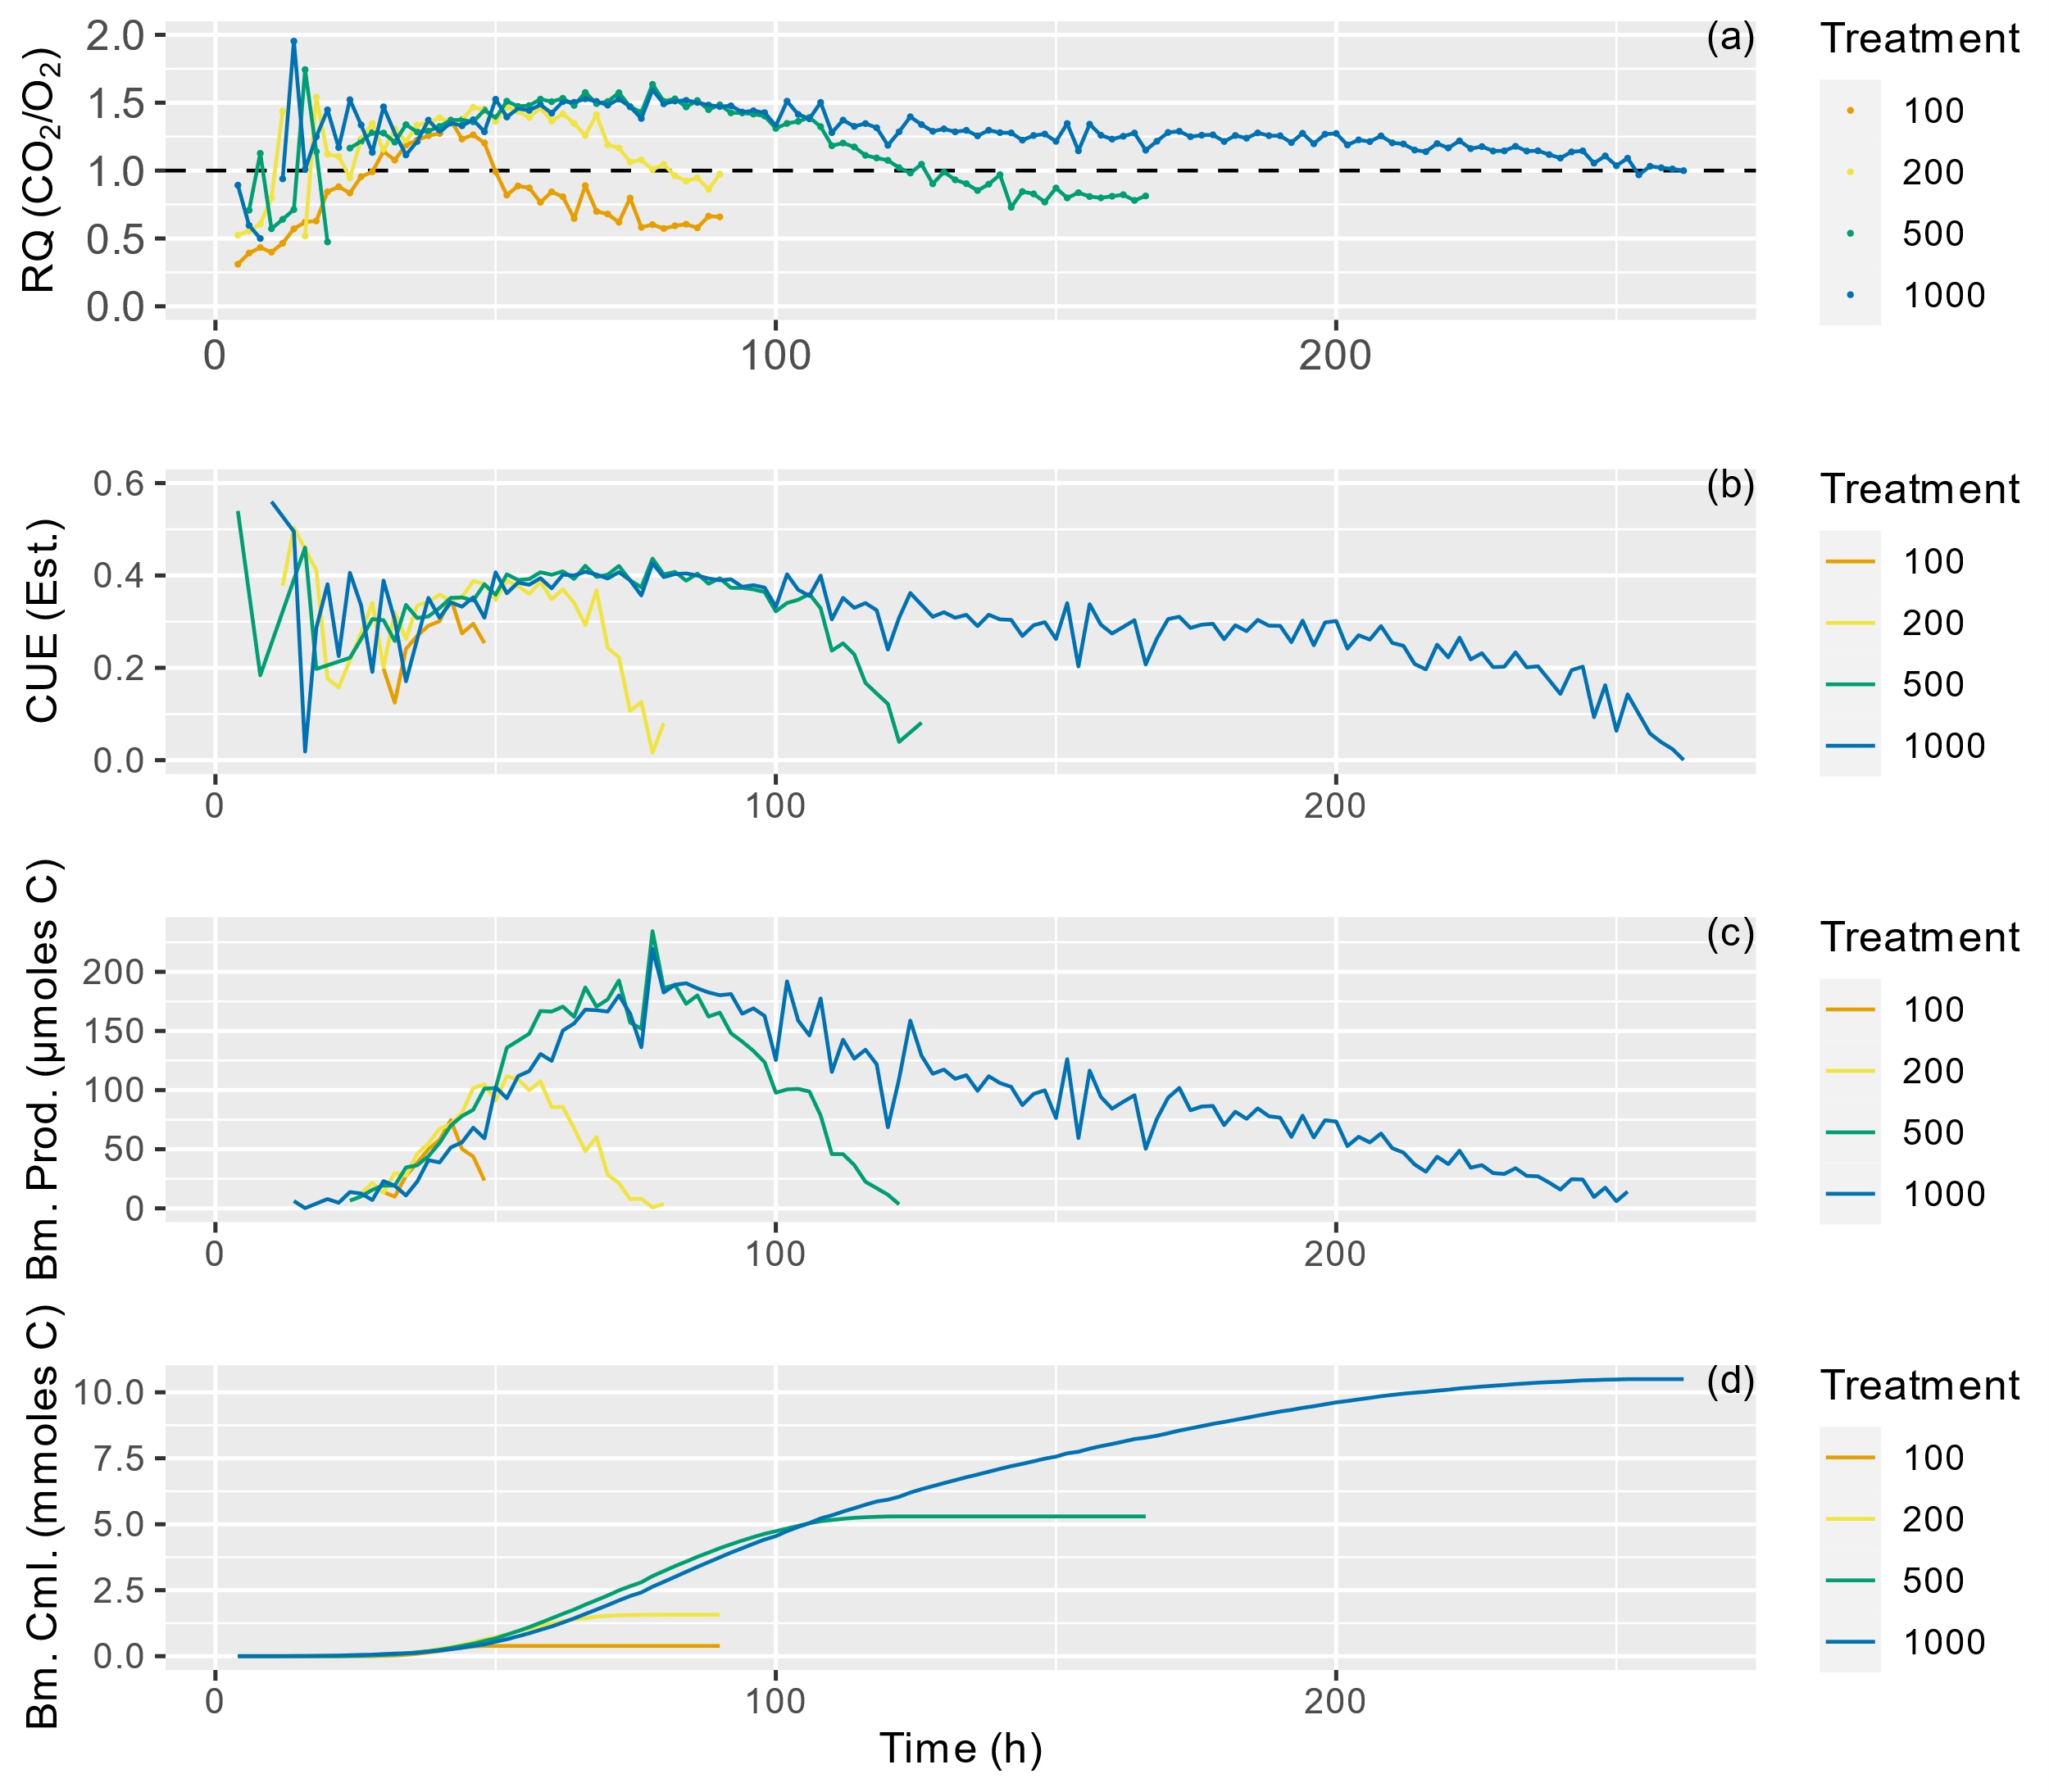

Figure 4: Panel (a) displays RQ over the incubation period, it is the same data presented in Fig.3c. Panel (b) displays Carbon Use Efficiency estimated for this incubation using the RQ—CUE relationship presented in Fig. 1. Panel (c) displays micromoles of biomass (carbon) produced at each 2 h time point for the incubation period. Panel (d) displays the cumulative sum of biomass produced during the incubation in millimoles carbon. All panels present one replicate from each amended treatment for use as an example.

## 4.3 Comparison of the RQ—CUE Approach with Microbial Biomass Carbon Extraction

In order to test the validity of our defined RQ—CUE relationship, we applied it to our observed measurements. This addition was carried out in three replicates and results are presented in Fig.5. Chloroform Fumigation Extraction was conducted on replicate subsamples at time 0, and at the end of the incubation periods for of each treatment for comparison. The results of our gas based cumulative biomass production estimates and CFE results are plotted against each other in Fig.5. It is important to note a few points: (1) uncertainty values for CFE method are unclear, variability in subsamples, extraction efficiency, and precision can vary between samples, and soil types (Dictor et al., 1998; Ross, 1990); (2) the application of the RQ—CUE method does not provide an estimate of pre-existing biomass in the soils, only that which is stimulated by the amendment. It is clear from Fig.5 that the results of our gas-based estimates of cumulative biomass produced do not agree with that of the CFE. The solid diagonal line represents a one-to-one relationship, which our dataset clearly does not satisfy. 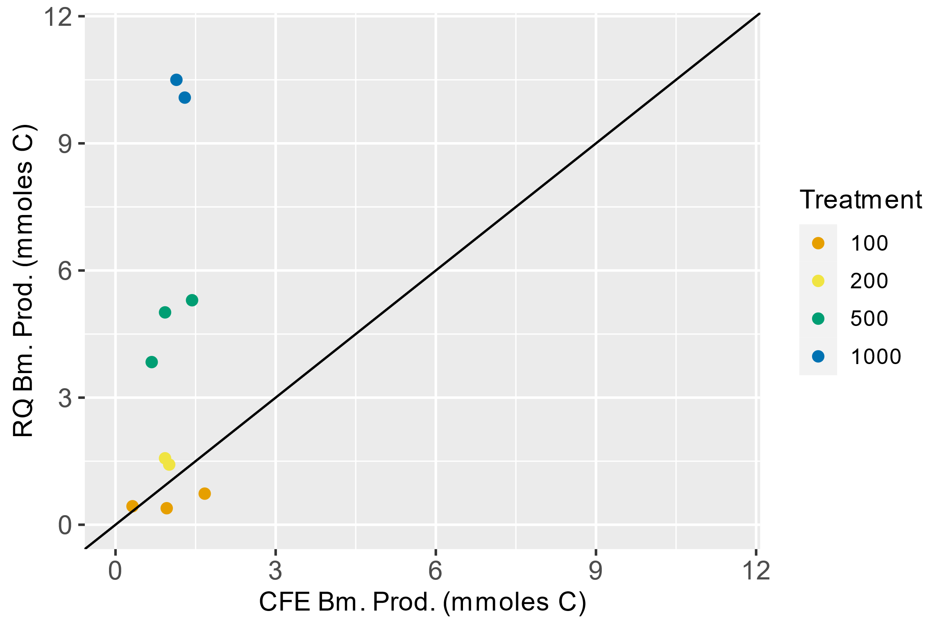

Figure 5: Scatter plot displaying the cumulative biomass produced from the RQ—CUE relationship and measured from chloroform fumigation extraction method.

Given this outcome, there are two possible scenarios which could explain this difference, either; (1) Our gas-based estimations are overestimating biomass production, or (2) the chloroform fumigation extraction is inappropriate to apply to our study given the order of magnitude increase in amendment. To examine these two possibilities, we compare our measurable pools of carbon below in Fig.6. It is clear in Fig.6 that as the mass of amended glucose increases the mass of carbon respired also increases proportionally. Further, our gas based estimations of biomass production increase proportionally with amendment (Fig. 5 & Fig. 6), whereas the results of the CFE procedure do not increase with amendment size. With an increase in both maximum respiration rates (Fig. 2a) and in the summed mass of CO2 respired (Fig.6), it is reasonable to assume that a proportional increase in biomass is to be expected, however the values reached through the CFE do not agree.

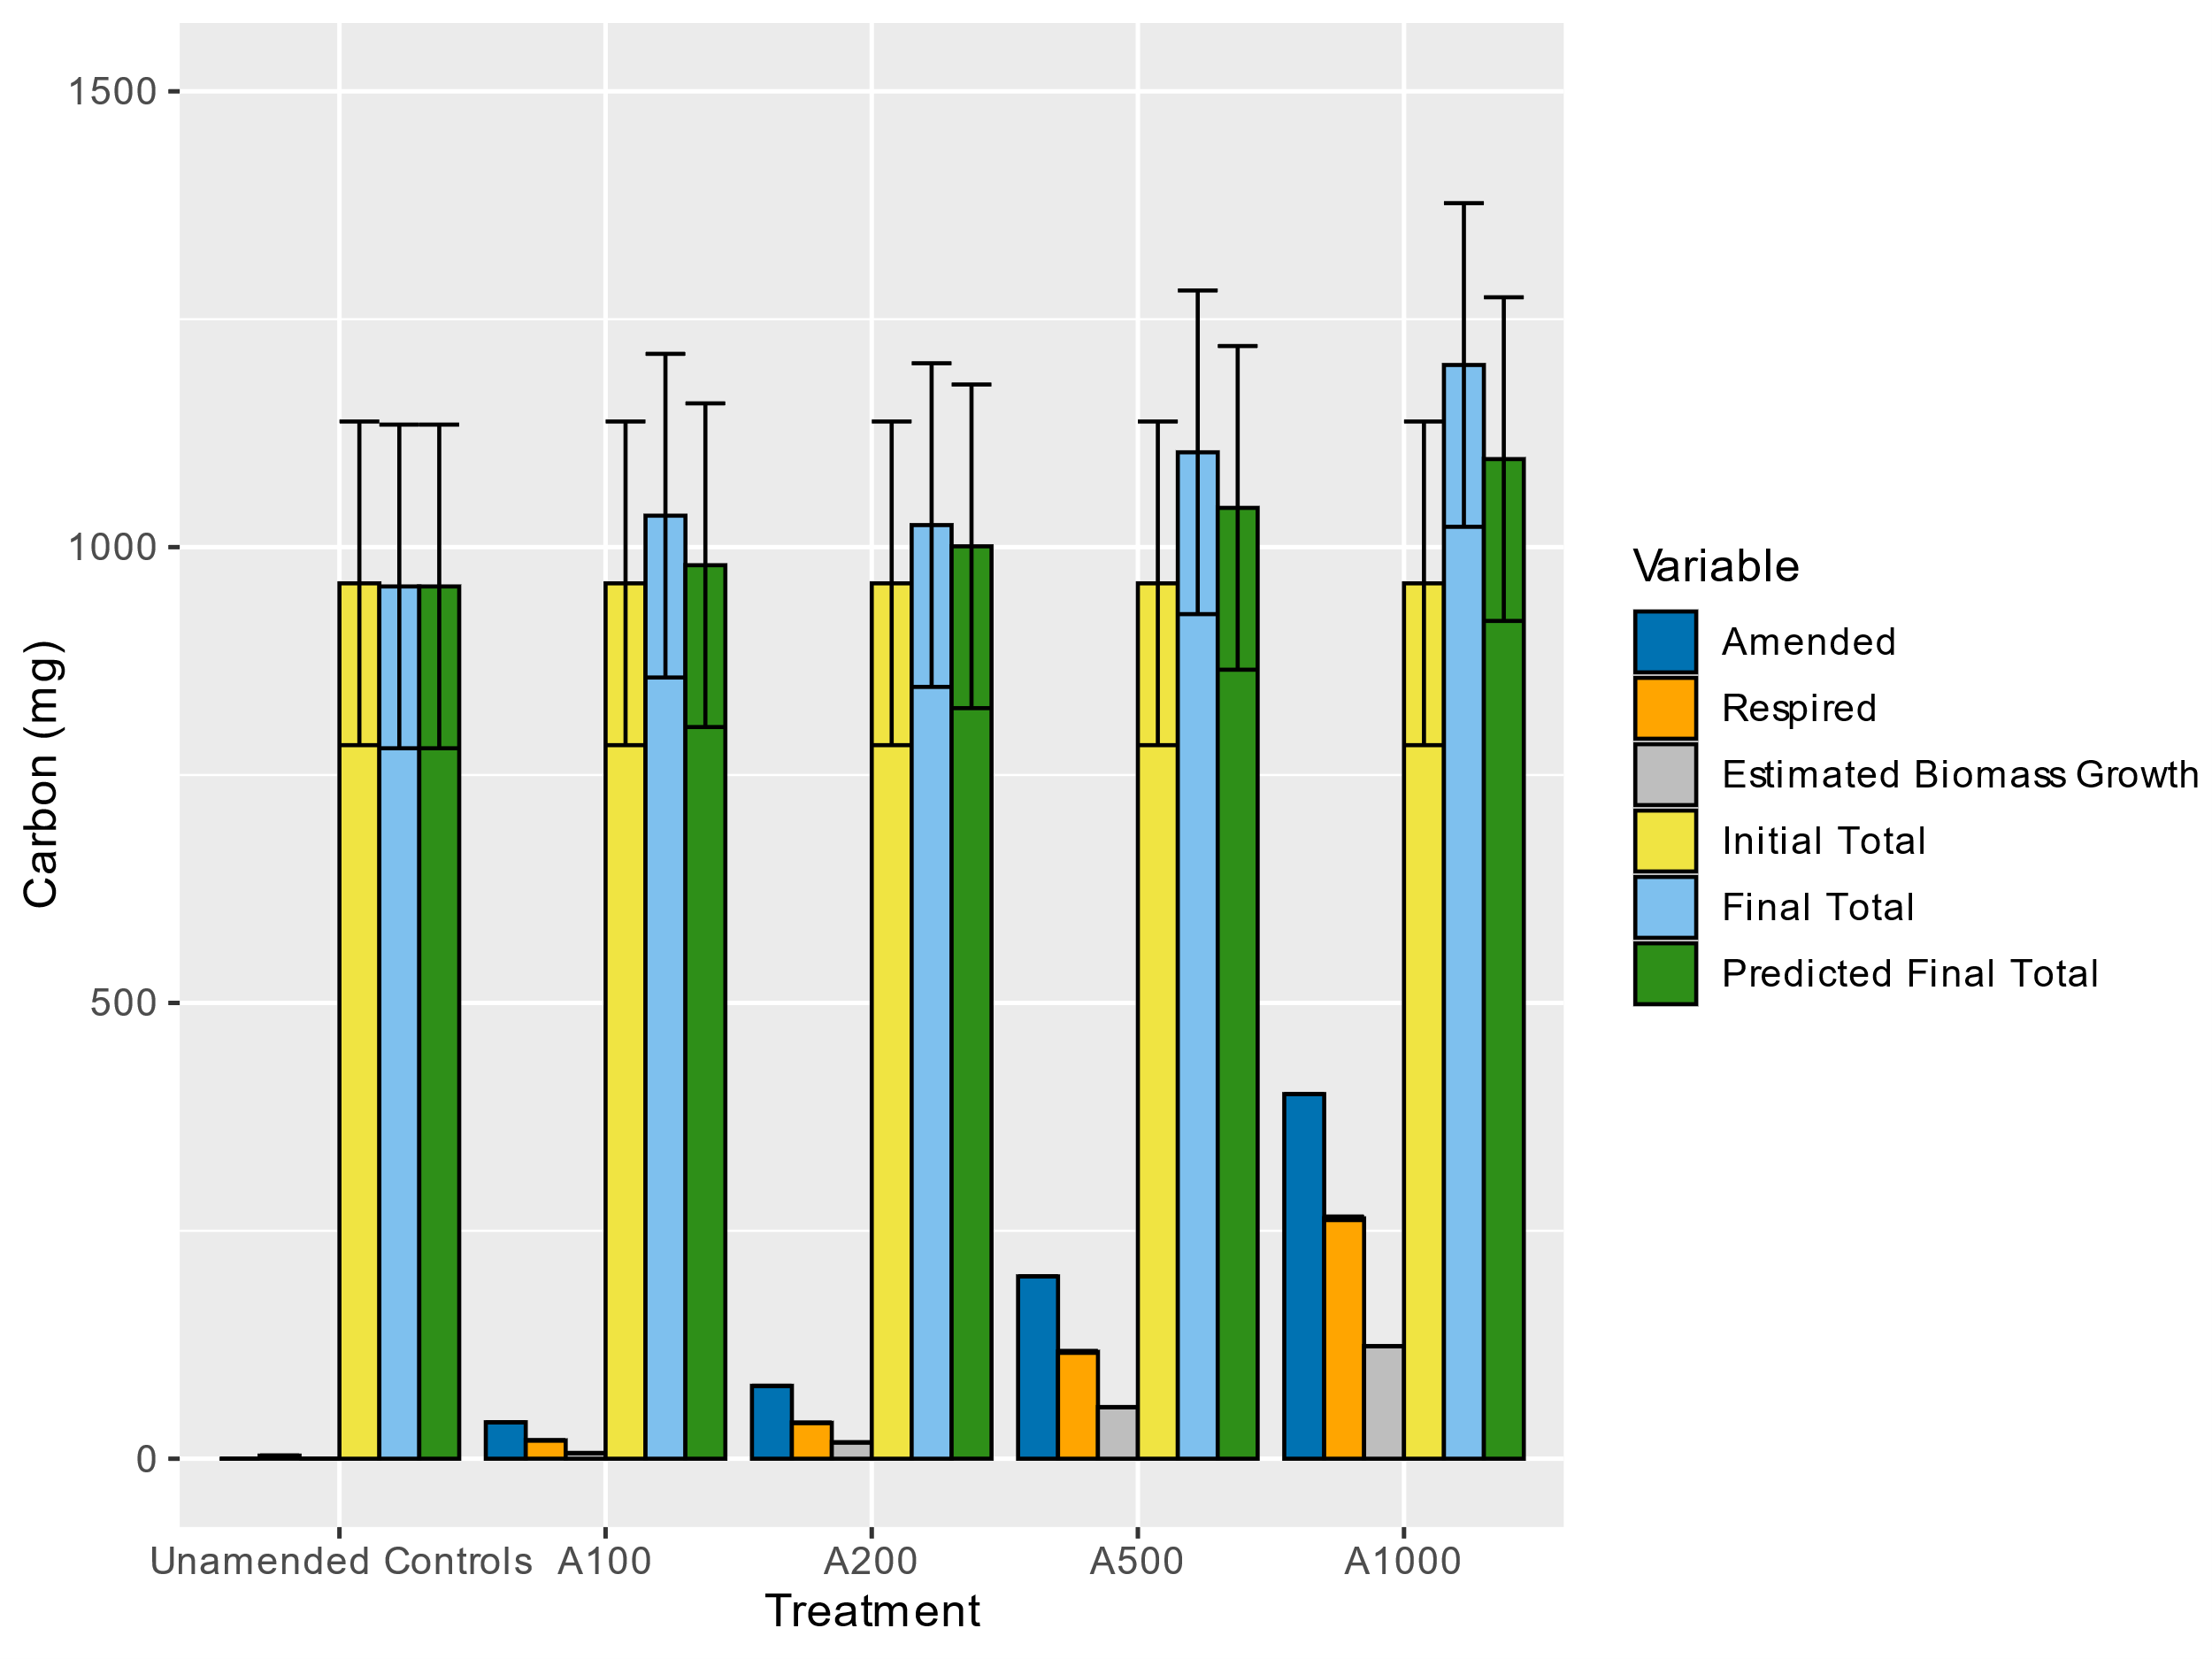

Figure 6: This bar graph displays the average values for carbon amended, carbon respired, calculated Biomass carbon, total initial carbon, final total carbon, and predicted final carbon . Replicate numbers for the treatments are as follows: Unamended controls (n=7), A100 (n=3), A200 (n=3), A500 (n=3), A1000 (n=3). Respired carbon in unamended controls taken as (n=4), as 3 replicates were not measured through incubation. Error bars on Initial Total, Final Total, and Predicted Final Total represent the standard deviation of unamended controls (3 at T0, 2 at T1, and 2 at T2). Error bars on Respired carbon represent the average cumulative uncertainty on respiration measurements.

# 5 Conclusions

A new automated gas sampling apparatus design enabled measurement of high-precision RQ values at a high temporal resolution (~2 h). Its non-destructive sampling method allows samples to continuously incubate for a wide range of experimental durations without needing to disturb the incubation chamber. Our results demonstrate that RQ values observed in incubations display systematic deviations from pure respiration predicted values in a manner that cannot be explained by a shift to other substrates. Instead, these variations in RQ are best explained by some fraction of the substrate consumed being used to biosynthesize other compounds. A stoichiometric relationship between RQ and CUE values was derived, which enables measurements of RQ to provide contextual information regarding microbial respiration and biosynthesis. Not only can this approach provide estimates of CUE at a temporal resolution matching that of RQ, but by combining this information with respiration rate, simultaneous estimates of biomass production can also be calculated. Importantly, this derived CUE—RQ relation must only be used when glucose induced respiration is achieved under the assumption that one dominant metabolism is present, although more complex relationships between CUE and multiple compounds could be derived.

This work has implications for other studies that measure RQ values in the field or laboratory, especially in settings where meaningful changes in microbial biomass are expected to occur. These changes in biomass will likely impart a systematic deviation in RQ values which may add an additional layer of complexity and must be accounted for. Additionally, we show that changes in carbon use efficiency may occur on short timescales and may not directly be related to substrate availability, or the production of other biosynthetic compounds like extracellular enzyme which we do not account for in our relationship could be driving these temporal estimations of CUE. These findings can help contextualize field-based soil RQ observations. For example, increases in ARQ could indicate pulses of microbial activity in response to increases in available substrate especially when root exudates are fueling microbial metabolisms and carbon source would be expected to remain constant. Finally, we provide evidence that the CFE method is not applicable in this method for comparison and should be used with caution when it is applied to studies where large differences in amendment quantities are used.

# References

A Miltner, P. B. B. S.-B. M. K. (2012). SOM genesis: microbial biomass as a significant source. *Biogeochemistry*, *111*, 41–55.

Adingo, S., Yu, J. R., Xuelu, L., Li, X., Jing, S., & Xiaong, Z. (2021). Variation of soil microbial carbon use efficiency (CUE) and its Influence mechanism in the context of global environmental change: a review. *PeerJ*, *9*. https://doi.org/10.7717/PEERJ.12131

Allison, S. D., & Vitousek, P. M. (2005). Responses of extracellular enzymes to simple and complex nutrient inputs. *Soil Biology and Biochemistry*, *37*(5), 937–944. https://doi.org/10.1016/J.SOILBIO.2004.09.014

Angert, A., Yakir, D., Rodeghiero, M., Preisler, Y., Davidson, E. A., & Weiner, T. (2015). Using O2 to study the relationships between soil CO2 efflux and soil respiration. *Biogeosciences*, *12*(7), 2089–2099. https://doi.org/10.5194/bg-12-2089-2015

Barnett, S. E., Youngblut, N. D., Koechli, C. N., & Buckley, D. H. (2021). Multisubstrate DNA stable isotope probing reveals guild structure of bacteria that mediate soil carbon cycling. *Proceedings of the National Academy of Sciences of the United States of America*, *118*(47), e2115292118. https://doi.org/10.1073/PNAS.2115292118/SUPPL_FILE/PNAS.2115292118.SD02.XLSX

Beare, M. H., Neely, C. L., Coleman, D. C., & Hargrove, W. L. (1990). A substrate-induced respiration (SIR) method for measurement of fungal and bacterial biomass on plant residues. *Soil Biology and Biochemistry*, *22*(5), 585–594. https://doi.org/10.1016/0038-0717(90)90002-H

Blagodatskaya, E., Blagodatsky, S., Anderson, T. H., & Kuzyakov, Y. (2014). Microbial Growth and Carbon Use Efficiency in the Rhizosphere and Root-Free Soil. *PLOS ONE*, *9*(4), e93282. https://doi.org/10.1371/JOURNAL.PONE.0093282

Chakrawal, A., Herrmann, A. M., Šantrůčková, H., & Manzoni, S. (2020). Quantifying microbial metabolism in soils using calorespirometry — A bioenergetics perspective. *Soil Biology and Biochemistry*, *148*, 107945. https://doi.org/10.1016/J.SOILBIO.2020.107945

Cotrufo, M. F., Soong, J. L., Horton, A. J., Campbell, E. E., Haddix, M. L., Wall, D. H., & Parton, W. J. (2015). Formation of soil organic matter via biochemical and physical pathways of litter mass loss. *Nature Geoscience 2015 8:10*, *8*(10), 776–779. https://doi.org/10.1038/ngeo2520

Dictor, M. C., Tessier, L., & Soulas, G. (1998). Reassessement of the Kec coefficient of the fumigation–extraction method in a soil profile. *Soil Biology and Biochemistry*, *30*(2), 119–127. https://doi.org/10.1016/S0038-0717(97)00111-9

Dilly, O. (2001). Microbial respiratory quotient during basal metabolism and after glucose amendment in soils and litter. *Soil Biology and Biochemistry*, *33*(1), 117–127. https://doi.org/10.1016/S0038-0717(00)00123-1

Dilly, O. (2003). Regulation of the respiratory quotient of soil microbiota by availability of nutrients. *FEMS Microbiology Ecology*, *43*(3), 375–381. https://doi.org/10.1111/J.1574-6941.2003.TB01078.X

Dilly, O., Nii-Annang, S., Franke, G., Fischer, T., Buegger, F., & Zyakun, A. (2011). Resilience of microbial respiration, respiratory quotient and stable isotope characteristics to soil hydrocarbon addition. *Soil Biology and Biochemistry*, *43*(9), 1808–1811. https://doi.org/10.1016/J.SOILBIO.2010.09.026

Dynarski, K. A., Bossio, D. A., & Scow, K. M. (2020). Dynamic Stability of Soil Carbon: Reassessing the “Permanence” of Soil Carbon Sequestration. *Frontiers in Environmental Science*, *8*, 218. https://doi.org/10.3389/FENVS.2020.514701/BIBTEX

Gaiser, T., & Stahr, K. (2013). Soil organic carbon, soil formation and soil fertility. *Ecosystem Services and Carbon Sequestration in the Biosphere*, 407–418. https://doi.org/10.1007/978-94-007-6455-2_17/FIGURES/00177

Gallagher, T. M., & Breecker, D. O. (2020). The Obscuring Effects of Calcite Dissolution and Formation on Quantifying Soil Respiration. *Global Biogeochemical Cycles*, *34*(12), e2020GB006584. https://doi.org/10.1029/2020GB006584

Geyer, K. M., Dijkstra, P., Sinsabaugh, R., & Frey, S. D. (2019). Clarifying the interpretation of carbon use efficiency in soil through methods comparison. *Soil Biology and Biochemistry*, *128*, 79–88. https://doi.org/10.1016/J.SOILBIO.2018.09.036

Geyer, K., Schnecker, J., Grandy, A. S., Richter, A., & Frey, S. (2020). Assessing microbial residues in soil as a potential carbon sink and moderator of carbon use efficiency. *Biogeochemistry*, *151*(2–3), 237–249. https://doi.org/10.1007/S10533-020-00720-4/FIGURES/5

Godley, A. R. (2004). Factors affecting the soil microbial quality measurements of biomass quotient and respiration quotient. *Water and Environment Journal*, *18*(2), 73–79. https://doi.org/10.1111/J.1747-6593.2004.TB00500.X

Grogan, P., Michelsen, A., Ambus, P., & Jonasson, S. (2004). Freeze-thaw regime effects on carbon and nitrogen dynamics in sub-arctic heath tundra mesocosms. *Soil Biology and Biochemistry*, *36*(4), 641–654. https://doi.org/10.1016/j.soilbio.2003.12.007

Hanson, P. J., Edwards, N. T., Garten, C. T., & Andrews, J. A. (2000). Separating root and soil microbial contributions to soil respiration: A review of methods and observations. *Biogeochemistry 2000 48:1*, *48*(1), 115–146. https://doi.org/10.1023/A:1006244819642

Hicks Pries, C., Angert, A., Castanha, C., Hilman, B., & Torn, M. S. (2020). Using respiration quotients to track changing sources of soil respiration seasonally and with experimental warming. *Biogeosciences*, *17*(12), 3045–3055. https://doi.org/10.5194/BG-17-3045-2020

Hill, P. W., Farrar, J. F., & Jones, D. L. (2008). Decoupling of microbial glucose uptake and mineralization in soil. *Soil Biology and Biochemistry*, *40*(3), 616–624. https://doi.org/10.1016/J.SOILBIO.2007.09.008

Hilman, B., Weiner, T., Haran, T., Masiello, C. A., Gao, X., & Angert, A. (2022). The Apparent Respiratory Quotient of Soils and Tree Stems and the Processes That Control It. *Journal of Geophysical Research: Biogeosciences*, *127*(3), e2021JG006676. https://doi.org/10.1029/2021JG006676

Hodges, C., Kim, H., Brantley, S. L., & Kaye, J. (2019). Soil CO 2 and O 2 Concentrations Illuminate the Relative Importance of Weathering and Respiration to Seasonal Soil Gas Fluctuations . *Soil Science Society of America Journal*, *83*(4), 1167–1180. https://doi.org/10.2136/sssaj2019.02.0049

Huang, L.-N., Tang, F.-Z., Song, Y.-S., Wan, C.-Y., Wang, S.-L., Liu, W.-Q., & Shu, W.-S. (n.d.). *Biodiversity, abundance, and activity of nitrogen-fixing bacteria during primary succession on a copper mine tailings*. https://doi.org/10.1111/j.1574-6941.2011.01178.x

KM Geyer, E. K.-S. A. G. S. F. (2016). Microbial carbon use efficiency: accounting for population, community, and ecosystem-scale controls over the fate of metabolized organic matter. *Biogeochemistry*, *127*, 173–188.

Kögel-Knabner, I. (2002). The macromolecular organic composition of plant and microbial residues as inputs to soil organic matter. *Soil Biol. Biochem.*, *34*, 139–162.

Landsberg, J. J., & Gower, S. T. (1997). Carbon Balance of Forests. *Applications of Physiological Ecology to Forest Management*, 125–160. https://doi.org/10.1016/B978-012435955-0/50005-4

Lavigne, M. B., Foster, R. J., & Goodine, G. (2004). Seasonal and annual changes in soil respiration in relation to soil temperature, water potential and trenching. *Tree Physiology*, *24*(4), 415–424.

Madrid, R. E., & Felice, C. J. (2008). Microbial Biomass Estimation. *Https://Doi.Org/10.1080/07388550500248563*, *25*(3), 97–112. https://doi.org/10.1080/07388550500248563

Manzoni, S., Čapek, P., Porada, P., Thurner, M., Winterdahl, M., Beer, C., Brüchert, V., Frouz, J., Herrmann, A. M., Lyon, S. W., SantrÅčkova, H., Vico, G., & Way, D. (2018). Reviews and syntheses: Carbon use efficiency from organisms to ecosystems - Definitions, theories, and empirical evidence. *Biogeosciences*, *15*(19), 5929–5949. https://doi.org/10.5194/BG-15-5929-2018

Manzoni, S., Taylor, P., Richter, A., Porporato, A., & Ågren, G. I. (2012). Environmental and stoichiometric controls on microbial carbon‐use efficiency in soils. *New Phytologist*, *196*(1), 79–91. https://doi.org/10.1111/j.1469-8137.2012.04225.x

Masiello, C. A., Gallagher, M. E., Randerson, J. T., Deco, R. M., & Chadwick, O. A. (2008). Evaluating two experimental approaches for measuring ecosystem carbon oxidation state and oxidative ratio. *Journal of Geophysical Research: Biogeosciences*, *113*(G3), 3010. https://doi.org/10.1029/2007JG000534

McDaniel, M. D., Grandy, A. S., Tiemann, L. K., & Weintraub, M. N. (2014). Crop rotation complexity regulates the decomposition of high and low quality residues. *Soil Biology and Biochemistry*, *78*, 243–254. https://doi.org/10.1016/J.SOILBIO.2014.07.027

MF Cotrufo, M. W. C. B. K. D. E. P. (2013). The Microbial Efficiency-Matrix Stabilization (MEMS) framework integrates plant litter decomposition with soil organic matter stabilization: do labile plant inputs form stable soil organic matter? *Glob. Change Biol.*, *19*, 988–995.

Mooshammer, M., Hofhansl, F., Frank, A. H., Wanek, W., Hämmerle, I., Leitner, S., Schnecker, J., Wild, B., Watzka, M., Keiblinger, K. M., Zechmeister-Boltenstern, S., & Richter, A. (2017). Decoupling of microbial carbon, nitrogen, and phosphorus cycling in response to extreme temperature events. *Science Advances*, *3*(5), 1–14. https://doi.org/10.1126/sciadv.1602781

Mukul, S. A., Halim, Md. A., & Herbohn, J. (2020). *Forest Carbon Stock and Fluxes: Distribution, Biogeochemical Cycles, and Measurement Techniques*. 1–16. https://doi.org/10.1007/978-3-319-71065-5_23-1

Paul, E. (2016). The nature and dynamics of soil organic matter: plant inputs, microbial transformations, and organic matter stabilization. *Soil Biol. Biochem.*, *98*, 109–126.

Qiao, N., Schaefer, D., Blagodatskaya, E., Zou, X., Xu, X., & Kuzyakov, Y. (2014). Labile carbon retention compensates for CO2 released by priming in forest soils. *Global Change Biology*, *20*(6), 1943–1954. https://doi.org/10.1111/GCB.12458

Roels, J. A. (1980). Application of Macroscopic Principles To Microbial Metabolism. *Biotechnology and Bioengineering*, *22*(12), 2457–2514. https://doi.org/10.1111/j.1749-6632.1981.tb14182.x

Ross, D. J. (1990). Estimation of soil microbial c by a fumigation-extraction method: influence of seasons, soils and calibration with the fumigation-incubation procedure. *Soil Biology and Biochemistry*, *22*(3), 295–300. https://doi.org/10.1016/0038-0717(90)90103-7

Sánchez-Cañete, E. P., Barron-Gafford, G. A., & Chorover, J. (2018). A considerable fraction of soil-respired CO2 is not emitted directly to the atmosphere. *Scientific Reports 2018 8:1*, *8*(1), 1–10. https://doi.org/10.1038/s41598-018-29803-x

Scharlemann, J. P. W., Tanner, E. V. J., Hiederer, R., & Kapos, V. (2014). Global soil carbon: Understanding and managing the largest terrestrial carbon pool. *Carbon Management*, *5*(1), 81–91. https://doi.org/10.4155/CMT.13.77/SUPPL_FILE/TCMT_A_10816421_SM0001.DOC

Schimel, J. P., & Clein, J. S. (1996). Microbial response to freeze-thaw cycles in tundra and taiga soils. *Soil Biology and Biochemistry*, *28*(8), 1061–1066. https://doi.org/10.1016/0038-0717(96)00083-1

Schimel, J. P., & Weintraub, M. N. (2003). The implications of exoenzyme activity on microbial carbon and nitrogen limitation in soil: a theoretical model. *Soil Biology and Biochemistry*, *35*(4), 549–563. https://doi.org/10.1016/S0038-0717(03)00015-4

Schimel, J., & Schaeffer, S. (2012). Microbial control over carbon cycling in soil. *Frontiers in Microbiology*, *3*.

Scott-Denton, L. E., Rosenstiel, T. N., & Monson, R. K. (2006). Differential controls by climate and substrate over the heterotrophic and rhizospheric components of soil respiration. *Global Change Biology*, *12*(2), 205–216. https://doi.org/10.1111/J.1365-2486.2005.01064.X

Sinsabaugh, R. L., Manzoni, S., Moorhead, D. L., & Richter, A. (2013). Carbon use efficiency of microbial communities: Stoichiometry, methodology and modelling. *Ecology Letters*, *16*(7), 930–939. https://doi.org/10.1111/ELE.12113

Spohn, M., Pötsch, E. M., Eichorst, S. A., Woebken, D., Wanek, W., & Richter, A. (2016). Soil microbial carbon use efficiency and biomass turnover in a long-term fertilization experiment in a temperate grassland. *Soil Biology and Biochemistry*, *97*, 168–175. https://doi.org/10.1016/J.SOILBIO.2016.03.008

Vance, E. D., Brookes, P. C., & Jenkinson, D. S. (1987). An extraction method for measuring soil microbial biomass C. *Soil Biology and Biochemistry*, *19*(6), 703–707. https://doi.org/10.1016/0038-0717(87)90052-6

von Lützow, M., Kögel-Knabner, I., Ekschmitt, K., Flessa, H., Guggenberger, G., Matzner, E., & Marschner, B. (2007). SOM fractionation methods: Relevance to functional pools and to stabilization mechanisms. *Soil Biology and Biochemistry*, *39*(9), 2183–2207. https://doi.org/10.1016/J.SOILBIO.2007.03.007

W Wieder, A. G. C. K. G. B. (2014). Integrating microbial physiology and physiochemical principles in soils with the MIcrobial-MIneral Carbon Stabilization (MIMICS) model. *Biogeoscience*, *11*, 3899–3917.

Walker, T. W. N., Kaiser, C., Strasser, F., Herbold, C. W., Leblans, N. I. W., Woebken, D., Janssens, I. A., Sigurdsson, B. D., & Richter, A. (2018). Microbial temperature sensitivity and biomass change explain soil carbon loss with warming. *Nature Climate Change 2018 8:10*, *8*(10), 885–889. https://doi.org/10.1038/s41558-018-0259-x