Setup for doing LLM Circuit Analysis using
VS Code, LiteLLM, and the Universal-Netlist MCP Server

Setup of environment
- Install the VSCode Insiders version IDE
Download from here: https://code.visualstudio.com/insiders/#
- Universal Netlist MCP Server - The Universal Netlist MCP Server gives AI agents the tools to understand and analyze your electrical schematics, for powerful and comprehensive design reviews through natural conversations (https://github.com/IntelligentElectron/universal-netlist/tree/main)
- Install on Windows:
Windows (PowerShell):
irm https://raw.githubusercontent.com/IntelligentElectron/universal-netlist/main/install.ps1 | iex
- Connect the Universal-Netlist MCP Server to VSCode:
In VSCode (GitHub Copilot) create the following directory and file:
Add to .vscode/mcp.json in your project:
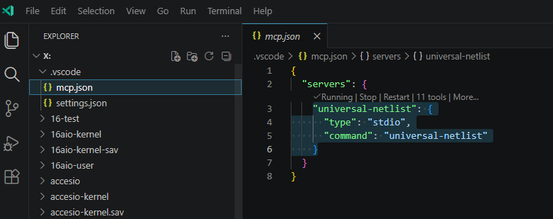
Then enable it in the Extensions Pane:
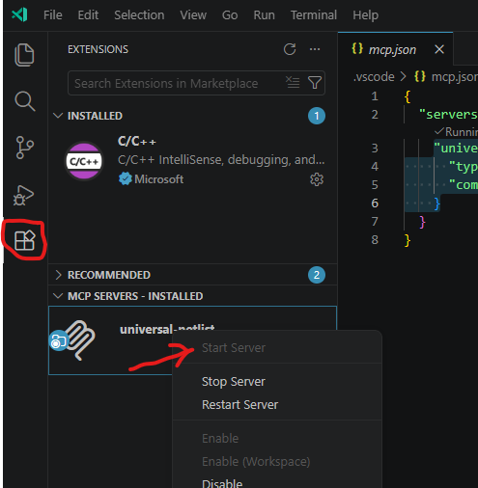
- To be able to use the Fermilab hosted Large Language Models (LLMs) you need to create a new virtual key on llm-keys.fnal.gov. Login using your services account
Create a new Virtual Key:
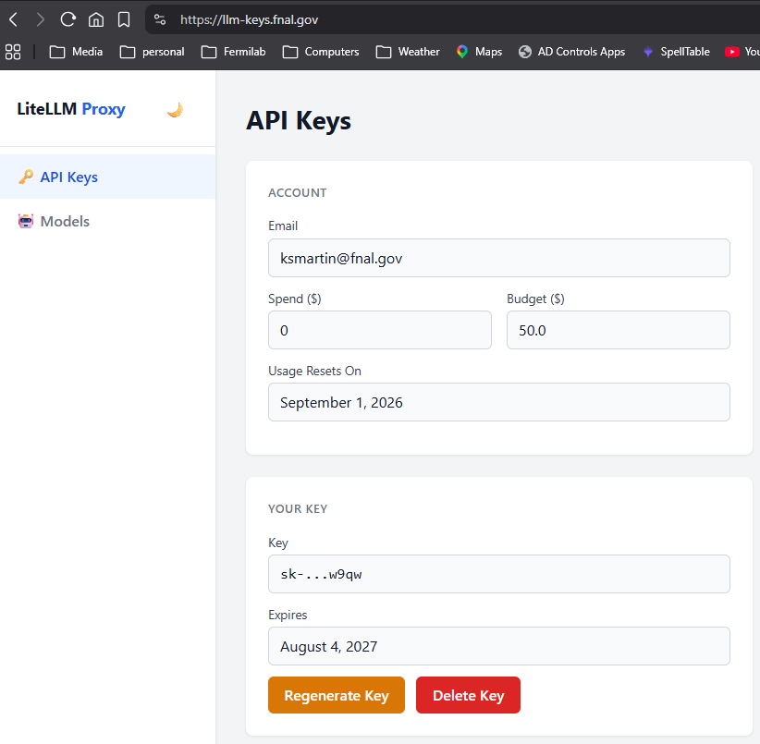
Once it’s created it will display the secret key. Make sure you record the generated secret key. You will need it later and this is the only time it will be given to you.
Contact Burt Holzman (burt@fnal.gov) if you have problems
3. Configure Github Copilot on VSCode to use LiteLLM.fnal.gov
- must be logged into github on VSCode
- In VSCode open the palette (ctrl-shift-p) and select Chat: Manage Language Models
- Click the "Add models" button on the upper right and select OpenAI Compatible.
- Give it a name for the model group rather than OpenAI Compatible (e.g. FNAL LiteLLM)
- Enter the API key you generated for use with LiteLLM (the secret key you saved)
- It then opens chatLanguageModels.json. You can edit the models array and add an entry like the following for an open-weight model:
[
{
"name": "FNAL LiteLLM",
"vendor": "customoai",
"apiKey": "${input:chat.lm.secret.-57fdc8a5}",
"models": [
{
"id": "qwen/qwen3-coder-next",
"name": "Qwen 3 Coder Next (liteLLM)",
"url": "https://litellm.fnal.gov/v1",
"toolCalling": true,
"vision": false,
"maxInputTokens": 262144,
"maxOutputTokens": 60000
},
{
"id": "codestral/codestral-latest",
"name": "Ollama Codestral Latest (liteLLM)",
"url": "https://litellm.fnal.gov/v1",
"toolCalling": true,
"vision": false,
"maxInputTokens": 32768,
"maxOutputTokens": 32768
},
{
"id": "google/gemma4-31b",
"name": "Google Gemma4 31b (liteLLM)",
"url": "https://litellm.fnal.gov/v1",
"toolCalling": true,
"vision": false,
"maxInputTokens": 262144,
"maxOutputTokens": 262144
}
]
}
]
- Other Fermilab AI/LLM Guides/Tips/Trick/Documentation can be found here:
https://ai-coding.fnal.gov
- From the copilot CHAT select the LLM to be used:
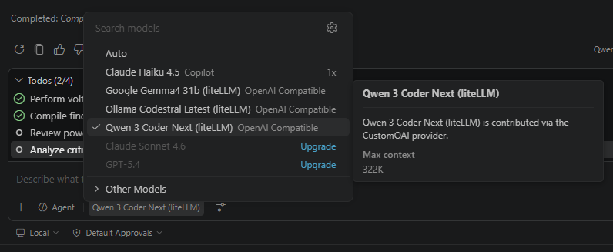
From the copilot CHAT give the command(s) to do a circuit analysis (example):
QWEN 3 Coder Next (liteLLM) Prompt:
You are an expert electronic circuit design reviewer using the Universal-Net MCP Server for circuit analysis.
Your task is to perform a circuit analysis on the Altium circuit design located at: "X:\RaPR_System_Controller\ACORN RaPR Control Board.PcbLib".
Follow this systematic approach:
### 1. Voltage Rails Analysis
- Identify all voltage rail nets (e.g., VCC, VDD, 3V3, 5V, 12V, AVDD, DVDD, etc.)
- For each voltage rail, trace its connectivity across the design
- Identify all components that connect to each voltage rail
- Check for proper decoupling capacitors on each voltage rail
- Verify voltage rail naming consistency
- Report any isolated/unconnected voltage rails
- Document the fan-out ratio (number of components per rail)

### 2. Ground Planes Analysis
- Identify all ground nets (e.g., GND, AGND, DGND, PGND, SGND, etc.)
- Trace connectivity of each ground plane
- Verify proper grounding of all components
- Check for ground loops or isolated ground sections
- Identify ground pins on power supplies and connectors
- Document ground plane partitioning if present

### 3. Device Voltage Connection Verification
- List all components in the design
- For each component, verify:
- All required power pins are connected
- Power-on reset circuits are properly connected
- Enable/standby pins are properly biased
- No floating power pins
- Flag components with missing or incorrect power connections
- Identify potential short circuits (voltage rails connected directly without regulation)

### Output Format:
Provide your analysis in the following structured format:

## Executive Summary
- Total components analyzed
- Total voltage rails identified
- Total ground planes identified
- Critical issues found

## Voltage Rails Details
[Rail Name]
- Components: [list]
- Decoupling caps: [count]
- Issues: [none/minor/major]

## Ground Planes Details
[Ground Name]
- Components: [list]
- Issues: [none/minor/major]

## Device Connection Issues
[Component RefDes]
- Missing connections: [list]
- Incorrect voltages: [list]

## Recommendations
[Priority-ordered list of improvements]

##### End of Prompt #####

The following prompt assumes that all MPN Datasheets have been downloaded into a subdirectory of the Altium Project directory and then converted from PDF to HTML format. LLMs cannot use PDF documents because they are binary.

QWEN 3 Coder Next (liteLLM) Prompt #2:
Do a device voltage supply analysis for the Altium circuit design located at: "X:\RaPR_System_Controller\ACORN RaPR Control Board.PcbLib":
Crosscheck the Universal-Net MCP Server component information with specification data using the HTML Data Sheets located here X:\RaPR_System_Controller\datasheets\*\*.html. Do a device voltage supply analysis (AVDD, DVDD, VCC etc.). The names of the HTML datasheet are named after the MPN from the .BomDoc. Make sure device voltages supplied are within specifications.

### Output Format:
Provide your analysis in the following structured format:

## Device Volatge Specification Issues
- Components: [List]
- Voltage: Specification
- Voltage: Supply Voltage
- Issues: [none/minor/major]

## Recommendations
[Priority-ordered list of improvements]

##### End of Prompt #####

