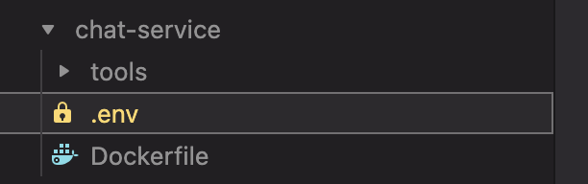

DATABASE_URL="file:/usr/src/app/prisma/databaseintro.db"

DB_PORT=4002
HOST=0.0.0.0

JWT_SECRET=votre_secret
JWT_EXPIRATION=1h

EMAIL_PASSWORD=fgkl xhco gmux untk
EMAIL_USER=ahmedsaki2003@gmail.com

COOKIE_SECRET=your_cookie_secret

UID=u-s4t2ud-e34dd718010d2528712e5e0bb2ddc4da2c62cc37e1fe1de5a6be9d172313810d
SECRET=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
CALLBACK_URL=http://localhost:3000/api/v1/auth/42/callback

FRONTEND_URL=http://localhost:8080

GOOGLE_CLIENT_ID=293659078118-42g9mtsksh6vii0tda3mstr74eiuj766.apps.googleusercontent.com
GOOGLE_CLIENT_SECRET=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
GOOGLE_CALLBACK_URL=http://localhost:3000/api/v1/auth/google/callback

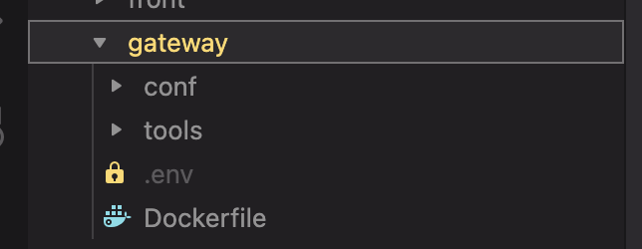

DATABASE_URL="file:/usr/src/app/prisma/databaseintro.db"

DB_PORT=4000
HOST=0.0.0.0

JWT_SECRET=votre_secret
JWT_EXPIRATION=1h

COOKIE_SECRET=your_cookie_secret

UID=u-s4t2ud-e34dd718010d2528712e5e0bb2ddc4da2c62cc37e1fe1de5a6be9d172313810d
SECRET=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
CALLBACK_URL=http://localhost:3000/api/v1/auth/42/callback

FRONTEND_URL=http://localhost:8080

GOOGLE_CLIENT_ID=293659078118-42g9mtsksh6vii0tda3mstr74eiuj766.apps.googleusercontent.com
GOOGLE_CLIENT_SECRET=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
GOOGLE_CALLBACK_URL=http://localhost:3000/api/v1/auth/google/callback

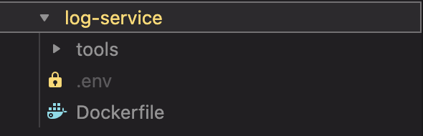

DATABASE_URL="file:/usr/src/app/prisma/databaseintro.db"

DB_PORT=4001
HOST=0.0.0.0

JWT_SECRET=votre_secret
JWT_EXPIRATION=1h

EMAIL_PASSWORD=fgkl xhco gmux untk
EMAIL_USER=ahmedsaki2003@gmail.com

COOKIE_SECRET=your_cookie_secret

UID=u-s4t2ud-e34dd718010d2528712e5e0bb2ddc4da2c62cc37e1fe1de5a6be9d172313810d
SECRET=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
CALLBACK_URL=http://localhost:3000/api/v1/auth/42/callback

FRONTEND_URL=http://localhost:8080

GOOGLE_CLIENT_ID=293659078118-42g9mtsksh6vii0tda3mstr74eiuj766.apps.googleusercontent.com
GOOGLE_CLIENT_SECRET=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
GOOGLE_CALLBACK_URL=http://localhost:3000/api/v1/auth/google/callback

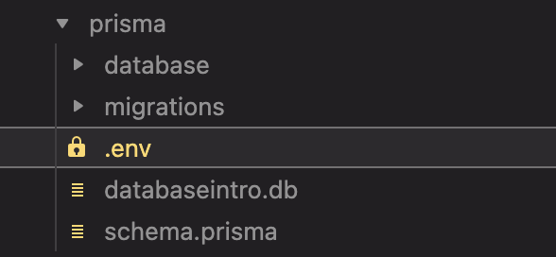

DATABASE_URL="file:/usr/src/app/prisma/databaseintro.db"

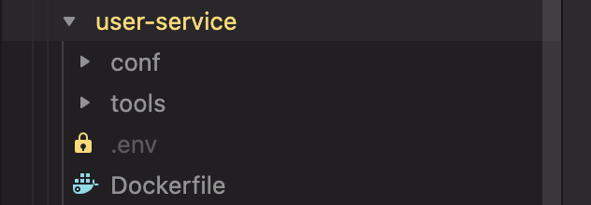

DATABASE_URL="file:/usr/src/app/prisma/databaseintro.db"

DB_PORT=4000
HOST=0.0.0.0

JWT_SECRET=votre_secret
JWT_EXPIRATION=1h

COOKIE_SECRET=your_cookie_secret

UID=u-s4t2ud-e34dd718010d2528712e5e0bb2ddc4da2c62cc37e1fe1de5a6be9d172313810d
SECRET=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
CALLBACK_URL=http://localhost:3000/api/v1/auth/42/callback

FRONTEND_URL=http://localhost:8080

GOOGLE_CLIENT_ID=293659078118-42g9mtsksh6vii0tda3mstr74eiuj766.apps.googleusercontent.com
GOOGLE_CLIENT_SECRET=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
GOOGLE_CALLBACK_URL=http://localhost:3000/api/v1/auth/google/callback

EMAIL_PASSWORD=wcqp axsk vauj vrvi
EMAIL_USER=anasksabi1999@gmail.com

