**Team Members:** Julia Thee, Derek Janzen, Jess Lembke and Kenneth Smith

**Course:** CIS 687 Object Oriented Design

**Assignment:** CIS 687 Homework 3

**Instructor:** Professor Scott Roueche

College of Engineering & Computer Science  
Syracuse University

* To run the created package following the following steps

1. Access the package folder
2. Double click the following file: TestHarness.exe

**Note: The server and worker thread will start, and the following consoles will be present:**

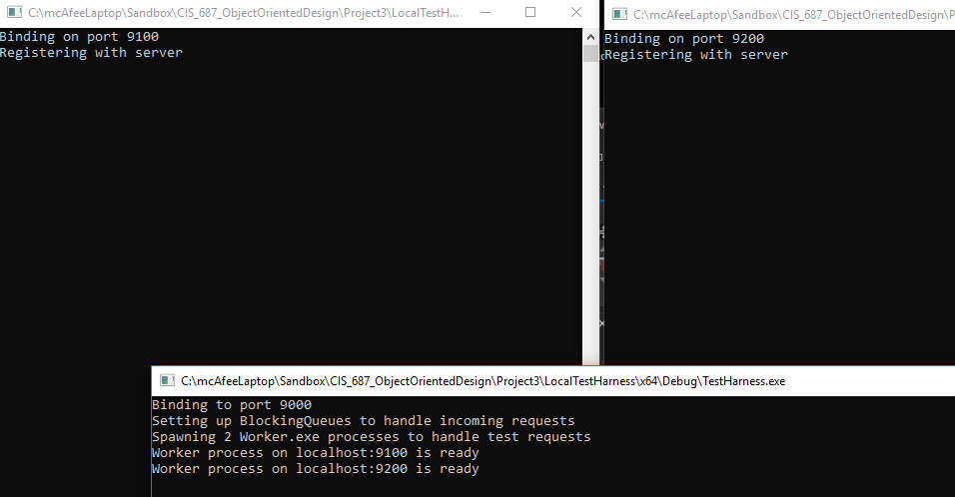

1. Double click the client application file: Client.exe

Note: The XML and test files will be placed on the local server. See the console below:

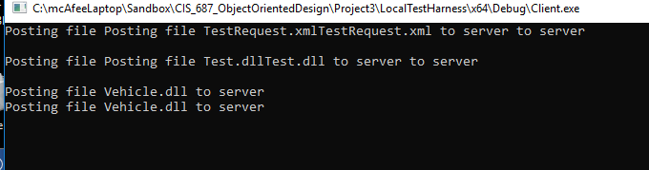

1. Once the files have been posted then the worker thread will run the tests. See the console below

