Curves / arc in canvas

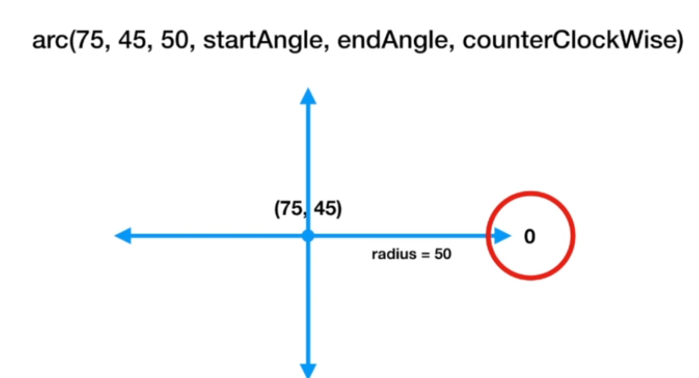

Coordinate system is similar to trignomatry coordinate system and angles are provided in radians

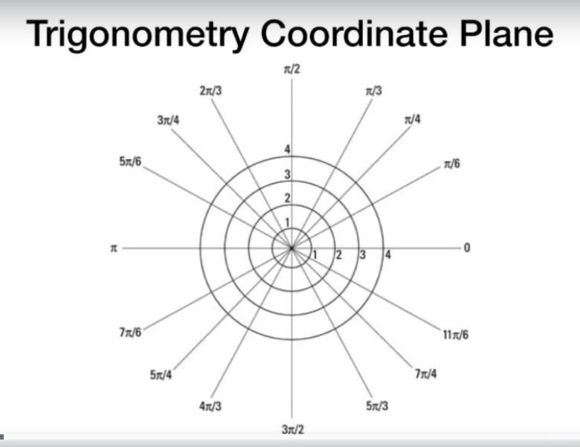

Example

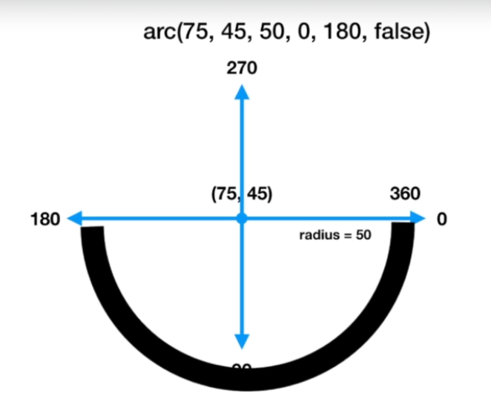

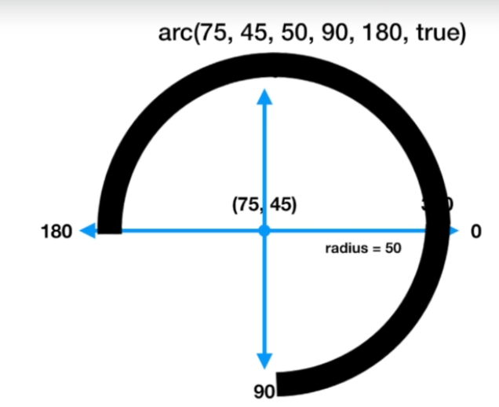

Quadratic curves can also be drawn

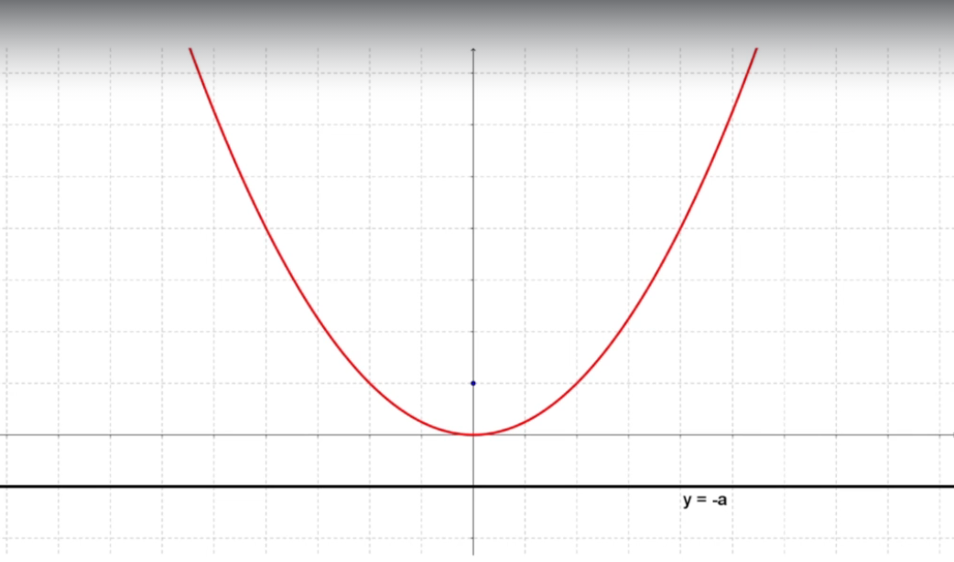

context.quadraticCurveTo(controlX,controlY,endX,endY)

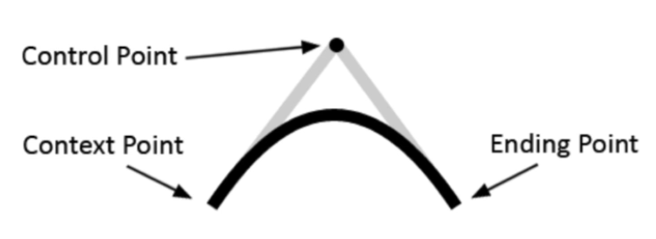

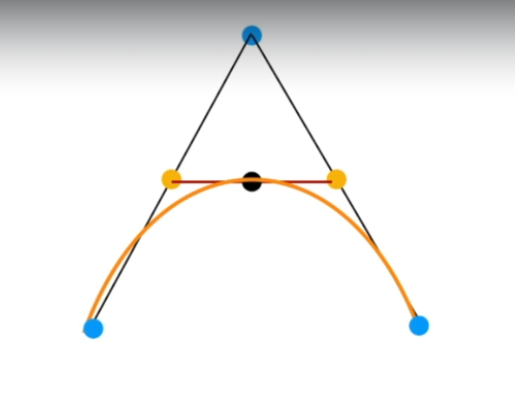

Beginning point and endpoints are there. Begin point is where draw will start. Then we have a control point which is top point above. Canvas will first draw lines from control point. Then from middle of both lines a line is drawn and its middle will become a peak point for quadratic curve.

Different variations

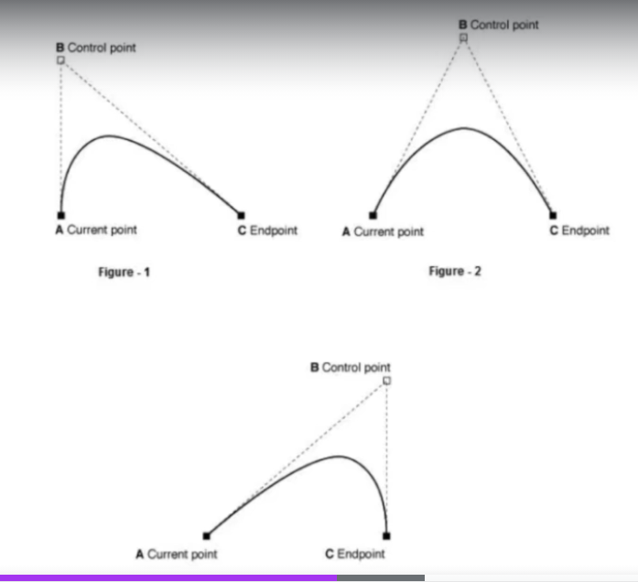

Drawing more complex curves



With this we get 2 control points

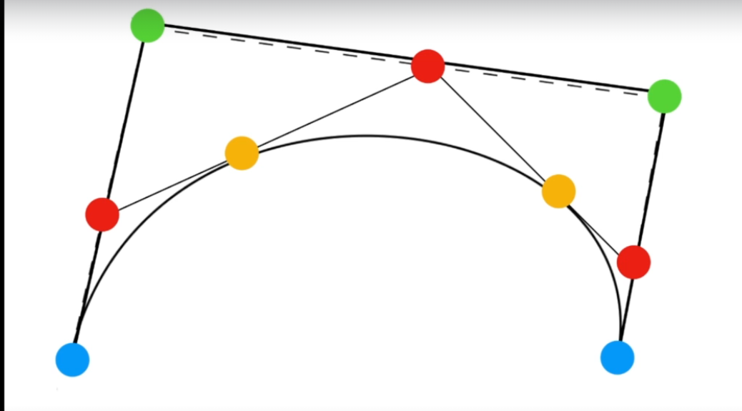

Blue – start and endpoints

Green – 2 control points

First lines are joined between these 4 points and then middle of these lines is set in Red.

Then lines created between Red points and their middle is set as yellow

Curve then defined with these yellow peak points

Some variations

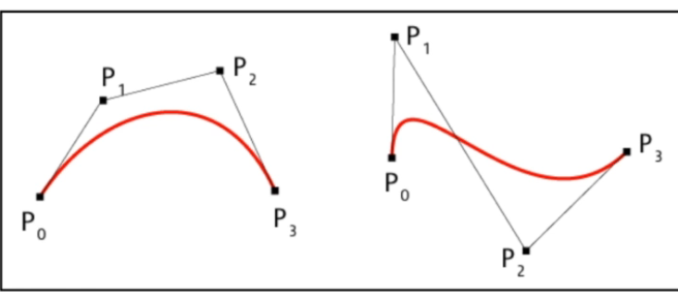

Example drawing heart with Bezier and quadratic curves

