**COMP 3059 – Capstone Project I**

**Software Requirements Analysis and Design Assignment**

This assignment is an overview to gather the software needs with requirements analysis and help to proceed with the design.

The requirements analysis helps to break down functional and non-functional requirements to a basic design view to provide a clear system development process framework. It involves various entities, including business, stakeholders and technology requirements.

The design is the activity following requirements specification and before programming. Software design usually involves problem solving and planning a software solution.

To work on this assignment you could use the references and a sample template given below. The sample template can be customised to suit the nature of your project.

Reference Readings/Example:

<http://www.uacg.bg/filebank/acadstaff/userfiles/publ_bg_397_SDP_activities_and_steps.pdf>

<http://gmitweb.gmit.ie/pdunne/sweng/03-Requirements.pdf>

[www.cse.msu.edu/~chengb/RE-491/Papers/SRSExample-webapp.doc](http://www.cse.msu.edu/~chengb/RE-491/Papers/SRSExample-webapp.doc)

<https://nces.ed.gov/pubs2005/tech_suite/part_2.asp>

Reference template:

[www.tricity.wsu.edu/~mckinnon/cpts322/cpts322-srs-v1.doc](http://www.tricity.wsu.edu/~mckinnon/cpts322/cpts322-srs-v1.doc)

# Introduction

This document describes our idea and values for the ShareShake Rental Web App. It defines the clients’ view of the web application to be developed, specified in terms of the clients’ key needs and features. Containing an outline of the envisioned core requirements, it provides the basis for the more detailed technical requirements.

## Purpose

The Purpose of this document is to provide project owners clear understanding on ShareShake rental web app, and help them make a decision on initiating and supporting the project activities to create this rental web app. In terms of developer’s perspective, it provides guidelines for app development. ​

## Scope

The project is a web application that allows users to rent and borrow products between each other. This lets consumers use products without having to pay the full price to purchase the product. The project will be completed by April 2018.

### In Scope

Our web application will allow users to view postings for items and create their own postings. The site will have accounts and logging in is required to lend or borrow items. Users are able to make payments for borrowing items through PayPal.

### Out of Scope

The web application will currently not have a search bar to search for posts. There will also be no way to sort items by distance, only by city. There will also not be any report buttons in the current release of the application.

# System Overview

## Project Perspective

It is a replacement for existing systems. It differs from existing e-commerce systems that it provides a rent specific platform for e-commerce. It provides alternative to the existing system.

## System Context

Currently, there is no rent-specific e-commerce platform that covers diverse range of products. Lot of resources wasted globally for production of products that are only needed for temporally. Buyers want to save money on that. Resulting software will provide a web platform where users will be able to post products that they want as well as search products they want to rent. The platform will provide means to make commercial transaction

## General Constraints

* Specified
* How people ship and return items are not supervised by the app
* Users understand and speak English
* Designed
* Only able to access via web browser
* Implemented
* Any financial transaction requires a PayPal account
* Tested
* Users need internet connection
* No two users can borrow same item simultaneously, and during the time item is rented, it is no longer available on the listing

## Assumptions and Dependencies

• Only legal items are listed and rented

• Items does not include food or other kind of consumables

• Only users that are capable of using courier service can interact for item rental

• A basic form of the web application will be required to create and use the database

• PayPal is required for the web application to function

## 3.0 Functional Requirements

This section describes specific features of the software project. If desired, some requirements may be specified in the use-case format and listed in the Use Cases Section.

### 3.1 Functional Requirements

* Customer Registration: New Users who are new to the website must register their account before they login
* After they login, Users can begin to view the posting of the products. User can also have the right to upload their product posting. Users must remember the posting must be relevant and appropriate
* When a user uploads a posting, the posting will be stored in a database where other users can search through keywords or view the posting.
* Users have the option to sell, buy, or rent a product by selecting a radio button or clicking a button
* Users can also have the right to comment or question about the posting (Forum or blogging feature will be included). Inappropriate comments or questions about the posting is unacceptable. If any user abuses the application, their account will automatically be aborted by admins in next 24 hours
* The admins monitor the daily web traffic and maintains the web application. Forgotten Username or password will be taken care of the admins. Users can send a request to admin to change a password or a request a password. The database is also controlled by admins. The password must be strong and should at least contain 8 characters but the max is 16 characters
* Moreover, users have the right to add update or delete multiple posting at the same time called the add update or delete key option in list item options before proceeding to the proceeding to checkout
* Users can update their account such as phone number, home address, email address so on
* When Renting Items, there are some rules & restrictions. When an item is rented, the item will be sent to that user’ s address and they have that item to be rented only about a month. The item must be returned on the day of the due date or before. If the item is due after the due, the cost of the rented item including a penalty per day will be added. Moreover, Users like rentiers must include the expiration date and the cost of the rented item. An email will be sent as a reminder to let users know who are returning rented items. Rentiers must be caution what they are lending to other Renters
* User Registration must be validated. Security & Privacy is a big deal and must be caution. These include bank card information, phone numbers, address, username & passwords must be hidden to other users.

## 3.2 Use Cases

## *C:\Users\100956581\Downloads\Rental Service.jpg*

**3.3 Data Modelling and Analysis**

* Normalized Data Model Diagram

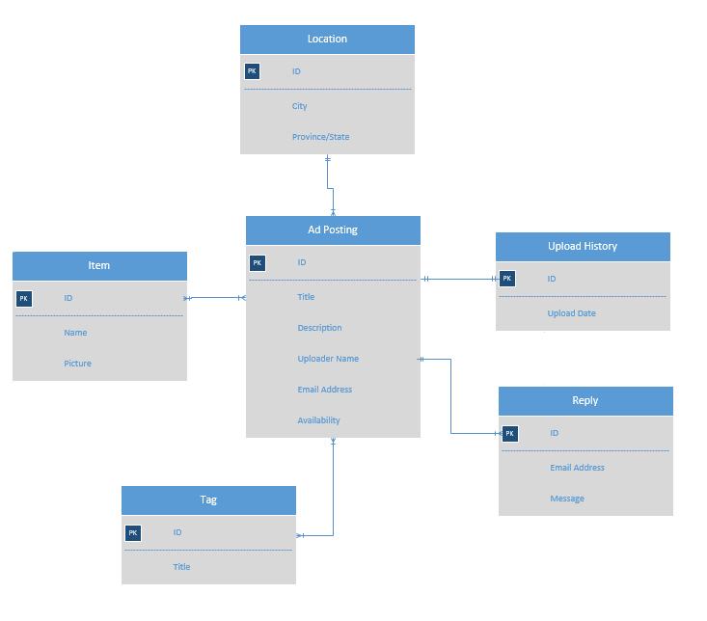

* Activity Diagrams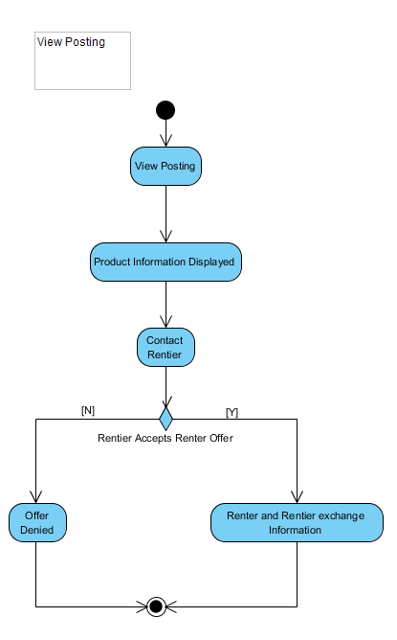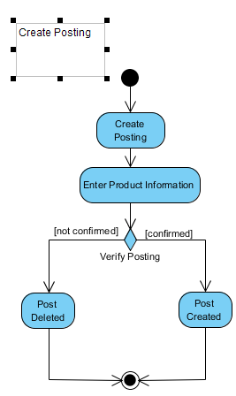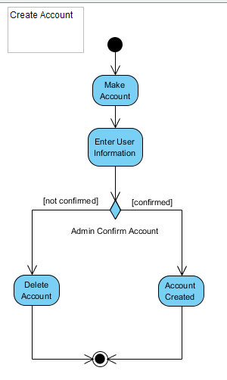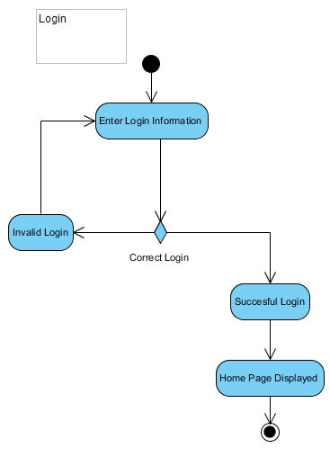
* Sequence Diagrams
  + Account Control Sequence Diagram   
    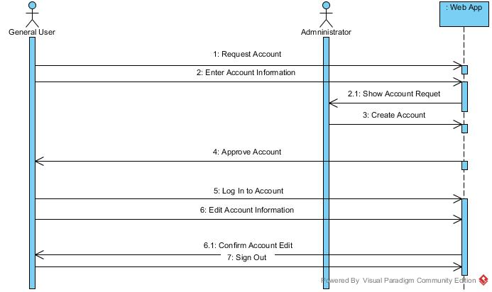
  + Inquiry Sequence Diagram

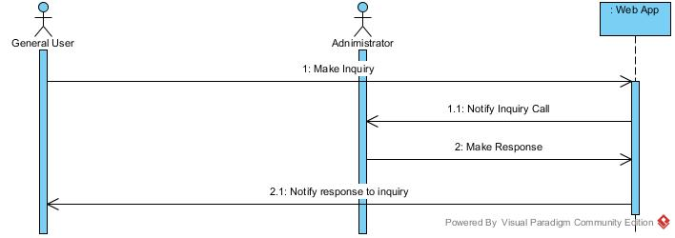

* + Post Products Sequence Diagram 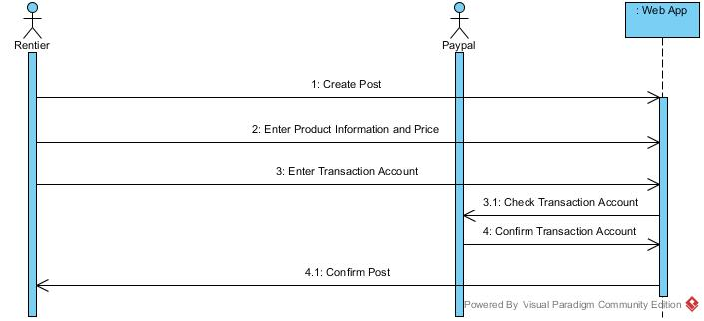
  + Transaction Sequence Diagram

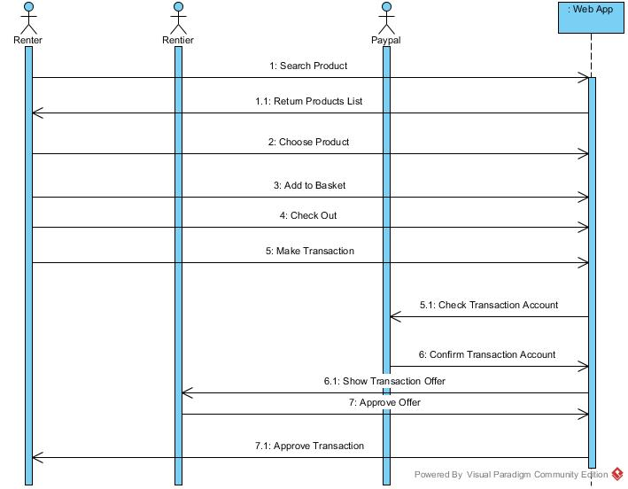

* UML Class Diagram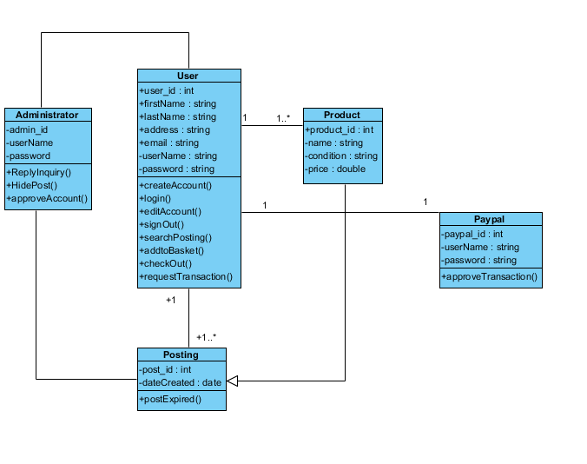

**3.4 Process Modelling**

* Data Flow Diagram

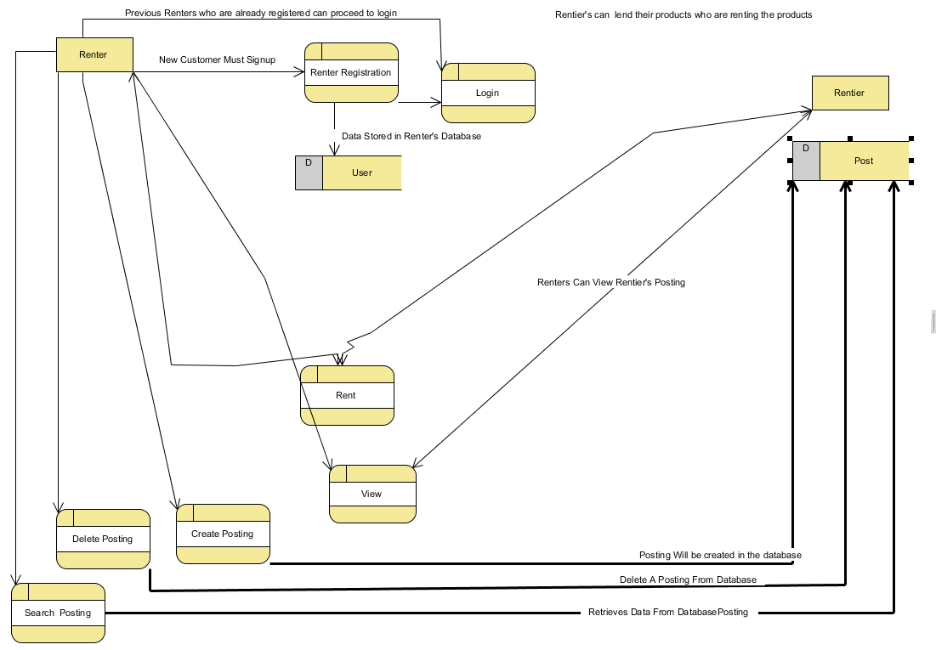

## 4.0 Non-Functional Requirements

**Reliability**:

User will be able to create account under 2 minutes

User will be able to create posting under 1 minute

Confirmation email to create account will be sent in less than 5 minutes

**Performance:**

Web application will never go down

Each web page will load up in no less than 5 seconds

**Availability:**

Administrator access will be available from 9-5 on weekdays

Database access will be always available

UI will simple enough for anyone to grasp

**Security:**

Users will be required to change their username and password every 6 months

Only admins will be able to delete postings or user accounts

Passwords will never be viewable

Once a user has unsuccessfully attempted to sign in 3 times, the system will time them out and they won’t be able to attempt to sign back in until 1 minute has passed. If the login attempt is still unsuccessful, the time out period will keep increasing exponentially.

User will get emailed when an attempt to sign in using their username has been done 5 or more times

**Capacity:**

User will be able to create a maximum of 50 postings

User can only make one account per email

**Legal Constraints:**

Users may only be able to rent and post products that can be legally moved from user to user

## 5.0 Logical Database Requirements

A database will be used to store every user’s login credentials and for every ad posting. There are several requirements for data formats. Each user’s username must be a properly formatted email and each password must have a certain character length. Each of those fields will be a required field. Each posting will have requirements on the data fields and will have several required fields.

To ensure data retention is properly met, only necessary data will be stored and in proper order. The most effective way to meet the requirement would be to create a policy with guidelines that describe which data will be archived and for how long it will be kept. This will reduce storage costs and help maintain storage capabilities as well.

To meet the logical requirements for data integrity, any information will be accessed from a single data source. This will assure the data remains accurate and consistent throughout the system.

## 

## 6.0 Other Requirements

A physical storage requirement is having a hard drive with enough available storage to store the database and other information.

**7.0 Approval**

|  |  |  |  |
| --- | --- | --- | --- |
| Project Role | Name | Signature | Date |
| Developer | Haitham Ahmed Khalil | Haitham.AhmedKhalil@georgebrown.ca | 8/12/2017 |
| Developer | Kyung Neung Lee | KyungNeung.Lee@georgebrown.ca | 8/12/2017 |
| Developer | Faheem Choudhury | Faheem.Choudhury@georgebrown.ca | 8/12/2017 |
| Developer | Karthik Shankar Prasad | Karthik.ShankarPrasad@georgebrown.ca | 8/12/2017 |