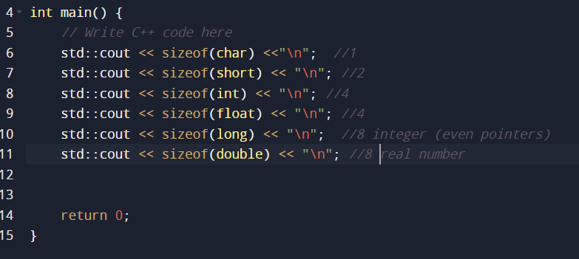

* Max int stored in n bits: 2^n -1 // -1 is due to 0
* 2^10 = 1024
* Pointer size = 8byte, block it points to is size of datatype (i.e.1 byte for char)
  + 8 byte char ptr can point to 2^64 byte
  + 2^64 = 2^4 \* 2^10(EB) \* 2^10(pB) \*2^10(TB) \* 2^10(GB) \* 2^10(M) \*2^10(K) byte = 16EB
* In virtual memory, part of array can move between RAM and disk