  - Statquest illustrated guide to machine learning
    - Chapter 1 : fundamental
      - ML : classification and regression (quantitative prediction)
      - Decision tree : classification
      - Linear regression :
      - Training and testing data
      - Bias and variance
      - Overfitting
    - Cross validation
      - Data leakage : if same data is used for training and testing (overfit)
      - Cross validation : iterate (3 group , each group gets to be the testing data once(iteration -fold) , and check the error)
      - Leave one out cross validation (small data set)
    - Statistics
      - Histogram: Divide in range (bin) and plot
      - Probability
      - Probability distribution : bell curve etc. ,
        - binomial distribution : explanation in book
        - 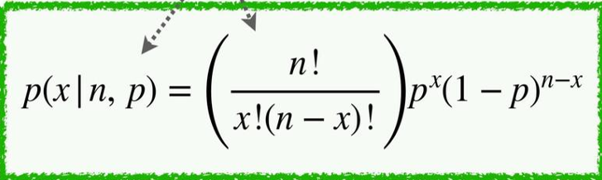
        - Poison distribution: equation in book
      - Continuous probability distribution
        - Normal distribution(gaussian): bell curve : mean + standard deviation
          - Probability is area under curve
        - Exponential distribution
        - Uniform distribution
      - Sum of squared residual : square is preferred over absolute value, as its easier to take derivative to calculate gradient descend
      - Mean squared residual
      - R^2: compare SSR, MSR around mean and prediction
      - 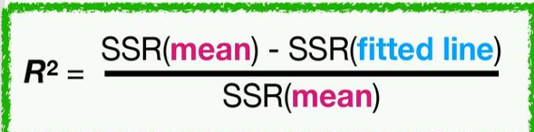

  - 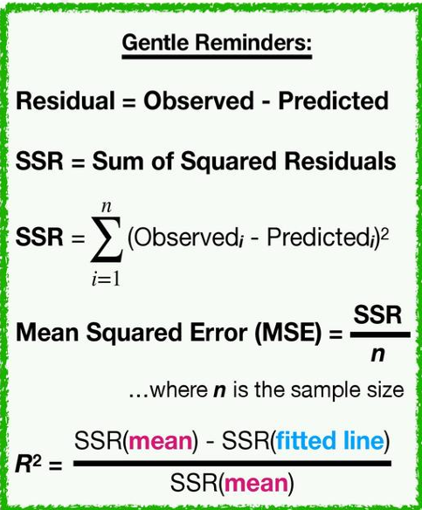
  - P value
  - Linear regression
    - Line , plane and beyond
  - Gradient descend
    - derivative of SSR (partial)
    - Helps in deciding step size: gradient descend * learning rate .
    - Putting derivative = 0, solves for local minima, but may not work for all so use step size
    - Stochastic gradient descend: calculate across just one random point (few points)
  - Logistic regression
    - Used for discrete classification
    - Likelihood vs probability
    - use likelihood in place of residual value (linear regression)
    - Log is used in place of multiplication to avoid underflow
    - Used for simple classification that fits in s shaped
  - Naïve bayes classification
    - Multinomial
    - Prior probability * p(word | spam / not spam)
    - 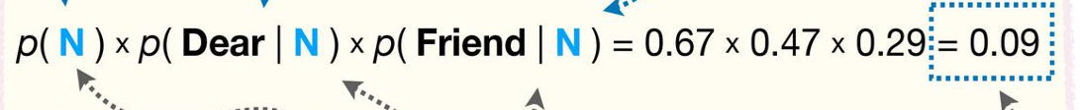

  - Missing data is a problem : fixed by pseudo count
  - Gausian naïve bayes = use likelyhood
  - It can be used with any distribution , including mix of cont and discrete
  - Assess model performance
    - Confusion matrix
    - Receiver operator curve
    - Sensitivity and specificity
    - 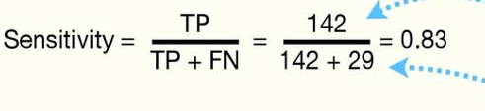

  - 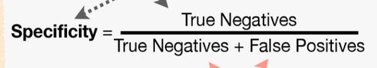

  - 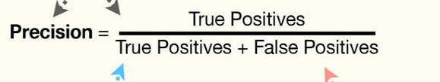
  - Recall = sensitivity
  - 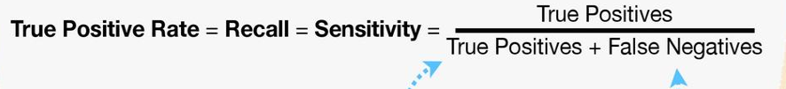

  - Precision recall graph
  - Regularization to avoid overfitting
    - Increase bias and decrease variance :
    - Ridge regularization : minimize SSR + lambda * slope ^ 2 : works well with multiple features
    - Lasso regularization : minimize SSR + lambda * |slope | : used to remove unrelated variable
  - Decision tree
    - Both classification
    - 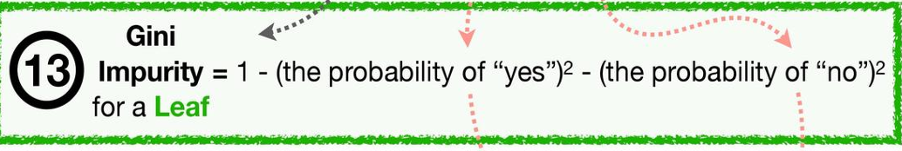

  - 
  - Regression tree : use SSR to determine node
  - SVMs
    - Taking square to project data to different dimension
    - Outliers
    - Support vector classifier : the threshold point
    - Kernel function to project data in higher dimension
    - 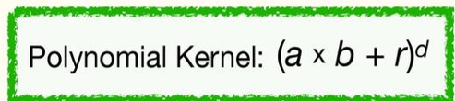
    - Radial kernel (infinite dimention)
  - Neural network
    - Activation function : Relu etc
    - Back propagation
    - Make squizle by combining various line , each node is a line

  - Appendix 1:
    - Some math

