Course: IT3883/Section W01
Student Name: Komi Sowu
Assignment Number: Lab 4
Due Date: 11/06/2026

Assignment 4: Python Network Communication

Objective:
Create two Python applications that communicate via a socket channel. Application A accepts user inputs, sends the string to Application B, gets its response, and prints it out. Application B accepts the string, converts it to uppercase letters, and returns it to Application A.
Implementation
Both programs are using the Python socket module with IPv4 (AF_INET) and TCP (SOCK_STREAM). The two programs are communicating with each other using localhost 127.0.0.1 and port 45566.
Program B (the server): Creates and binds a socket, listens for connections, accepts Program A, receives and decodes the message, transforms it with upper() function, returns the transformed message, and closes sockets.
Program A (the client): Connects with the server (Program B), asks the user for input, encodes and sends it to the server, receives and decodes the message, prints it, and closes sockets.
Testing and Results
From the given screenshots below, it can be seen that Program B begins with the phrase “Program B is waiting for connection.” Program A was initiated using the input “hello world!”. This program then showed “Response from Program B: HELLO WORLD!”.
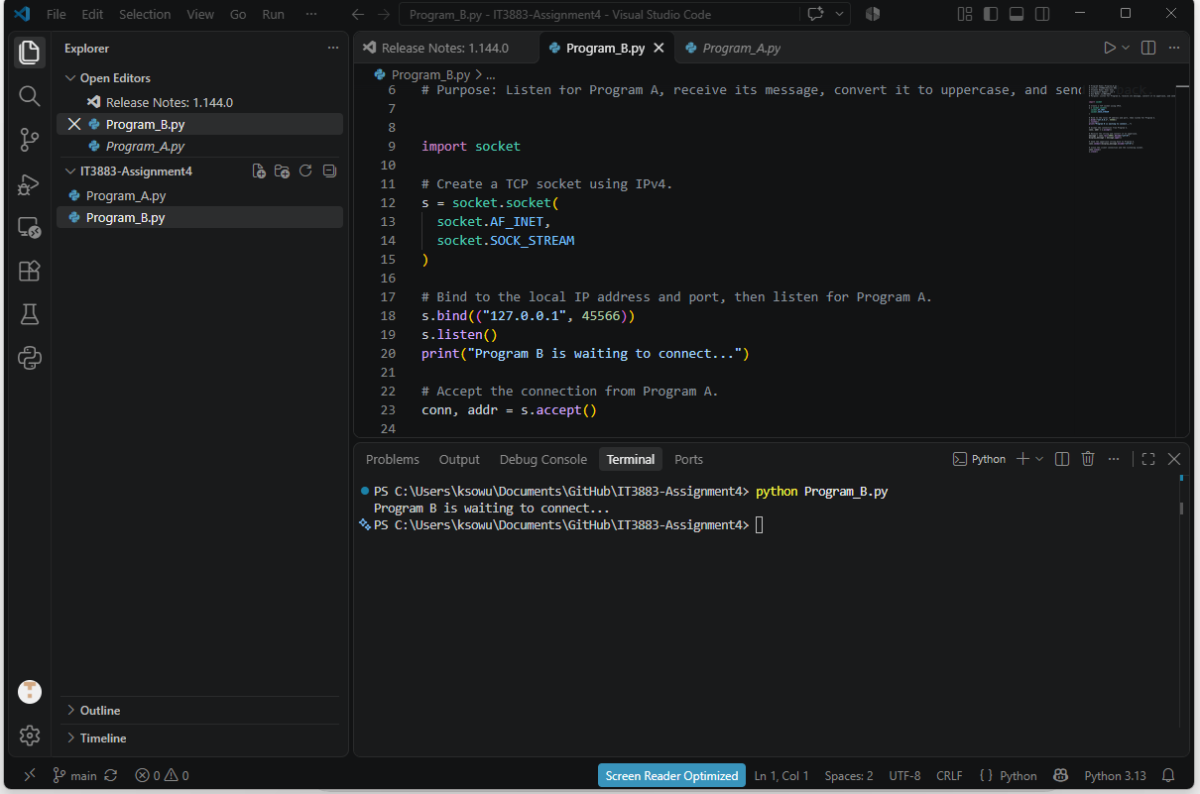
Figure 1. Program B server code and waiting message

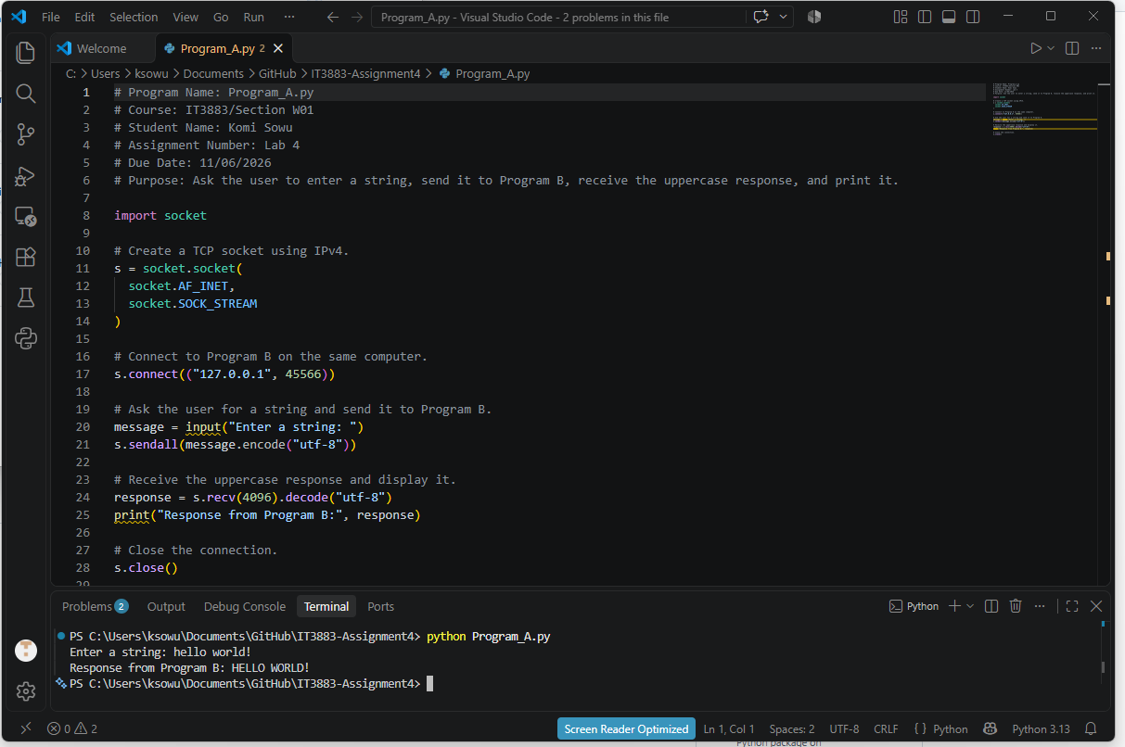
Figure 2. Program A client code, entered text, and uppercase response

