Predicting Edibility of Mushrooms Through Visual Traits

Kyle M. Spalding
Department of Data Science, Bellevue University
DSC680: Applied Data Science
Professor Xu Ashton
September 23, 2026

Business Problem
Walk outside on a trail, in a forest, or a campground, and you are bound to see many types of fungi all around you. While some may look different than others, there are some that will look the same. Without knowing what exactly you are picking up to potentially consume, you can be playing a game of chance. Misidentification of mushrooms can sometimes cause no harm, while other times you can have gastrointestinal issues, and even fatalities. Most of the field guides that you can buy at a bookstore are complex and sometimes hard to read and will sometimes require you to collect spores for later use under a microscope to see the size and color of the spore deposits. This project looks to help foragers greatly reduce any misidentification by gathering a list of visual features and then run those features through a model to classify whether they are poisonous, edible, or not certain. The analysis is therefore built around minimizing potentially dangerous errors, not maximizing the overall accuracy.
Research Questions
- Can this model accurately identify poisonous, and edible mushrooms accurately using only observable traits?
- Which observable traits are the strongest predictors of mushroom edibility?
- How much accuracy is lost if the model is kept to only the features a novice forager can easily identify?
- Will and how can the model be tuned to minimize false positives?
Background / History
Humans have foraged mushrooms for food and medicine for thousands of years with dental-calculus evidence from a cave in Spain called El Miron suggesting Paleolithic people (18,000 years ago) consuming mushrooms (Power et al., 2015). The issue has not been with humans not being able to locate mushrooms, but with humans being able to correctly identify foraged mushrooms between edible and poisonous. Between the years 1999 and 2016, the National Poison Data System (NPDS) advised that 133,700 people over the age of 18 years old were exposed to potentially toxic mushrooms, with 704 of those cases causing major harm, and 52 ending in fatalities. This suggests misidentification of edible mushrooms (Brandenburg & Ward, 2018).
Identification of mushrooms is especially difficult due to some of the toxic species resembling edible species. For instance, Gyromitra Esculenta (False Morel) resembles Morchella spp. (True Morel), and Amanita Bisporigera (Destroying Angel) resembles Agaricus Campestris (Meadow Mushrooms). Through the misdiagnosis of these mushrooms, gastrointestinal problems can occur, alongside even death. Most of the field guides that exist today expect one to collect the spore prints and then further examine them under a microscope. However, this is not a practical solution when a novice is foraging for mushrooms.
Data Explanation
The main dataset that is being used is UCI Secondary Mushroom Dataset (Wagner, Heider, & Hattab, 2021). It has 61,069 records of mushrooms that were taken from 173 different species. Unknown mushrooms in this dataset are preemptively grouped as poisonous. The data is first being prepared through evaluating missing values, in which there were four columns that had greater than 80% of missing values. These missing values were ‘stem-root’, ‘veil-type’, ‘veil-color’, and ‘spore-print-color’. I then began looking at columns that had more than 90% missing values and dropped those which included ‘spore-print-color’ as I want this to be a novice friendly model.
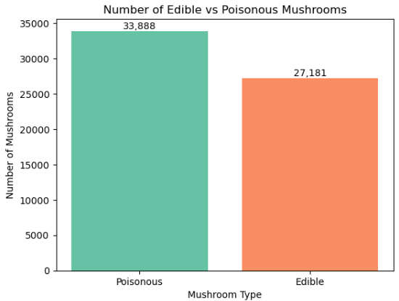
Figure 1 - Bar cart displaying the total number of poisonous and edible mushrooms
There were also some columns such as ‘cap-surface’, gill-attachment’, and ‘gill-spacing’ that had some missing data, so I filled those with ‘unknown’. This led me into looking at duplicate values in the dataset. There were 146 duplicate rows. I ended up leaving these untouched as I strongly feel these were valid and not errors. The last preparation step that was made was to encode categorical features using one-hot encoding. The target was ‘1 = poisonous’, and ‘0 = edible’.
Column | Type | Description
class | Target | Edible (e) or Poisonous (p)
cap-diameter | Numeric | Cap width in cm
stem-height | Numeric | Stem height in cm
stem-width | Numeric | Stem thickness in mm
cap-color | Categorical | Cap color code
gill-color | Categorical | Gill color code
habitat | Categorical | Where it grows (woods, grasses, etc.)
season | Categorical | Season observed
Table 1 - Brief Data Dictionary of key fields for my analysis. The complete UCI dataset includes 21 columns.
Methods
This is going to be a supervised classification model as the outcome will be either edible/poisonous/uncertain. The models that are being implemented are Logistic Regression to act as a baseline, Decision Tree for rules, and Random Forest for feature importance. For validation, a 75/25 training/test split was utilized. The models were then later judged based on recall, accuracy, and a confusion matric.
Analysis / Conclusion
The results of the three models show that the Random Forest model was a top performer at 100% for accuracy and recall. This, however, should not be solely used as the labels were determined by traits so can learn the pattern. However, by dropping some traits and leaving only cap, bruising, stem, ring, habitat, and season, the accuracy drops to ~98.8 and recalls to ~99.2. The Random Forest’s feature importance does show that stem-width, stem-height, and cap-diameter were the top performers of predicting edibility.
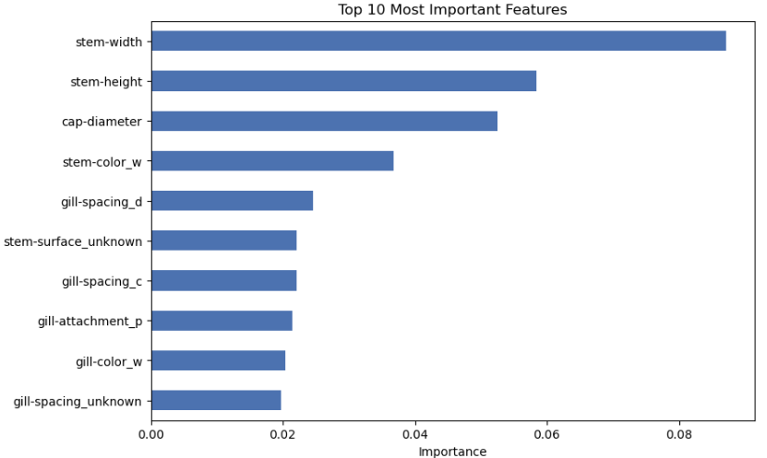
Figure 2 - Top 10 most important features from the Random Forest model.
Logistic regression was the model that came in second with accuracy at ~82.6 and recall at ~83.4. This is due to weights being added to each feature which is then added up and splits edible from poisonous mushrooms. The issue with this, however, is that the difference between edible and poisonous mushrooms are not always linear. For the final model, Decision tree scored ~82.4 accuracy and ~74 recall. This appears to have suffered from having a depth set too low (which was my choice) which placed too many various mushrooms in the same decision, hence why the recall was poor.
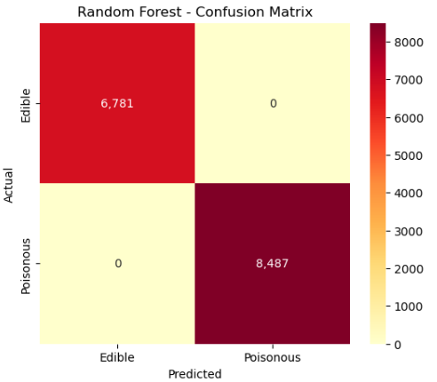
Figure 3 - Confusion matrix for the Random Forest model. This shows it predicted both poisonous and edible mushrooms correctly.
Looking back on whether this model(s) can accurately identify poisonous, and edible mushrooms accurately using only observable traits. The answer to this is yes. Observable traits can and are a strong predictor of the mushrooms poisonous/edibility. Taking the Random Forest model into account, was able to hit ~99 accuracy.
Assumptions
There are two assumptions that I have:
- Values about mushroom traits will be entered correctly.
- The duplicate values are all valid traits.
Limitations
Regardless of how well the model is programmed, if a forager/user does not correctly identify a trait, this will give a wrong prediction. Another limitation that this project faces is that users/foragers are not being asked to submit a picture to compare against the mushroom they are seeing.
Challenges
One of the challenges faced with this project is related to the data naming scheme. The dataset ended up using single letter codes for various fields. This means that a legend had to be built so a user can input its traits without too much issue. Another challenge faced is the storytelling aspect. Since classifying mushrooms into edible or poisonous has been done quite a bit, I needed to make certain that readers are aware that the predictions they are getting from this model are coming from visual traits, not based upon the mushroom species.
Future Uses
A future use that I would like to see for this project is the implementation of this onto an ESP32 or similar microprocessor with a built-in camera function. Not only would it be field compatible since it is so small, but by visually being able to capture the image of the mushroom and compare it to various other mushrooms based on traits could be a game changer. This would be especially useful to those that are visually impaired.
Recommendations
By using this model, one should err on the side of caution still and only harvest and eat a mushroom after a mycology expert has looked at the mushroom harvested. If a mushroom pops as poisonous and/or uncertain, you should not harvest or eat the mushroom as gastrointestinal issues or even death can occur.
Implementation Plan
There are multiple ways that this model can be implemented. One such way which I plan on doing is to implement this on an ESP32 board. This will then be able to allow foragers to take this model with them when they go out in the field. To do such, the trained model will need to be saved and then work with an API which can then be turned into an application for easy viewing.
Ethical Assessment
Ethical Concern:
- One of the biggest ethical concerns is that people are going to misuse this tool by still eating a mushroom that is not classified correctly.
- Inputting the incorrect traits that one believes are true could throw off the prediction quite heavily.
- Automation bias is another concern. A worry is that a forager will utilize this advice over a expert forager.
Likelihood & Impact:
- The likelihood of this is going to be the highest with the impact potentially being gastrointestinal issues or even potential death.
- The likelihood of this occurring is going to be medium to high. The impact is going to be like the first ethical concern, potential death or gastrointestinal issues.
- The likelihood of this happening is low to medium. The impact, however, is great with users potentially misidentifying a mushroom.
Mitigation:
- To mitigate this, the model will never tell a user to either eat or not to eat the mushroom and will state to reach out to an expert in the field before any consumption.
- To mitigate this, validation needs to be performed on real mushrooms specimens before using this.
- To mitigate this, warnings will need to be displayed multiple times to the user after identification.

References
Brandenburg, W. E., & Ward, K. J. (2018). Mushroom poisoning epidemiology in the United States. Mycologia, 110(4), 637–641. https://doi.org/10.1080/00275514.2018.1479561
Max Planck Institute for Evolutionary Anthropology. (2015, April 16). Oldest evidence for the use of mushrooms as a food source. https://www.mpg.de/
Wagner, D., Heider, D., & Hattab, G. (2021). Secondary mushroom dataset [Data set]. UCI Machine Learning Repository. https://archive.ics.uci.edu/dataset/848/secondary+mushroom+dataset

