Computer Graphics with OpenGL

Lecture Notes – Input Devices

By,
K S PAVAN KRISHNA
1MS17IS051

Input Devices
Data Glove
A data glove is an interactive device, resembling a glove worn on the hand, which facilitates tactile sensing and fine-motion control in robotics and virtual reality. Data gloves are one of several types of electromechanical devices used in haptics applications.
Tactile sensing involves simulation of the sense of human touch and includes the ability to perceive pressure, linear force, torque, temperature, and surface texture. Fine-motion control involves the use of sensors to detect the movements of the user's hand and fingers, and the translation of these motions into signals that can be used by a virtual hand (for example, in gaming ) or a robotic hand (for example, in remote-control surgery).
The glove has been hand carved and modeled from wax, working directly on the performer's hand to create a custom fit. It is fully jointed for comfortable, natural movement, and includes cutting and digging tools at the ends of the fingertips. The joints will allow for the transfer of input signals via a series of flex sensors that will produce varied electrical signals to drive other suit elements. The wax original has been dismantled, molded with silicon and duplicated using wax injection. The individual parts are now being cast in titanium. The resulting units will eventually be jointed with fiber composites. The final product will have an organic appearance, mechanical movement and functional input.
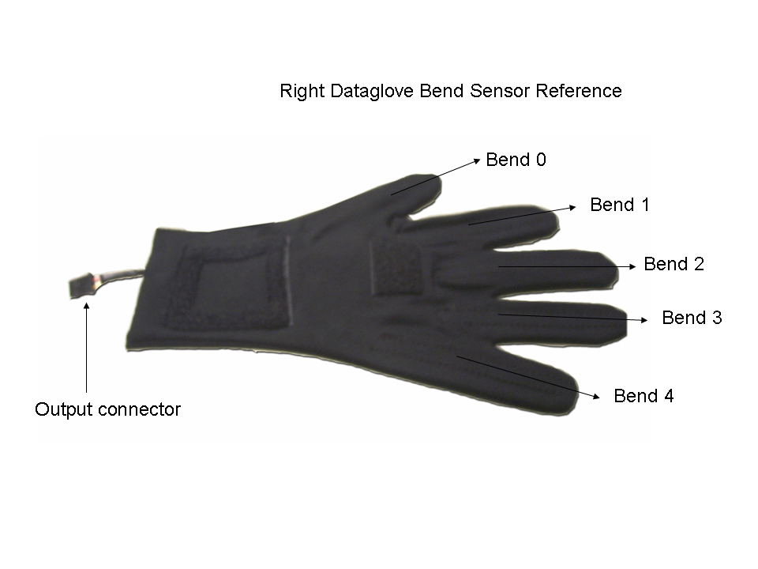

Digitizers

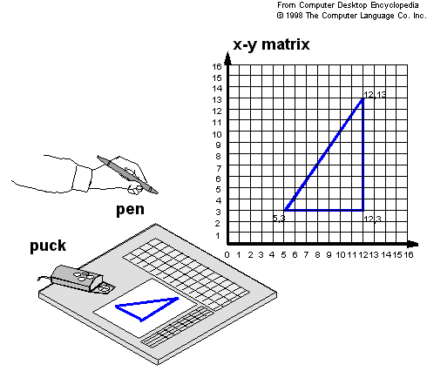
A common device for drawing, partitioning or interactively selecting co-ordinates positions on an object is digitizer. These devices can be used to input co-ordinate values in either a 2D or 3D space. One type of digitizer is the graphics tablet which is used to input 2D co-ordinates by activating a hand cursor at selected positions on a flat surface. A hand cursor contains cross hairs for sighting positions, while a stylus is a pencil shaped device that is pointed at positions on the tablet.
Many graphics tablets are constructed with a rectangular grid of wires embedded in the tablet surface. Electromagnetic pulses are generated in sequence along the wires, and an electric signal is induced in a wire coil in an activated stylus or hand cursor to record a tablet position.
Acoustic (or Sonic) tablets use sound waves to detect the stylus position. 3D digitizers use sonic or electromagnetic transmissions to record positions.

JOYSTICK
1) A joystick is an input device consisting of a stick that pivots on a base and reports its angle or direction to the device it is controlling.
2) Joysticks, also known as 'control columns'.
3) A joystick consists of a small, vertical lever (called the stick) mounted on a base that is used to steer the screen cursor around.
4) Most joysticks select screen positions with actual stick movement; others respond to pressure on the stick.
5) The distance that the stick is moved in any direction from its center position corresponds to screen-cursor movement in that direction.

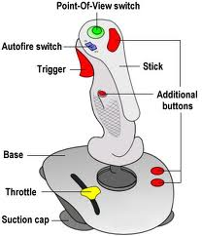

6) Potentiometers mounted at the base of the joystick measure the amount of the movement, and springs return the stick to the centre position when it is released. One or more buttons can be programmed to act as input switches.
7) One or more buttons can be programmed to act as input switches to signal certain actions once a screen position has been detected.
8) Joysticks are often used to control video games, and usually have one or more push-buttons whose state can also be read by the computer.
9) Joysticks are also used for controlling machines such as cranes, trucks, underwater unmanned vehicles, wheelchairs, surveillance cameras and zero turning radius lawn mowers.
10) Miniature finger-operated joysticks have been adopted as input devices for smaller electronic equipment such as mobile phones.

Mouse
A mouse typically controls the motion of a pointer in two dimensions in a graphical user interface (GUI). Clicking or hovering (stopping movement while the cursor is within the bounds of an area) can select files, programs or actions from a list of names, or (in graphical interfaces) through small images called "icons" and other elements. Wheels or rollers on the bottom of the mouse can be used to record the amount and direction of movement. Another method for detecting mouse motion is with an optical sensor. For these systems, the mouse is moved over a special mouse pad that has a grid of horizontal and vertical lines. The optical sensor detects movement across the lines in the grid. Since a mouse can be picked up and put down at another position without change in cursor movement, it is used for making relative changes in the position of the screen cursor. One, two, or three buttons are usually included on the top of the mouse for signaling the execution of some operation, such as recording cursor position or invoking a function.

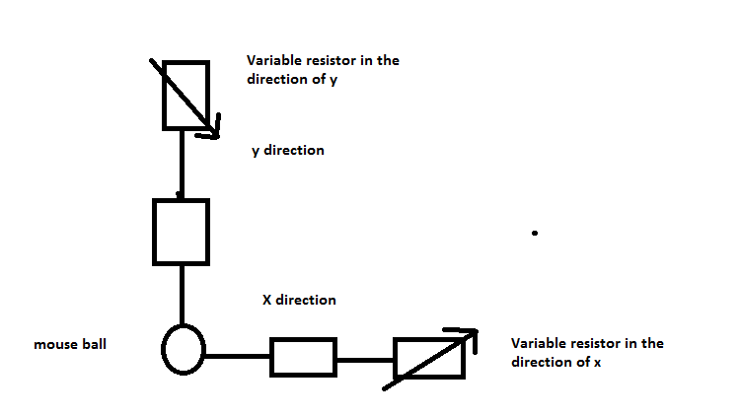

From ohm’s law, we know that V=IR, where V is the voltage, I is the current and R is the resistance.
The mouse ball is simply assumed to be connected to two variable resistors, one in the direction of the x axis and one in the direction of the y axis.
Chance the resistance will automatically change the voltage across the respective axes and hence the position of the mouse pointer on the screen also changes. Any position on the computer screen can be obtained by using this concept.
Trackball
A trackball is a pointing device consisting of a ball held by a socket containing sensors to detect a rotation of the ball about two axes—like an upside-down mouse with an exposed protruding ball. The user rolls the ball with the thumb, fingers, or the palm of the hand to move a pointer. Compared with a mouse, a trackball has no limits on effective travel; at times, a mouse can reach an edge of its working area while the operator still wishes to move the screen pointer farther. With a trackball, the operator just continues rolling.
As the name implies, a trackball is a ball that can be rotated with the finger or palm of the hand, to produce screen-cursor movement. Potentiometers attached to the ball, measure the amount and direction of rotation. Track balls are often mounted on keyboards.
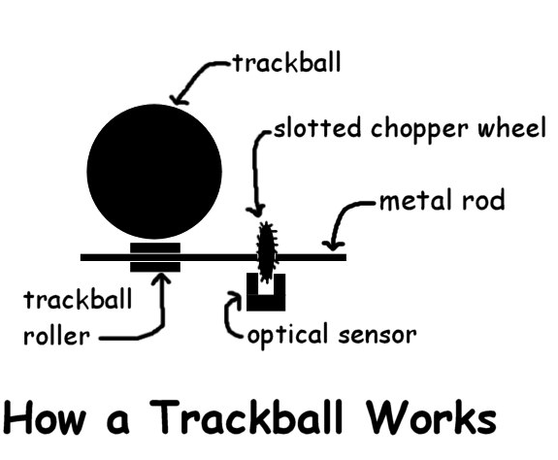
How a trackball works - Basically the trackball rolls against a trackball roller which then turns a slotted chopper wheel which is scanned by an optical sensor which converts your movement into digital information which is then sent to your computer via a USB connection.

Light Pen
A light pen is a computer input device in the form of a light-sensitive wand used in conjunction with a computer's CRT display. It allows the user to point to displayed objects or draw on the screen in a similar way to a touch screen but with greater positional accuracy. It was long thought that a light pen can work with any CRT-based display, but not with LCDs. A light pen works by sensing the sudden small change in brightness of a point on the screen when the electron gun refreshes that spot. By nothing exactly where the scanning has reached at that moment, the X and Y position of the pen can be resolved. This is usually achieved by the light pen causing an interrupt at which point the scan position can be read from a special register, or computed from a counter or timer. The pen position is updated on every refresh of the screen.
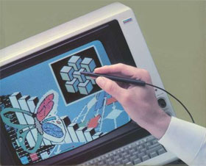
Light pen is a hand held input device which looks similar to a small pen or wand.
It is connected to a computer monitor and allows the user to both point to objects and to draw on the screen.
It works because the monitor contains a light sensitive detector which picks up light emitted from the pen and calculates its position on the screen.

Touch Screen
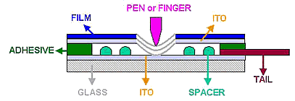
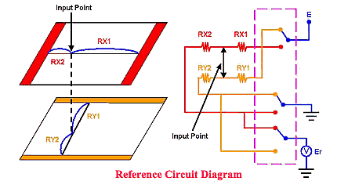
A touch screen is a display which can detect the presence and location of a touch within the display area. The term generally refers to touch or contact to the display of the device by a finger or hand. Touch screens can also sense other passive objects, such as a stylus. However, if the object sensed is active, as with a light pen, the term touch screen is generally not applicable. The ability to interact directly with a display typically indicates the presence of a touch screen.
The touch screen has two main attributes. First, it enables one to interact with what is displayed directly on the screen, where it is displayed, rather than indirectly with a mouse or touchpad. Secondly, it lets one do so without requiring any intermediate device, again, such as a stylus that needs to be held in the hand. Such displays can be attached to computers or, as terminals, to networks. They also play a prominent role in the design of digital appliances such as the personal digital assistant (PDA), satellite navigation devices, mobile phones, and video games.

