TS Contract UI
Functional Specification
Table of contents
1 Introduction 3
2 Scope 3
3 Functional Capabilities 3
3.1 General 3
3.2 XForms 3
3.3 Functionality levels: users and privileges 3
3.4 Navigating in the repository 3
3.4.1 Repository folder structure 3
3.5 Reader group functionality 3
3.5.1 Viewing contract header 3
3.5.2 Viewing contract attachment file content 3
3.5.3 Exporting the contract attachments 3
3.5.4 Searching for contracts 3
3.6 Administrator group functionality 3
3.6.1 Modifying contract document header 3
3.6.2 Modifying contract attachment 3
3.6.3 Deleting contracts 3
4 Data Structures 3
4.1 Documentum Repository internal object model 3
4.2 Contract as a virtual document in the Documentum repository 3
4.3 Contract attributes 3
4.4 XML content 3
4.4.1 XML Schema 3
4.4.2 XML application 3
5 Access Control and Security 3
5.1 ACL Requirements 3
6 Appendices 3
6.1 Appendix 1: Excel to XML conversion and XML Import description 3
6.2 Appendix 2: BCS - Business Classification Schema 3
6.3 Appendix 3: TSF Blueprint document 3
6.4 Appendix 4: ts_purchase_contract sample XML content 3
6.5 Appendix 5: ts_purchase_contract XML-schema 3
6.6 Appendix 6: ts_purchase_contract XML application 3
6.7 Appendix 7: Contracts and Orders Customisations 3
7 Change history 3

Contracts and Orders User Interface Functional Specification

Introduction
The data from TeliaSonera Sweden’s old purchasing system “Pankration” will be migrated into the Documentum repository. After that it will become accessible through the Contracts and Orders User Interface (Contract UI). Contracts and Orders repository will be holding TeliaSonera’s old contracts with their clients and orders with their suppliers.
This document specifies the functionality of Contract UI regarding to the “Pankration” data.

Scope
This document describes only the functionality of the target Documentum system - Contract UI. The technical details of the migration process can be found from a separate specification document [Appendix 1]. The list of customisations made to the documentum system during this project can be found from separate Contracts and Orders Customisations document [Appendix 7].

Functional Capabilities

General
Contract UI is a customised version of Documentum Webtop 6.7 sp2. The contract data is represented with Documentum’s virtual document technique. Each contract has a contract header (set of attributes defining the contract) and zero or more attachments containing contract related documents. These objects together form a single virtual document portraying the particular contract.
Interface language is English. The “description” attribute’s values in the old Pankration documents’ metadata are in Swedish, all other metadata in English.

XForms
XForms is a way for creating more complex and interactive forms for web pages instead of the regular HTML forms. Forms are created based on xml templates created beforehand. Also the data and possible initialisation data are stored in XML format.
In Contract UI the XForms engine has been customised into the Virtual Document Manager and properties view of the ts_purchase_contract object type. Following templates are used and they can be customised with Documentum Forms Builder:
- ts_purchase_contract template – for ts_purchase_contract properties
- ts_purchase_contract_positions template – for ts_purchase_contract VDM
Documentum Composer doesn’t support editing forms, so all the forms will be created with Forms Builder in QA and then transferred to the Production repository with Documentum Composer. This isn’t the optimal solution, but it has to suffice until better options can be found.
Further information about XForms in Documentum can be found from Forms Builder development guide.

Functionality levels: users and privileges
The Contract UI has two different user groups: readers (consumers in Documentum terminology) and administrators. The groups have their own functionalities based on the configured ACL and presets. See chapter 5 for details.

Navigating in the repository

Repository folder structure
The contract data is stored in two folders of the repository – “Purchase Order” folder and “Supplier Agreement” folder, according to two types of documents.
Business Division Name 1
Purchase Order
Supplier Agreement
Contract 1
Contract 2
A
B
C
Alphabetical range
Contract party (begins with A)
Contract 1
Contract 2
Business Division Name 2
…
Figure 1: Folder structure

Reader group functionality
These functionalities are available for all users that have access to Contract UI, but they are specifically the functionalities that Reader group users will use.

Viewing contract header
Contract header information can be viewed by browsing to the relevant contract and selecting View action for it. Virtual document display for object type ts_purchase_contract has been customised to show the contract attributes divided among 5 categories. These main categories are ‘Contract/Order’, ‘TeliaSonera’, ‘Opposing Party’, ‘Positions’ and ‘Additional Information’. See chapter 4.3 for details about contract attributes.

Viewing contract attachment file content
Attachments are created as the children of the contract virtual document. Users can browse them either through the default Documentum Webtop functionalities or by using the list of attachments on the bottom of the main virtual document manager view.

Exporting the contract attachments
When an attachment file is exported, a copy of it is created at a location outside of the repository.
To export an attachment file a user has to select the file from the virtual document view. Multiple files can be selected at the same time. Right-clicking the attachment file offers an Export option.
In case of multiple attachments’ export, the user is prompted to specify export options, such as which files to export and to which location(s).
In addition to right-clicking the export function can be performed with the keyboard shortcut option: Shift + E or with the menu action File > Export.

Searching for contracts

Search criteria
Both quick word search and advanced search options are provided. To make the search more efficient a user can first select whether he/she is searching for Order or Contract. After selecting the document type properties list will be populated with appropriate search properties. If you decide to change the searchable type later, the properties list will be automatically repopulated.
The user can search the repository using all TS Metadata attributes described in BCS document as search parameters [Appendix 2]. For many attributes drop-down value lists are provided.
Search option is not provided for the attachment documents. It is not possible to search directly the attachment document. Instead, user has to search for contract and then related attachment documents will be shown as part of the contract virtual document.

Search result display
The default result display shows the following fields from the Contract attribute list in chapter 4.3:
ID, Name, Opposing Party, Type, Segment, Status and Contributor.

Saving search
Search can be saved, both its settings and results. By pressing the “save” icon in the search result view (see above 3.7.2) a user gets an opportunity to give a name to a particular search and to describe it. Saved searches are then stored in the “Searches” cabinet and can be reused – both the results of the search and filled in parameters.

Administrator group functionality
These functionalities are available only if user has logged in as a member of Administrator group.

Modifying contract document header
Administrator users can modify the contract information through the virtual document ‘Properties’ display. User browses to the relevant document and selects ‘Properties’ from the context menu. All default ways for accessing properties page in Documentum Webtop will also work.
Properties page is an embedded XForms object that has been scoped to be shown for ts_purchase_contract documents. Administrator user can modify the attributes described in chapter 4.3 and the data will be saved to both database and the XML content file. See chapter 4.4 for further details about the contract and its XML content file.

Modifying contract attachment
When attachment is selected in the attachment list of the virtual document, it can be edited with File > Edit function. Modified document is then saved and checked in (from File menu), the default version being minor. The versions then can be checked from View > Versions.

Deleting contracts
Virtual documents representing contracts can be deleted in the contract name list view. When contract name is selected, a user can either right click it and select Delete, or employ File menu and from there Delete.

Data Structures
Target repository will be hosted in TeliaSonera core platform so it will follow the core system guidelines outlined in TSF Blueprint [Appendix 3].
All contract related attributes/metadata will be stored as part of the one master Documentum object. Individual object will be created for each of the attachment files. Master object and attachment object are related by association relation, and whenever user opens the master object, all related attachments become visible as well.

Documentum Repository internal object model
The TS specific object model is shown on the Figure 3. In Contract UI the contract documents are type ts_purchase_contract and have attachments that are of type ts_purch_attach.

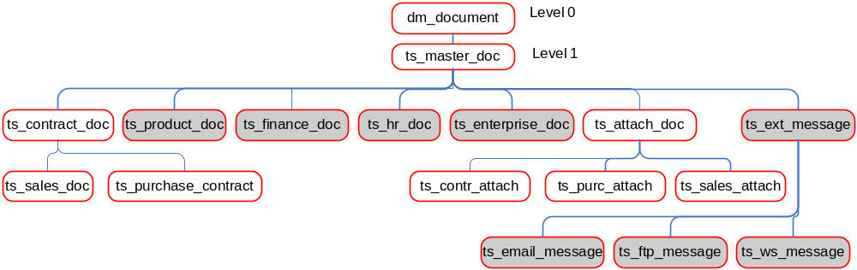
Figure 2: TeliaSonera object model

Contract as a virtual document in the Documentum repository
One virtual document along with its child documents will represent a particular contract. Virtual document will contain the contract specific metadata. If it is possible to identify the master document inside the contract it will be part of virtual document content otherwise virtual document as such will not have any content. Different versions of the contract are turned into virtual documents as shown on Figure 4.

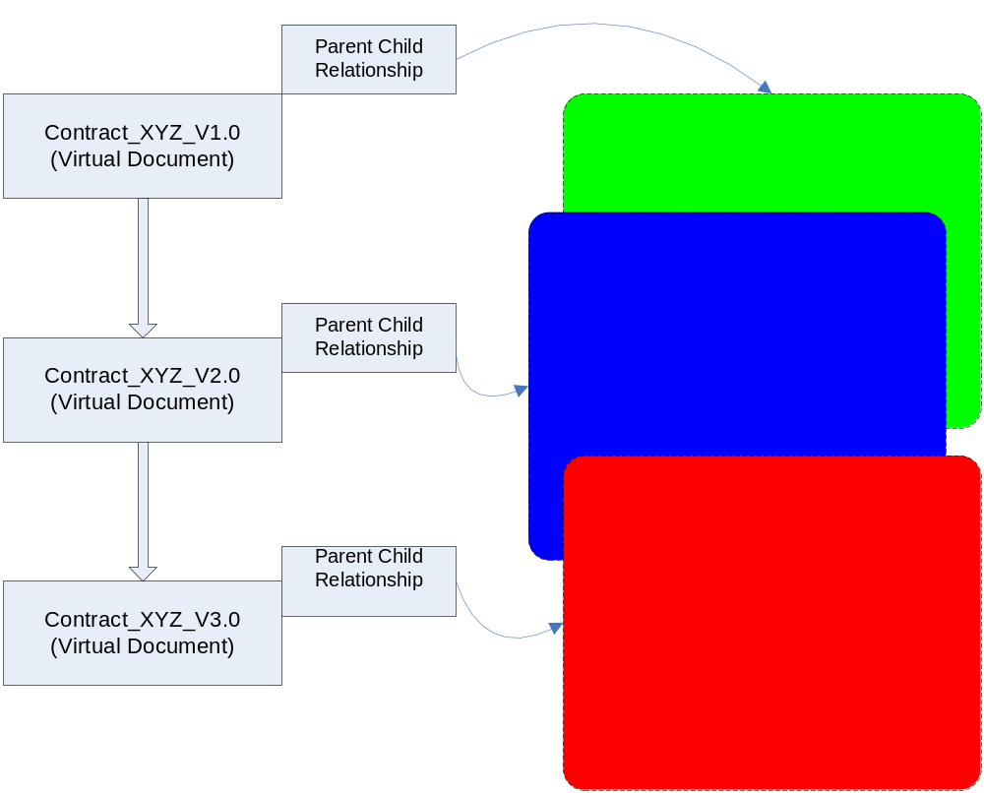
Figure 3: Making virtual documents out of contracts

Contract attributes
Contract includes several different types of attribute fields that can be either viewed or edited if the user is administrator.
The main input control types for UI are described in the table below. Please note, that in positions category all attributes are repeating ones, but the UI presentation is customised. You can find the most up to date information from the latest BCS [Appendix 2]
Input control types
Name | Description
Input field | For short text values
Text area | Multi row input field with a scrollbar for longer texts
Drop down | Drop down field for attributes with a set of possible values. Values may be mapped for more user friendly display values.
Date | Input field for date. Date format is yyyy-MM-dd.
Date time | Input field and several drop-down fields forming a control for inputting both date and time. Date format is yyyy-MM-dd and time is chosen with separate drop down menus for hours, minutes and seconds each.
Repeating | Radio button, input field of some type, insert button and delete button forming a control for inputting several values for one attribute. Insert button adds a new row that consists of a radio button and input field. Delete button deletes the row that has been selected with the radio buttons.

Category 1: Contract/Order
Label | Attribute name | Description | Field type | Field length | Value mapping
TS identifier | ts_identifier | Unique ID of the object. Same for all versions of the object  An unambiguous, unique key (document ID) which is unchangeable for the whole life cycle of the document. This ID will be created automatically for all documents created in repository | Text input | 50 | False
Name | object_name | The name of the document | Text input | 255 | False
Contract Status | contr_contract_status | Describes in what state the contract is. | Drop down |  | True
Valid from | ts_valid_from | The first date when the contract is valid | Date time |  | False
Valid to | ts_valid_to | The last date when the contract is valid | Date time |  | False
Contract/Order type | contr_contract_order_type | Contract type:  Framework agreements  Agreement  Order  Master order | Drop down |  | True
Segment | contr_segment2 | To which business segment the contract belongs to. More detailed than contr_segment1. | Drop down |  | True
Creator | ts_creator | Creator of the document | Text input | 32 | False
Creation Date | ts_creation_date | Creation date of the document | Date time |  | False

Category 2: TeliaSonera
Label | Attribute name | Description | Field type | Field length | Value mapping
Coverage | ts_coverage | Organization to which the document applies: for example the TeliaSonera Group, TeliaSonera Sweden | Drop down |  | True
Authors | Authors | People who are responsible for the contract or parts of it | Repeating | 48 | False
Purchasing attestation | purc_purc_attest | Person who has approved the contract | Text input | 30 | False
Purchasing attestation date | purc_purc_attest_date | Date of the approval | Date time |  | False
TS signer | contr_ts_signer_r | People who have signed the document from TS side. | repeating | 128 | False
TS signing date | contr_sign_date | Signing date for each of the TS signers. | Date time |  | False
Related | ts_relation | A reference to a related resource  “Linked to” Relation shows to which larger entity documents or publications are linked. | Text input | 128 | False
CA/CC | purc_ca_cc | Cost centre | Text input | 20 | False
Project number/WBS | purc_proj_number | Project number or WBS | Text input | 32 | False

Category 3: Opposing party
Label | Attribute name | Description | Field type | Field length | Value mapping
Opposing party name | contr_external_part_r | Opposing party of contract (E.g., Customer name or Vendor name) | Repeating | 255 | False
Opposing party’s identity number | contr_ext_identity_r | Identification number of the Opposing party. | Repeating | 20 | False
Opposing party’s signer | contr_ext_signer_r | People who have signed the document from the opposing party’s side. | Repeating | 128 | False

Category 4: Positions (multiple position rows can be inserted)
Label | Attribute name | Description | Field type | Field length | Value mapping
Name (position level) | purc_pos_name_r | Profile name | Text input | 250 | False
Description | purc_pos_desc_r | Profile description | Text area | 3000 | False
Purchase pos delivery date | purc_pos_delivery_date_r | Purchase delivery date for the profile | Date |  | False
Currency | purc_pos_currency_r | Currency for the profile | Drop down |  | False
Amount | purc_pos_amount_r | Amount for the profile | Text input | Int | False
Price | purc_pos_price_r | Price for the profile | Text input | Int | False
Price model | purc_pos_pris_model_r | Price model for the profile | Drop down |  | True
Scope (%) | purc_pos_scope_r | Scope for the profile | Text input | Int | False
Unit | purc_pos_unit_r | Unit for the profile | Text input | 6 | False

Category 5: Additional information
Label | Attribute name | Description | Field type | Field length | Value mapping
Description | ts_description | A summary of the content of the resource. | Text area | 2000 | False
Comments, will be sent to the vendor | purc_comments_ext | Free comments about the document that will be sent to the vendor. | Text area | 3000 | False
Comments (internal) | purc_comments_int | Free comments about the document that will be available for internal users. | Text area | 550 | False

XML content
The actual content of the contract document is XML file that is mapped to the document properties with two-way xml application. With this method the contract xml content stays always synchronized with its properties in database and the data can be easily transferred to other systems as an XML file if needed.
XML content follows the XML schema designed for that particular object type. In Contract UI the only type used is ts_purchase_contract. Sample content file is attached to the end of this document [Appendix 4]

XML Schema
The XML Schema for ts_purchase_contract describes the allowed structure for the actual XML content. Schema basically lists allowed elements with a separate structure for contract position data table and contract attachments. [Appendix 5]

XML application
The XML application for ts_purchase_contract document type maps the xml content to the document properties in database and vice versa. The most up to date version can be found from the CVS address ‘:pserver:user_name@tmcvs.tietoenator.com:/home/cvsvendord6/pankration_conv/‘. Current version at the time of writing this document can be found from Appendices. [Appendix 6]

Access Control and Security

There are two different user groups in the Contract UI system
- Reader (ts_read_group) – reading contracts
- Administrator (admingroup) – modifying, creating and deleting contracts

Reader: User can view the contract header, view the attachments and export attachments. Most other basic Documentum functionalities have been hidden from the reader group by a separate contract_preset and saved_search_preset that are attached to ts_contract_read role. In addition to this ts_contract_read role the reader group should have form_user role to allow accessing embedded XForms element in virtual document manager (contract header).
Administrator: User will have the regular Documentum Webtop administration functionalities available. Administrators can also modify, create and delete contracts and the available functions for them haven’t been reduced with any preset. Administrator users should be given form_designer role to allow them to customise embedded XForms elements.

ACL Requirements
There will be only one permission set created. All documents will have the same permission set applied. In Server Configuration object new object ACL should be set to be inherited from the containing folder by default.
ACL Entry | Access Rights
Reader group | READ
Administrator group | DELETE

Appendices

Appendix 1: Excel to XML conversion and XML Import description
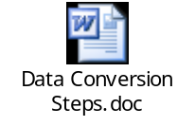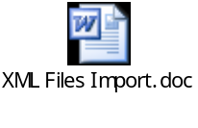

Appendix 2: BCS - Business Classification Schema
https://luuta.stadi.sonera.fi:7014/gdw/drl/autonumber/gdwd_10005383

Appendix 3: TSF Blueprint document
https://luuta.stadi.sonera.fi:7014/gdw/drl/autonumber/gdwd_10005384

Appendix 4: ts_purchase_contract sample XML content
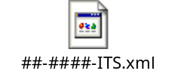

Appendix 5: ts_purchase_contract XML-schema
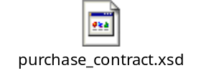

Appendix 6: ts_purchase_contract XML application
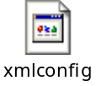

Appendix 7: Contracts and Orders Customisations
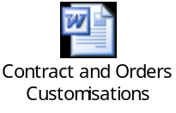

Change history

Version | Date | Author | Reviewed by | Approved by | Change history
DRAFT | 2008-09-19 | T. Pursiainen |  |  | Draft Version
DRAFT | 2009-01-07 | J. Virta |  |  | Updated the document
DRAFT | 2009-01-26 | J. Virta |  |  | Updated attachments and attribute descriptions
DRAFT | 2009-02-04 | J.Virta |  |  | Added customisations appendix
DRAFT | 2009-02-05 | Rajeshkumar Jha |  |  | Updated Excel to XML conversion and XML Import description appendix

