Creator
Tero Karttunen
<tel.>
tero.karttunen@tieto.com

LinkHandler
 | Project owner | Project manager
 | <Corporation> | <Corporation>
 | <Unit> | <Unit>
 | <Name> | <Name>
 | Checked by
 | Accenture Oy
 | <Unit>
 | Jaakko Hyvärinen
 | 2011-01-17 <signature>
 | Approved by
 | Accenture Oy
 | <Unit>
 | Jaakko Hyvärinen
 | 2011-01-17 <signature>
 | Purpose
 | This document describes the architecture of the LinkHandler solution. The System Overview part describes the solution in a high level, and is intended for all stakeholders of the project. The Architectural Description part describes the technical aspects of the solution, and is intended for the system’s technical stakeholders.

Version history
Version | Status |  | Date |  | Created/  modified by | Commented by/comments
<0.1-0.x> | <Draft> |  | yyyy-mm-dd |  | <Name> | <Name/Comment>
<0.x> | <Ready |  | yyyy-mm-dd |  | <Name> | <Name/Comment>
1.0 | Approved |  | 2011-01-17 |  | Tero Karttunen | <Valid
1.1  1.2 |  |  | 2011-03-05  2013-11-06 |  | Jaakko Hyvärinen  Veera Badhram Chukka | AS a part of DPRI project, Link handler application is upgraded to Documentum 6.7sp2

Terms and abbreviations | Description

File or storage of the project documentation
[Enterprise_contents repository]/Documentation/ecm/solutions/linkhandler
http://ecmlink.stadi.sonera.fi/virtualrepository?ts_identifier=TS1209151414

Link to the supplementary information on the project
<Write

Person responsible for the project documentation
<Name
<Necessary

Appendices

Document | Name or web link of the document
<Name of the appendix> | <Web link for the appendix>

Distribution
<Direct

Table of Contents
PART I: System Overview 5
1 System Description 5
2 Architectural Drivers, Design Decisions and Rationale 5
2.1 “Old web links must continue to function” 6
2.2 “Solution must be scalable” 6
2.3 “Service interruptions must be minimized” 7
2.4 “Solution should be easily expandable with new system integrations” 7
PART II: Architectural Description 8
3 Organization of Architectural Description 8
4 Application Decomposition View 9
4.1 Primary Presentation 9
4.2 Element Catalog 9
4.2.1 Elements 9
4.2.2 Relations 10
4.2.3 Interfaces 10
4.2.4 Behavior 13
4.2.5 Constraints 13
4.3 Context Diagram 13
4.4 Variability Guide 14
4.5 Architecture Background 14
4.6 Relation to Other Views 15
4.7 Other Information 15
5 Web Link Preprocessing View – Production environment 15
5.1 Element Catalog 15
5.1.1 Elements 15
5.1.2 Relations 16
5.1.3 Interfaces 16
5.1.4 Behavior 17
5.1.5 Constraints 17
5.2 Context Diagram 17
5.3 Variability Guide 18
5.4 Architecture Background 18
5.5 Relation to Other Views 18
5.6 Other Information 18
6 Repository Replication View 18
6.1 Primary Presentation 19
6.2 Element Catalog 19
6.2.1 Elements 19
6.2.2 Relations 20
6.2.3 Interfaces 20
6.2.4 Behavior 22
6.2.5 Constraints 22
6.3 Context Diagram 23
6.4 Variability Guide 23
6.5 Architecture Background 23
6.6 Relation to Other Views 24
6.7 Other Information 24
PART III: Viewpoint Catalog 25
7 Application Decomposition Viewpoint Definition 25
7.1 Abstract 25
7.2 Stakeholders and Their Concerns Addressed 25
7.3 Elements, Relations, Properties, and Constraints 26
7.4 Language(s) to Model/Represent Conforming Views 26
7.5 Applicable Evaluation/Analysis Techniques and Consistency/Completeness Criteria 26
7.6 Viewpoint Source 26
8 Web Link Preprocessing Viewpoint Definition 26
8.1 Abstract 26
8.2 Stakeholders and Their Concerns Addressed 26
8.3 Elements, Relations, Properties, and Constraints 27
8.4 Language(s) to Model/Represent Conforming Views 27
8.5 Applicable Evaluation/Analysis Techniques and Consistency/Completeness Criteria 27
8.6 Viewpoint Source 27
9 Repository Replication Viewpoint Definition 28
9.1 Abstract 28
9.2 Stakeholders and Their Concerns Addressed 28
9.3 Elements, Relations, Properties, and Constraints 28
9.4 Language(s) to Model/Represent Conforming Views 28
9.5 Applicable Evaluation/Analysis Techniques and Consistency/Completeness Criteria 29
9.6 Viewpoint Source 29

PART I: System Overview

System Description
LinkHandler is a general-purpose, HTTP-based system integration that provides a set of interfaces for a client to browse and fetch documents and their metadata. The documents can originate from multiple data sources; LinkHandler attempts to hide the sources and form a Virtual Repository which the client can query. The interfaces can have different business logic and behaviour, but they mainly differ in their accepted query parameters; the primary purpose of many of them is to provide backwards compatibility for old web links, and thus the interfaces are known as emulators.
LinkHandler supports multiple response types – content files, XML metadata, JSON metadata, and a graphical GWT-based HTML UI. The GWT UI provides user-friendly browsing capabilities in the form of expandable folder hierarchy. LinkHandler core has a special interface to serve these GWT call-back queries.
LinkHandler is a stateless solution, so each HTTP request to any interface is handled separately. All possible state information is kept client-side. Only read-only usage is supported, and system usage must not have any side effects beside log and audit trail generation.
Some data sources require user authentication. LinkHandler can be accessed anonymously, in which case such data sources are not used. In case the client is authenticated, a solution-wide single identity is created for the client (the client does not authenticate separately for each data source, although as a stateless service, the client can of course change identity between requests).
Data sources have different back-end systems. They can be divided to publishing and non-publishing data sources. Publishing data sources have some sort of local mirror repositories to which originating data repositories push data for efficient retrieval. Mechanisms for data transfer vary from the use of a shared file system to publishing changes directly to a special HTTP interface. Non-publishing data sources connect to back-end repositories directly and act as a gateway.
LinkHandler application is a J2EE application running on multiple TC server instances that are being load-balanced by a local Apache HTTPD server instance. The proxy server also does some preliminary URI-rewriting that helps in system integration. Other participants for successful web link emulation are external load balancers and DNS servers; the legacy web links must find their way to LinkHandler in the first place!
LinkHandler solution comprises LinkHandler servers, LinkHandler application, publishing extensions to back-end repositories and the fore-mentioned network topology configurations.

Architectural Drivers, Design Decisions and Rationale
LinkHandler solution description document chapter one explains the business drivers and the “story” behind LinkHandler.
The main concerns that drove architecture development were:
- The functional requirement (FR1) for all old web links to continue to function in the new environment.
- The non-functional requirement (QR2) that the solution must be scalable to high volumes of usage.
A wrong kind of architecture that could not fulfill these requirements would prevent content migrations to new environment and lead to failure.
Other two quality attributes availability (QR1) and expandability (QR3) also guided architecture design.

“Old web links must continue to function”
HTTP URLs contain host names and port numbers, context paths and query strings. If LinkHandler solution is to serve legacy web links, the requests must be redirected to LinkHandler application. This requires changes to network topology – changes in DNS entries and proxy servers. These changes become part of LinkHandler solution.
For convenience purposes, some context path and query string rewriting can be done by the proxy server instead on LinkHandler application. The correct emulator (servlet) to handle the request can usually be selected this way. Architecturally speaking, this muddles the responsibilities between an emulator and the proxy server, but it does not really introduce new dependencies – the network topology configurations are already tightly coupled to LinkHandler application. See subchapter 5.4 for further discussion.
LinkHandler application architecture supports web link emulation with the Emulator abstraction (variation point). The Emulator base class can easily be extended with new emulators that can have custom logic. Also, LinkHandler provides Transformer design pattern that helps in converting HTTP parameters to canonical form.

“Solution must be scalable”
The main choke points for scalability are back-end servers and repositories and the LinkHandler application itself.
The back-end choke points can be avoided with publishing architecture (see Solution Description for an easy explanation). Each change to back-end repository needs to be signaled only once, after which LinkHandler solution can serve the requests to the data on its own.
The architecture addresses LinkHandler application scalability concerns by declaring the service stateless and without side effects and thus easily deployable to multiple servers with load balancing. Furthermore, by selecting GWT as client-side UI technology, the whole load of UI rendition is on client-side browser.
Network topology, network bandwidth or shared file system capabilities are not considered to be likely limitations to scalability.

“Service interruptions must be minimized”
Happily, well-designed load balancing also helps with high availability requirements, especially if server processes are distributed across several machines. It is possible to take some servers down intentionally for maintenance purposes without disrupting service; the effects of hardware failures are also mitigated.
As some shared resources (NFS, back-end databases, network) cannot be distributed, single points of failure remain. High Availability requirements must also be kept in mind while doing further architectural design; for example, data sources with publishing architecture should distribute their local repositories lest a new single point of failure is created.

“Solution should be easily expandable with new system integrations”
The architecture helps with this requirement with the choice of XML as canonical metadata format. Technical integrations can forego HTML UI altogether and request responses in XML format (over HTTP). Also, one of emulators allows system integrations to do requests in canonical parameter format that corresponds to metadata format without any parameter transformers.
New data sources can be configured dynamically without restarting processes, if existing emulators are suitable. If not, new emulators can easily be developed.

PART II: Architectural Description
This part contains architectural views of the solution.

Organization of Architectural Description
Viewpoints that have been selected to organize the representation of the architecture are listed in Table 3.1.
These viewpoints and the corresponding views have been designed using Carnegie Mellon® Software Engineering Institute’s Documentum Software Architectures: View and Beyond (V&B) approach. The approach is compatible with IEEE Recommended Practice for Architectural Description of Software-Intensive Systems, 1471-2001.
Table 3.1: Utilized Viewpoints (V&B Styles)
Viewpoint | Purpose | Stakeholders
Application Decomposition | Hybrid of uses and generalization views for LinkHandler application. Shows how the application is decomposed into static elements, and how those elements relate to each other. | Project manager, architects, developers
Web Link Preprocessing | Hybrid of pipe-and-filter and deployment views for resolving web links. Shows how legacy links are handled before LinkHandler application actually solves the underlying request. | ITOC, Architect, Support
Repository Replication | Hybrid of shared-data and publisher-subscriber views for LinkHandler solution. Shows how repository caching works and how NFS is utilized as shared data store. | Architect, developers, ITOC, Support

The documentation of each view follows the same organization:
- Primary presentation
- Element catalog
- Elements and their properties
- Relations and their properties
- Element interfaces
- Element behavior
- Element constraints
- Context diagram
- Variability guide
- Architecture background
- Relation to other views
- Other information

Parts are excluded if not needed for the particular view. Each view is relatively self-contained set of information about the system or a part of it. Views are related to each other either as parent/child refinements, or as siblings that represent different parts or concerns of the same element.

Application Decomposition View
This is the application decomposition view of LinkHandler application (J2EE Web Application). See chapter 7 for viewpoint definition.

Primary Presentation
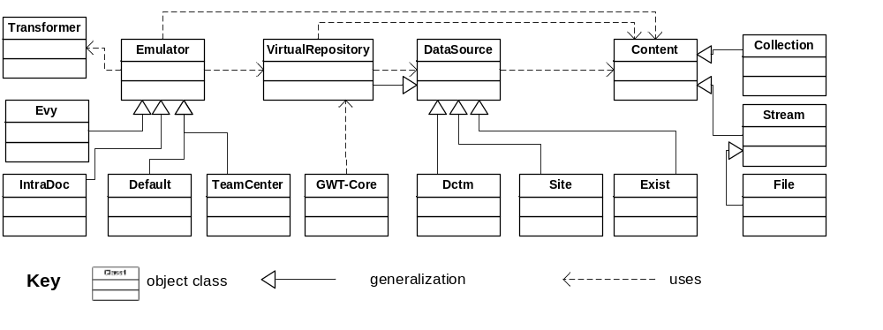

Element Catalog

Elements
Emulator provides HTTP interface for client requests. In J2EE terms it is a HTTPServlet. It is responsible for translating the queries to canonical format using Transformers, and then using VirtualRepository to fetch the required Content.
Transformer substitutes non-canonical query parameters with canonical parameters that are understood by VirtualRepository.
Default is the “standard” Emulator that needs not do any transforming. New system integrations should use this Emulator.
Evy, IntraDoc and TeamCenter are Emulators for different kind of legacy web links. They emulate retired legacy applications.
VirtualRepository acts as a façade for all configured data sources and provides a unified API for searching for content across all data sources with canonical requests.
GWT-Core provides HTTP interface for GWT UI call-back requests. It uses VirtualRepository to fetch the required Content, and it is then responsible for mapping Content to GWT UI model and returning the results to GWT UI.
DataSource is an abstraction for a data source that can be searched for content with canonical criteria. It creates Content objects.
Note: VirtualRepository can itself assume the role of a DataSource, allowing VirtualRepositories to be chained. This is separate from its main role as façade.
Dctm, Exist and Site are data source implementations. Dctm uses Documentum Content Server as back-end, Site uses a shared file system for back-end for both content files and metadata, and Exist embeds a local XML database for metadata and uses a shared file system for content files.
Content objects are query responses. They contain both metadata and file contents for search results. Content is responsible for rendering itself in different formats; possible formats include the bare content file, XML metadata, JSON metadata and HTML UI.
File and Stream are Contents that represent a single document. Collection is a Content that represents an ordered set of Contents. This allows for recursive hierarchies.

Relations
As defined by the viewpoint. Generalizations provide primary extension points for new development. Uses-relations are often implemented with object references.
Uses-relation multiplicities are:
User | # | Target | #
Emulator | 1 | Transformer | 0..*
Emulator | * | VirtualRepository | 1
GWT-Core | 1 | VirtualRepository | 1
VirtualRepository | 1 | DataSource | 1..*
DataSource | 1 | Content | 0..*

Interfaces
LinkHandler application has the following HTTP interfaces to outside world.
Note: These interfaces should be documented in detail. Current level is documentation is not enough.

Emulators
Emulator has a HTTP interface for client requests (web links).

Base emulator
Base emulator provides a canonic query language which can be executed using HTTP requests to the service. Other emulators will transform their incoming parameters (own query language) to this canonic form. Canonic query language is based to key and value pairs (symmetric to http get parameters). It contains also set of reserved key words. If parameter name is not “reserved” key word it will be used as a search criterion.
Example query:
domain=Enterprise_contents&vat=FI07654321
domain is reserved keyword which “scopes” queries to Enterprise_contents domain. vat is not reserved and it will be used as search criteria. Example query will return all objects whose vat is FI07654321.
Following table describes all linkhandler query language reserved key words
Key word | Sample value | Description
domain | ‘Enterprise_contents’  ‘/mnt/scs/Documentum/SCS/sites1/templates’ | Domain to where queries will be executed
passwd | ‘test’ | Password for the domain which needs authentication
user | webcache | Username for the domain which needs authentication
path | ‘/’  ‘/TeliaSonera Finland Oyj’ | Folder path to where queries will be executed
group |  | Privileged client dynamic group name, reserved for the future use
emulator |  | Emulator name, reserved for the future use
application | ‘Templates’ | Name of the application
response | ‘xml’  ‘html’  ‘json’  ‘file’ | Type of response stream.  ‘xml’ will return query results in simple xml format. The schema may change in the future.  ‘html’ will return the query results within the gwt ui  ‘json’ will return the query results within json format.  ‘file’ will return a single query result within binary stream.
ts_identifier | TS1111836783 | TS Specific id. Queries are always scooped to ts_master_doc, ts_folder or their sub types.
ts_legacy_id | ABBA1234 | TS Specific id. Queries are always scooped to ts_master_doc, ts_folder or their sub types.

Canonic query language provides a possibility to combine multiple search criteria. Matching is always exact match and used Boolean operator is AND.
Example query: response=xml&r_object_type=ts_master_doc&r_creator=eyn2616
Will return all objects from all public domains whose type is ts_master_doc and which are created by eyn2616.

TeamCenter emulator
<for each Emulator implementation, document the supported query language (query string, HTTP headers etc) and behavior>

Intradoc emulator
<for each Emulator implementation, document the supported query language (query string, HTTP headers etc) and behavior>

EShop emulator
<for each Emulator implementation, document the supported query language (query string, HTTP headers etc) and behavior>

GWT-Core
GWT-Core has a HTTP interface for GWT UI call-backs. This interface is similar to Default interface, and it allows GWT UI to make canonical search requests.
<explain API interface, operations and full contract>

Exist DataSource
Exist DataSource has a HTTP interface for back-end repository change notifications (blackboard end-point).
<describe RESTful interface>

Behavior
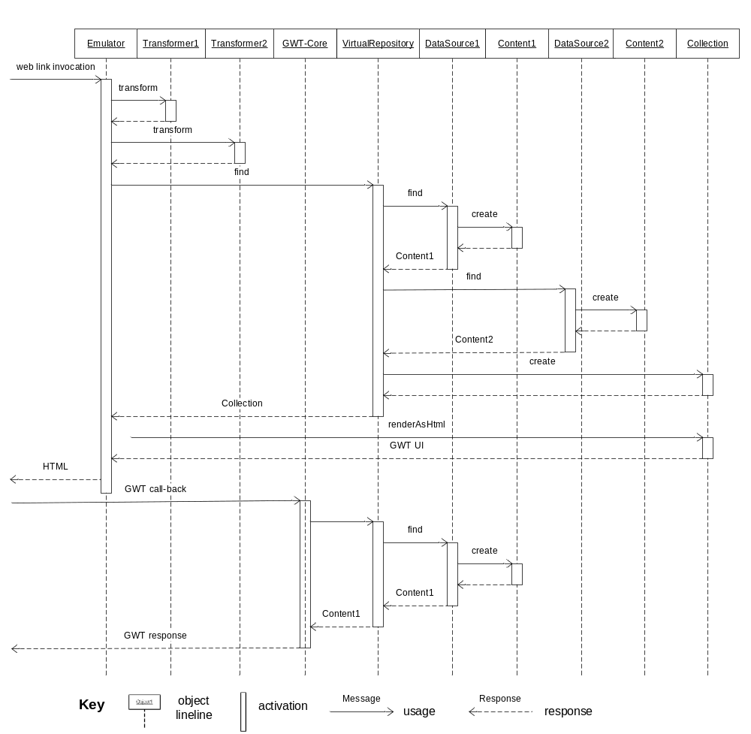

Constraints
Collection must represent a finite tree. It must not be cyclical.

Context Diagram
This context diagram shows how the application and the whole LinkHandler solution interact with the outside world. The viewpoint constraint for showing only intra-process communication is lifted, and the diagram uses informal notation.
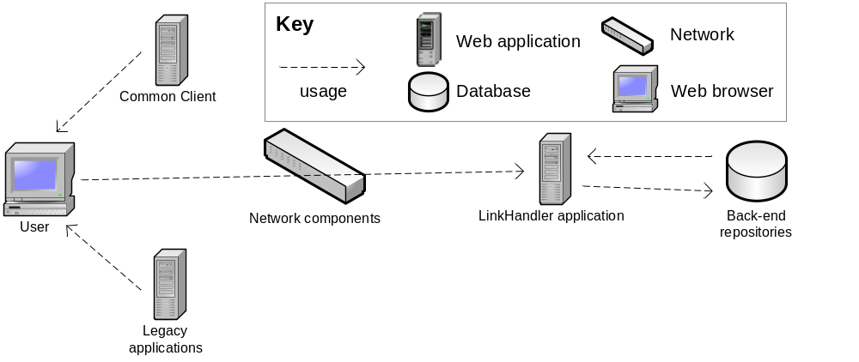
The main purpose of LinkHandler solution is to resolve web links. These web links are produced to user by Common client and legacy applications, amongst others. Once the user chooses to follow those links, network topology configurations ensure that the web links point to LinkHandler application, which resolves them, utilizing back-end repositories depending on data source type. Some back-end systems may also automatically publish data to LinkHandler server for local caching purposes.

Variability Guide
The concept of variability is closely related to expandability. Look for generalization relations for built-in variation points.
Another, more temporary kind of variability is data source configuration. It is possible to change data source configuration dynamically. The available data source types are selected at build time, but data source instances can be added, removed and reconfigured at runtime. See installation and configuration guide for more information.

Architecture Background
Chapter 2 introduces general architectural background for LinkHandler solution.
The architecture assumes that a sufficiently generic, “canonical” query format can be found and that it will be possible and feasible to transform legacy web links to this format by substituting HTTP query string parameters with other parameters. As the canonical query format is directly based on underlying data model properties, this assumption rests on great similarity and almost one-to-one mapping between data model attributes in the legacy system and the current back-end repository. This assumption has usually held true quite well.
An even more significant architectural choice is to let Content objects render themselves. The complete discussion of the pros and cons of this design choice is beyond the scope of this document. The most important consequence of this choice is that it tends to limit the variability of responses as data sources are decoupled from emulators. There are no “reverse transformers” that would transform query results back to the language of legacy systems.
All in all, LinkHandler application architecture is not well suited for perfect emulation of legacy solution behavior. If the new data model is not very different from the old one, the architecture can fulfill the requirement FR1 for all old web links to continue to function, but all stakeholders should accept some visible changes in user experience.

Relation to Other Views
Not applicable, as this view does not have any parent, child or sibling views.

Other Information
See Deployment description document for information on application package contents and its characteristics as a J2EE Web Application.

Web Link Preprocessing View – Production environment
This is the web link preprocessing view of LinkHandler solution production environment. See chapter 8 for viewpoint definition.

Element Catalog

Elements
Workstation represents a workstation of an internal TeliaSonera user that confirms to TeliaSonera’s WorkIT environment. It is running Windows XP operating system.
Internet Explorer is the client web browser that starts web link processing. It resolves the socket address (IP and port) by doing a DNS lookup, and then connects to the HTTP server at that socket and requests the resource with the original resource path and query string.
korvatunturi.stadi.sonera.fi or Proxy is a combined web proxy/load balancer that owns all the virtual domains and IP addresses of the emulated web links. It is configured to pass through all requests to these virtual domains to LinkHandler servers. It is likely to be a dedicated piece of network hardware, but the implementation details of this node are unknown.
dm100linkprod.gad.teliasonera.net and dm101linkprod.gad.teliasonera.net are two identical LinkHandler solution production server .
vFabric Web Server is based on Apache HTTP server, software running as a process on LinkHandler solution servers. It contains several URL rewriting rules that aim to convert legacy resource paths of web links to more uniform form that is easier to process with a J2EE Web Application. It also load-balances the request to a number of TC Server process instances.
TC server1(8002) and TC server 2 (8012) are Tomcat Application Server process instances that provide a software platform for LinkHandler application components. They are nodes within server machine nodes.
POST Redirect and LinkHandler are web server components that form the LinkHandler application. They do not redirect the HTTP requests any further; instead, they finally serve the requests themselves.
LinkHandler, the main application, only fully supports HTTP GET requests. POST Redirect is a J2EE servlet that always responds to POST requests with a client-side GET-type redirect request, effectively converting POST requests to GET requests with a slight performance penalty.

Relations
As defined by the viewpoint. Attachment relation properties are listed on the following Interfaces subsection. Allocated-to relation properties include the deployment location:
Node | Component | Location
Workstation | IE7 | C:\Program Files\Internet Explorer
korvatunturi | Proxy | ?
dm100linkprod  dm101linkprod | vFabric Web Server
Tomcat1/2 | POST Redirect
Tomcat1/2 | LinkHandler

Interfaces
The socket address of each HTTP interface is composed of host IP address and port number.
Component | Host name | Port | Local-only
Proxy | ecmlink.stadi.sonera.fi | * | no
Proxy | intradoc.telia.se | * | no
vFabric Web Server | dm100linkprod  dm101linkprod |  | yes
POST Redirect  LinkHandler | dm100linkprod  dm101linkprod | 8002 (TC server 1),  8012 (TC server 2) | yes

Behavior
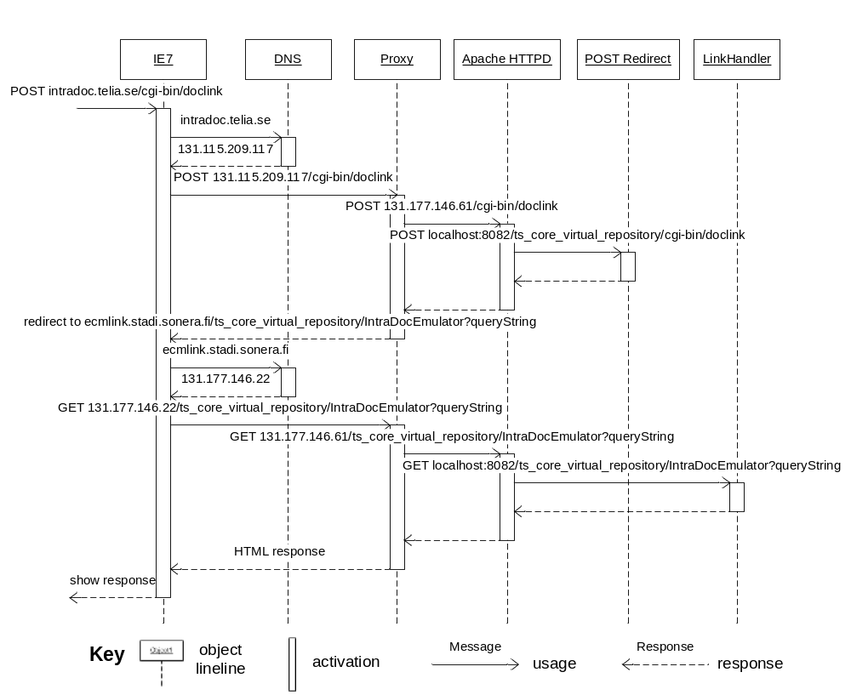

Constraints
As Proxy redirects all traffic from several virtual IP addresses to Apache HTTPD, original host name and port information is lost and unavailable for use in business logic. However, resource paths and query strings typically identify the request unambiguously, and HTTP headers may be examined for extra information.

Context Diagram
The context diagram in chapter 4.3 also shows web link preprocessing in context. There the proxy servers are depicted as network components that route traffic to LinkHandler application.
For further information on back-end in context, see Documentum platform documentation.

Variability Guide
New virtual IP addresses can be added relatively easily with configuration changes to DNS and Proxy servers, and new LinkHandler server hosts and web server instances can be added for load balancing purposes without major changes to architecture. As new emulators are added, minor configuration changes to Apache HTTPD are also needed.

Architecture Background
Chapter 2 introduces general architectural background for LinkHandler solution.
There are no practical alternatives to using DNS aliases and hardware-based load balancer for capturing traffic to legacy hosts to LinkHandler solution.
The choice to allow URL rewriting by Apache HTTPD was significant, as HTTPD could have taken care of load balancing only and LinkHandler application could have captured all requests with a wide servlet mapping and taken care of all request dispatching and interpretation itself.
The pros are:
- No need to re-invent the wheel – mod_rewrite already contains powerful functionality
- “Proxies typically do this kind of tricks”
- Well-understood unified configuration file
- The configuration is easier to review security-wise
The cons are:
- Unclear responsibilities
- Request mapping rules to emulators can sometimes be rather arbitrary
- Emulators are an unnecessary abstraction outside LinkHandler application
- The full power of Java programming language would allow more architectural variety.

Relation to Other Views
Not applicable, as this view does not have any parent, child or sibling views.

Other Information
See Deployment description document for information on LinkHandler solution servers, and Installation and configuration guide for more information on configurations.

Repository Replication View
This is repository replication view of LinkHandler solution. See chapter 9 for viewpoint definition.
This view shows Documentum Repository and Content Servers as LinkHandler back-end repository, but this does not mean that the LinkHandler solution is limited to running on top of Documentum platform. Other kind of repositories could be replicated as well with a suitable data pump.
Also, note that those data sources (Dctm) that access back-end directly instead of accessing a replicated repository are not shown in this picture at all! As the name implies, this viewpoint only concentrates on repository replication!

Primary Presentation
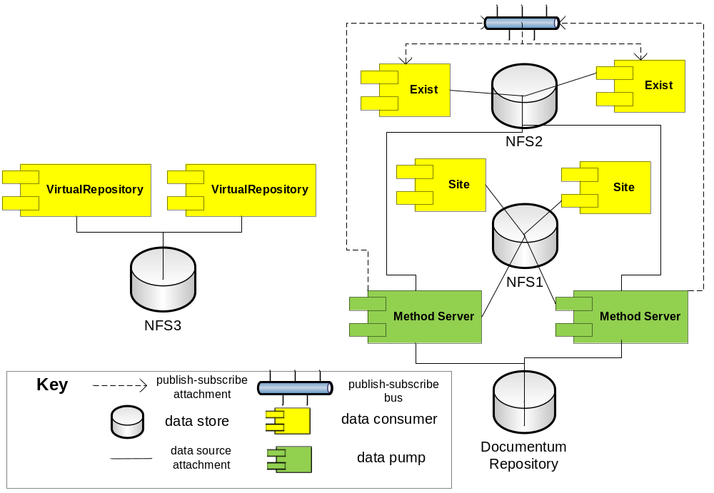

Element Catalog

Elements
Documentum Repository is the source repository to repository replication. It is a shared data store that all Content Server instances can access.
Content Servers’ Method Servers are, amongst other things, data pumps from Documentum Repository to NFS1 and NFS2 repositories. They can access network file system directly and place files (xml metadata and binary files) on disk. They also publish data change events to Exist data sources.
NFS1 is a target repository to Documentum Repository replication. It is a shared data store composed of both object metadata and object content files, and it is based on network file system. It accepts Site data source type of consumers. To increase reliability, NFS1 itself is duplicated into two identical directories; one directory is being maintained by one Content Server, and the other directory by the other one.
NFS2 is a target repository to Documentum Repository replication. It is a shared data store composed of both object metadata and object content files, and it is based on network file system. It accepts Exist data source type of consumers. While object metadata remains in file store, Exist data source further caches object metadata separately to a non-shared store.
NFS3 is a shared data store that provides configuration data to LinkHandler application server instances. It does not replicate any other repository.
Site and Exist are LinkHandler data sources; see the element catalog of the application decomposition view.

Relations
Data store attachment to NFS data stores are made with simple network file system connection (mount points in Solaris, network drives in Windows) as NFS natively provides persistence storage and concurrent access functionalities. There is, however, no version or access control, so data consumers must synchronize between themselves.
As NFS is not a relational database, object metadata (if it is to be stored) must be modeled as XML files. For efficiency reasons, there should be one file per data store or one file per directory. Object file contents are separate, “normal” binary files. Directory structure within NFS-based data store may either mirror source repository structure or be based on hash-codes or some other structure.
NFS1 stores both object metadata and object file content. Metadata for the whole repository is stored as a single root.xml while at root directory. Source repository directory structure and file names are mirror as closely as possible for object file content.
NFS2 stores both object metadata and object file content, which are hashed into directory structure with the hash code of its object unique identifier. Some large directories may furthermore be segmented into smaller metadata files to avoid excessive file sizes.
NFS3 contains simple xml configuration files and does not represent object data at all.
Content Servers publish notifications on repository metadata changes to Exist data source in LinkHandler application. These notification messages contain file path to the new metadata fragments for changed objects and each Exist data source instance fetches and saves them to an xml database local to the LinkHandler server instance. Thus, all LinkHandler server instances are subscribers to these change events.

Interfaces
See Deployment description document for NFS locations.
The mechanism for placing files on NFS is an implementation detail of each data pump. Data consumers need not know how files get to the repository. The data pump for NFS1 has chosen to use Documentum Site Caching Services (SCS) for file transfer; the data pump for NFS2 places the files on disk directly through file system mount point. In both cases, the repository synchronization is made in daily batch runs and is not triggered automatically for each change to repository objects.
The subscriber interface for Exist data source is a J2EE servlet that (indirectly, by file reference) accepts new XML metadata files for directories where changes to object metadata have occurred. Despite the way the cartoon in the primary representation of this view has been drawn, there is no separate publish-subscribe bus component and subscribers do not register themselves to publishers. Instead, the list of subscriber interfaces are manually configured and updated to each publisher.
The subscriber interface servlet resides within LinkHandler application in context root /ExistServlet.

Behavior
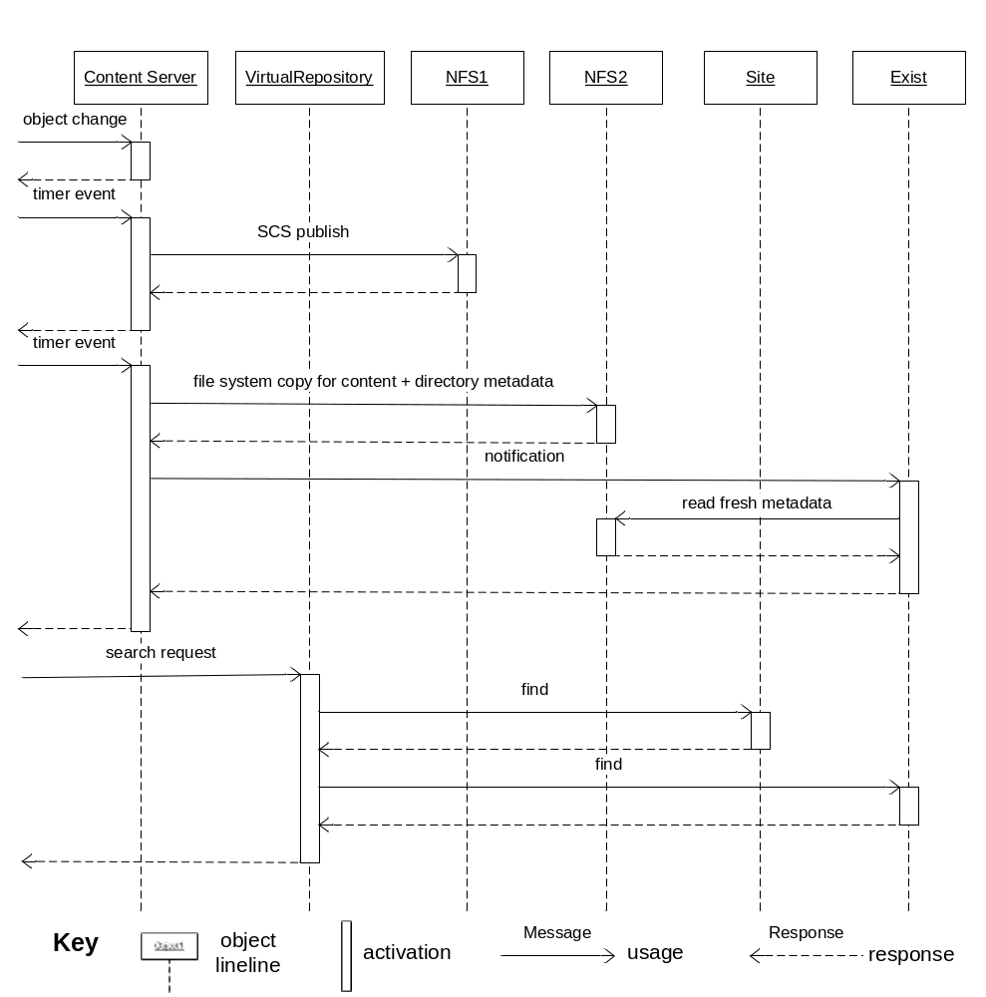

Constraints
As repository synchronization is done daily with a batch run, the state of repositories can be different at any time.
LinkHandler application solves concurrency and redundancy issues by offering only read-only access without side effects to clients. This is a fundamental property of this architecture that cannot be changed.

Context Diagram
This simple, high-level context diagram shows how back-end repositories act as a shared data stores for LinkHandler and other data consumers. Common client and other applications can modify and make changes to back-end repositories, which will then be visible through LinkHandler either immediately (via data sources offering direct access) or through repository replication.
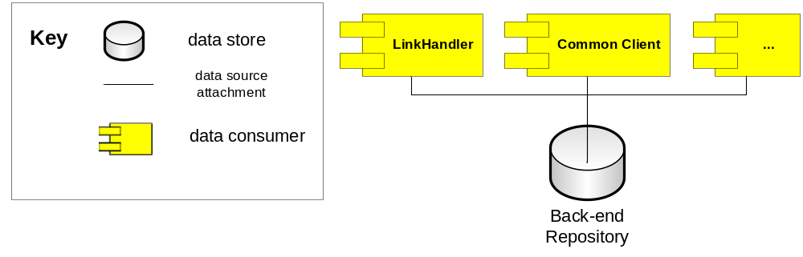

Variability Guide
Both Site and Exist data sources can be utilized for other, non-Documentum repositories if suitable data pumps are developed. Their XML metadata schemas are derived from Documentum usage, so at this stage some refactoring work is recommended.
Site and Exist data sources are similar but completely distinct, as are their data pumps and metadata formats. There are historical reasons for this. With a little extra work, these similarities could be unified into abstract base classes and unified metadata format.

Architecture Background
Repository replication is necessary for performance reasons, as it allows the LinkHandler application data sources optimized access to repository content. Site data source keeps the metadata in an in-memory DOM structure, whereas Exist data source has an embedded XML database for metadata storage. The separate database allows larger amounts of data to be stored and with its indexes, actually gives better performance with XQueries.
As an additional bonus, repository replication is also an excellent way to enhance security, as it is easy to define the portion of the repository content to be replicated exactly. The other data is safe at the originating repository.
Exist data source data pump began its life as an evolutionary version of Site data source data pump, but it has since branched off. As explained in variability guide section above, these data sources could be refactored back to common base classes.
Each LinkHandler server instance hosts its own embedded Exist data source instance (where Exist data source is being used). This enhances reliability and (potentially) performance with a serious cost in machine resources (memory, CPU, disk space). It is possible to move from an embedded database to a separate client-server installation where all LinkHandler server instances share the same database server. However, other XML database products should also be considered at this point, as eXist may be unfeasible as a long-term choice.

Relation to Other Views
Not applicable, as this view does not have any parent, child or sibling views.

Other Information
See Deployment description and Installation and configuration guide documents for information on how to deploy and configure data sources and data pumps.

PART III: Viewpoint Catalog
This part contains the definitions of viewpoints utilized in part II.
For each viewpoint, the following subsections are defined:
- Abstract: A brief overview of the viewpoint.
- Stakeholders and their concerns addressed: This section describes the stakeholders and their concerns that this viewpoint is intended to address. Listed are questions that can be answered by consulting views that conform to this viewpoint. Optionally, the section includes significant questions that cannot be answered by consulting views conforming to this viewpoint.
- Elements, relations, properties and constraints: This section defines the types of elements, the relations among them, the significant properties they exhibit, and the constraints they obey for views conforming to this viewpoint.
- Language(s) to model/represent conforming views. This section lists the language or languages that will be used to model or represent views conforming to this viewpoint, and cite a definition document for each
- Applicable evaluation/analysis techniques and consistency/completeness criteria: This section describes rules for consistency and completeness that apply to views in this viewpoint, as well as any analysis of evaluation techniques that apply to the view that can be used to predict qualities of the system whose architecture is being specified.
- Viewpoint source: This section provides a citation for the source of this viewpoint definition, if any.

Application Decomposition Viewpoint Definition

Abstract
Views conforming to application decomposition viewpoint are a hybrid of uses and generalization styles in V&B, applied to classes in an object-oriented program. It shows functional dependencies between classes alongside with specialization relationships.

Stakeholders and Their Concerns Addressed
Stakeholders and their concerns addressed by this viewpoint include
- project managers, who define work assignments, formulate project plans with incremental steps and plan future expansions
- architects, who must understand the software architecture in order to modify and expand it or evaluate its correctness
- developers, who implement the application

Elements, Relations, Properties, and Constraints
Elements of the application decomposition viewpoint are conceptual classes and interfaces in an object-oriented program. All the depicted elements must be running within the same process (in case of Java, same virtual machine). The implementation classes and interfaces may not map one-to-one to conceptual ones.
The relations are uses, which is a specialization of depends-on relation whereby one module requires the correct implementation of another module for its own correct functioning, and generalization, which is a specialization of is-a relation.
Element properties include name, responsibilities and multiplicity (in case the uses-relationship is realized with object references). See UML standard for the definition of multiplicity.

Language(s) to Model/Represent Conforming Views
UML class diagram

Applicable Evaluation/Analysis Techniques and Consistency/Completeness Criteria
This viewpoint is useful for planning incremental development and expansion. Generalizations support reuse and extension, so generalization should be considered for identified extension points. Uses-relationship supports dependency analysis and work planning.
See uses and generalization styles for consistency/completeness criteria.

Viewpoint Source
Uses and generalization styles belong to V&B approach.

Web Link Preprocessing Viewpoint Definition

Abstract
Views conforming to web link preprocessing viewpoint are a hybrid of pipes-and-filter and deployment styles in V&B, specialized to describe how HTTP protocol URLs (web links) are redirected to a request handling web server through a series of proxies. It shows how each proxy component takes its turn in interpreting the web link, and how the proxies are laid out across server nodes.

Stakeholders and Their Concerns Addressed
Stakeholders and their concerns addressed by this viewpoint include
- ITOC (the hardware team), who design network topologies and plan service operations
- Architects, who estimate system performance and reliability and other runtime quality attributes
- Support team, who use the information to trace (debug) HTTP requests when anomalies and incidents occur

Elements, Relations, Properties, and Constraints
Elements of the web link preprocessing viewpoint are HTTP proxies deployed to hardware or software nodes, web servers and HTTP connections between proxies and the subsequent servers. A proxy is a component that establishes another connection and passes through the request and its eventual response through the new connection. The web server is a component that actually processes the request and does not delegate it any further to another HTTP server.
The relations are attachment and allocated-to. Attachment binds a proxy to the port of the HTTP server that acts as a delegate. This port may belong to another proxy or a web server; these are indistinguishable from caller’s point of view. Allocated-to shows on which node each component resides.
Component properties include name, software product name and functionality. Node properties include host name, operating system / platform version and security properties. Attachment relation properties are the same as interface properties; allocated-to relation properties include the deployment location in node.
This viewpoint allows both resource path and query string to be modified by proxies, but these modifications must be limited to URL rewriting and access control. “Hard” business logic is the responsibility of a web server.
Also, note that in this viewpoint, nodes can contain either proxies or sub-nodes.

Language(s) to Model/Represent Conforming Views
The basis is UML component diagram. Allocated-to relationship is modeled with containment between node and component (node contains component). Dependency relations are used to model attachment. If several attachment relationships originate from a proxy, they are all equal and functionally similar unless noted otherwise with a description about which requests should be redirected to this connection.

Applicable Evaluation/Analysis Techniques and Consistency/Completeness Criteria
This viewpoint is useful for evaluating web link emulation completeness. The complete set of web links to be handled should match the filtering criteria at each proxy. At environment planning stage, this viewpoint should be utilized to ensure that requirement hardware will be allocated for the system.
See pipes-and-filter and deployment styles for consistency/completeness criteria. The model also allows proxy to choose from several attachment relations based on some link criteria; in this case, the choice must be unambiguous and every possible web link must belong to one alternative.

Viewpoint Source
Pipes-and-filter and deployment styles belong to V&B approach.

Repository Replication Viewpoint Definition

Abstract
Views conforming to repository replication viewpoint are a hybrid of shared-data and publish-subscribe styles in V&B, applied to repository replication (also known as mirroring). It shows how content from one repository is pushed to another repository by a component acting as a data pump, for the use of other components that are data consumers. The data pump may also publish notifications of changes to a number of data consumers that have subscribed to such notifications.

Stakeholders and Their Concerns Addressed
Stakeholders and their concerns addressed by this viewpoint include
- Architects, who estimate system performance and reliability and other runtime quality attributes
- ITOC (the hardware team), who design network topologies, plan service operations and reserve sufficient machine resources for operation
- Support team, who use the information to validate repository contents when anomalies and incidents occur

Elements, Relations, Properties, and Constraints
Elements of repository replication viewpoint are data stores and software components that act as either data pumps or data consumers. Data pumps move content from one repository to another (unidirectional transfer), and data consumers read and/or modify content at the target repository. At the same time, data consumers can subscribe for data change notifications that can originate either from the data pump or other data consumers.
The relations are data store attachment, which determines which data pumps and data consumers are connected to which data stores, and publish-subscribe attachment, which associates components with the publish-subscribe connector.
Possible properties are the same as in shared-data and publish-subscribe styles.
This viewpoint does not constraint publish-subscribe notification mechanisms. The mechanism must be described in “relations” or “interfaces” section of the conforming view.

Language(s) to Model/Represent Conforming Views
UML component diagram. Publish-subscribe attachment relations can be modeled either as point-to-point connections, or as component publishing events to some sort of bus that delivers them to connected subscribers.

Applicable Evaluation/Analysis Techniques and Consistency/Completeness Criteria
This viewpoint is useful for evaluating system performance and security characteristics. Planning system around a shared data source also effectively decouples data consumers from each other, allowing for expansion and implementation changes.
Data pumps must be unidirectional and contain no loops. A single component may simultaneously have both data pump and data consumer roles. See shared-data and publish-subscribe styles for other consistency/completeness criteria.
Data stores need not be object repositories or part of replication scheme.

Viewpoint Source
Shared-data and publish-subscribe styles belong to V&B approach.

