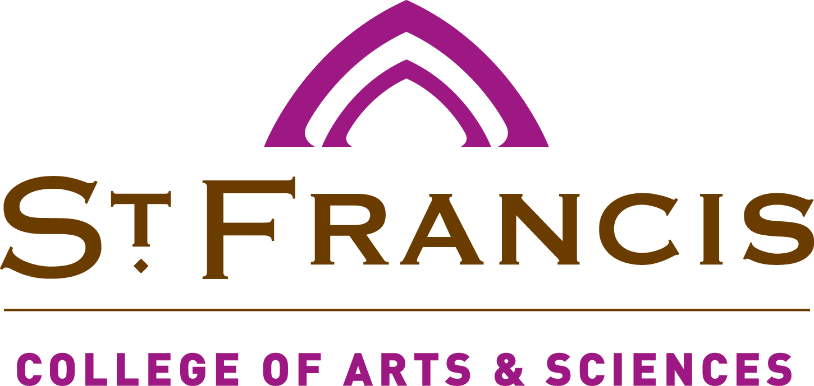

500 Wilcox Street
Joliet, IL 60435
www.stfrancis.edu

Course: ENGL-321A: American English: Dialects and Grammars (CRN 20769)
Semester: Spring 2019
Time &
Location: MW 11:20-12:10; F online

Materials: Plato, Phaedrus
China Mieville, Embassytown
Lohren Green, Poetical Dictionary
Raymond Queneau, Exercises in Style
Danesi Marcel, The Semiotics of Emoji: The Rise of Visual Language in the
Age of the Internet
Gustave Flaubert, Bouvard and Pecuchet
David Crystal, The Stories of English
Jonathan Swift, Gulliver’s Travels
Karen Sullivan, Mixed Metaphors: Their Use and Abuse
Friedrich Nietzsche, “On Truth and Lies in an Extra-Moral Sense” (on
Canvas)
Theodor Adorno, “Punctuation Marks” (on Canvas)
Selections from Martha Kolln, Rhetorical Grammar (on Canvas)
Selections from Jacques Derrida, Of Grammatology (on Canvas)
Other possible texts will be made available on Canvas.

Professor: Dr. Kevin Andrew Spicer
Associate Professor
Chair, Dept of English and Foreign Languages
Office: Tower Hall, S-306
Office Hours: MWF 8:15-9, 10-11:15, 12:30-2, TR 8-2, F 10-2
Phone: 815.740.3852
Cell: 331-771-0311
Email: kspicer@stfrancis.edu

USF Mission Statement:
As a Catholic university rooted in the liberal arts, we are a welcoming community of learners challenged by Franciscan values and charism, engaged in a continuous pursuit of knowledge, faith, wisdom, and justice, and ever mindful of a tradition that emphasizes reverence for creation, compassion, and peacemaking. We strive for academic excellence in all programs, preparing women and men to contribute to the world through service and leadership.

College Mission Statement:
Embracing excellence in its diverse disciplines of study, the College of Arts and Sciences serves as the home, shepherd, and guardian of Franciscan liberal arts values for the University. It serves to inspire in its students a love of learning through continual investigation, nurturing of curiosity, exploration, discovery, and sharing that leads to the passionate life as a servant leader. The College provides a rich environment of inspiration, learning, and service to prepare its students to build their future through programs and opportunities that represent the values of our Catholic/Franciscan University mission.

Course Description:
In the context of the philosophy of language, this course treats the history and politics of the English language, the relationship of English to other languages, and the process of language change. It also examines the structure of modern American English as it is described in the major grammars. Prerequisite: ACAF 102, or ENGL 112, or equivalent.

Course Objectives/Outcomes:

By the end of this course the student will be able to:

Course Requirements:

Students will be expected to:
- Complete the assigned readings.
- Complete the assessments.
- Participate in class/seminar discussions.

Course Schedule/Outline:

Course schedule is available at the end of this syllabus.

Methods of Evaluation:
- Participation on the Discussion Boards and in-class
- Three short analytical/critical essays.

Grading Scale

Standard USF Grading Scale.

Course Evaluations/IDEA Surveys

USF has elected to participate in the AQIP Program which requires a focus on continuous quality improvement as part of our Higher Learning Commission accreditation. The information learned during the IDEA Course Evaluations is an important part of maintaining quality and continuous improvement in courses, and it is the University’s expectation that students will thoughtfully participate in this evaluation process.

The instructor reserves the right to adjust the syllabus and class schedule as circumstances may warrant during the semester.

Students are expected to follow all policies in the USF Catalog and Student Handbook, both of which can be found in the student portal.

Policies not covered in this document will be handled in accordance with the USF Catalog and/or Student Handbook.

Institutional Policies:
The student should use the USF portal as the first resource for guidance and support on items such as student complaints, safety, security and transportation questions, contact information for various USF departments, student support services such as counseling and academic resources. Information on these resources can be found in the “For Students” section of the USF portal.

A complete listing of university policies and procedures can be found in the University of St. Francis Course Catalog and Student Handbook. For the most current version of the catalog, please visit
http://stfrancis.edu/academics/university-catalog

Academic Integrity:

Academic integrity requires that all academic work be wholly the product of an identified individual or individuals. Collaboration is only acceptable when it is explicitly acknowledged. Ethical conduct is the obligation of every member of the University community, and breaches of academic integrity constitute serious offenses. Since a lack of integrity hinders the student’s academic development, it cannot be tolerated under any circumstances. Violations include but are not limited to: cheating, fabrication, facilitating academic dishonesty, plagiarism, and denying others access to information or material. See the USF Catalog for further clarification and information on grievance procedures.
Services and Accommodations for Students with Disabilities (Americans with Disabilities Act):
The University strives to be in compliance with the Americans with Disabilities Act (ADA) and the ADA Amendments Act (ADAAA). A student who requires special accommodations or arrangements due to a disability should contact the Office of Disability Services. This contact preferably should occur no later than the first week of classes. Early contact before the semester starts is encouraged to allow sufficient time to provide accommodations. Extra time is needed for some types of accommodations such as sign language interpreters or special text formatting. Should a need arrive after the start of a semester; the student is encouraged to contact the Office of Disability Services as soon as possible. Note that accommodations are not retroactive. Each case will be reviewed on an individual basis to determine reasonable and appropriate accommodations.
USF is committed to ensuring the full participation of all students in its programs, regardless of the course format. If you have a documented disability and need a reasonable accommodation to participate in a course, complete course requirements, or benefit from the University’s programs or services, please contact the Office of Disability Services at 815-740-3631 or ODS@stfrancis.edu . The Office of Disability Services is in the Academic Resource Center (ARC) and is located on the second floor of the LaVerne and Dorothy Brown Library in room L214. Consultations are welcome, please contact the Office of Disability Services for an appointment.

Academic Support Services:

The Academic Resource Center (ARC) located in Room L214 in the Library (815-740-5060) offers various types of academic services. Online and distance learning students can contact ARC for appropriate resources. ARC serves students who need tutoring in many areas of study including writing and math. Library services include a number of online services and full text databases. Call the Library at 815-740-5041 for additional information. If you need academic-related resources or assistance, please contact the Academic Resource Center.

Course Reading Schedule: See Canvas page for the “Reading Schedule/Reading Log”

Notice of Copyright
This course may contain copyrighted materials that are intended to support the learning experiences of students currently enrolled in the course. No student may retain or further disseminate any copyrighted materials, in their entirety or any portion thereof, under penalty of law.

Technology Support
- The Department of Academic Technology (DAT) administers the learning management system Canvas. If you are experiencing any difficulty using Canvas or need technical assistance, you have several options to receive support, including:
  - 24x7 Live Canvas Support. If you experience technical difficulties or have a question about Canvas, you can receive support 24 hours a day 7 days a week through the Canvas help menu. From the help menu, select Chat with Canvas Support for a “live” text-based click-to-chat session,
  - select Report a Problem to send an email support request, or speak to someone directly by using the toll-free number listed under the Canvas Support Hotline.

NOTE: Responses to Canvas’ email-based Report a Problem request system will go to your USF stfrancis.edu email account, NOT your personal email.

- Online Self-Service Help Resources. A student user guide and other resources for solving issues related to Canvas can be found at http://learnitnow.stfrancis.edu

- Telephone Support from DAT. You can also phone the Department of Academic Technology for personal help at (815) 740-5080 or (866) 337-1497 (toll-free) between 8 a.m. and 4 p.m. Central Standard Time, Monday through Friday.

For any technical support issues that are not related to Canvas, please contact the USF Technology Support Center (TSC). You can reach them via:
- Phone: 1-815-768-TECH (8324)
- Email: techsupport@stfrancis.edu
- Web: http://techsupport.stfrancis.edu
- Or visit them on the first floor of Marian Hall

N.B. A better title will perhaps be: “Philosophy, Rhetoric, and Grammar of English Languages.”
N.B. The students and instructor will generate together a list of course objectives and outcomes early in the semester.

