**CHEM-E-CLOCK**

**TEAM :** SHREYA SENGUPTA

KRITIKA KASHYAP

**-------------------------------------------------------------------------------------------------------------------------**

**AIM**: To design a heat exchanger using an exothermic reaction and a trigger mechanism for heating a given amount of water (500ml).

**APPARATUS REQUIRED:**

|  |  |  |  |
| --- | --- | --- | --- |
| **Sl.no** | **Particulars** | **Quantity** | **Amount** |
| 1. | Calcium oxide | 1kg | 210x2=410/- |
| 2. | water | 2.5 litres | - |

**MODEL DIAGRAM :**

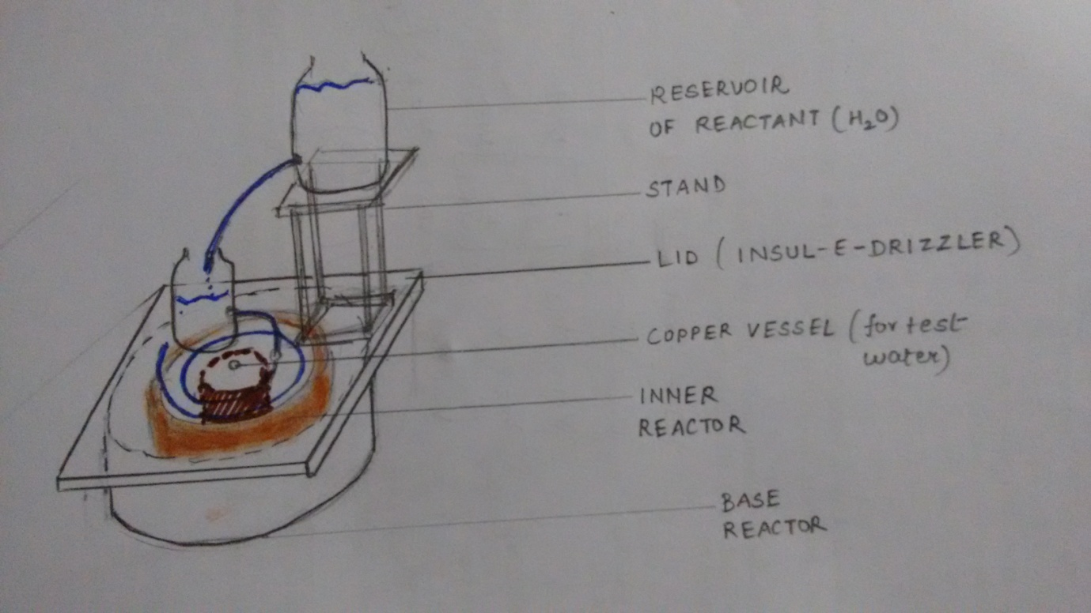

**Component Details:**

1. Base Reactor: is made of a clay ceramic pot in the form of a cylinder, of Diameter = 37cm and height 12cm . It provides a thick layer of insulation for the exothermic reaction being carried inside itself. Apart from that, it is a firm, strong and sturdy base for the entire model setup as well as the base of our reaction. Consists of a base coat of heat insulating Araldite.
2. Inner Reactor: The place where the overall chemical reaction will be conducted. It is present inside the outer ceramic pot as a concentric cylinder of height = 10 cm. It has been constructed using 3 thin layers of thermocol sheets sandwiched between 2 layers of sand paper. The materials have been fixed using easily available fevicol MR. The waterproof sandpapers on both ends of the thermocol cylinder have been well insulated by putting 2 coats of Araldite(Heat Resistant, insulating adhesive resin). A few holes have been made as excess water drainage system.
3. Test Water Container: A Cu vessel of diameter 10cm .The main aim of using a copper vessel is that it has a high thermal conductivity of 398 J/Kg-K . It is completely non-reactive towards the reaction being carried out around it .Its upper ends have been bent to provide a better mechanism for the reaction. It has been made by gas welding of copper sheets.
4. Insul-E-Drizzler: This is a plywood lid. Its inner wall, that faces the pot, is coated with 2 layers of araldite and heat resistant Fevicol. It provides a strong base for the trigger mechanism. It consists of 2 holes. One hole is for the insertion of thermometer for measuring temperature of the test water and the other one is for the insertion of a pipe that carries the reactant 2 ( hot water) inside the pot to reaction 1( CaO). This pipe has been perforated and coiled on the inner surface of the lid in such a way that it drizzles the reactant 2( hot water) exactly on the walls of the Cu vessel to increase the reaction efficiency and the rest of the water drizzles on the rest of the CaO as the coiling diameter of the pipe increases

**PROCEDURE**

Water from the top container is allowed to flow at time t=0secs into another container placed on the lid. This second container fills up till time t=60secs and at a calibrated point this water pours out through an orifice and pipe, entering the base through a hole in the lid. This pipe is coiled on the inner surface of the lid and is perforated at certain distances; such that the water flowing in the pipe drizzles out through these perforations on the calcium oxide. This reaction is exothermic and the amount of heat generated is transferred to the test water through the copper surface. The excess heat dissipation is controlled using the araldite coating on the lid. The excess water from the end of the pipe is collected in the outer groove of the base. The reaction continues for the next 5 minutes and the source of water stops ending the reaction. All the calcium oxide has been converted into calcium hydroxide in form of slurry. Maximum heat from this slurry is transferred to heat up the test water.

**REACTION**

$Cao \left(s\right)+ H20\left(l\right)-→ Ca\left(OH\right)2 \left(s\right) ΔH= -989\frac{kJ}{kgK}$

1000gms 2.5 litres

**RESULTS AND INDUSTRIAL APPLICATIONS**

Initial temperature of test water= 29’C

Final temperature of test water =72’C

Temperature rise = 43’C

When this model is scaled up, the heat generated can be used to preheat process water / inlet liquids/liquid feed in industries. The amount of Ca(OH)2 slurry formed will also scale up. This slurry is actually used in white washing buildings. Therefore this reaction is very much feasible in industrial level application.

**ADVANTAGES:**

1. Large amount of heat generated with ΔH= -989 kJ/kgK.
2. Efficient heat transfer due to use of copper as the test water container that has k=398 J/Kg-K
3. No byproduct is formed except for formation of some steam.
4. The large amount of slurry generated has a direct application in white washing.