PRODUCT DESIGN OF CHOCOLATES

**Siddharth Gumber, Sampatt Kumar, Kritika Kashyap, Vishal Apte, Madala Sachitanada, Ashutosh**

School of Civil and Chemical Engineering (SCALE)  
VIT University, Vellore



FINAL REPORT

**ABSTRACT**

Chocolate and Candy has one of the most flourishable and highly acknowledged markets. Many world class chocolate manufacturing companies have been working on improving the texture and taste of the product. They have also invested huge in providing a class in flavour and novelty. The biggest resistance to this is the temperature and storage conditions. The variation in the freezing patterns cut down the Universal Sale Point of many varieties due to the loss in texture and flavour. Also, packaging interferes with the product once it achieves a fluidic state. The increasing demand of fluid filled varieties face the biggest challenge. Many companies including Lindt have come up with workable solutions which can slightly overcome the thermodynamics glitch. The present proposal focusses upon developing chemical engineering solutions to maintain the texture and flavour of the confectionery to the maximum extent possible.

Keywords: ***texture, taste, flavour, novelty, temperature, fluidic, thermodynamics, engineering, confectionery.***

Table of Contents

Abstract**2**

**Survey4**

Problem Estimation and formulation**7**

Product formulation and best possible solution**10**

Maintaining the Texture and Flavour of Milk Chocolates and Candies……………..11

Milk Fat………………………………………………………………………………12

Molecular Composition Dynamics…………………………………………………...12

Cocoa Butter Alternatives……………………………………………………………12

Indian Standards……………………………………………………………………15

Crystallisation………………………………………………………………………17

1. SURVEY

A survey was conducted to gather information on the problems and type of product preferred among the chocolate consumers. Below are the schematic representations on the preferences which sustain within the chocolate lovers.

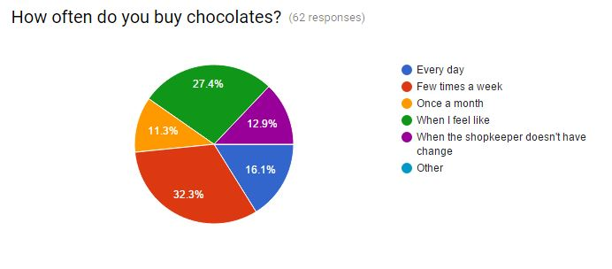

Fig. 1: Frequency of chocolate sale within VIT campus

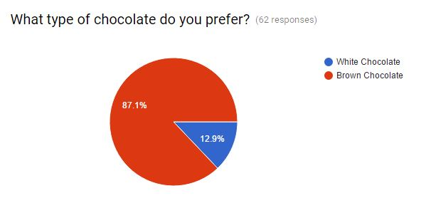

Fig. 2: Preferences on type of chocolate consumed

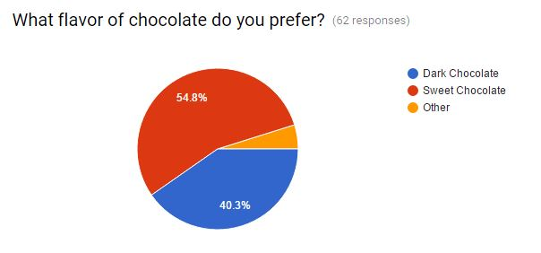

Fig. 3: Preferences on flavour of chocolate consumed

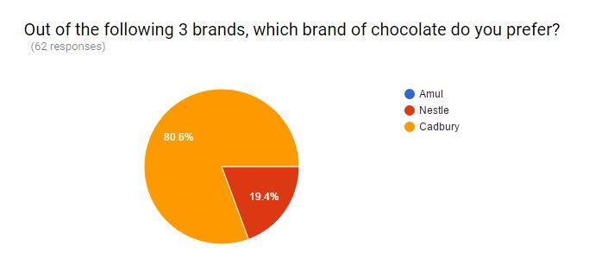

Fig. 4: Preferences on brand of chocolate consumed

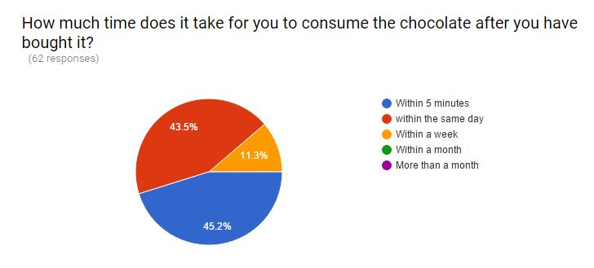

Fig. 5: Consumption time

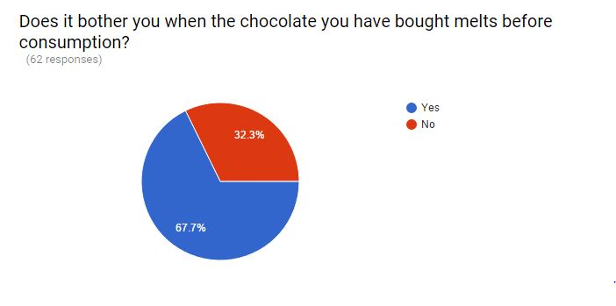

Fig. 6: Melting issues

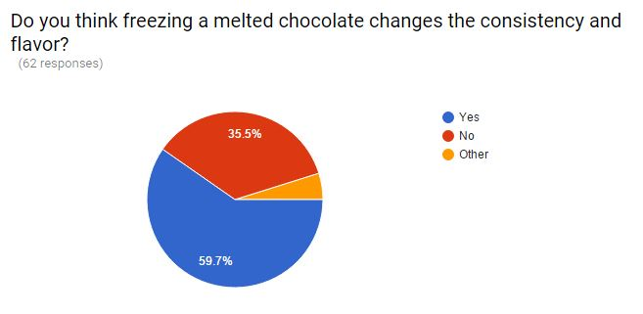

Fig. 7: Flavor loss during storage cycles

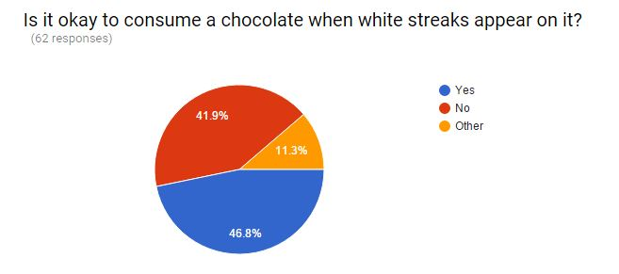

Fig. 8: Crystallization issues

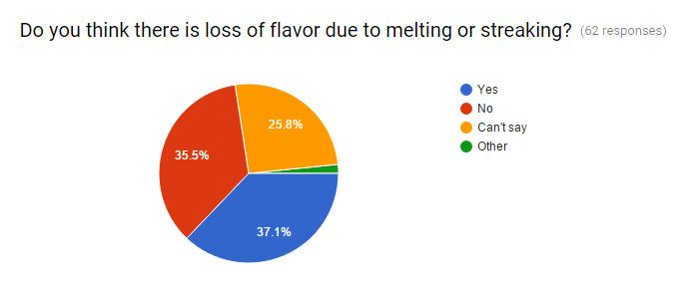

Fig. 9: Flavor loss due to melting and streaking

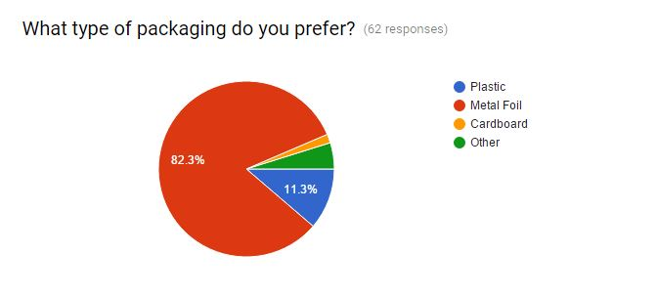

Fig. 10: Packaging preferences

1. PROBLEM ESTIMATION AND FORMULATION

It was found that people prefer brown over milk chocolates and sweet over dark chocolates. Most of them consuming it within the same day of purchase and 43.5% people consuming it within 5 minutes after purchase. Melting of chocolate is seen as a major issue affecting 67.7% people. Freezing a melted chocolate is known to change the consistency in texture and flavour by initiating crystallization which is disliked by 59.7% people. People have preferred metal foil for packaging despite of the very fact that chocolate develops a foil texture on melting. It can be seen as a major disadvantage owing to the products which get sold because of texture as one of its U.S.P.

Conclusively, melting and changes in storage cycles is seen as a major hit towards loss of flavour and texture.

Fig. 11: Problems and possible solutions

Chocolate consists of VI types of crystals amongst which Type V crystal is what manufacturers look for. Type V crystal has the most desirous melting point and is glossy and firm.

For the best possible finished product, proper tempering is all about forming the most of the type V crystals. This will provide the best appearance and mouth-feel and creates the most stable crystals so the texture and appearance will not degrade over time. To accomplish this, the temperature is carefully manipulated during the crystallization.

The chocolate is first heated to melt all six forms of crystals (heat dark chocolate to 120°F, milk chocolate to 115°F, and white chocolate to 110°F). Then the chocolate is cooled to allow crystal types IV and V to form (VI takes too long to form) (cool dark chocolate to 82°F, milk chocolate to 80°F, and white chocolate to 78°F). At this temperature, the chocolate is agitated to create many small crystal "seeds" which will serve as the nuclei to create small crystals in the chocolate. The chocolate is then heated to eliminate any type IV crystals, leaving just the type V (heat dark chocolate to 90°F, milk chocolate to 86°F, and white chocolate to 82°F). After this point, any excessive heating of the chocolate will destroy the temper and this process will have to be repeated. The figure illustrates the target crystal.

|  |  |  |
| --- | --- | --- |
| Crystal | Melting Temp | Notes |
| I | 17°C (63°F) | Soft, crumbly, melts too easily. |
| II | 21°C (70°F) | Soft, crumbly, melts too easily. |
| III | 26°C (78°F) | Firm, poor snap, melts too easily. |
| IV | 28°C (82°F) | Firm, good snap, melts too easily. |
| V | 34°C (94°F) | Glossy, firm, best snap, melts near body temperature (37°C). |
| VI | 36°C (97°F) | Hard, takes weeks to form. |
|  |  |  |

Fig. 12: Chocolate crystals

The replacement of part of the cocoa butter content of chocolate with cocoa butter equivalents (CBEs) improves the heat stability of the chocolate. In countries with a warmer climate the addition of CBEs may significantly improve the shelf life of a chocolate product. CBEs are vegetable fats derived from palm and shea oils, which are chemically and physically very close to cocoa butter. CBEs can be made with heat resistant properties superior to cocoa butter.

1. PRODUCT FORMULATION AND BEST POSSIBLE SOLUTION

The figure illustrates the ingredients and their contribution in each type of chocolate.

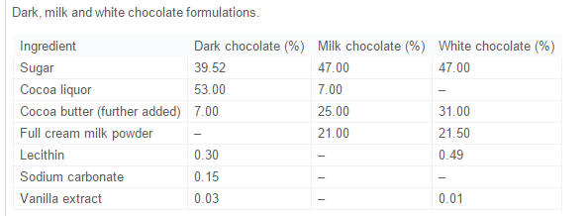

Fig. 13 : Chocolate ingredients

The ingredient which makes milk and white chocolate melt faster is the cocoa butter which has a melting point of 34.1°C. White and milk chocolates have the highest cocoa and milk content. Dark chocolates wither less and can sustain in fairly high temperatures without melting.

**Thixotropy** is a time-dependent [shear thinning](https://en.wikipedia.org/wiki/Shear_thinning) property. A thixotropic fluid is a fluid which takes a finite time to attain equilibrium viscosity when introduced to a step change in shear rate. The following graph depicts the shear thinning property of the chocolates.

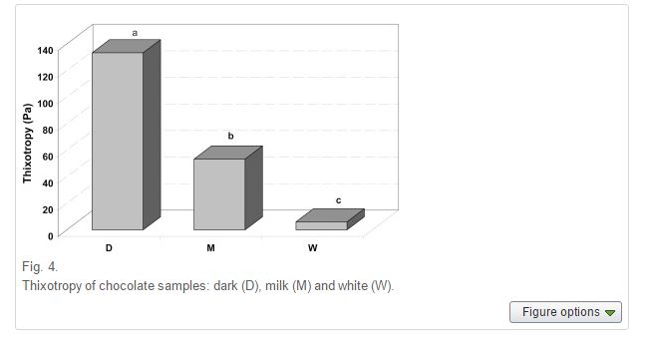

Fig. 14: Thixotropy of chocolate samples (Dark, Milk, and White)

Due to the crystalline and agile micro physical structure of Dark chocolate, it doesn’t come back to its original shape. It has the maximum thixotropic nature.

White streaks, sugar bloom and melting are the major issues affecting consumers worldwide.

According to the Bureau of American Standards, a chocolate is termed as its name only if cocoa butter content is 100%. A 5 % allowance is provided in India and a bigger percentage is prevalent in tropical countries like UAE where a high temperature rise causes a degradation of the confectionary items. Figure 14 demonstrates the Cocoa Butter Equivalents (CBEs), Cocoa Butter Replacement (CBR) and Cocoa Butter Substitute (CBSs) which is one of the most promising solutions to prevent early melting of chocolates or confectionary items which are thermally sensitive.

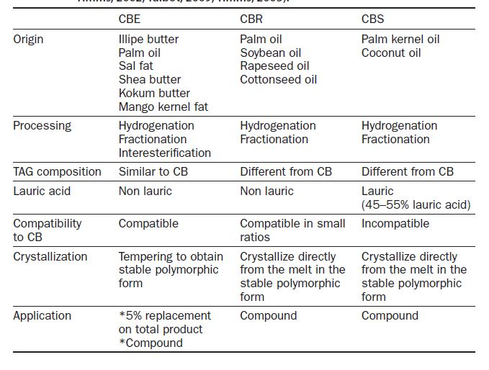

Fig 15: Composition of CBE,CBR and CBS

**Maintaining the Texture and Flavour of Milk Chocolates and Candies**

Cocoa beans are processed into roughly equal parts of butter and powder, which is used in cakes, biscuits and drinks. Chocolate typically contains about 20 percent cocoa butter, so confectioners in Asia and Europe are looking to save money which can replace about a quarter of the cocoa butter with something else. Cocoa butter prices jumped 28 percent this year to as high as $8,200 a tonne on strong demand and tight supply after global grinders cut processing to reduce inventory. The world's capacity for making cocoa butter substitutes of all grades is now about 150,000 tonnes per year, up by 25,000 to 30,000 tonnes since 2013, according to an industry source. The rise in the price of palm oil-based cocoa butter substitutes has come even as palm oil prices have fallen to five-year lows, underlining the increased demand for the product. The largest market for vegetable fats in chocolate is count lines, bitesize chocolate bars eaten as snacks, although some of this will be used in the fillings rather than the chocolate itself, according to Euromonitor International. Nutritionists say both products may be equally bad for you. "They are both high in saturated fat and will raise total cholesterol, and I would expect that there would not be a great difference from a health perspective," said Walter Willett, professor and chairman of the Department of Nutrition for Harvard School of Public Health in Boston.

**MILK FAT**

Milk chocolate provides one of the most popular flavor combinations—the special appeal of chocolate and the creaminess of milk fat. This combination makes milk chocolate the favorite of many consumers. As delicious as milk chocolate is, the mixture of milk fat and cocoa butter provides challenges for controlling lipid interactions to give consistent product quality. From phase behavior to crystallization kinetics, understanding the interactions between milk fat and cocoa butter is critical to controlling the quality characteristics and shelf life of milk chocolate.

Milk fat in milk is found in finely divided globules surrounded by a natural globule membrane made of various polar lipids. Although its primary role is to provide nutrition for the young, milk fat finds widespread application in a range of food products, including chocolate. Milk fat is a primary ingredient in milk chocolate, providing both flavor and texture modification, but it is also often used in dark chocolate to moderate texture and physical properties through its phase interactions with cocoa butter.

**MOLECULAR COMPOSITION DYNAMICS AND STRUCTURE OF COCOA BUTTER**

Chocolate is a smooth suspension of particulate sugar, cocoa and milk solids in a continuous fat phase composed of cocoa butter and a minor portion of milk fat. Upon cooling of a chocolate melt, this continuous fat phase will solidify into an ordered crystalline structure, directly affecting chocolate’s functional and sensory characteristics, ultimately impacting consumer acceptance. Its constituent lipid species will define different levels of structure within its crystal network and determine essential attributes. For example, the chemical composition and crystal habit of cocoa butter dictate the distinctive texture, snap, gloss, and melting character of chocolate. Crystal habit includes polymorphism, crystallite size and shape, and spatial distribution of network mass. Furthermore, heat, mass, and momentum transfer conditions during the tempering process used in the manufacturing/crystallization of chocolate greatly affect the solid fat fraction and crystal habit of cocoa butter.

**COCOA BUTTER ALTERNATIVES**

Cocoa butter (CB) is an essential ingredient in chocolate as it forms the continuous phase of chocolate. It is responsible for the gloss, texture, and typical melting behavior of chocolate. An increasing demand for chocolate and chocolate-type products increases the demand for cocoa from year to year. *Although cocoa butter is the ideal ingredient, the varying supply and increasing price depending on fluctuating cocoa bean prices, forced manufacturers to seek alternatives.* Cocoa butter can be replaced by other vegetable fats, collected under the name cocoa butter alternatives (CBAs). Attempts were made as early as 1930 by confectioners to use fats other than cocoa butter but they failed due to incompatibility of the fat blends. The continued research in the field of confection science resulted in the development of fats resembling the characteristics of cocoa butter. The CBAs are divided into three main categories according to their functionality and similarity to cocoa butter: the cocoa butter equivalents (CBEs), the cocoa butter replacers (CBRs) and the cocoa butter substitutes (CBSs).

The CBEs are nonlauric fats with similar physicochemical characteristics as cocoa butter and are therefore compatible with cocoa butter in every amount without altering the properties of cocoa butter. A CBE should allow processing of chocolate products in an identical manner to that of cocoa butter based products. The CBEs are subdivided into two groups. The first group, the cocoa butter extenders (CBEXs), are defined as fats that extend or dilute cocoa butter to make it more economical feasible. The second group, the cocoa butter improvers (CBIs), are characterized by a high content of StOSt. StOSt increases the solid fat content and as such the melting point and the hardness of chocolate. Chocolates with CBIs have better resistance to softness and fat bloom at higher ambient temperatures, such as in summer or in tropical climates. Illipe butter, shea fraction, and kokum fat have a higher content of StOSt and have been reported to impart these qualities and can therefore be used to harden cocoa butter and chocolate products.

The nonlauric CBRs consist of fractions of hydrogenated oils: palm, soybean, cotton, corn, peanut, safflower and sunflower oil. They are hydrogenated either alone or as a blend under selective; *trans* promoting (elaidic acid) conditions to give relatively steep SFC melting curves. They posses good flavor, odour and colour properties and do not need tempering. As a result of the similarity in the chain length and the molecular weight, products of this type can tolerate up to 25% cocoa butter on a fat basis when used in confectionary coating. Outside these boundaries eutectics occur due to incompatibility. This gives rise to softer products and provokes loss of gloss and fat bloom formation. The high level of *trans* fatty acids in these products is a significant disadvantage as the consumption of *trans* fatty acids may be seen as a risk factor in cardiovascular disease. To address the issue of *trans* fatty acids in CBRs, manufacturers are trying to produce low *trans* or even no-*trans* alternatives. Unlike the CBEs and CBRs, the CBSs fats contain a large amount (45–55%) of lauric acid and a considerable amount (15–20%) of myristic acid. They can be produced from palm kernel and/or coconut oil by means of fractionation and/or hydrogenation. Palm kernel oil is more useful than coconut oil, because it has a higher content of oleic acid and a lower content of short-chain (C6 to C10) fatty acids. Due to the presence of lauric and myristic acid, CBSs have a sharp melting profile. This melting profile gives a good mouth feel to the compound chocolates. Due to their triacylglycerol composition there is a considerable degree of incompatibility between lauric CBSs and cocoa butter. CBSs and cocoa butter form strong eutectics. CBSs are suitable to substitute cocoa butter completely or an addition of cocoa butter up to 5% is acceptable. If more than 5% cocoa butter is present in the fat phase, excessive softening and fat bloom occurs. Therefore compound chocolates with CBSs have to be made with low-fat cocoa powders instead of cocoa mass. This makes it difficult to achieve a compound with a strong cocoa flavour.

CBRs and CBSs have a different crystallization behaviour compared to cocoa butter. They crystallize in a stable form directly from the melt, so no tempering is needed. If these fats are cooled very quickly (shock cooling), small crystals are formed with uniform sized crystals. Small crystals give excellent gloss and have a good bloom stability. In the European Union, the use of vegetable fats is regulated by the EU Directive 2000/36/EC relating to cocoa and chocolate products intended for human consumption. They are defined as nonlauric vegetable fats, which are rich in symmetrical monounsaturated triacylglycerols (TAG) of the type POP, POSt, and StOSt. They are miscible in any proportion with cocoa butter, and are compatible with its physical properties (melting point and crystallization temperature, melting rate, need for tempering phase). They are obtained only by the processes of refining and/or fractionation, which excludes enzymatic modification of the triacylglycerol structure. This description corresponds with the definition of a CBE. Prior to 2003 any vegetable fat could be used, provided it met the properties mentioned above.

But since 3rd of August 2003 an amendment on the EU Directive 2000/36/EC stated that only six vegetable fats, i.e. illipe, palm oil, sal, shea, kokum gurgi and mango kernel can be used in chocolate. The addition of these fats cannot exceed 5% of the finished product after deduction of the total weight of any other edible matter used, without reducing the minimum content of cocoa butter or total dry cocoa solids. Coconut oil is an exception as it may be used in chocolate for the manufacturing of ice cream and similar frozen products. Chocolate products which contain vegetable fats other than cocoa butter following the EU Directive, may be marketed as chocolate, provided that their labeling is supplemented by a clearly legible statement: ‘contains vegetable fats in addition to cocoa butter’. This statement must be in the same field of vision as the list of ingredients, in lettering at least as large and in bold with the sales name nearby.

Countries outside the EU have their own national regulations. For example the United States do not permit the use of vegetable fat other than cocoa butter in chocolate, but do allow its use in ‘chocolate and vegetable fat coatings’. Also the Codex Alimentarius standard STAN 87-1981 was revised in 2003 (FAO/WHO, 2003) to permit the use of vegetable fats in chocolate up to a level of 5% of the finished product. The standards published by Codex Alimentarius are used by many countries as the basis for determining the acceptability of foods. The standard has many similarities with the EU Directive. Most countries permit higher levels of CBEs in chocolate, but these products cannot be labelled ‘chocolate’. However, legislation can change so it is desirable to check the legislation of the specific country before applying a CBA in a chocolate product.

List of Figure

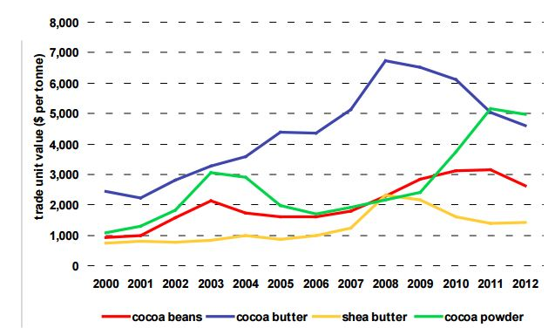

Fig. 17: Price trends of CB and CBEs

**INDIAN STANDARDS (CHOCOLATE SPECIFICATION)**

The material should be of following types:

a) Milk chocolate,

b) Milk covering chocolate,

c) Plain chocolate,

d) Plain covering chocolate,

e) White chocolate,

f) Filled chocolate,

g) Composite chocolate, and

h) Blended chocolate.

**REQUIREMENTS:**

**Description**

The material should be a smooth homogeneous cocoa product obtained by the grinding of cocoa nibs from mature, sound and wholesome cocoa beans, which have been properly fermented, dried and roasted. This may also be obtained by dispensing cocoa butter in low-fat cocoa powder. The chocolate shall not contain any vegetable fat other than cocoa butter.

The material shall have a colour, taste and flavour characteristic of good chocolate and shall be free from rancidity or other off odour, insect and fungus infestations, filth, added colouring matter except in the case of filled chocolates, adulterants, and harmful or injurious foreign matter.

**PACKING**

The bulk chocolates shall be packed in clean, sound and odour-free containers made of tin-plate, plastic, grease-proof paper, aluminum foil, cellulose film or other suitable flexible packing material (food grade) as agreed to between the purchaser and the vendor. In case of moulded chocolates bars, each unit of chocolate shall be wrapped in aluminium foil, printed or otherwise, and may be lined with glassine or greaseproof paper. Such units may be overwrapped. These units, in turn, shall be collectively packed in clean and odour-free cartons.

|  |  |  |
| --- | --- | --- |
| Sl.No | Characteristics | Requirements  for |
|  |  | Milk Chocolate | Milk covering chocolate | Plain chocolate | Plain covering chocolate | White chocolate | Blended chocolate |
| 1 | Total Fat (on dry basis) % by mass (min) | 25 | 29 | 25 | 29 | 25 | 25 |
| 2 | Milk fat (on dry basis) % by mass (min) | 2 | 2 | - | - | 2 | - |
| 3 | Cocoa solids (moisture free and fat free basis) % by mass (min) | 2.5 | 2.5 | 12 | 12 | - | 3 |
| 4 | Milk solids (moisture free and fat free basis) % by mass |  |  |  |  |  |  |
|  | Min | 10.5 | 10.5 | - | - | 10 | 1 |
|  | Max | - | - | - | - | - | 9 |
| 5 | Sugar (sucrose) % by mass (max) | 55 | 55 | 60 | 60 | 55 | 60 |
| 6 | Acid insoluble ash % by mass(max) | 0.2 | 0.2 | 0.2 | 0.2 | 0.2 | 0.2 |

**CRYSTALLISATION**

Crystallisation is the process by which crystal nuclei are formed and grow based on a thermodynamic driving force.