**PRANVEER SINGH INSTITUTE OF TECHNOLOGY, KANPUR**

**DEPARTMENT OF COMPUTER SCIENCE & ENGINEERING**

**Odd Semester 2023-24**



**B. Tech.- Third Year**

## Semester- V

Lab File

**Design and Analysis of Algorithm (KCS553)**

|  |  |  |  |
| --- | --- | --- | --- |
| **Submitted To :** | | **Submitted By :** | |
| **Faculty Name** | **:** | **Name** | **:** |
| **Designation** | **:** | **Roll No.** | **:** |
|  |  | **Section** | **:** |

# Table of Contents

## Vision and Mission Statements of the Institute

* **Vision and Mission Statements of the Department**

## PEOs, POs, PSOs of the Department

* **Course Objective and Outcomes**

## List of Experiments

* **Index**

## Department Vision Statement

To be a recognized Department of Computer Science & Engineering that produces versatile computer engineers, capable of adapting to the changing needs of computer and related industry.

## Department Mission Statements

The mission of the Department of Computer Science and Engineering is:

1. To provide broad based quality education with knowledge and attitude to succeed in Computer Science & Engineering careers.
2. To prepare students for emerging trends in computer and related industry.
3. To develop competence in students by providing them skills and aptitude to foster culture of continuous and lifelong learning.
4. To develop practicing engineers who investigate research, design, and find workable solutions to complex engineering problems with awareness & concern for society as well as environment.

## Program Educational Objectives (PEOs)

1. The graduates will be efficient leading professionals with knowledge of computer science & engineering discipline that enables them to pursue higher education and/or successful careers in various domains.
2. Graduates will possess capability of designing successful innovative solutions to real life problems that are technically sound, economically viable and socially acceptable.
3. Graduates will be competent team leaders, effective communicators and capable of working in multidisciplinary teams following ethical values.
4. The graduates will be capable of adapting to new technologies/tools and constantly upgrading their knowledge and skills with an attitude for lifelong learning

## Department Program Outcomes (POs)

The students of Computer Science and Engineering Department will be able:

* 1. **Engineering knowledge:** Apply the knowledge of mathematics, science, Computer Science & Engineering fundamentals, and an engineering specialization to the solution of complex engineering problems.
  2. **Problem analysis:** Identify, formulate, review research literature, and analyze complex engineering problems reaching substantiated conclusions using first principles of mathematics, natural sciences, and Computer Science & Engineering sciences.
  3. **Design/development of solutions:** Design solutions for complex Computer Science & Engineering problems and design system components or processes that meet the specified needs with appropriate consideration for the public health and safety, and the cultural, societal, and environmental considerations.
  4. **Investigation:** Use research-based knowledge and research methods including design of experiments, analysis and interpretation of data, and synthesis of the information to provide valid conclusions.
  5. **Modern tool usage:** Create, select, and apply appropriate techniques, resources, and modern engineering and IT tools including prediction and modelling to complex Computer Science & Engineering activities with an understanding of the limitations.
  6. **The Engineering and Society:** Apply reasoning informed by the contextual knowledge to assess societal, health, safety, legal and cultural issues and the consequent responsibilities relevant to the professional engineering practice in the field of Computer Science and Engineering.
  7. **Environment and sustainability:** Understand the impact of the professional Computer Science & Engineering solutions in societal and environmental contexts, and demonstrate the knowledge of, and need for sustainable development.
  8. **Ethics:** Apply ethical principles and commit to professional ethics and responsibilities and norms of the Computer Science & Engineering practice.
  9. **Individual and team work:** Function effectively as an individual, and as a member or leader in diverse teams, and in multidisciplinary settings.
  10. **Communication:** Communicate effectively on complex Computer Science & Engineering activities with the engineering community and with society at large, such as, being able to comprehend and write effective reports and design documentation, make effective presentations, and give and receive clear instructions.
  11. **Project management and finance:** Demonstrate knowledge and understanding of the Computer Science & Engineering and management principles and apply these to one’s own work, as a member and leader in a team, to manage projects and in multidisciplinary environments.
  12. **Life-long learning:** Recognize the need for, and have the preparation and ability to engage in independent and life-long learning in the broadest context of technological change.

## Department Program Specific Outcomes (PSOs)

The students will be able to:

* + 1. Use algorithms, data structures/management, software design, concepts of programming languages and computer organization and architecture.
    2. Understand the processes that support the delivery and management of information systems within a specific application environment.

## Course Outcomes

|  |  |  |  |
| --- | --- | --- | --- |
| **\*Level of Bloom’s Taxonomy** | **Level to be met** | **\*Level of Bloom’s Taxonomy** | **Level to be Met** |
| L1: Remember | 1 | L2: Understand | 2 |
| L3: Apply | 3 | L4: Analyze | 4 |
| L5: Evaluate | 5 | L6: Create | 6 |

|  |  |
| --- | --- |
| **CO Number** | **Course Outcomes** |
| **KCS-551.1** | Implement algorithm to solve problems by iterative approach. |
| **KCS-551.2** | Implement algorithm to solve problems by divide and conquer approach |
| **KCS-551.3** | Implement algorithm to solve problems by Greedy algorithm approach. |
| **KCS-551.4** | Implement algorithm to solve problems by Dynamic programming, backtracking, branch and bound approach. |
| **KCS-551.5** | Implement algorithm to solve problems by branch and bound approach |

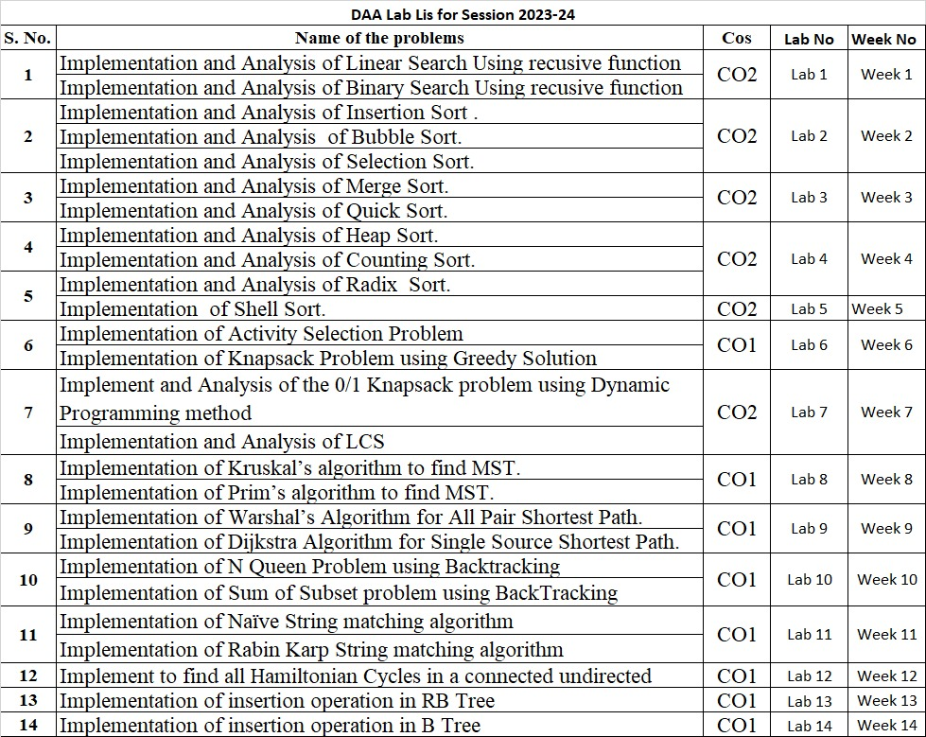

**INDEX**

|  |  |  |  |  |  |
| --- | --- | --- | --- | --- | --- |
| **S**  **No** | **Lab Experiment** | **Date of**  **Experiment** | **Date of**  **Submission** | **Marks** | **Faculty**  **Signature** |
| **1** |  |  |  |  |  |
| **2** |  |  |  |  |  |
| **3** |  |  |  |  |  |
| **4** |  |  |  |  |  |
| **5** |  |  |  |  |  |
| **6** |  |  |  |  |  |
| **7** |  |  |  |  |  |
| **8** |  |  |  |  |  |
| **9** |  |  |  |  |  |
| **10** |  |  |  |  |  |
| **11** |  |  |  |  |  |
| **12** |  |  |  |  |  |
| **13** |  |  |  |  |  |
| **14** |  |  |  |  |  |