# SYNOPSIS ON

**“TITLE OF THE PROJECT”**

Submitted in

Partial Fulfillment of requirements for the Award of Degree

*of*

Bachelor of Technology

*In*

Computer Science and Engineering

By

**(Project Id: )**

**Student Name (Roll No) Student Name (Roll No) Student Name (Roll No) Student Name (Roll No) Student Name (Roll No)**

Under the supervision of **Supervisor Name (Designation)**



# Pranveer Singh Institute of Technology.

Kanpur - Agra - Delhi National Highway - 19 Bhauti -Kanpur - 209305.

(Affiliated to Dr. A.P.J. Abdul Kalam Technical University)

## Introduction

The introduction part will include the brief introduction about the project to be developed, field of project (if specialized one), any special technical terms about the project

## (should not exceed 1 page).

1. **Project Objective**

Project objectives are **what you plan to achieve by the end of your project**. Objectives should be clearly specified. What the project ends up to and in what way it is going to help the end user to be mentioned.

## Feasibility Study:

Feasibility Study analyses whether the proposed business ideas will succeed or fail. It determines the practicality by assessing the opportunities and threats of the proposed plan. There are different types of studies to check feasibility, such as **technical feasibility, operational feasibility, economic feasibility, schedule feasibility and legal feasibility. (Prepare a Gantt Chart to represent your project schedule.)**

**Start Date: 05-sep-2023 End Date: 30-Nov-2023.**

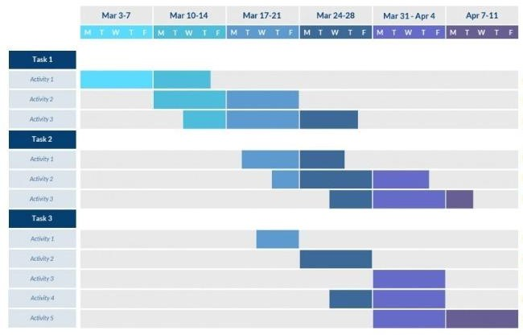

## Methodology/ Planning of work

Methodology will include the steps to be followed to achieve the objective of the project during the project development. This is to be supported by **Architecture Diagram/ DFD/ ER/ Class diagram** to explain the flow of information.

## Tools/Technology Used:

* 1. **Minimum Hardware Requirements**
     + **CPU:** Intel core i5, AMD Ryzen 5
     + **RAM:** 8 GB
     + **GPU:** NVIDIA
     + **HDD:** 500 GB
     + **Others(if any):** NIC, SD, Wifi
  2. **Minimum Software Requirements**
     + **OS :** Windows 11

## References: [IEEE format]:

1. Interoperability and Security in Wireless Body Area Network Infrastructures Conference Paper in Conference proceedings: ... Annual International Conference of the IEEE Engineering in Medicine and Biology Society. IEEE Engineering in Medicine and Biology Society. Conference · February 2005
2. Wireless body-area network monitoring with ZigBee, 5G and 5G with MIMO for outdoor environments Ahmed Mohammed Qasim Kamil Al-Asadi1, Karrar Shakir Muttair2, Ahmed Ghanim Wadday3, Mahmood Farhan Mosleh4 1Al-Najaf Al-Ashraf International Airport, Najaf, Iraq 2Department of Computer Techniques Engineering, College of Technical Engineering, The Islamic University, Najaf, Iraq 3Engineering Technical College, Al-Furat Al Awsat Technical University, Najaf, Iraq 4Department of Computer Engineering Techniques, Electrical Engineering Technical College, Middle Technical University, Baghdad.
3. International Journal of Engineering and Innovative Technology (IJEIT) Volume 1, Issue 1,January 2012 . A Review on 5G Technology . Suvarna Patil, Vipin Patil, .Pallavi Bhat
4. 5G and wireless body area networks Conference Paper · April 2018 Conference Paper · April 2018
5. From 5Gtobeyond5G: AComprehensive Survey of Wireless Network Evolution, Challenges, and Promising Technologies Ali Sufyan 1,* , Khan Bahadar Khan 1, Osama A. Khashan 2,* , Talha Mir 3 and Usama Mir 4. Department of Information and Communication Engineering, The Islamia University of Bahawalpur (IUB),Bahawalpur 63100, Pakistan Research and Innovation Centers, Rabdan Academy, Abu Dhabi 114646, United Arab Emirates Department of Electronic Engineering, Baluchistan University of IT, Engineering and Management Sciences (BUITEMS), Quetta 87300, Pakistan Department of Computer Science, University of Windsor, Windsor, ON N9B 3P4, Canada Correspondence: ali.sufyan@iub.edu.pk (A.S.); okhashan@ra.ac.ae (O.A.K.)