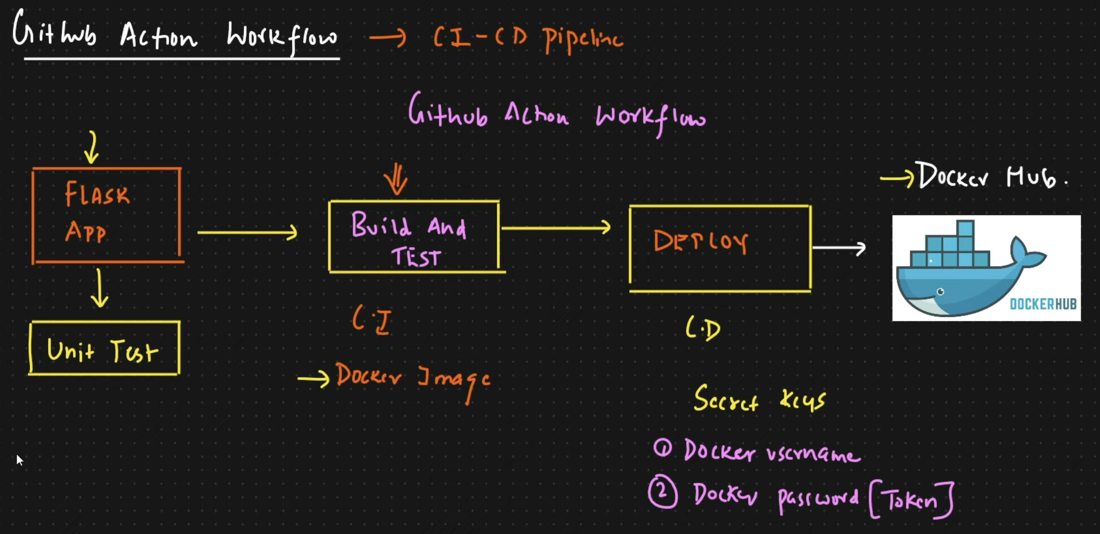

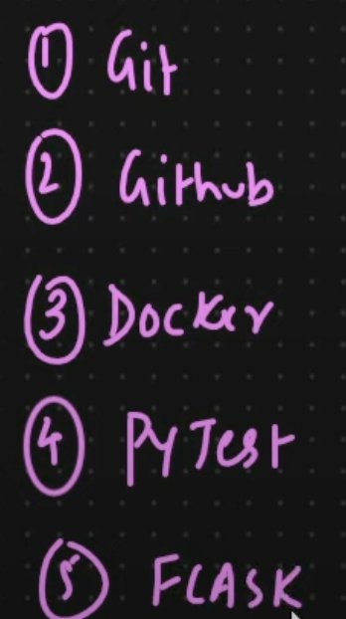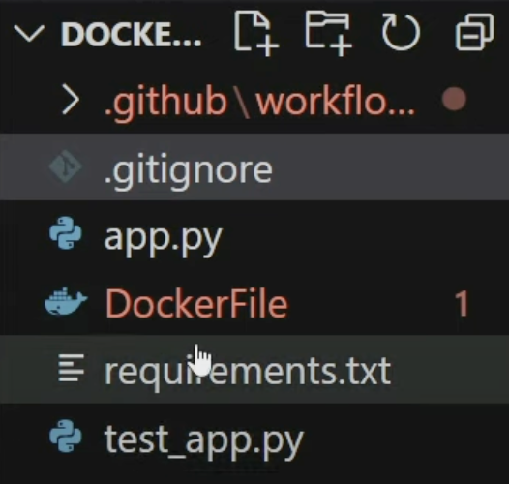

for macbook:

create a new folder

drag and drop to vs code

open terminal window 🡪 zsh

terminal must in that folder 🡪 ex: (base) kishore@kishores-MacBook-Air **22-TO-24S_Langchain** %

(base) kishore@kishores-MacBook-Air 22-TO-24S_Langchain % **python3 -m venv .venv**

Create any python file 🡪 demo.py 🡪 print(“hello”)🡪 **python demo.py** 🡪 o/p: hello

See the python version at **bottom of terminal** window or at above in **Select Interpreter**

Select recommended from above select interpreter

Activate venv: Terminal 🡪 **source .venv/bin/activate**

Installing: terminal 🡪 **pip3 install pandas**

python --version

pip install -r requirements.txt

**create a new repository on the command line**

echo "# dockerImageHub2" >> README.md

git init

git add README.md

git add .

git commit -m "first commit"

git branch -M main

git remote add origin https://github.com/ksr2312/dockerImageHub2.git

git push -u origin main

**push an existing repository from the command line**

git remote add origin https://github.com/ksr2312/dockerImageHub2.git

git branch -M main

git push -u origin main