Choose the Right Hardware

Proposal Template filled by KS Rajanbabu

# Scenario 1: Manufacturing

Client Requirements and Potential Hardware Solution

Look through the scenario and find any relevant client requirements. Then, suggest a potential hardware type and explain how this hardware would satisfy each of the requirements.

|  |
| --- |
| **Which hardware might be most appropriate for this scenario?**  **(CPU / IGPU / VPU / FPGA)** |
| *IGPU-* [Intel HD Graphics 500](https://devcloud.intel.com/edge/devices/intel-hd-500-gpu/) |

|  |  |
| --- | --- |
| **Requirement Observed**  **(Include at least two.)** | **How does the chosen hardware meet this requirement?** |
| *Example requirement:*  Monitor/Identify number of people in production line | *Using CPU and IGPU installed open vino product with 24*7 running* |
| *Using existing vision camera* | *Using New Graphics PC* |
| *Chips package monitor* | *High precessions object detection it is second phase based this choose IGPU* |
| *Easily re programmable for chip new design scan* | *If it is HD graphic pc it can easily upgradeable new design change and learned rate* |

## Queue Monitoring Requirements

|  |  |
| --- | --- |
| **Maximum number of people in the queue** | *9* |
| **Model precision chosen (FP32, FP16, or Int8)** | *FP32* |

## Test Results

After you've tested your application on all four hardware types (CPU, IGPU, VPU, and FPGA), copy the matplotlib output showing the comparison into the spaces below. You should have three graphs (for model load time, inference time, and FPS).

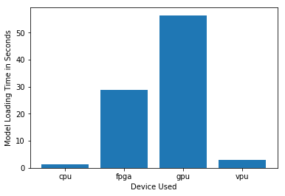

***Model Load Time***

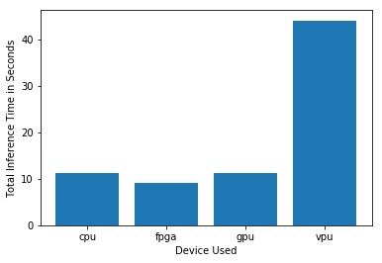

***Inference Time***

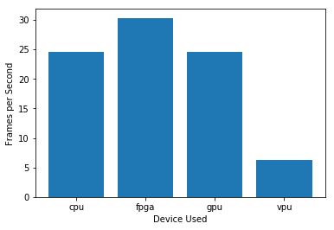

***FPS***

## Final Hardware Recommendation

Now synthesize your points from above and provide a brief write-up describing why the chosen hardware is the best choice for this scenario. Be sure to discuss the client's requirements, the test results, and how these relate to one another (e.g., perhaps one of the devices performed better than the rest, but does not meet one of the client's requirements).

|  |
| --- |
| **Write-up: Final Hardware Recommendation** |
| *CPU-* [Intel Core i5 6500TE](https://devcloud.intel.com/edge/devices/intel-core-i5-6500te-cpu/) |

# 

# 

# Scenario 2: Retail

Client Requirements and Potential Hardware Solution

Look through the scenario and find any relevant client requirements. Then, suggest a potential hardware type and explain how this hardware would satisfy each of the requirements.

|  |
| --- |
| **Which hardware might be most appropriate for this scenario?**  **(CPU / IGPU / VPU / FPGA)** |
| *CPU* |

|  |  |
| --- | --- |
| **Requirement Observed**  **(Include at least two.)** | **How does the chosen hardware meet this requirement?** |
| *Example requirement:*  Client want to utilize existing Intel I7 processor PC/Terminal | *Example explanation:*  I choose their running old PC/Terminal which are Intel I7-processor |
| *[Faster Billing and checkout* | *Giving alert information on display free counter assistant* |
|  |  |
|  |  |

## Queue Monitoring Requirements

|  |  |
| --- | --- |
| **Maximum number of people in the queue** | *2* |
| **Model precision chosen (FP32, FP16, or Int8)** | *FP32* |

## Test Results

After you've tested your application on all four hardware types (CPU, IGPU, VPU, and FPGA), copy the matplotlib output showing the comparison into the spaces below. You should have three graphs (for model load time, inference time, and FPS).

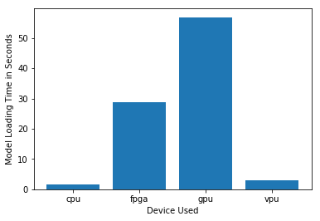

***Model Load Time***

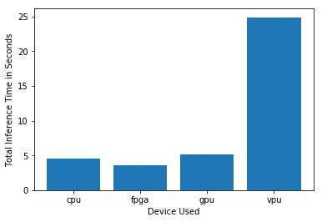

***Inference Time***

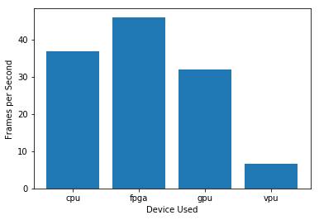

***FPS***

## Final Hardware Recommendation

Now synthesize your points from above and provide a brief write-up describing why the chosen hardware is the best choice for this scenario. Be sure to discuss the client's requirements, the test results, and how these relate to one another (e.g., perhaps one of the devices performed better than the rest, but does not meet one of the client's requirements).

|  |
| --- |
| **Write-up: Final Hardware Recommendation** |
| *CPU-* [Intel Core i5 6500TE](https://devcloud.intel.com/edge/devices/intel-core-i5-6500te-cpu/) |

# 

# 

# Scenario 3: Transportation

Client Requirements and Potential Hardware Solution

Look through the scenario and find any relevant client requirements. Then, suggest a potential hardware type and explain how this hardware would satisfy each of the requirements.

|  |
| --- |
| **Which hardware might be most appropriate for this scenario?**  **(CPU / IGPU / VPU / FPGA)** |
| *VPU* |

|  |  |
| --- | --- |
| **Requirement Observed**  **(Include at least two.)** | **How does the chosen hardware meet this requirement?** |
| *Example requirement:*  Decongest queues for boarding | *Need to implement new hardware* |
| *No extra process available in local pc/Video encoder* | *Need to purchase* |
| *Able to spent up to 300$ per system* | *Intel-vcs2 stick* |
|  |  |

## Queue Monitoring Requirements

|  |  |
| --- | --- |
| **Maximum number of people in the queue** | 9 |
| **Model precision chosen (FP32, FP16, or Int8)** | *FP32* |

## Test Results

After you've tested your application on all four hardware types (CPU, IGPU, VPU, and FPGA), copy the matplotlib output showing the comparison into the spaces below. You should have three graphs (for model load time, inference time, and FPS).

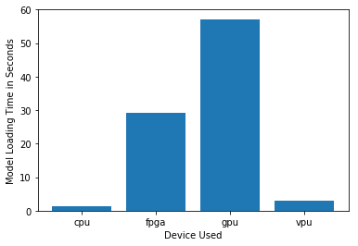

***Model Load Time***

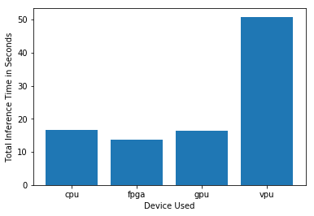

***Inference Time***

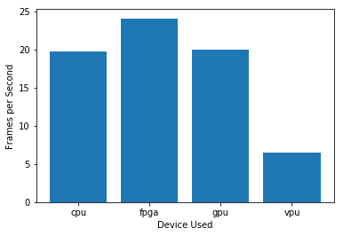

***FPS***

## Final Hardware Recommendation

Now synthesize your points from above and provide a brief write-up describing why the chosen hardware is the best choice for this scenario. Be sure to discuss the client's requirements, the test results, and how these relate to one another (e.g., perhaps one of the devices performed better than the rest, but does not meet one of the client's requirements).

|  |
| --- |
| **Write-up: Final Hardware Recommendation** |
| *FPGA* |

# 