Kazakhstan's Resource Economy   
in the Age of Global Value Chains

This draft: 31 July 2021

Contents

Tables, Figures, and Boxes 3

Foreword 5

Acknowledgments 6

Abbreviations 7

Highlights 8

1 Introduction 13

2 Overview of Economy and Trade 16

3 Participation in Global Value Chains 23

4 Specialization and Competitiveness 34

5 Special Topics 44

The South Asian Association for Regional Cooperation 44

Agglomeration 49

The COVID-19 Shock 53

6 Conclusion 59

References 62

Appendices 66

# Tables, Figures, and Boxes

**Tables**

Table A1: Economies in the ADB Multiregional Input–Output Database 66

Table A2: Sectors in the ADB Multiregional Input–Output Database 68

**Figures**

Figure ‎2.1: Real Gross Domestic Product Growth Rate, Pakistan, 1980–2026 16

Figure ‎2.2: Trade Openness at Various Levels of Economic Development, 2019 18

Figure ‎2.3: International Merchandise Trade, 2019 19

Figure ‎2.4: Merchandise Exports by Broad Product Groupings, Pakistan, 2002–2019 20

Figure ‎2.5: Merchandise Export Diversification, Selected Countries, 2005, 2010, 2015, 2019 22

Figure ‎3.1: Decomposition of Exports into Value-Added Categories, Pakistan, 2000, 2007–2020 26

Figure ‎3.2: Top Ten Trading Partners by Value-Added Category, Pakistan, 2020 27

Figure ‎3.3: Global Value Chain Participation Rates, Pakistan, 2000, 2007–2020 28

Figure ‎3.4: Global Value Chain Participation Rates, Selected Countries, 2000, 2010, 2020 28

Figure ‎3.5: Decomposition of Exports into Value-Added Categories by Sector, Pakistan, 2020 29

Figure ‎3.6: GVC Production Lengths by Sector, Pakistan, 2000, 2010, 2020 32

Figure ‎3.7: Forward GVCs Lengths for Selected Sectors, Pakistan, 2000, 2010, 2019, 2020 33

Figure ‎4.1: Revealed Comparative Advantage Indices, Pakistan, 2020 36

Figure ‎4.2: Positioning in Textile and Agriculture GVCs, Selected Countries, 2010 and 2020 37

Figure ‎4.3: Real Effective Exchange Rate Weights, Selected Sectors, Pakistan, 2010–2020 39

Figure ‎4.4: Change in Real Effective Exchange Rate Index, Pakistan and Cambodia, Selected Sectors, 2010–2019 41

Figure ‎4.5: Real Effective Exchange Rate Mean and Volatility, 2010–2019 42

Figure ‎5.1: Regional Concentration Indices, Selected RTAs, 2000, 2007–2020 46

Figure ‎5.2: Skyline Chart for the SAARC Countries, 2020 48

Figure ‎5.3: Backward and Forward Agglomeration Indices, 2007, 2010, 2007 52

Figure ‎5.4: Agglomeration Map, Textiles, 2010, 2019 53

Figure ‎5.5: The COVID-19 Shock to Growth Under Varying Rates of GVC Participation 55

Figure ‎5.6: The COVID-19 Shock under Different Trade Scenarios, Selected Economies 58

**Boxes**

Box 1: The Asian Development Bank Multiregional Input–Output Database 13

Box 2: Resource Curse 18

Box 3: Export Diversification 23

Box 3: Decomposing Exports into Value-Added Categories 26

Box 4: Measuring Average Production Lengths 32

Box 5: Calculating the Revealed Comparative Advantage Index 36

Box 6: Calculating the Real Effective Exchange Rate Index 40

Box 7: Calculating the Regional Concentration Index 47

Box 8: Constructing the Skyline Chart 49

Box 9: Constructing the Agglomeration Index 52

Box 10: Estimating the COVID-19 Shock 56

Box 11: The COVID-19 Shock under Different Trading Scenarios 58

# Foreword

Joint foreword ERCD and IsDB

# Acknowledgments

This report is the product of an ongoing collaboration between the Asian Development Bank (ADB) and the Islamic Development Bank (IsDB) in providing knowledge solutions to key socioeconomic issues. It was written by Kenneth Anthony Luigi Reyes under the direction of Mahinthan Joseph Mariasingham, with inputs from [...]. The participation of [...] from IsDB is also acknowledged.

Many of the indicators featured here were computed using the ADB Multi-Regional Input–Output Database, a resource maintained by an ADB team led by Mahinthan Joseph Mariasingham and comprising John Arvin Bernabe, Julieta Magallanes, Sarah Mae Manuel, and Ana Francesca Rosales. Additional assistance was provided by [...].

XX edited the publication. The cover was designed by XX and XX led the typesetting process. Eric Suan organized and coordinated the preparation of this report. The publishing team in ADB’s Department of Communications and Office of Administrative Services Logistics Management Unit (Printing) provided general guidance on production issues.

# Abbreviations

ADB Asian Development Bank

ASEAN Association of Southeast Asian Nations

COVID-19 Coronavirus disease 2019

DAVAX Directly absorbed value-added exports

DVA Domestic value added

FVA Foreign value added

GDP Gross domestic product

GVC Global value chain

GVCP GVC participation rate

HHI Herfindahl-Hirschman Index

HS Harmonized system

IMF International Monetary Fund

IsDB Islamic Development Bank

METI Japan Ministry of Economy, Trade and Industry

MRIO Multiregional Input–Output

NAFTA North American Free Trade Agreement

PDC Pure double-counting

PRC People’s Republic of China

RCA Revealed comparative advantage

RCI Regional concentration index

REER Real effective exchange rate

REF Reflection

REX Reexports

RTA Regional trade agreement

SAARC South Asian Association for Regional Cooperation

VAX Value-added exports

WIOD World Input–Output Database

WTO World Trade Organization

# Highlights

This report examines the economy and trade of Pakistan in the context of global value chains (GVCs) during the period 2000–2020. It combines innovative analytical tools with the latest available data to produce indicators that describe facets of Pakistan’s GVC participation, the lengths of its GVC production, its patterns of specialization, and the price competitiveness of its exports—among many others.

**Overview of Economy and Trade**

* Pakistan has had an uneven growth experience. After an average annual gross domestic product (GDP) growth rate of 6.4% in the 1980s, its decade averages have since been below 5%. Many workers remain employed in low-productivity jobs in agriculture and the informal sector. Per capita GDP is similar to Bangladesh and Cambodia but is behind other developing countries in Asia and the Pacific like the Philippines and Viet Nam. Nevertheless, it is to Pakistan’s credit that it had managed to cut poverty from 64% in 2001 to 24% in 2015 under national poverty lines.
* One viable strategy that Pakistan can adopt to boost its growth is to further open its economy to trade. At just 30%, Pakistan exhibits one of the lowest trade-to-GDP ratios in the world, even when taking its size into account. This indicates great potential for improvement. Studies have affirmed numerous benefits to economic openness, including opportunities for specialization, access to wider markets, the inflow of know-how, and the formalization of the economy.
* Existing patterns indicate that Pakistan’s trade is currently oriented to the United States, Europe, and the People’s Republic of China (PRC). It specializes in textiles, though some of its agriculctural products are sold to the Middle East. Interestingly, it does not have a significant trading relationship with its proximate neighbors in South Asia.
* While the vast majority of its export products fall under the textiles group, formal measures of export concentration suggest that Pakistan’s exports basket is relatively more diversified than other textiles-heavy exporters like Bangladesh and Cambodia. However, its exports are less diversified than its neighbor India.

**Participation in GVCs**

* Decomposing the value added origins and destinations of Pakistan’s exports illuminates much about its participation in GVCs. It is found that a large portion of its exports fall under direct trading, the simplest kind of trade where value added solely from Pakistan is sent to and absorbed completely by the importing partner. In 2020, this amounted to $18.9 billion against gross exports of $24.7 billion. Indirect trading involves foreign value added entering into countries’ production. Such are the cross-border production-sharing arrangements that mark GVCs. In 2020, Pakistan’s indirect trading amounted to $5.8 billion.
* Decomposing trade by value added reveals indirect trading relationships that are masked by conventional trade data. Some 15.8% of Pakistan’s exports that would undergo reexporting made their first landing in the PRC. Bangladesh also gets a prominent role, receiving 7.8% of exports that would undergo reexporting. On the other hand, some 17.4% of the imported inputs embedded in Pakistan’s exports came from the PRC, followed by 12.8% that came from the United States.
* Quantifying the importance of GVCs is the GVC participation rate. Two approaches are possible: a trade-based approach, which looks at the share of indirect trading in exports, and a production-based approach, which looks at the share of domestic value added (i.e. GDP) that is exported in an unfinished state. Pakistan’s GVC participation rates are low. While other developing countries, notably Viet Nam and Cambodia, have greatly expanded their GVC engagement since 2000, Pakistan’s rates have stayed within a tight range over the course of two decades. At the sector level, water transport services and metals had the highest participation rates, though textiles remained the largest in terms of the absolute level of GVC-related exports.
* Another way to characterize GVCs is to measure their lengths. Any given firm may be positioned in its value chain by measuring, on the one hand, the number of stages separating its output from final consumers, and on the other, the number of stages separating its output from primary inputs. These are forward and backward production lengths, respectively. Total GVC length for Pakistan was 7.58 stages in 2000, rising to 8.03 in 2010, then rising more modestly to 8.18 by 2020. Across sectors, the general conclusion is that lengths increased between 2000 and 2010 but decreased between 2010 and 2020.
* Decomposing forward lengths suggests that Pakistan exports relatively simple types of textile products, relying on foreign processing—about 2.09 stages in 2020—to produce the finished goods that reach consumers. Exports of agricultural products, meanwhile, undergo both domestic and foreign processing—about 2.26 and 2.09 stages, respectively, in 2020.

**Specialization and Competitiveness**

* The concept of comparative advantage is operationalized by the revealed comparative advantage (RCA) index, a ratio that compares the share of a sector in a given country’s exports to the average share of that sector across all countries. An RCA index of greater than 1 indicates a comparative advantage in that sector. Using GVC-adjusted measures, Pakistan heavily specializes in textiles (RCA of 10.2) and agriculture (RCA of 6.4). It registered very low RCA indices for the manufacturing sectors.
* A question arises on where along these value chains Pakistan is finding its niche: in the upstream sections (closer to primary producers), the downstream sections (closer to final consumers), or somewhere in the middle? The GVC position index suggests that the top textiles-specializing countries were in the downstream end, and Pakistan was no exception. It tended to use designs from abroad to produce textile products that, with little further processing, went straight to final consumers. In contrast, Pakistan was the only one in the upstream region among the agriculture-specializing countries, suggesting that its products undergo plenty of further processing abroad before final consumption.
* The real effective exchange rate (REER) is a price index that measures changes in a country’s price competitiveness relative to its competitors. If the REER goes up, then the country’s prices have gone up relative to its competitors; thus, it is said to have lost in competitiveness. Likewise, if the REER goes down, then it has gained in competitiveness.
* Pakistan’s REER indices for textiles and agriculture are strongly correlated, with both experiencing high appreciation in 2011 and modest depreciation in 2018–2019. This may be concerning since it implies little diversification in Pakistan’s export competitiveness. Moreover, the modest depreciations the two sectors registered in 2018–2019 were overshadowed by a much larger depreciation in the aggregate REER, suggesting a boost in overall competitiveness that appears to have been dampened by Pakistan’s largest sectors.
* Countries are generally advised to try and aim for stable currencies. Measuring volatility by the standard deviation in changes in the REER index over 2010–2019, Pakistan’s 8.3 points was one of the highest among the countries and economies included in the ADB MRIO. It is more volatile than like countries Bangladesh, Cambodia, Sri Lanka, and Viet Nam. This makes any effort to expand its external sector more challenging.

**Other Topics in GVCs**

* As globalization picked up pace in the 1990s, so did initiatives to deepen and regulate trade on a regional basis. Beginning in the 1980s, the countries of South Asia began to abandon the import-substitution policies they had followed since independence in favor of trade liberalization, establishing the South Asian Association for Regional Cooperation (SAARC) in 1985 to promote dialogue. Through the SAARC, the South Asian Preferential Trade Area was established in 1995 and expanded into the South Asian Free Trade Area in 2006. Its members are Afghanistan, Bangladesh, Bhutan, India, Maldives, Nepal, Pakistan, and Sri Lanka.
* The regional concentration index (RCI) quantifies the extent of regional integration using value-added-adjusted trade flows, where an index of greater than 1 implies the region’s members are trading with each other more than expected. By this measure, the SAARC bloc is less integrated than other blocs like Association of Southeast Asian Economies, the European Union, and the North American Free Trade Agreement.
* Regional integration may also be visualized with a skyline chart, which represents each sector as a “tower” whose width is its share in the region’s output and whose height is its output expressed as a share of the portion induced by domestic demand. Its main purpose is to show where the region is self-sufficient in, these being the sectors for which its own internal demand is enough to exhaust its output. The skyline chart for SAARC makes evident the economic structure of its members, with a large share attributable to agriculture for which the region is just about self-sufficient. Its most export-oriented sector is unsurprisingly textiles, for which output is 1.5 times the amount the region demands. The SAARC’s manufacturing demand is generally dependent on imports, its output in metals, electricals, transport equipment, and other machinery meeting just 80% of its own demand.
* Domestic linkages add a layer of complexity in a country’s role in GVCs. Largely due to trade barriers, domestic linkages play a significant role in Pakistan. An agglomeration index that measures how much value added is sourced from and/or absorbed by domestic sectors relative to the rest of the world suggests that on average, production in Pakistan generate more value added to domestic sectors compared to neighbors Bangladesh, India, the PRC, and Sri Lanka.
* Various combinations of high and low backward and forward agglomeration indices give four distinct classes: reshoring, high agglomeration, low agglomeration, and domestic value-added generating. Focusing on the textiles sector, Pakistan, along with India, belongs to the high agglomeration class. This implies high backward and forward agglomeration in both countries’ textiles sector.
* The coronavirus disease 2019 (COVID-19) pandemic that began in 2020 set off unprecedented disruptions to economic activity and trade. Preliminary data in the ADB MRIO suggest an inverted-U relationship where the size of the COVID-19 shock increases (that is, becomes more negative) the higher the GVC participation rate up to about 45%, after which the shock decreases the higher the participation rate. Pakistan fits the pattern as it had both a low GVC participation rate (25.4%) and a relatively mild COVID-19 shock (–2.8 points).
* Counterfactual analysis shows that different countries experienced different outcomes from GVCs. In Pakistan’s case, the analysis suggests that without any trade, its pandemic-induced contraction would have been 0.5 percentage points larger, meaning GVCs had a dampening effect. The opposite is found for a country like Sri Lanka, where the presence of trade relative to no trade increases the size of its contraction.

**Reaping the Benefits of GVC Involvement**

* Having among the lowest GVC participation rates in the world, the Pakistan economy is primed to benefit enormously from adopting a more outward-oriented development strategy. Provided that it does so in a careful and deliberate manner, its already impressive achievements in poverty reduction can be pushed further. The following are some principles in must keep in mind.
* **Diversification.** The key to managing many types of risk is diversification. In the case of GVCs, Pakistan would do well to diversify not just its export basket but also the markets it sells to. Specialization in textiles is not necessarily an unsound strategy, but Pakistan must ensure that within this sector, its firms are able to participate all along the productivity spectrum and are not stuck in low-value-added segments. While its trade partners seem diversified, a trade-to-GDP ratio of 30% implies that Pakistan’s producers are in effect concentrated in a single market: its own. Greater trade participation, then, will in itself diversify the country’s sources of demand.
* **Investing in people.** Apart from its worthy contribution to welfare, investing in human capital yields significant returns when paired with the opportunities provided by GVCs. The services sector is already a proven driver of poverty reduction in Pakistan, albeit through the informal economy. Such talent can be turned to more productive employment in the global business process outsourcing industry. Indeed, the experiences of India and the Philippines have shown that manufacturing need no longer be synonymous with an export-led development strategy.
* **Institutional support.** Institutions must be responsive to the temporary disruptions that arise from opening up to trade. Policies must be designed to ensure that no group suffers too great a drop in welfare and that all have a path to participating gainfully in the external sector. Moreover, since good policy design requires plenty of timely information, support must be given to data-collecting agencies.
* **Multilateral engagement.** Trade can only thrive in a stable, rules-based global environment where competition is as free and as fair as possible. As such, it is in Pakistan’s interest to strengthen multilateral bodies like the WTO and the SAARC. It must actively participate not only in crafting their rules but also in enforcing them. Moreover, Pakistan must continue to pursue new trade agreements through which it can lower barriers to trade, exchange information, and establish mutual trust.
* **Remembering the basics.** Beyond GVCs, the usual set of principles that promote a robust and dynamic economy must not be neglected. The population must be healthy and educated. Sustained investments in physical infrastructure and information and communications technologies are necessary. Financial markets must be inclusive and well-developed. There must be faith in an impartial court system dedicated to the rule of law. All these provide the foundations upon which long-term growth can be possible.

# Introduction

This report examines the economy and trade of Kazakhstan in the context of global value chains (GVCs), a form of fragmented production that has affected everything from automobiles to vaccines. It combines innovative analytical tools with the latest available data to produce indicators that describe Kazakhstan’s rate of GVC participation, the lengths of its GVC production, its patterns of specialization, and the price competitiveness of its exports—among many others. This report’s key data source is the Asian Development Bank’s (ADB) Multiregional Input–Output (MRIO) Database, the only time series of intercountry input–output tables to-date that includes Kazakhstan. Box 1 provides more information on this dataset. It is hoped that the insights this report presents will prove useful for policymakers and the general public alike.

|  |  |  |  |  |  |  |  |  |  |  |  |  |  |  |  |  |  |  |  |  |  |  |  |  |  |  |  |  |  |  |  |  |  |  |  |  |  |  |  |  |  |  |  |  |  |  |  |  |
| --- | --- | --- | --- | --- | --- | --- | --- | --- | --- | --- | --- | --- | --- | --- | --- | --- | --- | --- | --- | --- | --- | --- | --- | --- | --- | --- | --- | --- | --- | --- | --- | --- | --- | --- | --- | --- | --- | --- | --- | --- | --- | --- | --- | --- | --- | --- | --- | --- |
| Box : The Asian Development Bank Multiregional Input–Output Database  The Asian Development Bank (ADB) Multiregional Input–Output (MRIO) Database is a time series of intercountry input–output tables maintained by a dedicated team in ADB. Information on cross-sectoral linkages are provided for 72 countries for the years 2017–2022 and for 62 countries for the years 2000 and 2007–2016. A residual “Rest of the world” entity is also included, allowing the table to capture the entirety of global flows.  The ADB MRIO Database was originally an extended version of the World Input–Output Database, 2013 release. Each country or economy is divided into 35 sectors, based on Table A2 of Timmer, et al. (2015). There are five final demand categories: household final consumption expenditure (FCE), non-profit institutions serving households FCE, government FCE, gross fixed capital formation, and changes in inventories.  Officially published national supply–use tables (SUTs) and/or input–output tables (IOTs) serve as benchmarks in the construction of the ADB MRIO. In each national SUT or IOT, sectoral and product classifications were harmonized to follow the 35 sectors, and whenever necessary, SUTs were transformed into IOTs following the industry technology transformation assumption discussed in European Commission (2008).  Benchmark IOTs also serve as the base structure for producing time-series of the ADB MRIO tables using published estimates on gross output, gross value added, taxes less subsidies on products, imports, and exports sourced from national statistical agencies and central bank databases as control totals. The structure of imports and exports are based on bilateral trade data extracted from the United Nations COMTRADE Database and government trade and balance of payments statistics. Once the national IOTs are integrated into the MRIO, accounts for the sectors of “Rest of the world” are manually and systematically adjusted to ensure consistency with economy–sector totals in the MRIO.  The basic structure of each of MRIO table is given below. It is composed of **Z**, a matrix of intermediates use; **Y**, a matrix of final demand; **va**, a vector of country-sector value added; and **x**, a vector of output. Read vertically, the table shows the purchases of each country-sector, distinguished between intermediate inputs and primary inputs, the latter also called value added. Read horizontally, it shows the sales of each country-sector, distinguished between intermediate sales and final sales. The market-clearing condition stipulates that total purchases and total sales for each country-sector must equal. This amount is total output.  **A Schematic Representation of the ADB MRIO**   |  |  |  |  |  |  |  |  |  | | --- | --- | --- | --- | --- | --- | --- | --- | --- | |  |  | **Country A** |  | **Rest of the world** | **Country A** |  | **Rest of the world** | **Total output** | |  |  | c1 c35 |  | c1 c35 | f1 f5 |  | f1 f5 | | **Country A** | c1  c35 | **Z** | | | **Y** | | | **x** | |  |  | | **Rest of the world** | c1  c35 | | **Value added** | | **va** | | |  |  |  |  | | **Total output** | | **x** | | |  |  |  |  |   Source: Asian Development Bank. Multiregional Input–Output Database.  **References**  European Commission. 2008. *Eurostat Manual of Supply, Use and Input-Output Tables*. Luxembourg: European Commission. Retrieved from https://ec.europa.eu/eurostat/web/products-manuals-and-guidelines/-/KS-RA-07-013.  M. P. Timmer, E. Dietzenbacher, B. Los, R. Stehrer, and G. J. de Vries. 2015. An Illustrated User Guide to the World Input-Output Database: The Case of Global Automotive Production. *Review of International Economics*. 23(3). pp. 575–605. |

Kazakhstan is a vast, land-locked country that sits at the heart of the Eurasian landmass. Migrants, traders, armies, and pastoral nomads have crossed its steppes for centuries. Historians date the emergence of a distinct Kazakh identity in the 16th century, when tribes sharing a common culture formed a loose federation known as the Kazakh Khanate. It fell under increasing Russian influence in the 18th century, culminating in its incorporation into the Union of Soviet Socialist Republics in the 20th century. Upon the dissolution of that body in 1991, the modern state of Kazakhstan was born (Pavlović 2003).

Following independence, the exploitation of Kazakhstan's sizable oil reserves led to rapid growth, particularly during the 2000s boom in oil prices. It transitioned from lower-middle to upper-middle income status by 2006 according to the World Bank.[1] It has the highest Human Development Index among the states of the former Soviet Union.[2] However, overdependence on an extractive resource sector naturally poses risks, making diversification crucial to Kazakhstan's long-term economic health (Azretbergenova and Syzdykova 2020).

The next chapter examines Kazakhstan's economy and trade in more detail. Chapter 3 introduces an array of indicators obtained from the literature that characterizes Pakistan’s place in international production sharing. Chapter 4 draws further insights into its specialization and competitiveness by refining two classic trade indicators to account for GVCs. A number of special topics are discussed in chapter 5, including its membership in the South Asian Association for Regional Cooperation, its patterns of domestic agglomeration, and its economic performance under the coronavirus pandemic of 2020. Chapter 6 concludes with recommendations for maximizing the benefits of GVCs and minimizing their risks.

# Overview of Economy and Trade

Summary.

Throughout the 1990s, Kazakhstan, along with the other states of the former Soviet Union, faced severe economic dislocation as they transitioned into independent, market-based economies. Hyperinflation struck the region after price controls were lifted in January 1992. Though Kazakhstan replaced the Russian ruble with its own currency, the tenge, in 1993, it was not until 1996 when monthly inflation fell below 50%. Some 1 million people, mostly ethnic Russians, would go on to emigrate (Pomfret 2019). Coal production, once a major industry, fell from 138 million tons in 1989 to 58 million tons in 1999.[3] In real terms, the economy in 1999 was just 63% of its size in 1990.[4]

The economy eventually stabilized and then thrived by 1999, due mainly to a prolonged period of rising oil prices. This enticed foreign capital to invest in the exploitation of Kazakhstan's vast oil reserves, which at 30 billion barrels per day is among the world's largest.[5] For instance, the offshore Kashagan oil field, discovered in 2000, was developed by a consortium of European, American, Chinese, and Japanese firms. New modes of transport were also constructed to complement the Russian state-owned Transneft pipeline, connecting Kazakhstan to broader markets (Pomfret 2019). Consequently, oil production rose steadily from 558,000 barrels per day in 1998 to a peak of 1.7 million barrels per day by 2013.[6] At the height of the boom years in 2000–2007, average annual GDP growth was at 10% (see Figure ‎2.1).

Figure .: Real Gross Domestic Product Growth Rate and Brent Crude Prices, 1990–2028

GDP = gross domestic product

Notes: Forecasts are by the International Monetary Fund as of April 2023.

Sources: International Monetary Fund. World Economic Outlook Database (April 2023). https://www.imf.org/en/Publications/WEO/weo-database/2023/April (accessed 19 June 2023); U.S. Energy Information Administration. https://www.eia.gov/dnav/pet/hist/LeafHandler.ashx?n=PET&s=RBRTE&f=M (accessed 19 June 2023).

Oil prices retreated in 2014 and remained relatively subdued until the 2022 Russian invasion of Ukraine. Kazakhstan saw more moderate GDP growth during this time—an average of 3.1% in 2013–2019. It weathered the COVID-19 pandemic fairly well, suffering a 2.6% contraction before bouncing back in 2021 with a 4.1% growth rate. Kazakhstan grew by a modest 3.2% in 2022 in spite of the oil price spike that should have benefited its economy. One possible explanation why it did not stems from the relative ephemerality of the spike, lasting just a few months rather than the years-long mid-2000s boom. The International Monetary Fund forecasts Kazakhstan's growth to hold steady at an average of 3.3% until 2028.

Kazakhstan's reliance on oil puts it in danger of adverse economic outcomes (ADB 2018). As Box 2 explains, the resource curse refers to how countries with rich extractive resource endowments tend to grow slower than their resource-scarce counterparts. Dutch disease may be one cause, where the resource sector crowds out investments in the non-resource sectors that hold the key to long-run sustainable growth. Indeed, estimates suggest that Kazakhstan's oil reserves will be depleted in 45 years[7], though world demand for oil may peak even before that, resulting in a plunge in prices (Fickling 2022). It is therefore crucial for Kazakhstan to build up its non-oil sector.

|  |
| --- |
| Box : The Resource Curse  Intuition might hold that a country blessed with abundant natural resources is well positioned for rapid growth. But this is not always the case: some studies actually point to *slower* growth for resource-rich countries (Sachs and Warner 2001). Rather than a blessing, there may in fact be a "resource curse" (Auty 1993), especially when the resource is of the extractive type—minerals, petroleum  What causes this? One set of explanations revolve around the Dutch disease hypothesis, which states that a booming resource sector causes the non-resource export sector (e.g. manufacturing) to shrink due to two effects. First, by making the real exchange rate appreciate, it makes non-resource exports less competitive. Second, it draws labor and capital away from the non-resource sector (Corden and Neary 1982). Since manufacturing is associated with learning by doing and other positive externalities, its demise may hamper long-run growth. Moreover, since the global prices of natural resources tend to be volatile, an economy specialized in it will also experience much volatility, hampering growth (van der Ploeg 2011).  Another set of explanations focus on the quality of a country's institutions. The wealth generated by natural resources may facilitate more corruption, rent-seeking, and civil conflict. Governments may be less inclined to invest in non-resource sectors or in building up physical and human capital (van der Ploeg 2011). In these analyses, oil wealth appears to be particularly associated with institutional erosion (Ross 2015).  Because econometrically measuring the impact of natural resources on growth is plagued by measurement and identification issues, the existence of a resource curse is still debated. Resource-rich countries can therefore take heart that the curse is "not cast in stone" (van der Ploeg 2011, p. 385).  **References**  R. M. Auty. 1993. *Sustaining Development in Mineral Economies: The Resource Curse Thesis*. Routledge: London, UK.  W. M. Corden and J. P. Neary. 1982. Booming Sector and De-Industrialisation in a Small Open Economy. *Economic Journal*. 92. pp. 825–848.  M. L. Ross. 2015. The Politics of the Resource Curse: A Review. In C. Lancaster and N. van de Walle (eds.), *The Oxford Handbook of the Politics of Development*, pp. 200–223. Oxford University Press: Oxford, UK.  J. D. Sachs and A. M. Warner. 2001. The Curse of Natural Resources. *European Economic Review*. 45. pp. 827–838.  F. van der Ploeg. 2011. Natural Resources: Curse or Blessing? *Journal of Economic Literature*. 49(2). pp. 366–420. |

Figure ‎2.2 shows that it has some ways to go.

One viable strategy that Pakistan can adopt to boost its growth is to further open its economy to trade. Many studies, including the classic paper by Jeffrey A. Frankel and David Romer (1999), have affirmed that countries who trade more tend to grow faster. The four Asian Tigers—Hong Kong, China; the Republic of Korea; Singapore; and Taipei,China—had famously used an export-oriented development strategy to become advanced economies by the 1990s (Stiglitz 1996), an approach that is now being followed by Viet Nam and Cambodia, among others. Benefits to economic openness include opportunities for specialization, access to wider markets, and the inflow of investments, technology, and know-how. There is also evidence that trade promotes the reallocation of labor from the informal to the formal sector (McCaig and Pavcnik 2018). And whereas it was once thought that industrialization was the primary objective of openness, the experiences of India and the Philippines point to the possibility of services trade being a catalyst for growth as well (Chatterjee and Subramanian 2020; Thomas 2019).

In this regard, shows that Pakistan has a lot of room for improvement. Using statistics from 2019 since 2020 was an unusual year, the scatterplot provides a snapshot of economic openness across various levels of GDP for 166 countries and economies with available data. At just 30%, Pakistan exhibits one of the lowest trade-to-GDP ratios in the world, measured as the sum of exports and imports divided by GDP. It is less open than neighbors India (39%) and Bangladesh (37%). Among the sample, it is only more open than Ethiopia, Brazil, and Sudan. While its present ratio is higher than the 15–20% it registered in the 1960s–1970s, it is down from the peaks it saw in the 1990s when it reached 38%.

Figure .: Trade Openness at Various Levels of Economic Development, 2021

GDP = gross domestic product, PPP = purchasing power parity, PRC = People’s Republic of China.

Notes: Horizontal axis is gross domestic product in current international dollars at purchasing power parity. Vertical axis is the sum of exports and imports of goods and services as a share of gross domestic product.

Source: World Bank. World Development Indicators. https://data.worldbank.org/indicator (accessed 19 June 2023).

The scatterplot does highlight an inverse relationship between economic size and openness, with bigger countries tending to have smaller trade-to-GDP ratios. This is unsurprising since with size comes more opportunities to buy from and sell to domestic markets. Sitting at the 13th percentile of the sample by size, Pakistan is a relatively large country. However, even with this taken into account, its openness remains remarkably low. The GDP of the Philippines, the Netherlands, and Viet Nam are comparable to that of Pakistan, but their ratios are much higher at 69%, 156%, and 210%, respectively. India’s GDP is almost ten times larger than Pakistan’s yet trade plays a greater role in its economy.

visualizes international trading networks as of 2019 and Pakistan’s place in them. As it utilizes the United Nations COMTRADE Database (as processed by CEPII’s BACI International Trade Database), only merchandise trade is included. Each node is a country or economy, positioned so as to group together those with significant mutual trade. For visual clarity, the figure only draws a trading link if the importing country is among the three largest importers of the exporting country. Node sizes are proportional to the number of such links a country is connected to. Thus, the fact that the largest nodes are the United States and the People’s Republic of China (PRC) means they appear among the top three importers of other countries the most. The thickness of a link, meanwhile, is proportional to the value of trade it is representing. Again, the thickest link is that between the United States and the PRC, indicating that it is the most significant bilateral relationship in the world.

Figure .: Network Diagram of Global Merchandise Trade, 2021

ARE = United Arab Emirates, BEL = Belgium, FRA = France, GER = Germany, IND = India, ITA = Italy, JPN = Japan, KOR = Republic of Korea, NET = Netherlands, POL = Poland, PRC = People’s Republic of China, RUS = Russia, SAU = Saudi Arabia, SIN = Singapore, SPA = Spain, SWI = Switzerland, THA = Thailand, UKG = United Kingdom, USA = United States, ZAF = South Africa.

Notes: Each node represents a country or economy. Nodes appear only if they meet a threshold of connectedness, defined as being among the three largest importers of some country. Node sizes reflect the number of such links connected to the node, while edge thickness reflect the dollar value of the trade flow. Nodes are arranged using the Davidson and Harel (1996) layout algorithm. Regional groupings are from the World Bank. Taipei,China is proxied by “Other Asia, not elsewhere specified”.

Source: CEPII. BACI International Trade Database (January 2023). http://www.cepii.fr/cepii/en/bdd_modele/presentation.asp?id=37 (accessed 19 June 2023).

Color-coding by geographic region reveals a gravity-type clustering of nodes, in that countries that are physically near each other on the map tend to trade more with each other. This, however, is belied by Pakistan, whose top trading partners are outside South Asia. The network draws four links connecting to it: outward to its top three importers the United States, Germany, and the PRC, and inward from Afghanistan, for which it is the second-largest importer.

The advantage of COMTRADE/BACI data is its granularity, reporting exports of products at the 6-digit level of the Harmonized System (HS). It is possible to establish, therefore, that in 2019, Pakistan’s top goods export was “Trousers, bib and brace overalls, breeches and shorts: men's or boys', of cotton (not knitted or crocheted)” (HS code 6203.42), valued at $1.7 billion. Product categories may be aggregated into broader categories if needed. The “chapter” of 6203.42, for example, is 62, “Articles of apparel and clothing accessories, not knitted or crocheted”.

examines the product make-up of Pakistan’s merchandise exports over 2002–2019 by aggregating HS codes into nine broad groupings. Exports are overwhelmingly dominated by textiles and footwear, which in 2019 accounted for 56% of export value or $15.5 billion. While down from its almost three-fourths share in 2002, it is still far larger than any other grouping. Within textiles and footwear, a few sub-groups dominate. “Cotton trousers”—shorthand for all trousers, bib-and-brace overalls, breeches, and shorts made of cotton, whether hand- or machine-sewn—accounted for 11.6% of 2019 export value, almost double its 6.0% share in 2012. This is largely oriented towards the European and North American markets, which took in 90% of such exports in 2019. Other major subgroups include all types of bed linen (8.9% in 2019) and all types of kitchen and toilet linen (3.8% in 2019).

Figure .: Merchandise Exports by Broad Product Groupings, 2002–2021

Notes: Broad product groupings are based on the chapters of the Harmonized System, 2002 edition. “Food” covers 01–24. “Minerals” covers 25–27, of which "crude oil" (2709.00), "natural gas" (2711.11, 2711.21), and "ores" (2601.11–2617.90) are separately identified. “Chemicals” covers 28–38. "Metals" covers 72–83, of which "ferroalloys" (7202.11–7202.99) and "copper" (7401.10–7419.99) are separately identified. The remaining chapters are collected under "Others".

Source: CEPII. BACI International Trade Database (January 2023). http://www.cepii.fr/cepii/en/bdd_modele/presentation.asp?id=37 (accessed 19 June 2023).

Testifying to the persistence of agriculture in Pakistan’s economy is the significance of “vegetables” in its exports, whose share of 12.5% was the second-largest in 2019. Dominant here is milled rice, sent mostly to the PRC and the Middle East. Other major exports include those under machinery, weapons, and art, particularly medical, surgical or dental instruments and appliances, most of which goes to the United States and Mexico.

The dominance of textile products in Pakistan’s exports raises the issue of diversification—or potentially the lack of it. Concentrating too much on only a few sectors or products poses risks to an economy since shocks to the dominant sector can more easily cause an economy-wide recession. However, while textile exports are indeed very significant for Pakistan, it does appear to export several different types of textile products, from apparel to bed sheets to kitchen towels. To properly quantify the overall diversification of Pakistan’s exports, the Herfindahl–Hirschman index (HHI) is computed on the 2-digit level of its HS product categories. See Box 2 for more details on this methodology.

|  |
| --- |
| Box : Export Diversification  Export diversification refers to the diversity in products exported by an economy. To quantify this, this report uses a widely accepted measure of concentration, the Herfindahl–Hirschman index (HHI), computed by summing the squared share of each entity in the population in question (Shughart 2008). Formally,  where is the share of entity and is the number of entities in the population. The HHI ranges from to 1, with higher numbers indicating greater concentration, or conversely, lower diversification. While originally devised to measure market concentration, it is applicable to a wide range of distribution-related contexts.  The HHI is sensitive to , with the index tending to be lower as gets bigger. For this report, the 4-digit level of the Hamonized System is used, which aggregates 5223 products into 1245 categories.  **Reference**  W. F. Shughart. 2008. Industrial Concentration. In D. R. Henderson (Ed.), *Concise Encyclopedia of Economics*, 2nd ed. Indianapolis, IN: Library of Economics and Liberty. |

plots the exports HHI of Pakistan along with, for comparison, its neighbors Bangladesh, India, and Sri Lanka. As a textiles-oriented trader in Asia and the Pacific, Cambodia is included as well. The measures suggest that Pakistan’s exports remain relatively diverse, its HHI going down slightly from 9.1 points to 8.2 points between 2005 and 2019. This is in contrast to two of the most prolific textiles exporters in the world, Bangladesh and Cambodia, though it must be noted that trends for each are going in opposite directions. Bangladesh has by far the most concentrated exports basket, its HHI leaping from 29.0 points in 2005 to 37.7 points in 2019. While Cambodia began as the most concentrated in the sample, it has since diversified somewhat, achieving an HHI of 17.6 points in 2019, within reach of Sri Lanka’s 14.0 points. Pakistan’s exports, however, remain less diverse than India’s, whose continental size likely helps sustain a wider variety of exports. In 2019, its HHI was only 5.2 points, down from 6.0 points in 2005.

Figure .: Merchandise Export Concentration, Selected Countries, 2005, 2010, 2015, 2021

Notes: Diversification is measured by the Herfindahl–Hirschman index. A higher index implies more concentration. Products are disaggregated at the 2-digit level of the Harmonized System, 2002 edition.

Sources: CEPII. BACI International Trade Database (January 2023). http://www.cepii.fr/cepii/en/bdd_modele/presentation.asp?id=37 (accessed 19 June 2023); Asian Development Bank estimates.

In summary, this chapter has shown that Pakistan has historically experienced uneven growth and remains among the least open economies in the world, even after taking its relatively large size into account. What it does export is dominated by textile products and rice, though a formal measure of concentration suggests that its exports basket is on the whole quite diversified, especially compared with other major textile exporters Bangladesh and Cambodia. Its top trading partners are the United States, Europe, and the People’s Republic of China, though it also sells much of its rice to the Middle East. The only economy for which it is a major market is its northern neighbor Afghanistan.

# Participation in Global Value Chains

A global value chain (GVC) is a type of production arrangement where different stages are undertaken in different territories, typically by different firms.[8] It intensified in the 1990s as several trends took shape, including leaps in information and communications technologies, the spread of market economies in the former Communist states, and perhaps most importantly, the opening up of the People’s Republic of China (PRC) to world trade. All these encouraged managers to relocate certain stages of production to where they can be performed at the lowest cost.

Among the numerous consequences of GVCs is statistical. Trade is generally reported in gross bilateral terms: country A’s exports to country B. GVCs complicate this in two ways. First, some of A’s exports may contain value added that did not originate in A. Second, not all of A’s exports to B are finally consumed in B. Imported inputs on the one hand and reexports on the other mean that third countries may have an indirect relationship with each other via the bilateral link between A and B, relationships that are hidden in standard trade data.

This chapter explores Kazakhstan’s engagement with GVCs by combining the rich information found in the Asian Development Bank Multiregional Input–Output (ADB MRIO) Database with the GVC-focused input–output models that have been developed in the literature. The ADB MRIO is available for the years 2017–2022 and covers 72 economies, including 26 from ADB’s member economies in Asia and the Pacific. Tables are also available for the years 2000 and 2007–2016, albeit for a smaller set of 62 economies. More details on this database are given in Box 1.

Accounting for intersectoral linkages allows this chapter to take a value added approach to Kazakhstan’s trade. This begins with a careful decomposition of its exports into various value added categories. Using the methodology in ADB (2021), gross exports are divided into those whose value added originated domestically (DVA), those that originated from foreign sources (FVA), and those that did not originate from value added at all. The last, called pure double-counting (PDC), refers to duplicated recordings of the same value added crossing the same border more than once. DVA, in turn, is further divided into those that are directly absorbed by the importer (DAVAX), those that are reexported by the importer and eventually absorbed abroad (REX), and those that are reexported by the importer and eventually returns to and is consumed by the exporter (“reflection”, or REF). See Box 3 for more details on this framework.

|  |
| --- |
| Box : Decomposing Exports into Value-Added Categories  The prevalence of cross-border production sharing—what this report calls global value chains (GVCs)—has meant that flows of value added may increasingly diverge from the flows captured in standard trade statistics. Datasets like balance of payments accounts and the United Nations COMTRADE database record bilateral flows from one economy to another, but do not typically provide information on the value added make-up of such flows.  In a framework pioneered by Koopman, Wang, and Wei (2014) and refined by Borin and Mancini (2019), information from an intercountry input–output table is used to decompose export flows into value added categories. An exposition of the particular methodology employed in this report is given in Asian Development Bank (ADB) (2021). To summarize, exports are broken down into five main categories, as shown in the figure below.  Decomposition of Home’s Exports to Partner  H = home, P = partner  Source: Asian Development Bank. 2021. *Key Indicators for Asia and the Pacific 2021*. Manila, Philippines: Asian Development Bank.  DAVAX are exports of domestic value added that are directly absorbed by the importer. It will be useful to subdivide this into DAVAX1 and DAVAX2, corresponding to exports of final goods and exports of intermediates, respectively. REX and REF are exports of domestic value added that are reexported by the importer, to eventually be absorbed abroad (REX) or returned to and absorbed by the exporter (REF). FVA are foreign value added embedded in exports, arising from the use of imported inputs. Finally, PDC are the pure double-counting that results from value-added crossing the same border more than once. The levels, shares, and trends of each of these categories provide insights into an economy’s engagement with GVCs.  A useful statistic derived from this framework is the GVC participation rate. ADB (2021) identifies two approaches to measuring this. The trade-based approach, used among others by Hummels, Ishii, and Yi (2001) and Borin and Mancini (2019), is computed as  This rate may be divided into a forward participation rate and a backward participation rate, given by the first and second terms respectively.  The second approach is due to Wang, Wei, Yu, and Zhu (2017). This production-based GVC participation rate is computed as  **References**  Asian Development Bank. 2021. *Key Indicators for Asia and the Pacific 2021*. Manila, Philippines: Asian Development Bank.  A. Borin and M. Mancini. 2019. Measuring What Matters in Global Value Chains and Value-Added Trade. *Policy Research Working Paper No. 8804*. Washington, DC: World Bank.  D. Hummels, J. Ishii, and K. M. Yi. 2001. The Nature and Growth of Vertical Specialization in World Trade. *Journal of International Economics*. 54. pp. 75–96.  R. Koopman, Z. Wang, and S. Wei. 2014. Tracing Value-Added and Double Counting in Gross Exports. *American Economic Review*. 104 (2). pp. 459–494.  Z. Wang, S. Wei, X. Yu, and K. Zhu. 2017. Measures of Participation in Global Value Chains and Global Business Cycles. *NBER Working Paper No. 23222*. Cambridge, MA: National Bureau of Economic Research. |

Figure ‎3.1 presents the decomposition of Kazakhstan’s exports into the five categories described. DAVAX, also called direct trading, takes up a little over half of total exports in any given year. This is the portion of exports whose value added originates solely from Kazakhstan and is finally consumed by the direct importer without passing through any further production stages in some third country. In 2022, Kazakhstan's DAVAX exports amounted to $35.6 billion against gross exports of $66.8 billion. This is nearly unchanged from pre-pandemic, pre-Russian invasion figures from 2019, which stood at $35.5 billion and $63.4 billion respectively.

The remaining portion of exports may then be called indirect trading. For Kazakhstan, only the REX and FVA categories are significant. REX exports indicate the continued flow of Kazakh value added down the production chain and is thus a measure of forward integration. FVA exports, meanwhile, indicate the extent of imported inputs embedded in Kazakhstan’s exports and is thus a measure of backward integration. In 2022, REX amounted to $25.0. billion while FVA amounted to $6.1 billion. Total indirect trading, equal to the sum of REX, REF, FVA, and PDC, was $31.2 billion.

Figure .: Decomposition of Exports into Value-Added Categories, Kazakhstan, 2000, 2007–2022

GVC = global value chain.

Notes: Gross exports are decomposed using the methodology in Asian Development Bank (2021). DAVAX are directly absorbed domestic value-added exports. REX are domestic value-added exports reexported by direct importer and eventually absorbed abroad. REF are domestic value-added exports reexported by direct importer and eventually returned to and absorbed at home. FVA are foreign value added embedded in gross exports. PDC are pure double-counting, a result of value added crossing the same border more than once. The boxed portions measure global value chain production according to Wang, Wei, Yu, and Zhu (2017).

Sources: Asian Development Bank. 2021. *Key Indicators for Asia and the Pacific 2021*. Manila, Philippines: Asian Development Bank; Z. Wang, S. Wei, X. Yu, and K. Zhu. 2017. Measures of Participation in Global Value Chains and Global Business Cycles. *NBER Working Paper No. 23222*. Cambridge, MA: National Bureau of Economic Research; Asian Development Bank. Multiregional Input–Output Database (July 2023); Asian Development Bank estimates.

While the sum of REX, REF, FVA, and PDC—what we call indirect trade—comprise GVCs under the trade-based approach, all trade in intermediates comprise GVCs in the production-based approach (see Box 3). This is indicated in Figure ‎3.1 by the boxed regions, which are just indirect trade plus the portion of DAVAX that consist of intermediate exports. In this approach, almost all of Kazakhstan's exports are counted as GVCs. This is mainly because most of its exports consist of oil, which is used as an input to production.

Kazakhstan’s top trading partners are its two large neighbors the People's Republic of China (PRC) and the Russian Federation, though the 2022 Russian invasion of Ukraine appears to have brought Kazakhstan much closer to the PRC. Figure ‎3.2 shows that in 2021, 17.7% of exports went to the PRC while 13.0% went to the Russian Federation. The PRC's lead widened in 2022 as its share rose to 20.1% while the Russian Federation's share dropped to 9.0%. This pattern is replicated when looking only at DAVAX, which is no surprise since DAVAX is the largest component of Kazakhstan's exports (see Figure ‎3.1). For REX exports, or the portion of exports that go on to be reexported, Austria was Kazakhstan's top partner in 2021 with a 10.5% share, but this dropped to 6.3% in 2022. The PRC's share, meanwhile, rose from 9.6% to 11.5%; it has risen from third to first place.

Figure .: Top Ten Trading Partners by Value Added Category, Kazakhstan, 2021 vs 2022

AUT = Austria, BGR = Bulgaria, FRA = France, GER = Germany, GRC = Greece, ITA = Italy, JPN = Japan, KOR, MAL = Malaysia, NET = Netherlands, PRC = People’s Republic of China, RUS = Russia, SIN = Singapore, SPA = Spain, UKG = United Kingdom, USA = United States.

Notes: Top ten are based on 2021 values. Gross exports are decomposed using the methodology in Asian Development Bank (2021). DAVAX are directly absorbed domestic value added exports. REX are domestic value added exports reexported by direct importer and eventually absorbed abroad. FVA are foreign value added embedded in gross exports.

Sources: Asian Development Bank. 2021. *Key Indicators for Asia and the Pacific 2021*. Manila, Philippines: Asian Development Bank; Asian Development Bank. Multiregional Input–Output Database (July 2023); Asian Development Bank estimates.

One possible explanation for the PRC's rise in importance in Kazakhstan's trade can be seen in the foreign value added origins of Kazakhstan's exports. Rather than retreating, the Russian Federation's share here has risen dramatically from 7.9% to 33.9%. It is well known that the Russian Federation has moved closer economically to the PRC following Western sanctions (Wang 2023). Kazakhstan therefore appears to have become a conduit through which Russian value added reaches the PRC. Nevertheless, the fact that FVA from the PRC also rose dramatically (from 8.9% in 2021 to 14.1% in 2022) speaks to a tightening integration between Kazakhstan and the PRC independent of the Russian Federation.

Quantifying the importance of GVCs in Kazakhstan's economy is the GVC participation rate, which is just the amount of GVC trade expressed as a share of some base. As mentioned briefly above, two approaches are possible: a trade-based approach and a production-based approach. The trade-based participation rate divides indirect trade by gross exports, thereby measuring the *intensive* importance of GVCs. It may further be divided into a forward and a backward participation rate, corresponding to the forward and backward integration into GVCs discussed above. The production-based approach, meanwhile, divides indirect plus intermediate trade with domestic value added (i.e. gross domestic product or GDP), thereby measuring the *extensive* importance of GVCs. More details on computing participation rates are provided in Box 3.

Figure ‎3.3 looks at the historical trend in Kazakhstan's participation rates while compares these rates with those of related economies. The fact that forward participation is much higher than backward participation in the trade-based approach implies that Kazakhstan tends to be situated at the more upstream sections of GVCs. That is, Kazakhstan's inputs (mainly oil) are used by other economies to a greater degree than other economies’ inputs are used by Kazakhstan. As of 2022, the forward trade-based GVC participation rate stood at 37.5% while the backward rate was 9.2%. This gives an overall trade-based GVC participation rate of 46.7%, which as seen in Figure ‎3.4, is below the world average.

Figure .: Global Value Chain Participation Rates, Kazakhstan, 2000, 2007–2022

Notes: Participation rates are computed using the methodology in Asian Development Bank (2021). The forward trade-based participation rate is the share of domestic value-added exports re-exported by the direct importer in gross exports. The backward trade-based participation rate is the share of foreign value-added and pure double-counting in gross exports. The production-based participation rate is the share of unfinished exports in gross exports.

Sources: Asian Development Bank. 2021. *Key Indicators for Asia and the Pacific 2021*. Manila, Philippines: Asian Development Bank; Asian Development Bank. Multiregional Input–Output Database (July 2023); Asian Development Bank estimates.

While Kazakhstan's trade-based participation rates have been relatively stable over the last decade, its production-based trade has declined markedly. The GVCs in its economy as a whole peaked at 45.7% in 2008; by 2022, it stands at just 27.3%. Given the prominence of oil in Kazakhstan's GVC sector, the volatility in its production-based participation rate is likely a result of the volatility in global oil prices. Indeed, the 2015 nadir in GVC participation (24.5%) coincides with the end of the oil price boom (see Figure ‎2.1).

Figure ‎3.4 contextualizes Kazakhstan's participation rates by comparing it with its neighbors and fellow oil exporters. Its trade-based participation rate trails that of fellow Central Asian economies Kyrgyz Republic, Georgia, and Mongolia. Among oil exporters, it is well below the participation rate of Brunei Darussalam but remains ahead of the Russian Federation and Saudi Arabia. As for its production-based participation, despite having declined over the decades, it remains well above the world average.

Figure .: Global Value Chain Participation Rates, Selected Countries, 2000, 2010, 2022

Notes: Participation rates are computed using the methodology in Asian Development Bank (2021). The trade-based participation rate is the share of indirect trade in gross exports. The production-based participation rate is the share of unfinished exports in gross exports.

Sources: Asian Development Bank. 2021. *Key Indicators for Asia and the Pacific 2021*. Manila, Philippines: Asian Development Bank; Asian Development Bank. Multiregional Input–Output Database (July 2023); Asian Development Bank estimates.

Aggregate-level rates may mask differences across sectors. With this in mind, Figure ‎3.5 applies the exports decomposition framework at the sector level. Sectors here are identified by the sector that actually exports, rather than the sector from which the value added originated from. Thus, mining exports, for example, may contain value added from other sectors, but the good that is actually exported is classified under the mining sector. This approach was chosen to allow for comparability with the aggregate decomposition.

The sector with the highest (trade-based) rate of GVC participation was mining, with a forward rate of 43.9% and a backward rate of 9.5% in 2022. As it makes up 59.7% of gross exports ($39.9 billion), the mining sector undoubtedly leads trends in Kazakhstan's overall GVC participation. Other sectors with relatively high participation rates like water transport services and leather and wood manufacturing have miniscule exports (less than 0.1% of the total) and so are not really relevant for Kazakhstan. Its most significant GVC sector besides mining is metals manufacturing, which holds a respectable 17.9% share of total exports ($11.9 billion). Its forward and backward participation rates are 36.1% and 8.8%, placing it relatively upstream in the production chain like mining. Given that metals manufacturing is associated with more sophisticated, higher value added production processes than mining, it is a good candidate sector for Kazakhstan to expand to in its pursuit of diversification.

Figure .: Decomposition of Exports into Value Added Categories by Sector, Kazakhstan, 2022

Notes: Gross exports are decomposed using the methodology in Asian Development Bank (2021). DAVAX are directly absorbed domestic value-added exports. REX are domestic value-added exports re-exported by direct importer and eventually absorbed abroad. REF are domestic value-added exports re-exported by direct importer and eventually returned to and absorbed at home. FVA are foreign value-added embedded in gross exports. PDC are pure double-counting, a result of value-added crossing the same border more than once. Sectors disaggregation is by export sector.

Sources: Asian Development Bank. 2021. *Key Indicators for Asia and the Pacific 2021*. Manila, Philippines: Asian Development Bank; Asian Development Bank. Multiregional Input–Output Database. https://mrio.adbx.online (accessed 1 August 2021); Asian Development Bank estimates.

To formalize the idea of upstreamness and downstreamness in GVCs, it helps to have a measure of production lengths. Distance in production can be measured if one adopts the simplification of treating value chains like actual “chains”—that is, as a sequence of stages that progresses in one direction from beginning to end. Any given firm, therefore, may be positioned in its value chain by measuring, on the one hand, the number of stages separating its output from final consumers, and on the other, the number of stages separating its output from primary inputs. These are forward and backward production lengths, respectively. Averaging these lengths for all the firms in a sector or economy gives average production lengths. Furthermore, isolating the GVC component of a firm’s production results in GVC production lengths. provides more details.

|  |
| --- |
| Box : Measuring Average Production Lengths  While production can take many forms, it is useful to conceive of it as a series of sequential stages where each stage adds value until a finished product results at the very end. This simplification allows for the calculation of a firm’s production length, computed from two perspectives. The forward length counts the number of stages separating the firm’s output from the final consumer. The backward length counts the number of stages separating its output from primary inputs. Averaging these lengths for all the firms in a sector or economy gives average production lengths.  Antràs and Chor (2013) propose a methodology for computing average production lengths using information in an input–output table. They first identify the share of an entity’s output produced after every possible number of stages. They then use these to take a weighted average of the integers 1, 2, 3, 4, and so on. The result provides the number of stages the bulk of the entity’s production concentrates on.  Wang, Wei, Yu, and Zhu (2017b) refine this by defining average lengths for both forward and backward perspectives. Not only can adding them give the total length of a particular value chain, taking their ratio also gives the relative position of the entity in that chain, whether it is relatively more upstream (longer forward length compared with backward length) or more downstream. Moreover, they apply the decomposition of production in Wang, Wei, Yu, and Zhu (2017a) to isolate the global value chain (GVC) activity of the entity, defined according to the production-based approach (see ).  The resulting GVC production lengths may be divided into two segments: the number of stages that occur within the domestic economy of the exporter and the number of stages that occur abroad.  When computing lengths at the sector level, Wang, et al.’s (2017b) methodology identify sectors by the origin of value added.  **References**  P. Antràs and D. Chor. 2013. Organizing the Global Value Chain. *Econometrica*. 81(6). pp. 2127–2204.  Z. Wang, S. Wei, X. Yu, and K. Zhu. 2017a. Measures of Participation in Global Value Chains and Global Business Cycles. *NBER Working Paper*. No. 23222. Cambridge, MA: National Bureau of Economic Research.  Z. Wang, S. Wei, X. Yu, and K. Zhu. 2017b. Characterizing Global Value Chains: Production Length and Upstreamness. *NBER Working Paper*. No. 23261. Cambridge, MA: National Bureau of Economic Research. |

Longer production lengths, by involving more rounds of value added contribution, are associated with more complex value chains (Escaith and Inomata 2013). Thus, it complements the essentially binary approach of the GVC participation rate, which classifies each dollar of exports as either belonging to GVCs or not. In Figure ‎3.6, GVC lengths in Kazakhstan at both the aggregate and the sector level for the years 2000, 2010, and 2022 are plotted, specifically highlighting changes between 2000 and 2010 and between 2010 and 2022. Note that in contrast to , sectors here are identified by the sector from which the value added originated from following the Wang, et al. (2017b) methodology.

At the aggregate, total GVC length was at 8.32 stages in 2000, shortened slightly to 8.24 in 2010, then lengthened to 8.46 in 2022. Across sectors, the general conclusion is that lengths decreased between 2000 and 2010 then increased between 2010 and 2022. The mining sector has been lengthening consistently throughout the decades, from 7.83 stages in 2000, to 8.06 in 2010, to 8.36 in 2022. The same is not true for metals, which was 8.27 stages long in 2000 but only 8.19 stages long in 2022. Insofar as more production stages imply greater complexity, this suggests that Kazakhstan's metals sector has remained at the same level of sophistication for over two decades.

Figure .: GVC Production Lengths by Sector, Kazakhstan, 2000, 2010, 2022

AHF = agriculture, hunting, forestry and fishing; GVC = global value chain; MFM = basic metals and fabricated metal; MIN = mining and quarrying; WST = wholesale trade, except of motor vehicles and motorcycles.

Notes: Average global value chain production lengths are computed using the methodology of Wang, Wei, Yu, and Zhu (2017). Values are the sum of forward and backward lengths. Sectors with no global value chain production have no lengths and are not included in the chart. Sectors are disaggregated by value-added origins.

Sources: Z. Wang, S. Wei, X. Yu, and K. Zhu. 2017. Characterizing Global Value Chains: Production Length and Upstreamness. *NBER Working Paper No. 23261*. Cambridge, MA: National Bureau of Economic Research; Asian Development Bank. Multiregional Input–Output Database (July 2023); Asian Development Bank estimates.

takes a closer look at the forward GVC length by breaking it down into two segments: stages that occur within the domestic economy and stages that occur abroad. Note that this only looks at the forward GVC length, meaning production stages are counted from when value added is created in Kazakhstan; the stages that foreign value added underwent are not counted. In the aggregate, 1.64 stages of the GVC sector occur domestically while 2.84 stages occur abroad, for a total GVC production length of 4.48. Mining has a shorter GVC production length at 4.20 stages. Moreover, much of it occurs abroad: 2.95 stages versus the 1.25 stages that occur domestically. This suggests that Kazakhstan exports largely raw mining products, leaving it to foreign firms to process the materials further. The same is the case for the metals sector, where 1.39 stages occur domestically and 2.70 stages occur abroad.

Figure .: Forward GVCs Lengths for Selected Sectors, Pakistan, 2000, 2010, 2020, 2022

GVC = global value chain.

Notes: Average global value chain production lengths are computed using the methodology of Wang, Wei, Yu, and Zhu (2017). Sectors are disaggregated by value-added origins.

Sources: Z. Wang, S. Wei, X. Yu, and K. Zhu. 2017. Characterizing Global Value Chains: Production Length and Upstreamness. *NBER Working Paper No. 23261*. Cambridge, MA: National Bureau of Economic Research; Asian Development Bank. Multiregional Input–Output Database (July 2023); Asian Development Bank estimates.

The only major sector for which both domestic and foreign stages are increasingly significantly is wholesale trade. Forward GVC length here was 4.26 stages in 2000, of which 1.79 occurred domestically and 2.47 occurred abroad. By 2022, forward length was at 4.93 stages, of which 2.16 was domestic and 2.78 was foreign. The lengthening of wholesale trade suggests that exports here have been growing in complexity, with its value added undergoing more and more production stages both domestically and abroad.

In conclusion, this survey into Kazakhstan's GVC activities points to an economy whose GVC participation revolves mainly around the export of oil, a major input to production used the world over. Unfortunately, Kazakhstan appears to have remained in the relatively simple segment of this value chain, exporting raw materials that other countries process. The only other significant GVC sector is metals manufacturing, which is the second-largest source of exports. However, it likewise remains on the simple end of the value chain. In terms of trading partners, Kazakhstan appears to be moving closer to the PRC at the expense of the Russian Federation.

# Specialization and Competitiveness

This chapter uses GVC-adjusted versions of two classic trade indicators to explore Pakistan’s specialization and competitiveness. First, the revealed comparative advantage index, proposed by Balassa (1965), describes patterns of specialization given a country’s trade flows. Second, the real effective exchange rate, developed by the International Monetary Fund (Bayoumi 2005), summarizes changes in the price levels of a country’s exports relative to its competitors, thereby measuring price competitiveness. Using the frameworks discussed in the previous chapter, both these indicators may be adjusted to reflect value-added rather than gross flows, lending them new relevance in the GVC era.

The concept of comparative advantage originated with the English economist David Ricardo in the 19th century. Balassa operationalized it with his revealed comparative advantage (RCA) index, a ratio that compares the share of a sector in a given country’s exports to the average share of that sector across all countries. By convention, an RCA index of greater than 1 indicates a comparative advantage in that sector. This chapter uses two versions of the RCA index to examine Pakistan’s sectoral specialization: the standard RCA that uses gross exports and a GVC-adjusted RCA that uses value-added exports. Details of this methodology are in .

|  |
| --- |
| Box : Calculating the Revealed Comparative Advantage Index  Comparative advantage is used to explain prevailing patterns of trade, the theory being that countries export goods and services they have a comparative advantage in and import the rest. If there are two goods, cars and shirts, and two countries, A and B, and if A’s proficiency in making cars relative to shirts is better than B’s proficiency in making cars relative to shirts, then A will be exporting cars to B and B will be exporting shirts to A. Note that B might be absolutely better than A at making both cars and shirts: what is crucial is *comparative* proficiency.  Balassa (1965) operationalized this concept with a ratio called the revealed comparative advantage (RCA) index. Take the share of sector in a given country’s exports and compare it with the average share of sector across all countries’ exports. If it is higher, then the country’s export make-up “reveals” it to have a comparative advantage in sector . If it is lower, then it reveals the absence of a comparative advantage in that sector. Formally, country ’s RCA index for sector is given by  where the denominator sums across all economies in the world. An RCA index of higher than 1 indicates a comparative advantage in that sector while an index lower than 1 indicates the lack of a comparative advantage.  As discussed in Asian Development Bank (2021), the RCA index may be adjusted to account for global value chains by using value-added exports. This removes foreign value added and pure double-counting from the country’s exports, resulting in an RCA index that is based on domestic value-added flows that are absorbed abroad (see ). In this chapter, sector disaggregations are by value-added origins.  **References**  Asian Development Bank. 2021. *Key Indicators for Asia and the Pacific 2021*. Manila, Philippines: Asian Development Bank.  B. Balassa. 1965. Trade Liberalisation and “Revealed” Comparative Advantage. *The Manchester School*. 33(2). pp. 99–123. |

Figure ‎4.1 charts both RCA indices for Pakistan across sectors in 2020, ranking them from highest to lowest and tracing how these rankings change as the standard index is adjusted for GVCs. Some similarities emerge. Consistent with previous chapters, textiles had by far the highest RCA index in either formulation. Using gross exports, textiles had an index of 16.7, meaning its share in Pakistan’s exports was 16.7 times larger than its average share across the world in 2020. Removing foreign value added and pure double-counting reduces this to a still-high 10.2. A related sector that Pakistan appears to also be specializing in is leather, which had gross and value-added indices of 2.9 and 2.4, respectively.

Emphasizing Pakistan’s concentration in textile and leather goods were its low RCA indices in all other manufacturing sectors. Electricals, a staple of fast-growing GVC-oriented economies like Viet Nam, registered gross and value-added indices of 1/12 and 1/13, respectively, implying its share in Pakistan’s exports was less than a tenth of the world average. The same was observed for metals, transport equipment, and chemicals. Particularly acute was “other machinery”, which notched just 1/45 for both indices.

Significant differences are observed for two sectors when comparing the gross with the value-added index: retail trade and agriculture. Both of these had indices of less than 1 when looking at gross exports but among the highest indices when looking at value-added exports. Retail trade may be explained by the fact that services are still not as easily tradeable as goods. For Pakistan to record exports in this sector under standard trade statistics, the buyer has to be relatively nearby, like a tourist or a business traveler. Thus, its RCA here was an abysmal 1/10,000. However, looking at value-added flows completely changes the picture as the services embedded in exported goods is properly accounted for. The GVC-adjusted RCA jumps to 2.2, implying that in value-added terms, Pakistan was specializing in the exports of retail trade services in 2020.

Figure .: Revealed Comparative Advantage Indices, Kazakhstan, 2022

RCA = revealed comparative advantage.

Notes: Revealed comparative advantage (RCA) index computed according to Balassa (1965) and ADB (2021). Sectors with revealed comparative advantage indices of greater than 1 are sectors Kazakhstan is said to have a revealed comparative advantage in. Value-added exports are exports of domestic value added that are absorbed abroad disaggregated by origin sectors, computed following ADB (2021). Sectors with no value-added exports are omitted.

Sources: Asian Development Bank. 2021. *Key Indicators for Asia and the Pacific 2021*. Manila, Philippines: Asian Development Bank; B. Balassa. 1965. Trade Liberalisation and “Revealed” Comparative Advantage. *The Manchester School*. *33*(2). pp. 99–123; Asian Development Bank. Multiregional Input–Output Database (July 2023); Asian Development Bank estimates.

A similar explanation may be behind the shift in agriculture, in that much of its exports were embedded in goods from other sectors. In particular, note that while the RCA of agriculture goes up when GVC-adjusted (from 0.6 to 6.4), that of food and beverages goes down (from 1.4 to 0.8), suggesting that exports of the latter were mostly composed of value added from the agriculture sector.

In value-added terms, shows that Pakistan is an economy that specializes in textiles and agriculture. A question arises, however, on where along these value chains Pakistan is finding its niche. Is it in the upstream sections (closer to primary producers), the downstream sections (closer to final consumers), or somewhere in the middle? To answer this, the forward and backward GVC production lengths of Wang, Wei, Yu, and Zhu (2017b) (described in ) is compared with one another. If the forward length is longer, then the economy is said to be more upstream, while if the backward length is longer, the economy is more downstream.

Using this convention, Figure ‎4.2 traces Pakistan’s position in the textiles and agriculture value chains from 2010 to 2020. For reference, the figure also includes other countries that were found to be specializing in these sectors: Bangladesh, Cambodia, Sri Lanka, and Turkey in textiles and Brazil, Cambodia, Lao People’s Democratic Republic (PDR), and Nepal for agriculture. Dots above the 45-degree line are upstream countries while dots below the 45-degree line are downstream countries.

Figure .: Positioning in Textile and Agriculture GVCs, Selected Countries, 2010 and 2022

GVC = global value chain

Notes: Global value chain production lengths are computed according to Wang, Wei, Yu, and Zhu (2017). Sector breakdown is by value added origins.

Sources: Asian Development Bank. 2021. *Key Indicators for Asia and the Pacific 2021*. Manila, Philippines: Asian Development Bank; Z. Wang, S. Wei, X. Yu, and K. Zhu. 2017. Characterizing Global Value Chains: Production Length and Upstreamness. *NBER Working Paper No. 23261*. Cambridge, MA: National Bureau of Economic Research; Asian Development Bank. Multiregional Input–Output Database (July 2023); Asian Development Bank estimates.

All the top countries specializing in textiles were in the downstream end, suggesting that these five tended to use designs from abroad to produce textile products that, with little further processing, went straight to final consumers. Pakistan’s position did not change much between 2010 and 2020, unlike the more dramatic movements of the other players. Looking only at the blue dots, Pakistan is found to have had the shortest forward GVC length, placing it closest to final consumers, while its backward GVC length was the median of the group.

In contrast, Pakistan was the only country in the upstream region in the agriculture value chain. Between 2010 and 2020, its GVC length from both perspectives increased, though as its forward length increased by much more, its overall position moved further upstream. All other countries were in the downstream end, with Cambodia shifting from upstream to downstream between 2010 and 2020. These suggest that Pakistan is an agricultural exporter whose products undergo plenty of further processing abroad before final consumption. Note, however, that its fairly high backward GVC length means it does also rely on some upstream processing.

Having established the position of Pakistan in the value chains of these two sectors, this chapter turns next to how its price competitiveness has changed over the decade 2010–2019. This is measured by the real effective exchange rate (REER) index. The REER is a price index in the spirit of the GDP deflator and the consumer price index, though it accounts not just for a country’s domestic prices but also the prices of its international competitors, weighted by the degree to which it competes with them. If the REER goes up, then the country’s prices have gone up relative to its competitors; thus, it is said to have lost in competitiveness. Likewise, if the REER goes down, then it has gained in competitiveness. Moreover, like the RCA index, this chapter implements a refinement of the REER that considers value-added rather than gross flows. See for more details.

|  |
| --- |
| Box : Calculating the Real Effective Exchange Rate Index  The real effective exchange rate (REER) is a price index that summarizes a country’s prices relative to its trade competitors. Changes in the REER can be thought of as the residual price change after inflation rates and nominal exchange rate movements have been taken into account. Changes in the REER would always be zero under purchasing power parity (PPP), but it generally is not due to factors like home bias, market frictions, and policy (Itskhoki 2020). Because of this, the REER acts like an inverse competitiveness index. Depreciation, which by convention means a fall in the REER, implies that the home country’s goods have become relatively cheaper in the markets it competes in and can therefore expect higher demand; appreciation, conversely, is associated with lower demand.  The REER index is a weighted average of bilateral real exchange rates (Chinn 2006). Price levels in countries with whom the home country has more trade have a larger influence in its REER. Formally, the weight country assigns to the prices of country is  That is, it is proportional to two fractions summed across all markets . The first is the importance of market in ’s exports and the second is the market share of in market . The higher either of these are, the higher the weight.  The REER itself is obtained by multiplying the weights matrix with the vector of price changes:  Calculating the weights matrix typically relies on trade statistics that only report gross exports, resulting in the implicit assumption that all trade is in final goods (see ). This has grown increasingly untenable with the rise of global value chains (GVCs) (Bems and Johnson 2017). To illustrate, consider a trading relationship where Japan exports electronic components to the People’s Republic of China (PRC), who assembles them into toys that then compete with toys from the United States. Suppose there is no direct trade between Japan and the United States. Then in computations of the United States REER, a depreciation of the yen registers no impact, though by decreasing PRC input costs, it may well result in cheaper PRC exports, making United States exports less competitive. In short, if the presence of global value chains is not taken into account, the resulting REER index may miss a lot of relevant nuances.  This chapter implements the GVC-adjusted REERs of Patel, Wang, and Wei (2019). Expanding on Bems and Johnson (2017), they build a dynamic stochastic general equilibrium model using Armington (1969) demand functions to derive a weights matrix at the country-sector level, which may be aggregated to the country level through value-added-weighted averages. This chapter simplifies their model by assuming constant and uniform elasticities.  **References**  P. S. Armington. 1969. A Theory of Demand for Products Distinguished by Place of Production. *Staff Papers (International Monetary Fund).* 16(1). pp. 159–78.  T. Bayoumi, J. Lee, and S. Jayanthi. 2005. New Rates from New Weights. *IMF Working Paper WP/05/99*. Washington, DC: International Monetary Fund.  R. Bems and R. C. Johnson. 2017. Demand for Value Added and Value-Added Exchange Rates. *American Economic Journal: Macroeconomics*. 9(4). pp. 45–90.  M. D. Chinn. 2006. A Primer on Real Effective Exchange Rates: Determinants, Overvaluation, Trade Flows and Competitive Devaluation. *Open Economies Review*. 51. pp. 115–43.  O. Itskhoki. 2020. The Story of the Real Exchange Rate. *NBER Working Paper*. No. 28225. Cambridge, MA: National Bureau of Economic Research.  S. Patel, Z. Wang, and S. Wei. 2019. Global Value Chains and Effective Exchange Rates at the Country-Sector Level. *Journal of Money, Credit, and Banking*. 51(1). pp. 7–42. |

The two panels of show the countries whose prices have the largest weights in Pakistan’s textiles and agriculture REERs. These weights reflect the market leaders in the markets Pakistan competes in. For textiles in panel (a), the United States held the single largest weight across 2010–2020. It was established in chapter 2 that the United States was among the top destinations for Pakistan’s textile exports; from this, it can be inferred that the United States itself is the leader in its own market for textiles. Thus, its prices have a large effect on Pakistani competitiveness. Other countries with substantial weight include the PRC and Germany, both of which are also top export destinations.

Figure .: Real Effective Exchange Rate Weights, Selected Sectors, Pakistan, 2010–2020

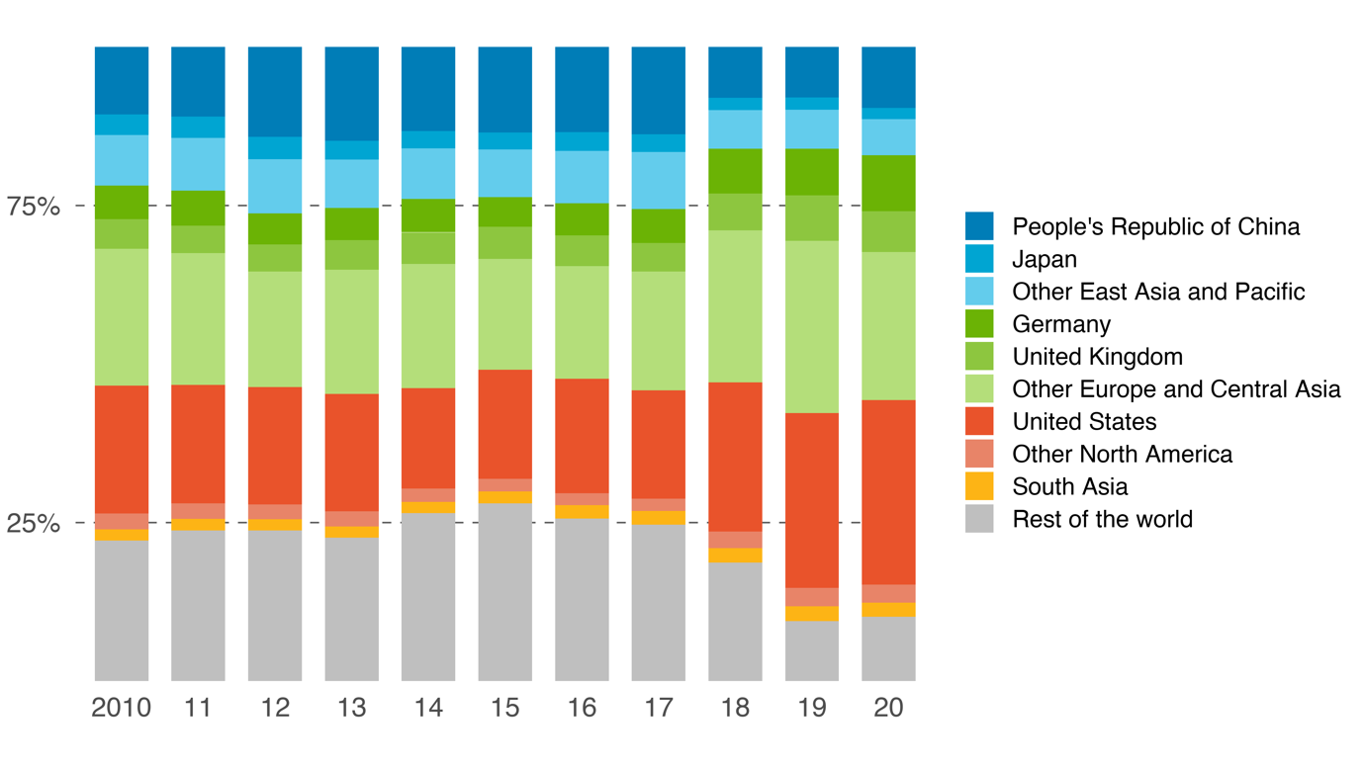 (a) Textiles

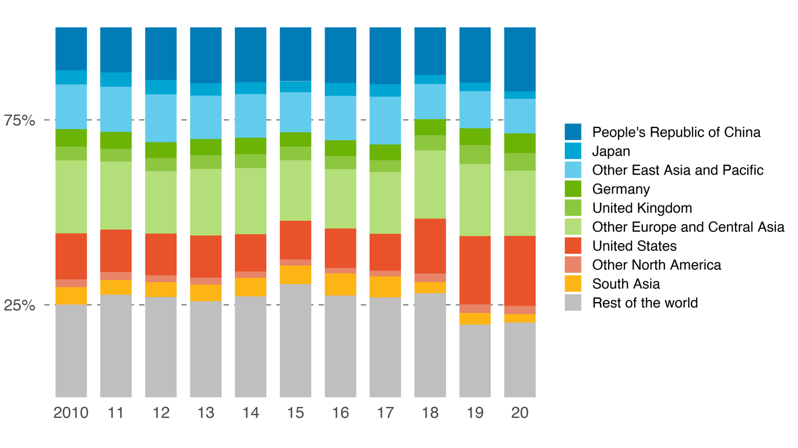(b) Agriculture

Notes: Weights reflect the importance of each country’s prices to Pakistan’s sector-level real effective exchange rate index, computed according to Patel, Wang, and Wei (2019).

Sources: S. Patel, Z. Wang, and S. Wei. 2019. Global Value Chains and Effective Exchange Rates at the Country-Sector Level. *Journal of Money, Credit, and Banking*. *51*(1). pp. 7–42; Asian Development Bank. Multiregional Input–Output Database. https://mrio.adbx.online (accessed 1 August 2021); Asian Development Bank estimates.

Region-wise, Europe and Central Asia held the largest weight at 38.6%. The fact that the weights of Pakistan’s neighbors in South Asia were miniscule suggests that these countries do not have a substantial presence in the markets Pakistan competes in.

Turning to agriculture, panel (b) shows that the same countries are highlighted though their weights differ. Here, the United States and the PRC alternate in holding the largest weight. The share of the residual “rest of the world” is noticeably higher here, likely because, as mentioned in chapter 2, the Middle East is a significant market for Pakistan’s rice. The countries of this region are not separately identified in the ADB MRIO Database.

Using these weights to take an average of Pakistan’s bilateral exchange rates yields the REER index. plots percent-changes in REERs for textiles and agriculture as well as for the aggregate country. For added context, the figure also plots these REERs for Cambodia, a country with a similar export profile. Indeed, it was the only one besides Pakistan to appear in both panels of . The figure ends in 2019 as sector-level price data for 2020 are not yet available.

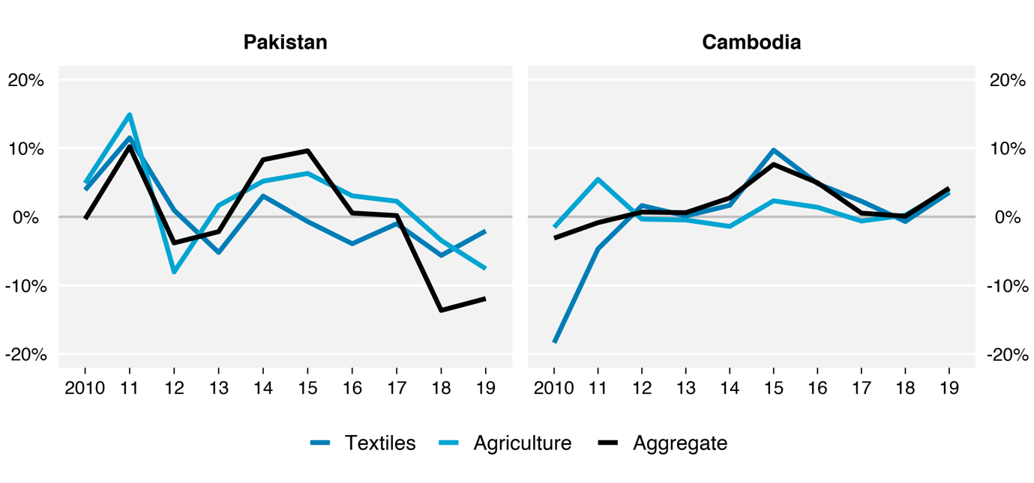Figure .: Change in Real Effective Exchange Rate Index, Pakistan and Cambodia, Selected Sectors, 2010–2019

Note: Real effective exchange rate indices are computed according to Patel, Wang, and Wei (2019).

Sources: S. Patel, Z. Wang, and S. Wei. 2019. Global Value Chains and Effective Exchange Rates at the Country-Sector Level. *Journal of Money, Credit, and Banking*. *51*(1). pp. 7–42; Asian Development Bank. Multiregional Input–Output Database. https://mrio.adbx.online (accessed 1 August 2021); Asian Development Bank estimates.

Owing to the dominance of textiles and agriculture to Pakistan’s exports, it is no surprise that its aggregate REER tracks these two closely. However, the two sectors themselves have REERs that are strongly correlated, with both experiencing high appreciation in 2011 and modest depreciation in 2018–2019. This may be concerning since it implies little diversification in Pakistan’s export competitiveness. Moreover, the modest depreciations the two sectors registered in 2018–2019 were overshadowed by a much larger depreciation in the aggregate REER, suggesting a boost in overall competitiveness that appears to have been dampened by Pakistan’s largest sectors.

Cambodia’s sector-level REERs more tightly track its aggregate REERs, implying that these have an even bigger share in its exports than they do in Pakistan. A key difference between the trends in each country is that Cambodia’s have tended to fluctuate less. Notwithstanding a massive depreciation in its textiles REER in 2010, Cambodia’s REERs have generally hovered close to zero. This is potentially significant since research suggests that maintaining a stable exchange rate is most conducive to trade (Eichengreen, 2008; Rodrik, 2008). In the aggregate, the standard deviation in Cambodia’s REER change was 3.1 points while that of Pakistan’s was 8.3 points.

To place these numbers into context, plots the mean appreciation and standard deviation in aggregate REERs across the 62 countries and economies included in the ADB MRIO Database. The period covered is 2010–2019, right after the 2008–2009 global financial crisis and right before the 2020 pandemic, thereby approximating “normal” trading conditions. Stable currencies mean being as close to 0% mean appreciation as possible with low standard deviation, a feat achieved most successfully by Singapore. This stems from having a diverse set of exports and export destinations, which in turn diversifies competitors and minimizes the impact of price changes in each one. On the other end are the commodities-oriented countries of the Russian Federation and Brunei Darussalam, both registering high mean appreciations at high standard deviations. This is no surprise given their heavy reliance on oil exports.

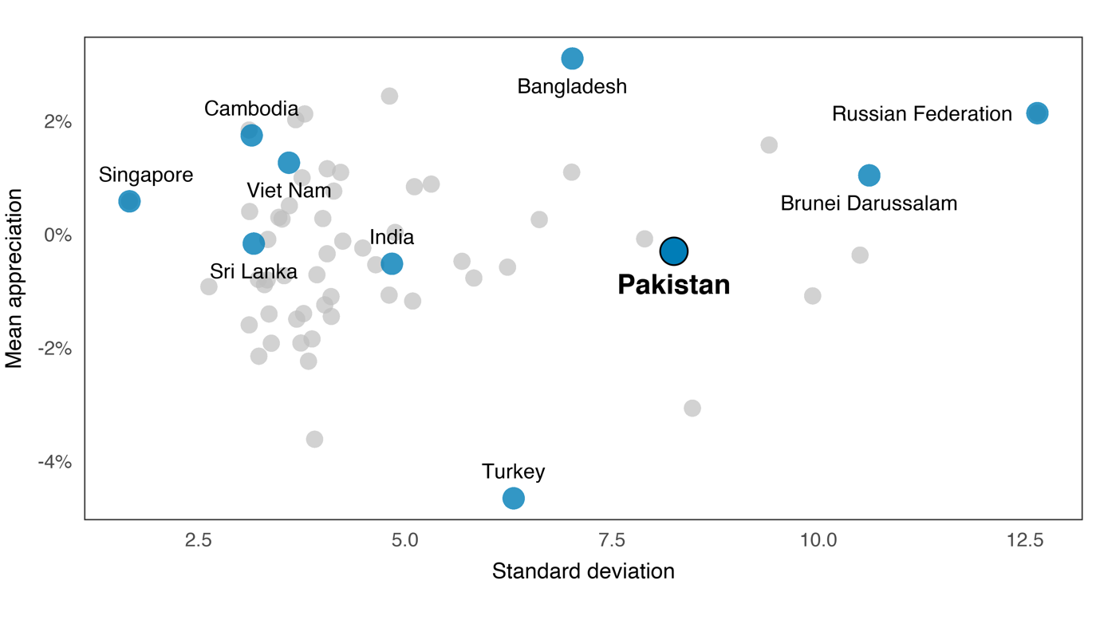Figure .: Real Effective Exchange Rate Mean and Volatility, 2010–2019

Notes: REER indices are computed according to Patel, Wang, and Wei (2019).

Sources: S. Patel, Z. Wang, and S. Wei. 2019. Global Value Chains and Effective Exchange Rates at the Country-Sector Level. *Journal of Money, Credit, and Banking*. *51*(1). pp. 7–42; Asian Development Bank. Multiregional Input–Output Database. https://mrio.adbx.online (accessed 1 August 2021); Asian Development Bank estimates.

Among the countries most similar to Pakistan, Cambodia, Viet Nam, and Sri Lanka all have fairly low volatilities while Bangladesh has high volatility with very high mean appreciation. India is somewhere in the middle. Pakistan itself, though it is close to zero mean appreciation, registered the among the highest standard deviations in the entire sample. This makes any effort to expand its external sector more challenging.

To conclude, the RCA index, coupled with GVC production lengths, show that Pakistan is specializing in the downstream segments of textiles and the upstream segments of agriculture. The latter only emerges when using the value-added version of the RCA, suggesting that exported value added here are mostly embodied in exports from other sectors. Pakistan’s main competitors in these sectors are the domestic producers in its top export destinations, namely the United States, the PRC, and Europe. The value-added-adjusted REER index shows that price competitiveness in these sectors have experienced volatile swings over 2010–2019. Indeed, its aggregate REER is found to have had among the highest volatilities in 62 countries and economies. Given this, greater efforts to maintain a stable and competitive exchange rate must be undertaken.

# Special Topics

This chapter covers some further issues relating to Pakistan’s economy and trade with a focus on global value chains. In the first section, its membership in the South Asian Association for Regional Cooperation is analyzed using a regional concentration index and visualized via a skyline chart. The objective here is to measure how deep this regional trade agreement is and in what sectors, using both gross and value-added flows.

In the second section, Pakistan’s performance during the coronavirus disease 2019 (COVID-19) pandemic is investigated. In particular, the question of whether GVCs mitigated or exacerbated the pandemic-induced shock across economies is explored using both a simple correlation and an input–output-based counterfactual exercise.

## The South Asian Association for Regional Cooperation

As globalization picked up pace in the 1990s, so did initiatives to deepen and regulate trade on a regional basis. Notwithstanding the success of multilateral initiatives like the creation of the World Trade Organization (WTO) in 1995, negotiating regional trade agreements (RTAs) remained less challenging given the fewer stakeholders involved and the greater immediacy of its benefits (WTO 2011; Limão 2016). During this period, the North American Free Trade Agreement (NAFTA) was formed and the free trade areas of the European Union and the Association of Southeast Asian Nations (ASEAN) were substantially expanded, among others. RTA initiatives continued into and after the 2010s with the signing of the Comprehensive and Progressive Agreement for Trans-Pacific Partnership and the Regional Comprehensive Economic Partnership.

Pakistan did not sit out this wave of regionalism. Beginning in the 1980s, the countries of South Asia began to abandon the import-substitution policies they had followed since independence in favor of trade liberalization, establishing the South Asian Association for Regional Cooperation (SAARC) in 1985 to promote dialogue. Through the SAARC, the South Asian Preferential Trade Area was established in 1995 and expanded into the South Asian Free Trade Area in 2006 (Baysan, Panagariya, and Pitigala 2006). The SAARC’s present members include Afghanistan, Bangladesh, Bhutan, India, Maldives, Nepal, Pakistan, and Sri Lanka.

A common way of measuring the extent of regional trade integration is to take the share of intraregional trade in the region’s total trade (exports plus imports). This has been criticized by Frankel (1997), who argues that such a share monotonically increases as the number of members goes up. He proposes normalizing this by the share of the region in world trade, a methodology detailed in . To illustrate, the intra-regional trade share of the 27-member European Union was 52% in 2020, compared with 4.3% for the eight-member SAARC, suggesting the former is over 12 times more integrated than the latter. However, the European Union takes up 31% of world trade against the 2.7% of SAARC. Thus, the countries of the European Union trade among themselves 1.7 times more than they do with the world, while the SAARC countries trade among themselves 1.6 times more. These two numbers, called regional concentration indices (RCI), are now more directly comparable.

|  |
| --- |
| Box : Calculating the Regional Concentration Index  The regional concentration index (RCI) measures the extent to which a collection of countries (a “region”) is trading among themselves relative to the rest of the world. Following Frankel (1997), it is computed as a ratio of two fractions: the share of the region’s trade with itself and the share of the region in world trade. Formally, the RCI for region is given by  Note that and . That is, the exports of a region to itself is necessarily equal to its imports from itself.  A random collection of countries would have an RCI of close to 1, meaning they trade among each other at about the same rate they trade with the world. If the collection is, for example, geographically close, or share cultural ties, or belong to a deep trading agreement, its RCI would be higher than 1. Conversely, an RCI below 1 means trade within the region is less significant than trade outside it.  Because of international production sharing, the RCI based on gross exports may misstate regional integration in two ways. First, exports may contain value added from outside the region. Second, reexporting by the region’s members may result in regional value added actually being absorbed outside the region. To correct for these, an adjusted RCI is also computed that accounts for value added from beginning to end, ensuring that regional flows are truly regional. This is called the end-to-end RCI.  **Reference**  J. A. Frankel. 1997. *Regional Trading Blocs in the World Economic System*. Washington, DC: Peterson Institute for International Economics. |

The RCIs for four RTAs are plotted in . RCIs on the left panel use gross exports to measure regional integration. These show that among the four, SAARC has tended to have the lowest integration, registering an RCI of 1.6 in 2020. On average, the most integrated region was NAFTA, though in 2019–2020 it was overtaken by a sudden rise in ASEAN integration from 2.0 to 2.5. Finally, the European Union, being the most institutionally mature of the group, exhibited the most stable RCI, hovering between 1.5 and 2.0.

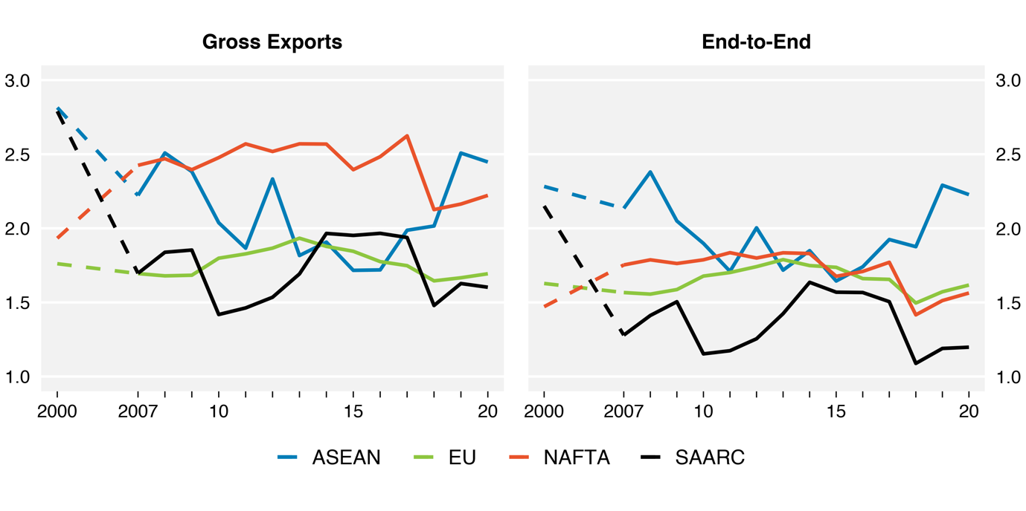Figure .: Regional Concentration Indices, Selected RTAs, 2000, 2007–2020

ASEAN = Association of Southeast Asian Nations, NAFTA = North American Free Trade Agreement, RTA = regional trade agreement, SAARC = South Asian Association for Regional Cooperation.

Notes: Groupings are missing some members if they are not identified in the Asian Development Bank Multiregional Input–Output Database. ASEAN includes Brunei Darussalam, Cambodia, Indonesia, Lao People's Democratic Republic, Malaysia, Philippines, Singapore, Thailand, and Viet Nam and is missing Myanmar. EU includes Austria, Belgium, Bulgaria, Croatia, Cyprus, Czech Republic, Denmark, Estonia, Finland, France, Georgia, Germany, Greece, Hungary, Ireland, Italy, Latvia, Lithuania, Luxembourg, Netherlands, Poland, Portugal, Romania, Slovak Republic, Slovenia, Spain, and Sweden. NAFTA includes Canada, Mexico, and the United States. SAARC includes Bangladesh, Bhutan, Sri Lanka, India, Maldives, Nepal, and Pakistan and is missing Afghanistan.

Sources: Asian Development Bank. Multiregional Input–Output Database. https://mrio.adbx.online (accessed 1 August 2021); Asian Development Bank estimates.

As explained in , using gross exports to calculate RCI may be misleading due to imported inputs on the one hand and reexporting on the other. In other words, value added from outside the region may be mixed in, a possibility all the more relevant in the age of GVCs. Thus, an “end-to-end” RCI that traces value added from creation to final consumption is also presented in . Perhaps because of South Asia’s relatively low GVC participation, the trend of its RCI here is almost identical to the gross exports version. It remains the least integrated of the four. Elsewhere, the high integration of NAFTA disappears, placing it at about the level of the European Union. This suggests that much of what appears to be intra-NAFTA trade actually involves much outside value added.

One interesting observation about SAARC’s RCI is that, in either version, it was much higher in 2000 than in the years after its free trade area took effect in 2006. This, however, stems not so much from higher regional integration in the past but rather a lack of engagement with the rest of the world. Looking at the formula in , it is clear that the RCI may go up if either the share of intra-regional trade goes up (the numerator) or the region’s share in world trade goes down (the denominator). Using gross exports, one finds that while intra-regional trade in SAARC remained stable between 2000 and 2007 at 3.2% and 3.2% respectively, its share in world trade went up from 1.2% to 1.9%. Hence the drop in its RCI from 2.8 to 1.7.

Turning to the sector level, regional integration may be visualized with a skyline chart, whose construction is described in . It represents each sector as a “tower” whose width is its share in the region’s output and whose height is its output expressed as a share of the portion induced by domestic demand. A region measuring the output supressed due to imports is also indicated. The skyline chart’s main purpose is to show where the region is self-sufficient in, these being the sectors for which its own internal demand is enough to exhaust its output.

|  |
| --- |
| Box : Constructing the Skyline Chart  The skyline chart visualizes the industrial structure of an economy and the extent to which it relies on imports (METI, 2011; WTO, 2011b). Each sector is represented by a “tower”, as in the figure. The width of the tower measures the share of that sector in the economy’s output. The height of the tower measures output induced by demand for that sector, computed using data from an input–output table. Output induced by domestic demand is normalized at 100%, with anything above it corresponding to output induced by export demand. Part of the tower is shaded red to indicate the reduction in output induced by imports, which, being negative, starts from the top of the tower and extends downward.  **A Tower in a Skyline Chart**  Share in output  100%  Domestic demand-induced output  Export demand-induced output  Import demand-induced output (negative)  Self-sufficiency ratio  Source: Authors’ drawing based on World Trade Organization (2011b).  If the blue region of the tower is above the 100% line, then the sector it represents is said to be self-sufficient. That is, its own output is enough to satisfy its induced domestic demand. If it is below the 100% line, however, then domestic output is insufficient and the economy has had to import the shortfall in supply. The actual height of the blue region is called the sector’s self-sufficiency ratio.  In this chapter, the skyline chart is constructed at the regional level. Thus, the underlying input–output table is aggregated at the regional level, meaning imports and exports now refer to flows going in and out of the region while flows between economies within the region are treated as “domestic” flows. Self-sufficiency then refers to the ability of the region to supply its induced demand without having to import from outside the region.  **References**  METI (Japan Ministry of Economy, Trade and Industry). 2011. *White Paper on International Economy and Trade,* *Supplementary Notes*. Retrieved from https://www.meti.go.jp/english/report/data/gWT2011fe.html.  WTO (World Trade Organization). 2011a. *World Trade Report 2011: The WTO and Preferential Trade Agreements: From Co-Existence to Coherence*. Geneva, Switzerland: World Trade Organization.  WTO. 2011b. *Trade Patterns and Global Value Chains in East Asia: From Trade in Goods to Trade in Tasks*. Geneva, Switzerland: World Trade Organization. |

The skyline chart for SAARC using 2020 data is presented in . The economic structure of its members is evident in the large shares attributable to agriculture, for which the region is just about self-sufficient in. Its most export-oriented sector is unsurprisingly textiles, for which output is 1.5 times the amount the region demands. Another major sector is “other business activities”, though this is likely driven solely by India, whose business process outsourcing sector is a global powerhouse.

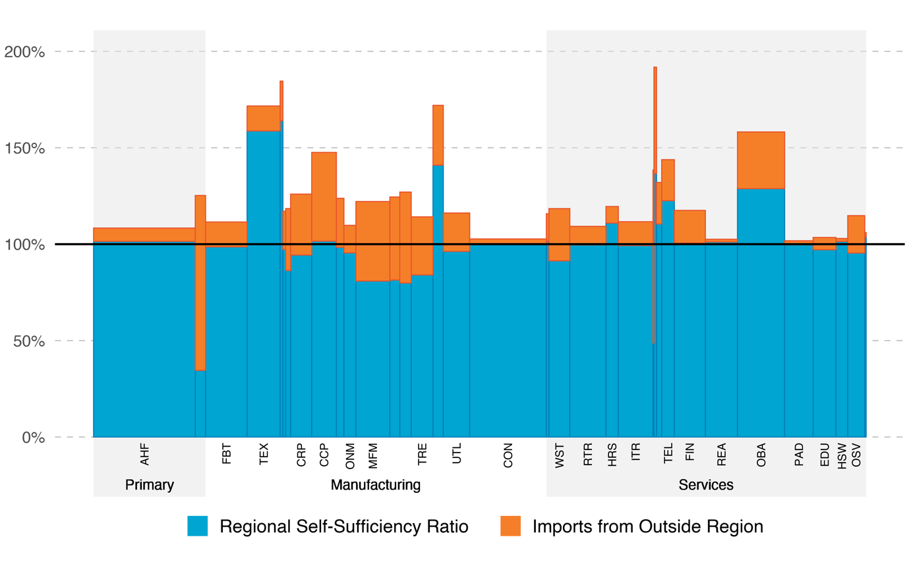Figure .: Skyline Chart for the SAARC Countries, 2020

AHF = agriculture, hunting, forestry and fishing; CCP = chemicals and chemical products; CON = construction; CRP = coke, refined petroleum and nuclear fuel; EDU = education; EOE = electrical and optical equipment; FBT = food, beverages and tobacco; FIN = financial intermediation; HRS = hotels and restaurants; HSW = health and social work; ITR = inland transport; MCH = machinery, not elsewhere classified; MFM = basic metals and fabricated metal; OBA = renting of machinery & equipment and other business activities; ONM = other non-metallic mineral; OSV = other community, social and personal services; PAD = public administration and defense; compulsory social security; REA = real estate activities; RTR = retail trade and repair, except of motor vehicles and motorcycles; SAARC = South Asian Association for Regional Cooperation; TEL = post and telecommunications; TEX = textiles and textile products; TRE = transport equipment; UTL = electricity, gas and water supply; WST = wholesale trade, except of motor vehicles and motorcycles.

Notes: The South Asian Association for Regional Cooperation includes Afghanistan, Bangladesh, Bhutan, Sri Lanka, India, Maldives, Nepal, and Pakistan. However, Afghanistan is excluded from the chart due to missing data.

Sources: Asian Development Bank. Multiregional Input–Output Database. https://mrio.adbx.online (accessed 1 August 2021); Asian Development Bank estimates.

Apart from textiles, construction, and some other relatively small sectors, SAARC’s manufacturing demand is dependent on imports. Its output in metals, electricals, transport equipment, and other machinery meet just 80% of its own demand, a far cry from the surpluses generated in other regions like ASEAN who use these exports to fuel growth. While textiles have come to serve this function for the SAARC countries, their role in this sector have remained in the relatively low-value-adding segments (see chapter 3). , then, provides a clear picture of the challenges facing SAARC should it strive for a larger export sector.

## Agglomeration

Domestic linkages add a layer of complexity in a country’s role in GVCs. In a highly integrated global economy, domestic sectors contribute either through intermediate inputs later consumed by other sectors or through a domestic sector’s demand for inputs from other sectors. However, indicators of GVCs do not typically capture the indirect contribution of domestic sectors (Mercer-Blackman, et al. 2017; Bernard, et al. 2007).

In Pakistan, domestic linkages play a significant role. As shown in chapter 2, the country is less integrated in global production networks relative to its regional neighbors (see also State Bank of Pakistan 2020). Most production activities remain concentrated in the domestic market, a result of policies that seek to increase domestic value added (DVA) in the economy (Dollar, et al. 2020). For example, Pakistan’s tariff structure is designed to promote exports in key sectors while protecting local industries, incentivizing manufacturers to source their inputs locally (Nasir 2020).

Pakistan’s textile industry illustrates the concentration of activities in the domestic economy. Like Bangladesh, textiles are the largest exporting sector in Pakistan. Despite this, the performance of the sector differs between the two countries. The DVA for the textiles sector in Pakistan was at 80% in 2016, in contrast to 64.5% of Bangladesh. However, exports of textiles in Bangladesh exhibit a higher growth rate compared to Pakistan (Dollar, et al. 2020).

The dominance of DVA for Pakistan’s textiles sector arises from barriers to trade. Tariffs on intermediates are at 8%, four times higher than that of East Asia’s average. High tariffs discourage the imports of intermediate inputs. While there are existing tax concessions for selected sectors in imported inputs, availing these concessions remain difficult in practice (Nasir 2020; World Bank 2020). It is not surprising, therefore, to find that textiles exporters in Pakistan continue to rely on domestic sources for their inputs (World Bank 2020).

The economic implications of domestic linkages are not straightforward. On the one hand, strong domestic linkages imply spillovers from sectors interlinked with the rest of the world to sectors whose activities are mostly concentrated in the home country. Thus, strong domestic linkages are associated with gains from participating in GVCs (Banga 2014). On the other hand, strong domestic linkages may result from policies that encourage sectors to source inputs from the domestic economy. This, in turn, implies less reliance in international trade, resulting in a “reshoring” of activities back to the domestic economy.

Developing a measure of domestic linkages becomes critical in examining how concentration of economic activities in the domestic economy evolves, on the aggregate and at a sector level. Earlier measures use output multipliers to measure the strength of domestic linkages (Jones 2011; Bartelme and Gorodnichenko 2015). More recent measures use either the imported inputs ratio in the manufacturing sector or the indirect value added in exports (Kearney 2021; Tang, Wei, and Wang 2020). However, these are either limited to specific sectors or challenging to implement.

This section adapts the concept of agglomeration for GVCs by measuring domestic linkages as the tendency of economic activities to “locate” domestically. Specifically, the agglomeration index proposed here measures how much value added is sourced from and/or absorbed by domestic sectors relative to the rest of the world. A discussion on how the index is constructed is provided in .

|  |  |  |  |  |
| --- | --- | --- | --- | --- |
| Box : Constructing the Agglomeration Index  Assume that is the vector of value-added coefficients and be the vector of domestic final good sales. Denote as the matrix of domestic technical coefficients and . Then  is the vector of value-added generated in each country-sector that end up as final goods absorbed domestically, while  is the vector of each country-sector’s final goods absorbed domestically whose value added also originated domestically. A hat on top of a vector, as in , denotes its diagonalized version.  Let be the vector of value added generated by each country-sector. The forward agglomeration index for country-sector is given by  The numerator is the share of value added generated in that end up as final goods absorbed domestically in total value added generated in . The denominator is the two-year moving average of the same share for sector for all countries, using sector share () as weights. Thus, the forward agglomeration index is the ratio of ’s share against the world average for that sector.  Likewise, let be the vector of final good sales by each country-sector. The backward agglomeration index for country-sector is given by  This is the ratio of ’s share in final goods sales against the world average for that sector.  Being ratios, agglomeration in either perspective is said to be high if the index is greater than 1; conversely if it were less than 1. A country-sector may be profiled by whether it has high or low forward and backward agglomeration. The four possible types are presented in the agglomeration map below.  **The Agglomeration Map**     |  |  | | --- | --- | | Reshoring economies | High agglomeration | | Low agglomeration | DVA generating economies |   Source: Authors’ drawing.  A high backward agglomeration signals that domestic value added embodied in final goods and services consumed domestically is high. Intuitively, this imply that domestic production for domestic consumption is higher than the world average. Meanwhile, a high forward agglomeration indicates that domestic sectors absorb a significant portion of value added generated by a country-sector. This means that value added that goes to domestic production is higher than world average. The classification presented in the agglomeration map combine these two effects to determine the form of domestic linkages taking place in a country-sector. |

The agglomeration indices allow for an analysis of how concentrated economic activities are in Pakistan relative to other countries. Focus is given to neighboring ADB MRIO countries, namely Bangladesh, India, the PRC, and Sri Lanka. Both the backward and forward agglomeration indices are higher in Pakistan across the years (). High backward agglomeration implies that domestic production for domestic consumption is high, which may be attributed to barriers to trade. For example, tariff rates in Pakistan and Bangladesh are highest in the region from 2007 to 2017.[9] This, in turn, incentivizes reliance on the domestic sector for sourcing inputs, resulting in high backward agglomeration. It must be noted, however, that Pakistan’s backward agglomeration has declined over time in contrast to the rest of the region.

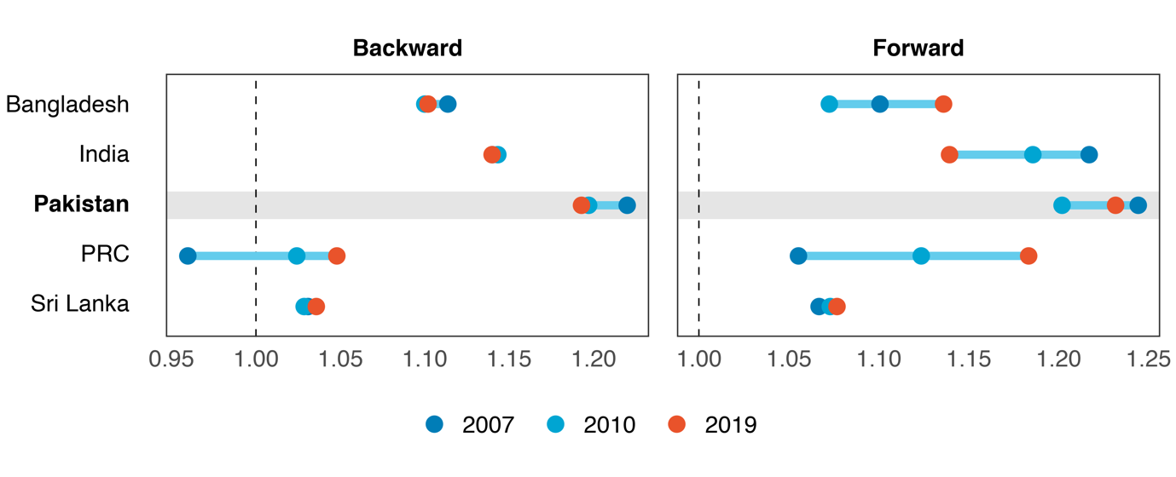Figure .: Backward and Forward Agglomeration Indices, 2007, 2010, 2007

PRC = People’s Republic of China.

Source: Asian Development Bank. Multiregional Input–Output Database. https://mrio.adbx.online (accessed 1 August 2021).

Meanwhile, a high forward agglomeration signals that value added absorbed domestically as final goods and services in Pakistan is higher compared to other countries. Thus, on average, sectors in Pakistan generate more value added to domestic sectors compared to the rest of the region.

The agglomeration indices allow for a deeper analysis of domestic concentration at a sector level. Using the ADB MRIO sector classification, plots the agglomeration indices for the textiles sector in 2010 and 2019. Pakistan is compared to Bangladesh, Cambodia, India, and Sri Lanka, who contribute significantly to textiles exports in the world. The indices are plotted in the agglomeration map, which examines (1) the level of agglomeration in the textile sector of different countries; and (2) the movement of the textile sector across different agglomeration classes over time.

Among the sample of countries selected, Pakistan and India belong to the high agglomeration class in the last decade. This implies high backward and forward agglomeration in both countries’ textiles sector. Other countries, such as Bangladesh, Cambodia, and Sri Lanka, are consistently in the low agglomeration class. This implies that for the selected countries, the value added that textiles sector sources from and/or forwards to domestic sectors are lower than the world average.

Focusing on Pakistan illustrates a decline in backward agglomeration between 2010 and 2019. Hence, the textiles sector is starting to rely less on domestic sectors as a source of inputs. Meanwhile, forward agglomeration exhibits very little change for Pakistan’s textiles sector and remains to be high (). Thus, the value added generated by Pakistan’s textiles sector that is absorbed domestically as final goods is higher compared to the rest of the world.

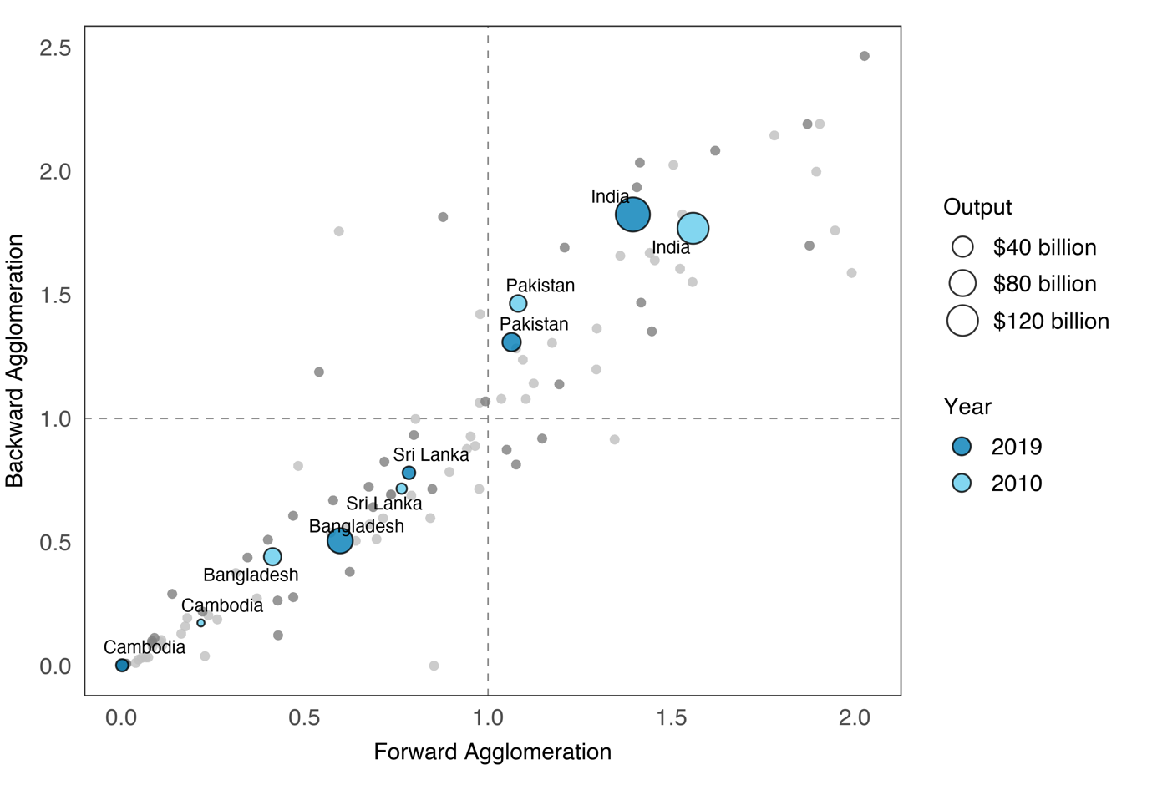Figure .: Agglomeration Map, Textiles, 2010, 2019

Source: Asian Development Bank. Multiregional Input–Output Database. https://mrio.adbx.online (accessed 1 August 2021).

Overall, this illustrates that Pakistan’s textiles sector exhibits strong domestic linkages, which are evolving overtime. The decline in backward agglomeration for Pakistan’s textiles sector may signal that Pakistan is starting to rely less on domsestic sectors as sources of intermediates. Strong forward agglomeration, on the other hand, depict ability of domestic sectors to absorb value added from GVCs, increasing incentives to participate. Whether this marks the start of a period of increased integration to GVCs for Pakistan remains to be seen.

## The COVID-19 Shock

The COVID-19 pandemic that began in 2020 set off unprecedented disruptions to economic activity and trade. While the full extent of its consequences will take years to unfold, preliminary data in the ADB MRIO Dataset provide a glimpse into one facet of the crisis: the role of global value chains. By connecting countries to other markets in complex ways, GVCs have the power to both mitigate shocks (through diversification) and amplify shocks (though contagion effects). Which effect dominates will depend on the circumstances prevailing in a given country (ADB 2021).

As a first approximation of the impact of GVCs on COVID-19 outcomes, this section correlates each country’s GVC participation in 2019 with the shock to GDP it experienced in 2020. The former is measured by the share of indirect trade in exports (see ), lagged by one year to remove potential distortions that occurred during the pandemic. The latter uses the difference in forecasted and actual growth rates for 2020, the reasoning being that this reflects the unexpected disruptions of the pandemic. provides more details.

|  |
| --- |
| Box : Estimating the COVID-19 Shock  The COVID-19 shock is defined as the percentage-point deviation in the growth of a macroeconomic variable attributable to the unexpected disruptions caused by the pandemic. That is, if a country contracted by 5% in 2020 where it would have grown by 5% had there been no pandemic, then the COVID-19 shock was negative 10 percentage points.  Of course, counterfactual growth rates are impossible to know for certain, but a reasonable approximation, used in research like Giglioli, et al. (2021), are pre-2020 forecasts. Growth forecasts for a country reflect all available information at the moment they are made, so any deviation from them would be shocks in the truest sense—that is, random fluctuations with an expected value of zero. By comparing forecasts made just before the onset of the pandemic with actual growth rates in 2020, an estimate of the COVID-19 shock is obtained.  In this section, forecasts for gross domestic product growth are taken from the October 2019 edition of the International Monetary Fund’s *World Economic Outlook* (IMF, 2019).  **References**  S. Giglioli, G. Giovannetti, E. Marvasi, and A. Vivoli. 2021. The Resilience of Global Value Chains During the Covid-19 Pandemic: The Case of Italy. *UniFI* *DISEI Working Paper No. 07/2021*. Florence, Italy: Università degli Studi Firenze Dipartimento di Scienze per L’Economia e L’Impresa.  International Monetary Fund (IMF). 2019. *World Economic Outlook: Global Manufacturing Downturn, Rising Trade Barriers*. Washington, DC: International Monetary Fund. |

plots these two variables for the 62 countries covered in the ADB MRIO Database. A quadratic line is fitted through them along with its 95% confidence interval. What emerges is an inverted-U relationship where the size of the COVID-19 shock increases (that is, becomes more negative) the higher the GVC participation rate up to a rate of about 45%, after which the shock *decreases* the higher the participation rate.

Pakistan had the lowest GVC participation rate in the dataset at 25.4%. Tellingly, its COVID-19 shock was a relatively mild –2.8 points, meaning growth in 2020 was 2.8 percentage points lower than what it would have been without the pandemic. This compares favorably with a country like the Philippines, whose GVC participation was much higher at 47.1% and whose shock was also much higher at –15.7 points.

On the flipside, those economies with the highest rates of GVC participation appeared to have done relatively well. The most dramatic case is Taipei,China, whose participation rate was 57.5% and whose shock was actually positive at 1.2 points, meaning the pandemic’s disruptions seemed to have made it grow *faster*. Elsewhere, Viet Nam, with a participation rate of 58.8%, experienced a shock of –3.6 points.

As the figure shows, there is much variation around the average relationship. Indeed, both the Philippines and Taipei,China are far away from the fitted curve, suggesting that a host of other factors contributed to influencing the size of the shock. Nevertheless, the U-shaped relationship is distinct. One explanation may be found in a similar study by Giglioni, et al. (2021), who divide 2020 into a “first wave” (October 2019 to April 2020) and a “second wave” (April to October 2020). They find that while GVC participation exacerbated the shock in the first wave, its impact was positive-to-neutral in the second wave. By taking 2020 as a whole, may be collating these two trends.

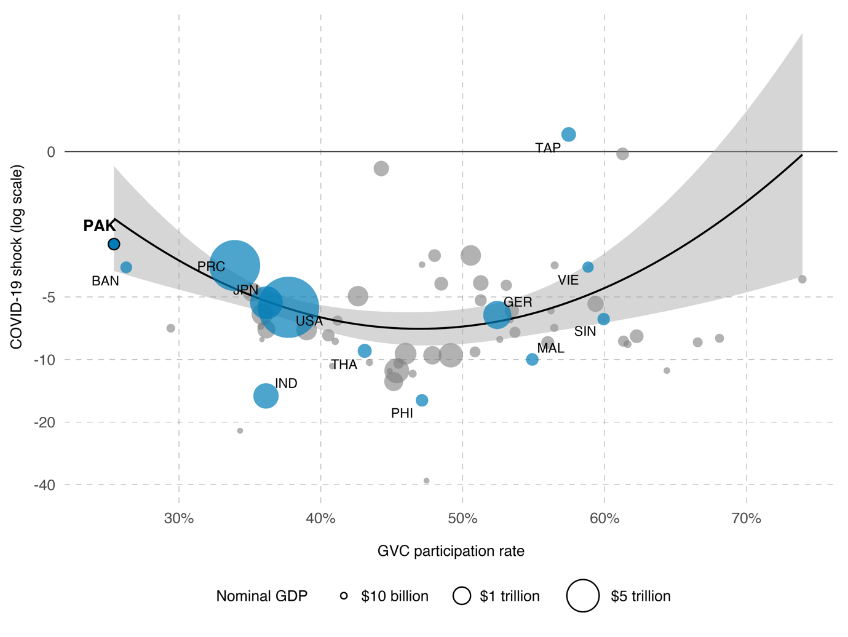Figure .: The COVID-19 Shock to Growth Under Varying Rates of GVC Participation

BAN = Bangladesh, COVID-19 = coronavirus disease 2019, IND = India, GDP = gross domestic product, GER = Germany, GVC = global value chain, JPN = Japan, MAL = Malaysia, PAK = Pakistan, PHI = Philippines, PRC = People’s Republic of China, TAP = Taipei,China, THA = Thailand, SIN = Singapore, USA = United States, VIE = Viet Nam.

Notes: Participation rates are trade-based rates computed using the methodology in Asian Development Bank (2021). The COVID-19 shock is the percentage-point difference between forecasted gross domestic product growth for 2020 and actual growth in 2020. Participation rates and nominal GDP are as of 2019.

Sources: Asian Development Bank. Multiregional Input–Output Database. https://mrio.adbx.online (accessed 1 August 2021); forecasted growth rates from the International Monetary Fund’s World Economic Outlook (October 2019); and actual growth rates from the International Monetary Fund’s World Economic Outlook (April 2021).

As for whether the U-shaped pattern points to some “optimal” level of GVC participation, the results given here are unable to give a definitive answer. Even if better data in the coming years proves that the relationship is robust, there is no guarantee that the unique circumstances of the COVID-19 pandemic generalizes to other types of shocks. A better prescription to keep in mind is that trade in general must be accompanied by a sound institutional framework that maximizes its benefits while minimizing its costs.

Rather than correlating the output shock with GVC participation, another way to investigate the role of GVCs during the pandemic is to start from the demand shock and use this to estimate the output shock under different degrees of openness. Box 11 outlines how the information in an intercountry input–output table can be used to control the channels by which demand shocks propagate through the world economy.

|  |
| --- |
| Box : The COVID-19 Shock under Different Trading Scenarios  Input–output analysis allows one to distinguish the channels by which demand shocks impact the gross domestic product (GDP) of a country. Different scenarios are identified by turning certain channels on and off. The present analysis identifies three:  **Baseline scenario**. This corresponds to real-world conditions, where imported inputs and reexporting within global value chains have connected countries in indirect ways.  **Classical trading scenario**. Trading occurs, but only directly, i.e., there is no usage of imported inputs and no reexporting. This corresponds to the classical idea of trade commonly assumed in economics textbooks.  **Autarkic scenario**. No trading occurs.  The COVID-19 shock is estimated by the difference in reported final demand for 2020 and forecasts for 2020 made by the World Bank at the start of the year (World Bank 2020). The World Bank has the widest set of final demand forecasts, so its dataset is used here. All other data are derived from the Asian Development Bank Multiregional Input–Output Database. Values are in current prices.  Under scenario *R*, the impact of the COVID-19 shock to the GDP of country *s* is given by  A comparison of ,, andprovides a heuristic explanation of how the presence of global value chains dampens or intensifies global demand shocks.  **Reference**  World Bank. 2020. *Global Economic Prospects: Slow Growth, Policy Challenges (January 2020)*. Washington, DC: World Bank. |

The intuition behind this counterfactual exercise is as follows. Lockdown measures during the pandemic resulted in demand shocks around the world. Each country was exposed to these shocks via three channels: through its own domestic economy, through its direct trading partners, and through its indirect trading partners. Several outcomes are possible. If the shock a country faced from domestic sources was large (severe lockdowns, extreme falls in disposable income) while the shocks it faced from its trading partners were more mild (shorter lockdowns, generous government assistance), then open trading channels allow the overall shock to its GDP to be mitigated. On the other hand, if its domestic shock was mild while its trading partners’ shocks were severe, then open trading channels worsens the overall shock to its GDP.

Three trading scenarios are considered: baseline, classical trading, and autarky. The baseline scenario corresponds to real-world conditions, where the presence of global value chains means countries may be affected even by demand shocks from sources with whom they have no direct trade with. Classical trading allows only direct trading. That is, there is no usage of imported inputs and no reexporting.[10] Finally, autarky turns off all trading channels.

The top panel of plots the percent-changes in nominal GDP following the pandemic-induced demand shock under the three trading scenarios. In Pakistan’s case, its GDP falls by 12.4% under the baseline scenario. Turning off indirect trade channels worsens this slightly to –12.5%, while turning off all trade channels brings this to –12.9%. These estimates are not far from each other, likely because Pakistan’s exposure to trade in general and GVCs in particular is not very high to begin with. Nevertheless, looking at the bottom panel, these suggest that without any trade, Pakistan’s contraction would have been 0.5 percentage points larger. GVCs were thus able to mitigate some of the effects of the pandemic.

The opposite is the case for other countries. Sri Lanka, for example, is estimated to contract by 10.0% under both the baseline and classical trading scenarios but only by 8.2% under autarky. An interesting case is Maldives. Under the baseline scenario, its GDP contracts by 27.4%, while under classical trading, this worsens by almost 1 percentage-point to 28.4%. However, under autarky, this shrinks to 26.6%. Thus, moving from a state of autarky to classical trading worsens outcomes severely for Maldives, but opening its trade further to allow GVCs mitigates these outcomes somewhat.

and demonstrate what ADB (2021) calls the two faces of GVCs. That is, as far as the available data suggests, exposure to global value chains had both benefits and costs during the COVID-19 pandemic. As countries take advantage of the opportunities GVCs bring, they must also ensure that the accompanying risks are properly accounted for.

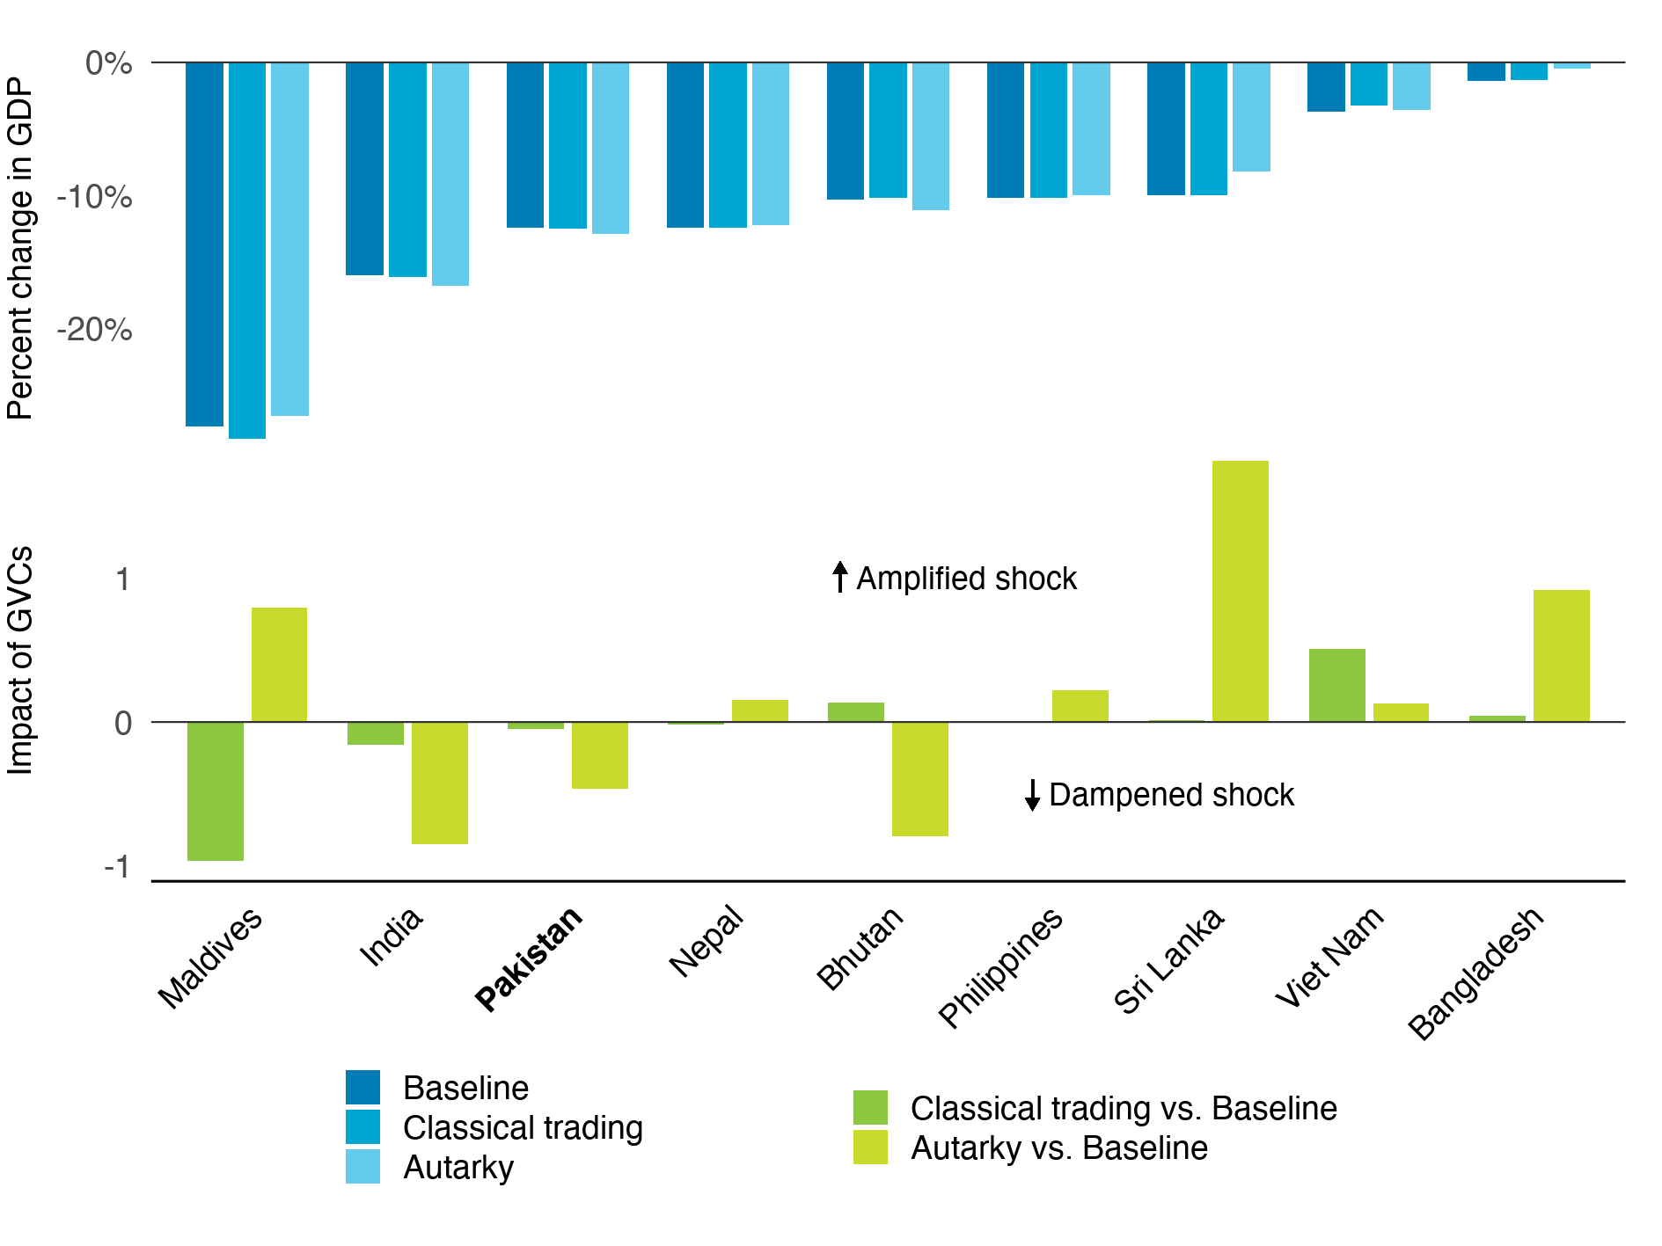Figure .: The COVID-19 Shock under Different Trade Scenarios, Selected Economies

GDP = gross domestic product, GVC = global value chain.

Notes: The top panel gives the percent change in GDP given the pandemic-induced demand shock under different trade scenarios. “Baseline” assumes all forms of trade and corresponds to the real world. “Classical trading” assumes only direct trade. “Autarky” assumes no trade. The bottom panel is the percentage-point differences of the numbers in the top panel.

Sources: Asian Development Bank. Multiregional Input–Output Database. https://mrio.adbx.online (accessed 1 August 2021); Asian Development Bank estimates.

# Conclusion

In its country partnership strategy with Pakistan, ADB (2020) outlines three pillars its assistance will prioritize over the period 2021–2025:

1. Improving economic management to restore stability and growth.
2. Building resilience through human capital development and social protection to enhance productivity and people’s well-being.
3. Boosting competitiveness and private sector development to create jobs and expand economic opportunities.

This report is a knowledge product that complements this country partnership by describing the state of Pakistan’s economy and its engagement with GVCs. It builds its analysis from a combination of up-to-date datasets and the best available analytical tools. By efficiently connecting suppliers to consumers and lowering barriers to entry into high-value industries, GVCs have proven to be a potent stimulus to growth, human capital development, and competitiveness. This report, however, has also highlighted the risks of GVCs (see and ). In a more interconnected world, shocks in one place ripple through the system to affect seemingly distant economies. GVC participation, therefore, must be done the right way.

Having among the lowest GVC participation rates in the world (), the Pakistan economy is primed to benefit enormously from adopting a more outward-oriented development strategy. Provided that it does so in a careful and deliberate manner, its already impressive achievements in poverty reduction can be pushed further and its boom-and-bust growth pattern can be put on a more stable trend.

To maximize the benefits and minimize the costs of GVCs, this report recommends the following principles:

**Diversification.** The key to managing many types of risk is diversification. In the case of GVCs, Pakistan would do well to diversify not just its export basket but also the markets it sells to. In chapter 2, it was shown that while Pakistan’s merchandise exports were generally more diversified than Bangladesh and Cambodia, they were still less diverse than India’s (). Moreover, pointed to the dominance of textile products. Specialization in this sector is not necessarily an unsound strategy, as demonstrated by the solid growth record of other textiles-heavy exporters like Bangladesh and Cambodia. However, Pakistan must ensure that within this sector, its firms are able to participate all along the productivity spectrum and are not stuck in low-value-added segments. Some evidence that the latter is occurring is the decomposition of GVC production lengths shown in , which indicates that textiles exports rely heavily on processing abroad.

It was also shown in chapter 2 that Pakistan maintains a fairly diverse set of trading partners, which includes the United States, Europe, and the People’s Republic of China for its textiles and the Middle East for its rice. also showed that export destinations and foreign value added sources were spread out across many countries when looked at by value-added category. Nevertheless, it is worth noting that with a trade-to-GDP ratio of 30%, Pakistan’s producers are in effect highly concentrated in a single market: its own. Greater trade participation, then, will in itself diversify the country’s sources of demand and is a strategy worth exploring from a risk management perspective.

**Investing in people.** Using government census data for 2017, WorldBank (2020a) paints a concerning picture of the state of human capital in Pakistan. Almost 60% of the labor force are either uneducated or completed only primary education, with the out-of-school population numbering some 20–25 million. Of 1,000 live births, about 75 children die before the age of 5, the highest rate in South Asia. Among those who live, over one-third are stunted. Access to education and health services are vastly unequal. Moreover, all this have been made more challenging by the COVID-19 pandemic.

Apart from its worthy contribution to welfare, investing in human capital yields significant economic returns when paired with the opportunities provided by GVCs. The services sector is already a proven driver of poverty reduction in Pakistan, albeit largely through the informal economy. Such talent can be turned to more productive employment in the global business process outsourcing industry. Indeed, the experiences of India and the Philippines have shown that manufacturing need no longer be synonymous with an export-led development strategy. Services, too, can fill this function, with the bonus of generally having lower fixed capital requirements. This can serve to complement Pakistan’s textiles sector.

**Institutional support.** The set of institutional frameworks prevailing in a country greatly influences its economy. These may be divided into those that deal with enlarging the economic pie and those that deal with how that pie is shared. To enlarge the pie, the government can focus on the collection of general growth-promoting policies discussed in the last principle below. Redistributing the pie, however, will involve more country-specific concerns. Opening up to GVCs tends to cause temporary disruptions as the existing stock of skills adjusts to the actual skills demanded by the world economy. There will be winners and losers, at least in the short term. Policies must be designed to ensure that no group suffers too great a drop in welfare and that all have a path to participating gainfully in the external sector. Moreover, since good policy design requires plenty of timely information, institutional support must also be given to data-collecting agencies. Indeed, such support was needed to construct the input–output tables that much of this report was based on.

**Multilateral engagement.** Trade can only thrive in a stable, rules-based global environment where competition is as free and as fair as possible. As such, it is in Pakistan’s interest to strengthen multilateral bodies like the WTO and the SAARC. It must actively participate not only in crafting their rules but also in enforcing them. Moreover, Pakistan must continue to pursue new trade agreements through which it can lower barriers to trade, exchange information, and establish mutual trust. International cooperation can also help Pakistan address trade-adjacent issues that require collective action such as climate change, migration, and conflict. Such initiatives will also aid in the principles of diversification and institutional support described above.

**Remembering the basics.** Beyond GVCs, the usual set of principles that promote a robust and dynamic economy must not be neglected. The population must be healthy and educated, as already mentioned above. To efficiently move people and goods around the country, sustained investments in physical infrastructure and information and communications technologies are necessary. Financial markets must be inclusive and well-developed, with mechanisms to deal with defaults that do not unduly punish risk-taking. Property rights must be secure. Workers, entrepreneurs, and investors alike must have faith in an impartial court system dedicated to the rule of law. Labor and redistribution policies must be studied thoroughly to ensure that they achieve what they are meant to achieve and that the market distortions they introduce are kept to a minimum. All these provide the foundations upon which long-term growth in Pakistan can be possible.

# References

P. Antràs and D. Chor. 2013. Organizing the Global Value Chain. *Econometrica*. 81(6). pp. 2127–2204.

P. S. Armington. 1969. A Theory of Demand for Products Distinguished by Place of Production. *Staff Papers (International Monetary Fund).* 16(1). pp. 159–78.

ADB (Asian Development Bank). 2020. Pakistan, 2021–2025—Lifting Growth, Building Resilience, Increasing Competitiveness. *ADB Country Partnership Strategy*. Manila, Philippines: Asian Development Bank.

ADB. 2021. *Key Indicators for Asia and the Pacific 2021*. Manila, Philippines: Asian Development Bank.

B. Balassa. 1965. Trade Liberalisation and “Revealed” Comparative Advantage. *The Manchester School*. 33(2). pp. 99–123.

R. Banga. 2014. Linking into Global Value Chains Is Not Sufficient: Do You Export Domestic Value Added Contents? *Journal of Economic Integration*. 29(2). pp. 267–297.

D. Bartelme and Y. Gorodnichenko. 2015. Linkages and Economic Development. *NBER Working Paper*. No. 21251. Cambridge, MA: National Bureau of Economic Research.

T. Bayoumi, J. Lee, and S. Jayanthi. 2005. New Rates from New Weights. *IMF Working Paper WP/05/99*. Washington, DC: International Monetary Fund.

T. Baysan, A. Panagariya, and N. Pitigala. 2006. Preferential Trading in South Asia. *World Bank Policy Research Working Paper 3813*. Washington, DC: World Bank.

R. Bems and R. C. Johnson. 2017. Demand for Value Added and Value-Added Exchange Rates. *American Economic Journal: Macroeconomics*. 9(4). pp. 45–90.

A. Borin and M. Mancini. 2019. Measuring What Matters in Global Value Chains and Value-Added Trade. *Policy Research Working Paper*. No. 8804. Washington, DC: World Bank.

A. B. Bernard, J. B. Jensen, S. J. Redding, and P. K. Schott. 2007. Firms in International Trade. *Journal of Economic Perspectives*. 21(3), pp. 105–130.

S. Chatterjee and A. Subramanian. 2020. India’s Export-Led Growth: Exemplar and Exception. *Ashoka Centre for Economic Policy Working Paper No. 1*. Sonipat, India: Ashoka University.

M. D. Chinn. 2006. A Primer on Real Effective Exchange Rates: Determinants, Overvaluation, Trade Flows and Competitive Devaluation. *Open Economies Review*. 51. pp. 115–43.

D. Dollar, B. Khan, and P. Pei. 2019. Should High Domestic Value Added in Exports Be an Objective of Policy? In World Bank and World Trade Organization. *Global Value Chain Development Report 2019: Technological Innovation, Supply Chain Trade, and Workers in a Globalized World.* Washington, DC: World Bank.

H. Escaith and S. Inomata. 2013. Geometry of Global Value Chains in East Asia: The Role of Industrial Networks and Trade Policies. In D. K. Elms and P. Low (eds.), *Global Value Chains in a Changing World* (pp. 135–157). Geneva, Switzerland: World Trade Organization.

European Commission. 2008. *Eurostat Manual of Supply, Use and Input-Output Tables*. Luxembourg: European Commission. Retrieved from https://ec.europa.eu/eurostat/web/products-manuals-and-guidelines/-/KS-RA-07-013.

J. A. Frankel. 1997. *Regional Trading Blocs in the World Economic System*. Washington, DC: Peterson Institute for International Economics.

J. A. Frankel and D. Romer. 1999. Does Trade Cause Growth? *American Economic Review*. 89(3). pp. 379–399.

S. Giglioli, G. Giovannetti, E. Marvasi, and A. Vivoli. 2021. The Resilience of Global Value Chains During the Covid-19 Pandemic: The Case of Italy. *UniFI* *DISEI Working Paper No. 07/2021*. Florence, Italy: Università degli Studi Firenze Dipartimento di Scienze per L’Economia e L’Impresa.

D. Hummels, J. Ishii, and K. M. Yi. 2001. The Nature and Growth of Vertical Specialization in World Trade. *Journal of International Economics*. 54. pp. 75–96.

S. Inomata. 2017. Analytical Frameworks for Global Value Chains: An Overview. In World Bank, *Global Value Chain Development Report 2017: Measuring and Analyzing the Impact of GVCs on Economic Development.* pp. 15–35. Washington, DC: World Bank.

IMF (International Monetary Fund). 2019. *World Economic Outlook: Global Manufacturing Downturn, Rising Trade Barriers*. Washington, DC: International Monetary Fund.

O. Itskhoki. 2020. The Story of the Real Exchange Rate. *NBER Working Paper No. 28225*. Cambridge, MA: National Bureau of Economic Research.

C. I. Jones. 2011. Intermediate Goods and Weak Links in the Theory of Economic Development. *American Economic Journal: Macroeconomics*.3(2). pp. 1–28.

Kearney. 2021. *Global Pandemic Roils 2020 Reshoring Index, Shifting Focus from Reshoring to Right-Shoring*. Chicago, IL: Kearney.

R. Koopman, Z. Wang, and S. Wei. 2014. Tracing Value-Added and Double Counting in Gross Exports. *American Economic Review*. 104(2). pp. 459–494.

N. Limão. 2016. Preferential Trade Agreements. *NBER Working Paper No. 22138*. Cambridge, MA: National Bureau of Economic Research.

B. McCaig and N. Pavcnik. 2018. Export Markets and Labor Allocation in a Low-Income Country. *American Economic Review*. 108(7). pp. 1899–1941.

V. Mercer-Blackman, A. Foronda, and M. J. Mariasingham. 2017. Using Input–Output Analysis Framework to Explain Economic Diversification and Structural Transformation in Bangladesh. *ADB Economics Working Paper*. No. 513. Manila, Philippines: Asian Development Bank.

METI (Japan Ministry of Economy, Trade and Industry). 2011. *White Paper on International Economy and Trade,* *Supplementary Notes*. Retrieved from https://www.meti.go.jp/english/report/data/gWT2011fe.html.

J. Nasir. 2020. The Tariff Tripod of Pakistan: Protection, Export Promotion, and Revenue Generation. *PIDE Working Papers*. No. 2020-6. Islamabad: Pakistan Institute of Development Economics.

S. Patel, Z. Wang, and S. Wei. 2019. Global Value Chains and Effective Exchange Rates at the Country-Sector Level. *Journal of Money, Credit, and Banking*. 51(1). pp. 7–42.

W. F. Shughart. 2008. Industrial Concentration. In D. R. Henderson (Ed.), *Concise Encyclopedia of Economics*, 2nd ed. Indianapolis, IN: Library of Economics and Liberty.

State Bank of Pakistan. 2020. *The State of Pakistan’s Economy: The First Quarterly Report of the Board of Directors*. Retrieved from https://www.sbp.org.pk/reports/quarterly/fy21/First/Complete.pdf.

I. Stephens. 1967. *Pakistan* (3rd ed.). New York, NY: Frederick A. Praeger.

J. E. Stiglitz. 1996. Some Lessons from the East Asian Miracle. *The World Bank Research Observer*. 11(2). pp. 151–77.

M. P. Timmer, E. Dietzenbacher, B. Los, R. Stehrer, and G. J. de Vries. 2015. An Illustrated User Guide to the World Input-Output Database: The Case of Global Automotive Production. *Review of International Economics*. 23(3). pp. 575–605.

M. P. Thomas. 2019. Impact of Services Trade on Economic Growth and Current Account Balance: Evidence from India. *Journal of International Trade and Economic Development*. 28(3). pp. 331–347.

P. Wang. 2023, June 7. China sees biggest trade increase with Russia in 2023, Chinese customs data shows. *CNN*. Retrieved from https://edition.cnn.com/2023/06/07/business/china-russia-trade-increase-intl/index.html (accessed 12 July 2023).

Z. Wang, S. Wei, X. Yu, and K. Zhu. 2017a. Measures of Participation in Global Value Chains and Global Business Cycles. *NBER Working Paper*. No. 23222. Cambridge, MA: National Bureau of Economic Research.

Z. Wang, S. Wei, X. Yu, and K. Zhu. 2017b. Characterizing Global Value Chains: Production Length and Upstreamness. *NBER Working Paper*. No. 23261. Cambridge, MA: National Bureau of Economic Research.

S. A. Wolpert. 2004. *A New History of India* (7th ed). Oxford, United Kingdom: Oxford University Press.

World Bank. 2020a. *Islamic Republic of Pakistan: Leveling the Playing Field: Systematic Country Diagnostic*. Washington, DC: World Bank.

World Bank. 2020b. *Global Economic Prospects: Slow Growth, Policy Challenges (January 2020)*. Washington, DC: World Bank.

WTO (World Trade Organization). 2011a. *World Trade Report 2011: The WTO and Preferential Trade Agreements: From Co-Existence to Coherence*. Geneva, Switzerland: World Trade Organization.

WTO. 2011b. *Trade Patterns and Global Value Chains in East Asia: From Trade in Goods to Trade in Tasks*. Geneva, Switzerland: World Trade Organization.

# Appendices

Table A: Economies in the ADB Multiregional Input–Output Database

|  |  |  |  |
| --- | --- | --- | --- |
| **ID** | **Code** | **Name** | **Region** |
| 1 | AUS | Australia | East Asia and Pacific |
| 2 | AUT | Austria | Europe and Central Asia |
| 3 | BEL | Belgium | Europe and Central Asia |
| 4 | BGR | Bulgaria | Europe and Central Asia |
| 5 | BRA | Brazil | Latin America and the Caribbean |
| 6 | CAN | Canada | North America |
| 7 | SWI | Switzerland | Europe and Central Asia |
| 8 | PRC | People's Republic of China | East Asia and Pacific |
| 9 | CYP | Cyprus | Europe and Central Asia |
| 10 | CZE | Czech Republic | Europe and Central Asia |
| 11 | GER | Germany | Europe and Central Asia |
| 12 | DEN | Denmark | Europe and Central Asia |
| 13 | SPA | Spain | Europe and Central Asia |
| 14 | EST | Estonia | Europe and Central Asia |
| 15 | FIN | Finland | Europe and Central Asia |
| 16 | FRA | France | Europe and Central Asia |
| 17 | UKG | United Kingdom | Europe and Central Asia |
| 18 | GRC | Greece | Europe and Central Asia |
| 19 | HRV | Croatia | Europe and Central Asia |
| 20 | HUN | Hungary | Europe and Central Asia |
| 21 | INO | Indonesia | East Asia and Pacific |
| 22 | IND | India | South Asia |
| 23 | IRE | Ireland | Europe and Central Asia |
| 24 | ITA | Italy | Europe and Central Asia |
| 25 | JPN | Japan | East Asia and Pacific |
| 26 | KOR | Republic of Korea | East Asia and Pacific |
| 27 | LTU | Lithuania | Europe and Central Asia |
| 28 | LUX | Luxembourg | Europe and Central Asia |
| 29 | LVA | Latvia | Europe and Central Asia |
| 30 | MEX | Mexico | Latin America and the Caribbean |
| 31 | MLT | Malta | Middle East and North Africa |
| 32 | NET | Netherlands | Europe and Central Asia |
| 33 | NOR | Norway | Europe and Central Asia |
| 34 | POL | Poland | Europe and Central Asia |
| 35 | POR | Portugal | Europe and Central Asia |
| 36 | ROU | Romania | Europe and Central Asia |
| 37 | RUS | Russia | Europe and Central Asia |
| 38 | SVK | Slovak Republic | Europe and Central Asia |
| 39 | SVN | Slovenia | Europe and Central Asia |
| 40 | SWE | Sweden | Europe and Central Asia |
| 41 | TUR | Turkey | Europe and Central Asia |
| 42 | TAP | Taipei,China | East Asia and Pacific |
| 43 | USA | United States | North America |
| 44 | BAN | Bangladesh | South Asia |
| 45 | MAL | Malaysia | East Asia and Pacific |
| 46 | PHI | Philippines | East Asia and Pacific |
| 47 | THA | Thailand | East Asia and Pacific |
| 48 | VIE | Viet Nam | East Asia and Pacific |
| 49 | KAZ | Kazakhstan | Europe and Central Asia |
| 50 | MON | Mongolia | East Asia and Pacific |
| 51 | SRI | Sri Lanka | South Asia |
| 52 | PAK | Pakistan | South Asia |
| 53 | FIJ | Fiji | East Asia and Pacific |
| 54 | LAO | Lao People's Democratic Republic | East Asia and Pacific |
| 55 | BRU | Brunei Darussalam | East Asia and Pacific |
| 56 | BHU | Bhutan | South Asia |
| 57 | KGZ | Kyrgyz Republic | Europe and Central Asia |
| 58 | CAM | Cambodia | East Asia and Pacific |
| 59 | MLD | Maldives | South Asia |
| 60 | NEP | Nepal | South Asia |
| 61 | SIN | Singapore | East Asia and Pacific |
| 62 | HKG | Hong Kong, China | East Asia and Pacific |
| 63 | ROW | Rest of the world | South Asia |

ADB = Asian Development Bank.

Source: Asian Development Bank. Multiregional Input–Output Database. https://mrio.adbx.online (accessed 1 August 2021).

Table A: Sectors in the ADB Multiregional Input–Output Database

|  |  |  |  |  |
| --- | --- | --- | --- | --- |
| **ID** | **Name** | **Short Name** | **Code** | **ISIC 3.1** |
| 1 | Agriculture, hunting, forestry and fishing | Agriculture | AHF | A–B |
| 2 | Mining and quarrying | Mining | MIN | C |
| 3 | Food, beverages and tobacco | Food & beverages | FBT | D15–16 |
| 4 | Textiles and textile products | Textiles | TEX | D17–18 |
| 5 | Leather, leather products and footwear | Leather | LTH | D19 |
| 6 | Wood and products of wood and cork | Wood | WDC | D20 |
| 7 | Pulp, paper, printing and publishing | Paper | PPP | D21–22 |
| 8 | Coke, refined petroleum and nuclear fuel | Refined fuels | CRP | D23 |
| 9 | Chemicals and chemical products | Chemicals | CCP | D24 |
| 10 | Rubber and plastics | Rubber | RBP | D25 |
| 11 | Other non-metallic mineral | Other minerals | ONM | D26 |
| 12 | Basic metals and fabricated metal | Metals | MFM | D27–28 |
| 13 | Machinery, not elsewhere classified | Other machinery | MCH | D29 |
| 14 | Electrical and optical equipment | Electricals | EOE | D30–33 |
| 15 | Transport equipment | Transport equipment | TRE | D34–35 |
| 16 | Manufacturing, not elsewhere classified; recycling | Other manufacturing | MFG | D36–37 |
| 17 | Electricity, gas and water supply | Utilities | UTL | E |
| 18 | Construction | Construction | CON | F |
| 19 | Sale and repair of motor vehicles and motorcycles; retail sale of fuel | Sale of motor vehicles | MTV | G50 |
| 20 | Wholesale trade, except of motor vehicles and motorcycles | Wholesale trade | WST | G51 |
| 21 | Retail trade and repair, except of motor vehicles and motorcycles | Retail trade & repair | RTR | G52 |
| 22 | Hotels and restaurants | Hotels & restaurants | HRS | H |
| 23 | Inland transport | Inland transport | ITR | I60 |
| 24 | Water transport | Water transport | WTR | I61 |
| 25 | Air transport | Air transport | ATR | I62 |
| 26 | Other supporting transport activities | Other transport services | OTR | I63 |
| 27 | Post and telecommunications | Telecommunications | TEL | I64 |
| 28 | Financial intermediation | Finance | FIN | J65–67 |
| 29 | Real estate activities | Real estate | REA | K70 |
| 30 | Renting of machinery & equipment and other business activities | Other business services | OBA | K71–74 |
| 31 | Public administration and defence; compulsory social security | Public administration | PAD | L |
| 32 | Education | Education | EDU | M |
| 33 | Health and social work | Social work | HSW | N |
| 34 | Other community, social and personal services | Other personal services | OSV | O |
| 35 | Private households with employed persons | Private households | PHE | P |

ADB = Asian Development Bank.

Source: Asian Development Bank. Multiregional Input–Output Database. https://mrio.adbx.online (accessed 1 August 2021).

1. World Bank. https://datahelpdesk.worldbank.org/knowledgebase/articles/906519-world-bank-country-and-lending-groups (accessed 19 June 2023).
2. United Nations. Human Development Index. https://hdr.undp.org/data-center/human-development-index#/indicies/HDI (accessed 22 June 2023).
3. BP. *Statistical Review of World Energy* *2022*. https://www.bp.com/en/global/corporate/energy-economics/statistical-review-of-world-energy/downloads.html (accessed 21 June 2023).
4. World Bank. World Development Indicators (May 2023). https://data.worldbank.org/indicator/NY.GDP.MKTP.KN (accessed 21 June 2023).
5. BP. *Statistical Review of World Energy* *2022*. https://www.bp.com/en/global/corporate/energy-economics/statistical-review-of-world-energy/downloads.html (accessed 21 June 2023).
6. BP. *Statistical Review of World Energy* *2022*. https://www.bp.com/en/global/corporate/energy-economics/statistical-review-of-world-energy/downloads.html (accessed 21 June 2023).
7. BP. *Statistical Review of World Energy* *2022*. https://www.bp.com/en/global/corporate/energy-economics/statistical-review-of-world-energy/downloads.html (accessed 21 June 2023).
8. For an overview of the concept, see Inomata (2017).
9. World Bank. Tcdata360. https://tcdata360.worldbank.org/indicators/TM.TAX.MRCH.WM.AR.ZS (accessed 29 September 2021).
10. Chapter 3 discusses the difference between direct and indirect trading in greater detail.