Write an algorithm and draw the flow chart:-

1. Find a student average mark given mark1 and mark2.

Algorithm:-

step1-start

step2-declare mark1,mark2 and avg

step3-Read values mark1 and mark2

step4-add mark1 and mark2 and divide by 2 and assign the result to average

average <- (mark1 and mark2) / 2

step5-display avg

step6-stop

Flowchart:-

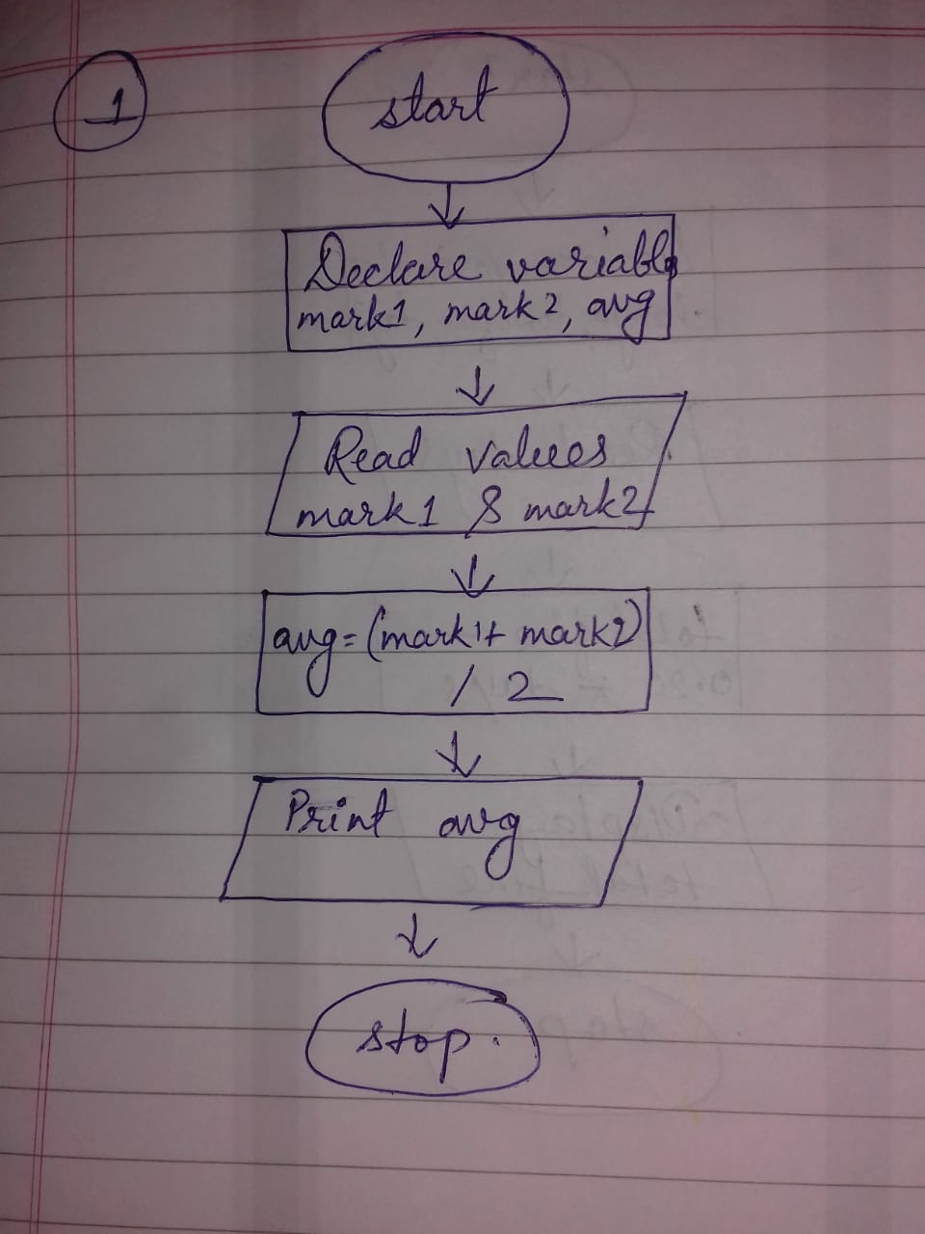

2. Calculate the total fine charged by library for late-return books. The charge is 0.20 INR for 1 day.

Algorithm:-

step1-start

step2-declare variable total_fine and days

step3-initialize the charge 0.20 INR for 1 day

step4-multiply 0.20 by days variable and assign to the total_fine

total_fine <- 0.20 * days

step5-Display total_fine

step6-stop

Flowchart:-

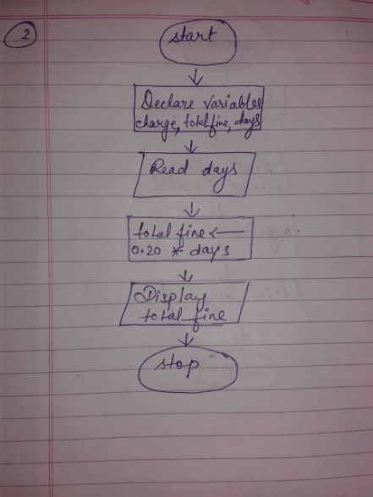

3. You had bought a nice shirt which cost Rs. 29.90 with 15% discount. Count the nett price for the shirt.

Algorithm:-

step1-start

step2-declare variable actual_price,dis_cost and nett_price

step3-initialize the Rs 29.90 to actual_price

step4-multiply actual_price by 0.15 and assign to the discounted_cost

0.15 * actual_price=dis_cost

step5-assign the final value to the nett price

nett Price = actual_price - dis_cost

step6-Display nett_price

step7-stop

Flowchart:-

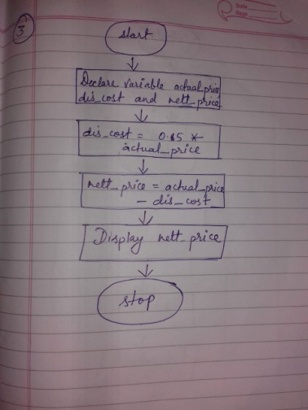

4. Find the smallest number among three different numbers.

Algorithm:-

step1-start

step2-declare variables a, b and c

step3-read variables a, b and c

step4-if a<b

a<c

display a is smallest

else

display c is smallest

else

if b<c

display b is smallest

else

display c is smallest

step5-stop

Flowchart:-

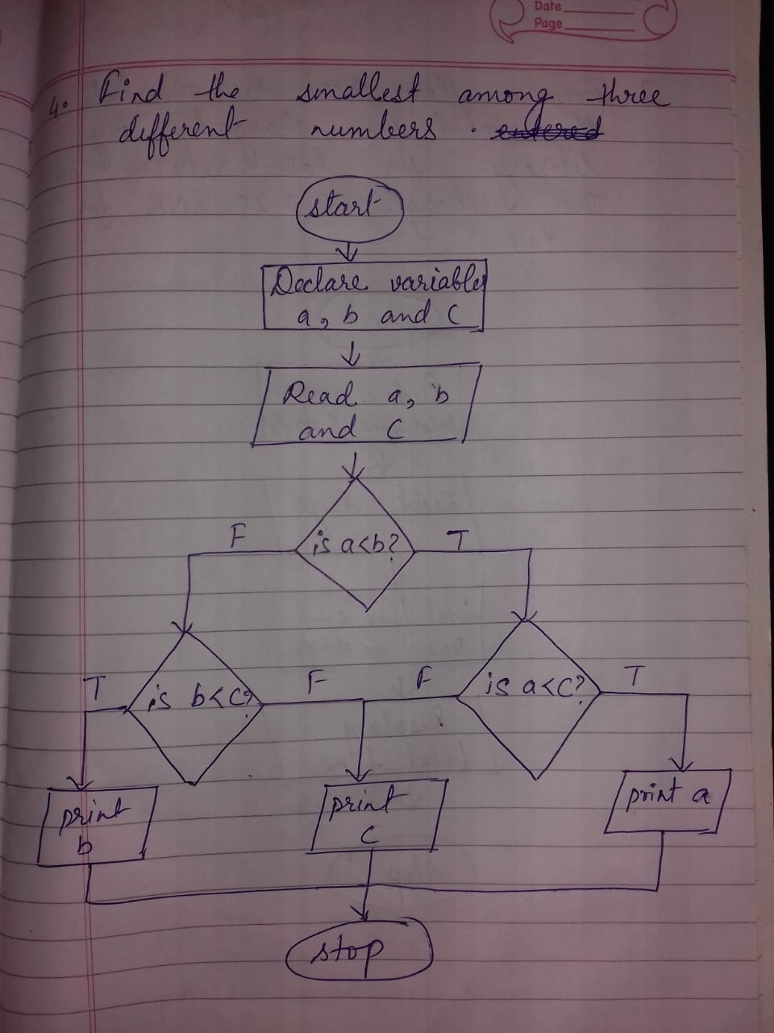

5. Find the roots of a quadratic equation ax2+bx+c=0

Algorithm:-

Step1-start

Step2-Read the variable a, b, c and D

Step3-assign b2 -4ac to D

D= b2 -4*a*c

Step4-if D<0

Display roots are complex

Else

Display roots are real

Step5-stop

Flowchart:-

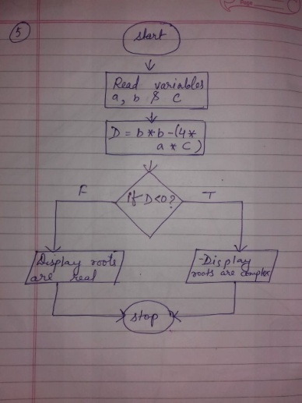

6. Find the factorial of a given number.

Algorithm:-

Step1-start

Step2-declare variable as num and fact

Step3-assign fact=1 and i=1

Step4-check condition i<num if false go to step 7

Step5-fact=fact*i

Step6-update i=i+1 go to step 4

Step7-display fact

Step8-stop

Flowchart:-

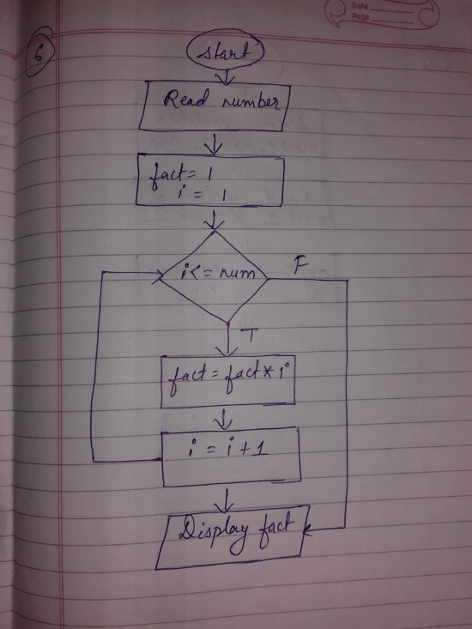

Practice questions(optional):-

D. get marks of 3 subject and declare the result . if the marks>=35 in all the subjects the students passes else fails.

Algorithm:-

Step1-Start

Step2-Declare variables m1,m2 and m3

Step3-Read the value of m1,m2 and m3

Step4-if m1>=35 go to step5 otherwise goto step 7

Step5-if m2>=35 go to step6 otherwise goto step 7

Step6-if m3>=35 print pass otherwise goto step 8

Step7-print fail

Step8-stop

Flowchart:-

