ASSIGNMENT-7

Write a C Program for the following problem statements .

1. Read n number of values in an array and display it in reverse order.

#include <stdio.h>

void main()

{

int i,num,arr[50];

printf("enter the number of elements:");

scanf("%d",&num);

printf("enter %d number of elements in the array :\n",num);

for(i=0;i<num;i++)

{

scanf("%d",&arr[i]);

}

printf("\n array in reverse order are : ");

for(i=num-1;i>=0;i--)

{

printf("%2d",arr[i]);

}

}

Output:-

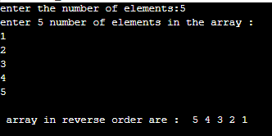

2. Find the sum of all elements of the array.

#include <stdio.h>

int main()

{

int arr[30],i,num,sum=0;

printf("enter the number of elements in the array :");

scanf("%d",&num);

printf("Input elements in the array :\n");

for(i=0;i<num;i++)

{

scanf("%d",&arr[i]);

}

for(i=0; i<num; i++)

{

sum=sum+arr[i];

}

printf("Sum of all elements: %d\n", sum);

return 0;

}

Output:-

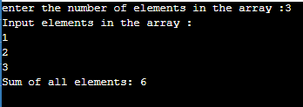

3. Copy the elements of one array into another array.

#include <stdio.h>

void main()

{

int arr1[30], arr2[30],i,num;

printf("enter the number of elements: ");

scanf("%d",&num);

for(i=0;i<num;i++)

{

scanf("%d",&arr1[i]);

}

for(i=0; i<num; i++)

{

arr2[i] = arr1[i];

}

printf("\nelements in the first array :\n");

for(i=0; i<num; i++)

{

printf("% 2d", arr1[i]);

}

printf("\ncopied into the second array :\n");

for(i=0; i<num; i++)

{

printf("% 2d", arr2[i]);

}

printf("\n");

}

Output:-

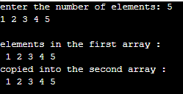

4. Count a total number of duplicate elements in an array.

#include <stdio.h>

void main()

{

int arr1[30],arr2[30],arr3[30],num,a=1,count=0,i,j;

printf("enter the number of elements :");

scanf("%d",&num);

printf("enter the elements in the array :\n");

for(i=0;i<num;i++)

{

scanf("%d",&arr1[i]);

}

for(i=0;i<num; i++) //copy in other array

{

arr2[i]=arr1[i];

arr3[i]=0;

}

for(i=0;i<num; i++) //duplicate array

{

for(j=0;j<num;j++)

{

if(arr1[i]==arr2[j])

{

arr3[j]=a;

a++;

}

}

a=1;

}

for(i=0; i<num; i++) //printing the array

{

if(arr3[i]==2)

{

count++;

}

}

printf("duplicate elements in the array are: %d\n", count);

printf("\n");

}

Output:-

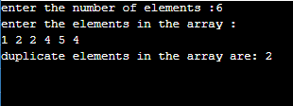

5. Find the maximum and minimum element in an array.

#include <stdio.h>

int main()

{

int a[30],max,min,num,i;

printf("enter the number of elements :");

scanf("%d",&num);

printf("enter elements in the array :\n");

for(i=0;i<num;i++)

{

scanf("%d",&a[i]);

}

max = a[0];

min = a[0];

for(i=1; i<num; i++)

{

if(a[i]>max)

{

max = a[i];

}

if(a[i]<min)

{

min = a[i];

}

}

printf("Minimum: %d\n", min);

printf("Maximum: %d\n", max);

return 0;

}

Output:-

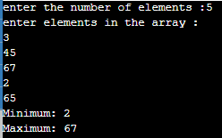

6. Separate odd and even integers in separate arrays.

#include <stdio.h>

int main()

{

int arr1[20], arr2[20], arr3[20],r,c=0,m=0,num;

printf("enter the number of elements :");

scanf("%d",&num);

printf("enter elements in the array :\n");

for(r=0;r<num;r++)

{

scanf("%d",&arr1[r]);

}

for(r=0;r<num;r++)

{

if (arr1[r]%2 == 0)

{

arr2[c] = arr1[r];

c++;

}

else

{

arr3[m] = arr1[r];

m++;

}

}

printf("Even elements are : \n");

for(r=0;r<c;r++)

{

printf("%d ",arr2[r]);

}

printf("\nOdd elements are :\n");

for(r=0;r<m;r++)

{

printf("%d ", arr3[r]);

}

printf("\n");

}

Output:-

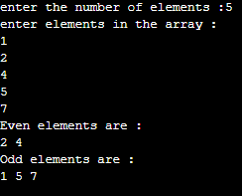

7. Insert new value in the array.

#include <stdio.h>

int main()

{

int arr[30],i,num,p,start;

printf("enter the size of array : ");

scanf("%d", &num);

printf("enter the elements in ascending order:\n");

for(i=0;i<num;i++)

{

scanf("%d",&arr[i]);

}

printf("enter the value to insert : ");

scanf("%d",&start);

printf("The exist array list is :\n ");

for(i=0;i<num;i++)

printf("% 2d",arr[i]);

for(i=0;i<num;i++)

if(start<arr[i])

{

p = i;

break;

}

for(i=num;i>=p;i--)

arr[i]= arr[i-1];

arr[p]=start;

printf("\nAfter Inserting:\n ");

for(i=0;i<=num;i++)

printf("% 2d",arr[i]);

printf("\n");

return 0;

}

Output:-

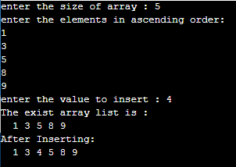

8. Delete an element at desired position from an array.

#include <stdio.h>

int main()

{

int arr[50],i,position,num;

printf("enter the size of array : ");

scanf("%d", &num);

for(i=0;i<num;i++)

{

scanf("%d",&arr[i]);

}

printf("\nenter the position to delete: ");

scanf("%d",&position);

i=0;

while(i!=position-1)

i++;

while(i<num)

{

arr[i]=arr[i+1];

i++;

}

num--;

printf("After deleting :");

for(i=0;i<num;i++)

{

printf(" %d",arr[i]);

}

printf("\n");

}

Output:-

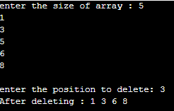

9. Find the second largest element in an array.

#include <stdio.h>

int main(){

int arr[30],num,i,j=0,large,sec_large;

printf("enter the size of array: ");

scanf("%d",&num);

printf("enter elements in the array :\n");

for(i=0;i<num;i++)

{

scanf("%d",&arr[i]);

}

large=0;

for(i=0;i<num;i++)

{

if(large<arr[i])

{

large=arr[i];

j = i;

}

}

sec_large=0;

for(i=0;i<num;i++)

{

if(i==j)

{

i++;

i--;

}

else

{

if(sec_large<arr[i])

{

sec_large=arr[i];

}

}

}

printf("Second largest element in the array is : %d\n", sec_large);

return 0;

}

Output:-

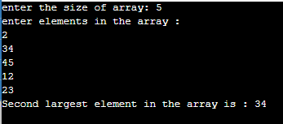

10. Find the median of two sorted arrays of same size.

#include <stdio.h>

int max(int a, int b)

{

return ((a > b) ? a : b);

}

int min(int a, int b)

{

return ((a < b) ? a : b);

}

int median(int arr[], int size)

{

if (size % 2 == 0)

return (arr[size/2] + arr[size/2-1])/2;

else

return arr[size/2];

}

int median2SortedArrays(int arr1[], int arr2[], int size)

{

int med1;

int med2;

if(size <= 0) return -1;

if(size == 1) return (arr1[0] + arr2[0])/2;

if (size == 2) return (max(arr1[0], arr2[0]) + min(arr1[1], arr2[1])) / 2;

med1 = median(arr1, size);

med2 = median(arr2, size);

if(med1 == med2) return med1;

if (med1 < med2)

{

return median2SortedArrays(arr1 + size/2, arr2, size - size/2);

}

else

{

return median2SortedArrays(arr2 + size/2, arr1, size - size/2);

}

}

int main()

{

int i,m,n;

int arr1[] = {1, 5, 13, 24, 35};

int arr2[] = {3, 8, 15, 17, 32};

m = sizeof(arr1) / sizeof(arr1[0]);

n = sizeof(arr2) / sizeof(arr2[0]);

printf("The given array - 1 is : ");

for(i = 0; i < m; i++)

{

printf("%d ", arr1[i]);

}

printf("\n");

printf("The given array - 2 is : ");

for(i = 0; i < n; i++)

{

printf("%d ", arr2[i]);

}

printf("\n");

printf("\nThe Median of the 2 sorted arrays is: %d",median2SortedArrays(arr1, arr2, n));

printf("\n");

return 0;

}

Output:-

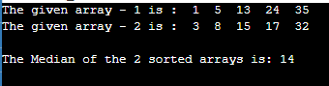

11. Multiplication of two square Matrices

#include<stdio.h>

int main()

{

int a[20][20],b[20][20],multi[20][20],r,c,i,j,k;

//system("cls");

printf("enter the number of row: ");

scanf("%d",&r);

printf("enter the number of column: ");

scanf("%d",&c);

printf("enter the first matrix element: \n");

for(i=0;i<r;i++)

{

for(j=0;j<c;j++)

{

scanf("%d",&a[i][j]);

}

}

printf("enter the element of second matrix: \n");

for(i=0;i<r;i++)

{

for(j=0;j<c;j++)

{

scanf("%d",&b[i][j]);

}

}

printf("multiply of the matrix: \n");

for(i=0;i<r;i++)

{

for(j=0;j<c;j++)

{

multi[i][j]=0;

for(k=0;k<c;k++)

{

multi[i][j]+=a[i][k]*b[k][j];

}

}

}

for(i=0;i<r;i++)

{

for(j=0;j<c;j++)

{

printf("%d\t",multi[i][j]);

}

printf("\n");

}

return 0;

}

Output:-

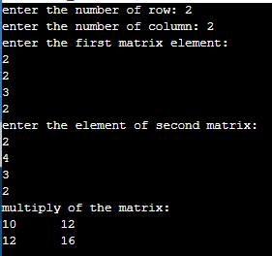

12. Find transpose of a given matrix.

#include <stdio.h>

int main()

{

int a[30][30],b[30][30],i,j,r,c;

printf("\nenter the rows and column : ");

scanf("%d %d",&r,&c);

printf("enter the element of first Matrix :\n");

for(i=0;i<r;i++)

{

for(j=0;j<c;j++)

{

scanf("%d",&a[i][j]);

}

}

printf("\ngiven matrix is:\n");

for(i=0;i<r;i++)

{

printf("\n");

for(j=0;j<c;j++)

printf("%d\t",a[i][j]);

}

for(i=0;i<r;i++)

{

for(j=0;j<c;j++)

{

b[j][i]=a[i][j];

}

}

printf("\nThe transpose of a matrix is : ");

for(i=0;i<c;i++)

{

printf("\n");

for(j=0;j<r;j++)

{

printf("%d\t",b[i][j]);

}

}

printf("\n");

return 0;

}

Output:-

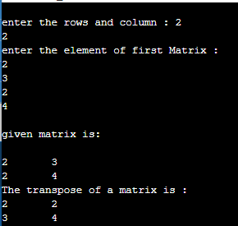

13. Find the sum of left diagonals of a matrix.

#include <stdio.h>

int main()

{

int i,j,a[20][20],sum=0,size,m=0;

printf("enter the size of the square matrix : ");

scanf("%d", &size);

m=size;

printf("enter elements of first matrix :\n");

for(i=0;i<size;i++)

{

for(j=0;j<size;j++)

{

scanf("%d",&a[i][j]);

}

}

printf("The matrix is :\n");

for(i=0;i<size;i++)

{

for(j=0;j<size ;j++)

printf("% 2d",a[i][j]);

printf("\n");

}

for(i=0;i<size;i++)

{

m=m-1;

for(j=0;j<size ;j++)

{

if (j==m)

{

sum= sum+a[i][j];

}

}

}

printf("Addition of the left Diagonal elements is :%d\n",sum);

return 0;

}

Output:-

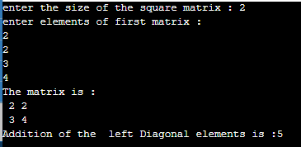

14. Check whether a given matrix is an identity matrix.

#include <stdio.h>

int main()

{

int a[10][10],r,c,i,j,k=1;

printf("enter the number of rows :");

scanf("%d", &r);

printf("enter the column of matrix :");

scanf("%d",&c);

printf("enter the elements of matrix :\n");

for(i=0;i<r;i++)

{

for(j=0;j<c;j++)

{

scanf("%d",&a[i][j]);

}

}

printf("given matrix is :\n");

for(i=0;i<r;i++)

{

for(j=0;j<c ;j++)

printf("% 2d",a[i][j]);

printf("\n");

}

for(i=0; i<r; i++)

{

for(j=0; j<c; j++)

{

if(a[i][j] != 1 && a[j][i] !=0)

{

k = 0;

break;

}

}

}

if(k == 1 )

printf(" identity matrix.\n");

else

printf(" not an identity matrix.\n");

return 0;

}

Output:-

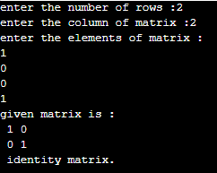

15. Search an element in a row wise and column wise sorted matrix.

#include <stdio.h>

int searchElement(int arr2D[4][4], int n, int x)

{

int i = 0, j = n-1;

while ( i < n && j >= 0 )

{

if ( arr2D[i][j] == x )

{

printf("\nThe element Found at the position in the matrix is: %d, %d", i, j);

return 1;

}

if ( arr2D[i][j] < x )

j--;

else

i++;

}

printf("\nThe given element not found in the 2D array.");

return 0;

}

int main()

{

int arr2D[4][4] = { {22, 20, 31, 39},

{18, 26, 36, 43},

{25, 18, 30, 32},

{30, 34, 29, 50},

};

int i,j,v;

v=20;

printf("The given array in matrix form is : \n");

for(i = 0; i < 4; i++)

{

for (j=0;j<4;j++)

{

printf("%d ", arr2D[i][j]);

}

printf("\n");

}

printf("The given value for searching is: %d",v);

searchElement(arr2D, 4, v);

return 0;

}

Output:-

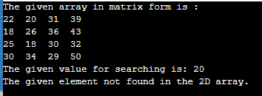

**OPTIONAL**

**1. Print all unique elements in an array.**

**#include <stdio.h>**

**int main()**

**{**

**int a[30], num,count=0,i,j,k;**

**printf("enter the number of elements: ");**

**scanf("%d",&num);**

**printf("enter elements in the array :\n");**

**for(i=0;i<num;i++)**

**{**

**scanf("%d",&a[i]);**

**}**

**printf("\nunique elements in the array are: \n");**

**for(i=0; i<num; i++)**

**{**

**count=0;**

**for(j=0,k=num; j<k+1; j++)**

**{**

**if (i!=j)**

**{**

**if(a[i]==a[j])**

**{**

**count++;**

**}**

**}**

**}**

**if(count==0)**

**{**

**printf("%d ",a[i]);**

**return 0;**

**}**

**}**

**printf("\n");**

**}**

**Output:-**

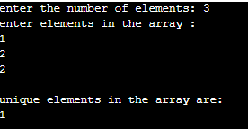

**3. Sort elements of the array in descending order.**

**#include <stdio.h>**

**int main()**

**{**

**int a[30],num,i,j,temp;**

**printf("enter the size of array : ");**

**scanf("%d",&num);**

**printf("enter elements in the array :\n");**

**for(i=0;i<num;i++)**

**{**

**scanf("%d",&a[i]);**

**}**

**for(i=0; i<num; i++)**

**{**

**for(j=i+1; j<num; j++)**

**{**

**if(a[i] < a[j])**

**{**

**temp = a[i];**

**a[i] = a[j];**

**a[j] = temp;**

**}**

**}**

**}**

**printf("\nIn descending order:\n");**

**for(i=0; i<num; i++)**

**{**

**printf("%d ", a[i]);**

**}**

**printf("\n");**

**return 0;**

**}**

**Output:-**

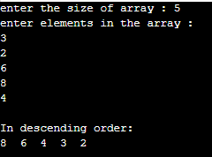

**4. Find the second smallest element in an array.**

**#include <stdio.h>**

**int main()**

**{**

**int a[30],num,i,j=0,small,sec_small;**

**printf("enter the size of array : ");**

**scanf("%d", &num);**

**printf("Input elements in the array:\n");**

**for(i=0;i<num;i++)**

**{**

**scanf("%d",&a[i]);**

**}**

**small=a[0];**

**for(i=0;i<num;i++)**

**{**

**if(small>a[i])**

**{**

**small=a[i];**

**j = i;**

**}**

**}**

**for(i=0;i<num;i++)**

**{**

**if(i==j)**

**{**

**i++;**

**i--;**

**}**

**else**

**{**

**if(sec_small>a[i])**

**{**

**sec_small=a[i];**

**}**

**}**

**}**

**printf("The Second smallest element in the array is : %d \n\n", sec_small);**

**return 0;**

**}**

**Output:-**

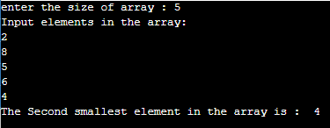

**6. Find numbers that occur odd number of times in an array.**

**#include <stdio.h>**

**int findOdd(int *arr, int num )**

**{**

**int i, ResultXor = 0;**

**for(i = 0; i < num; i++)**

**{**

**ResultXor = ResultXor ^ arr[i];**

**}**

**return ResultXor;**

**}**

**int main()**

**{**

**int i;**

**int arr[] = {3, 1, 8, 4, 1, 3, 1, 7, 3};**

**int ctr = sizeof(arr)/sizeof(arr[0]);**

**printf("The given array is : ");**

**for(i = 0; i < ctr; i++)**

**{**

**printf("%d ", arr[i]);**

**}**

**printf("\n");**

**printf("odd number occur : %d times.\n", findOdd(arr, ctr));**

**return 0;**

**}**

**Output:-**

**sd.png**

**8. Subtraction of two Matrices.**

**#include <stdio.h>**

**int main()**

**{**

**int a[30][30],b[30][30],c[30][30],i,j,num;**

**printf("enter the size of matrix ");**

**scanf("%d", &num);**

**printf("enter elements in the first matrix :\n");**

**for(i=0;i<num;i++)**

**{**

**for(j=0;j<num;j++)**

**{**

**scanf("%d",&a[i][j]);**

**}**

**}**

**printf("enter elements in the second matrix :\n");**

**for(i=0;i<num;i++)**

**{**

**for(j=0;j<num;j++)**

**{**

**scanf("%d",&b[i][j]);**

**}**

**}**

**printf("\nFirst matrix :\n");**

**for(i=0;i<num;i++)**

**{**

**printf("\n");**

**for(j=0;j<num;j++)**

**printf("%d\t",a[i][j]);**

**}**

**printf("\nSecond matrix:\n");**

**for(i=0;i<num;i++)**

**{**

**printf("\n");**

**for(j=0;j<num;j++)**

**printf("%d\t",b[i][j]);**

**}**

**for(i=0;i<num;i++)**

**for(j=0;j<num;j++)**

**c[i][j]=a[i][j]-b[i][j];**

**printf("\nSubtraction of two matrix: \n");**

**for(i=0;i<num;i++){**

**printf("\n");**

**for(j=0;j<num;j++)**

**printf("%d\t",c[i][j]);**

**}**

**printf("\n");**

**}**

**Output:-**

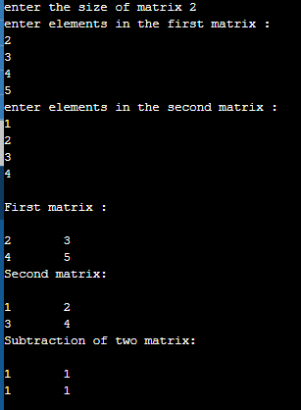

**9. Find sum of right diagonals of a matrix.**

**#include <stdio.h>**

**int main()**

**{**

**int i,j,a[30][30],sum=0,num;**

**printf("enter the size of matrix: ");**

**scanf("%d", &num);**

**printf("enter the elements of matrix :\n");**

**for(i=0;i<num;i++)**

**{**

**for(j=0;j<num;j++)**

**{**

**scanf("%d",&a[i][j]);**

**if (i==j)**

**sum= sum+a[i][j];**

**}**

**}**

**printf("The matrix is :\n");**

**for(i=0;i<num;i++)**

**{**

**for(j=0;j<num ;j++)**

**printf("% 2d",a[i][j]);**

**printf("\n");**

**}**

**printf("Addition of the right Diagonal elements :%d\n",sum);**

**return 0;**

**}**

**Output:-**

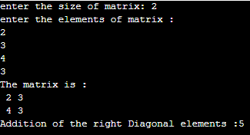

**10. Display the lower triangular of a given matrix.**

**#include <stdio.h>**

**int main()**

**{**

**int a[20][20],i,j,num;**

**printf("enter the size of the square matrix : ");**

**scanf("%d", &num);**

**printf("enter elements in the matrix :\n");**

**for(i=0;i<num;i++)**

**{**

**for(j=0;j<num;j++)**

**{**

**scanf("%d",&a[i][j]);**

**}**

**}**

**printf("The matrix is :\n");**

**for(i=0;i<num;i++)**

**{**

**for(j=0;j<num ;j++)**

**printf("% 2d",a[i][j]);**

**printf("\n");**

**}**

**printf("\nset 0 in lower traingle matrix: \n");**

**for(i=0;i<num;i++){**

**printf("\n");**

**for(j=0;j<num;j++)**

**if(i<=j)**

**printf("% 2d",a[i][j]);**

**else**

**printf("% 2d",0);**

**}**

**printf("\n");**

**}**

**Output:-**

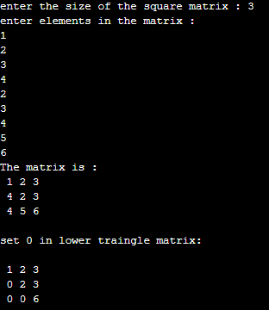

**11. Calculate determinant of a 3 x 3 matrix.**

**#include <stdio.h>**

**int main()**

**{**

**int a[10][10],i,j,n,det=0;**

**printf("enter elements in the first matrix :\n");**

**for(i=0;i<3;i++)**

**{**

**for(j=0;j<3;j++)**

**{**

**scanf("%d",&a[i][j]);**

**}**

**}**

**printf("The matrix is :\n");**

**for(i=0;i<3;i++)**

**{**

**for(j=0;j<3 ;j++)**

**printf("% 2d",a[i][j]);**

**printf("\n");**

**}**

**for(i=0;i<3;i++)**

**det = det + (a[0][i]*(a[1][(i+1)%3]*a[2][(i+2)%3] - a[1][(i+2)%3]*a[2][(i+1)%3]));**

**printf("\nThe Determinant of the matrix is: %d\n\n",det);**

**return 0;**

**}**

**Output:-**

