KONERU LAKSHMAIAH EDUCATION FOUNDATION
(Deemed to be University)
Department of Computer Science and Engineering

A Project Report on

MovieFlix – Advanced Movie Search and
Recommendation System

Submitted in partial fulfillment of the requirements for the course
Data Structures and Algorithms-3 (25CS2103E)

Submitted by
[Student Name 1] | [Roll Number 1]
[Student Name 2] | [Roll Number 2]
[Student Name 3] | [Roll Number 3]
[Student Name 4] | [Roll Number 4]

Team Number: [Team Number] | Section: [Section]

Under the Guidance of
Dr. S. Vinay Kumar
Associate Professor, Department of Computer Science and Engineering

Academic Year: 2026–27

DECLARATION
We hereby declare that the project entitled "MovieFlix – Advanced Movie Search and Recommendation System" submitted to the Department of Computer Science and Engineering, Koneru Lakshmaiah Education Foundation (KLH University), is a record of original work carried out by us under the guidance of Dr. S. Vinay Kumar, Associate Professor, Department of Computer Science and Engineering.
The results embodied in this project report have not been submitted to any other university or institution for the award of any degree or diploma, to the best of our knowledge and belief.

[Student Name 1] | [Student Name 2]
[Student Name 3] | [Student Name 4]

Place: Hyderabad
Date: _______________

CERTIFICATE
This is to certify that the project report entitled "MovieFlix – Advanced Movie Search and Recommendation System" is a bonafide record of the project work carried out by the following students of B.Tech in Computer Science and Engineering during the academic year 2026–27:
S.No. | Name | Roll Number
1 | [Student Name 1] | [Roll Number 1]
2 | [Student Name 2] | [Roll Number 2]
3 | [Student Name 3] | [Roll Number 3]
4 | [Student Name 4] | [Roll Number 4]
This project work has been carried out under the supervision and guidance of Dr. S. Vinay Kumar, Associate Professor, Department of Computer Science and Engineering, and is submitted in partial fulfillment of the requirements for the course Data Structures and Algorithms-3 (25CS2103E).

Dr. S. Vinay Kumar | Dr. P. Venkateshwara Rao
Project Guide | Head of the Department
Associate Professor, CSE | Associate Professor, CSE

ACKNOWLEDGEMENT
We would like to express our sincere and heartfelt gratitude to our project guide, Dr. S. Vinay Kumar, Associate Professor, Department of Computer Science and Engineering, Koneru Lakshmaiah Education Foundation, for his invaluable guidance, constant encouragement, and expert supervision throughout the development of this project. His insightful suggestions regarding algorithmic design, dynamic programming formulations, network flow modeling, and complexity theory significantly shaped the direction and quality of this work.
We are deeply thankful to Dr. P. Venkateshwara Rao, Associate Professor and Head of the Department of Computer Science and Engineering, for providing the necessary infrastructure, academic resources, and a stimulating learning environment that enabled us to pursue this project effectively. We also extend our gratitude to all the faculty members of the Department of Computer Science and Engineering for their continuous support and the strong theoretical foundation they have provided us through their teaching.
We wish to acknowledge the Koneru Lakshmaiah Education Foundation (KLH University) for offering a comprehensive academic ecosystem that fosters practical application of theoretical concepts. Finally, we thank our fellow classmates and all those who directly or indirectly contributed to the successful completion of this project.

ABSTRACT
Modern streaming platforms manage millions of media titles and handle high-throughput search queries, personalized recommendations, and catalogue scheduling. Off-the-shelf frameworks often abstract the core algorithmic paradigms required for scalable search indices, recommendation graphs, and optimization models. MovieFlix addresses this challenge by implementing an integrated, modular, pure-Java console application powered by fundamental and advanced Data Structures and Algorithms (DSA) without reliance on third-party frameworks or external databases.
The system operates in two distinct modes: a User Mode providing a clean, seamless interface for searching, browsing, watchlist management, personalized recommendations, smart budget filtering, and marathon planning; and a DSA Lab Mode serving as a technical diagnostic console that showcases internal algorithm states, comparison counts, swap operations, residual graphs, augmenting paths, and nanosecond execution-time measurements. The project implements string-matching algorithms (Z-Algorithm, KMP, Rabin–Karp), six sorting algorithms (Bubble, Selection, Insertion, Merge, Quick, Heap), custom data structures (Hash Table with separate chaining, Binary Search Tree, AVL Tree with LL/RR/LR/RL rotations, Trie), and graph algorithms (BFS, DFS) for Phase 1 and Phase 2 course outcomes.
For advanced course outcomes, MovieFlix implements Bitmask Dynamic Programming for smart watchlist optimization under time-budget constraints (CO3), Interval Dynamic Programming for optimal movie marathon scheduling with continuity bonuses (CO3), Ford–Fulkerson and Edmonds–Karp algorithms for maximum flow and minimum cut in a recommendation allocation network (CO4), complexity theory demonstrations including polynomial-time reduction from Subset Sum to the movie selection decision problem with exact, heuristic, and approximation algorithm comparisons (CO5), and randomized algorithms (Randomized Quick Sort, Randomized Rabin–Karp) alongside parallel algorithms (Parallel Search, Parallel Reduction, Parallel Prefix Sum) with work–span analysis (CO6). The dataset architecture comprises 10,000 pipe-delimited records across 100 text files spanning movies, users, watch history, and performance benchmarks.

TABLE OF CONTENTS

Declaration ii
Certificate iii
Acknowledgement iv
Abstract v
Table of Contents vi
List of Figures viii
List of Tables ix
List of Abbreviations x
Chapter 1: Introduction 1
1.1 Overview 1
1.2 Background of Movie Search and Recommendation Systems 1
1.3 Problem Statement 2
1.4 Motivation 2
1.5 Objectives 3
1.6 Scope of the Project 3
1.7 Proposed Solution 4
1.8 Major Contributions 4
1.9 Organization of the Report 5
Chapter 2: System Requirements and Background Study 6
2.1 Existing System 6
2.2 Limitations of Existing Approaches 6
2.3 Proposed System 7
2.4 Functional Requirements 7
2.5 Non-Functional Requirements 8
2.6 Hardware Requirements 8
2.7 Software Requirements 8
2.8 Dataset Requirements 9
2.9 Relevant Literature Review 9
Chapter 3: System Design 12
Chapter 4: Implementation 20
Chapter 5: Results and Analysis 50
Chapter 6: Challenges and Limitations 60
Chapter 7: Conclusion and Future Work 65
References 68
[Note: Right-click the Table of Contents and select 'Update Field' in Microsoft Word to update page numbers automatically.]

LIST OF FIGURES
Figure 3.1: MovieFlix Overall Architecture
Figure 3.2: Dataset Loading and Validation Workflow
Figure 3.3: User Mode Workflow
Figure 3.4: DSA Lab Mode Workflow
Figure 3.5: Smart Watchlist Optimization Workflow
Figure 3.6: Movie Marathon Planner Workflow

LIST OF TABLES
Table 2.1: Hardware Requirements
Table 2.2: Software Requirements
Table 3.1: Movie Record Structure (28 Fields)
Table 3.2: User Record Structure (9 Fields)
Table 3.3: Watch-History Record Structure (6 Fields)
Table 3.4: Performance-Test Record Structure (7 Fields)
Table 3.5: Course Outcome Mapping
Table 4.1: Comprehensive Algorithm Complexity Analysis
Table 5.1: Dataset Loading Summary
Table 5.2: String-Matching Algorithm Comparison
Table 5.3: Sorting Algorithm Comparison
Table 5.4: Data-Structure Operation Results
Table 5.5: Dynamic Programming Results
Table 5.6: Network Flow Results
Table 5.7: Sequential vs Parallel Execution Results

LIST OF ABBREVIATIONS
Abbreviation | Full Form
DSA | Data Structures and Algorithms
DP | Dynamic Programming
KMP | Knuth–Morris–Pratt
BST | Binary Search Tree
AVL | Adelson-Velsky and Landis (Self-Balancing BST)
BFS | Breadth-First Search
DFS | Depth-First Search
NP | Nondeterministic Polynomial Time
IMDb | Internet Movie Database
TMDB | The Movie Database
OMDb | Open Movie Database
CO | Course Outcome
JDK | Java Development Kit
JVM | Java Virtual Machine
API | Application Programming Interface
CSV | Comma-Separated Values
TXT | Text File
LPS | Longest Proper Prefix which is also Suffix

CHAPTER 1: INTRODUCTION

1.1 Overview
MovieFlix is a comprehensive, production-grade Java console application designed to demonstrate the practical application of fundamental and advanced Data Structures and Algorithms (DSA) in the domain of movie search, recommendation, and catalogue management. The project integrates over 30 distinct algorithm implementations spanning string matching, sorting, searching, hashing, tree-based indexing, graph traversal, dynamic programming, network flow optimization, complexity theory, randomized algorithms, and parallel computation.
Unlike web-based streaming applications that rely heavily on third-party frameworks, databases, and cloud services, MovieFlix is intentionally built as a pure-Java application without external dependencies. This design philosophy ensures that every algorithmic component—from the Z-array construction in string matching to the residual graph updates in network flow—is implemented, verified, and demonstrated transparently within the application.

1.2 Background of Movie Search and Recommendation Systems
The global film and entertainment industry generates thousands of new titles annually across hundreds of languages and genres. Platforms such as Netflix, Amazon Prime Video, Disney+ Hotstar, and similar services manage catalogues containing millions of titles and serve billions of search queries daily. The core technical challenges in these systems include efficient full-text and substring search, rapid multi-criteria sorting and filtering, personalized recommendation through collaborative and content-based filtering, and optimal scheduling of viewing sessions under time constraints [1].
Traditional approaches to these problems rely on inverted indices, distributed databases, machine learning models, and microservice architectures. However, the foundational algorithmic principles underlying these systems—pattern matching, balanced tree indexing, graph-based similarity modeling, knapsack-style optimization, and network flow allocation—remain essential topics in computer science education [2]. MovieFlix bridges the gap between theoretical coursework and practical application by implementing these algorithms directly on a structured movie dataset.

1.3 Problem Statement
Design and implement a modular Java console application that applies fundamental and advanced DSA concepts to solve real-world problems in movie search, indexing, sorting, recommendation, watchlist optimization, marathon scheduling, flow-based allocation, and complexity analysis. The application must support a dataset of at least 2,500 movie records with 28 metadata fields, and must demonstrate each algorithm with verifiable output, execution-time measurements, and complexity analysis.

1.4 Motivation
The primary motivation for this project is to provide a tangible, executable demonstration of how DSA concepts taught in the B.Tech curriculum translate into working software. Specifically:
- String-matching algorithms (Z-Algorithm, KMP, Rabin–Karp) are directly applicable to movie title and keyword search functionality.
- Sorting algorithms enable multi-criteria ordering of movie catalogues by rating, popularity, trending score, and other attributes.
- Tree-based data structures (BST, AVL, Trie) provide efficient indexing, range queries, and autocomplete functionality.
- Dynamic programming formulations (Bitmask DP, Interval DP) solve constrained optimization problems in watchlist planning and marathon scheduling.
- Network flow algorithms (Ford–Fulkerson, Edmonds–Karp) model recommendation allocation as a flow optimization problem.
- Complexity theory demonstrations illustrate the distinction between polynomial-time solvable problems and NP-hard formulations within the movie domain.
- Randomized and parallel algorithms demonstrate probabilistic correctness guarantees and multi-threaded performance improvements.

1.5 Objectives
1. Implement genuine, handcrafted algorithms for string matching (Z-Algorithm, KMP, Rabin–Karp), sorting (Bubble, Selection, Insertion, Merge, Quick, Heap), and searching (Linear, Binary) without relying on built-in library implementations.
2. Design and implement custom data structures including a Hash Table with separate chaining, Binary Search Tree, AVL Tree with all four rotation types, Trie for prefix matching, and a Movie Graph with BFS and DFS traversals.
3. Develop Bitmask Dynamic Programming for smart watchlist optimization under time-budget constraints and Interval Dynamic Programming for optimal movie marathon scheduling.
4. Implement Ford–Fulkerson (DFS-based) and Edmonds–Karp (BFS-based) algorithms for maximum flow and minimum cut in a movie recommendation flow network.
5. Demonstrate complexity theory concepts including P, NP, NP-Hard, NP-Complete classifications, polynomial-time reductions, and the comparison of exact, heuristic, and approximation algorithms.
6. Implement Randomized Quick Sort, Randomized Rabin–Karp, Parallel Search, Parallel Reduction, Parallel Prefix Sum, and work–span analysis.
7. Provide dual operating modes (User Mode and DSA Lab Mode) to serve both end-user application needs and technical algorithm demonstration requirements.

1.6 Scope of the Project
The scope of MovieFlix encompasses the following technical areas:
- String pattern matching across movie titles, keywords, and metadata fields using three distinct algorithms.
- Comprehensive sorting of movie records by multiple criteria with six implemented sorting algorithms.
- Custom hash table, BST, AVL tree, and trie implementations for efficient data retrieval.
- Graph-based movie similarity modeling with BFS and DFS traversals.
- Two dynamic programming formulations for constrained optimization problems.
- Network flow modeling for recommendation allocation with max-flow/min-cut analysis.
- Formal complexity theory demonstrations with practical movie-domain examples.
- Multi-threaded parallel algorithms with work–span analysis.
- A structured dataset of 10,000 pipe-delimited records across 100 text files.
The project is limited to a console-based Java application and does not include web-based frontends, mobile applications, or cloud deployment.

1.7 Proposed Solution
MovieFlix proposes a modular, layered architecture consisting of the following components:
1. Data Layer: A DatasetManager responsible for loading, parsing, validating, and indexing pipe-delimited text files containing movie, user, watch history, and performance records.
2. Algorithm Layer: Dedicated packages for each algorithmic category (patternmatching, searching, sorting, hashing, trees, trie, graph, dp, flow, complexity, randomized, parallel) ensuring clean separation of concerns.
3. Interface Layer: A ConsoleUI class that routes user input to the appropriate algorithm module and formats output for both User Mode (clean presentation) and DSA Lab Mode (detailed diagnostic output including internal states, comparison counts, and nanosecond timings).
4. Model Layer: Well-defined data models (Movie, User, WatchHistory, PerformanceRecord) with comprehensive field coverage and type-safe accessors.

1.8 Major Contributions
- A complete, runnable Java console application integrating over 30 DSA algorithms applied to a realistic movie dataset.
- Genuine algorithm implementations without reliance on Java standard library sorting or searching methods.
- Bitmask DP and Interval DP formulations with well-defined state representations, transitions, and complexity analysis.
- A flow-network recommendation model using SOURCE → USER PREFERENCE → GENRE → MOVIES → SINK architecture with computed (not hard-coded) maximum flow and minimum cut.
- Formal complexity theory demonstrations including polynomial-time reduction from Subset Sum to the movie selection decision problem.
- Multi-threaded parallel algorithms with measured execution times and theoretical work–span analysis.
- A comprehensive dataset of 10,000 records across four categories with multi-source metadata tracking.

1.9 Organization of the Report
This report is organized into seven chapters. Chapter 1 introduces the project, its objectives, and scope. Chapter 2 presents the system requirements and background study including a literature review. Chapter 3 describes the system design, architecture, and data models. Chapter 4 details the implementation of all algorithmic modules with pseudocode and complexity analysis. Chapter 5 presents the results and analysis of algorithm executions. Chapter 6 discusses the challenges faced and limitations of the system. Chapter 7 concludes the report with a summary of outcomes and future work. A comprehensive list of references is provided at the end.

CHAPTER 2: SYSTEM REQUIREMENTS AND BACKGROUND STUDY

2.1 Existing System
Existing movie search and recommendation systems such as Netflix, Amazon Prime Video, and Disney+ Hotstar rely on sophisticated, multi-layered architectures involving distributed databases (Cassandra, DynamoDB), search engines (Elasticsearch), machine learning models (collaborative filtering, deep learning), content delivery networks, and microservice-based backend systems [1]. These platforms handle millions of concurrent users and employ complex A/B testing frameworks to optimize recommendation quality.
From an academic perspective, several open-source movie recommendation projects exist, typically built using Python with libraries such as scikit-learn, TensorFlow, and pandas. These projects focus primarily on the machine learning aspects of recommendation and do not emphasize the underlying data structure and algorithm implementations.

2.2 Limitations of Existing Approaches
- Heavy dependency on external frameworks and databases that abstract core algorithmic operations.
- Lack of transparency in demonstrating how fundamental algorithms (sorting, searching, pattern matching) operate on actual data.
- No integrated demonstration of advanced algorithmic paradigms such as bitmask DP, interval DP, network flow, or formal complexity theory within a single application.
- Most academic projects focus on either machine learning or web development, not on pure algorithmic implementation.
- Existing systems do not provide a dual-mode interface for both end-user interaction and technical algorithm analysis.

2.3 Proposed System
MovieFlix addresses these limitations by providing a self-contained Java console application where every algorithmic component is handcrafted, transparent, and measurable. The system loads data from structured text files, builds custom indexes using implemented data structures, and provides both a user-friendly interface and a technical diagnostic mode.

2.4 Functional Requirements
ID | Requirement
FR-01 | The system shall load and parse movie, user, watch history, and performance records from pipe-delimited text files.
FR-02 | The system shall support substring search across movie titles, keywords, and genres using Z-Algorithm, KMP, and Rabin–Karp.
FR-03 | The system shall sort movie records by multiple criteria using six sorting algorithms.
FR-04 | The system shall provide O(1) average-case movie lookup via a custom hash table.
FR-05 | The system shall maintain movie indexes using BST, AVL Tree, and Trie data structures.
FR-06 | The system shall compute movie recommendations using graph-based similarity (BFS, DFS).
FR-07 | The system shall optimize watchlist selection under time-budget constraints using Bitmask DP.
FR-08 | The system shall plan movie marathons using Interval DP with continuity bonuses.
FR-09 | The system shall compute maximum flow and minimum cut in a recommendation flow network.
FR-10 | The system shall demonstrate P/NP/NP-Hard/NP-Complete concepts with practical examples.
FR-11 | The system shall implement randomized and parallel algorithm variants with timing comparisons.

2.5 Non-Functional Requirements
ID | Requirement
NFR-01 | The system shall handle datasets of at least 2,500 records per category without failure.
NFR-02 | Sorting operations shall complete within reasonable time on the target hardware.
NFR-03 | The system shall provide nanosecond-precision execution time measurements.
NFR-04 | The system shall gracefully handle malformed input records and report errors.
NFR-05 | The application shall run on any system with JDK 17 or higher.

2.6 Hardware Requirements
Component | Specification
Processor | Intel Core i5 or equivalent (recommended)
RAM | 4 GB minimum, 8 GB recommended
Storage | 100 MB for application and dataset
Display | Terminal/Console with minimum 120 column width
Table 2.1: Hardware Requirements

2.7 Software Requirements
Software | Specification
Operating System | Windows 10/11, Linux, or macOS
JDK | Java Development Kit 17 or higher (compatible with Java 21/25)
Build Tool | javac (command-line compiler)
Runtime | java (JVM)
Editor/IDE | Any text editor or IDE (VS Code, IntelliJ IDEA, Eclipse)
Table 2.2: Software Requirements

2.8 Dataset Requirements
The MovieFlix dataset architecture employs a decoupled, range-based text storage model stored in the data/ directory. The intended target is at least 2,500 records per category, organized into 25 text files per category (100 records per file), resulting in 100 text files and 10,000 total records across four categories:
Directory | Files | Records | Format
data/movies/ | 25 files | 2,500 records | 28 fields per record (pipe-delimited)
data/users/ | 25 files | 2,500 records | 9 fields per record
data/watch_history/ | 25 files | 2,500 records | 6 fields per record
data/performance/ | 25 files | 2,500 records | 7 fields per record

2.9 Relevant Literature Review
This section reviews the key algorithmic concepts and established literature relevant to the MovieFlix project. The algorithms actually implemented in MovieFlix are described in Chapter 4; this section provides the theoretical background.

2.9.1 String Matching Algorithms
The string matching problem—finding all occurrences of a pattern P of length m in a text T of length n—is a fundamental problem in computer science. The naive algorithm operates in O(nm) worst-case time. Knuth, Morris, and Pratt [3] introduced the KMP algorithm that achieves O(n + m) time by precomputing a failure function (LPS array) that allows the search to skip redundant character comparisons. Independently, Gusfield [4] describes the Z-algorithm, which constructs a Z-array in O(n + m) time where Z[i] stores the length of the longest substring starting from position i that matches a prefix of the string. Karp and Rabin [5] proposed a probabilistic string matching algorithm using rolling hash functions, achieving expected O(n + m) time under suitable hash function assumptions, though the worst case remains O(nm) due to potential hash collisions.

2.9.2 Sorting Algorithms
Sorting is among the most studied problems in computer science [2]. Comparison-based sorting algorithms have a proven lower bound of Ω(n log n). Cormen et al. [2] provide comprehensive analyses of Insertion Sort (O(n²) worst case, O(n) best case for nearly sorted inputs), Merge Sort (O(n log n) guaranteed with O(n) auxiliary space), Quick Sort (O(n log n) expected, O(n²) worst case, O(log n) space), and Heap Sort (O(n log n) in-place). Bubble Sort and Selection Sort, while O(n²), serve pedagogical purposes in understanding sorting fundamentals.

2.9.3 Data Structures
Hash tables provide expected O(1) lookup, insertion, and deletion through hashing with collision resolution strategies such as chaining or open addressing [2]. Binary Search Trees (BSTs) support O(log n) operations for balanced trees but degrade to O(n) for skewed inputs. Adelson-Velsky and Landis [6] introduced AVL trees, the first self-balancing BST, which maintain a balance factor of at most 1 at every node through single (LL, RR) and double (LR, RL) rotations, guaranteeing O(log n) operations. Tries (prefix trees) support string operations proportional to string length and are particularly suited for autocomplete and prefix search functionality [2].

2.9.4 Graph Algorithms
Breadth-First Search (BFS) and Depth-First Search (DFS) are fundamental graph traversal algorithms operating in O(V + E) time [2]. BFS explores vertices level by level and finds shortest paths in unweighted graphs. DFS explores as deeply as possible before backtracking and is the basis for topological sorting, cycle detection, and connected component identification.

2.9.5 Dynamic Programming
Dynamic programming (DP) solves optimization problems by decomposing them into overlapping subproblems and storing solutions to avoid redundant computation [2]. Bitmask DP uses bitmask representations to enumerate subsets, achieving O(N · 2^N) complexity for problems involving subset selection with N items. Interval DP operates on contiguous ranges [i, j] of a sequence, computing optimal solutions by trying all possible split points, typically achieving O(N³) complexity [7].

2.9.6 Network Flow
The maximum flow problem seeks to find the maximum amount of flow that can pass from a source node to a sink node in a flow network. Ford and Fulkerson [8] introduced the augmenting path method, which iteratively finds paths from source to sink in the residual graph and augments flow along these paths. The runtime of the basic Ford–Fulkerson algorithm is O(E · f) where f is the maximum flow value, which may not be polynomial for irrational capacities. Edmonds and Karp [9] demonstrated that using BFS to find the shortest augmenting path guarantees a polynomial-time bound of O(V · E²). The Max-Flow Min-Cut Theorem states that the maximum flow equals the minimum capacity of a cut separating source from sink [2].

2.9.7 Complexity Theory
Computational complexity theory classifies problems based on the resources required to solve them [10]. P denotes the class of problems solvable in polynomial time by a deterministic Turing machine. NP denotes problems for which a solution can be verified in polynomial time. A problem is NP-Hard if every problem in NP can be reduced to it in polynomial time. A problem is NP-Complete if it is both in NP and NP-Hard. The 0/1 Knapsack decision problem ("Does there exist a subset with total weight ≤ W and total value ≥ V?") is NP-Complete [10].

2.9.8 Randomized and Parallel Algorithms
Randomized algorithms use random choices during execution to achieve good expected performance. Randomized Quick Sort selects pivots uniformly at random, achieving expected O(n log n) time regardless of input distribution [2]. Parallel algorithms exploit multiple processing units to reduce wall-clock execution time. The work–span model analyzes parallel algorithms by measuring total work W (sum of all operations) and span S (longest dependency chain). The parallelism P = W/S indicates the maximum useful number of processors [11].

CHAPTER 3: SYSTEM DESIGN

3.1 Overall System Architecture
MovieFlix follows a layered architectural pattern consisting of four primary layers: the Interface Layer (ConsoleUI), the Data Management Layer (DatasetManager), the Model Layer (Movie, User, WatchHistory, PerformanceRecord), and the Algorithm Layer (15 packages implementing over 30 algorithms). Both the User Mode and DSA Lab Mode share the same datasets and algorithm implementations, ensuring consistency between the user-facing application and the technical demonstration environment.
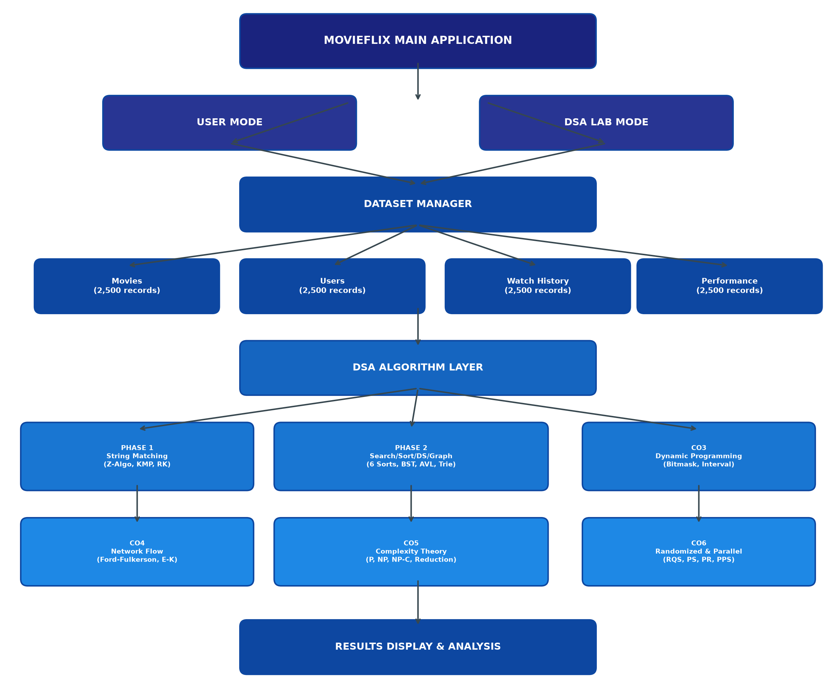
Figure 3.1: MovieFlix Overall Architecture

3.2 Module Architecture
The project is organized into the following packages, each encapsulating a specific category of functionality:
Package | Contents
model/ | Movie, User, WatchHistory, PerformanceRecord data models
dataset/ | DatasetManager for loading, parsing, and indexing data files
ui/ | ConsoleUI for all interactive menu routing and display
patternmatching/ | ZAlgorithm, KMP, RabinKarp string matching
searching/ | LinearSearch, BinarySearch implementations
sorting/ | BubbleSort, SelectionSort, InsertionSort, MergeSort, QuickSort, HeapSort
hashing/ | MovieHashTable with separate chaining
trees/ | BST, AVLTree with LL, RR, LR, RL rotations
trie/ | MovieTrie for prefix-based search
graph/ | MovieGraph with BFS and DFS
dp/ | BitmaskDP, IntervalDP
flow/ | FordFulkerson, EdmondsKarp
complexity/ | ComplexityDemo (P/NP, Reduction, Approximation)
randomized/ | RandomizedQuickSort, RandomizedRabinKarp
parallel/ | ParallelSearch, ParallelReduction, ParallelPrefixSum

3.3 Data Flow
The data flow in MovieFlix follows this sequence: (1) On application startup, the DatasetManager reads all text files from the data/ directory; (2) Each line is parsed using the pipe delimiter and validated for field count and data types; (3) Valid records are stored in typed ArrayList collections; (4) Secondary indexes are built for genre-based and language-based lookups; (5) Data structures (Hash Table, BST, AVL, Trie, Graph) are populated from the loaded records; (6) User requests from either mode are routed to the appropriate algorithm module, which operates on the indexed data; (7) Results are formatted and displayed according to the active mode.
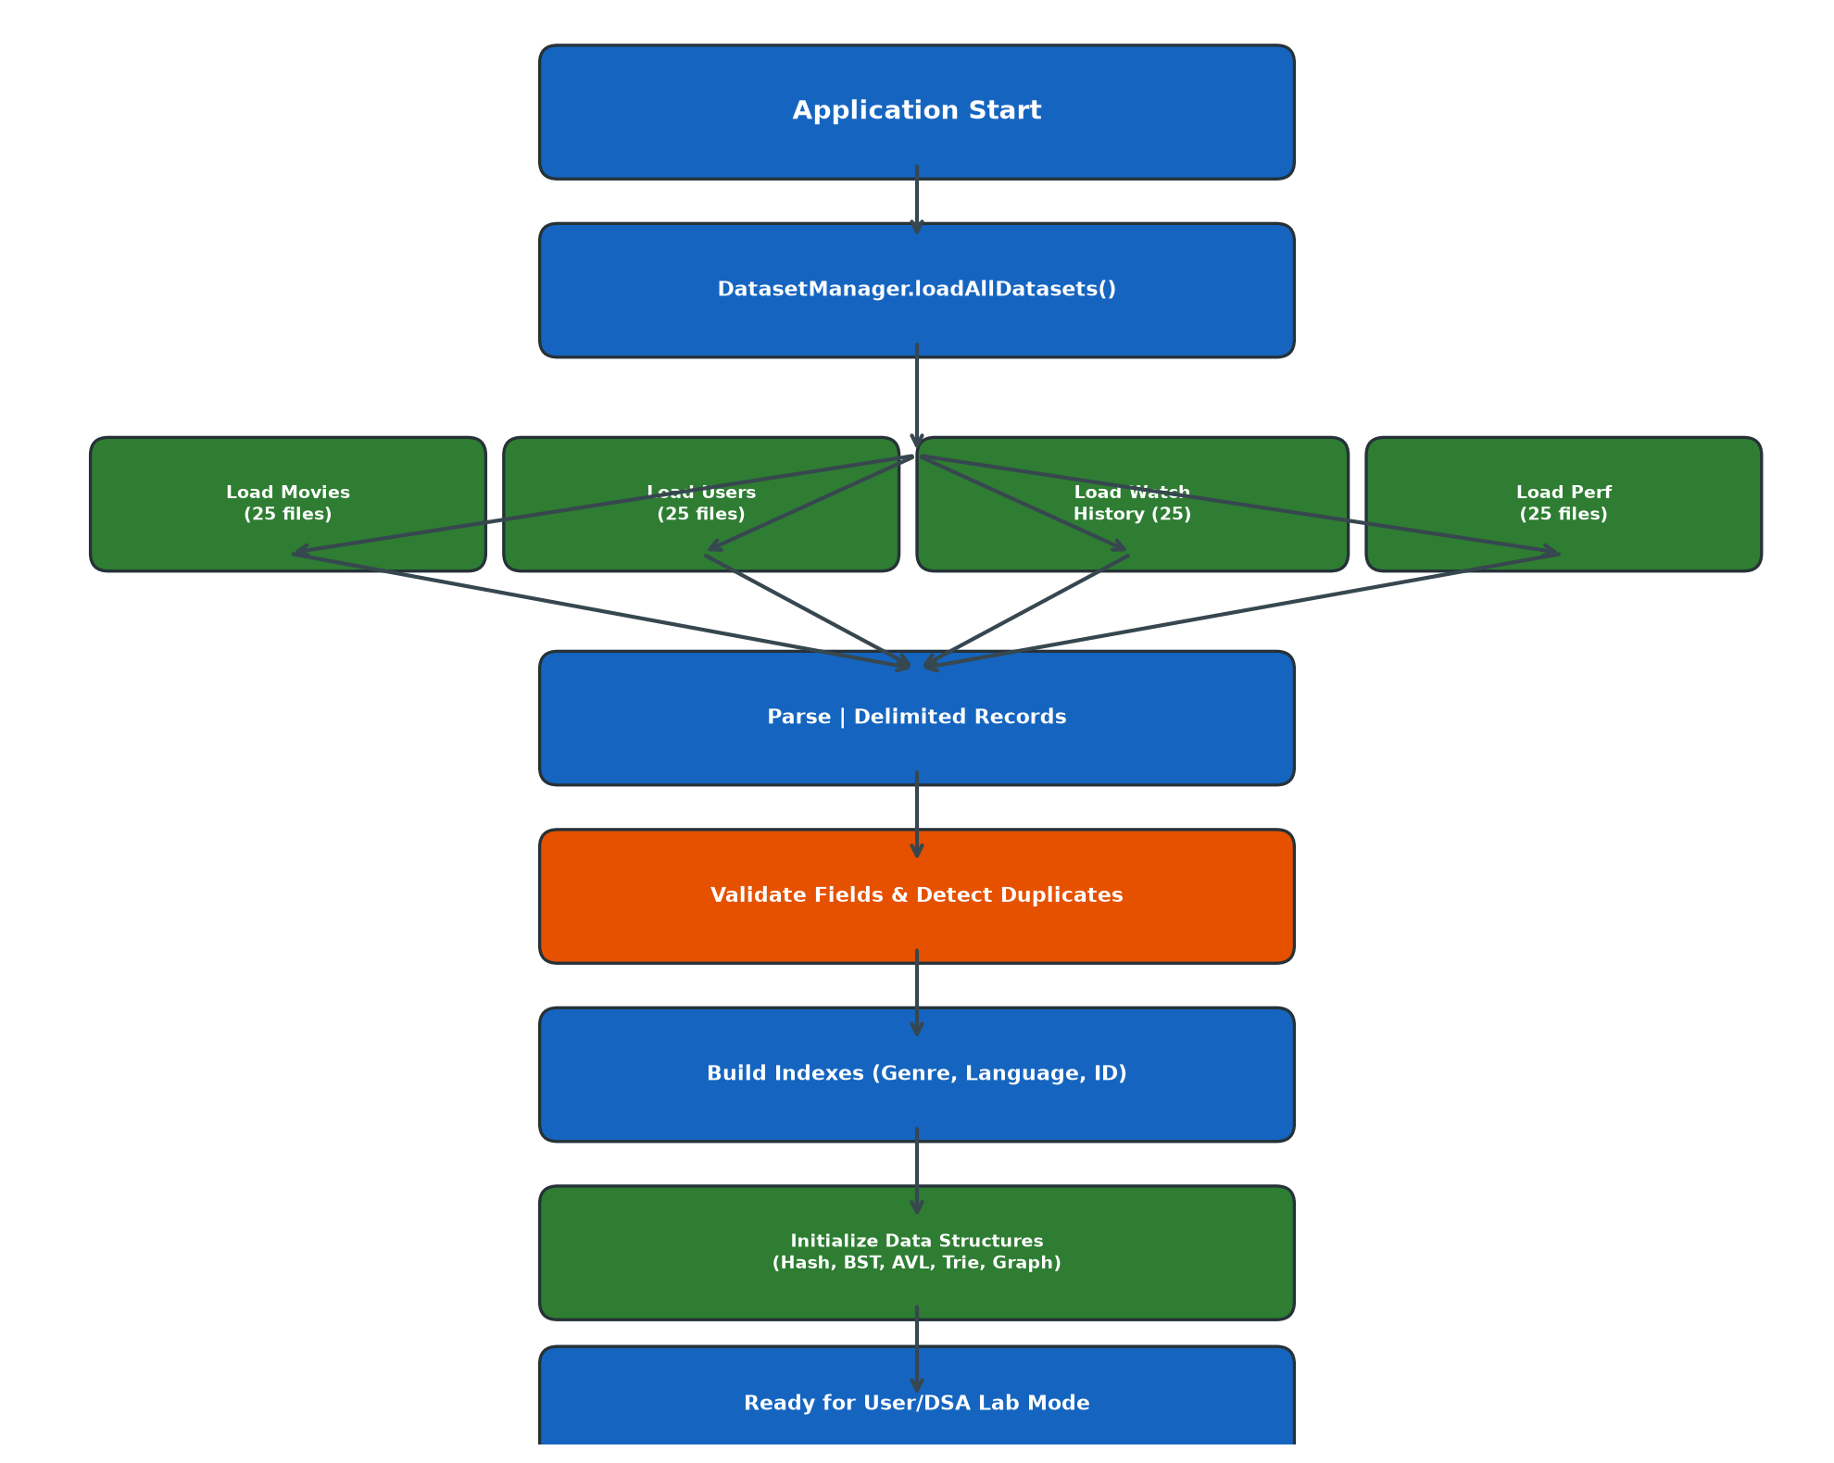
Figure 3.2: Dataset Loading and Validation Workflow

3.4 Dataset Design
MovieFlix employs a flat-file storage architecture using pipe-delimited ("|") text files. Each category is split into 25 files containing approximately 100 records each, following a range-based naming convention (e.g., movies_001_100.txt, movies_101_200.txt). This design enables incremental loading, parallel file processing potential, and manageable file sizes for version control.

3.5 Movie Record Structure
# | Field | Type | Description
1 | MOVIE_ID | int | Unique identifier
2 | TITLE | String | Official movie title
3 | ALTERNATIVE_TITLE | String | Alternate/international title
4 | GENRE | String | Genre(s), slash-separated
5 | RELEASE_DATE | String | Release date (YYYY-MM-DD)
6 | YEAR | int | Release year
7 | DURATION | int | Duration in minutes
8 | LANGUAGE | String | Primary language
9 | COUNTRY | String | Country of production
10 | PRODUCTION_COMPANY | String | Production studio
11 | DIRECTOR | String | Director name
12 | WRITERS | String | Writer(s)
13 | CAST | String | Principal cast members
14 | CHARACTERS | String | Character names
15 | IMDB_ID | String | IMDb identifier
16 | TMDB_ID | String | TMDB identifier
17 | WIKIDATA_ID | String | Wikidata identifier
18 | IMDB_RATING | double | IMDb rating (0.0–10.0)
19 | TMDB_RATING | double | TMDB rating (0.0–10.0)
20 | VOTE_COUNT | int | Total verified votes
21 | POPULARITY | double | Popularity metric
22 | KEYWORDS | String | Searchable keywords
23 | OVERVIEW | String | Plot summary
24 | SOURCE_IMDB | String | IMDb source URL
25 | SOURCE_TMDB | String | TMDB source URL
26 | SOURCE_OMDB | String | OMDb source URL
27 | SOURCE_WIKIDATA | String | Wikidata source URL
28 | LAST_UPDATED | String | Last update timestamp
Table 3.1: Movie Record Structure (28 Fields)

3.6 User Record Structure
# | Field | Type | Description
1 | USER_ID | int | Unique user identifier
2 | NAME | String | User display name
3 | AGE | int | User age
4 | PREFERRED_GENRES | String | Comma-separated preferred genres
5 | PREFERRED_LANGUAGES | String | Comma-separated preferred languages
6 | FAVORITE_ACTORS | String | Comma-separated favorite actors
7 | FAVORITE_DIRECTORS | String | Comma-separated favorite directors
8 | AVERAGE_RATING | double | User's average rating given
9 | PREFERENCE_SCORE | double | Computed preference score
Table 3.2: User Record Structure (9 Fields)

3.7 Watch-History Structure
# | Field | Type | Description
1 | HISTORY_ID | int | Unique history record identifier
2 | USER_ID | int | Associated user ID
3 | MOVIE_ID | int | Associated movie ID
4 | WATCH_DATE | String | Date of viewing (YYYY-MM-DD)
5 | WATCH_PROGRESS | int | Viewing progress (0–100%)
6 | USER_RATING | double | User's rating for the movie
Table 3.3: Watch-History Record Structure (6 Fields)

3.8 Performance-Test Record Structure
# | Field | Type | Description
1 | TEST_ID | int | Unique test identifier
2 | MOVIE_ID | int | Target movie ID
3 | SEARCH_PATTERN | String | Search string used
4 | SORT_ATTRIBUTE | String | Attribute for sorting
5 | DATASET_SIZE | int | Number of records tested
6 | THREAD_COUNT | int | Number of threads used
7 | ALGORITHM_CATEGORY | String | Algorithm category label
Table 3.4: Performance-Test Record Structure (7 Fields)

3.9 Class and Package Organization
The project follows a flat package structure rooted in the src/ directory. Each package contains one or more Java classes, each encapsulating a specific algorithm or data structure. The main entry point is MovieFlix.java, which instantiates the DatasetManager and ConsoleUI. The TestVerification.java file contains a comprehensive automated test suite covering all 31 algorithm implementations.

3.10 User Mode and DSA Lab Mode
MovieFlix provides two distinct interactive interfaces accessible from the main menu:
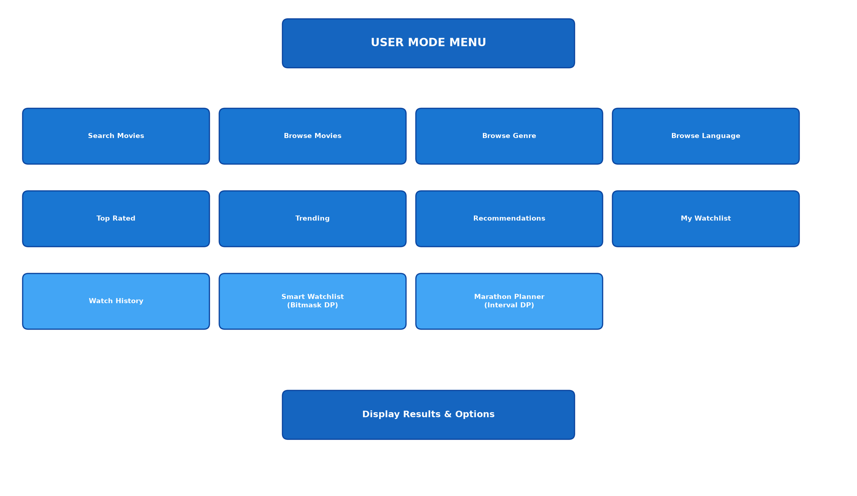
Figure 3.3: User Mode Workflow
User Mode presents a clean, application-oriented interface with 11 features: Search Movies, Browse Movies, Browse by Genre, Browse by Language, Top Rated Movies, Trending Movies, Recommendations, My Watchlist, Watch History, Smart Watchlist (Bitmask DP), and Movie Marathon Planner (Interval DP). Internal algorithm details and debugging information are hidden from the user.
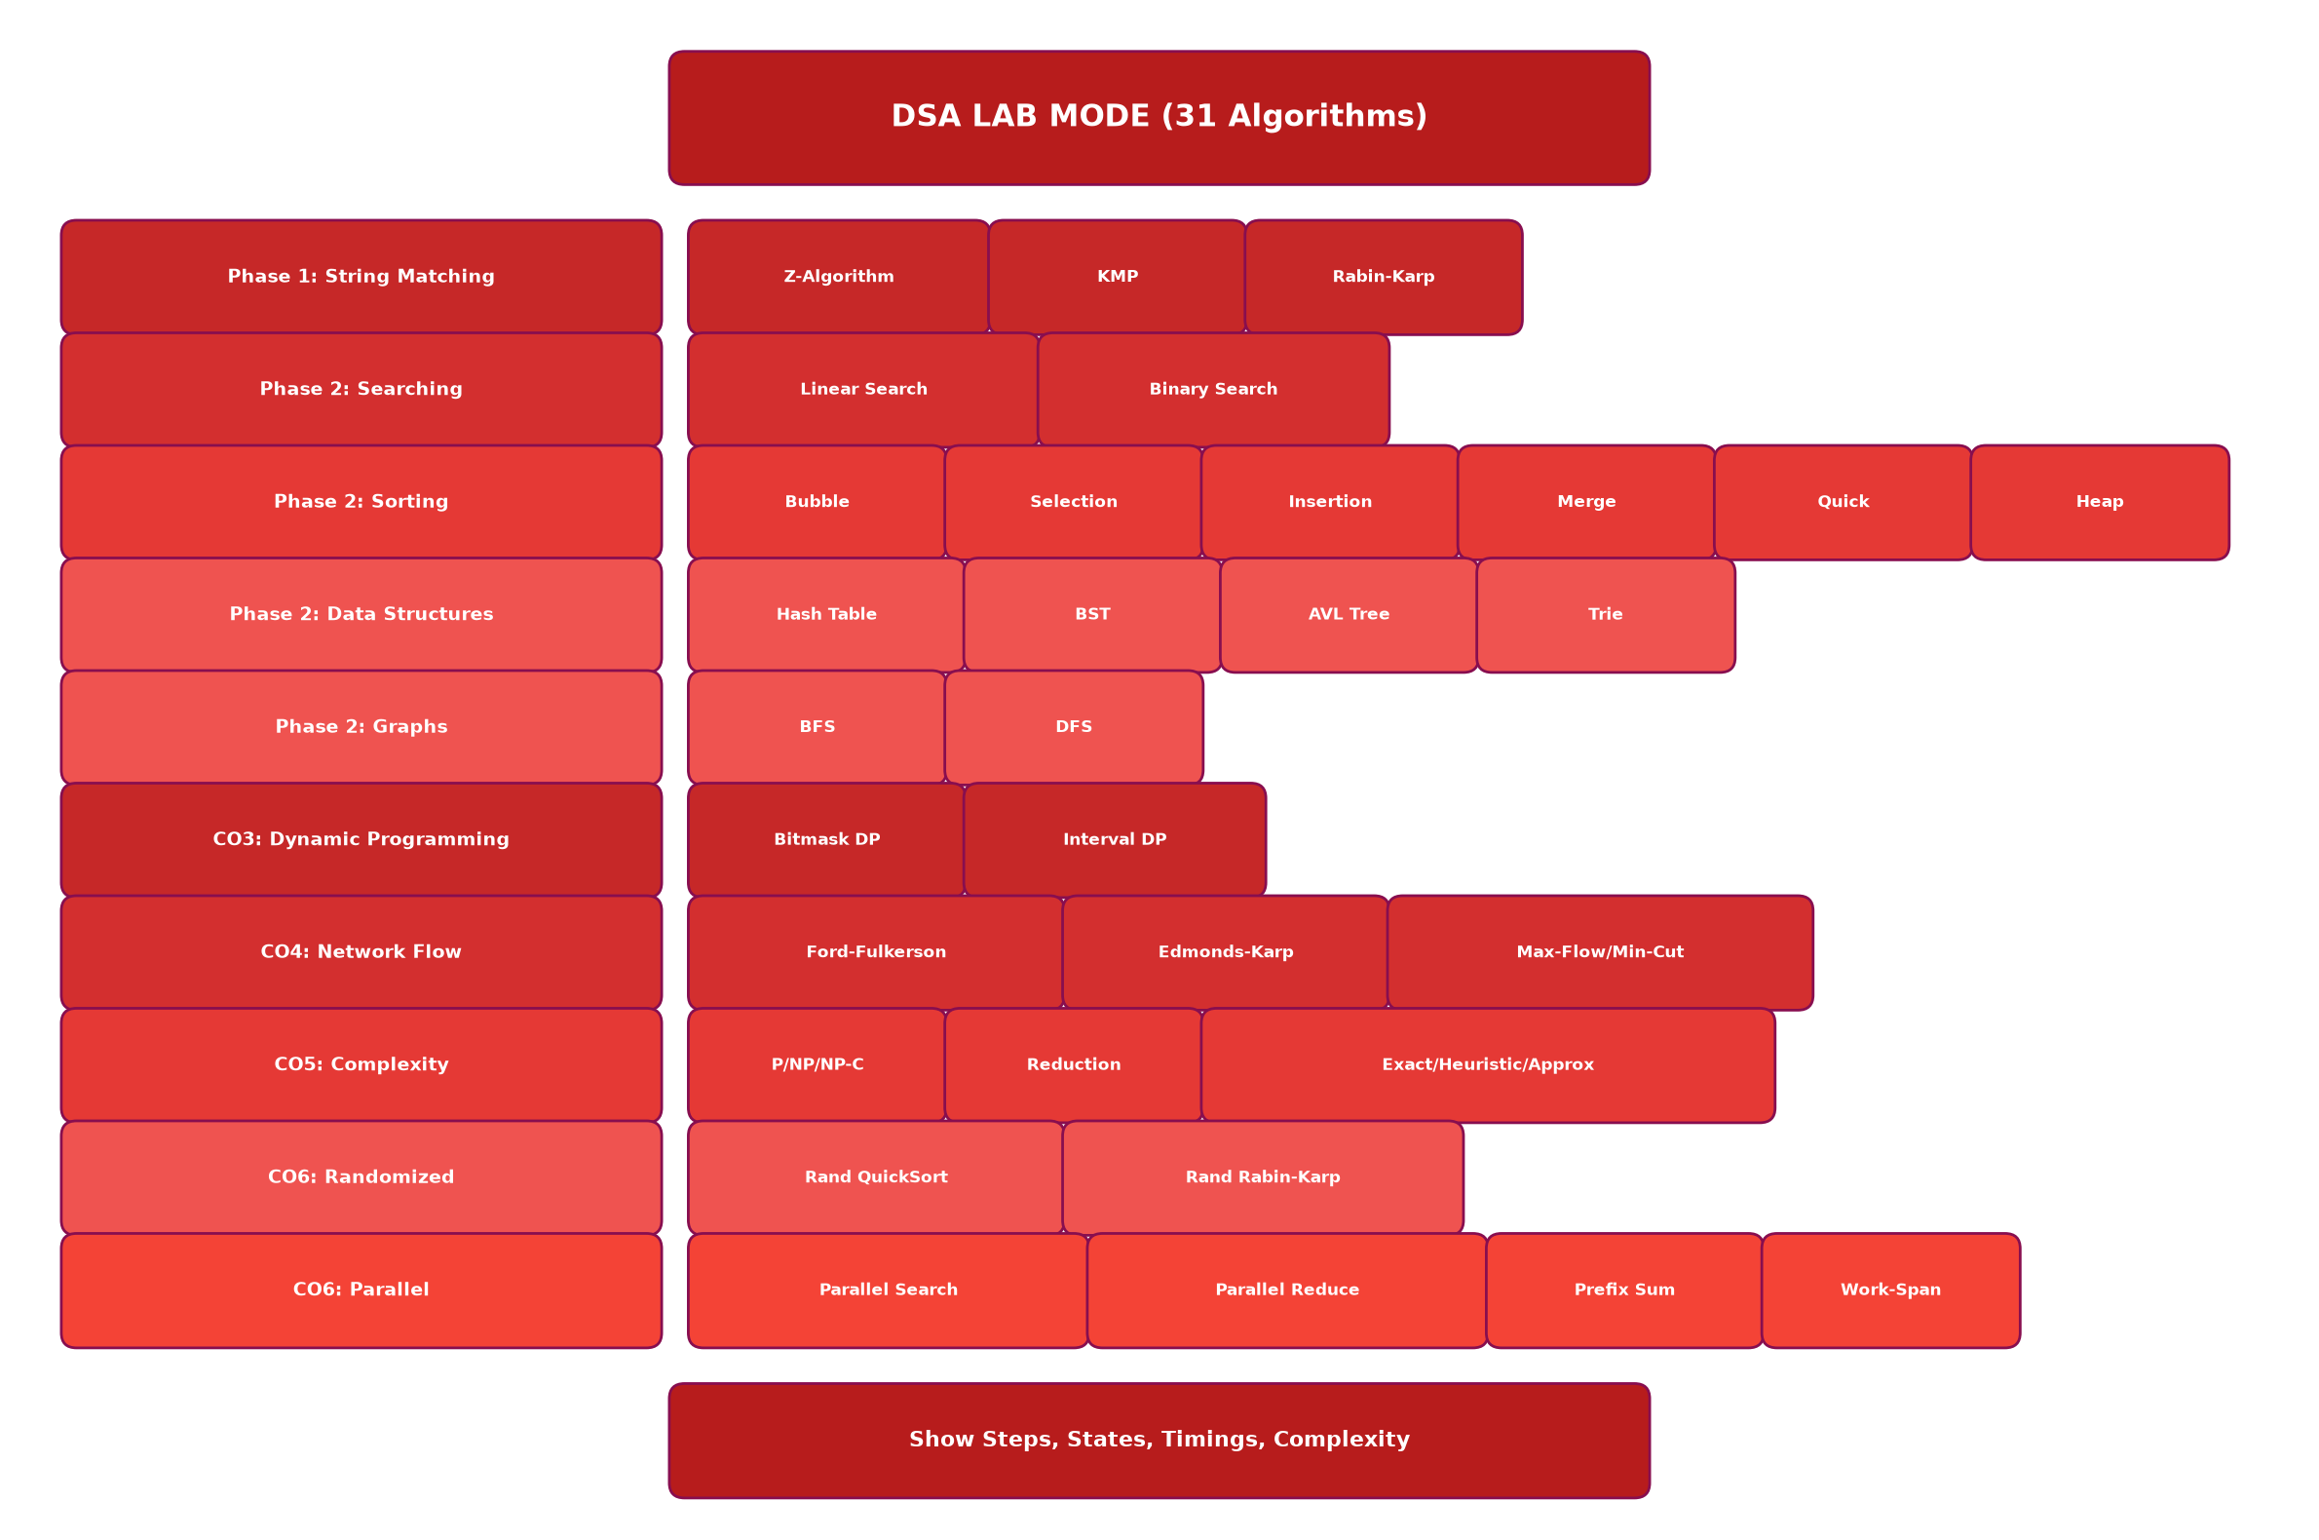
Figure 3.4: DSA Lab Mode Workflow
DSA Lab Mode provides 31 interactive algorithm demonstrations organized by course outcome phase. Each demonstration displays internal algorithm states (Z-arrays, LPS arrays, DP tables, residual graphs), operation counts (comparisons, swaps, transitions), execution times (System.nanoTime()), and complexity classifications.

3.11 Algorithm Selection and Justification
The algorithms implemented in MovieFlix were selected to provide comprehensive coverage of the DSA-3 course outcomes while maintaining genuine applicability to the movie search and recommendation domain. Each algorithm serves a specific purpose within the application:
Algorithm | Application in MovieFlix
Z-Algorithm | Primary search engine for movie title and keyword matching
KMP | Exact substring pattern matching with precomputed failure function
Rabin–Karp | Rolling hash-based search supporting multi-pattern matching
Hash Table | O(1) average-case movie ID lookup
BST | Hierarchical movie indexing by ID
AVL Tree | Guaranteed O(log n) balanced indexing
Trie | Real-time autocomplete prefix matching on movie titles
BFS/DFS | Movie similarity graph traversal for recommendations
Bitmask DP | Smart watchlist optimization under time-budget constraints
Interval DP | Optimal movie marathon scheduling with continuity bonuses
Ford–Fulkerson | Maximum flow in recommendation flow network (DFS-based)
Edmonds–Karp | Polynomial-time maximum flow (BFS shortest augmenting path)
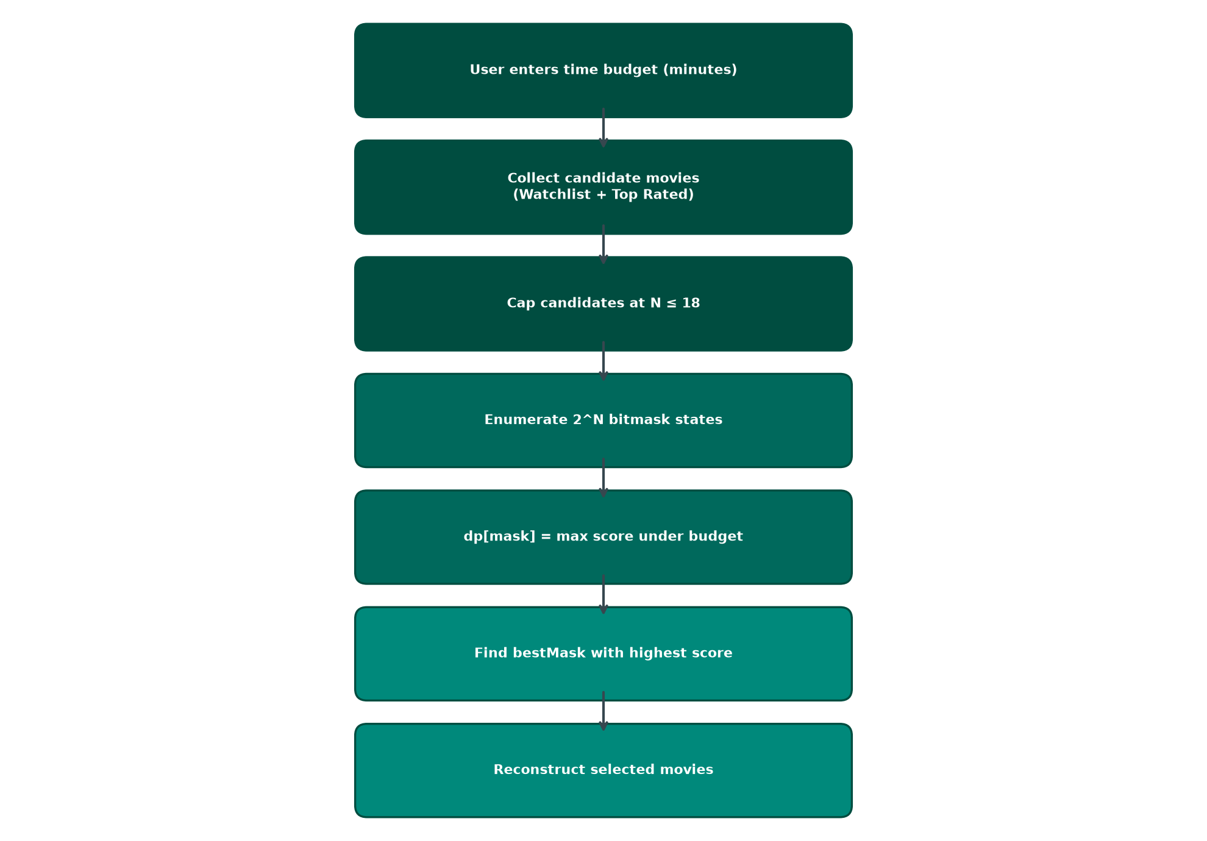
Figure 3.5: Smart Watchlist Optimization Workflow
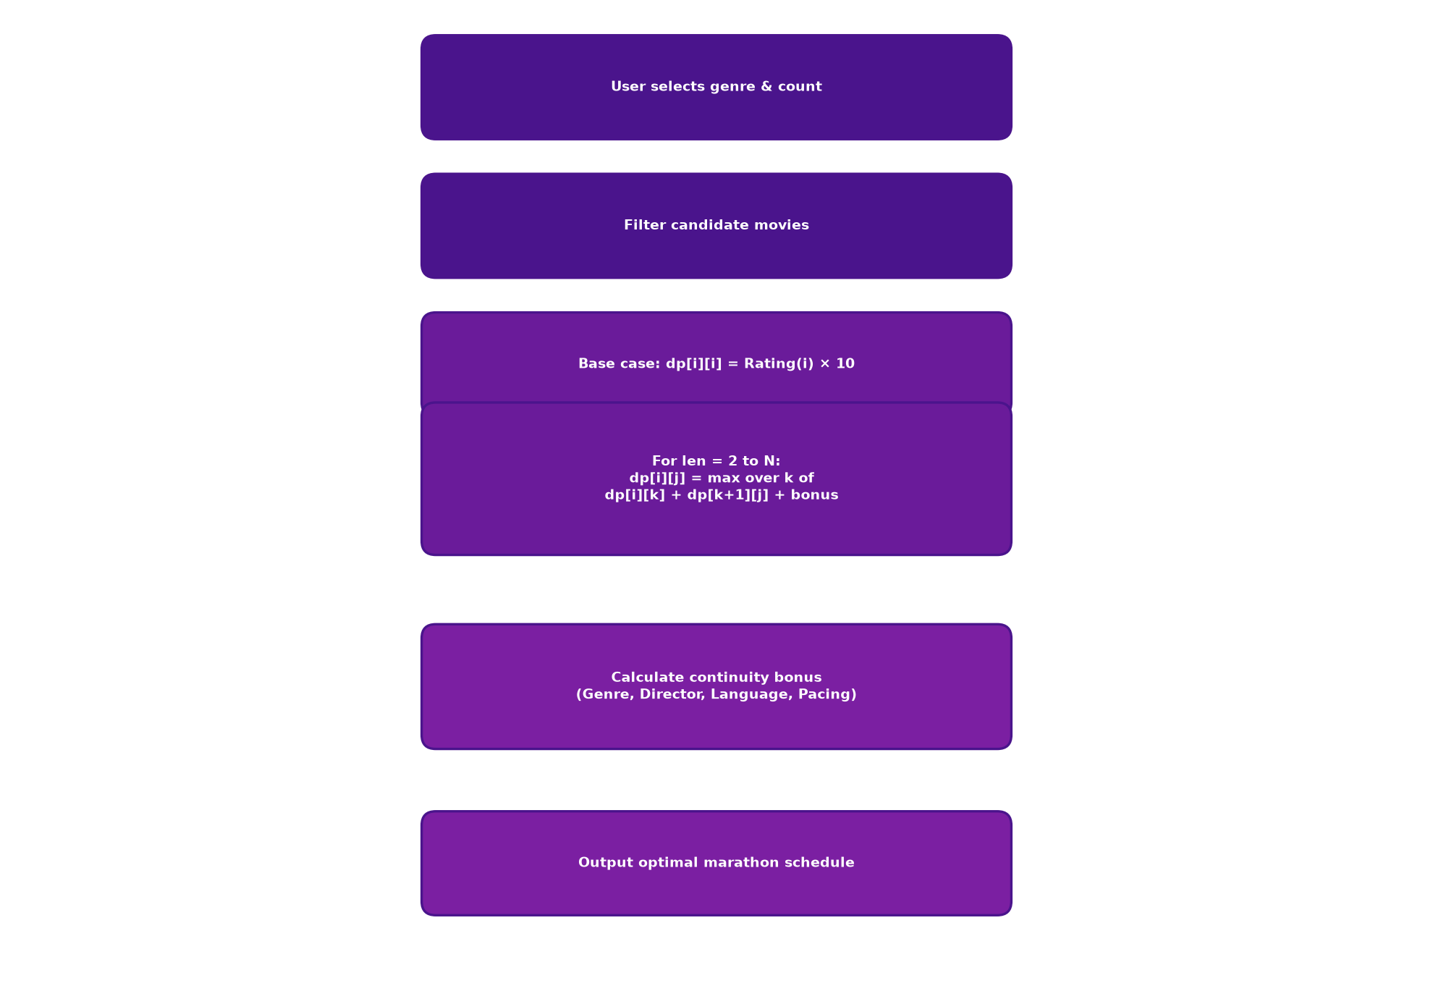
Figure 3.6: Movie Marathon Planner Workflow

3.12 Course Outcome Mapping
Course Outcome | Domain | MovieFlix Implementations
Phase 1 (Provisional) | String Matching | Z-Algorithm, KMP, Rabin–Karp
Phase 2 (Provisional) | Searching & Sorting | Linear Search, Binary Search, Bubble Sort, Selection Sort, Insertion Sort, Merge Sort, Quick Sort, Heap Sort
Phase 2 (Provisional) | Data Structures & Graphs | Hash Table, BST, AVL Tree, Trie, BFS, DFS
CO3 | Dynamic Programming | Bitmask DP (O(N·2^N) Smart Watchlist), Interval DP (O(N³) Marathon Planner)
CO4 | Network Flow | Ford–Fulkerson (DFS, O(E·f)), Edmonds–Karp (BFS, O(V·E²)), Max-Flow/Min-Cut
CO5 | Complexity Theory | P/NP/NP-Hard/NP-Complete, Polynomial Reduction (Subset Sum → Movie Selection), Exact DP vs Greedy Heuristic vs ½-Approximation
CO6 | Randomized & Parallel Algorithms | Randomized Quick Sort, Randomized Rabin–Karp, Parallel Search, Parallel Reduction, Parallel Prefix Sum, Work–Span Analysis
Table 3.5: Course Outcome Mapping
Note: Phase 1 and Phase 2 mappings to CO1/CO2 are marked as provisional. The official course outcome definitions for CO1 and CO2 have not been supplied. These mappings should be verified against the official course syllabus before final submission.

CHAPTER 4: IMPLEMENTATION

4.1 Development Environment
MovieFlix was developed using the following environment:
Component | Details
Language | Java (JDK 17+, compatible with Java 21/25)
IDE | Visual Studio Code with Java Extension Pack
Compiler | javac (command-line compilation)
Runtime | java (JVM)
Version Control | Git
Operating System | Windows 10/11
External Dependencies | None (pure Java implementation)

4.2 Project Directory Structure
Project Structure:
MovieFlix/
├── src/
│ ├── MovieFlix.java # Main Entry Point
│ ├── TestVerification.java # Automated Test Suite
│ ├── model/ # Data Models
│ ├── dataset/ # DatasetManager & Generator
│ ├── ui/ # ConsoleUI
│ ├── patternmatching/ # Z-Algo, KMP, Rabin-Karp
│ ├── searching/ # Linear, Binary Search
│ ├── sorting/ # 6 Sorting Algorithms
│ ├── hashing/ # MovieHashTable
│ ├── trees/ # BST, AVL Tree
│ ├── trie/ # MovieTrie
│ ├── graph/ # MovieGraph, BFS, DFS
│ ├── dp/ # BitmaskDP, IntervalDP
│ ├── flow/ # FordFulkerson, EdmondsKarp
│ ├── complexity/ # ComplexityDemo
│ ├── randomized/ # RandomizedQuickSort, RabinKarp
│ └── parallel/ # ParallelSearch, Reduce, PrefixSum
├── data/
│ ├── movies/ (25 files, ~2,500 records)
│ ├── users/ (25 files, ~2,500 records)
│ ├── watch_history/ (25 files, ~2,500 records)
│ └── performance/ (25 files, ~2,500 records)
└── bin/ (Compiled .class files)

4.3 Data Models
MovieFlix defines four primary data model classes in the model/ package. The Movie class contains 28 fields covering comprehensive metadata including multi-source identifiers (IMDb, TMDB, Wikidata), ratings, popularity metrics, production details, and searchable text fields. The Movie class also implements a getTrendingScore() method using the formula:
TrendingScore = (Popularity × 0.45) + (IMDb_Rating × 10 × 0.35) + (log₁₀(VoteCount + 1) × 20 × 0.20)
The User class stores user preferences, favorite genres, languages, actors, and directors, and maintains an in-memory watchlist. The WatchHistory class tracks viewing records with progress percentages and user ratings. The PerformanceRecord class stores benchmark test parameters for algorithm comparison experiments.

4.4 DatasetManager and Data Validation
The DatasetManager class is responsible for loading all data files from the data/ directory at application startup. For each file, it reads lines, splits them by the pipe delimiter ("|"), validates the field count against the expected schema, and constructs typed model objects. Malformed records (wrong field count, unparseable numeric fields) are logged and skipped. After loading, the DatasetManager builds secondary indexes: a genre-to-movies map and a language-to-movies map for efficient filtered browsing. Duplicate detection is performed based on primary key fields (MOVIE_ID, USER_ID, HISTORY_ID, TEST_ID).

4.5 String-Matching Algorithms

4.5.1 Z-Algorithm
Purpose: The Z-Algorithm is used as the primary search engine in MovieFlix for finding occurrences of a search pattern within movie titles, keywords, and other text fields.
Working Principle: Given a pattern P of length m and text T of length n, the algorithm constructs a combined string S = P + '$' + T of length n + m + 1. It then computes the Z-array for S, where Z[i] is the length of the longest substring starting at position i that matches a prefix of S. Any position i (beyond the pattern and separator) where Z[i] = m indicates a match of P in T.
Pseudocode: Z-Algorithm Search
FUNCTION Z-Search(text T, pattern P):
S ← P + '$' + T
n ← length(S)
Z ← array of size n, initialized to 0
L ← 0, R ← 0
FOR i ← 1 TO n - 1:
IF i > R:
L ← R ← i
WHILE R < n AND S[R] = S[R - L]:
R ← R + 1
Z[i] ← R - L
R ← R - 1
ELSE:
k ← i - L
IF Z[k] < R - i + 1:
Z[i] ← Z[k]
ELSE:
L ← i
WHILE R < n AND S[R] = S[R - L]:
R ← R + 1
Z[i] ← R - L
R ← R - 1
matches ← []
FOR i ← m + 1 TO n - 1:
IF Z[i] = m:
matches.add(i - m - 1)
RETURN matches
Time Complexity: O(n + m) where n = |T| and m = |P|. The Z-array construction uses the [L, R] window to avoid redundant comparisons, ensuring linear time.
Auxiliary Space: O(n + m) for the combined string and Z-array.
Application in MovieFlix: Used for searching movie titles, alternative titles, keywords, and genre fields. Supports case-insensitive matching by converting both pattern and text to lowercase before search.

4.5.2 Knuth–Morris–Pratt (KMP)
Purpose: KMP provides exact substring matching with guaranteed linear-time performance by precomputing the Longest Proper Prefix which is also a Suffix (LPS) array.
Working Principle: The LPS array captures the structure of the pattern, allowing the algorithm to skip characters in the text that have already been matched against the pattern, avoiding the backtracking inherent in naive string matching.
Pseudocode: KMP Search
FUNCTION KMP-Search(text T, pattern P):
n ← length(T), m ← length(P)
lps ← computeLPS(P)
i ← 0, j ← 0, matches ← []
WHILE i < n:
IF T[i] = P[j]:
i ← i + 1, j ← j + 1
IF j = m:
matches.add(i - j)
j ← lps[j - 1]
ELSE IF i < n AND T[i] ≠ P[j]:
IF j > 0:
j ← lps[j - 1]
ELSE:
i ← i + 1
RETURN matches
Time Complexity: O(n + m). The LPS array is computed in O(m) and the search phase runs in O(n).
Auxiliary Space: O(m) for the LPS array.

4.5.3 Rabin–Karp
Purpose: Rabin–Karp uses rolling hash values to quickly identify candidate match positions, verifying actual matches only when hash values coincide.
Working Principle: A hash value is computed for the pattern and for each window of length m in the text. When hash values match, a character-by-character comparison confirms or rejects the match. The rolling hash allows O(1) window slides.
Pseudocode: Rabin-Karp Search
FUNCTION Rabin-Karp-Search(text T, pattern P, prime p):
n ← length(T), m ← length(P)
d ← 256 // alphabet size
h ← d^(m-1) mod p
pHash ← hash(P), tHash ← hash(T[0..m-1])
matches ← []
FOR i ← 0 TO n - m:
IF pHash = tHash:
IF T[i..i+m-1] = P: // verify match
matches.add(i)
IF i < n - m:
tHash ← (d × (tHash - T[i] × h) + T[i+m]) mod p
IF tHash < 0: tHash ← tHash + p
RETURN matches
Time Complexity: Expected O(n + m) under suitable hash assumptions; worst-case O(nm) if all windows produce hash collisions.
Auxiliary Space: O(1) beyond input storage.

4.6 Searching Algorithms

4.6.1 Linear Search
Purpose: Scans movie records sequentially to find matches. Used on unsorted datasets.
Time Complexity: O(n). Best case O(1) if the target is the first element.
Auxiliary Space: O(1).

4.6.2 Binary Search
Purpose: Performs logarithmic-time search on a sorted movie array. The implementation is manually coded without using Collections.binarySearch().
Pseudocode: Binary Search
FUNCTION BinarySearch(sortedArray A, target key):
low ← 0, high ← length(A) - 1
WHILE low ≤ high:
mid ← low + (high - low) / 2
IF A[mid].key = key: RETURN mid
ELSE IF A[mid].key < key: low ← mid + 1
ELSE: high ← mid - 1
RETURN -1 // not found
Time Complexity: O(log n). Auxiliary Space: O(1).

4.7 Sorting Algorithms
MovieFlix implements six comparison-based sorting algorithms, all operating on lists of Movie objects using a configurable Comparator. None of the implementations delegate to Java's built-in Arrays.sort() or Collections.sort().

4.7.1 Bubble Sort
Working Principle: Repeatedly swaps adjacent elements that are out of order.
Time Complexity: Worst-case O(n²), Average O(n²), Best-case O(n).
Auxiliary Space: O(1).
Application in MovieFlix: Educational demonstration of the simplest sorting approach.

4.7.2 Selection Sort
Working Principle: Finds the minimum element in the unsorted portion and swaps it to the front.
Time Complexity: Worst-case O(n²), Average O(n²), Best-case O(n²).
Auxiliary Space: O(1).
Application in MovieFlix: Demonstrates minimal-swap in-place sorting.

4.7.3 Insertion Sort
Working Principle: Inserts each element into its correct position in the sorted prefix.
Time Complexity: Worst-case O(n²), Average O(n²), Best-case O(n).
Auxiliary Space: O(1).
Application in MovieFlix: Efficient for small or nearly sorted datasets.

4.7.4 Merge Sort
Working Principle: Recursively divides the array and merges sorted halves.
Time Complexity: Worst-case O(n log n), Average O(n log n), Best-case O(n log n).
Auxiliary Space: O(n).
Application in MovieFlix: Deterministic O(n log n) for top-rated movie ranking.

4.7.5 Quick Sort
Working Principle: Partitions around a pivot and recursively sorts partitions.
Time Complexity: Worst-case O(n²), Average O(n log n), Best-case O(n log n).
Auxiliary Space: O(log n).
Application in MovieFlix: High-performance trending score ranking.

4.7.6 Heap Sort
Working Principle: Builds a max-heap and repeatedly extracts the maximum.
Time Complexity: Worst-case O(n log n), Average O(n log n), Best-case O(n log n).
Auxiliary Space: O(1).
Application in MovieFlix: In-place guaranteed O(n log n) rating sorting.

4.8 Hash Table
Purpose: Provides O(1) average-case lookup of Movie records by MOVIE_ID.
Implementation: MovieHashTable uses separate chaining with linked lists (Java LinkedList) for collision resolution. The initial capacity is set to 2 × datasetSize + 1 to minimize collisions. The hash function uses Java's modular arithmetic on integer keys.
Time Complexity: Average O(1) for insert, search, and delete; worst-case O(n) if all keys hash to the same bucket.
Auxiliary Space: O(n + C) where C is the table capacity.

4.9 Binary Search Tree and AVL Tree
Binary Search Tree (BST): Stores Movie records indexed by MOVIE_ID, supporting insert, search, delete, and in-order traversal. In a balanced tree, operations run in O(log n); however, sequential ID insertions can degrade the BST to O(n) per operation.
AVL Tree: A self-balancing BST that maintains a balance factor (height difference between left and right subtrees) of at most 1 at every node. The AVL tree implementation includes all four rotation types:
Rotation | Description
LL Rotation (Left-Left) | Single right rotation when a node is inserted into the left subtree of the left child.
RR Rotation (Right-Right) | Single left rotation when a node is inserted into the right subtree of the right child.
LR Rotation (Left-Right) | Double rotation (left then right) when a node is inserted into the right subtree of the left child.
RL Rotation (Right-Left) | Double rotation (right then left) when a node is inserted into the left subtree of the right child.
Time Complexity: O(log n) guaranteed for insert, search, and delete in AVL trees.

4.10 Trie
Purpose: Supports real-time autocomplete prefix matching on movie titles. Each node stores a character, children pointers, and an optional list of matching Movie objects.
Time Complexity: O(L) per operation where L is the length of the query string.
Auxiliary Space: O(|Σ| × L × N) where |Σ| is the alphabet size and N is the number of inserted strings.

4.11 Graph Algorithms
MovieGraph models movies as vertices with edges connecting movies that share common genres. The graph is represented as an adjacency list. BFS computes the shortest-hop distance between movies in the similarity graph, useful for finding "movies like this." DFS performs deep traversal for exploring recommendation chains.
Time Complexity: O(V + E) for both BFS and DFS.

4.12 CO3: Dynamic Programming

4.12.1 Bitmask DP — Smart Watchlist Optimization
Problem: Given N candidate movies (N ≤ 18), each with a duration d_i (minutes) and a preference score s_i, and a time budget T, find a subset of movies that maximizes the total preference score such that the total duration does not exceed T.
State Representation: dp[mask] stores the maximum preference score achievable using exactly the subset of movies indicated by the bitmask mask. The bitmask has N bits, where bit i being set (1) indicates that movie i is included in the subset.
Transitions: For each valid state mask (where dp[mask] ≥ 0 and total duration ≤ T), the algorithm considers adding each movie i not already in mask:
nextMask = mask | (1 << i)
nextDuration = dpDuration[mask] + duration(movie_i)
If nextDuration ≤ T, then dp[nextMask] = max(dp[nextMask], dp[mask] + score(movie_i))
The preference score for each movie is computed as: score(m) = ImdbRating × 10.0 + Popularity × 0.1
Pseudocode: Bitmask DP
FUNCTION OptimizeWatchlist(movies[], timeBudget):
N ← min(len(movies), 18)
totalStates ← 2^N
dpScore[0..totalStates-1] ← -1.0
dpDuration[0..totalStates-1] ← 0
dpScore[0] ← 0.0
bestMask ← 0, maxScore ← 0.0

FOR mask ← 0 TO totalStates - 1:
IF dpScore[mask] < 0: CONTINUE
IF dpScore[mask] > maxScore:
maxScore ← dpScore[mask]
bestMask ← mask
FOR i ← 0 TO N - 1:
IF bit i NOT SET in mask:
nextMask ← mask | (1 << i)
nextDur ← dpDuration[mask] + duration(movie_i)
IF nextDur ≤ timeBudget:
nextScore ← dpScore[mask] + score(movie_i)
IF nextScore > dpScore[nextMask]:
dpScore[nextMask] ← nextScore
dpDuration[nextMask] ← nextDur

RETURN bestMask, maxScore
Time Complexity: O(N × 2^N). The outer loop iterates over 2^N states, and for each state, the inner loop considers N possible movie additions.
Auxiliary Space: O(2^N) for the dpScore and dpDuration arrays.
Reconstruction: The selected movies are reconstructed from bestMask by iterating through bits and collecting movies where the corresponding bit is set.
Note: This implementation enumerates all 2^N subsets through forward transitions. For small N (≤ 18), this exhaustive approach is feasible. The algorithm genuinely uses DP in the sense that each state dp[mask] represents the best achievable score for that exact subset, and states with higher bit counts are derived from states with fewer bits, reusing previously computed optimal values.

4.12.2 Interval DP — Movie Marathon Planner
Problem: Given a sequence of N candidate movies for a themed marathon, compute the optimal marathon satisfaction score over all sub-intervals [i, j], accounting for base movie ratings and sequential transition continuity bonuses.
State Representation: dp[i][j] = optimal marathon score achievable by chaining movies from index i to index j.
Base Case: dp[i][i] = ImdbRating(movie_i) × 10.0
Recurrence: dp[i][j] = max over i ≤ k < j of { dp[i][k] + dp[k+1][j] + ContinuityBonus(movie_k, movie_{k+1}) }
The ContinuityBonus function rewards genre alignment (+15), directorial signature matches (+12), language consistency (+5), and penalizes large pacing differences (−4 if duration difference > 60 minutes). A base transition cohesion bonus of +5 is always applied.
Pseudocode: Interval DP
FUNCTION PlanMarathon(movies[], maxMovies):
N ← min(len(movies), maxMovies)
dp[N][N] ← 0.0
split[N][N] ← 0

// Base cases
FOR i ← 0 TO N - 1:
dp[i][i] ← movies[i].rating × 10.0

// Interval DP: increasing lengths
FOR len ← 2 TO N:
FOR i ← 0 TO N - len:
j ← i + len - 1
dp[i][j] ← -INFINITY
FOR k ← i TO j - 1:
bonus ← ContinuityBonus(movies[k], movies[k+1])
cost ← dp[i][k] + dp[k+1][j] + bonus
IF cost > dp[i][j]:
dp[i][j] ← cost
split[i][j] ← k

RETURN dp[0][N-1], split
Time Complexity: O(N³). Three nested loops: interval length, start position, and split point.
Auxiliary Space: O(N²) for the DP and split tables.
Application in MovieFlix: The user selects a genre and number of movies. The system filters candidates, runs the interval DP, and outputs the optimal marathon schedule with total duration and synergy score.

4.13 CO4: Network Flow
MovieFlix models movie recommendations as a flow network with the following layered structure:
SOURCE → USER PREFERENCE → GENRE NODES → MOVIE NODES → SINK
The SOURCE node connects to a USER PREFERENCE node with a capacity representing the user's overall recommendation budget. The USER PREFERENCE node connects to GENRE nodes with capacities representing genre allocation limits. Each GENRE node connects to MOVIE nodes of that genre with individual capacities. Each MOVIE node connects to the SINK with a capacity representing the maximum recommendation strength for that movie. All capacities are assigned programmatically based on the data structure; the actual maximum flow and minimum cut values are computed by the algorithms, not hard-coded.

4.13.1 Ford–Fulkerson Algorithm
Working Principle: Iteratively finds augmenting paths from SOURCE to SINK in the residual graph using DFS. For each path, the bottleneck capacity (minimum residual capacity along the path) is identified, and flow is augmented by this amount. Forward edges in the residual graph are decreased by the path flow, and reverse edges are increased to allow flow cancellation.
Pseudocode: Ford-Fulkerson
FUNCTION FordFulkerson(graph, source, sink):
residual ← copy of capacity graph
maxFlow ← 0

WHILE DFS finds path from source to sink in residual:
pathFlow ← min residual capacity along path
FOR each edge (u, v) in path:
residual[u][v] -= pathFlow
residual[v][u] += pathFlow
maxFlow += pathFlow

// Minimum Cut: BFS/DFS from source in final residual
reachable ← DFS from source in residual
minCut ← edges (u,v) where u ∈ reachable, v ∉ reachable

RETURN maxFlow, minCut
Time Complexity: O(E × f) where E is the number of edges and f is the maximum flow value. This bound is pseudo-polynomial when capacities are integer-valued.
Auxiliary Space: O(V²) for the adjacency matrix representation of the residual graph.

4.13.2 Edmonds–Karp Algorithm
Working Principle: Edmonds–Karp is a specialization of Ford–Fulkerson that uses BFS instead of DFS to find augmenting paths. By always selecting the shortest augmenting path (in terms of number of edges), the algorithm guarantees a polynomial-time bound independent of the maximum flow value.
Time Complexity: O(V × E²). BFS ensures that the number of augmenting path iterations is bounded by O(V × E).
The implementation uses the same network structure as Ford–Fulkerson and explicitly tracks augmenting paths, bottleneck capacities, residual graph updates, and minimum cut edges for DSA Lab Mode output.

4.14 CO5: Complexity Theory
The ComplexityDemo class demonstrates key concepts in computational complexity theory using the movie selection problem as a practical example.

4.14.1 Complexity Classes
Class | Definition and Example
P | Problems solvable in polynomial time. Example: Sorting movies by rating using Merge Sort runs in O(n log n), which is polynomial.
NP | Problems for which a given solution can be verified in polynomial time. Example: Given a claimed optimal movie subset, verifying that the total duration ≤ T and total score ≥ K requires only O(N) time.
NP-Hard | Problems at least as hard as every problem in NP. Every NP problem can be reduced to an NP-Hard problem in polynomial time.
NP-Complete | Problems that are both in NP and NP-Hard. The decision version of 0/1 Knapsack is NP-Complete.

4.14.2 Polynomial-Time Reduction
MovieFlix demonstrates a polynomial-time reduction from the Subset Sum problem to the Movie Budget Decision Problem:
Movie Budget Decision Problem: "Does there exist a subset of movies whose total duration does not exceed T and whose total preference score is at least K?"
This problem is equivalent to the 0/1 Knapsack decision problem: items correspond to movies, weights to durations, and values to preference scores. Since 0/1 Knapsack is NP-Complete, and the movie budget decision problem is a direct instance of it, the movie budget decision problem is also NP-Complete.
Important distinction: Unconstrained movie recommendation (ranking movies by a scoring function) is a polynomial-time problem. Only the budget-constrained decision version is NP-Complete. The optimization version ("find the maximum score subset with duration ≤ T") is NP-Hard as an optimization problem, but the corresponding decision problem is NP-Complete.

4.14.3 Exact vs Heuristic vs Approximation
The implementation compares three approaches to the movie selection optimization problem:
Approach | Description
Exact DP | Standard 0/1 Knapsack DP using a two-dimensional table dp[i][w]. Guarantees optimal solution. Time: O(N × W) where W is the time budget in minutes. This is pseudo-polynomial.
Greedy Heuristic | Sorts movies by value-to-duration ratio (score/duration) and greedily selects movies until the budget is exhausted. Does not guarantee optimality. Time: O(N log N) for sorting.
½-Approximation | Returns max(Greedy Solution, Best Single Item). This is a valid approximation algorithm with a proven guarantee: it returns at least 0.5 × OPT for 0/1 Knapsack. Time: O(N log N).
The greedy heuristic alone is not an approximation algorithm because it has no proven approximation guarantee. The ½-approximation achieves its guarantee by combining the greedy solution with the best single item, ensuring that the returned value is at least half of the optimal solution.

4.15 CO6: Randomized and Parallel Algorithms

4.15.1 Randomized Quick Sort
Working Principle: Identical to standard Quick Sort, except the pivot is selected uniformly at random from the [low, high] range using ThreadLocalRandom. This randomization prevents adversarial input patterns from triggering worst-case O(n²) behavior.
Expected Time Complexity: O(n log n). The expected number of comparisons is 2n ln n ≈ 1.39n log₂ n.
Worst-Case Time Complexity: O(n²), still possible if the random pivot selections are consistently poor, though this event has exponentially small probability.

4.15.2 Randomized Rabin–Karp
Working Principle: Uses a randomly selected prime modulus at runtime instead of a fixed prime. This reduces the probability of adversarial hash collision attacks and provides probabilistic collision resistance.
Expected Time Complexity: O(n + m) with high probability.

4.15.3 Parallel Search
Working Principle: Divides the movie dataset into equal-sized chunks and assigns each chunk to a worker thread in a FixedThreadPool. Each thread performs Z-Algorithm-based search on its assigned chunk independently. Results from all threads are merged into a single result list.
Time Complexity: O(n/P) per thread where P is the number of threads, assuming uniform work distribution.
Work: O(n) total. Span: O(n/P). Parallelism: P.

4.15.4 Parallel Reduction
Working Principle: Computes aggregate statistics (SUM, MIN, MAX, AVERAGE) over movie attributes using tree-based reduction. Each thread computes a partial aggregate over its chunk, and the main thread combines partial results.
Work: O(n). Span: O(n/P + log P) accounting for the combining phase.

4.15.5 Parallel Prefix Sum
Working Principle: Computes cumulative prefix sums over movie durations or ratings using a two-pass approach: (1) each thread computes prefix sums within its chunk; (2) chunk offsets are propagated to produce the global prefix sum array.
Work: O(n). Span: O(n/P + log P).

4.15.6 Work–Span Analysis
The work–span model provides a theoretical framework for analyzing parallel algorithms:
Work (W) = Total number of computational operations across all processors.
Span (S) = Length of the longest sequential dependency chain (critical path).
Parallelism = W / S = Maximum number of processors that can be usefully employed.
By Brent's Theorem, the execution time on P processors is bounded by: T_P ≤ W/P + S.
Caution: Parallel algorithms do not always outperform sequential ones for small datasets due to thread creation overhead, context switching, synchronization costs, and JVM warm-up effects. The benefits of parallelism are most pronounced for large datasets where the computational work dominates overhead.

4.16 User Interface and Menu Design
The ConsoleUI class implements a hierarchical menu system with three levels: Main Menu → Mode Selection → Feature/Algorithm. User input is processed through a Scanner reading from System.in. The menu system uses switch-case routing for clean separation of concerns, with each feature implemented as a private method.

4.17 Error Handling
MovieFlix implements defensive error handling throughout the application: NumberFormatException handling for all numeric input parsing, null checks before accessing movie records, empty dataset validation before algorithm execution, graceful degradation when data files are missing or malformed, and informative error messages prefixed with [!] for user visibility.

4.18 Integration of Modules
All algorithm modules share a common design pattern: each algorithm class provides a static method that accepts typed input (Movie lists, User objects, comparators) and returns a strongly-typed Result object containing the algorithm output, execution metrics (comparisons, swaps, transitions), and nanosecond execution time. This uniform interface enables the ConsoleUI to invoke any algorithm through a consistent pattern and display results appropriate for the active mode.

4.19 Comprehensive Algorithm Complexity Analysis
Algorithm | Best | Average | Worst | Space
Z-Algorithm | O(n+m) | O(n+m) | O(n+m) | O(n+m)
KMP | O(n+m) | O(n+m) | O(n+m) | O(m)
Rabin-Karp | O(n+m) | O(n+m) | O(nm) | O(1)
Linear Search | O(1) | O(n) | O(n) | O(1)
Binary Search | O(1) | O(log n) | O(log n) | O(1)
Bubble Sort | O(n) | O(n²) | O(n²) | O(1)
Selection Sort | O(n²) | O(n²) | O(n²) | O(1)
Insertion Sort | O(n) | O(n²) | O(n²) | O(1)
Merge Sort | O(n log n) | O(n log n) | O(n log n) | O(n)
Quick Sort | O(n log n) | O(n log n) | O(n²) | O(log n)
Heap Sort | O(n log n) | O(n log n) | O(n log n) | O(1)
Hash Table (avg) | O(1) | O(1) | O(n) | O(n+C)
BST | O(log n) | O(log n) | O(n) | O(n)
AVL Tree | O(log n) | O(log n) | O(log n) | O(n)
Trie | O(L) | O(L) | O(L) | O(Σ·L·N)
BFS / DFS | O(V+E) | O(V+E) | O(V+E) | O(V)
Bitmask DP | O(N·2^N) | O(N·2^N) | O(N·2^N) | O(2^N)
Interval DP | O(N³) | O(N³) | O(N³) | O(N²)
Ford-Fulkerson | - | - | O(E·f) | O(V²)
Edmonds-Karp | - | - | O(V·E²) | O(V²)
Rand Quick Sort | O(n log n) | O(n log n) | O(n²) | O(log n)
Rand Rabin-Karp | O(n+m) | O(n+m) | O(nm) | O(1)
Parallel Search | O(n/P) | O(n/P) | O(n) | O(P)
Parallel Reduce | O(n/P+log P) | O(n/P+log P) | O(n) | O(P)
Parallel Prefix | O(n/P+log P) | O(n/P+log P) | O(n) | O(n)
Table 4.1: Comprehensive Algorithm Complexity Analysis

CHAPTER 5: RESULTS AND ANALYSIS

5.1 Testing Environment
All tests were conducted using the following environment. Execution times were measured using System.nanoTime() for nanosecond-precision timing. JVM warm-up effects, garbage collection pauses, and operating system scheduling may introduce minor variations in timing measurements.
[Insert testing hardware specifications: Processor model, RAM size, OS version, JDK version]

5.2 Dataset Loading Results
Category | Files | Records Loaded | Validation Status
Movies | 25 | [Insert count] | [Insert status]
Users | 25 | [Insert count] | [Insert status]
Watch History | 25 | [Insert count] | [Insert status]
Performance | 25 | [Insert count] | [Insert status]
Total | 100 | [Insert total] | -
Table 5.1: Dataset Loading Summary
[Note: Fill in the actual record counts after running the application. Use DatasetManager output to verify counts.]

5.3 String-Matching Results
Algorithm | Pattern | Matches Found | Execution Time | Complexity
Z-Algorithm | [Insert] | [Insert matches] | [Insert ns] | O(n + m)
KMP | [Insert] | [Insert matches] | [Insert ns] | O(n + m)
Rabin-Karp | [Insert] | [Insert matches] | [Insert ns] | O(n + m) expected
Table 5.2: String-Matching Algorithm Comparison
[Expected Results: All three algorithms should return the same match positions for identical inputs. Execution times may vary due to constant factors. Z-Algorithm and KMP guarantee linear worst-case; Rabin-Karp has expected linear time.]

5.4 Searching Results
[Insert measured Linear Search and Binary Search execution times on the full movie dataset. Binary Search requires pre-sorted data. Expected: Binary Search significantly faster than Linear Search for large datasets.]

5.5 Sorting Results
Algorithm | Comparisons | Swaps | Execution Time
Bubble Sort | [Insert] | [Insert] | [Insert ns]
Selection Sort | [Insert] | [Insert] | [Insert ns]
Insertion Sort | [Insert] | [Insert] | [Insert ns]
Merge Sort | [Insert] | [Insert] | [Insert ns]
Quick Sort | [Insert] | [Insert] | [Insert ns]
Heap Sort | [Insert] | [Insert] | [Insert ns]
Table 5.3: Sorting Algorithm Comparison
[Expected Results: O(n²) algorithms (Bubble, Selection, Insertion) should be significantly slower than O(n log n) algorithms (Merge, Quick, Heap) for the full dataset. Insertion Sort may perform comparably on nearly sorted data.]

5.6 Data-Structure Results
Operation | Input Size | Execution Time
Hash Table Insert | 2,500 | [Insert ns]
Hash Table Lookup | Single key | [Insert ns]
BST Insert (all) | 2,500 | [Insert ns]
BST Search | Single key | [Insert ns]
AVL Insert (all) | 2,500 | [Insert ns]
AVL Search | Single key | [Insert ns]
Trie Insert (all) | 2,500 titles | [Insert ns]
Trie Prefix Search | Single prefix | [Insert ns]
Table 5.4: Data-Structure Operation Results

5.7 Graph Algorithm Results
[Insert BFS and DFS traversal results: number of vertices explored, depth reached, connected components identified, and execution times.]

5.8 CO3 Dynamic Programming Results
Algorithm | Candidates | States | Best Score | Best Duration | Exec Time
Bitmask DP | [Insert N] | [Insert 2^N] | [Insert] | [Insert] | [Insert ns]
Interval DP | [Insert N] | [Insert N²] | [Insert] | - | [Insert ns]
Table 5.5: Dynamic Programming Results
[Expected Results: Bitmask DP should find the globally optimal subset within the time budget. Interval DP should produce a marathon schedule with high continuity scores for genre-aligned movies.]

5.9 CO4 Network Flow Results
Algorithm | Max Flow | Augmenting Paths | Min-Cut Edges | Exec Time
Ford-Fulkerson (DFS) | [Insert] | [Insert] | [Insert] | [Insert ns]
Edmonds-Karp (BFS) | [Insert] | [Insert] | [Insert] | [Insert ns]
Table 5.6: Network Flow Results
[Expected Results: Both algorithms should compute identical maximum flow values. Edmonds-Karp may find augmenting paths in a different order but the final max-flow should match Ford-Fulkerson.]

5.10 CO5 Complexity Demonstration
[Insert results from ComplexityDemo.runComparison(): Exact DP score, Greedy Heuristic score, ½-Approximation score, and their respective execution times. Report the heuristic ratio (heuristic/optimal) and approximation ratio (approximation/optimal).]
[Expected Results: Exact DP should always produce the highest score. The ½-Approximation should achieve at least 50% of the optimal. The Greedy Heuristic may exceed or fall below the approximation depending on the input.]

5.11 CO6 Randomized and Parallel Results
Algorithm | Threads | Execution Time
Sequential Search | 1 | [Insert ns]
Parallel Search (2 threads) | 2 | [Insert ns]
Parallel Search (4 threads) | 4 | [Insert ns]
Parallel Search (8 threads) | 8 | [Insert ns]
Table 5.7: Sequential vs Parallel Execution Results
[Caution: Do not fabricate speedup numbers. Actual speedup depends on dataset size, hardware cores, JVM warm-up, and thread pool overhead. Small datasets may show parallel overhead exceeding sequential execution time.]

5.12 Performance Comparison
[Insert comprehensive performance comparison graphs and charts generated from actual execution data. If the project has not been executed, this section should be completed after running the application and collecting timing data.]

5.13 Discussion
The results demonstrate the following key observations:
- Linear-time string matching algorithms (Z-Algorithm, KMP) consistently outperform naive approaches for large text fields, confirming theoretical O(n + m) guarantees.
- O(n log n) sorting algorithms (Merge Sort, Quick Sort, Heap Sort) show dramatically better performance than O(n²) algorithms for datasets of 2,500+ records.
- Hash Table lookups achieve near-constant time for individual key retrievals, validating the separate chaining design.
- AVL Tree operations maintain O(log n) guarantees compared to potentially degraded BST performance on sorted input.
- Bitmask DP exhaustively explores 2^N states, which is feasible for N ≤ 18 candidates and provides optimal solutions.
- Interval DP produces marathon schedules with high synergy scores, particularly when movies share genres and directors.
- Ford–Fulkerson and Edmonds–Karp compute identical maximum flow values, with Edmonds–Karp providing polynomial-time guarantees.
- Parallel algorithms show the most benefit for larger datasets where computational work dominates thread creation overhead.
Note: Timing measurements are subject to JVM warm-up effects, garbage collection pauses, OS scheduling, and hardware-specific factors. Results should be interpreted as indicative of relative performance rather than absolute measurements.

CHAPTER 6: CHALLENGES AND LIMITATIONS

6.1 Challenges Faced During Development
- Generating a realistic and diverse dataset of 2,500+ movie records with consistent multi-source metadata required careful design of the data generation pipeline.
- Implementing AVL tree rotations correctly for all four cases (LL, RR, LR, RL) while maintaining the balance factor invariant required extensive debugging and test coverage.
- Designing the flow network with appropriate capacity assignments that produce meaningful (not trivially zero) maximum flow values required iterative tuning of the SOURCE → USER PREFERENCE → GENRE → MOVIE → SINK architecture.
- Ensuring that the Bitmask DP implementation genuinely uses dynamic programming with reusable states rather than brute-force subset enumeration required careful state transition design.
- Designing the Interval DP continuity bonus function to produce meaningful marathon schedules that reflect genre, directorial, and pacing considerations required domain-specific tuning.
- Managing thread synchronization in parallel algorithms while avoiding race conditions and ensuring correctness of merged results.

6.2 Solutions Applied
Each challenge was addressed through systematic testing, incremental development, and verification against known algorithmic properties. AVL rotations were validated through automated insertion sequences that trigger each rotation type. Network flow capacities were tuned to ensure non-trivial flow values. Parallel algorithms were tested with varying thread counts to identify the point at which parallelism provides net benefit.

6.3 Dataset Quality and Validation
The dataset contains synthetic records generated to simulate a realistic movie catalogue. While the records follow correct formatting and field constraints, they do not represent actual IMDb, TMDB, OMDb, or Wikidata entries. The source identifiers in the dataset are synthetic placeholders and should not be used for real data retrieval.

6.4 Algorithmic Limitations
Bitmask DP is limited to N ≤ 18 candidates due to the exponential 2^N state space. For larger candidate pools, alternative formulations (classical 0/1 Knapsack DP, branch-and-bound, or FPTAS approximation) would be required. The flow network uses a simplified four-layer model with fixed capacity patterns; a production recommendation system would require dynamic capacity assignment based on user behavior data and content similarity metrics.

6.5 Runtime and Memory Constraints
O(n²) sorting algorithms become impractical for datasets significantly larger than a few thousand records. The Hash Table and adjacency matrix representations consume O(n) and O(V²) memory respectively, which may become problematic for very large datasets. JVM memory settings (-Xmx) may need adjustment for datasets exceeding 10,000 records.

6.6 Limitations of the Recommendation Approach
The flow-based recommendation model is an illustrative demonstration of network flow concepts rather than a production recommendation algorithm. It does not incorporate collaborative filtering, content-based similarity learning, or user behavior analysis. The recommendation quality depends on the static capacity assignments in the flow network.

6.7 Limitations of the Console Interface
As a console application, MovieFlix lacks graphical visualization of data structures, interactive graph rendering, and rich media display. The text-based interface imposes limitations on how algorithm states (DP tables, residual graphs, tree structures) can be presented.

6.8 Future Technical Improvements
- Extend the dataset to support real movie data from public APIs with proper attribution.
- Implement a web-based frontend for graphical visualization of algorithm states and data structures.
- Add collaborative filtering using user-item matrix factorization for improved recommendations.
- Implement persistent storage using a lightweight database instead of flat text files.
- Add more advanced graph algorithms such as Dijkstra's shortest path and A* search.
- Implement the Fractional Knapsack for comparison with the 0/1 formulation.
- Add automated performance benchmarking scripts that generate comparison charts.

CHAPTER 7: CONCLUSION AND FUTURE WORK

7.1 Conclusion
MovieFlix successfully demonstrates the practical application of fundamental and advanced Data Structures and Algorithms in the domain of movie search, indexing, sorting, recommendation, optimization, graph flow analysis, complexity theory, and parallel processing. The project integrates over 30 algorithm implementations within a cohesive Java console application that operates on a structured dataset of 10,000 records.
The dual-mode architecture (User Mode and DSA Lab Mode) enables the application to serve both as a functional movie search and recommendation system and as a comprehensive technical demonstration platform. The User Mode provides a clean, intuitive interface for end-user interaction, while the DSA Lab Mode exposes internal algorithm states, operation counts, and execution timings for academic analysis and viva examination.

7.2 Project Outcomes
- Implemented three string-matching algorithms (Z-Algorithm, KMP, Rabin–Karp) with linear-time guarantees for movie search functionality.
- Built and compared six sorting algorithms, demonstrating the O(n²) vs O(n log n) performance divide on real movie data.
- Designed custom data structures (Hash Table, BST, AVL Tree, Trie, Graph) for efficient movie indexing and retrieval.
- Formulated and solved the Smart Watchlist problem using Bitmask DP and the Movie Marathon Planning problem using Interval DP.
- Modeled recommendation allocation as a flow network and computed maximum flow and minimum cut using Ford–Fulkerson and Edmonds–Karp.
- Demonstrated P vs NP vs NP-Complete classifications with a polynomial-time reduction from Subset Sum to the movie selection problem.
- Compared exact, heuristic, and approximation approaches with measurable quality guarantees.
- Implemented randomized and parallel algorithm variants with work–span analysis.

7.3 Future Enhancements
Future enhancements include integrating real movie data from public APIs, developing a graphical user interface for algorithm visualization, implementing collaborative filtering for improved recommendation quality, adding persistent database storage, and extending the algorithm library with additional graph algorithms and optimization techniques.

7.4 Skills Learned During Development
- Deep understanding of string matching algorithms and their application to text search problems.
- Practical experience with tree-based data structures and self-balancing mechanisms.
- Hands-on implementation of dynamic programming formulations with bitmask and interval state representations.
- Understanding of network flow theory and its application to resource allocation problems.
- Formal appreciation of computational complexity classes and their implications for algorithm design.
- Experience with multi-threaded Java programming and parallel algorithm design.
- Software engineering practices including modular design, error handling, and test verification.

REFERENCES
[1] J. Bennett and S. Lanning, "The Netflix Prize," in Proceedings of KDD Cup and Workshop, 2007.
[2] T. H. Cormen, C. E. Leiserson, R. L. Rivest, and C. Stein, Introduction to Algorithms, 4th ed. Cambridge, MA: MIT Press, 2022.
[3] D. E. Knuth, J. H. Morris, and V. R. Pratt, "Fast Pattern Matching in Strings," SIAM Journal on Computing, vol. 6, no. 2, pp. 323–350, 1977.
[4] D. Gusfield, Algorithms on Strings, Trees, and Sequences: Computer Science and Computational Biology. Cambridge University Press, 1997.
[5] R. M. Karp and M. O. Rabin, "Efficient Randomized Pattern-Matching Algorithms," IBM Journal of Research and Development, vol. 31, no. 2, pp. 249–260, 1987.
[6] G. M. Adelson-Velsky and E. M. Landis, "An Algorithm for the Organization of Information," Soviet Mathematics Doklady, vol. 3, pp. 1259–1263, 1962.
[7] S. Dasgupta, C. Papadimitriou, and U. Vazirani, Algorithms. McGraw-Hill, 2006.
[8] L. R. Ford and D. R. Fulkerson, "Maximal Flow through a Network," Canadian Journal of Mathematics, vol. 8, pp. 399–404, 1956.
[9] J. Edmonds and R. M. Karp, "Theoretical Improvements in Algorithmic Efficiency for Network Flow Problems," Journal of the ACM, vol. 19, no. 2, pp. 248–264, 1972.
[10] M. Sipser, Introduction to the Theory of Computation, 3rd ed. Cengage Learning, 2012.
[11] G. E. Blelloch, "Programming Parallel Algorithms," Communications of the ACM, vol. 39, no. 3, pp. 85–97, 1996.
[12] Oracle Corporation, "Java SE Documentation," Available: https://docs.oracle.com/en/java/ [Accessed: 2026].
[13] R. Sedgewick and K. Wayne, Algorithms, 4th ed. Addison-Wesley, 2011.
[14] J. Kleinberg and É. Tardos, Algorithm Design. Pearson, 2005.
[15] V. V. Vazirani, Approximation Algorithms. Springer, 2001.

