**ANALYSIS OF NEFT TRANSCATIONS OF BANKS IN INDIA**

Prepared By

**Kartik Srinivasan (GMITE10130)**

**Nilesh Agarwal (GMITE10142)**

**Surabhi Sharma (GMITE10165)**

**Yash Londhe (GMITE10171)**

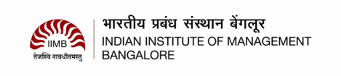

**10 December 2016**

Submitted under the fulfillment of requirement for

Business Intelligence course in

GMITE-10 programme taught by

Professor Dr. Shankar Venkatagiri

**ANALYSIS OF NEFT TRANSCATIONS OF BANKS IN INDIA**

**© Copyright by**

**Kartik Srinivasan, Nilesh Agarwal, Surabhi Sharma, Yash Londhe**

**2016**

**All Rights Reserved**

**ANALYSIS OF NEFT TRANSCATIONS IN BANKS IN INDIA**

\

**About The Data**

The data is a list of NEFT transactions that was recorded by RBI in from January 2009 to October 2016. The data contains the following:-

* Name of the bank
* Outward Number of Transactions (i.e. transactions from the Bank)
* Outward Value of Transactions in Rs. Millions
* Inward Number of Transactions (i.e. transactions to the Bank)
* Inward Value of Transactions in Rs. Millions

The raw data (month by month from Jan 2009 to October 2016) was collected from the RBI website ([https://www.rbi.org.in/Scripts/NEFTView.aspx#](https://www.rbi.org.in/Scripts/NEFTView.aspx)). The data was then collated into 8 files based on year (2009.xls to 2016.xls). Two new columns were introduced in the data set namely, *Month* and *Year.*

Another Data file “Classifiication.xls” was prepared with contains the “sector” of the Bank viz Public (PSB), Private (PVT), Foreign (FOR), Cooperative (CO-OP) or Other Financial Institutions (FI).

Using the data as structured above, a preprocessing was done on the data to make it in the desired format.

Preprocessing is done in the “RBI_Neft.R” file, which does the following:-

1. Reads the raw data files year by year
2. Creates 3 new columns:-
   * MonthAndYear – Combination of Month And Year separated by space.

Example: Jan 2009, July 2012, etc.

* + TotalTxns – Sum of the inbound number of transactions and outbound number of transactions
  + TotalTxnValue – Sum of the inbound value of transactions and outbound value of transactions.

1. Creates a new column “Sector” by taking the join of the above modified dataset and the data in the “Classification.xls” file.

**Analysis of the Data**

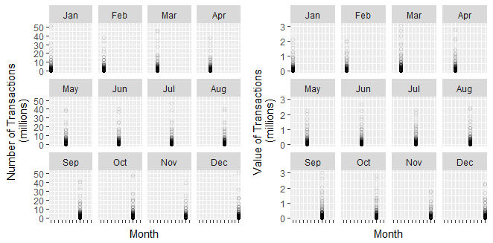

**Graph 1 Plot of Total Number of Transactions/Total Value of Transactions by each month**

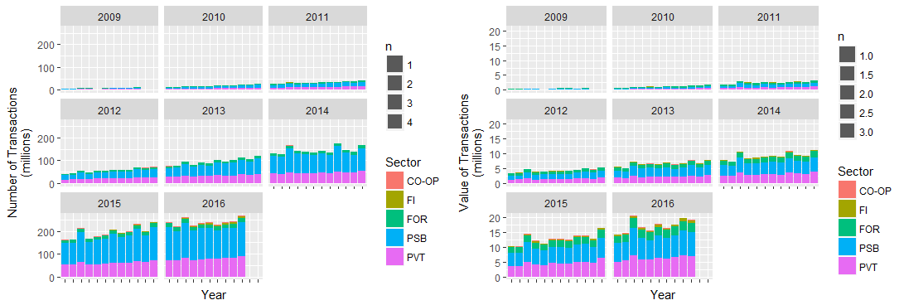

**Graph 2 Graph of the Number of Transactions/Value of Transactions month wise (clubbed by year) and then arranged as per the Bank Sector**

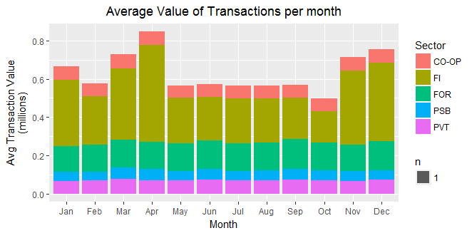

**Graph 2 Bar-Graph of the Average Value of Transactions month-wise and then arranged as per the Bank Sector**

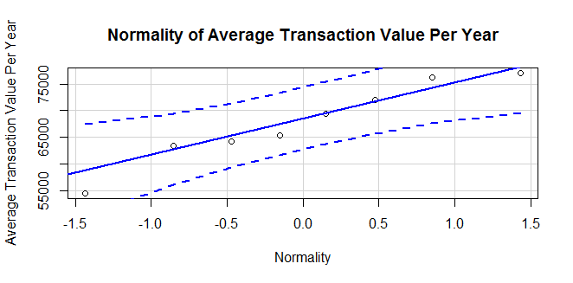

**Graph 3 Normality of Average Number of Transactions per year**

**Summary Measures of Average Number of Transactions per year:-**

|  |  |  |  |  |  |
| --- | --- | --- | --- | --- | --- |
| Min. | 1st Quartile | Median | Mean | 3rd Quartile | Max. |
| 54470 | 63980 | 67380 | 67760 | 73040 | 77080 |

Skewness: -0.3615122

Standard Deviation: 7493.371

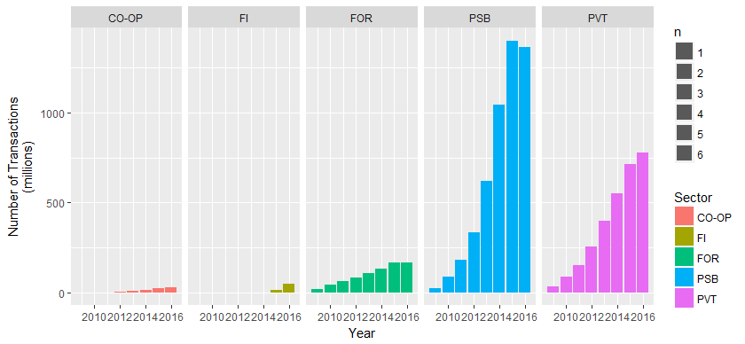

**Graph 5 Graph of the Total Number of Transactions year-wise grouped by the Bank Sector**

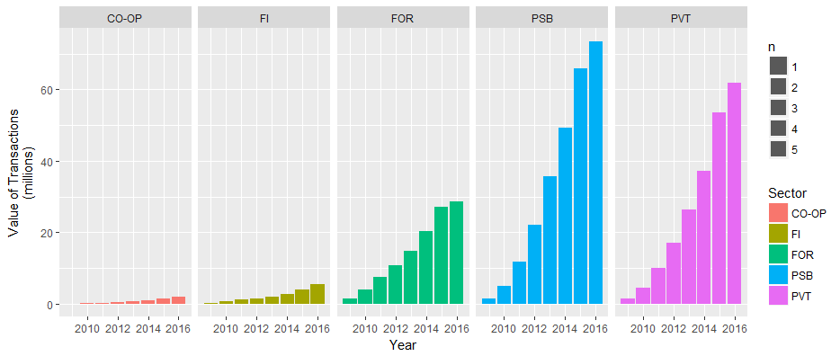

**Graph 6 Graph of the Total Value of Transactions year-wise grouped by the Bank Sector**

**Interpretation from the Graphs**

* Looking at the graph1 and graph2 plots, it can be seen that the number of transactions are particularly high during the months of March, October and December. This may be attributed to year end closing being in March, festive seasons during October, and calendar year end during December. This also aligns with the Total Transaction Value noted during the period.
* Looking at Graph 3 and 4 it can be said that the average value of transaction per year is quite normal and the skewness is -0.3 approximately. Also the median and mean do not vary too much.
* If we take a look at the Graph 5 we can observe that the total number of transactions in the PSB is larger than any other sector. The second sector is the PVT sector. But looking at the Graph 6 reveals that even though the number of transactions of PUB sector is quite large compared to that of PVT sector, the value of transactions isn’t significantly large. This may signify that the average value of transactions done in PVT sector is larger than the average value of transactions done in the PUB sector.

*Important Points regarding the data and analysis:-*

* The data files does not contain data for November 2016 (and December 2016), which is why it was not possible to analyze the impact of demonetization on the NEFT transactions.