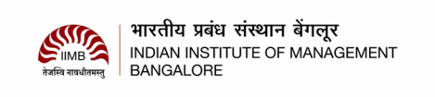

## **Analysis of NEFT transactions of Indian Banks (2009-2016)**

|  |  |
| --- | --- |
| Submitted under the fulfillment of  requirement for Business Intelligence  course in GMITE-10 programme taught by  Prof. Dr. Shankar Venkatagiri | Presented By:  Kartik Srinivasan (GMITE10130)  Nilesh Agarwal (GMITE10142)  Surabhi Sharma (GMITE10165)  Yash Londhe (GMITE10171**)** |

Analysis of NEFT transactions of Indian Banks (2009-2016) 1

Introduction 3

About the Data 4

Source 4

Schema 4

Challenges 5

Data Analysis 6

Frequency Distribution 6

Total Value of Transactions 6

Measures of Central Tendency and Dispersion 6

Average Transaction Value Per Year 7

Trend Analysis 8

Average Transaction Value Per Month 8

Month-wise analysis - by volume and value 8

Sector-wise Analysis 9

# Introduction

The central bank of any country drives the development of the country’s payment systems. The Reserve Bank of India as the central bank of India has been playing this developmental role and has taken several initiatives for building faster, safe, secure and reliable payment systems in the country.

As the volume of cheques in the banking system in a huge country like India was adding a lot of pressure and unpredictability in clearing transactions, the RBI, since the late eighties and nineties has been diligently working to put together numerous technology based solutions and products for improving the payment and settlement systems in India.

In November 2005, RBI introduced an electronic system which facilitated one-to-one funds transfer requirements of individuals / corporates. The NEFT system as it is called, provides for batch settlements at hourly intervals, enabling near real-time transfer of funds.

Understanding that India is a country where a significant proportion (70%-95% based on various estimates) of all transactions are done in cash, we attempt to analyze the data around NEFT transactions that RBI has made publically available to draw inferences about the adoption of electronic transactions across various Banks in India across the Public, Private, Foreign and Co-Operative categories.

We intend to analyze the RBI published NEFT data for banks are interested to seek answers to questions like

* How are NEFT transactions growing YoY in India ?
* How much (in value) on an average, do we transact on NEFTs
* Banks of which sector fuel this growth ?
* Is the growth significant ? What are its characteristics ?
* Are there seasonal patterns in the value / volume of NEFT transactions
* Can we expect the recent De-monetization measures increase the adoption of NEFT transactions in India?

# About the Data

## Source

The data is a list of NEFT (National Electronic Fund Transfers) transactions that was recorded by RBI in from January 2009 to October 2016. The raw data (month by month from Jan 2009 to October 2016) was collected from the RBI website (<https://www.rbi.org.in/Scripts/NEFTView.aspx>). The monthly data was downloaded and then collated into 8 files based on year (2009.xls to 2016.xls).

## Schema

The schema of the monthly dataset provided by RBI is

|  |  |
| --- | --- |
| Field | Description |
| Name of the Bank | The Bank Name |
| Outward Number of Transactions | The Number of NEFT Transactions that originate from the bank |
| Outward Value of Transactions (Millions) | The value of NEFT Transactions that originate from the bank |
| Inward Number of Transactions | The Number of NEFT Transactions that get credited to accounts in from the bank |
| Inward Value of Transactions (Millions) | The value of NEFT Transactions transacted towards credits into accounts of the bank |

* Two new columns were introduced in the data set namely, Month and Year to capture the interval variables.
* Another data file “Classifiication.xls” was prepared with contains the “sector” mapping of the Bank viz.

|  |  |
| --- | --- |
| **Sector** | **Code** |
| Public | PSB |
| Private | PVT |
| Foreign | FOR |
| Co-operative | CO-OP |
| Other Financial Institutions | FI |

This was done to introduce a nominal (categorical) variable on which we will base some of our analysis

* Using the data as structured above, a preprocessing was done on the data to convert it into the desired format. Preprocessing is done in the “RBI_Neft.R” file, which does the following:

1. Reads the raw data files year by year
2. Enhances the dataset by adding 3 new fields
   1. **MonthAndYear** – Combination of Month And Year separated by space. Example: Jan 2009, July 2012, etc. (Interval variables)
   2. **TotalTxns** – Sum of the inbound number of transactions and outbound number of transactions
   3. **TotalTxnValue** – Sum of the inbound value of transactions and outbound value of transactions.
3. Creates a new column “**Sector**” by taking the join (merge in R parlance) of the above modified dataset and the sector data in the “Classification.xls” file.
4. This enhanced dataset is represented as “**neftDataMerged**”

## Challenges

Numerous problems were encountered during the data collection and cleansing process. Some of the key challenges we faced are enumerated below.

1. Incomplete data – Data for some months missing (particularly November 2016, which was to be used to analyze the impact of demonetization on the NEFT transactions)
2. Units of data were inconsistent (some data was in million, others in crores). We decided to use millions as our units for value of transactions
3. Bank Names were inconsistent. Same banks were represented in different names across months/years.
4. RBI publishes the NEFT data monthly and in a proprietary format - data had to be downloaded for each month, standardized and collated together month by month.
5. In order to make sense of the data, additional nominal variables (Sector) had to be attached to the raw monthly dataset provided. As no out-of-the-box dataset for this was available, we had to dig up bank information to arrive at this classification.

# Data Analysis

## Frequency Distribution

### Total Value of Transactions

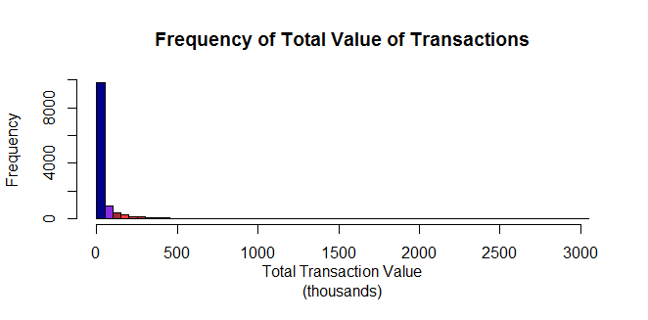

Graph 1 :Frequency of Total Value of Transactions

The above graph shows the frequency distribution of the total value of transactions per year. It is clear that a large number of transactions are carried under the transaction value of Rs.500,000.

## Measures of Central Tendency and Dispersion

|  |  |  |  |  |  |  |  |
| --- | --- | --- | --- | --- | --- | --- | --- |
| Year | Min. | 1st Quartile | Median | Mean | 3rd Quartile | Max. | SD |
| 2009 | 0.07 | 104.4 | 773.7 | 5367 | 4218 | 87450 | 252227.4 |
| 2010 | 0.02 | 144.2 | 1472 | 12180 | 8972 | 278500 | 475435.7 |
| 2011 | 0.2 | 300.9 | 3756 | 25130 | 21290 | 515300 | 802637.7 |
| 2012 | 0 | 275.8 | 2818 | 36560 | 32580 | 771700 | 1276600 |
| 2013 | 0 | 300.3 | 1457 | 45770 | 37730 | 1277000 | 2002122 |
| 2014 | 0 | 461.7 | 1767 | 58530 | 44230 | 1735000 | 2886055 |
| 2015 | 0 | 604.1 | 2417 | 77300 | 54410 | 2314000 | 3908475 |
| 2016 | 0 | 866.3 | 3177 | 99600 | 56200 | 3002000 | 4313386 |

Above table shows the summary measures of the data year wise. We notice that the variation (Standard Deviation - SD) in the data is increasing year on year.

### Average Transaction Value Per Year

The summary measures for the average value of transactions

|  |  |  |  |  |  |  |  |
| --- | --- | --- | --- | --- | --- | --- | --- |
| Min. | 1st Quartile | Median | Mean | 3rd Quartile | Max. | SD | Skewness |
| 54470 | 63980 | 67380 | 67760 | 73040 | 77080 | 7493.371 | -0.36151 |

Supported by the table of summary measures, we can see that the negative skewness which is close to zero conveys that the values may be normally distributed.

We further tested the normality further using a QQ Plot in R that indicates normality.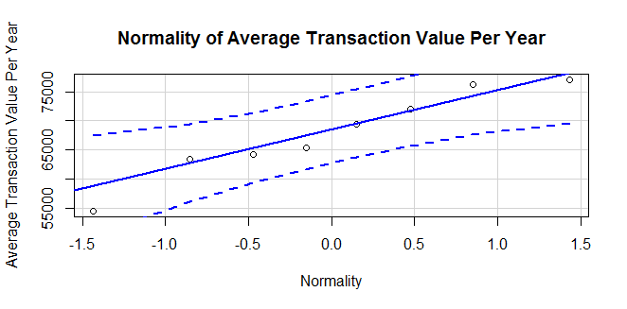

Supported by the table of summary measures, we can say that the distribution is normal.

## Trend Analysis and Insights

### Average Transaction Value Per Month

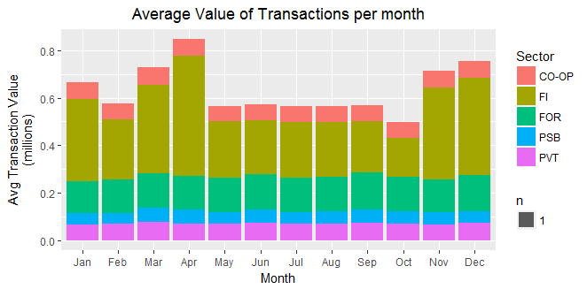

Graph 3 Bar-Graph of the Average Value of Transactions month-wise and then arranged as per the Bank Sector

Looking at the above graph, we see the trend in the average value of transactions taking place per month for each of the bank sectors. We see that the Financial Institutions like the Clearing Corporation Of India etc. show the most variation in the total value contribution. Otherwise, the value of transactions has remained pretty consistent across other sectors.

### Month-wise analysis - by volume and value

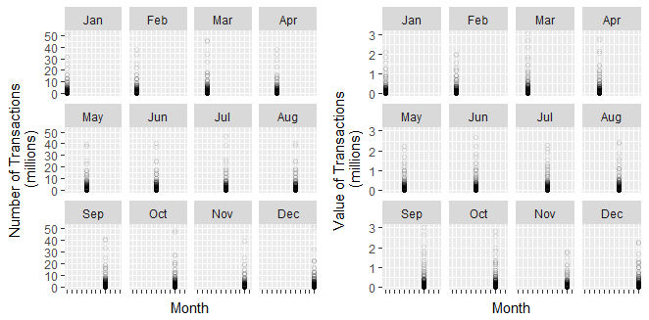

Graph 4 Plot of Total Number of Transactions/Total Value of Transactions by each month

The scatter plot shows an interesting pattern of peaks in the months of March, October through December. This is seen for both the number of transactions and the total value.

### Sector-wise Analysis

#### Annual Volume and Value of Transactions

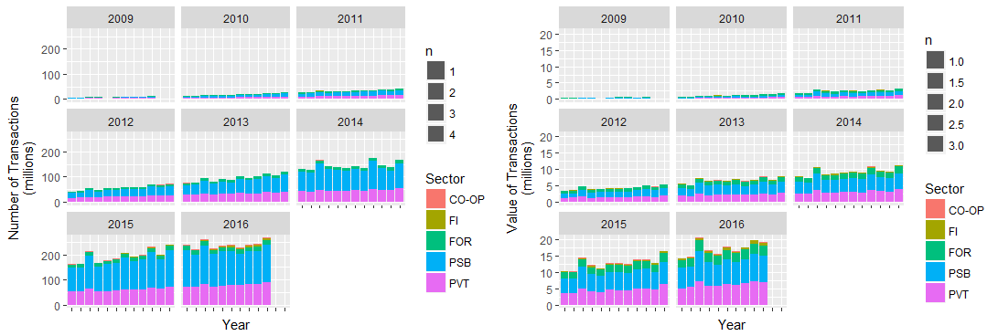

Graph 5 : Sector-wise – Annual No. of Transactions/Value of Transactions month wise Bank Sector