ParkMe Proposal

**Service Provided:**

Users will be able to locate nearby parking lots. The application will try and find the best suitable parking lot and parking space from their available location.

**Program Implementation:**

A sensor will be connected to a parking spot. The sensor will detect whether or not a car is present. The database will be accessed through an app, and the app will display the data to the end user.



**Primary Users:**

YOU! Every drivers such as students, faculty member, staff, and guests may utilize the app.

Why use ParkME?

We are all aware about the parking situation in this campus, especially during peak hours. Using ParkMe will ease up the time to find a parking space with the help of a navigation system.

What makes ParkMe Unique?

**Simplicity -** We want our app to be straightforward, two to three taps and it will navigate the user to an empty spot.

**User friendly -** An app that is easy to the eyes to the user, no other features that will only confuse the user will be included.

**Voice Command System –** In the works.

Simple steps to ParkME:

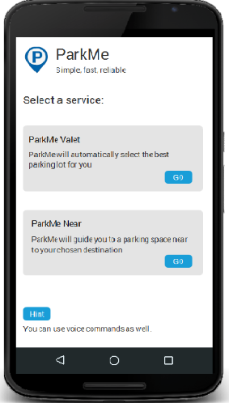Considering the user is already logged in to their account:

**Step 1:**

Choose the type of service you desire. **ParkMe Valet** or **ParkMe Near**.

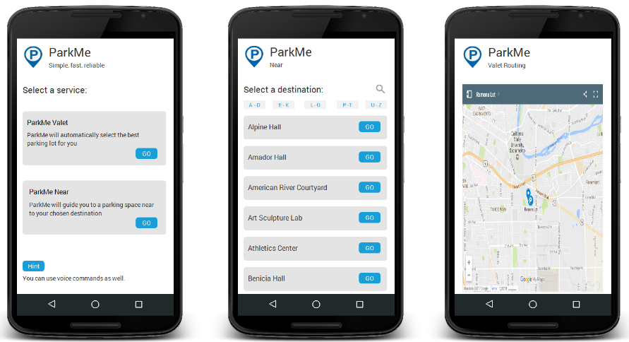

**Step 2:**

Choose the parking lot you wish to park on. (If ParkMe Near was selected).

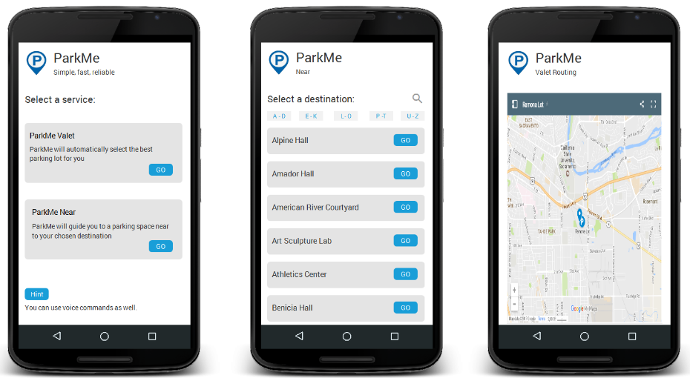

**Step 3:**

Not really a step, but enjoy driving to the chosen destination!

System Requirements:

In the works.

C:\Users\adriankarl\Desktop\Sac State\CSC 131\ParkMeLogo.png

ParkMe

Team 3:

Pink Unicorns

Members:

Name – Name

Name – Name

Name –Name

Webpage:

In the works.