Codes for rice and confusion:
Codes for rice and confusion:

Item Code | CPC Code | Item
35 | '39120.02 | Bran of rice
37 | '21910.01 | Cake of rice bran
110 | '23490.01 | Communion wafers; empty cachets of a kind suitable for pharmaceutical use; sealing wafers; rice paper and similar products.
38 | '23120.01 | Flour of rice
28 | '23162 | Husked rice
36 | '21691.01 | Oil of rice bran
27 | '0113 | Rice
32 | '23161.03 | Rice; broken
31 | '23161.02 | Rice; milled
29 | '23161.01 | Rice; milled (husked)
30 | 'F0030 | Rice; paddy (rice milled equivalent)
39 | '24230.02 | Rice-fermented beverages

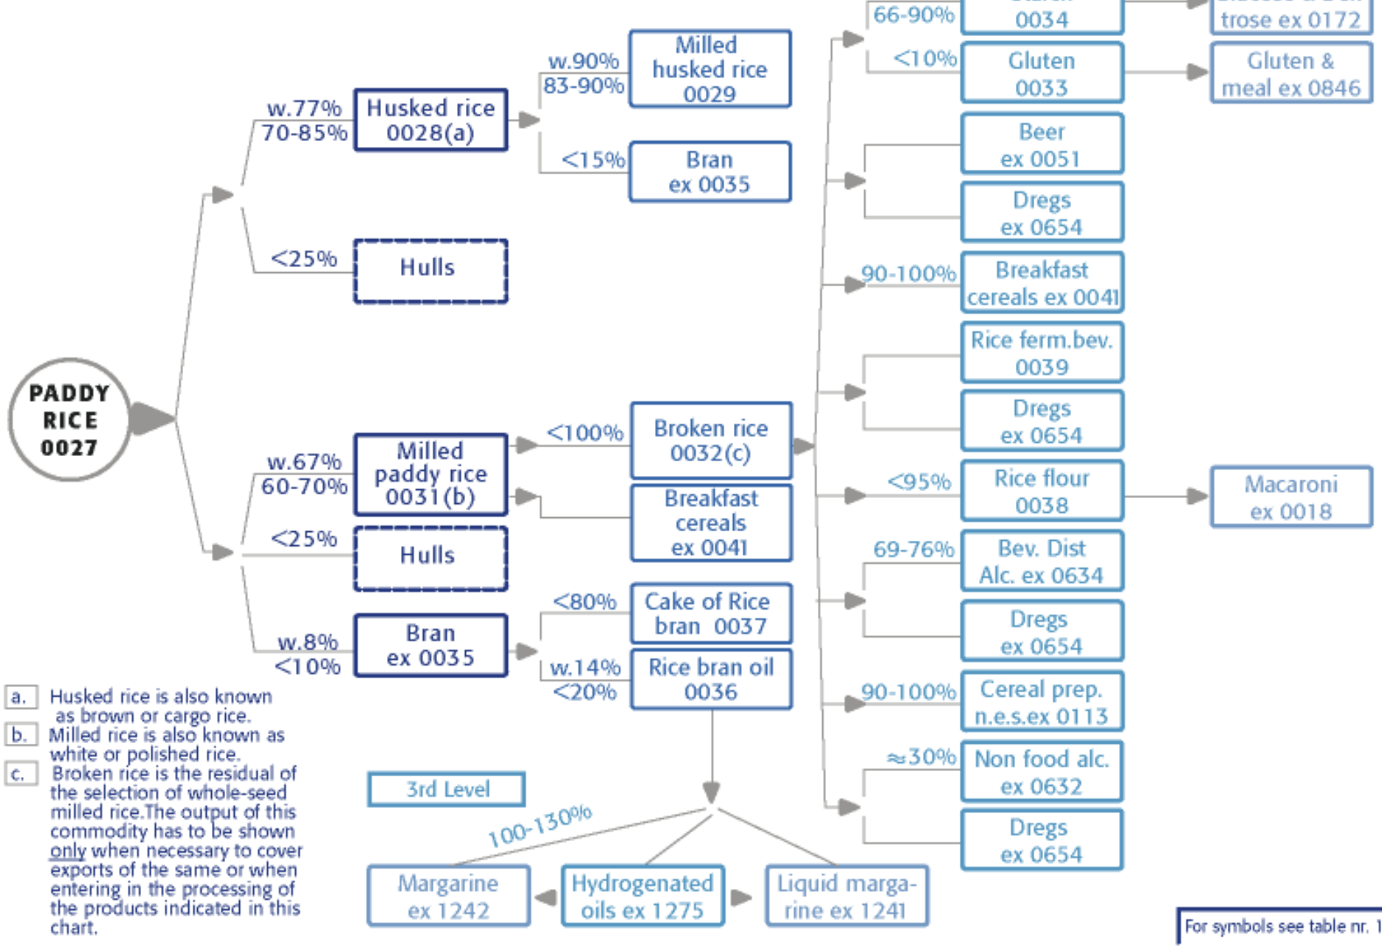

These are item code table take a look at rice code and here is the conversion table link what should be used for conversion and for which codes for production and export analysis
Ran a command
Now I can see your actual TCL rice items, and they map cleanly onto the commodity tree. Here's what to use — and, importantly, what the tree tells you about the codes so you don't double-count.
Your TCL rice items, mapped to the tree:
TCL Item Code | Item | Tree node | Factor from paddy (0027)
27 | Rice | = paddy (0027) | 1.00 (baseline)
28 | Husked rice | 0028 (brown/cargo) | ~0.77
29 | Rice; milled (husked) | 0029 (milled brown) | ~0.77 × 0.90
31 | Rice; milled | 0031 (white/polished) | ~0.67
32 | Rice; broken | 0032 (residual of milling) | sub-product of 31
30 | Rice; paddy (rice milled equiv.) | derived paddy-in-milled-terms | different basis
35, 36, 37, 38 | Bran, bran oil, cake, flour | downstream by-products | don't use
What to use for production-vs-export:
The two main traded forms are code 28 (husked/brown, ÷0.77) and code 31 (milled/white, ÷0.67). These are the two primary branches straight off paddy in the tree, and they're the bulk of real rice trade. Convert each to paddy-equivalent with its own factor, then sum:
export_paddy_eq = husked(28) / 0.77 + milled(31) / 0.67
Divide (not multiply), because you're recovering the paddy that these lighter processed forms came from.
What NOT to use, and why (from the tree):
Code 29 (Rice; milled (husked)) is a sub-product of 28 — the tree shows husked rice 0028 → milled husked rice 0029 at 90%. So 29 is 28 milled further. If you use both 28 and 29, you double-count the same brown rice. Pick 28 (the parent) OR 29, not both. Since 28 is the broader branch, use 28.
Code 32 (broken rice) is a residual of milling code 31 — the tree note (c) literally says it's the residual of whole-seed milled rice selection, shown "only when necessary to cover exports." So it's already inside the milled-rice stream; adding it to 31 double-counts. Don't include it unless a country's broken-rice trade is separately significant, and even then with care.
Code 30 (Rice; paddy, rice milled equivalent) is the trap — it says "paddy" but the parenthetical means it's paddy re-expressed in milled weight, a different basis than QCL's paddy production (27). Don't pair it with QCL 27. It's FAO's own aggregate; if anything, it's an alternative to doing the conversion yourself, but on a milled basis, so it won't match your paddy production.
Codes 35/36/37/38 (bran, bran oil, cake, flour) are downstream by-products, tiny trade, different products — ignore for a rice production-vs-export analysis.
So the clean recipe:
- Production side (QCL): code 27 (paddy) — what you already have.
- Export side (TCL): code 28 ÷ 0.77 + code 31 ÷ 0.67 = paddy-equivalent exports.
- Do NOT add: 29 (child of 28), 32 (child of 31), 30 (wrong basis), or the bran/flour lines.
- Simplest alternative: if you want just one code, use 31 alone ÷ 0.67 — milled white rice is the dominant traded form, and it avoids all double-count risk. Use 28+31 only if brown-rice trade matters for your countries.
On the conversion factors themselves — you mentioned a conversion table link but it didn't come through in this message (I can see the commodity-tree image and the ItemCodes file, but no link). The factors I'm using (0.77 husked, 0.67 milled) are the "w." defaults printed on the tree itself. If your linked table (the FAO TCF / cb2466t) gives country-specific rates, those are more precise — paste it and I'll tell you exactly which rows apply to codes 28 and 31.
what ic code 30 all about then?
Code 30 — "Rice; paddy (rice milled equivalent)" — is FAO's own pre-computed aggregate that does exactly the conversion you've been doing by hand, but in the opposite direction. It's a convenience series, and understanding it actually clarifies your whole pipeline.
Here's what it is: FAO takes all the different traded rice forms (husked, milled, broken, etc.), converts each to a common basis, and rolls them into one total rice trade figure. The "(rice milled equivalent)" in the name tells you the basis — everything is expressed in milled-rice weight, not paddy weight, despite the word "paddy" appearing in the label. That naming is genuinely confusing, but the parenthetical is the operative part.
So code 30 is essentially "total rice trade, all forms combined, expressed in milled-equivalent tonnes." It exists so analysts who don't want to juggle codes 28/29/31/32 and their individual factors can grab a single number.
Why the name is misleading: it says "paddy" but it's not in paddy weight — it's in milled weight. FAO uses "paddy" here to mean "the rice commodity in aggregate" (paddy being the origin of all rice), while "(rice milled equivalent)" specifies the actual unit. Two contradictory-sounding words, but the milled-equivalent part wins.
Why you shouldn't pair it with your QCL production: your QCL production (code 27) is in paddy weight. Code 30 is in milled weight. Dividing milled-basis trade by paddy-basis production mismatches the units — you'd understate the export share by the milling ratio (~0.67). To use code 30 against production you'd first have to convert it up to paddy (÷~0.67), at which point you've done the same work as building it yourself from 28+31.
When code 30 is actually useful: if you wanted total rice trade in milled terms and didn't care about comparing to paddy production — e.g. a pure trade analysis, or comparing against a milled-basis production figure. It's a shortcut that saves you the multi-code conversion, as long as you stay in milled-equivalent space throughout.
So for your specific analysis: skip code 30. You're comparing against paddy production, so you want everything in paddy-equivalent, which means building the export side from 28 (÷0.77) + 31 (÷0.67) yourself — that lands in paddy terms directly. Code 30 would force you to convert its milled basis back to paddy anyway, so it saves nothing and invites the units-mismatch mistake.
The one good use for code 30 in your work: a cross-check. Convert your 28+31 paddy-equivalent total back to milled (× ~0.67) and see if it roughly matches code 30's figure for the same country-year. If they're close, your conversion is sound; if they're wildly off, you've got a code or factor wrong somewhere. It's a handy sanity benchmark, just not your primary series.
Option B — bring code 30 up to paddy, compare to your paddy-eq sum:
python
code30_paddy_equiv = exp30 / 0.67 # milled-eq → paddy-eq

