Linux Basics – Practical Assignment
Prepared by: Praveen
Project folder: Linux_Basics_Praveen

Objective
Practise essential Linux command-line operations: file and directory management, viewing files, searching, archiving, downloading, permissions, and environment variables.

Environment and execution
The commands were run in a Linux-compatible shell environment. The supplied linux_basics.sh script contains the full sequence. Run it from this project directory with: bash linux_basics.sh
Note: /etc/passwd is a system file containing local account information. Its contents vary by Linux system. The screenshots show the output from the execution environment used to prepare this assignment.

1. Creating and renaming files/directories
Commands:
mkdir -p test_dir
touch test_dir/example.txt
mv test_dir/example.txt test_dir/renamed_example.txt
Explanation: mkdir creates the directory, touch creates an empty file, and mv renames the file. The resulting file is test_dir/renamed_example.txt.
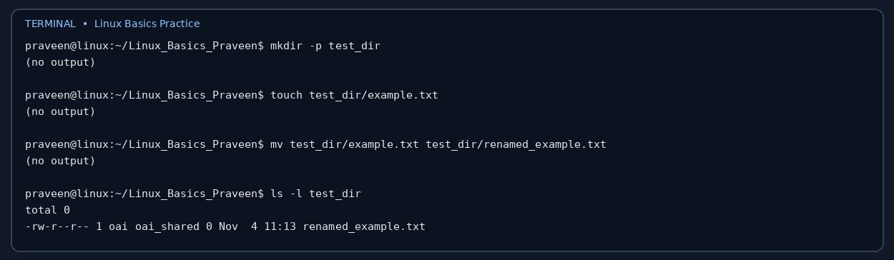

2. Viewing file contents
Commands:
cat /etc/passwd
head -n 5 /etc/passwd
tail -n 5 /etc/passwd
Explanation: cat displays the file, head -n 5 prints its first five lines, and tail -n 5 prints its last five lines.
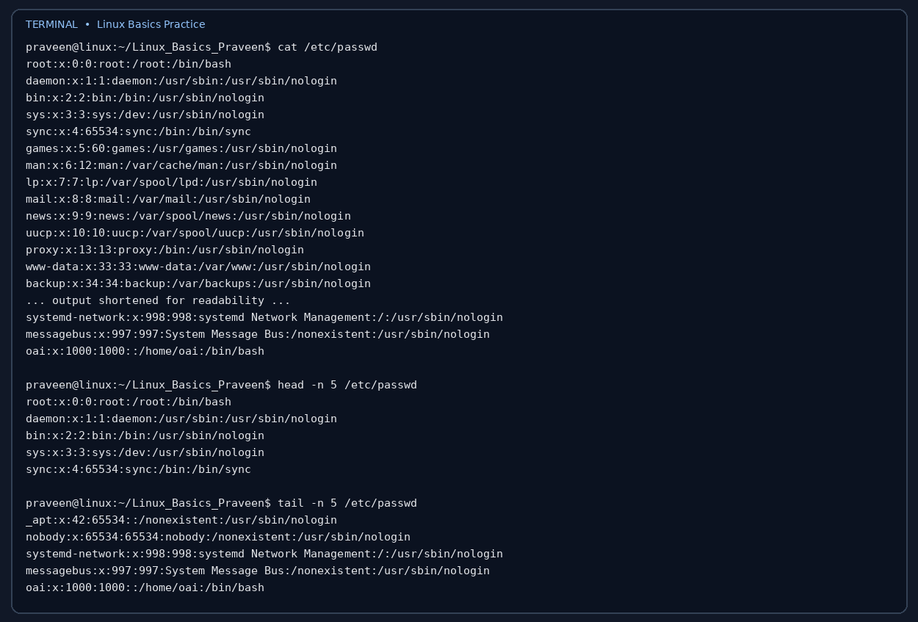

3. Searching for patterns
Commands:
grep "root" /etc/passwd
Explanation: grep searches each line and prints lines containing the text root.
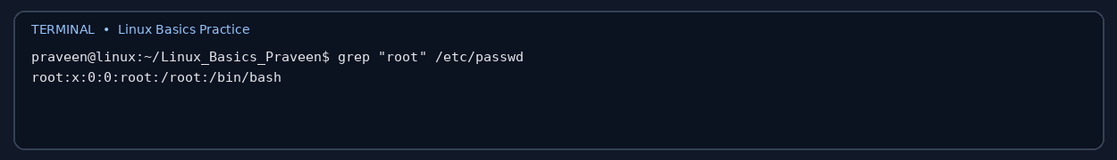

4. Zipping and unzipping
Commands:
zip -r test_dir.zip test_dir
mkdir -p unzipped_dir
unzip -o test_dir.zip -d unzipped_dir
Explanation: zip -r creates a ZIP archive recursively. unzip extracts the archive into the specified destination directory.
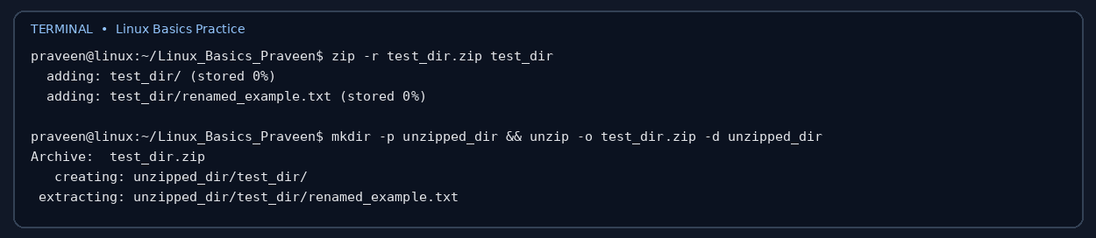

5. Downloading files
Commands:
wget -O sample.txt https://example.com/sample.txt
Explanation: wget retrieves a file from a URL. The -O option saves it using the name sample.txt. Network access is required; if the download fails in a restricted environment, rerun this command on a machine with internet access.
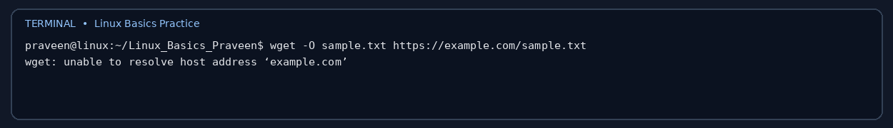

6. Changing permissions
Commands:
touch secure.txt
chmod 444 secure.txt
ls -l secure.txt
Explanation: chmod 444 gives read permission to the owner, group, and others, and removes write and execute permissions. The expected permission string is -r--r--r--.
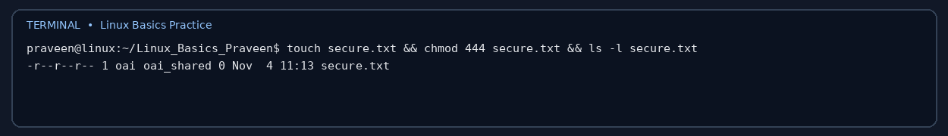

7. Working with environment variables
Commands:
export MY_VAR="Hello, Linux!"
echo "$MY_VAR"
Explanation: export makes MY_VAR available to child processes launched from the current shell. The value is available in the current shell session; it is not automatically permanent after closing the terminal.
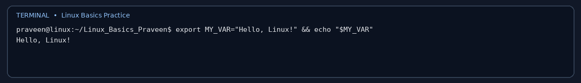

Final verification
The final screenshot checks the created files, ZIP archive, downloaded file, and secure.txt permissions.
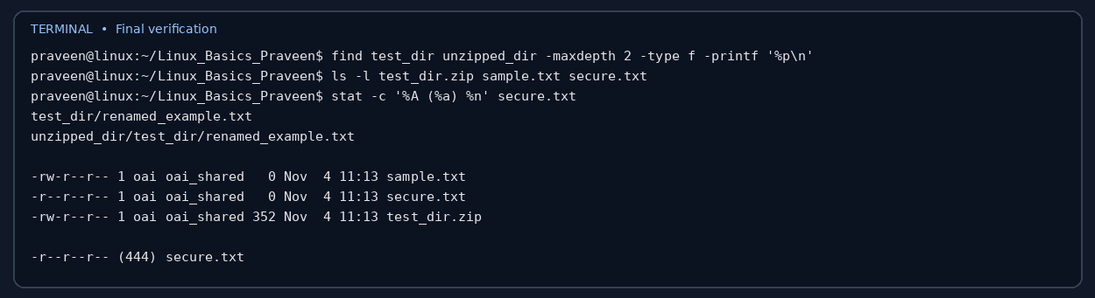

GitHub repository
Repository URL: TO BE ADDED AFTER PUSHING THIS PROJECT TO YOUR GITHUB ACCOUNT.
To publish: create a new GitHub repository named Linux_Basics_Praveen, then run the following commands from this folder:
git init
git add .
git commit -m "Complete Linux basics assignment"
git branch -M main
git remote add origin https://github.com/YOUR_USERNAME/Linux_Basics_Praveen.git
git push -u origin main

Submission checklist
- Complete project script and generated task files included.
- Documentation with commands, explanations, and terminal screenshots included.
- ZIP archive created as Linux_Basics_Praveen.zip.
- Add your actual GitHub repository URL to the document/README before final submission.

