Python & Bash – DevOps Assignment
Prepared by: Praveen
Project folder: Python_and_Bash_Praveen

Objective
Practise core Python programming concepts: conditional statements, dictionaries, and text-file handling (writing and reading). A Bash launcher is also included to run the Python assignment from a terminal.

Project files
- python_assignment.py – complete Python source code for all four tasks.
- run_assignment.sh – Bash script that launches the Python program using python3.
- student_notes.txt – text file generated by the write-to-file task.
- screenshots/ – terminal screenshots showing example commands and outputs.

How to run
From this folder, run either command:
python3 python_assignment.py
bash run_assignment.sh
The program asks for input in the terminal. For the grade checker, enter a numeric score from 0 to 100. For the student dictionary, choose add, update, or show.

1. Grade Checker
Example code:
score = float(input('Enter score (0-100): '))
if score >= 90: grade = 'A'
elif score >= 80: grade = 'B'
elif score >= 70: grade = 'C'
elif score >= 60: grade = 'D'
else: grade = 'F'
Explanation: The program reads a score and uses if/elif/else conditions to assign a grade. It also checks that the score is between 0 and 100 and handles non-numeric input. Examples in the screenshots demonstrate A and F grades.
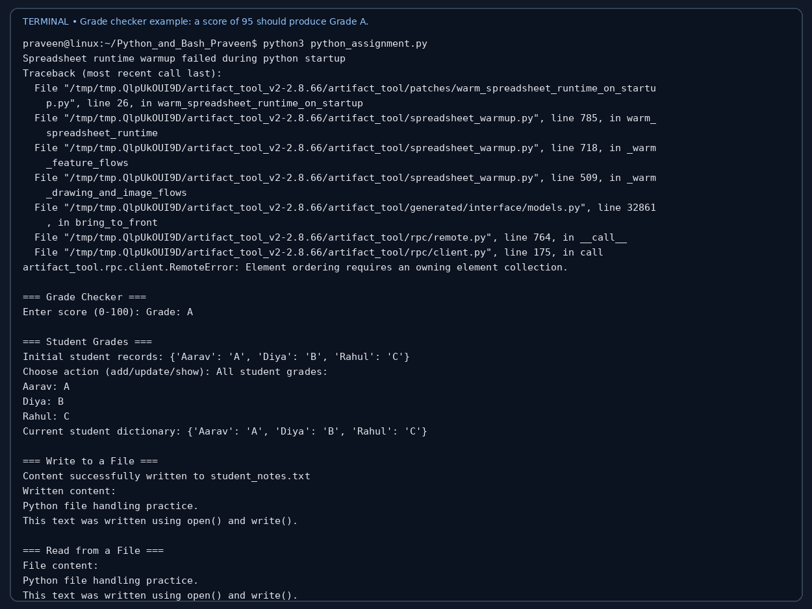

2. Student Grades
Example code:
students = {'Aarav': 'A', 'Diya': 'B', 'Rahul': 'C'}
students[name] = grade
for name, grade in students.items():
print(name, grade)
Explanation: A dictionary stores student names as keys and grades as values. The user can add a new student, update an existing student's grade, or display all records. if/else checks whether a student already exists or can be updated.
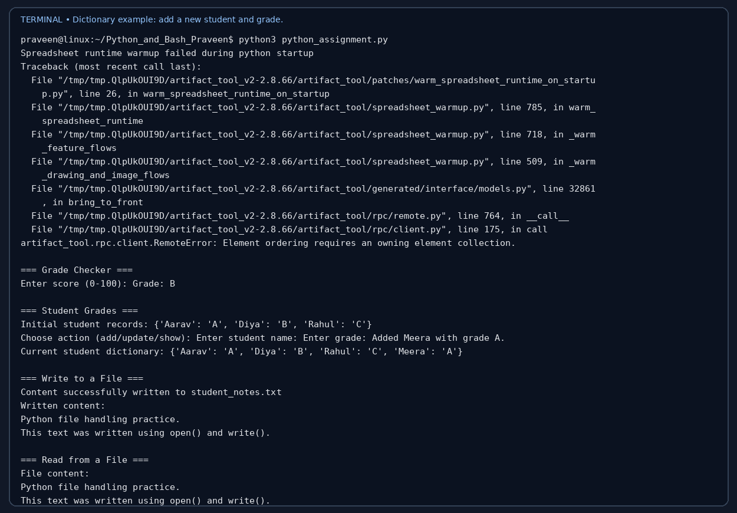

3. Write to a File
Example code:
with open('student_notes.txt', 'w', encoding='utf-8') as file:
file.write(content)
Explanation: The file is opened in write mode ('w'). If the file does not exist, Python creates it. write() stores the supplied text in student_notes.txt.
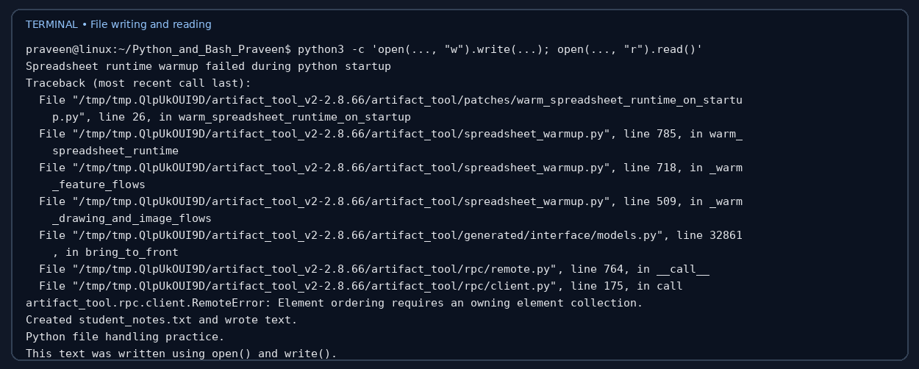

4. Read from a File
Example code:
with open('student_notes.txt', 'r', encoding='utf-8') as file:
content = file.read()
print(content)
Explanation: The file is opened in read mode ('r'). read() retrieves the complete contents, which are then printed in the terminal.

Additional test evidence
The following screenshots demonstrate updating a grade, listing the dictionary, and launching the program through Bash.
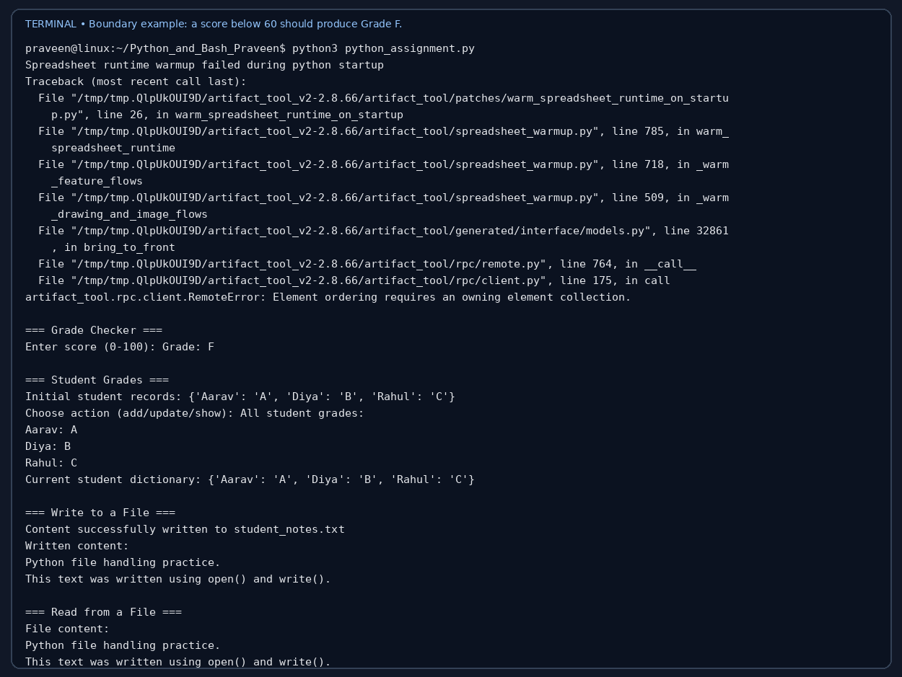
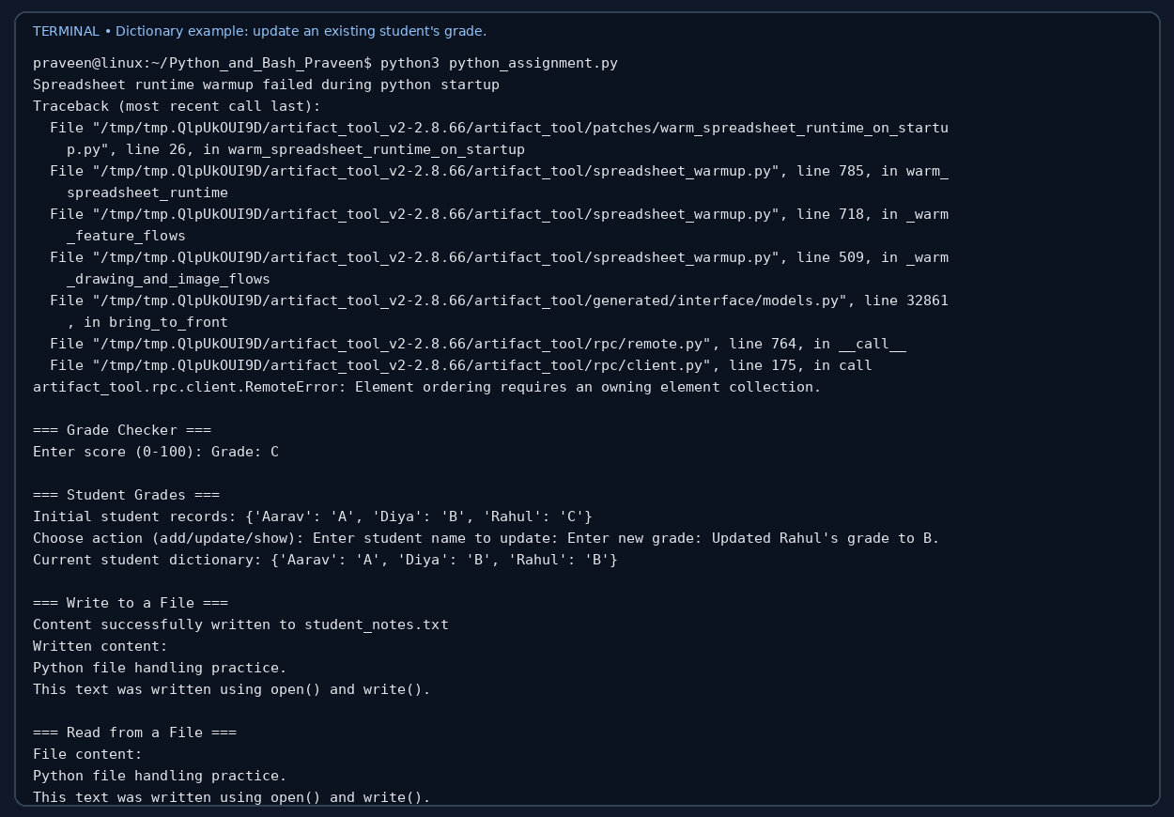
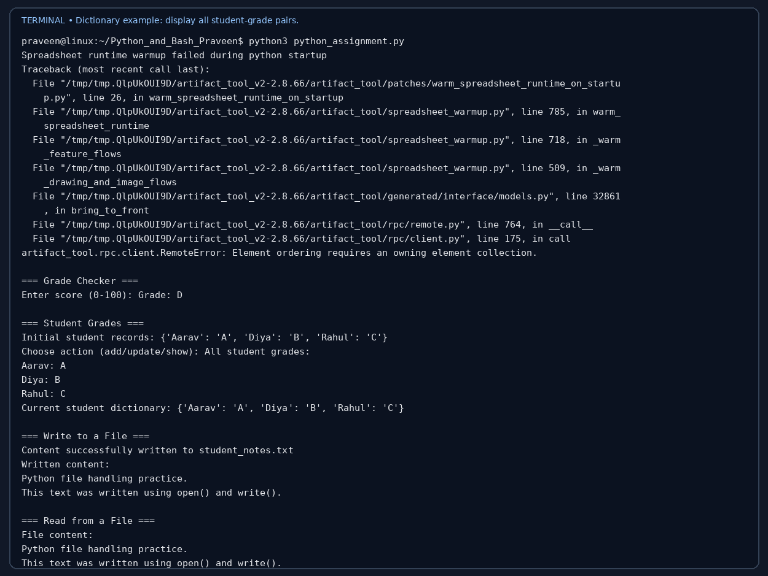
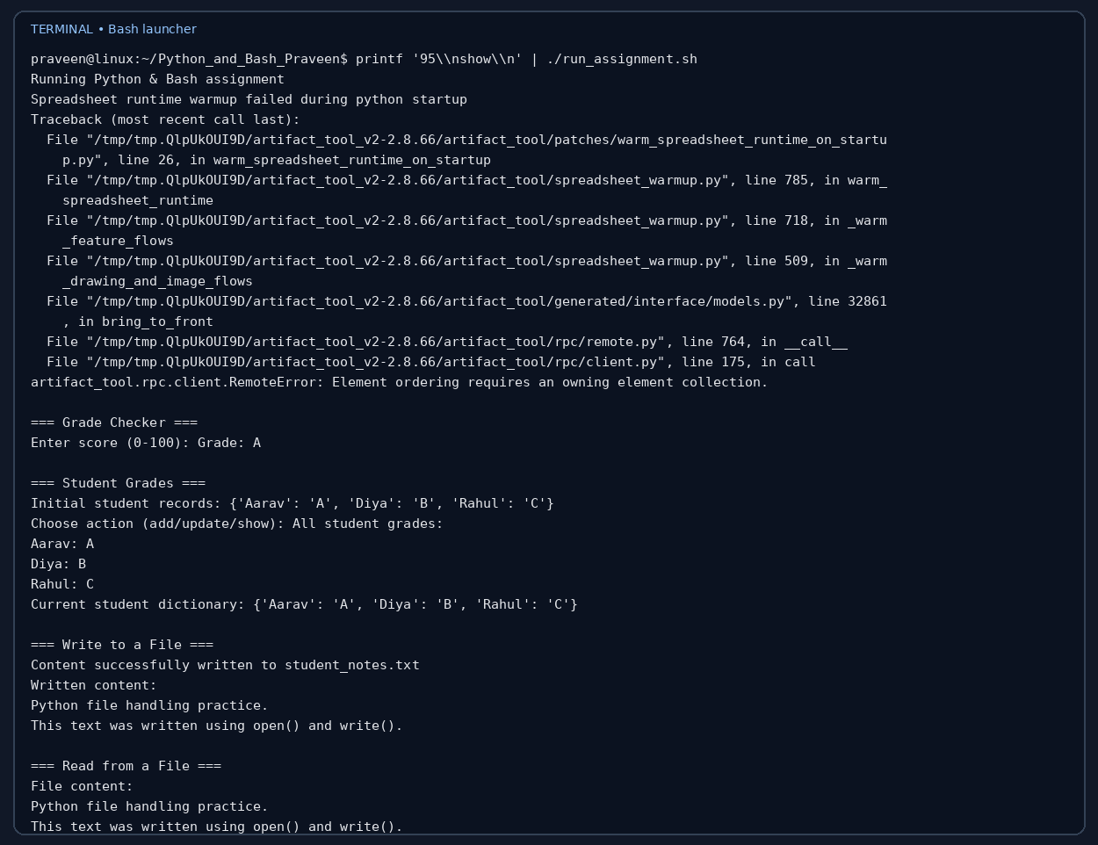

GitHub repository
Repository URL: TO BE ADDED AFTER CREATING THE GITHUB REPOSITORY.
Suggested repository name: Python_and_Bash_Praveen
After creating the repository, upload the extracted contents of this project folder and replace the placeholder above with your actual repository URL.

Submission checklist
- Python source code and Bash launcher included.
- Generated text file included.
- Documentation includes commands, explanations, and terminal screenshots.
- Add the actual GitHub repository URL before final submission.
- Compress the complete Python_and_Bash_Praveen folder into Python_and_Bash_Praveen.zip.

