|  |  |
| --- | --- |
|  | **2012** |
|  |  |

|  |
| --- |
| **city database using arrays & linked list** |
| ***MA 3105*** |

*In this project we develop a system for city database management. This is a menu-based program which will display a menu and then user will enter a choice and then the required function will be performed. The project is based on C programming language.*

*Sujith K S*

*Amal Narayanan*

*Anurag N P*

*Suchithra A S*

*Chaithanya K S*

**TABLE OF CONTENTS**

* **Acknowledgements**
* **Introduction**
* **Project Description**
* **Pseudo code**
* **C Programming Concepts Applied**
* **User Guide**
* **Test Plan**
* **Conclusion**
* **References**
* **Source Code**
* **Contributions of members**

**ACKNOWLEDGMENT**

In this project it is required to develop the system by writing the code for given project. This is a menu-based program which will display a menu and then user will enter a choice and then the required function will be performed. The project is based on C programming language.

We have put much effort into this project; however, it would not have been possible without the kind support and help of our teacher Dr. Koel Das. I would like to give sincere thanks to our teacher. We are highly indebted to Dr. Koel Das for her guidance and constant supervision as well as for providing necessary information regarding the project. Designing and implementing new software is very interesting for beginners: testing the software for syntax errors, logical and runtime errors, etc require a test plan. The work was started with writing test codes for the program segments and developing programs for each individual program, adding all of these to single menu driven program and after that testing and debugging the program for errors.

We wish to express our grateful thanks to Dr:Koel das and IISER-KOLKATA for the opportunity throughout the project work.

**INTRODUCTION**

There was an evolution in the world of computing when the C language was firstly introduced and till now this is the best language for software development and also the most powerful language for designing and implementing system software. C language was developed between 1969 and 1973 by Dennis Ritchie at the Bell Telephone Laboratories for use with the Unix operating system. C has built new programming techniques for software development because of its easy to use structured programming concept. Many languages like C++, Java etc. has been developed by using concepts of C, but they offer new features like Object Oriented Programming which is not supported by C. C language is used for embedded system development in most of the scientific research area and after learning the C language we can dream our career in these areas.

As beginners in the software industry, we firstly need to know the concepts of the C language, that is what this project is meant for. In this project we are required to develop a program in the C language creating a city database that allows the user to maintain the database file of cities and their co ordinates and to edit it. After reading the project question for the first time we come to a point that it will help us throughout our career as it is the very first introduction of us with the software industry projects. We are also reading Java and languages related to Web Designing like C# for ASP.NET, JavaScript etc. in this semester so this is a tough work to be aware of conflicts in concept occurred due to these other languages.

Designing and implementing new software is very interesting for a beginner, testing the software for syntax errors, logical and runtime errors requires a test plan. The work is started with writing pseudo codes for the program segments and developing programs for each individual program, adding all of these to single menu driven program and after that testing and debugging the program for errors.

Our teacher Dr: Koel das has helped us throughout the project work and she cleared our concept of C language in her lab sessions and tutorial session. Teaching a totally new subject to a beginner is not an easy work and how effectively our teacher taught us throughout the semester is the reason which helped us to work on the project.

**PROJECT DESCRIPTION**

In this project we are required to develop a C language based application which will perform these operations:

Main Menu: This will be the first menu on the screen the user will see.

1. new entry

2. delete

3. save to file

4. print all

5. find cities

6. exit

1. new entry: This menu will be executed if user chooses 1 in main menu.

this function allows the user to add new locations along with its latitudes and logitudes into the city databse

2. delete: This menu will be displayed if the user chooses 2 in main menu

i) delete by name.

this option allows user to delete an entry by the name of the city,when the name is entered the function will search for names of the same length and if a matching case is found the entry will be deleted from the database

ii)delete by coordinates.

this option allows the user to delete an entry from the database by entering the coordinates as latitude and longitude,the function will be called and will search for matching case and will be deleted if it found any.

3. save to file: This will be executed if the user chooses 3 in the main menu.

This function saves the data to a text file named 'city_database.dat' for future use.

4. print all:This menu will be displayed if the user chooses 3 in main menu

this option allows the user to see the entries of the databse at any point during the run time of the programme, the entries are displayed as sl no, the name of the cities along with latitude and longitudes in the order which user added and deleted

5 . find cities:This menu will be displayed if the user chooses 4 in main menu

i)find in between two latitudes: this option allows user to find all the cities in between the two latitudes that will be entered, and the names of those cities along with their co ordinates will be displayed on the screen

ii)find in between two longitudes: this option allows user to find all the cities in between the two longitudes that will be entered, and the names of those cities along with their co ordinates will be displayed on the screen

iii)find in between two co ordinates: this option allows user to find all the cities in between the two coordinates that will be entered, and the names of those cities along with their co ordinates will be displayed on the screen

-1 Exit: By choosing this option user can exit from the program.

**PSEUDOCODE**

**1.1. Pseudo code for new entry**

* BEGIN
* int sl,p1,p2,x,y
* Prompt user for city name
* while ( getchar() != '\n' );
* read city name
* change the last location to NULL by deleting the new line
* NAME_SEARCH
* Prompt user to enter latitude and longitude
* Read the coordinates
* POSITION_SEARCH
* Add the entry according to name search and position search results
* END

**1.2Pseudo code for print all**

In array based, a loop is run from 0 untill the length of array, and the corresponding elements are printed on screen.

In linked list based, a loop is run until the pointer points to NULL, ie, tail nide is reached and the corresponding node datas areprinted in the loop.

**1.3pseudo code for delete**

Search in list for the given name/coordinate

Position of the matching element is noted

The element is removed in array by shifting entire array after that to the left and reducing the length by 1

In linked list, the previous node’s pointer is assigned to the next node’s and the current node is freed.

**1.4 pseudo code for find**

Search in list whether any of the coordinates comes between the given set of coordinates or not.

If so, the element and details are printed on the screen.

For name search, first compare the lengths of the two, and if it matches, letter by letter is compared. If found to match, the element and its details are printed.

**C PROGRMAING CONCEPTS APPLIED**

* Header files: three header files are used in the system stdio.h and string.h, stdlib.h

#include <stdio.h>

#include <string.h>

#include<stdlib.h>

* Variable declaration and datatype
* Input Output: In this system scanf, gets, getch,fgets are used to take input from user and printf and gets are used to give output to the user.

printf("input string: ");

gets(str1);

fgets(a,size,input stream)

puts(str2);

scanf("%c", &p);

getch();

* Operators: These operators are used in this system to perform calculations.

= : for assigning values

== : for checking equality

> : for checking greater than value

< : for checking less than value

>= : for checking greater than equal to value

<= : for checking less than equal to value

-- : for decrement

++ : for increment

/ : for division

% : modulus operator used for calculating remainder

!= : not equal to

&& : logical and

|| : logical or

! : logical not

* Format Specifiers: It specifies that how corresponding argument is printed or how characters in input stream are converted. %c, %d, %ld are format specifiers used in this system.

scanf("%c", &p);

scanf("%d", &l2);

scanf("%ld",&n)

**USER GUIDE**

* Main Menu:

photo

Here user has to choose an option what he wants to do with the system.

1.1 new entry

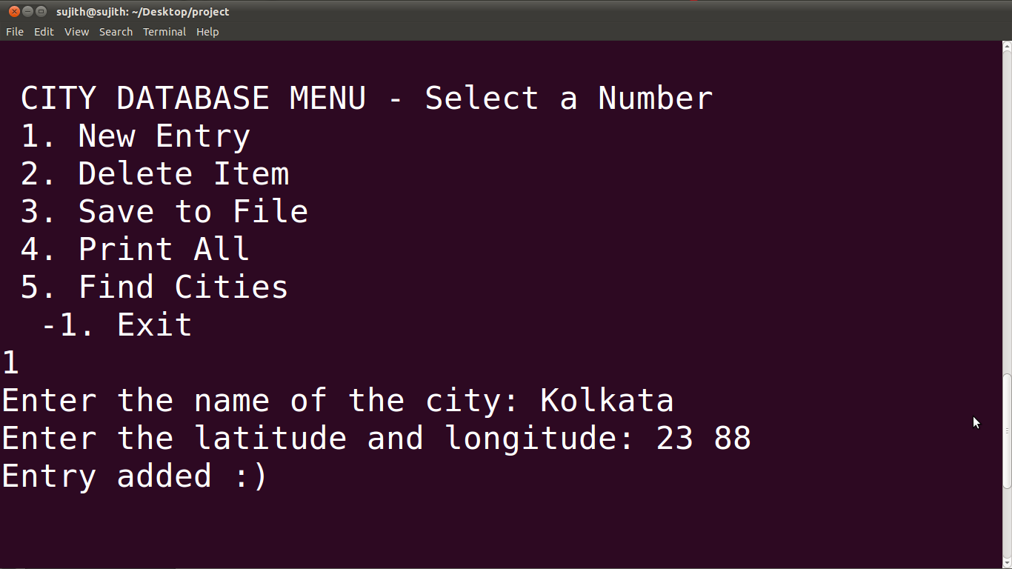

Here user has to enter the city name and coordinates

1.2 delete menu

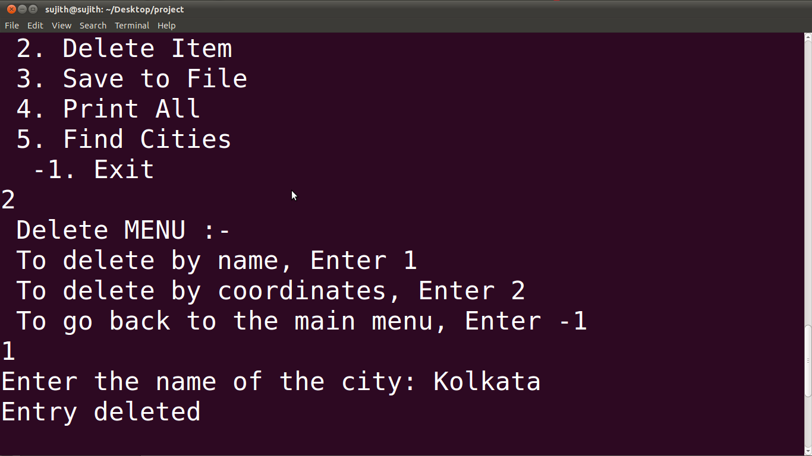

Here user has to choose an option what he wants to do with the system after he chooses 2 in main menu.

1.3 Save to file operation:

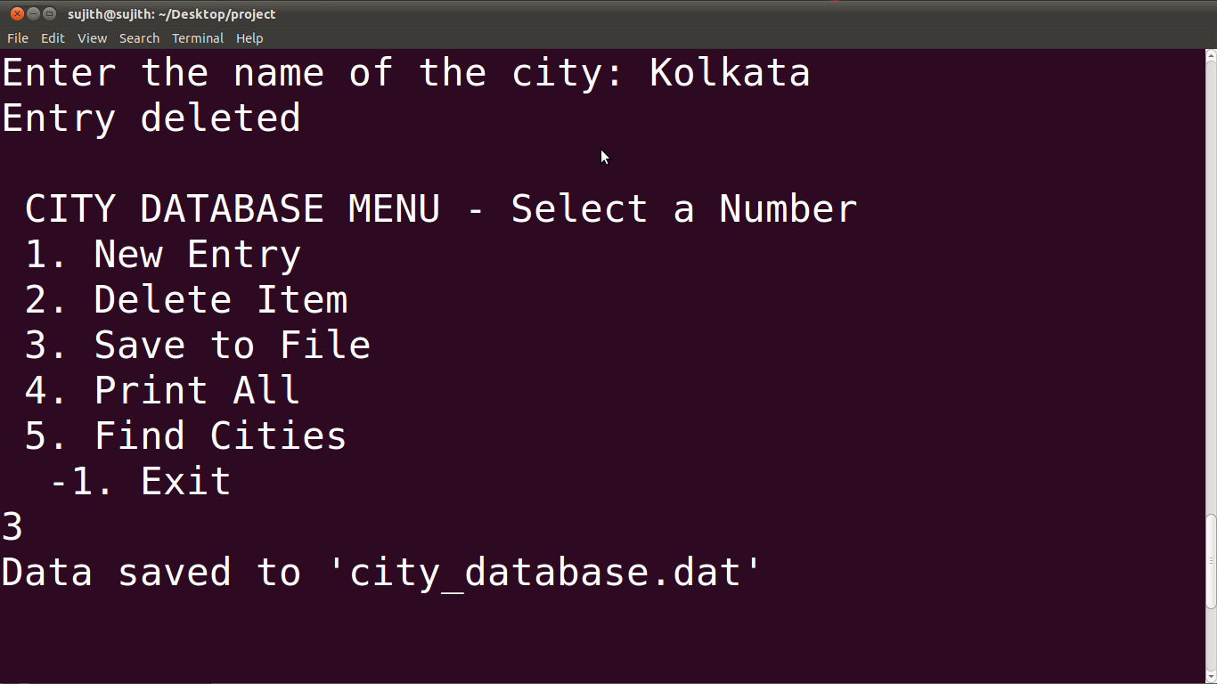

1.4 print all

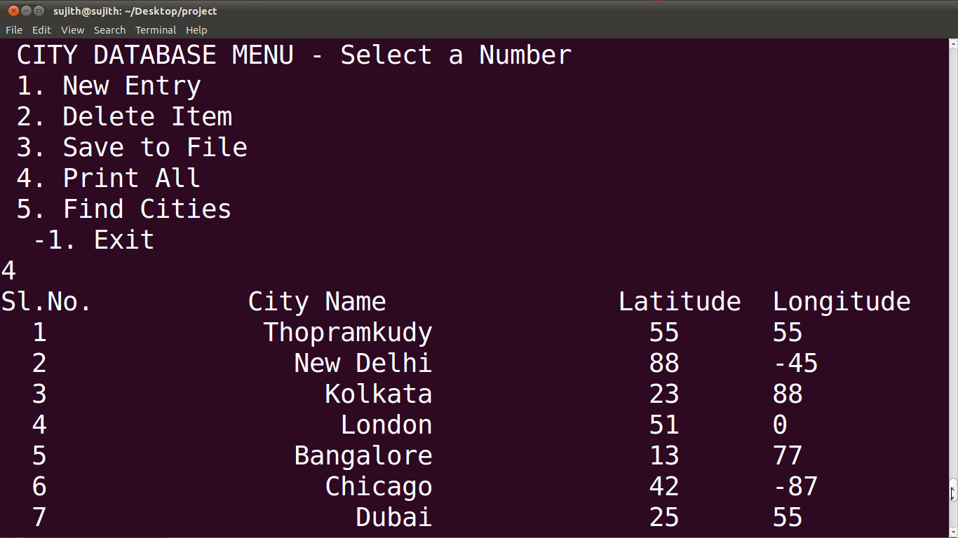

1.5 find menu

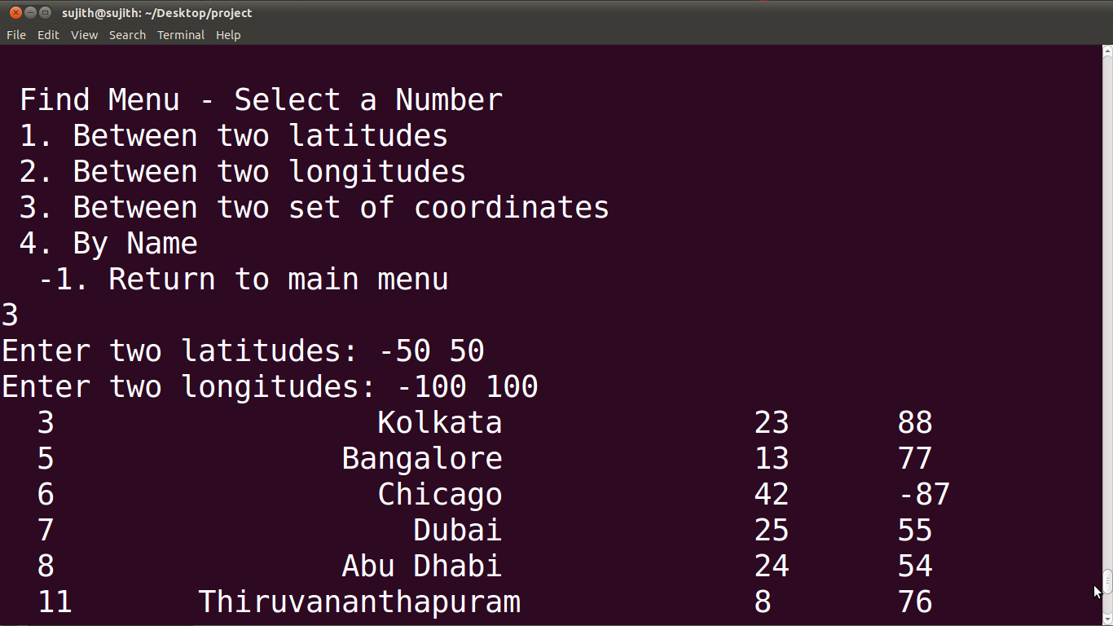

Here the use has tochoose an option what he wants to do with system after he chooses 5 in main menu

**TEST PLAN**

Test plan was based upon some examples from books and few math related online sources to check either the result is correct or not.

* In the test plan firstly working of menu was checked by entering choices either its working or not. Some errors were found while coming back to last menu after execution of program and then those errors were debugged.
* After that city name was entered and result was positive.
* After that latitude and longitude was checked by entering valid int value and result was positive.
* After that print function was checked by entering valid option and result was positive.
* After that find function it was also checked for many values that if the user enters wrong input then it will terminate back.
* After that find function was checked by entering option and then the value was checked with answer and result was correct.
* After that find function was checked by entering latitudes and then the value was checked with answer and result was correct.
* After that find function was checked by entering longitudesand then the value was checked with answer and result was correct.
* After that find function was checked by entering coordinates and then the value was checked with answer and result was correct.
* After that delete function was checked by entering city name and then the value was checked with answer and result was correct.
* After that delete function was checked by entering coordinates and then the result was checked and result was correct.

**CONCLUSION**

After the course for a semester, taking into account all components of basic program structure, it shows that the pseudo codes are most important part in program designing. Through this project we are able to relate the knowledge theory with real world program, which has certainly proved to be beneficial up to a great extent.

On the other hand, we had a very productive experience of working on pseudo codes and original c programming code and now we are able to design these things for real program which will definitely give a good result. This was not an easier task to complete this project but now after completing the project we are now confident for doing c programming language.

We conclude with the hope that this report will do enough well to meet the expectations.

**REFERENCES**

Reference to book:

* ***KANETKAR, YESHVANT, 2007,*** *Let Us C.* ***8th ed., New Delhi, BPB PUBLICATION.***
* ***DEITEL, DEITEL, 2005,*** *C How To Program.* ***4th ed., , PRENTICE-HALL OF INDIA PVT LTD.***
* ***BALAGURUSAMY, E., 2010,*** *Programming in ANSI C.* ***5th ed., , Tata McGraw hill***

Online Resource: <http://www.cprogrmmingsimplified.com>

**Source Code**

Program1.c :: using array based implementation

Program2.c :: using singly linked list based implementation

**CONTRIBUTIONS OF MEMBERS:-**

We sat down together in discussing and developed the algorithm for our project. It was then divided into parts for each member.

Amal Narayanan :: save to file function

Anurag N P :: delete function

Suchithra A S :: print all function

Chaithanya K S :: insert function

Sujith K S :: delete function

We sat together to discuss the errors and problems appeared during the coding and resolved them.