Project Name: | 16459 Management Training: Day 1 and 16460 Management Training: Day 2
Date: | July 1 and 2, 2008 | Writer: | Jillian Konst | Expert: | Robin White-Moore
This Management Training covers the following:
- Leadership Training | - Communication
- Being a Listener | - Utilizing your people
- 12 mistakes Managers make | - Managing things, Leading people
- Team Building
Outline
- Leadership skills
You don’t need a title to be a leader. Use the following important leadership skills:
- Personal Management
- Interpersonal Relationship
- Motivational Skills
- People Skills
- Administrative Skills
To build a feeling of ownership and leadership, consider the following:
- Know your purpose
- Have a clear vision
- Know and live by their values
- Set and achieve goals
- Inspire loyalty
Leadership is the ability to accomplish tasks or goals by guiding, directing or influencing others.
- Behavior and Communications Styles
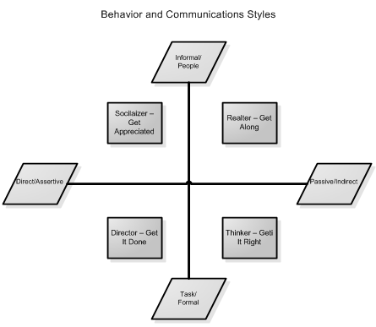
- Personality Profiles – Diagnosing
- Open | - Guarded
- Shows feelings and enthusiasm freely | - Keeps feelings private
- Animated facial expressions | - Limited range of facial expressions
- Friendly Handshake | - Formal Handshake
- Initiates/accepts physical contact | - Avoids/minimizes physical contact
- Direct | - Indirect
- Expresses opinions readily | - Reserves expression of opinions
- Less patient, More competitive | - More patient and cooperative
- Firm handshake | - Gentle Handshake
- Sustained eye contact | - Intermittent eye contact
- Personality Profiles
- Thinker/Get It Right | - Director/Get It Done
- Task Focused | - Results Oriented
- Need Accuracy and Documentation | - Task Focused
- Like Facts and Figures | - Assertive
- Prefer order and structure | - Decision Maker
- Difficulty making decisions | - Thrive on Change
- Strength: Planning | - Strength: Leadership
- Seeks: Precision | - Seeks: Productivity
- Needs: Thoroughness | - Needs: Control
- Motivator: The Process | - Motivator: Winning
- Likes you to: Be Precise | - Likes you to: Get to the Point
- Behave: Seriously | - Behave: Businesslike
- At play be: Structured | - At play be: Competitive
- Telephone: Organized | - Telephone: Succinct
- Weakness: Perfectionist | - Weakness: Impatient
- When communicating with a Thinker: | - When communicating with a Director:
- Be Well Prepared | - Be well prepared
- Lots of Documentation | - Talk about results
- Go Step By Step and Clarify Often | - Use executive summary
- Define a completion time | - Understand and support their goals
- Socializer/Get Appreciated | - Relater/Get Along
- People focused | - People Focused
- Friendly outgoing | - Team Player
- Need recognition | - Hate Conflict
- Creative, lots of ideas | - Difficulty With Change
- Poor follow through | - Strength: Listening
- Strength: Persuading | - Seeks: Acceptance
- Seeks: Applause | - Needs: Friendships
- Needs: Approval | - Motivator: Involvement
- Motivator: The Chase | - Likes you to: Be Pleasant
- Likes you to: Be Stimulating | - Behave: Personally
- Behave: Enthusiastically | - At play be: Casual
- At play be: Spontaneous | - Telephone: Chatty
- Telephone: Playful | - Weakness: Indecisive
- Weakness: Disorganized | - When communicating with a Relater:
- When communicating with a Socializer: | - Slow Down and Listen
- Make them feel important | - Be Friendly Sincere
- Be sure to interact with them | - Recognize Their Team Efforts
- Require follow through on ideas | - Encourage Input
- Expect them to be at the center of everything | - Challenge Them to Accept Change
- 12 Mistakes Managers Make
- Topics during interview
- Binding words for the company
- Don’t understand wage and hour law
- Don’t do proper documentation
- Not treating situations fairly
- Misunderstanding FMLA
- Understanding harassment properly
- Retaliating against employee
- No response to reports of harassment
- Respecting employee’s privacy
- Respecting the ADA laws
- Not being an effective leader
- Why Managers Fail
- Lose integrity and trust
- Don’t clearly communicate
- Lack focus
- No clearly defined vision/goal
- Ignore problems
- Hire the wrong people
- Refuse to leave comfort zone
- Common Mistakes Managers Make
- Making all the decisions
- Not delegating enough or at all
- Trying to fix all the problems at once or before they know what the problems are
- Not giving employees the authority to do their job
- Not supporting your employees
- Being afraid to take risk
- Habits of Successful Leaders
- Delegate
- Set goals with your employees
- Communicate willingly
- Keep Learning
- Be an agent of necessary change
- Take time to talk with your employees
- Acknowledge your employees accomplishments
- Solve problems at the cause
- Seize the moment
- Remember your ABCs
- Attitude - Have a Positive Mental Attitude. If you think you can you can if you think you cannot you are also right!
- Awareness - Before taking action, size up your situation. Don’t react too quickly as haste makes waste.
- Adaptability - Be open to change. Look and see old situations with new eyes.
- Basic Skills - Job and Leadership Skills- Are you paid for your skill or your time?
- Conservation Skills - Time and Energy

