Team 20

Deliverable 3

Kimberlee Gentry, Edward Kim, Kyle Stearns

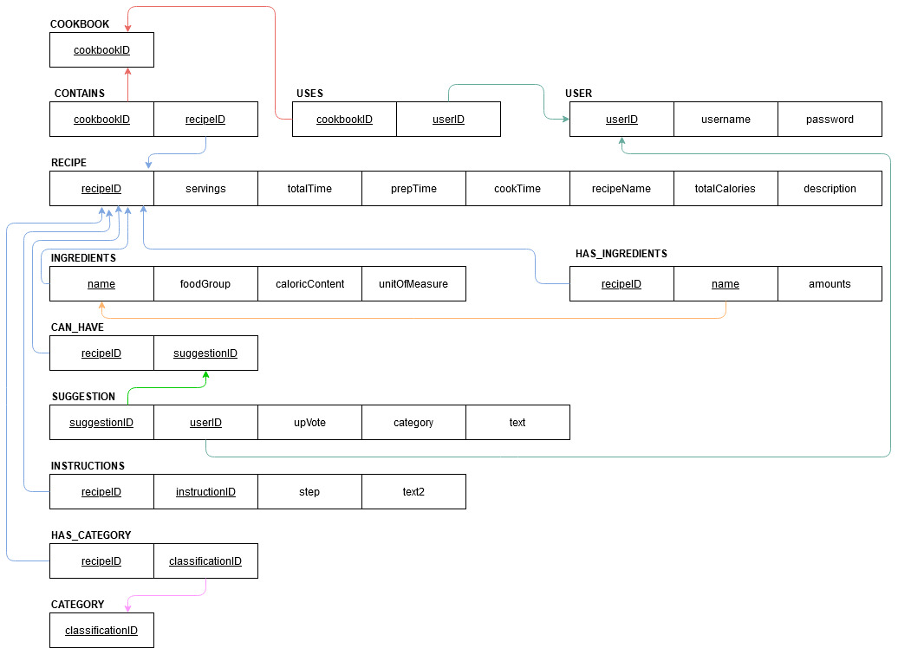

create schema cookbook;

create table cookbook.cookbook(

cookbookID INT NOT NULL AUTO_INCREMENT,

primary key(cookbookID)

);

create table cookbook.category(

classificationID INT NOT NULL,

primary key(classificationID)

);

create table cookbook.recipe(

recipeID INT NOT NULL AUTO_INCREMENT,

name VARCHAR(25) NOT NULL,

category VARCHAR(25) NOT NULL,

description VARCHAR(250) NOT NULL,

servings INT,

totalTime TIME,

prepTime TIME,

cookTime TIME,

totalCalories INT,

classificationID INT NOT NULL,

primary key(recipeID),

foreign key(classificationID) references category(classificationID)

);

create table cookbook.ingredients(

name VARCHAR(25) NOT NULL,

foodGroup VARCHAR(25) NOT NULL,

unitOfMeasure VARCHAR(25) NOT NULL,

caloricContent INT,

primary key(name)

);

create table cookbook.suggestion(

recipeID INT NOT NULL,

suggestionID INT NOT NULL AUTO_INCREMENT,

upVote INT(5) NOT NULL,

category VARCHAR(25) NOT NULL,

text VARCHAR(250) NOT NULL,

primary key(suggestionID),

foreign key(recipeID) references recipe(recipeID)

);

create table cookbook.instructions(

recipeID INT NOT NULL,

instructionID INT NOT NULL AUTO_INCREMENT,

step INT NOT NULL,

text VARCHAR(250) NOT NULL,

primary key(instructionID),

foreign key(recipeID) references recipe(recipeID)

);

create table cookbook.has_ingredients(

recipeID INT NOT NULL,

name VARCHAR(25) NOT NULL,

amount INT NOT NULL,

primary key(name),

foreign key(recipeID) references recipe(recipeID),

foreign key(name) references ingredients(name)

);

create table cookbook.user(

userID INT NOT NULL AUTO_INCREMENT,

username VARCHAR(25) NOT NULL,

password VARCHAR(25) NOT NULL,

primary key(userID)

);

INSERT INTO `cookbook` VALUES

('1'),

('2'),

('3'),

('4');

INSERT INTO `category` VALUES

('1'),

('2'),

('3'),

('4');

INSERT INTO `recipe`VALUES

(1,'Omelette','Breakfast','Delicious simple omelette made in ten minutes', 1, '00:10:00', '00:05:00','00:05:00',400,1),

(2,'Roast Broccoli','Dinner','Delicious and easy side dish for dinner', 2, '00:25:00', '00:05:00','00:20:00',120, 3),

(3,'Avocado on Toast','Breakfast','Simple and hardy breakfast meal that will keep you full', 1, '00:10:00', '00:03:00','00:07:00',200,1),

(4,'Ham and Cheese Sandwich','Lunch','Simple lunch item that even your kids will love', 1, '00:05:00', '00:01:00','00:04:00',400,2),

(5,'Pan Seared Salmon','Dinner','Tender Salmon dish that will leave your mouth wanting more', 1, '00:15:00', '00:05:00','00:10:00',400,3);

INSERT INTO `ingredients` VALUES

('Egg', 'Dairy' , 'Grams', '75'),

('Olive Oil', 'Oil' , 'Tbsp', '100'),

('Bread', 'Grain' , 'Grams', '80'),

('Cheese', 'Dairy' , 'Grams', '100'),

('Ham', 'Protein' , 'Grams', '20'),

('Broccoli', 'Vegetable' , 'Grams', '60'),

('Avocado', 'Vegetable' , 'Grams', '100'),

('Salmon', 'Protein' , 'Ounces', '170'),

('Butter', 'Oil' , 'tbsp', '120'),

('Chives', 'Vegetable' , 'tbsp', '0');

INSERT INTO `has_ingredients` VALUES

('1', 'Egg', '150'),

('1', 'Chives', '2'),

('2', 'Broccoli', '300'),

('2', 'Olive Oil', '.25'),

('3', 'Bread', '80'),

('3', 'Avocado', '100'),

('4', 'Cheese', '200'),

('4', 'Ham', '180'),

('5', 'Salmon', '170');

INSERT INTO `suggestion` VALUES

( '1','1','40', 'Breakfast', 'French Toast'),

( '2','2','30', 'Lunch', 'Fried chicken leg'),

( '3','3','24', 'Dinner', 'Roasted Rainbow Carrots'),

( '4','4','11', 'Breakfast', 'Eggs Benedict'),

( '5','5','9', 'Dinner', 'Ahi Poke');

INSERT INTO `instructions` VALUES

('1','1', '1', 'Get 2 eggs, salt, pepper, 1 tbsp of butter, and chopped chives'),

('1','2', '2', 'Turn on stove to medium high heat and place the pan on top'),

('1','3', '3', 'Add in the butter onto the pan once heated up'),

('1','4', '4', 'Pour the egg onto the pan and fold it inwards slowly'),

('1','5', '5', 'Once the egg is cooked fold the egg in half and add the chopped chives'),

('2','6', '1', 'Preheat the oven to 350 degree fahrenheit and get 300 grams of broccoli'),

('2','7', '2', 'Pour the broccoli into an oven safe pan and drizzle 1 tbsp of olive oil on top'),

('2','8', '3', 'Add salt and pepper and mix the broccoli'),

('2','9', '4', 'Place the broccoli into the oven for 20 minutes after completed take it out and enjoy'),

('3','10', '1', 'Take a slice of bread and put it into the toaster'),

('3','11', '2', 'While toasting get half an avocado and slice tit lengthwise'),

('3','12', '3', 'Once the toast is complete take the avocado and place it on top of the toast, using a fork to spread it'),

('3','13', '4', 'Drizzle 1/4 tbsp of olive oil on top, and salt pepper to taste'),

('4','14', '1', 'Obtain two slices of bread and place them into the toaster'),

('4','15', '2', 'While it is toasting get 6 slices of ham and 2 slices of cheese'),

('4','16', '3', 'Once the toast is complete, add the slices of ham and cheese onto one toast'),

('4','17', '4', 'Using the final toast put in top and enjoy'),

('5','18', '1', 'Turn on the stove to medium high heat to preheat the pan'),

('5','19', '2', 'While the pan is preheating, get one salmon piece and pat it dry with a paper towel to dry it out'),

('5','20', '3', 'In the pan add in 1 tbsp of oil and while the oil is heating up salt and pepper the skin side of the salmon'),

('5','21', '4', 'Place the skin side down salmon onto the pan and then salt and pepper the top of the salmon'),

('5','22', '5', 'Cook skin side down for 7 minutes and flip, then cook for an extra 3 minutes and enjoy');

INSERT INTO `user` VALUES

('1', 'CharlieFactory', 'charlie1234'),

('2', 'AbbyTabby', 'Tabby4321'),

('3', 'FrowningSmile', 'Frown123456'),

('4', 'FredRick', 'Freddyrick54321'),

('5', 'TurtleHappy', 'happyturtle321'),

('6', 'TeddyBerg', 'teddyTeddy321'),

('7', 'CuteDoggo123', 'Dogiscute123'),

('8', 'SadMummy45', 'happyMummy132');