DESIGN BRIEF · CONTRIBUTOR-READY PROOF OF CONCEPT

From runtime demand
to enforced access
  - A Backstage-aware adapter that turns Runtime Conditions Profiles into least-privilege Cilium network policy
Runtime Conditions · Cilium · Backstage · Kubernetes
THESIS A workload should declare the API capabilities it needs. The platform should decide which service provides them and grant only the access that was declared.

This brief provides the narrative context, architectural intent, and contributor boundary for the proposed demo. It deliberately separates the intended end state from the scaffold currently present in the repository.
Audience | Runtime Conditions contributors, platform engineers, security engineers, and reviewers
Decision | Build an API-focused adapter milestone before expanding to stateful services and external endpoints
Proof point | Declared HTTP operations become catalog-resolved, L7-enforced egress
Status | Design and partial fixture scaffold; the end-to-end runnable path is not yet complete

01 · CONTEXT

The handoff we are trying to fix
Runtime requirements are visible in code, catalogs, manifests, and conversations—but rarely in one portable contract.
Application developers understand the calls their workload makes. Platform teams understand which services exist, how they are operated, and what access controls are acceptable. Security teams see deployed network behavior or final manifests. Each group has part of the picture, but none owns a durable demand-side artifact that joins those views before deployment.
Runtime Conditions Profiles fill that gap. A profile is a machine-readable declaration of the external integrations required by one workload. It expresses demand—such as an HTTP operation, a PostgreSQL-compatible datastore, or a Redis-compatible cache—without naming a concrete service instance, embedding credentials, or prescribing deployment topology.
CORE IDEA Profiles describe demand. Platforms decide fulfillment.

Why network policy is the right proof
Network policy makes the demand-versus-fulfillment boundary visible. The application knows it needs specific API operations. It should not need to know the target Kubernetes Service name or hand-author a Cilium policy. The platform can combine the declared operations with catalog and cluster evidence, then produce a policy that is both specific and explainable.
Today | With a Runtime Conditions adapter | Visible outcome
Service names leak into app-owned YAML | Profile carries capability requirements only | The same demand can be fulfilled differently by environment
Policy is copied, inferred late, or omitted | Policy is rendered from validated demand | Security intent is reviewable before deployment
Catalog documents supply only | Adapter joins demand with catalog supply | Compatibility and provenance are checked explicitly
Broad L3/L4 access is common | HTTP method and path become L7 rules | Undeclared operations remain blocked

The project boundary
The Runtime Conditions specification standardizes the profile contract, not a universal fulfillment engine. This demo is intentionally one platform-specific interpretation: a Cilium adapter backed by Backstage and live Kubernetes metadata. A different platform could consume the same demand and render a gateway rule, cloud authorization policy, service binding, or another provider-native resource.
02 · PROPOSITION

What we are building
A contributor-ready lab where the only unfinished product work is the adapter itself.
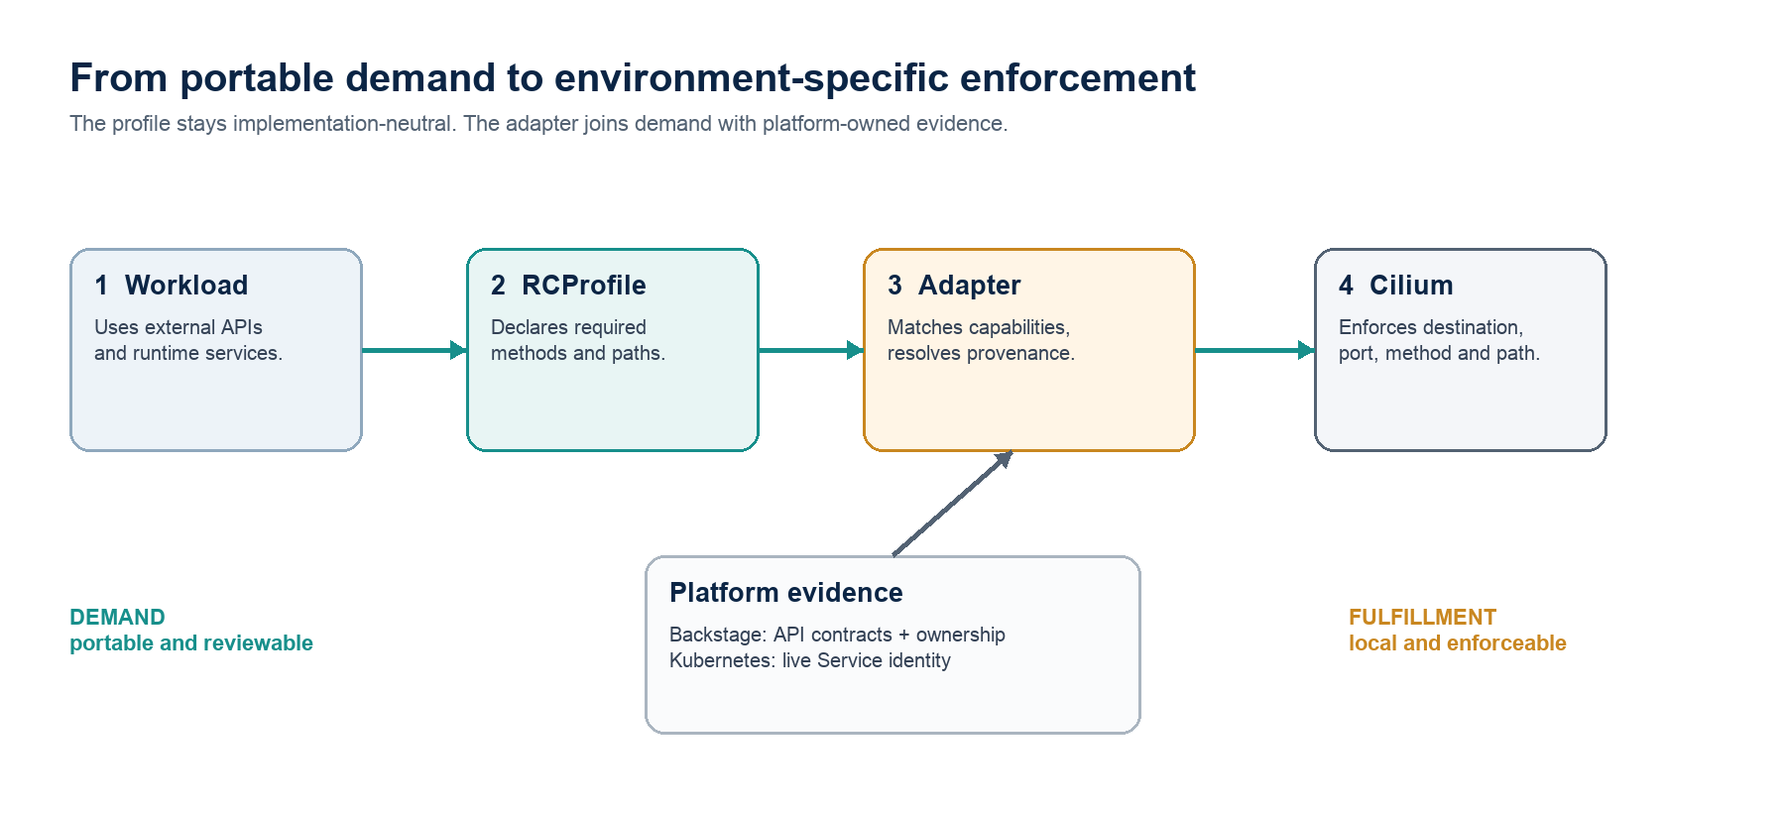
Figure 1. Portable workload demand is joined with platform-owned evidence only inside the adapter.
The target package provides a KinD cluster with Cilium, a Backstage catalog, a small community-resource application, and realistic backing services. Application egress starts denied. A contributor implements a solution using open source platform automation tools (e.g. Kratix, Crossplane, or OpenTofu) that reads one valid Runtime Conditions Profile, discovers which cataloged services satisfy its HTTP Conditions, resolves those providers to live Kubernetes Services, and renders a CiliumNetworkPolicy.

The proof in one sentence
EXPECTED DEMONSTRATION Before the generated policy, the request coordinator can resolve service names but cannot call its providers. After the policy is applied, the declared calls succeed and nearby undeclared calls still fail.

What the first milestone proves
- A profile Condition can drive a materially different platform decision.
- Backstage can represent supply through API contracts, provider relations, and Kubernetes provenance.
- The adapter can avoid hard-coded provider names by matching capabilities and resolving live objects.
- Cilium can enforce the result at destination, port, HTTP method, and HTTP path.
- Negative tests can show that generated access is narrower than general service reachability.

Planning for extensibility
This milestone adapter should be able to consume any profile that has an API Condition, and compare it to an API catalog to determine if the right target service exists, and if it has been deployed. In any case – whether there is indeed a downstream deployment to allocate access to, or if there is not, the adapter should handle it gracefully.
03 · SCENARIO

A concrete workload with meaningful dependencies
The demo uses a community resource fulfillment workflow so the network graph feels like a real-world application.
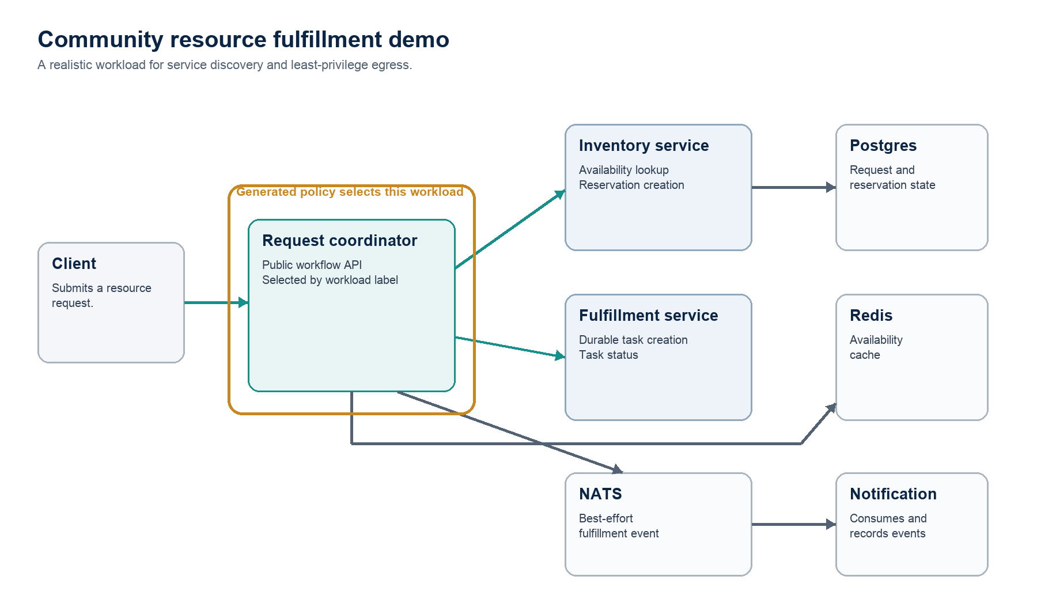
Figure 2. Target application topology. Teal arrows are the initial API-policy path; stateful and messaging integrations are follow-on work.
A user submits a request for an item to the request coordinator. The coordinator checks current availability, creates a reservation, creates a durable fulfillment task, stores request state, updates its cache, and publishes a fulfillment event. A notification worker consumes that event. The topology gives the adapter two API providers to discover and several non-HTTP integrations to support later.

Actor | Role in the demonstration
Request coordinator | The workload under test. It owns the Runtime Conditions Profile and is selected by policy labels.
Inventory service | Provides item availability and reservation operations. Its Kubernetes Service name is intentionally environment-specific.
Fulfillment service | Creates durable fulfillment tasks. It is independently cataloged and deployed.
Donor directory | A decoy API. It proves that a plausible but incompatible catalog entry is not selected.
Postgres + Redis | Real backing services included to extend the adapter after the API milestone.
NATS + notification worker | An event path included as a later vocabulary and policy exercise.

Naming is intentionally asymmetric
The workload-local Condition names, Backstage entity names, and Kubernetes Service names do not need to match. For example, a Condition named stock-read-and-reserve may resolve to the Backstage API inventory-api, then to the Component inventory-service, then to a live Service named stock-provider-v2. Renaming the Condition must not change the result because its method/path requirements—not its label—carry the portable meaning.
04 · INPUT

The profile is a demand document
It says what the coordinator must be able to do, not where to send traffic.
For the first milestone, the adapter needs only the two HTTP API Conditions below. The full application can still use Postgres, Redis, and NATS; those become follow-on fixtures once the API path is proven.
conditions:
- name: stock-read-and-reserve
kind: api
interface:
type: http
operations:
- method: GET
path: /items/{itemId}/availability
- method: POST
path: /reservations
- name: durable-work-creation
kind: api
interface:
type: http
operations:
- method: POST
path: /fulfillment-tasks
Illustrative Conditions excerpt from the request-coordinator profile. The complete fixture also carries the standard profile envelope, workload identity, and exact Common Integrations extension URI.

What the adapter may rely on
- The profile has already passed core and extension-aware validation.
- Each API Condition contains at least one HTTP operation
- HTTP method and path are adapter-actionable because they directly change the network policy.
- The profile identifies one workload, while deployment labels provide the platform-specific selector.

What must stay out of the profile
Do not embed | Why | Where it belongs
stock-provider-v2 | Environment-specific Service identity | Backstage provenance and Kubernetes
Cluster IP or DNS name | Changes by cluster and deployment | Live cluster resolution
Credentials or tokens | Sensitive fulfillment values | Platform secret mechanism
Cilium selectors | Provider-specific policy syntax | Adapter rendering policy

DESIGN TEST If a field does not change a portable adapter decision, it probably does not belong in the extension vocabulary.

05 · RESOLUTION

How the adapter turns demand into a destination
Resolution is evidence-based and fail-closed. Every hop is explainable.
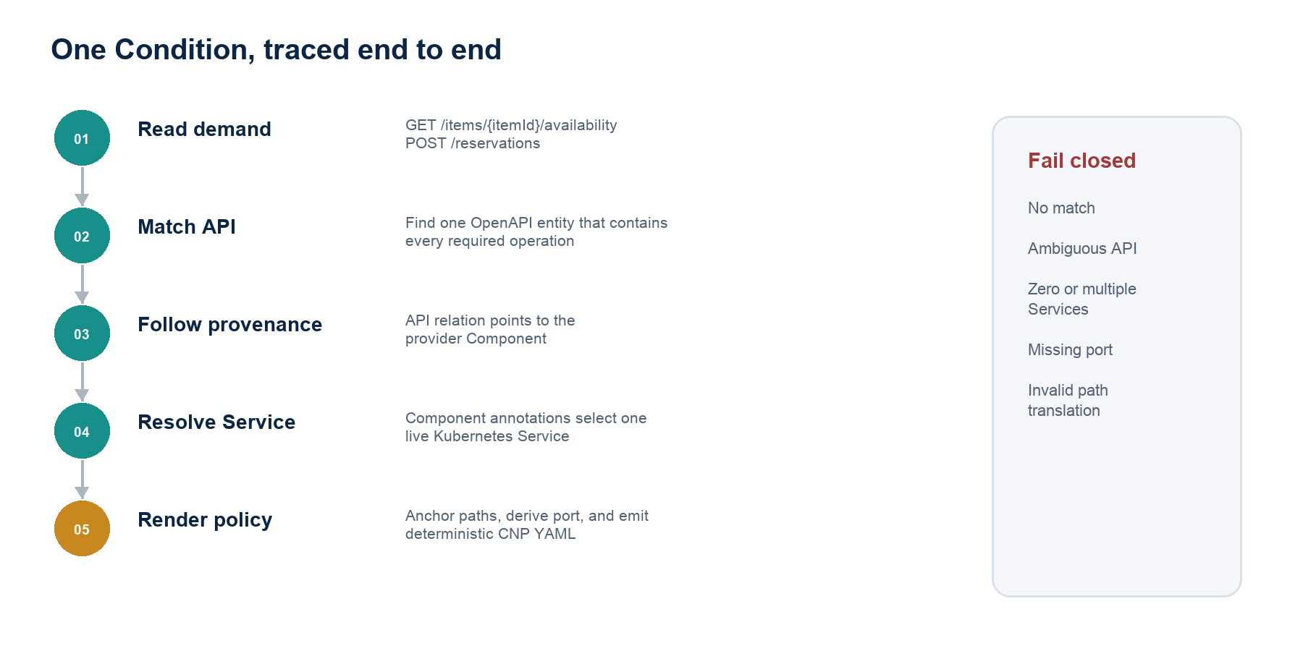
Figure 3. Resolution pipeline for one API Condition.
- Parse and normalize. Read required operations, normalize method casing, and reject malformed paths before querying the catalog.
- Match capabilities. Query Backstage API entities of type OpenAPI and retain only those whose documents contain every required method/path pair.
- Follow ownership provenance. Use the synthesized apiProvidedBy relation—derived from a Component's providesApis declaration—to identify the provider Component.
- Resolve the live Service. Read the Component's Kubernetes namespace and identity annotations, then query the cluster for a single matching Service.
- Derive enforceable coordinates. Select the service port and protocol, convert templated OpenAPI paths to anchored Cilium-compatible regular expressions, and bind them to the workload selector.
- Render deterministically. Sort destinations and rules, emit stable YAML, and include provenance annotations so reviewers can explain where each rule came from.

Ambiguity is an error, not a tie-breaker
A no-match result means the platform cannot fulfill the demand. Multiple matching APIs, missing provider relations, zero matching Services, multiple matching Services, or an unresolvable service port all produce actionable errors. The adapter should not silently choose the first result because that would convert catalog disorder into network authority.
06 · OUTPUT

The rendered policy is narrow by construction
The profile supplies application intent; catalog and cluster metadata supply the concrete target.
apiVersion: cilium.io/v2
kind: CiliumNetworkPolicy
metadata:
name: request-coordinator-runtime-access
namespace: applications
annotations:
runtimeconditions.io/profile: request-coordinator
spec:
endpointSelector:
matchLabels:
backstage.io/kubernetes-id: request-coordinator
egress:
- toServices:
- k8sService:
serviceName: stock-provider-v2
namespace: applications
toPorts:
- ports:
- port: "8080"
protocol: TCP
rules:
http:
- method: GET
path: "^/items/[^/]+/availability$"
- method: POST
path: "^/reservations$"
Illustrative output for the inventory Condition. The actual adapter should render one egress entry per resolved provider and combine them into one namespaced policy.

Why each field exists
endpointSelector | Limits the allow policy to the request-coordinator workload rather than the whole namespace.
toServices | References the resolved Kubernetes Service and lets Cilium track its backing endpoints.
port + protocol | Prevents an allowed destination from implying access to unrelated listeners.
HTTP method | Allows only the operations present in the Condition.
Anchored path | Converts an OpenAPI template to an enforceable regex without matching sibling routes.
Provenance annotation | Connects generated policy to the profile that justified it.

Path translation is a security decision
OpenAPI templates are not literal request paths. The adapter must transform each template segment deliberately—for example, {itemId} becomes one non-empty path segment—and anchor the result at both ends. A loose conversion such as /items/.*/availability could admit extra slashes or sibling resources. Unsupported templates should fail rather than degrade to a broader allow.
POLICY COMPOSITION The baseline egress policy creates isolation and allows DNS. The generated policy adds only the workload-specific provider access. Both policies must select the coordinator for the before/after proof to be valid.

07 · EXPERIENCE

What a reviewer should see in the demo
The demonstration is a sequence of observable claims, not just a successful apply.
- Start the prepared environment. KinD, Cilium, Backstage, the application, providers, and backing services become healthy from version-pinned manifests and scripts.
- Confirm the blocked baseline. DNS resolution succeeds, but the coordinator's provider calls time out or are denied because no workload-specific allow exists.
- Inspect demand and supply separately. The profile shows required operations; Backstage shows OpenAPI contracts and provider Components; Kubernetes shows actual Service names.
- Run the contributor-built adapter. The platform adapter reports each resolution hop and applies deterministic policy YAML to the cluster.
- Review the policy. A human can review the policy YAML to see exactly which workload, Services, ports, methods, and paths will be authorized.
- Prove least privilege. The intended workflow succeeds. Calls to the donor directory, the inventory admin endpoint, undeclared methods, and unrelated ports remain blocked.

Acceptance matrix
Check | Expected result | What it proves
Baseline workflow | Blocked | Isolation exists before generated fulfillment
Declared inventory GET | Allowed | Capability matched and rendered correctly
Declared reservation POST | Allowed | Multiple operations can share one provider rule
Declared fulfillment POST | Allowed | Multiple providers resolve independently
Inventory admin POST | Blocked | Path scope is least privilege
DELETE on reservations | Blocked | Method scope is least privilege
Donor directory call | Blocked | Catalog decoys do not gain access
Condition renamed | Same provider selected | Names are not fulfillment identities
Second matching API added | Adapter errors | Resolution fails closed on ambiguity

08 · OWNERSHIP

A clean contributor boundary
The environment should arrive complete enough that the contributor can spend time on interpretation, not platform assembly.
Provided by the project | Owned by the contributor | Explicitly deferred
KinD topology, Cilium, namespaces | Profile parsing and validation handoff | Production multi-cluster operation
Backstage deployment and catalog data | OpenAPI capability matching | Generic constraint solving
Runnable demo services and test data | API-to-Component relation traversal | Service provisioning
Kubernetes provenance labels | Component-to-Service resolution | Credential delivery
Default-deny baseline and DNS allow | Path translation and CNP rendering | Datastore/cache/broker policy
Smoke and adversarial test harness | Deterministic CLI behavior and errors | External endpoint policy

Suggested tooling options
The implementation language is intentionally open. The interface is what makes the exercise testable and lets contributors choose familiar tooling.
There are multiple tooling solutions that can be used to build this, all of which have their own viability and trade-offs. There’s no wrong option, but whatever is chosen should be implemented in a way that reflects common understanding and usage of the tool. That is, you don’t have to be an expert, but you’ve at least read through the documentation.
- Kratix: open source tooling that orchestrates containers based on Promises (https://www.kratix.io/)
- Crossplane: open source orchestration platform that creates custom APIs in the form of XRDs (https://www.crossplane.io/)
- OpenChoreo: relatively new open source IDP that uses different ComponentTypes to orchestrate platform automation (https://openchoreo.dev/)
- Terraform/OpenTofu: good ol’ IaC, which may not be an obvious choice as a platform automation tool if you’re not already familiar with it (https://opentofu.org/)

Quality bar
- No Kubernetes Service names hard-coded in the adapter.
- Deterministic ordering and byte-stable YAML for the same inputs.
- Readable errors that identify the Condition and failed resolution stage.
- Dry rendering by default; cluster mutation remains an explicit operator step.
- Unit tests for capability matching and path conversion; integration tests for catalog and cluster resolution.
- Negative tests are first-class acceptance criteria, not optional extras.
09 · STATUS

What exists today—and what still must be built
The repository currently contains a useful foundation, but it should not yet be presented as a runnable lab.
CURRENT STATE The cilium-policy directory is an untracked, partial scaffold. The target architecture is coherent; the end-to-end application and proof path are incomplete.

Implemented scaffold
- KinD cluster configuration with the default CNI disabled, plus applications, dependencies, and backstage namespaces.
- Helm values for Cilium, Backstage, and a three-replica NATS cluster.
- Backstage catalog entities for the coordinator, providers, a decoy API, and backing resources.
- OpenAPI fixtures for inventory, fulfillment, and donor-directory APIs.
- Postgres and Redis manifests, Backstage read-only RBAC, and a label-scoped DNS-only baseline Cilium policy.
- README material that defines the intended contributor exercise.

Missing for a runnable handoff
- Application source and container image for the coordinator, inventory, fulfillment, donor directory, and notification roles.
- Kubernetes application Deployments and Services, including the intentionally asymmetric Service names.
- The request-coordinator Runtime Conditions Profile fixture.
- Idempotent setup, build, deploy, readiness, teardown, and smoke-test scripts.
- Before/after and adversarial policy tests.
- A reference output policy for comparison, while keeping the adapter implementation itself contributor-owned.

Recommended completion order
- Finish the runnable application and Kubernetes manifests.
- Add the valid profile fixture and one intentionally ambiguous catalog fixture.
- Create idempotent setup and smoke-test scripts; verify all pinned versions together.
- Prove the default-deny baseline and label selection before handing off adapter work.
- Add golden policy and negative acceptance tests without shipping a completed adapter.
10 · DECISIONS

Principles that keep the demo honest
These choices make the proof narrow, repeatable, and aligned with the Runtime Conditions model.
Decision | Reason
Capability matching over name matching | Provider identity is environment-specific; required operations are portable demand.
Catalog supply plus live-cluster truth | Backstage explains ownership and contracts; Kubernetes supplies current enforcement coordinates.
Pre-existing providers in milestone one | The adapter demonstrates selection and authorization before taking on provisioning.
Plaintext internal HTTP | Cilium must observe HTTP semantics to enforce method and path in this lab.
Fail closed on ambiguity | Incorrect authority is worse than a visible fulfillment failure.
Review before apply as optional | Rendering and mutation can stay separate so generated authority remains inspectable.
Negative tests as product behavior | Least privilege is demonstrated by what remains inaccessible.
One workload per profile | The output policy has an explainable relationship to one declared demand document.

Known limitations
- Method/path matching does not yet validate request or response schema compatibility.
- Every provider Component is assumed to resolve to exactly one Service in one namespace.
- Port selection needs a documented rule when a Service exposes multiple HTTP ports.
- Cilium L7 policy behavior depends on proxy visibility and protocol configuration.
- Version pins become trustworthy only after the complete stack is installed and exercised together.
- The lab does not address TLS interception, service mesh policy composition, or cross-cluster discovery.

Follow-on milestones
Milestone | Profile demand | Possible platform output
2 · Stateful services | Postgres datastore and Redis cache | Service egress, bindings, ConfigMaps and Secrets
3 · Messaging | NATS actions and subjects | Broker egress plus subject-level authorization
4 · External APIs | Hostname and HTTP operations | FQDN and L7 egress policy
5 · Rich compatibility | Operation schemas or contract references | Pre-deployment API compatibility checks
6 · Continuous reconciliation | Versioned profile changes | Policy diff, drift detection, and controlled rollout

APPENDIX

Vocabulary and repository grounding
A compact reference for readers joining the project without a presenter.

Working vocabulary
Runtime Conditions Profile | Portable declaration of the external integrations required by one workload.
Condition | One required or optional runtime dependency expressed with extension-owned vocabulary.
Extension | A versioned vocabulary package defining kinds, interface types, fields, values, and validation schemas.
Adapter | Platform-specific component that maps a valid profile to services, policies, configuration, resources, or workflow steps.
Backstage API entity | Supply-side contract containing an OpenAPI document for capability comparison.
Backstage Component | Provider identity and ownership record linked to Kubernetes provenance.
CiliumNetworkPolicy | Kubernetes resource that enforces endpoint, service, port, and optional L7 traffic rules.
Fulfillment | The environment-specific result that satisfies declared demand; it is not part of the profile.

Repository sources used for this brief
spec/docs/sixth-draft.md — Current normative profile shape, adapter definition, and conformance boundaries.
spec/docs/runtime-conditions-whitepaper-draft.md — Project narrative, demand/fulfillment model, and Cilium policy use case.
spec/docs/intro.md — Reader map and architecture summary.
extensions/common-integrations/common-integrations-v1alpha1.yaml — HTTP API, datastore, and cache vocabulary.
runtimeconditions.github.io/concepts.html — Public explanation of demand before fulfillment.
runtimeconditions.github.io/platform.html — Current platform-adapter narrative.
rc-demos/cilium-policy/backstage/catalog/ — Proposed Backstage entities and OpenAPI fixtures.
rc-demos/cilium-policy/manifests/ — Current backing-service, RBAC, and baseline policy scaffold.

The handoff we want
The finished package should let a contributor begin at the adapter boundary with no missing platform assembly, while giving a reviewer enough evidence to understand the proof without verbal rescue.
- The blocked baseline is already reproducible before contributor code is introduced.
- Every resolution hop can be inspected from profile demand through catalog and cluster evidence.
- Success includes both intended access and the continued denial of undeclared access.
NORTH STAR The strongest version of this demo does not merely generate YAML. It gives a reviewer a trustworthy chain of reasoning from workload demand to catalog evidence to live platform identity to narrowly enforced access.

