Kate Stevens

November 30, 2019

IT FDN 100 A

Assignment08

[Github Repo](https://github.com/ksteve3/ITFDN100_Mod08)

Products Script

[Assignment08](https://canvas.uw.edu/courses/1342958/modules/items/9989527)(external link): Add code to the file called, "[Assigment08-Starter.py](https://canvas.uw.edu/courses/1342958/modules/items/9996796)"(external link) to make the application work.

Intro

During week eight of IT FDN, we learned more about working with classes and constructing objects from a class and well as the topics listed below. Our assignment for this module was based on the module notes found at [_Mod8PythonProgrammingNotes.pdf](https://canvas.uw.edu/courses/1342958/modules/items/9989526) (external link) and the YouTube tutorials [Module08 CourseVideo](https://www.youtube.com/watch?v=ZnTabY0Z-XE&feature=youtu.be), and [Starting Assignment08](https://www.youtube.com/watch?v=Zmgsg6HPxSM&feature=youtu.be) (external links).

The following information describes the steps I took and the resources that I found helpful to write the script located in the "[Assignment08.py](https://raw.githubusercontent.com/ksteve3/ITFDN100_Mod08/master/docs/Assignment08/Assignment08_final.py)" file submitted with this document.

Module 08 Topics

* Difference between a class and the objects made from a class
* Standard pattern of a class
* Class constructor
* Keyword "self”
* Use of the keyword "@staticmethod”
* Relation of fields, attributes, and property functions
* Difference between a property and a method
* Use of docstrings in a class
* Difference between Git and GitHub
* Use of GitHub Desktop

Creating the Application

I started creating my script by following [Module08 tutorial video](https://www.youtube.com/watch?v=ZnTabY0Z-XE&feature=youtu.be) and using the examples show in the video, to model my own version of the script, using “product names” and “product prices”(Figure 2), instead of a person’s “first name” and “last name” (Figure 2).

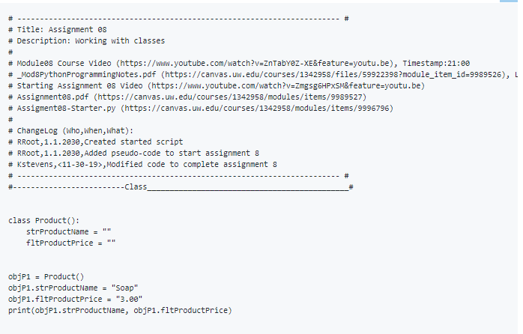

***Figure 1 (compared to YouTube tutorial shown in figure 2)***

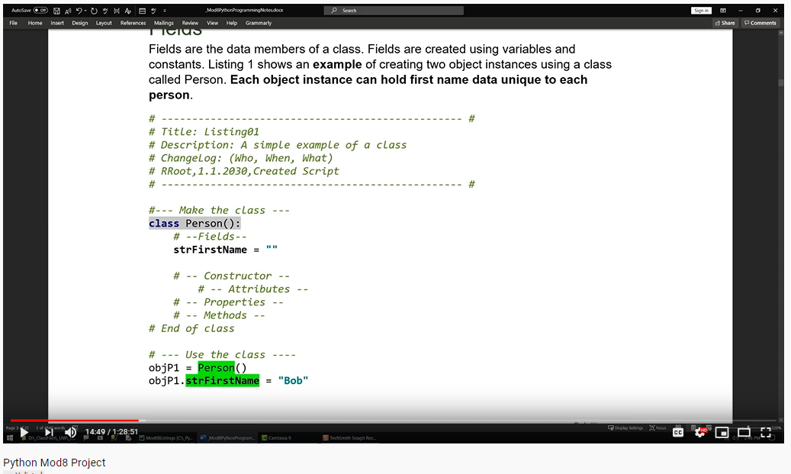

***Figure 2***

Understanding the basic principles after following the Labs presented by our instructor in the I was able to determine what the python script should look like to achieve similar output results shown in the figures below. From here I created code blocks interpreted from each of the listings found in [_Mod8PythonProgrammingNotes.pdf](https://canvas.uw.edu/courses/1342958/modules/items/9989526) (external link) as well as shown in description on the YouTube tutorial.

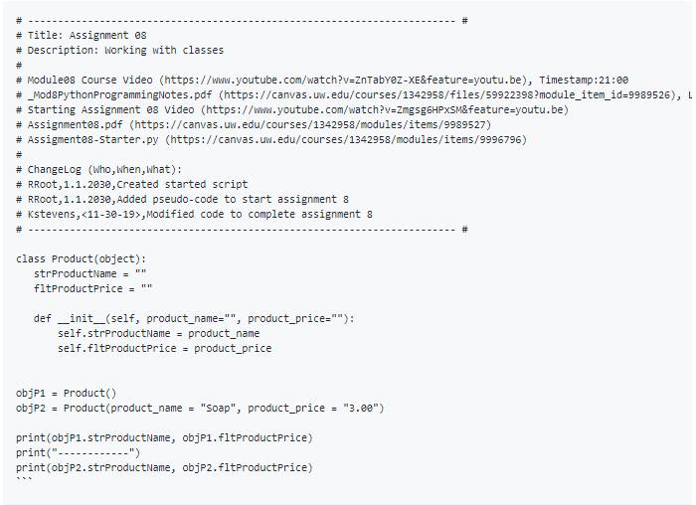

# Figure 3 (Building Constructors, compared to Figure 4, YouTube tutorial)

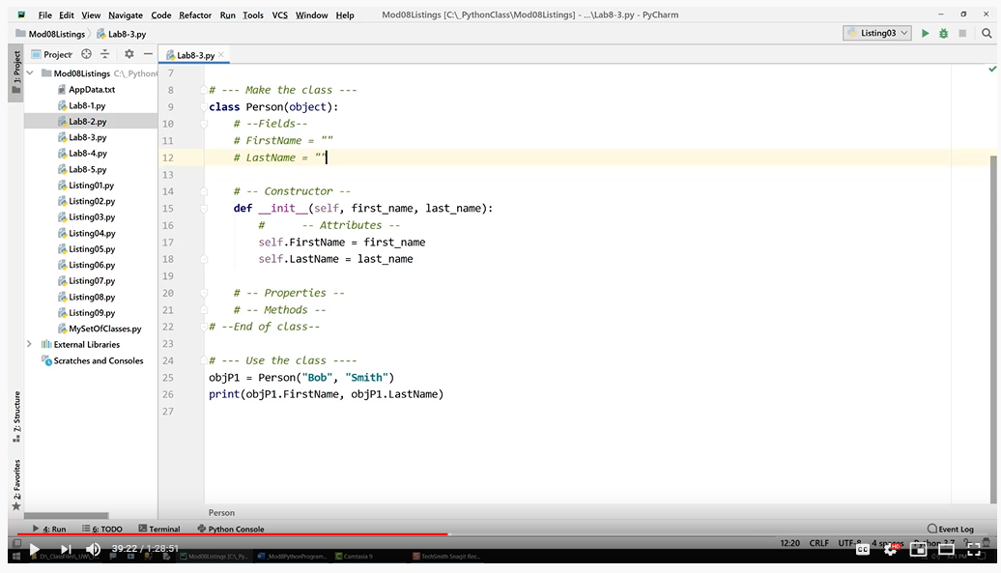

***Figure 4 (Constructors)***

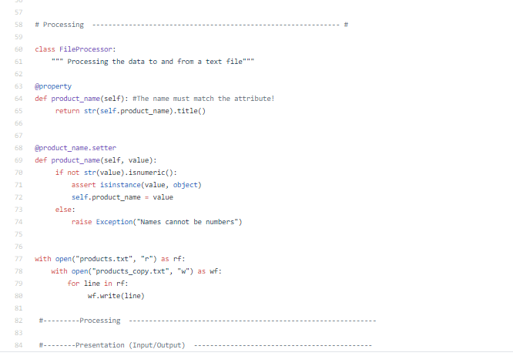

## Figure 5 (Setters & Getters, compared to YouTube tutorial shown in Figure 6)

***Figure 6 (Setters & Getters)***

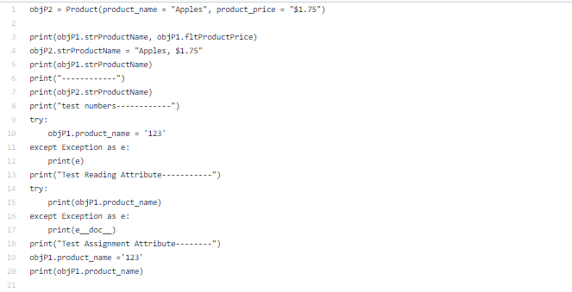

***Figure 7 ( e__doc__, compared to YouTube tutorial video Figure 8 )***

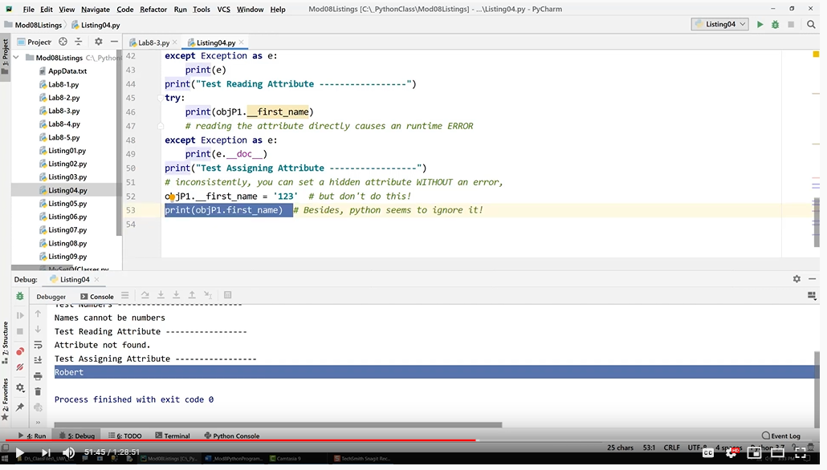

***Figure 8 ( e__doc__)***

After completing the different code blocks presented in the YouTube tutorial I referred back to the code in [Assignment 06, ToDoList.py](https://raw.githubusercontent.com/ksteve3/ITFDN100_Mod08/master/docs/Snips/lib/test-blocks/Assignment06_todolist/Assignment06_TodoFile.py) (external link) to complete the rest of the user choice menu, described in the “ToDo” requirement comments in the "[Assigment08-Starter.py](https://canvas.uw.edu/courses/1342958/modules/items/9996796)"(external link) (Figure 9).

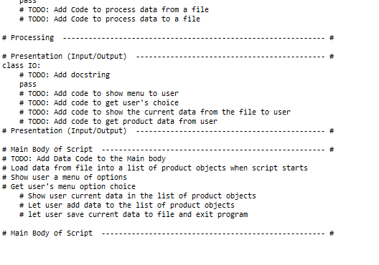

***Figure 9 ( user menu)***

Summary

This python script shows the basic usage of how to use objects made from a class, and how to create and deploying constructors in python and their importance in performing versions of abstraction in coding.