

**Report of the Spring 2015 Acoustic-Trawl (A-T) Survey of coastal pelagic fish species and krill (1504SH) of coastal pelagic fish species and krill within the California Current Ecosystem, 28 March 2015 to 1 May 2015, conducted aboard Fisheries Survey Vessel *Bell M. Shimada***

**National Oceanic and Atmospheric Administration**  
Southwest Fisheries Science Center  
Fisheries Resources Division  
Advanced Survey Technologies Program

# I. Introduction

Coastal pelagic fish species (CPS) and krill within the California Current Ecosystem (CCE) were surveyed using multi-frequency echosounders and surface trawls during the Spring 2015 Acoustic-Trawl (A-T) Survey of coastal pelagic fish species and krill (1504SH) (hereafter Spring CPS Survey) aboard the aboard the Fisheries Survey Vessel (FSV) *Bell M. Shimada* (hereafter, *Shimada*), 28 March 2015 to 1 May 2015. The objectives of the survey were to: 1) acoustically map the distributions and estimate the abundances of (CPS), including, but not limited to Pacific sardine (*Sardinops sagax*), Northern anchovy (*Engralus mordax*), and Pacific (*Scomber japonicus*) and jack mackerel (*Trachurus symmetricus*); and krill (euphausiid spp.); 2) characterize the biotic and abiotic environments of these CPS and krill, and investigate linkages; and 3) gather information regarding the animals' schooling and diel vertical migration (DVM) behaviors, and potential avoidance reactions to the survey vessel. This report includes a summary of the survey equipment, acoustic-system calibration, sampling and analysis methods, and preliminary results. **(updated)**

## I.1 Scientific Personnel

The collection and analysis of acoustic data was conducted by the Advanced Survey Technologies Program (AST) at the Southwest Fisheries Science Center (SWFSC). Fish-egg and trawl data were provided by D. Griffith and B. Macewicz, SWFSC. The following personnel contributed to the various components of the project: **(updated)**

**Project Leads:**

* D. Demer (AST Leader)
* K. Stierhoff (Project Leader)

**Acoustic Data Collection and Processing:**

* K. Stierhoff (Leg I)
* J. Zwolinski (Leg II)

**Echosounder Calibration:**

* J. Renfree, K. Stierhoff, and J. Zwolinski

**Trawl Sampling:**

* C. Alvarez-Malo, K. Gilmore, D. Griffith, M. Human, B. Macewicz, S. McClatchie, B. Overcash, W. Watson, and E. Weber

# II. Methods

## II.1. CUFES and CalVET

**[ADD DESCRIPTION OF CUFES AND CALVET SAMPLING AND PROCESSING]**

Throughout the survey, Continuous Underway Fish Egg Sampler (CUFES) data were collected and processed aboard Shimada. In areas where fish eggs exceeded a threshold density, CalCOFI Vertical Egg Tow (CalVET) sampling was conducted.

## II.2. Echosounders

Multi-frequency (18-, 38-, 70-, 120-, and 200-kHz) General Purpose Transceivers (Simrad EK60 GPTs), were configured with split-beam transducers (ES18-11, ES38B, ES70-7C, ES120-7C, and ES200-7C, respectively). The transducers were mounted on the bottom of a retractable keel or "centerboard" (**Figure II.1**). The keel was retracted (~ 5-m depth) during calibration, and in the intermediate position (~7-m depth) throughout the survey. Exceptions were made during shallow water operations, when the keel was retracted; or during times of heavy weather, when the keel was extended (~9-m depth) to provide extra stability.

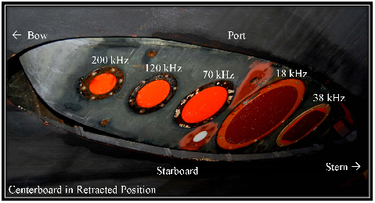

**Figure II.1.** Transducer locations aboard *Shimada*.

## II.2.1 Calibration

Impedance measurements were made of each transducer quadrant, individually and connected in parallel, using an Agilent 4294A Precision Impedance Analyzer and custom Matlab software. For each transducer, the magnitude (, ) and phase (, ) of the impedance, conductance (, mS), susceptance (, mS), and admittance circles ( vs. ) were plotted for each quadrant and for the quadrants in parallel. Also, the resonance frequency and quality factor were measured, and , , , and were measured at both the resonance and operational frequencies.

The echosounders were then calibrated using the standard sphere technique (Demer *et al.*, 2015; Foote *et al.*, 1987). The reference target was a 38.1-mm diameter sphere made from tungsten carbide (WC) with 6% cobalt binder material.

The GPTs were configured, via the ER60 software, using the parameters in Table IV.2. (**updated**)

## II.2.2. Data Collection

The logging-computer clock was synchronized with the GPS clock (GMT) using SymmTime (Symmetricon, Inc.), every six hours. At the nominal survey speed of 9 knots, echosounder pulses were transmitted simultaneously, at variable intervals as controlled by the ER60 Adaptive Logger (EAL, Renfree and Demer, 2016). The EAL optimizes the pulse interval, based on the seabed depth, while avoiding aliased seabed echoes.

Measurements of volume backscattering strength (; dB re 1m2) and target strength (; dB re 1 m2), indexed by time and geographic positions provided by GPS receivers (POS-MV MODEL and **XXXXX MODEL**), were logged to 750 m range, and stored in .raw format using the GPT-control software (Simrad ER60 V2.4.3). Backups of all raw and processed sampling data were archived to a laptop computer and external hard disk drive at least daily using SyncBack Free software.

Transmit pulses from a multibeam sonar (Simrad ME70) were triggered by the echosounder, with a variable delay, to minimize acoustic interference. All other instruments that produce sound within the echosounder bandwidths were secured during survey operations. Exceptions were made during stations (e.g., plankton sampling and fish trawling) or in shallow water when the captain occasionally operated the bridge echosounder (50 and 200-kHz Furuno), the Doppler velocity log, or both. (**updated**)

## II.2.3 Data Processing

The calibrated echosounder data were processed on a dedicated computer, using commercial software (Echoview V6.1.40.26321, Myriax) and the following procedure:

1. For each transect, the associated data files (.raw format) were loaded into two Echoview (.ev) files, one for CPS and one for krill. Transducer depths were set to 0 m.
2. In each .ev file, values for the environment were set using Echoview calibration supplement (.ecs) files, including data from the closest CTD or UCTD cast. For CPS files, environment data were averaged over 0- to 70-m depth. For krill files, values were averaged over 0- to 250-m depth.
3. For each frequency:
   * Echograms of were displayed.
   * "Noise-reduced" echograms were generated and displayed by estimating the background noise, subtracting it, in the linear domain, from the -echogram.
   * Data collected at ship-speed less than 4 kts was marked "bad data".
   * Data with variance-to-mean-ratio (, Demer *et al.*, 2009a) values < -60 and > 20 dB were set to -999 dB (practically zero) (e.g. **Figure III.2a**).
   * Data were smoothed by taking the median value in each 11-sample by 3-ping cell (**Figure III.2b**).
   * Data were provisionally ascribed to CPS or krill if their -differences (i.e., - ; - ; and - ) were within predicted ranges (**Table III.2.**).
   * Provisional CPS data were ascribed to CPS if the standard deviation (SD) of each 11-sample by 3-ping cell was > -50 dB at 120 and 200 kHz, else it was ascribed to salps.
   * Provisional Krill data were ascribed to Krill if the sd of each cell was > -60 dB at 120 and 200 kHz.
   * The 38-kHz CPS data with < -70 dB (corresponding to a density of approximately three fish 100 m-3 in the case of 20-cm-long sardine) were set to -999 dB.
   * An integration-start line was created at a range of 5-m from the transducers. When necessary, this line was manually modified to exclude bubble reverberation.
   * The range to the dead-zone was estimated using the VMR (Demer *et al.*, 2009b).
   * An integration-stop line was created at 250-m depth or, when shallower, 3 m above the estimated dead-zone range.
   * Between the integration lines, to a maximum of 250 m, volume backscattering coefficients were integrated over 5-m depths and averaged over 100-m distances. The resulting integrated volume backscattering coefficients (; m2 nmi-2), for each transect and frequency, were output to .csv files.
   * The values were summed over ranges from 0- to 70-m depth for CPS, and 0- to 250-m for salps and krill.
   * Data collected during daytime, between nautical twilights, roughly thirty minutes before sunrise (ca. 14:00) to thirty minutes after sunset (ca. 03:00), were averaged over 2-km distances, and mapped. Nighttime data, assumed to be negatively biased due to diel-vertical-migration (DVM) of the target species (Cutter and Demer, 2008; Demer and Hewitt, 1995)., were omitted.

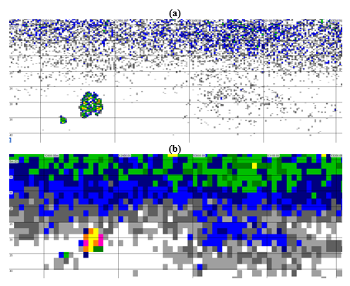

**Figure III.2b** Synchronized echograms of 38-kHz- after (a) noise-reduction and -masking; and (b) median re-sampling.

**Table V.1.** -differences (minimum, maximum; dB) used to identify echoes from CPS and krill.

|  |  |  |  |
| --- | --- | --- | --- |
| Species | - | - | - |
| CPS | -13.19, 7.86 | -16.03, 14 | -15.71, 10.80 |
| Krill | -2.81, 16.62 | 0.61, 34.34 | 3.54, 41.46 |

## III.3. Surface Trawls

**[ADD DESCRIPTION OF NORDIC TRAWL SAMPLING AND PROCESSING]**

In areas where the daytime acoustic backscatter indicated CPS, surface trawl (Nordic 264) sampling was conducted at night.

# IV. Results

## IV.1. Echosounder Calibration

The echosounders were calibrated on 27 March 2015 (~23:00 GMT) while the vessel was docked at Pier 30/32, San Francisco Bay (37.7867 N, -122.3843 W, **Figure IV.1**). Thermosalinograph (**Seabird XXX**) measurements of sea-surface temperature (,15.97oC) and salinity (, 29.25 psu) were input to the GPT-control software, which derived estimates of sound speed (, 1503 m s-1) and absorption coefficients (**Table IV.1**).

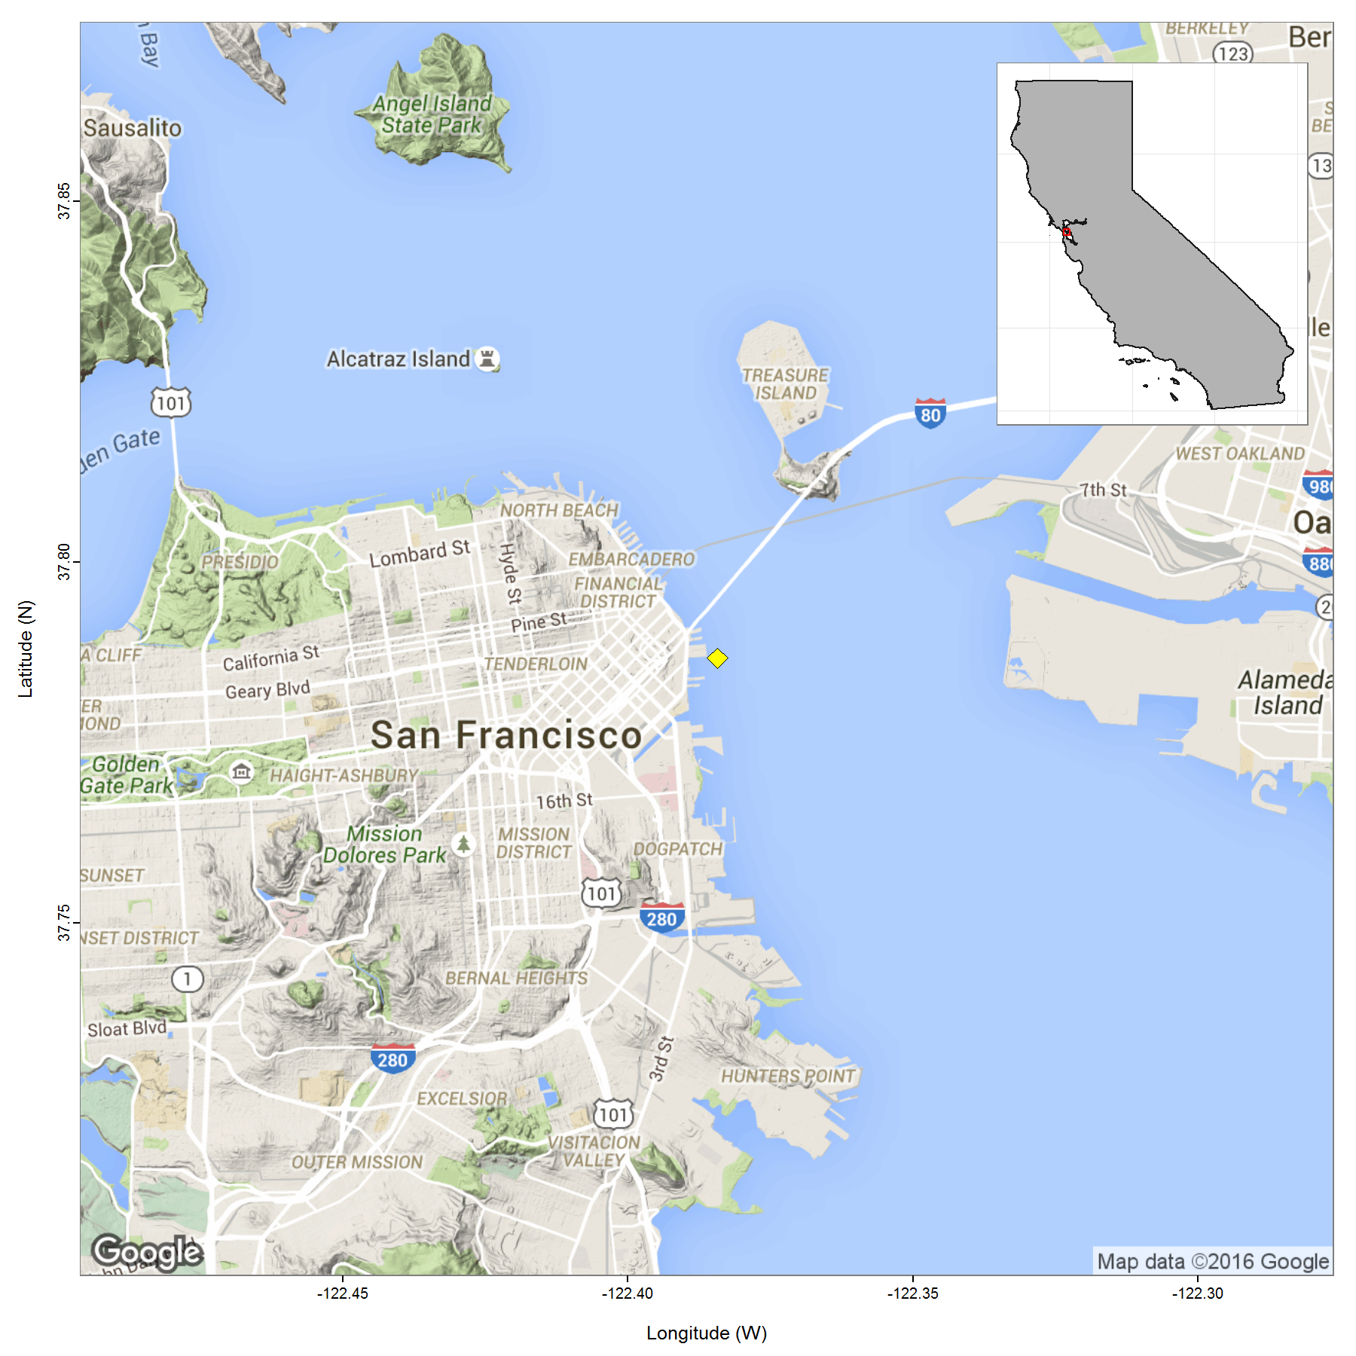

**Figure IV.1.** Map of calibration location (yellow diamond) near Pier 30/32, San Francisco Bay.

Varying with tide, the seabed was 10.8 to 12.8 m from the transducers. The sphere used for the calibration, AST #6, was positioned between 6.1 to 9 m below the transducers.

**Table IV.1.** GPT settings during calibration.

|  |  |  |  |  |  |  |
| --- | --- | --- | --- | --- | --- | --- |
| Frequency (, kHz) | Units | 18 | 38 | 70 | 120 | 200 |
| Model |  | ES18-11 | ES38B | ES70-7C | ES120-7C | ES200-7C |
| Serial Number |  | 2065 | 30715 | 168 | 573 | 339 |
| Transmit Power () | W | 2000 | 2000 | 750 | 250 | 100 |
| Pulse Duration () | ms | 1.024 | 1.024 | 1.024 | 1.024 | 1.024 |
| On-axis Gain () | dB re 1 | 23 | 26.26 | 26.26 | 26.01 | 25.8 |
| Correction () | dB re 1 | -0.75 | -0.56 | -0.29 | -0.33 | -0.35 |
| Bandwidth () | Hz | 1570 | 2430 | 2860 | 3030 | 3090 |
| Sample Interval | m | 0.193 | 0.193 | 0.193 | 0.193 | 0.193 |
| Eq. Two-way Beam Angle () | dB re 1 steradian | -18 | -21.4 | -21.5 | -20.8 | -20.8 |
| Absorption Coefficient () | dB km | 1.8 | 7.1 | 19.1 | 36.8 | 56.2 |
| Angle Sensitivity Along. () | Elec./Geom. | 13.68 | 21.62 | 22.64 | 22.78 | 22.69 |
| Angle Sensitivity Athw. () | Elec./Geom. | 13.68 | 21.62 | 22.64 | 22.78 | 22.69 |
| 3-dB Beamwidth Along. () | deg | 10.3 | 6.8 | 7 | 7.3 | 7.5 |
| 3-dB Beamwidth Athw. () | deg | 10.3 | 6.8 | 6.9 | 7.2 | 7.4 |
| Angle Offset Along. () | deg | 0 | 0 | 0 | 0 | 0 |
| Angle Offset Athw. () | deg | 0 | 0 | 0 | 0 | 0 |
| Theoretical () | dB re 1 m | -42.59 | -42.41 | -41.5 | -39.55 | -39.01 |
| Ambient Noise | dB re 1 W | -135 | -146 | -156 | -165 | -158 |

Measurements of beam-uncompensated sphere target strength (, dB) and the beam model are plotted in **Figure IV.2**. Beam-compensated sphere target strength (, dB) measurements are mapped in **Figure IV.3**. Time series of on-axis gain () and Correction () are plotted in **Figure IV.4**. Beam model results are presented in **Table IV.2**.

**Table IV.2.** Beam model results. Prior to the survey, on-axis gain () and Correction () values were entered into the GPT-control software. Beam angles and offsets were left at their factory specifications.

|  |  |  |  |  |  |  |
| --- | --- | --- | --- | --- | --- | --- |
| Frequency (, kHz) | Units | 18 | 38 | 70 | 120 | 200 |
| On-axis Gain () | dB re 1 | 23.16 | 26.14 | 26.1 | 26.02 | 25.39 |
| Correction () | dB re 1 | -0.74 | -0.57 | -0.34 | -0.35 | -0.36 |
| RMS | dB | 0.25 | 0.26 | 0.21 | 0.35 | 0.38 |
| 3-dB Beamwidth Along. () | deg | 11.22 | 7.04 | 6.67 | 6.42 | 6.55 |
| 3-dB Beamwidth Athw. () | deg | 11.28 | 7.1 | 6.73 | 6.45 | 6.49 |
| Angle Offset Along. () | deg | -0.21 | -0.01 | -0.13 | 0.05 | 0.03 |
| Angle Offset Athw. () | deg | 0.22 | -0.02 | 0.04 | 0.11 | -0.08 |

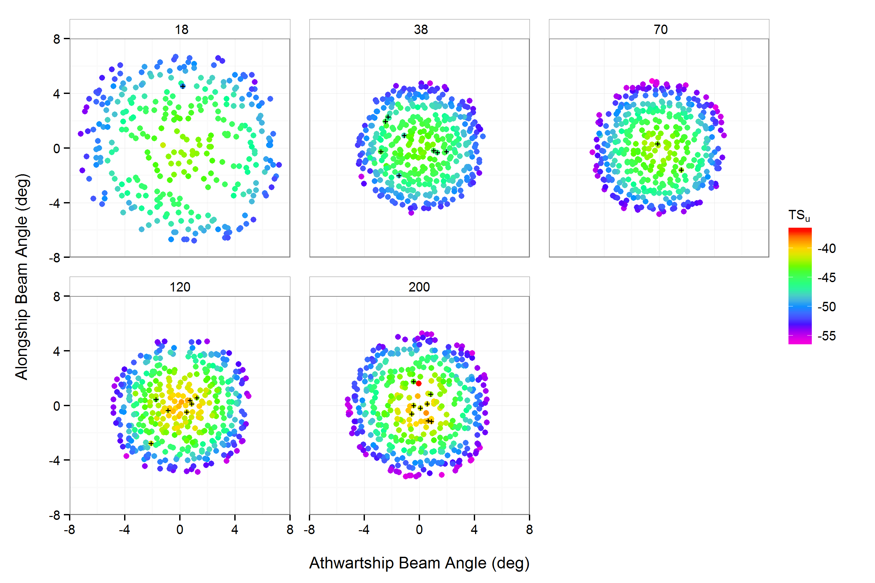

**Figure IV.2.** Simrad EK60 observed beam-uncompensated sphere target strength (, dB) measurements of a 38.1-mm diameter sphere made from tungsten carbide (WC) with 6% cobalt binder material, at multiple frequencies (18, 38, 70, 120, and 200 kHz). Crosses indicate measurements marked as outliers after viewing the beam model results.

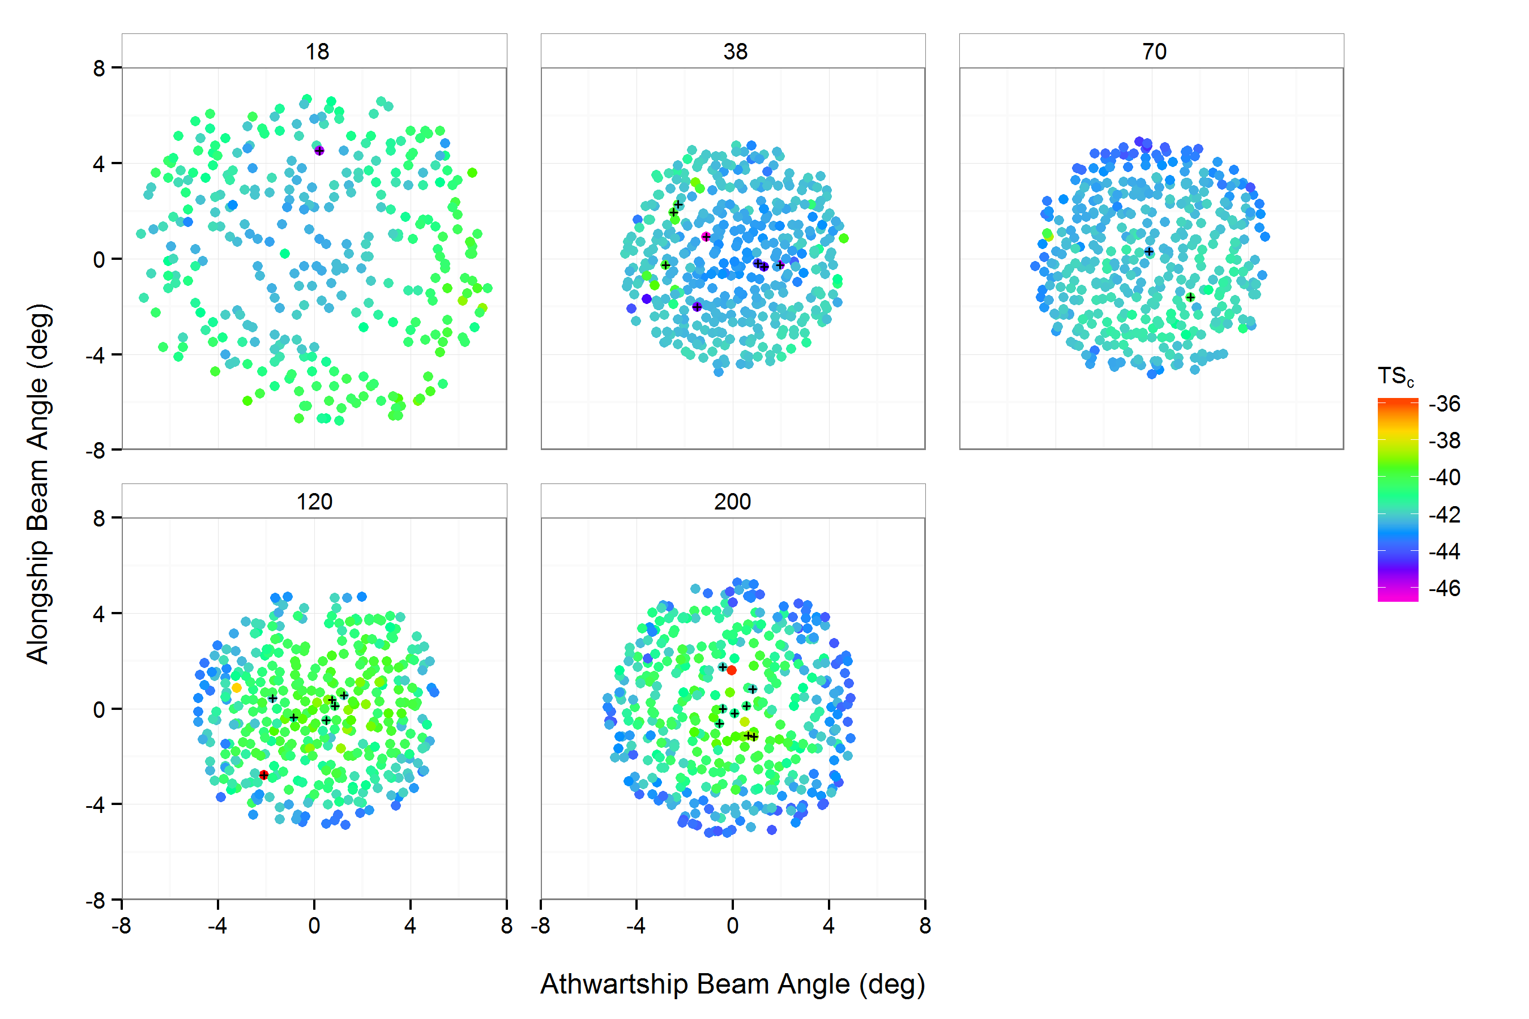

**Figure IV.3.** Simrad EK60 beam-compensated sphere target strength (, dB) measurements of a 38.1-mm diameter sphere made from tungsten carbide (WC) with 6% cobalt binder material, at multiple frequencies (18, 38, 70, 120, and 200 kHz). Crosses indicate measurements marked as outliers after viewing the beam model results.

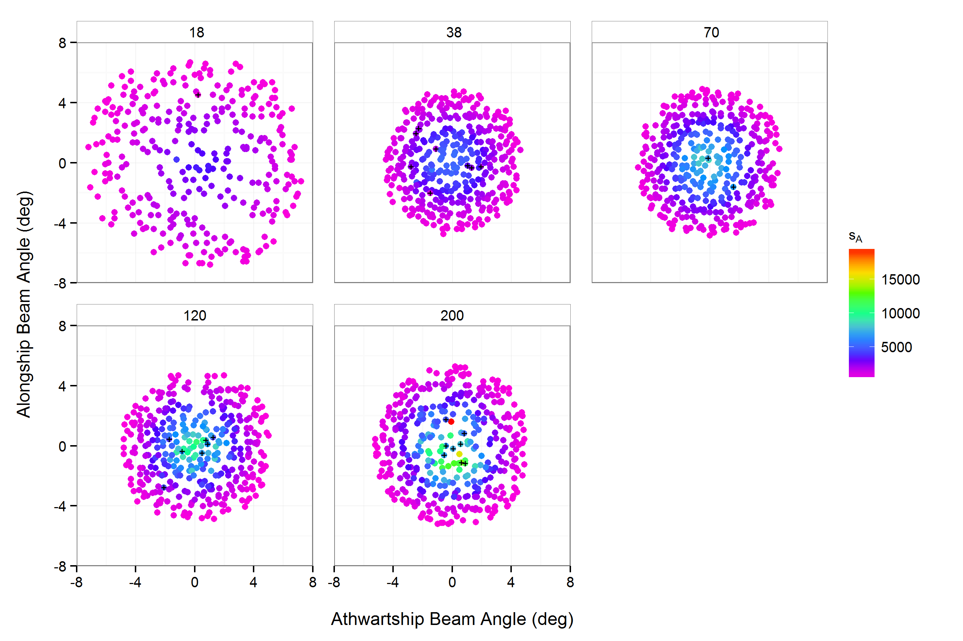

**Figure IV.4.** Simrad EK60 nautical area scattering coefficient (, ) measurements of a 38.1-mm diameter sphere made from tungsten carbide (WC) with 6% cobalt binder material, at multiple frequencies (18, 38, 70, 120, and 200 kHz). Crosses indicate measurements marked as outliers after viewing the beam model results. (**eventually update to be time series plots of and** )

# IV.2. Survey

The survey transects totaled **X** nmi, including **N** east-west transects and **N** north-south transects spanning an area from approximately Newport, OR to the U.S.-Mexico Border (**Figure IV.5**). NOTE ANY DEVIATION FROM THE PLAN (see **Figure II.1**).

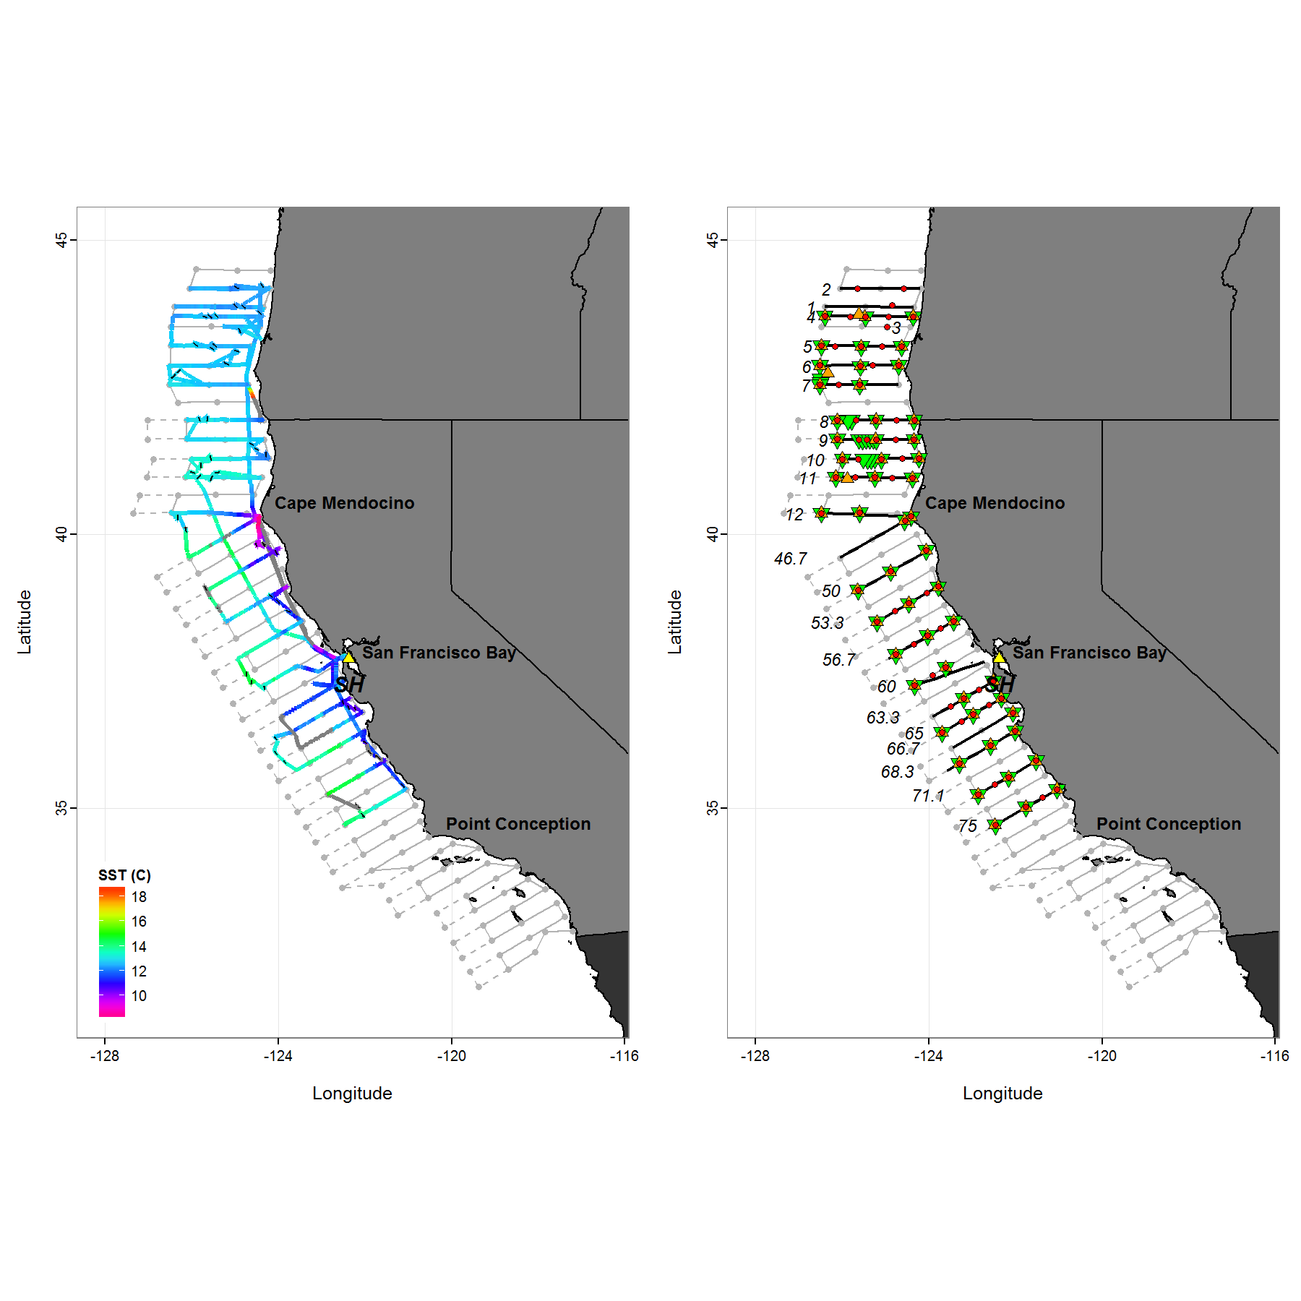

**Figure IV.5.** Cruise track of the *Shimada* (*SH*, yellow triangle), symbolized by sea-surface temperature (,oC) from the vessel's thermosalinograph and location of surface trawls (black lines, left panel); and location of CTD/UCTD (red circles), and plankton net (bongo net, orange triangles; PairoVet net, green triangles) samples relative to acoustic transects (black lines, right panel). Planned compulsory (solid gray line) and adaptive (dashed gray line) transect lines and sampling stations (gray points) are also shown. Last updated on 01/27/2016 22:39 GMT.

Leg I, *Shimada* departed from Pier 30/32 in San Francisco, CA on 28 March 2015 at *ca*. 19:00, and arrived at the first station *ca.* 30 nmi. north of Coos Bay, OR (Transect 3) at 15:22 on 30 March to begin survey operations. The Continuous Underway Fish Egg Sampler (CUFES) pump became inoperable while transiting north to begin the survey. Parts to repair the CUFES were received in Coos Bay, OR on 2 April at 21:30. The pump was repaired and CUFES sampling resumed on 3 April at 13:50. The first sardines were collected near the inshore portion of Transect 4, north of Coos Bay, OR. Incliment weather (>40 kt winds and 3-4 m seas) was encountered on 6 April at the inshore end of Transect 7, so it was decided to transit 40 nmi south to the line just north of Crescent City, CA (station 39.5-35.0). Conditions improved considerably on 7 April and sampling was continued. Relatively high (>0.3 eggs min-1) densities of sardine eggs in the CUFES and CPS-like acoustic backscatter was encountered on the outer portions of Transects 9 and 10, between Crescent City and Eureka, CA, and adaptive pairovet (**CalVET? Check on this.**) sampling was conducted. Survey operations were concluded on 11 April at the end of Transect 11 near Trinidad Head, CA. A total of 11 acoustic transects and 51 surface trawls were completed. The *Shimada's* POS MV was experiencing intermittent IMU failures that may affect the analysis of portions of Transects 7 and 8. The *Shimada* returned to Pier 15 (near the Exploratorium) in San Francisco, CA on 12 April 2015 at *ca.* 17:00.

Leg II, *Shimada* departed from Pier 15 in San Francisco, CA on 15 April 2015 at *ca.* DEPARTURE TIME (00:00 GMT). A total of 1 acoustic transects and 51 trawls were completed. NOTE ANY MALFUNCTIONS OF SHIP OR SCIENTIFIC EQUIPMENT OR WEATHER DAYS THAT MIGHT HAVE AFFECTED OPERATIONS. Survey operations were concluded on SURVEY END DATE (DD MONTH YYYY) at SURVEY END TIME (00:00 GMT) at STATION NAME. The *Shimada* returned to ARRIVAL PIER in San Francisco, CA on 1 May 2015 at *ca.* ARRIVAL TIME (00:00 GMT).

Multi-frequency echosounder data were logged to a range of 750 m in 50-MB .raw files. Each filename begins with "1504SH_"", and ends with the logging commencement date and time. Changes to the nominal transducer depth (~5 m) are indicated in **Table IV.3**.

**Table IV.3.** Transducer depths, associate with the centerboard position (retracted ~5-m, intermediate ~7-m, extended ~9-m) during the Spring CPS Survey survey aboard *Shimada*.

|  |  |  |  |  |
| --- | --- | --- | --- | --- |
|  | Date/Time (GMT) | Position | Latitude | Longitude |
| **1** | 03/28/2015 19:58 | CB Flush | 37.82 | -122.5 |
| **2** | 03/28/2015 21:59 | CB Intermed | 37.87 | -122.9 |
| **23** | 04/01/2015 21:30 | CB Flush | 43.37 | -124.4 |
| **24** | 04/01/2015 22:57 | CB Intermed | 43.38 | -124.4 |
| **153** | 04/07/2015 14:42 | CB Intermed | 42 | -124.4 |
| **303** | 04/15/2015 15:35 | CB Flush | 37.8 | -122.4 |
| **366** | 04/18/2015 18:41 | CB Down | 39.53 | -124.5 |
| **411** | 04/20/2015 02:59 | CB Intermed | 38.9 | -124.1 |
| **506** | 04/26/2015 15:09 | CB Intermed | NA | NA |
| **538** | 04/27/2015 15:11 | CB Intermed | 36.38 | -122.2 |
| **595** | 04/29/2015 14:49 | CB Down | 36.7 | -122.3 |

A detailed summary of the results, by transect, is presented in **Appendix B**.

## IV.2.1. CPS

Due to weather and other constraints...

Nonetheless, the entirety of the potential sardine habitat was sampled (**Fig. IV.6**). CPS backscatter was...

Throughout the survey area, the epipelagic backscatter was dominated by...

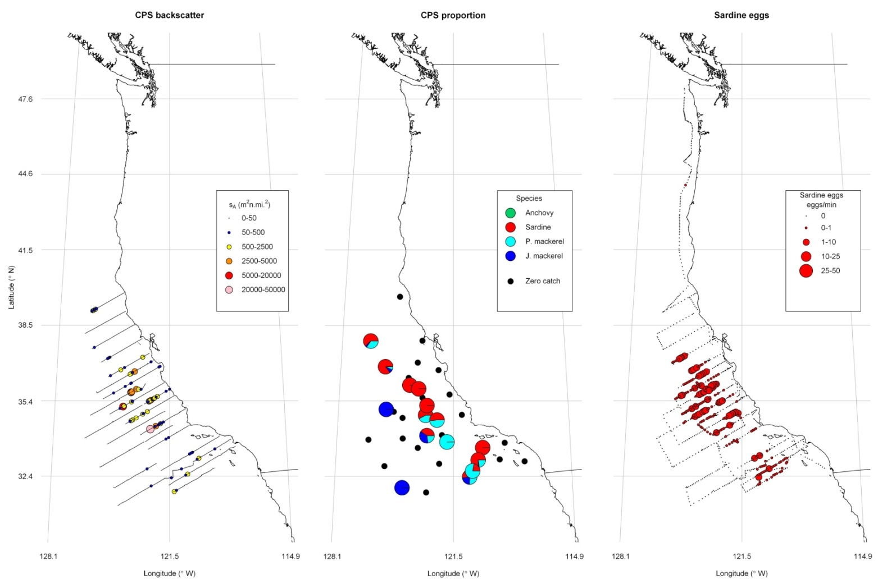

**Fig IV.6.** Survey transects performed aboard *Shimada* overlaid with the distribution of acoustic backscatter from coastal pelagic fish species (CPS; left), proportions of CPS in trawl clusters (middle), and sardine egg densities from the continuous underway fish-egg sampler (CUFES).

## IV.2.2. Krill

Krill densities were observed during the day between **70** and **250** m depth. (**Check these depths**)

**Fig. IV.8.** Survey transects performed aboard Shimada overlaid with (a) the distribution of 120-kHz integrated backscattering coefficients (s_A) ascribed to CPS, averaged over 2000 m distance intervals and from 70 m deep to the integration start line (5 m); (b) the daily cumulative backscatter as a function of depth; and cumulative backscatter as a function of time of day. The superimposed lines are local smoothers representing the mean trend.

# V. Problems and Suggestions

During calibration, one sphere, AST #7, was lost when the monofilament lines broke during deployment. Also, the starboard-aft downrigger lacked power to raise the sphere, and required manual assistance.

The 512 kbps bandwidth of the satellite-Internet connection (V. Welton, Chief ET) was inadequate to telemeter echosounder data ashore, and made email sporadic and slow.

# VI. Disposition of Data

Archived on computer hard disks are approximately 145 GB of raw and processed EK60 data and 435 GB of raw and processed ME70 data. Contact: David Demer (Southwest Fisheries Science Center, 8901 La Jolla Shores Drive, La Jolla, California, 92037, U.S.A.; phone: 858-546-5603; email: [david.demer@noaa.gov](mailto:david.demer@noaa.gov)).

# VII. Acknowledgements

We thank the crew members of *Shimada* and the scientists and technicians that participated in the sampling operations at sea.

# Appendix A. Impedance results

Plots of the magnitude (; ) and phase (; o) of the impedance, conductance (; mS), susceptance (; mS), and admittance circles ( vs. ) for each quadrant and for the quadrants in parallel, for each transducer. Tabulated are the resonance frequency and quality factors, and , , , and at both the resonance and operational frequencies.

# Appendix B. Detailed summary of transects

**Table B.1.** Acoustic transect summaries, arranged by order occupied.

|  |  |  |  |  |  |  |  |  |  |
| --- | --- | --- | --- | --- | --- | --- | --- | --- | --- |
| Transect | Leg | Start WPT | End WPT | Start Time | Start Lat | Start Lon | End Time | End Lat | End Lon |
| 1 | 1 | 3.1 | 3.3 | 03/30/15 15:52 | 43.9 | -124.4 | 03/31/15 00:43 | 43.91 | -126.4 |
| 2 | 1 | 2.1 | 2.3 | 03/31/15 15:34 | 44.22 | -124.2 | 04/01/15 23:36 | 44.21 | -126 |
| 3 | 1 | 4.1 | 4.3 | 04/01/15 16:01 | 43.57 | -124.4 | 04/02/15 02:51 | 43.58 | -125.3 |
| 4 | 1 | 3a.1 | 3a.3 | 04/02/15 13:58 | 43.75 | -124.3 | 04/03/15 16:19 | 43.75 | -126.4 |
| 5 | 1 | 5.3 | 5.1 | 04/03/15 21:50 | 43.25 | -126.5 | 04/04/15 18:03 | 43.25 | -124.7 |
| 6 | 1 | 6.1 | 6.3 | 04/04/15 22:09 | 42.94 | -124.7 | 04/05/15 18:07 | 42.92 | -126.5 |
| 7 | 1 | 7.3 | 7.1 | 04/05/15 23:14 | 42.6 | -126.5 | 04/06/15 20:37 | 42.59 | -124.7 |
| 8 | 1 | 39.5-35 | 36.2-52.5 | 04/07/15 13:51 | 42 | -124.3 | 04/08/15 00:44 | 41.99 | -126.1 |
| 9 | 1 | 37.6-54.9 | 41.0-37.5 | 04/08/15 13:54 | 41.66 | -126.1 | 04/09/15 01:06 | 41.66 | -124.3 |
| 10 | 1 | 42.6-38.7 | 39.3-56.3 | 04/09/15 13:47 | 41.34 | -124.2 | 04/10/15 00:38 | 41.32 | -126 |
| 11 | 1 | 40.4-60.1 | 43.8-42.7 | 04/10/15 13:52 | 41.01 | -126.1 | 04/11/15 23:03 | 41 | -124.4 |
| 12 | 2 | 44.7-46.8 | 41.4-64.2 | NA | NA | NA | NA | NA | NA |

# Appendix C. Echoview data analysis

**Table C.1.** Echoview data analysis file summary, arranged by order occupied. The sound velocity ratio (SV Ratio) is used to adjust the dead zone and integration stop depths for during krill analysis.

|  |  |  |  |  |  |  |  |
| --- | --- | --- | --- | --- | --- | --- | --- |
| Transect | Start Time | End Time | Start RAW | End RAW | CTD File | ECS File | SV Ratio |
| 1 | 03/30/15 15:52 | 03/31/15 00:43 | 1504SH-D20150330-T155216 | 1504SH-D20150331-T003923 | 1504SH_002 | 1504SH_1_CTD002 | 0.9974 |
| 2 | 03/31/15 15:34 | 04/01/15 23:36 | 1504SH-D20150331-T153454 | 1504SH-D20150331-T232759 | 1504SH_002 | 1504SH_1_CTD002 | 0.9974 |
| 3 | 04/01/15 16:01 | 04/02/15 02:51 | 1504SH-D20150401-T160135 | 1504SH-D20150402-T025015 | 1504SH_002 | 1504SH_1_CTD002 | 0.9974 |
| 4 | 04/02/15 13:58 | 04/03/15 16:19 | 1504SH-D20150402-T135839 | 1504SH-D20150403-T161853 | 1504SH_008 | 1504SH_4_CTD008 | 0.9959 |
| 5 | 04/03/15 21:50 | 04/04/15 18:03 | 1504SH-D20150403-T215052 | 1504SH-D20150404-T175922 | 1504SH_014 | 1504SH_5_CTD014 | 0.9968 |
| 6 | 04/04/15 22:09 | 04/05/15 18:07 | 1504SH-D20150404-T220922 | 1504SH-D20150405-T175545 | 1504SH_020 | 1504SH_6_CTD020 | 0.9959 |
| 7 | 04/05/15 23:14 | 04/06/15 20:37 | 1504SH-D20150405-T231452 | 1504SH-D20150406-T203350 | 1504SH_029 | 1504SH_7_CTD029 | 0.9961 |
| 8 | 04/07/15 13:51 | 04/08/15 00:44 | 1504SH-D20150407-T135133 | 1504SH-D20150408-T003424 | 1504SH_031 | 1504SH_8_CTD031 | 0.9953 |
| 9 | 04/08/15 13:54 | 04/09/15 01:06 | 1504SH-D20150408-T135411 | 1504SH-D20150409-T010450 | 1504SH_043 | 1504SH_9_CTD043 | 0.9955 |
| 10 | 04/09/15 13:47 | 04/10/15 00:38 | 1504SH-D20150409-T152714 | 1504SH-D20150410-T003115 | 1504SH_049 | 1504SH_10_CTD049 | 0.9957 |
| 11 | 04/10/15 13:52 | 04/11/15 23:03 | 1504SH-D20150410-T135237 | 1504SH-D20150410-T224934 | 1504SH_059 | 1504SH_11_CTD059 | 0.9959 |
| 12 | NA | NA |  |  |  |  | NA |

# Appendix D. Trawl sample summary

**Table D.1.** Trawl summaries, arranged by order completed. Trawl duration was nominally 45 min. The date and time indicate the net equilibration times. Temperature, salinity, and depth are mean values during the entire trawl deployment.

|  |  |  |  |  |  |  |  |
| --- | --- | --- | --- | --- | --- | --- | --- |
|  | Trawl | Date | Lat (N) | Lon (W) | Depth (m) | Temp (C) | Sal (psu) |
| **5** | 1 | 03/31/2015 06:53 | 43.9 | -125 | 658.9 | 12.24 | 32.15 |
| **13** | 2 | 03/31/2015 10:10 | 43.89 | -124.8 | 243.5 | 12.29 | 32.19 |
| **21** | 3 | 04/01/2015 04:40 | 44.21 | -124.9 | 147.1 | 12.27 | 32.17 |
| **29** | 4 | 04/01/2015 10:27 | 44.23 | -124.3 | 86.06 | 12.45 | 32.18 |
| **37** | 5 | 04/02/2015 04:53 | 43.53 | -124.9 | 735.6 | 12.54 | 32.3 |
| **45** | 6 | 04/02/2015 09:21 | 43.79 | -124.4 | 117.9 | 12.35 | 32.12 |
| **53** | 7 | 04/03/2015 05:20 | 43.74 | -125.4 | 56.49 | 12.56 | 32.26 |
| **61** | 8 | 04/03/2015 07:44 | 43.73 | -125.5 | 376.6 | 12.26 | 32.26 |
| **69** | 9 | 04/03/2015 10:34 | 43.73 | -125.7 | 7.7 | 12.52 | 32.4 |
| **77** | 10 | 04/04/2015 04:37 | 43.26 | -125.9 | 7.7 | 12.7 | 32.37 |
| **85** | 11 | 04/04/2015 08:53 | 43.19 | -125.5 | 7.7 | 12.6 | 32.32 |
| **93** | 12 | 04/04/2015 11:34 | 43.25 | -125.4 | 390.9 | 12.54 | 32.39 |
| **101** | 13 | 04/05/2015 07:00 | 43.15 | -124.9 | 698.7 | 12.6 | 32.32 |
| **109** | 14 | 04/05/2015 10:26 | 42.94 | -125.2 | 7.69 | 12.62 | 32.39 |
| **117** | 15 | 04/06/2015 06:24 | 42.84 | -126.3 | 7.69 | 12.87 | 32.4 |
| **125** | 16 | 04/06/2015 09:28 | 42.76 | -126.4 | 367.1 | 12.87 | 32.41 |
| **133** | 17 | 04/08/2015 04:43 | 41.99 | -125.6 | 7.7 | 13.07 | 32.44 |
| **141** | 18 | 04/08/2015 07:19 | 41.98 | -125.8 | 7.7 | 13.01 | 32.47 |
| **149** | 19 | 04/09/2015 03:25 | 41.56 | -124.6 | 708.3 | 12.56 | 32.27 |
| **157** | 20 | 04/09/2015 06:07 | 41.48 | -124.5 | 155.6 | 12.39 | 32.22 |
| **165** | 21 | 04/09/2015 09:24 | 41.38 | -124.3 | 84.02 | 12.22 | 32.45 |
| **173** | 22 | 04/10/2015 04:02 | 41.18 | -125.8 | 390.7 | 14.11 | 32.38 |
| **181** | 23 | 04/10/2015 06:43 | 41.31 | -125.6 | 19.46 | 13.37 | 32.42 |
| **189** | 24 | 04/10/2015 10:47 | 41.08 | -125.9 | 342.8 | 13.57 | 32.45 |
| **197** | 25 | 04/11/2015 04:50 | 41.09 | -125.4 | 18.69 | 13.46 | 32.41 |
| **205** | 26 | 04/11/2015 07:04 | 41.02 | -125.5 | 342.1 | 13.17 | 32.34 |
| **213** | 27 | 04/11/2015 10:16 | 41.03 | -125.8 | 402 | 13.32 | 32.34 |
| **221** | 28 | 04/17/2015 05:00 | 40.27 | -126.3 | 67.85 | 12.86 | 32.45 |
| **229** | 29 | 04/17/2015 08:50 | 40.06 | -126.1 | 69.59 | 13.59 | 32.64 |
| **237** | 30 | 04/18/2015 05:23 | 39.79 | -124.5 | 393 | 9.631 | 33.33 |
| **245** | 31 | 04/18/2015 08:29 | 39.8 | -124.3 | 619.7 | 9.93 | 33.19 |
| **253** | 32 | 04/18/2015 12:25 | 39.65 | -124 | 449 | 10.61 | 33.14 |
| **261** | 33 | 04/19/2015 05:18 | 39.02 | -125.7 | 53.28 | 13.92 | 32.74 |
| **279** | 36 | 04/20/2015 04:17 | 38.89 | -124.1 | 16.17 | 11.84 | 32.79 |
| **287** | 37 | 04/20/2015 07:25 | 38.78 | -124 | 603.5 | 11.56 | 32.8 |
| **295** | 38 | 04/20/2015 10:59 | 38.62 | -123.7 | 415.9 | 11.43 | 32.92 |
| **303** | 39 | 04/21/2015 04:16 | 37.46 | -124.7 | 7.69 | 14.6 | 32.87 |
| **311** | 40 | 04/21/2015 07:38 | 37.32 | -124.6 | 83.67 | 14.67 | 32.91 |
| **319** | 41 | 04/21/2015 10:51 | 37.22 | -124.3 | 15.21 | 13.28 | 32.55 |
| **327** | 42 | 04/25/2015 10:32 | 35.41 | -121.1 | 269.4 | 11.47 | 33.47 |
| **335** | 43 | 04/26/2015 04:28 | 34.85 | -122 | 7.7 | 13.84 | 33.1 |
| **354** | 45 | 04/27/2015 05:29 | 35.92 | -121.7 | 731.2 | NA | NA |
| **362** | 46 | 04/27/2015 08:01 | 36.02 | -121.9 | 273.9 | NA | NA |
| **370** | 47 | 04/27/2015 10:24 | 36.21 | -122 | 560.6 | 10.53 | 33.57 |
| **378** | 48 | 04/28/2015 04:37 | 35.85 | -123.8 | 11.16 | 13.58 | 32.98 |
| **386** | 49 | 04/28/2015 07:26 | 36.01 | -124 | 12.32 | 13.5 | 32.83 |
| **394** | 50 | 04/28/2015 10:19 | 36.27 | -124 | 419 | 13.06 | 32.76 |
| **402** | 51 | 04/29/2015 04:12 | 36.95 | -122.5 | 430.9 | 10.97 | 33.6 |
| **410** | 52 | 04/29/2015 07:21 | 36.85 | -122.4 | 14.05 | 12.05 | 33.44 |
| **418** | 53 | 04/29/2015 10:07 | 36.83 | -122.2 | 715.4 | 10.3 | 33.6 |
| **426** | 54 | 05/01/2015 04:28 | 37.2 | -122.6 | 100.8 | 12.36 | 33.36 |

# Appendix E. Side-station samle summary

**Table E.1.** A summary of traditional conductivity, temperature, and depth (CTD) and underway CTD (UCTD) cast events.

|  |  |  |  |  |  |  |
| --- | --- | --- | --- | --- | --- | --- |
|  | Date | Event | Latitude | Longitude | CTD | UCTD |
| **11** | 03/31/2015 12:09 | CTD at Depth | 43.93 | -124.8 | 3 |  |
| **13** | 03/31/2015 17:12 | UCTD Deployed | 44.21 | -124.6 | NA | 1 |
| **14** | 03/31/2015 21:52 | UCTD Deployed | 44.21 | -125.6 | NA | 2 |
| **21** | 04/01/2015 18:22 | UCTD Deployed | 43.57 | -125 | NA | 3 |
| **31** | 04/02/2015 12:00 | CTD at Depth | 43.75 | -124.4 | 7 |  |
| **39** | 04/02/2015 21:19 | UCTD Deployed | 43.74 | -124.9 | NA | 4 |
| **41** | 04/02/2015 23:56 | CTD at Depth | 43.74 | -125.5 | 8 |  |
| **47** | 04/03/2015 02:30 | UCTD Deployed | 43.74 | -125.8 | NA | 5 |
| **59** | 04/03/2015 16:41 | CTD at Depth | 43.75 | -126.4 | 12 |  |
| **64** | 04/03/2015 20:53 | CTD at Depth | 43.25 | -126.5 | 13 |  |
| **70** | 04/03/2015 23:11 | UCTD Deployed | 43.25 | -126.2 | NA | 6 |
| **72** | 04/04/2015 02:13 | CTD at Depth | 43.25 | -125.6 | 14 |  |
| **84** | 04/04/2015 16:10 | UCTD Deployed | 43.25 | -125.1 | NA | 7 |
| **86** | 04/04/2015 18:21 | CTD at Depth | 43.24 | -124.6 | 18 |  |
| **91** | 04/04/2015 21:15 | CTD at Depth | 42.93 | -124.7 | 19 |  |
| **97** | 04/05/2015 00:48 | UCTD Deployed | 42.93 | -125.3 | NA | 8 |
| **99** | 04/05/2015 02:30 | CTD at Depth | 42.92 | -125.6 | 20 |  |
| **110** | 04/05/2015 18:26 | CTD at Depth | 42.92 | -126.5 | 23 |  |
| **119** | 04/05/2015 22:15 | CTD at Depth | 42.6 | -126.5 | 26 |  |
| **125** | 04/06/2015 01:09 | UCTD Deployed | 42.6 | -126.1 | NA | 9 |
| **137** | 04/06/2015 14:54 | CTD at Depth | 42.59 | -125.6 | 29 |  |
| **146** | 04/07/2015 12:58 | CTD at Depth | 41.99 | -124.3 | 30 |  |
| **155** | 04/07/2015 16:31 | UCTD Deployed | 42 | -124.7 | NA | 10 |
| **157** | 04/07/2015 19:00 | CTD at Depth | 42 | -125.2 | 31 |  |
| **163** | 04/07/2015 22:09 | UCTD Deployed | 41.99 | -125.7 | NA | 11 |
| **173** | 04/08/2015 01:04 | CTD at Depth | 41.99 | -126.1 | 34 |  |
| **182** | 04/08/2015 11:51 | CTD at Depth | 41.67 | -126.1 | 37 |  |
| **192** | 04/08/2015 16:39 | UCTD Deployed | 41.66 | -125.6 | NA | No data |
| **201** | 04/08/2015 18:24 | UCTD Deployed | 41.66 | -125.4 | NA | 12 |
| **211** | 04/08/2015 20:10 | CTD at Depth | 41.66 | -125.2 | 43 |  |
| **217** | 04/08/2015 23:12 | UCTD Deployed | 41.66 | -124.8 | NA | 13 |
| **219** | 04/09/2015 01:23 | CTD at Depth | 41.65 | -124.3 | 44 |  |
| **230** | 04/09/2015 12:10 | CTD at Depth | 41.34 | -124.2 | 48 |  |
| **236** | 04/09/2015 15:44 | UCTD Deployed | 41.33 | -124.6 | NA | 14 |
| **238** | 04/09/2015 18:14 | CTD at Depth | 41.32 | -125.1 | 49 |  |
| **260** | 04/09/2015 22:36 | UCTD Deployed | 41.32 | -125.6 | NA | 15 |
| **262** | 04/10/2015 00:59 | CTD at Depth | 41.32 | -126 | 54 |  |
| **273** | 04/10/2015 12:54 | CTD at Depth | 41.01 | -126.1 | 58 |  |
| **279** | 04/10/2015 15:52 | UCTD Deployed | 41 | -125.7 | NA |  |
| **281** | 04/10/2015 18:09 | CTD at Depth | 41 | -125.3 | 59 |  |
| **287** | 04/10/2015 20:56 | UCTD Deployed | 41 | -124.8 | NA |  |
| **289** | 04/10/2015 23:20 | CTD at Depth | 40.99 | -124.4 | 60 |  |
| **305** | 04/16/2015 13:27 | CTD at Depth | 40.32 | -124.4 | 64 |  |
| **315** | 04/16/2015 20:45 | CTD at Depth | 40.39 | -125.6 | 65 |  |
| **322** | 04/17/2015 01:53 | CTD at Depth | 40.38 | -126.5 | 66 |  |
| **341** | 04/17/2015 22:56 | CTD at Depth | 40.25 | -124.6 | 70 |  |
| **359** | 04/18/2015 15:20 | CTD at Depth | 39.72 | -124.1 | 74 |  |
| **369** | 04/18/2015 21:38 | CTD at Depth | 39.34 | -124.9 | 75 |  |
| **376** | 04/19/2015 03:45 | CTD at Depth | 39.01 | -125.6 | 76 |  |
| **390** | 04/19/2015 13:53 | CTD at Depth | 38.44 | -125.2 | 79 |  |
| **396** | 04/19/2015 17:08 | UCTD Deployed | 38.63 | -124.8 | NA | 18 |
| **398** | 04/19/2015 19:17 | CTD at Depth | 38.77 | -124.5 | 80 |  |
| **404** | 04/19/2015 22:33 | UCTD Deployed | 38.96 | -124.1 | NA | 19 |
| **406** | 04/20/2015 00:21 | CTD at Depth | 39.07 | -123.8 | 81 |  |
| **418** | 04/20/2015 14:24 | CTD at Depth | 38.45 | -123.4 | 85 |  |
| **424** | 04/20/2015 16:35 | UCTD Deployed | 38.32 | -123.7 | NA | 20 |
| **426** | 04/20/2015 18:33 | CTD at Depth | 38.19 | -124 | 86 |  |
| **432** | 04/20/2015 21:15 | UCTD Deployed | 38.04 | -124.3 | NA | 21 |
| **434** | 04/20/2015 23:46 | CTD at Depth | 37.85 | -124.8 | 86 |  |
| **447** | 04/21/2015 12:33 | CTD at Depth | 37.28 | -124.3 | 91 |  |
| **455** | 04/21/2015 16:03 | UCTD Deployed | 37.48 | -123.9 | NA | 22 |
| **457** | 04/21/2015 17:59 | CTD at Depth | 37.61 | -123.6 | 92 |  |
| **473** | 04/25/2015 12:58 | CTD at Depth | 35.35 | -121.1 | 94 |  |
| **479** | 04/25/2015 15:50 | UCTD Deployed | 35.19 | -121.4 | NA | 23 |
| **481** | 04/25/2015 18:13 | CTD at Depth | 35.02 | -121.8 | 95 |  |
| **492** | 04/26/2015 00:12 | CTD at Depth | 34.68 | -122.5 | 96 |  |
| **501** | 04/26/2015 15:04 | CTD at Depth | 35.25 | -122.9 | 99 |  |
| **508** | 04/26/2015 18:13 | UCTD Deployed | 35.44 | -122.5 | NA | 24 |
| **510** | 04/26/2015 20:23 | CTD at Depth | 35.58 | -122.2 | 100 |  |
| **519** | 04/27/2015 03:41 | CTD at Depth | 35.89 | -121.5 | 101 |  |
| **530** | 04/27/2015 13:14 | CTD at Depth | 36.44 | -122 | 105 |  |
| **540** | 04/27/2015 17:50 | CTD at Depth | 36.18 | -122.6 | 106 |  |
| **547** | 04/27/2015 23:08 | CTD at Depth | 35.84 | -123.3 | 107 |  |
| **561** | 04/28/2015 13:45 | CTD at Depth | 36.41 | -123.7 | 111 |  |
| **567** | 04/28/2015 17:13 | UCTD Deployed | 36.62 | -123.3 | NA | 25 |
| **569** | 04/28/2015 18:57 | CTD at Depth | 36.75 | -123 | 112 |  |
| **575** | 04/28/2015 21:54 | UCTD Deployed | 36.92 | -122.6 | NA | 26 |
| **577** | 04/28/2015 23:40 | CTD at Depth | 37.05 | -122.3 | 113 |  |
| **588** | 04/29/2015 12:38 | CTD at Depth | 36.78 | -122.1 | 117 |  |
| **602** | 04/30/2015 16:25 | UCTD Deployed | 36.9 | -123.5 | NA | 27 |
| **604** | 04/30/2015 19:19 | CTD at Depth | 37.05 | -123.2 | 119 |  |
| **610** | 04/30/2015 22:13 | UCTD Deployed | 37.2 | -122.8 | NA | 28 |
| **613** | 05/01/2015 00:50 | CTD at Depth | 37.36 | -122.5 | 120 |  |

# References

Cutter, G. R., and Demer, D. A. 2008. California current ecosystem survey 2006. Acoustic cruise reports for NOAA FSV *Oscar Dyson* and NOAA FRV *David Starr Jordan*. U.S. Dep. Commer., NOAA Tech. Memo., NOAA-SWFSC-415: 98.

Demer, D. A., and Hewitt, R. P. 1995. Bias in acoustic biomass estimates of *Euphausia superba* due to diel vertical migration. Deep-Sea Research Part I-Oceanographic Research Papers, 42: 455–475.

Demer, D. A., Cutter, G. R., Renfree, J. S., and Butler, J. L. 2009a. A statistical-spectral method for echo classification. ICES Journal of Marine Science, 66: 1081–1090.

Demer, D. A., Kloser, R. J., MacLennan, D. N., and Ona, E. 2009b. An introduction to the proceedings and a synthesis of the 2008 ICES Symposium on the Ecosystem Approach with Fisheries Acoustics and Complementary Technologies (SEAFACTS). ICES Journal of Marine Science, 66: 961–965.

Demer, D., Berger, L., Bernasconi, M., Bethke, E., Boswell, K., Chu, D., and Domokos, R. *et al.* 2015. Calibration of acoustic instruments. ICES Cooperative Research Report, XXX: 147 pp.

Foote, K. G., Knudsen, H. P., Vestnes, G., MacLennan, D. N., and J., S. E. 1987. Calibration of acoustic instruments for fish density estimation: A practical guide. ICES Cooperative Research Report, 144: 69 pp.

Renfree, J. S., and Demer, D. A. 2016. Optimising transmit interval and logging range while avoiding aliased seabed echoes. ICES Journal of Marine Science, XX: XXXX–XXXX.