- Introduction
The Acoustic-Trawl Method (ATM) is used by the National Oceanic and Atmospheric Administration (NOAA) Fisheries Resources Division (FRD) Southwest Fisheries Science Center (SWFSC) to estimate the abundances and distributions of coastal pelagic species (CPS) and krill (Stierhoff, Zwolinski et al. 2020). The Summer 2019 California Current Ecosystem Survey (CCES), conducted aboard NOAA Ship Reuben Lasker, used the ATM to estimate the biomasses of seven stocks of five CPS including: Northern Anchovy (Engraulis mordax), Pacific Herring (Clupea pallasii), Pacific Sardine (Sardinops sagax), Pacific Mackerel (Scomber japonicus), and Jack Mackerel (Trachurus symmetricus).
As Lasker traveled along parallel transects, oriented perpendicular to the coast in the area from Vancouver Island, Canada, to San Diego, California, sound pulses from multi-frequency echosounders were transmitted beneath the ship and receivers recorded the echoes from animals and the seabed (Stierhoff, Zwolinski et al. 2020). This acoustic backscatter was apportioned to the fish present using species composition and length data from nighttime surface-trawl catches in the same areas. The combined backscatter and catch data were thus used to estimate the distributions and abundances of each species and stocks (Stierhoff, Zwolinski et al. 2020).
Up to three surface trawls were conducted each night in areas where CPS echoes were detected in acoustic data earlier that day (Figure 1) (Stierhoff, Zwolinski et al. 2020). The trawls were conducted at night because CPS disperses close to the surface after sunset and are less able to avoid the net when they are not schooling and have reduced visibility (Stierhoff, Zwolinski et al. 2020).
The catch data from each night were summed into a trawl cluster, for which acoustic proportions, i.e., the percentages of acoustic backscatter contributed by each species, were estimated from models of mean backscattering cross-sectional area (1 m^2) weighted by the species’ sampled length distribution (Simmonds and MacLennan 2005, Stierhoff, Zwolinski et al. 2020). Integrated volume backscattering strength for each species was divided by the respective species’ mean acoustic backscattering cross-sectional area to estimate fish biomass density. Acoustic transects were grouped into strata based on similar biomass densities within the area and the spacing of the transects (Zwolinski, Demer et al. 2014). Biomass estimates per species in a strata were calculated by multiplying the total stratum area by the estimated mean species biomass densities in the respective stratum (Stierhoff, Zwolinski et al. 2020).
An assumption of the SWFSC’s ATM is that the information from nighttime trawl catches represents the species and sizes of fish that contribute to daytime acoustic backscatter in the same areas. Concerns about the temporal difference between acoustic data and surface trawls affecting the species biomass estimates have been raised (cite the critiques). An experimental design to test the effect of temporal differences in acoustic data collection and trawls would involve trawling the same area during the day and again at night, which is expensive and time intensive. One question that needs to be addressed first is if trawling effort is generally robust, regardless of the time the trawl was conducted.
Here, we assess the sensitivities of survey-estimated CPS biomasses to the numbers of nighttime trawl clusters and their spatial distribution. We test the null hypothesis that reducing trawling effort significantly increases uncertainty in CPS biomass estimates. Results of this study aim to aid in the decision-making process related to focusing trawling effort while conducting an ATM survey to improve accuracy of fish biomass estimates.

Figure 1: Spatial distributions of: a) polygons containing acoustic intervals closest to each trawl cluster; b) species proportions in nighttime trawl clusters; and c) species proportions in directed daytime purse seine clusters (Stierhoff, Zwolinski et al. 2020).

- Methods
The 2019 CCES data contain 61 trawl clusters. An R script subsample procedure generated 500 random samples for each of the following percentage reduction in trawl effort: 10%, 25% and 50%. A 10% reduction in the trawling effort randomly removed 6 clusters. Henceforth, the three percent effort test conditions will be referred to and referenced by the percentage of trawl clusters remaining (i.e., 90%, 75%, and 50%).
New biomass estimates were generated for each resample by recalculating the nearest trawl cluster to respective acoustic intervals. Biomass density for each interval was computed using the acoustic data and the corresponding acoustic proportion of the nearest trawl cluster. Stratums for each species were redrawn using the same parameters as the initial analysis with all 61 clusters; each stratum is bounded by zero-biomass density transects and contains at least three, equally spaced transects and fewer than three consecutive zero-biomass density transects (Stierhoff, Zwolinski et al. 2020). The redrawn stratum, acoustic interval cluster assignments, and species information were used to generate biomass point estimates.
- Analysis for this study was conducted primarily in R and included generating box plots, maps, and a Kolmogorov-Smirnov (K-S) statistical test to assess if reducing trawling effort significantly increases uncertainty in CPS biomass estimates.
- Box plots were drawn for each percent effort test condition for (1) total biomass estimates for the entire survey area per species and (2) total biomass estimates per each stratum per species.
- A map was also created to illustrate the effect of a reduction in trawl effort on the geographic distribution variation of generated stratum areas.
- A K-S test was used to compare the respective CPS biomass estimates cumulative distribution function (cdf) shapes.
  - A one-sample K-S test was conducted to compare the length disaggregated biomass estimate using all 61 trawl clusters to each respective percentage effort test conditions’ length disaggregated mean biomass estimate.
  - An additional one-sample K-S test was conducted to compare the distribution of the total biomass estimates generated in each of the 500 random samples for each of the three test conditions to the distribution of a 500 sample bootstrap with replacement biomass estimate using all 61 trawl clusters.

Results

  - Stratum Area
- Map of Geographic Distribution (need to change species name)
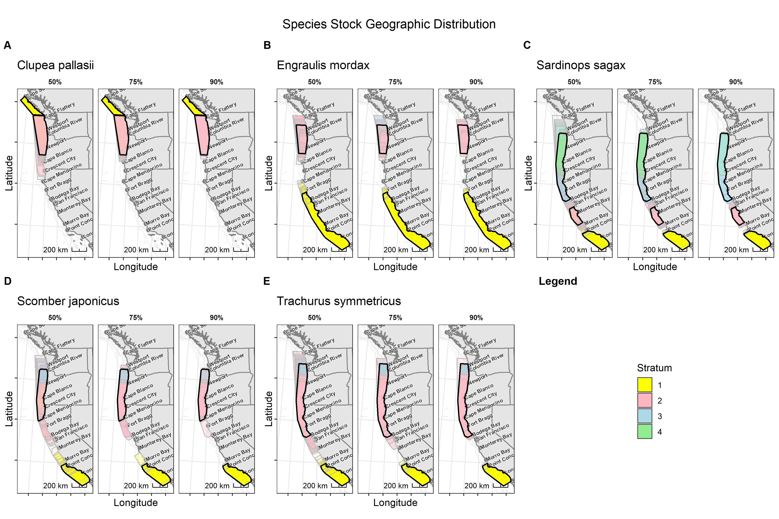
  - Biomass Estimates
- Box plot of total biomass (need to create)
- Box plot of total biomass/species/stratum (need to fix labels)
- K-S test comparing total biomass estimates

    - Biomass Estimates by Species Length
- Length disagg plots (need to switch to bar chart, I think)
- K-S test comparing length disagg (include table of results + analysis)

- Conclusion
- Answer question
  - Suggestions for ATS methodology/generally what protocols might be beneficial for targeting trawling effortPerhaps focusing trawling effort on areas where each trawl in a night has different species abundances
- Reject/not reject hypothesis
- Discussion
This research addressed the impact of randomly removing a varying proportion of trawl clusters. A future study could conduct a similar assessment except randomly remove a varying proportion of trawls before the trawls are summed into trawl clusters. This analysis might provide insight into how to efficiently use nightly survey time to collect the most amount of useful data. For example, this analysis might illustrate it is more useful to prioritize two trawls and then a bongo net tow instead of three nightly trawls.
This analysis aims to address a component of the overarching motivation question, “Does trawling at night adequately represent the species proportions?” by answering the sub-question, “Are biomass estimates and stock distributions sensitive to biological sampling effort?” The second question helps us determine if we are trawling enough to adequately represent species proportions, but it does not include the temporal aspect (i.e., nighttime trawls vs. daytime trawls) the first question seeks to address. To expand on this research and help answer the first question, an experiment could be developed to generate fish biomass estimates and stratum areas using trawl data collected during the day and again at night. The two biomass estimates could be compared to answer if there is temporal variation in the data if we trawl at night.

References
Simmonds, E. J. and D. N. MacLennan (2005). Fisheries Acoustics: Theory and Practice, 2nd Edition. Oxford, Blackwell Publishing.
Stierhoff, K. L., J. P. Zwolinski and D. A. Demer (2020). "Distribution, Biomass, and Demography of Coastal Pelagic Fishes in the California Current Ecosystem During Summer 2019 Based on Acoustic-Trawl Sampling."
Stierhoff, K. L., J. P. Zwolinski, J. S. Renfree, G. E. Johnson, S. A. Mau, D. W. Murfin, T. S. Sessions and D. A. Demer (2020). "Report on the Summer 2019 California Current Ecosystem Survey (1907RL), 13 June to 9 September 2019, conducted aboard NOAA Ship Reuben Lasker, Fishing Vessels Lisa Marie and Long Beach Carnage, and three unmanned sailboats."
Zwolinski, J. P., D. A. Demer, G. R. Cutter Jr, K. Stierhoff and B. J. Macewicz (2014). "Building on fisheries acoustics for marine ecosystem surveys." Oceanography 27(4): 68-79.

