The 10 knowledge management area of project management are: scope, time, cost, quality, human resources, communications, risk, procurement, stakeholder, and project integration management. Scope management involves defining and managing the work required in order to complete the project successfully. Time management involves estimating how long each work item will take and developing an acceptable project schedule to ensure the timely completion of the project.

Cost management involves preparing and managing the project budget. Quality management ensures that the project will meet the stated and implied needs for which it was undertaken. Communications management involves generating, collecting, disseminating, and storing information about the project.

Risk management is concerned with identifying, analysing, and responding to risks related to the project. Procurement management is concerned with the acquisition and procurement of goods and services for a project from outside the performing organisation. Stakeholder management involves requesting, rejecting, supporting, approving, and opposing projects from a stakeholder perspective. Project integration management ensures that the other nine knowledge areas are being managed properly. [transition]

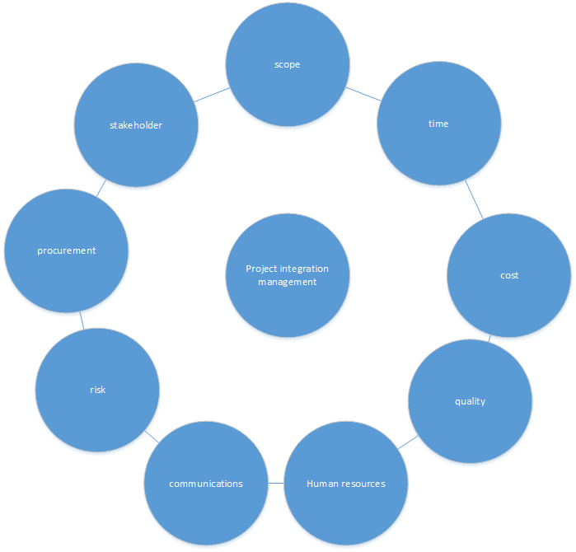

As stated above, quality is considered a knowledge area, however, this is a somewhat contested issue. Many argue that the vagueness of the definition for quality, specifically where it states that the implied needs of a project are met, in addition to the subjective nature of quality make it an ineffective knowledge area. Additionally, the similarities between quality and scope, wherein what is required for the project to be successful, can sometimes make quality seem redundant. The difficulty in defining what a quality product is makes managing quality all the more difficult as almost any product can be continuously redefined in order to seek better “quality”. That being said, the technology industry has a terrible track record when it comes to quality, almost to the extent where it is expected that the final product will not work.