People often describe a risk probability or consequence as being high, medium, or low.

Chart the probability and impact on a probability/impact chart.

Helps to identify risks that need attention.

Stakeholders list the risks they think might occur on their projects.

Then label the prob/impact as high/medium/low.

Project manager summarizes the results in a chart.

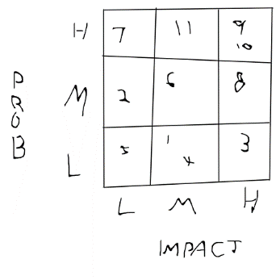

Focus on any risks that fall in the high section of prob/impact.

As in the above example, risk number 9 and 10 are considered high probability and high impact, so the project team would need to focus on responding to those. Risk 5 is considered low in both probability and impact so it could possibly be ignored.