10. What are the 8 agile project principles? List them and briefly describe what each on implies. Explain which ones are negotiable and which ones can never be ignored.

* Focus on the Business need
* Deliver on Time
* Build Incrementally from Firm Foundations
* Develop Iteratively
* Collaborate
* Never Compromise Quality
* Communicate continuously and Clearly
* Demostrate Control

Focusing on the business need means the project is built around its needs, not what is wanted. The Development team must have a clear understanding of the business priorities, this can be done using the MoSCoW principle. The team must guarantee the minimum useable subset (Must haves). The project must be supported by business roles and agreed products. Deliver On Time requires the team to use timeboxing to deliver work. They must also deliver according to MoSCoW and the timeline can never be moved. Build Incrementally from Firm fOundations (BIFO) requires the team to focus on early delivery of the business benefit when it is possible. The team must continuously confirm that the correct solution is being built and should re-assess MoSCoW and the project viability at the end of each timebox.

Develop Iteratively implies that nothing is built perfectly the first time, so many versions of the same thing will need to be made. Teams must follow the EDUF rule (Enough Design Up Front), they should have just enough design to be able to make something that can be shown. Team members should embrace and expect change, as change is inevitable and so they should harness the benefits. Collaborate requires the team to involve the right stakeholders at the right times throughout the project. Team members are empowered to make decisions. They should involve business representatives and should hold facilitated workshops. Never Compromise Quality requires the team to ensure that quality never becomes a variable. The team must set and agree on the acceptance criteria of deliverables. They must document, design and test their work. Constant review by the right people, test early and often.

Communicate Continuously and Clearly means that the team must hold daily stand-up meetings and facilitated workshops. The team must model and prototype their work and keep documentation. The team must also have face-to-face communications with stakeholders at all levels. Demonstrate Control requires the team to be able to guarantee timeboxing. The team must use burn down charts. A burn down chart is a graphical representation of work to be done versus time.

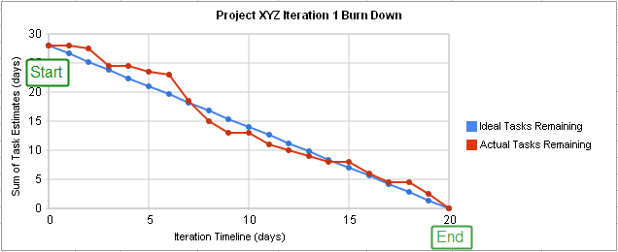

The team must track velocity and use their technical expertise throughout the project. None of these principles are negotiable and none of them can be ignored.

5. Why is a Timebox important to Agile Project Management? Explain its role with reference to the “MoSCoW” system of project evaluation.

A timebox is a planned portion of work that consists of 5 phases and can be no longer than 14 days. The 5 phases within a timebox include: Kick off MoSCoW, Investigation, Refinement, Consolidation, and Close Out. The team cannot move to the next timebox until the first one has been completed.

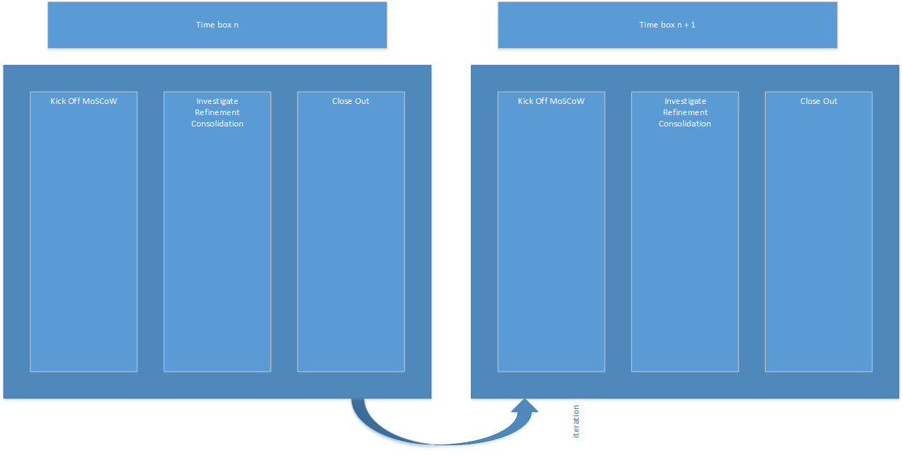

A timebox is important to Agile Project Management due to its fast pace, short durations, and firm rules. [transition] In the Kick Off MoSCoW phase of a timebox the team determines what the objective of the timebox is, whether there is enough time to complete the objective, and if it is the right next step (according to MoSCoW). The team must also set and agree on acceptance criteria for the timebox and analyse the risks involved. The investigation phase consists of defining the product to be delivered and the quantities of the product. Refinement is where the bulk of the development and testing is done and consolidation involves tying up the loose ends and ensuring that the product meets the acceptance criteria. Close out involves the formal acceptance of the timebox deliverables.

[possibly talk about Moscow]

MoSCoW is an important part of Agile Project Management. MoSCoW stands for Must have, Should have, Could have, Wont have (right now).

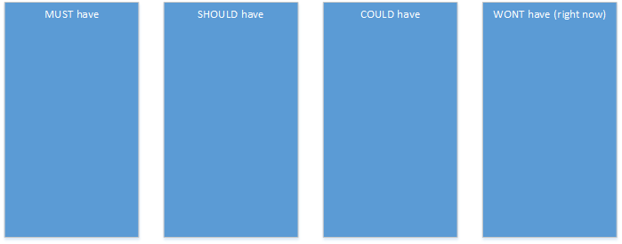

MoSCoW is used by the solutions team to determine what should be included in the project. The must in must have stands for Minimum Useable SubseT. Any items in this section must be included in the final product and the solutions team should prioritize these tasks. Items in the should or could have section can be done but only after all the must haves are completed. Wont haves are items not included in the project. At any time, items can be added, removed, or moved around in the MoSCoW, which is one of the key features that makes Agile so different from Tradtional. This kind of rapid change complements timeboxing techniques, that can only last as long as 14 days (and are usually less that 7).