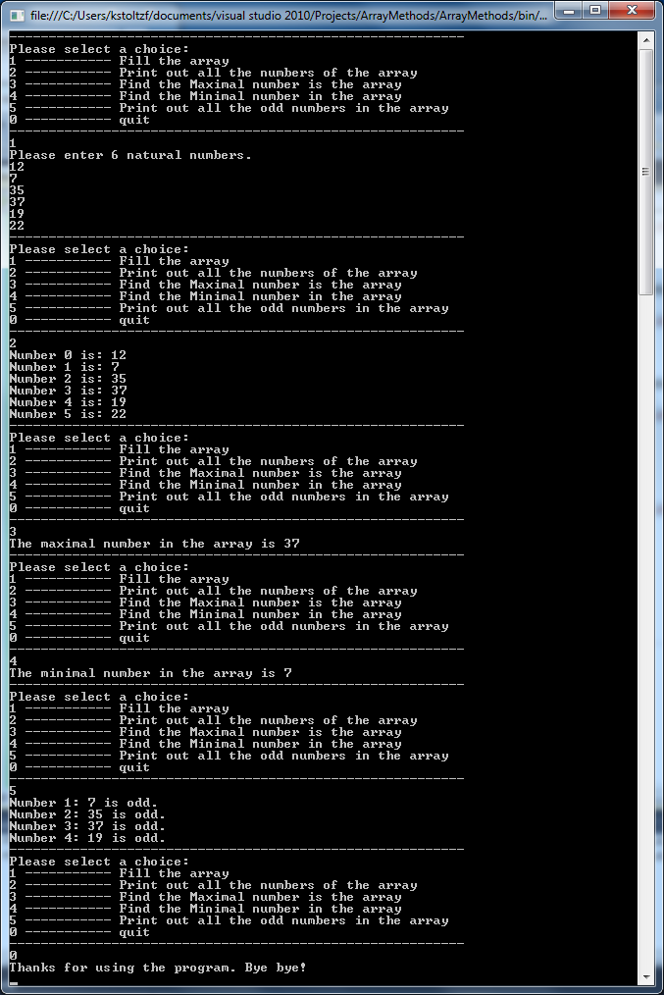

Option Strict On

Option Explicit On

Module Module1

Sub Main()

Dim intArray(5) As Integer ' An integer array with six elements

Dim choice As Integer ' to take the user choice from the menu

Dim filled As Boolean = False ' The intial status of the array is unfilled.

Dim quit As Boolean = False ' Will become true if user choose to quit.

Do

Console.WriteLine("----------------------------------------------------------")

Console.WriteLine("Please select a choice:")

Console.WriteLine("1 ----------- Fill the array")

Console.WriteLine("2 ----------- Print out all the numbers of the array")

Console.WriteLine("3 ----------- Find the Maximal number is the array")

Console.WriteLine("4 ----------- Find the Minimal number in the array")

Console.WriteLine("5 ----------- Print out all the odd numbers in the array")

Console.WriteLine("0 ----------- quit")

Console.WriteLine("----------------------------------------------------------")

choice = CInt(Console.ReadLine())

Select Case choice

Case 1

FillArray(intArray)

filled = True ' after calling FillArray(), the array should have been filled now.

Case 2

If (filled) Then

PrintArray(intArray)

Else

Console.WriteLine("The array has not been filled yet, please choose choice 1 first.")

End If

Case 3

If (filled) Then

Console.WriteLine("The maximal number in the array is " & FindMax(intArray))

Else

Console.WriteLine("The array has not been filled yet, please choose choice 1 first.")

End If

Case 4

If (filled) Then

Console.WriteLine("The minimal number in the array is " & FindMin(intArray))

Else

Console.WriteLine("The array has not been filled yet, please choose choice 1 first.")

End If

Case 5

If (filled) Then

PrintOdds(intArray)

Else

Console.WriteLine("The array has not been filled yet, please choose choice 1 first.")

End If

Case Else

quit = True

End Select

Loop While (Not quit)

Console.WriteLine("Thanks for using the program. Bye bye!") ' Try to be friendly

Console.ReadLine() ' Just to pause the program

End Sub

Private Sub FillArray(ByRef numberArray() As Integer)

Dim index As Integer

Console.WriteLine("Please enter 6 natural numbers.")

For index = 0 To 5

numberArray(index) = CInt(Console.ReadLine)

Next index

End Sub

Private Sub PrintArray(ByVal numberArray() As Integer)

Dim index As Integer

For index = 0 To numberArray.GetUpperBound(0)

Console.WriteLine("Number {0} is: {1}", index, numberArray(index))

Next

End Sub

Private Function FindMax(ByVal numberArray() As Integer) As Integer

Dim index, highest As Integer

For index = 0 To numberArray.GetUpperBound(0)

If numberArray(index) > highest Then

highest = numberArray(index)

Else

highest = highest

End If

Next

Return highest

End Function

Private Function FindMin(ByVal numberArray() As Integer) As Integer

Dim index As Integer

Dim lowest As Integer = numberArray(0)

For index = 1 To numberArray.GetUpperBound(0)

If numberArray(index) < lowest Then

lowest = numberArray(index)

Else

lowest = lowest

End If

Next

Return lowest

End Function

Private Sub PrintOdds(ByVal numberArray() As Integer)

Dim index As Integer

Dim isOdd As Boolean

For index = 0 To numberArray.GetUpperBound(0)

If numberArray(index) Mod 2 = 1 Then

isOdd = True

Else

isOdd = False

End If

If isOdd = True Then

Console.WriteLine("Number {0}: {1} is odd.", index, numberArray(index))

Else

Continue For

End If

Next

End Sub

End Module