ASSIGNMENT 4

Kurt Stoneburner

2020-06-15

# Markdown Basics

## Favorite Foods

1. Anything prepared for me
2. Wife’s cooking
3. Sushi

## Images

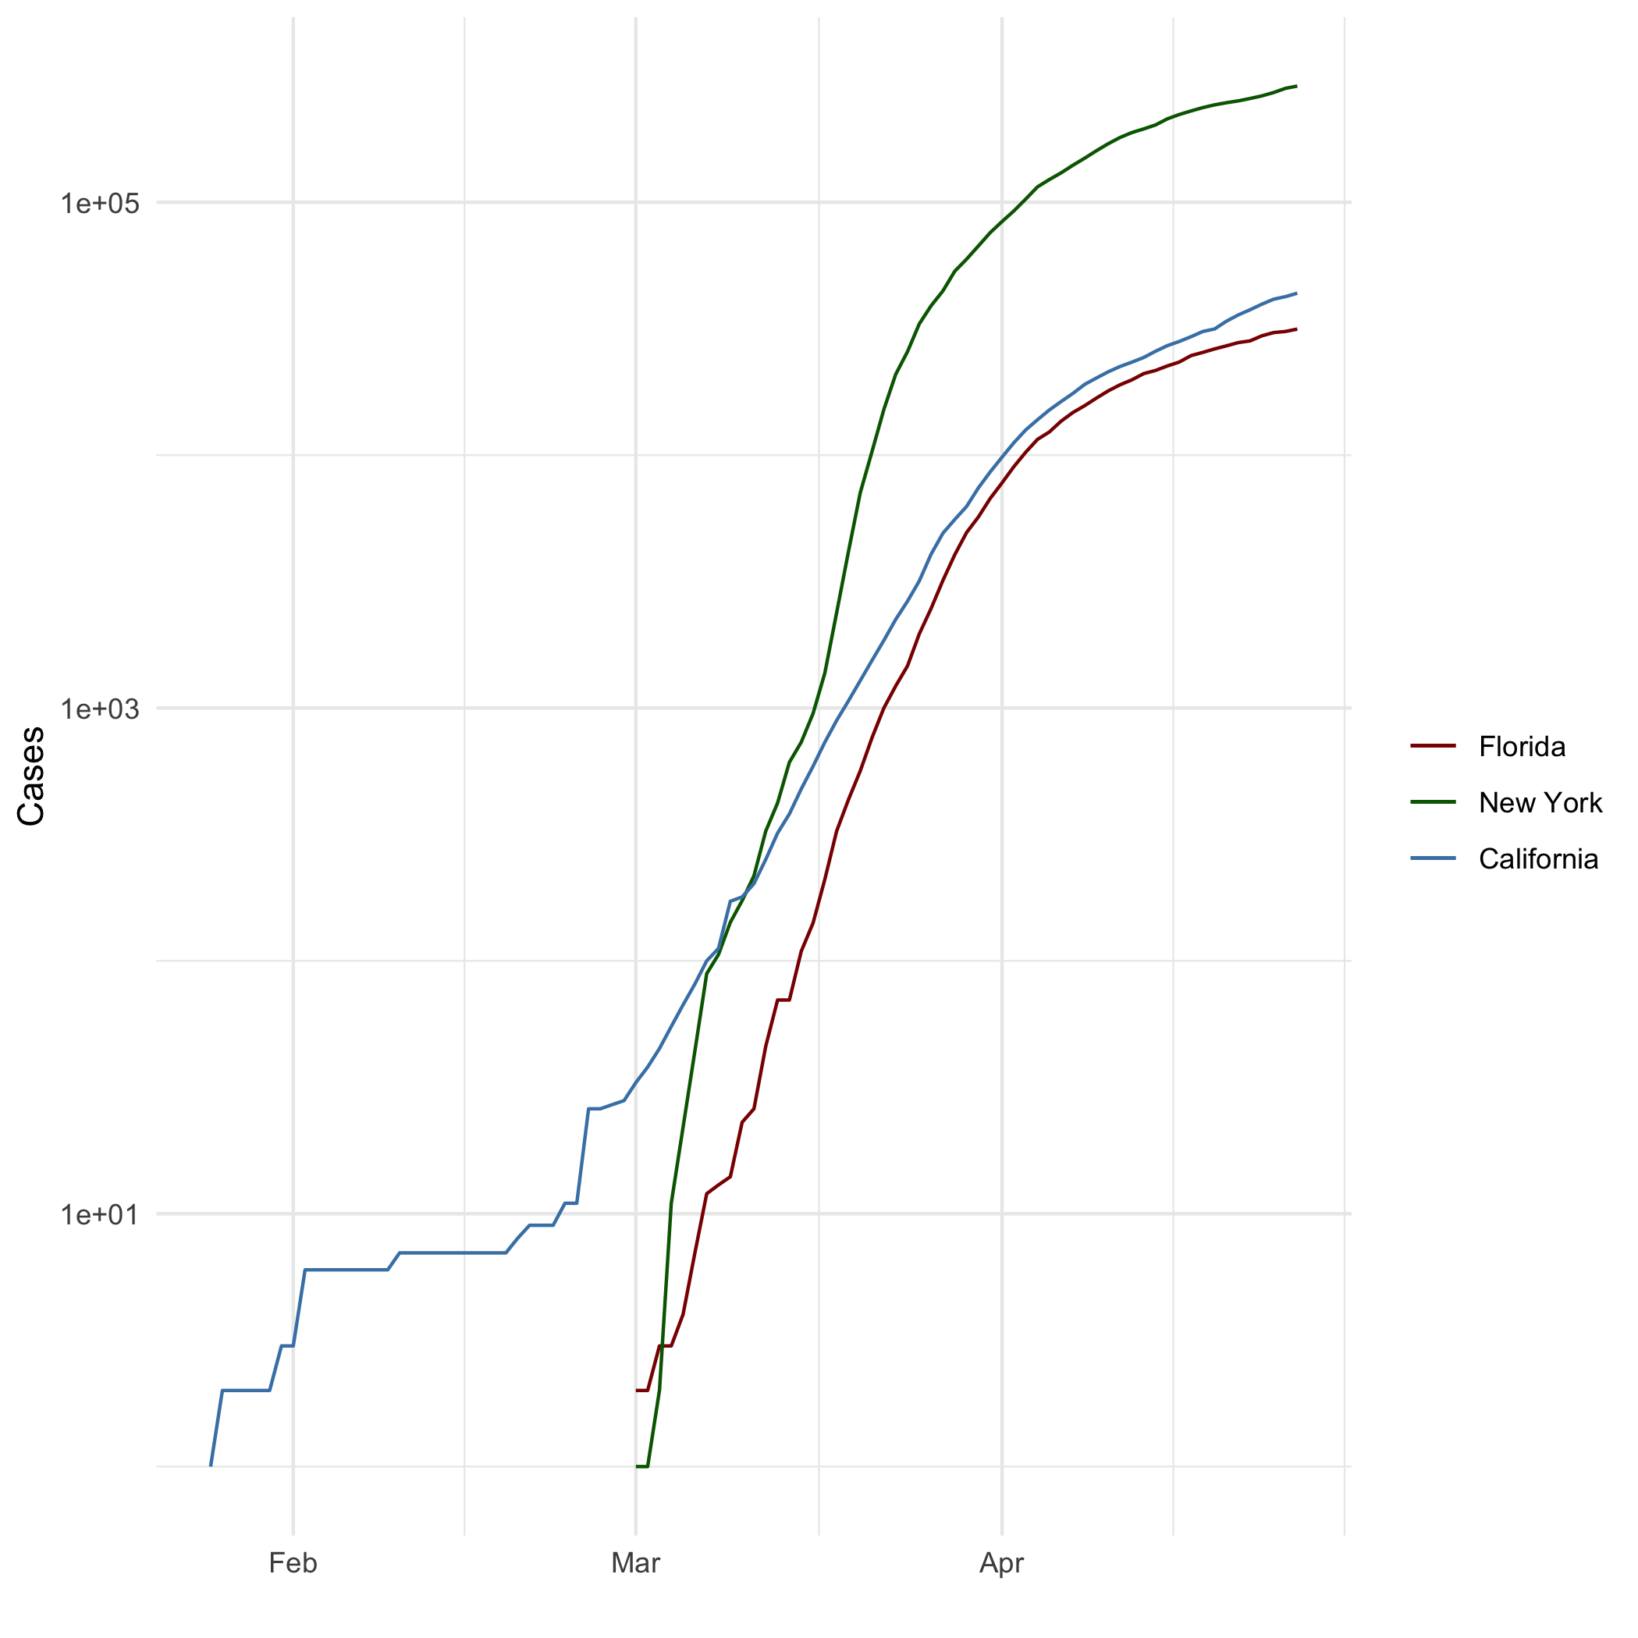

## Add a Quote

“The best laid plans of mice and men go oft awry, and leave naught but pain and suffering for promised joy.”[1]

– *To a Mouse*, Robert Burns

## Add an Equation

$$r=\frac{∑(x_{i}-\overline{x})(y_{i}-\overline{y})}{(N-1)s_{x}s_{y}}$$

## Add a Footnote

“The path of the righteous man and defender is beset on all sides by the iniquity of the selfish and the tyranny of evil men. Blessed is he, who in the name of charity and good will, shepherds the weak through the valley of darkness, for he is truly his brother’s keeper, and the father of lost children. And I will execute great vengeance upon them with furious anger, who poison and destroy my brothers; and they shall know that I am Chiba the Bodyguard when I shall lay my vengeance upon them!” – ezekiel 25:17[2]

– *The Bodyguard*, 1976

## Add Citations

* R for Everyone (Lander 2014)
* Discovering Statistics Using R (Field, Miles, and Field 2012)

# Inline Code

## NY Times COVID-19 Data

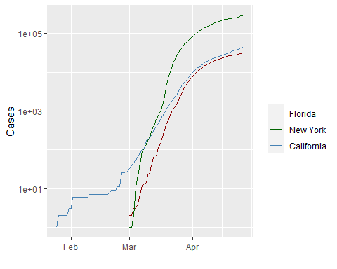

## R4DS Height vs Earnings

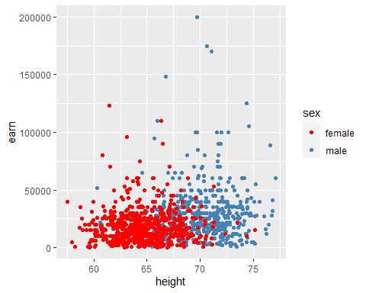

# Tables

## Knitr Table with Kable

|  |  |  |  |  |
| --- | --- | --- | --- | --- |
| name | race | in_fellowship | ring_bearer | age |
| Aragon | Men | TRUE | FALSE | 88 |
| Bilbo | Hobbit | FALSE | TRUE | 129 |
| Frodo | Hobbit | TRUE | TRUE | 51 |
| Galadriel | Elf | FALSE | FALSE | 7000 |
| Sam | Hobbit | TRUE | TRUE | 36 |
| Gandalf | Maia | TRUE | TRUE | 2019 |
| Legolas | Elf | TRUE | FALSE | 2931 |
| Sauron | Maia | FALSE | TRUE | 7052 |
| Gollum | Hobbit | FALSE | TRUE | 589 |

## Pandoc Table

|  |  |  |  |  |
| --- | --- | --- | --- | --- |
| Name | Race | In Fellowship? | Is Ring Bearer? | Age |
| Aragon | Men | Yes | No | 88 |
| Bilbo | Hobbit | No | Yes | 129 |
| Frodo | Hobbit | Yes | Yes | 51 |
| Sam | Hobbit | Yes | Yes | 36 |
| Sauron | Maia | No | Yes | 7052 |

# References

Field, A., J. Miles, and Z. Field. 2012. *Discovering Statistics Using R*. SAGE Publications. <https://books.google.com/books?id=wd2K2zC3swIC>.

Lander, J. P. 2014. *R for Everyone: Advanced Analytics and Graphics*. Addison-Wesley Data and Analytics Series. Addison-Wesley. <https://books.google.com/books?id=3eBVAgAAQBAJ>.

1. *“The best-laid schemes o’ mice an’ men Gang aft agley, An’ lea’e us nought but grief an’ pain, For promis’d joy!”*
2. Starring Sonny Chiba. If you thought these lines made famous by Samuel L. Jackson in *Pulp Fiction* were original, you’d be wrong. It was Quentin Tarantino who introduced me to this genre of film. Title Sequence: <https://www.youtube.com/watch?v=8LYT4JC2dd4>