Upgrading the Jetcis evaluation kit

instructions

This guide applies to all ams Mira evaluation kits.

First , go to the ams eval kit page

https://ams.com/mira130-nvidia-jetson-nano-evalkit#tab/tools

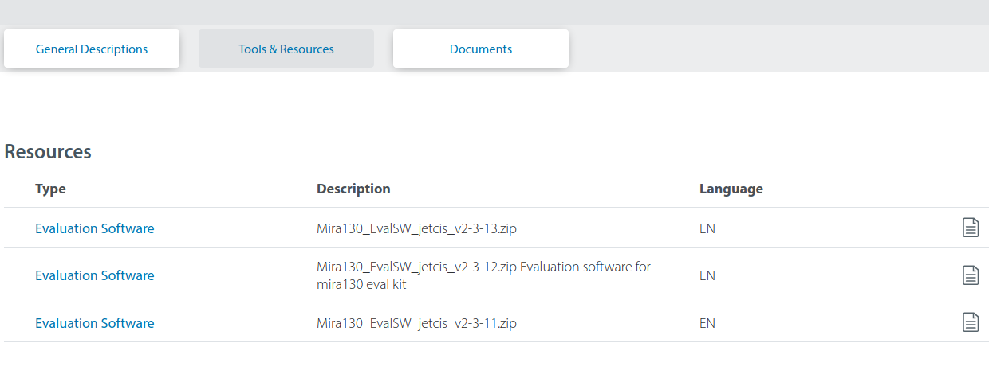
Select the latest version available under tools and recources.

Save the zip file

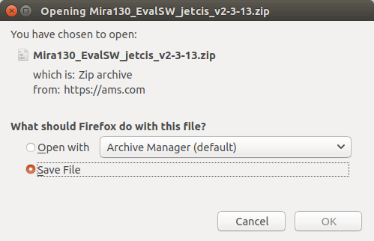

Navigate to the Downloads folder and extract the zip file
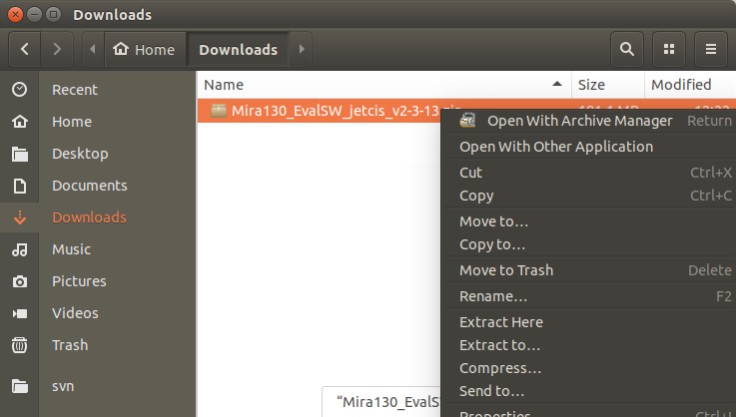

Extract the .tar.gz file

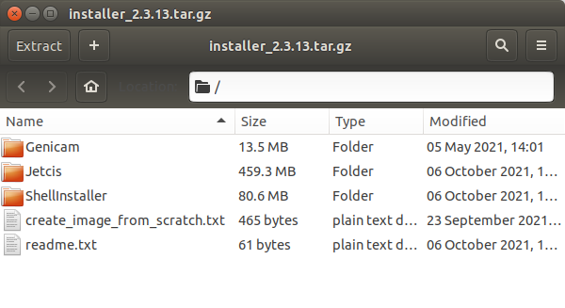

Open a terminal in the Shellinstaller folder

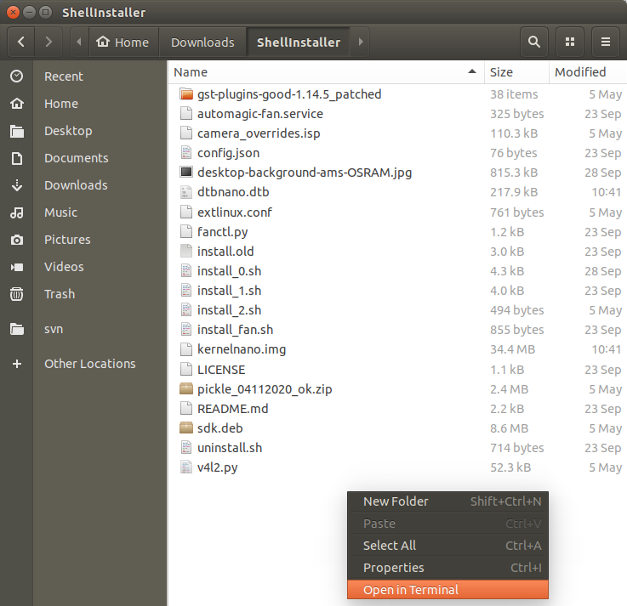

enter ./install_0.sh
enter the password when prompted (password = ‘jetcis’)
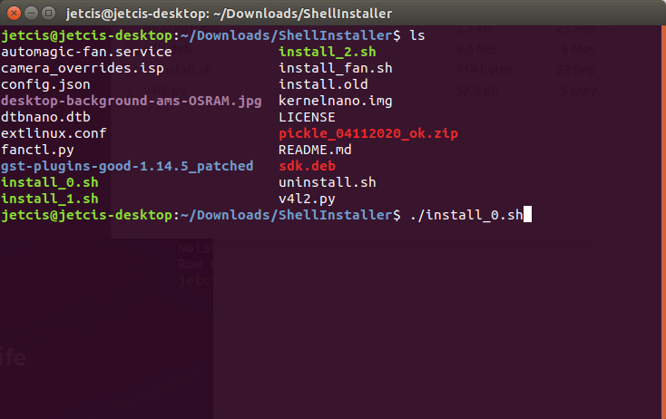

Installation is now complete.

