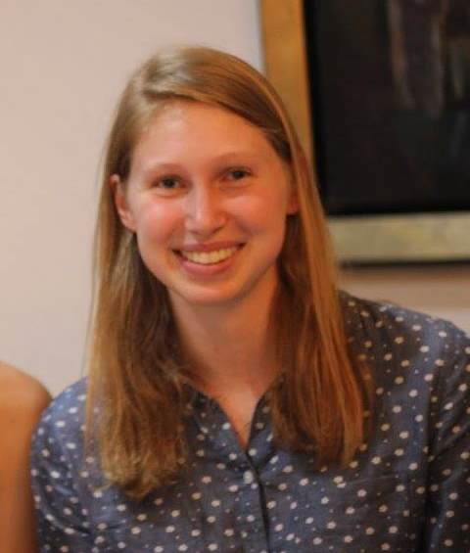
Name: Kari Stromhaug

Recent picture:
(optional)

Email: kstrom@mit.edu

Year: Senior

Major: 6-7

1. Academic background:

Bio: 5.12, 5.13, 7.012, 7.03, 7.05, 7.06, 7.371 (novel biotherapeutics)
CS: 6.009, 6.042, 6.006, 6.046, 6.036 on listener

Expertise: I’m very comfortable with Python (numpy/pandas), and have used R to analyze/process CRISPR data and generate ML models for prediction. I understand the nuances of CRISPR/Cas9 pretty well, as well as other common therapeutic models.

2. My previous research experience.

I did a brief UROP over sophomore IAP that involved mostly lab work, which I found a little dry.

Most recently, I worked at Intellia Therapeutics for a summer using machine learning to predict Cas9 editing. I worked with an untouched dataset, which I normalized, and then used a few different ML models such as GLMs and Gradient Boosted Machines to create predictive models. I’m also comfortable with using R, pandas, and bash to crunch large datasets and create graphs and figures, and create pipelines.

Although it is not computational bio, in the summer of 2017 I worked on a research project to learn about mental health challenges that arise after natural disasters, and how to develop a scalable, digital tool/service that can help to address these concerns. The project was conducted at an IDEO affiliate, so we rigorously use the Human Centered Design approach to conduct our research. We did a vast literature review, conducted interviews, and went out into the field to learn as much as we could about the situation. We then began ideating and prototyping, and in the end piloted two distinct programs we had developed in the field. I am currently continuing this project as a UROP at MIT with the goal of refining our program and conducting another pilot.

3. Areas of computational biology that interest me most:
I’m still learning about the different areas so am not quite sure. Some of the lecture topics that interest me are disease association mapping, GWAS, Machine Learning, Single-cell genomics, Regulatory Motifs.
I am intrigued by how much there is to learn from the less simply by processing the vast amount of data that exists and has existed for a long time. There is so much data out there and there is so much that can be learned by developing an applying various analytical techniques that extract meaningful information out of such huge sets of numbers. I’m interested in the idea of being able to detect patterns that help us to understand how cells function, and how this can be used in the treatment of various disease.

I’m also interested in parasites, as well as the microbiome and how it impacts are health.

4. Preferred type of project, and role that I would like to play:

Data processing and analysis
Creating/modifying algorithms to work with new datasets.

I would not be interested in working on a very theoretical project.

I can help with coding/pipelining and data analysis/generating figures. I am also familiar with various biotherapeutic techniques and have a decent background in biology, so can help think through various biological systems.

5. Ideal partner expertise, and role that I hope they can play:

They would have a stronger background in math and algorithms. They would be able to help with the design and structuring of algorithms and mathematical analyses of data. Experience in a biology wet-lab would also be helpful.

